Assignment feedback

Student Name: Kenny Owen
Student University Email: 1300552@student.uwtsd.ac.uk
Module code: AHAC5008  Module title: Palaeoenvironmental Archaeology | Student ID number:  1300552 |  | Educational support needs:  Dyslexic
Assignment title:
Discuss the impact of changing ground conditions on the preservation of wood and human/animal remains and how these factors influence the nature of the questions that can be addressed in an archaeological project.

Assignment due date: 12th December 2017
Assignment Number: 1
(i.e. 1,2,3)
Marker’s signature: |  | Date:
Provisional.
NB. All marks are provisional until confirmed by the final examination board.

Contents

Introduction
Pedogenesis
Case Studies
Star Carr
Sutton Hoo
Flag Fen - Must Farm
Conclusion
Appendix
References

Introduction
The essay will examine four archaeological sites, from the Mesolithic to the Anglo-Saxon era discussing natural and cultural ground changes. It will include change through proto-occupation, occupation and abandonment, climate, the effect varying soils have on archaeological records through decay and preservation. Firstly, a description of how soils and sediments are formed, pedogenesis and the biological remain in archaeological record.

Pedogenesis
Processes that form sediments and soils are significantly different. Sediments are allochthonous deposits formed through weathering, erosion, transportation and disposition. Erosion can occur when rocks, pounded by waves, transport and deposit sediments at differing locations. Aeolian (air blown) soil, forming loess from Pleistocene glaciers, covered large areas of the northern hemisphere creating the basis for soils. ‘Sediments are often thick and of variable thickness, show stratigraphy, are often paler and less organic than soils, and do not have a crumb structure’ (O’Connor and Evans, 2005, p.147). In contrast, soils are autochthonous, weathering of the parent material, for example, bed rock, manipulated by animals and plants, transform the substance surface. Soil forms at the surface of the parent material working downwards creating clear horizons (Wilkinson and Stevens, 2003, p. 25-26, 53).

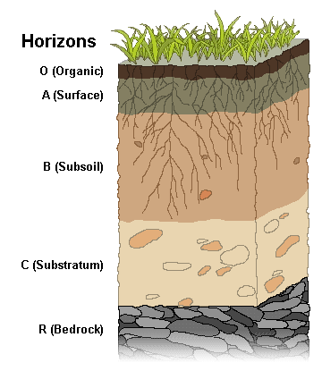
Layers of soil are called horizons; the A-horizon is typically organic, the B-horizon clay, the C-horizon weathered parent material and the D (or R)-horizon un-weathered bedrock. Environmental changes, natural and cultural, affect soil over time; dense layers of sediment above can prevent soil formation. These encapsulated buried soils, termed palaeosols, can preserve significant archaeological evidence (Fig. 1). (Goldberg and Macphail, 2006). (Add table 3.2). ‘Buried soils have a crumb structure, have weathering horizons of different chemical and textural composition, but do not show stratigraphy’ (O’Connor and Evans, 2005, p.147). Biological remains, give clues to past environments and chronologies. Pollen – vegetation species; insects – climate and habitat; molluscs - vegetation environment and climate change ; diatoms – water levels (fresh and saline), acid rain; foraminifera, sensitive to temperature, live only in saline environments - climate change/water level; ostracods, live in fresh and saline environments – climate change/water level (Wilkinson and Stevens, 2003; O’Connor and Evans, 2005).
Fig. 1

Case Studies
Star Carr (TA 0283 8097)
Figs. 2 and 3
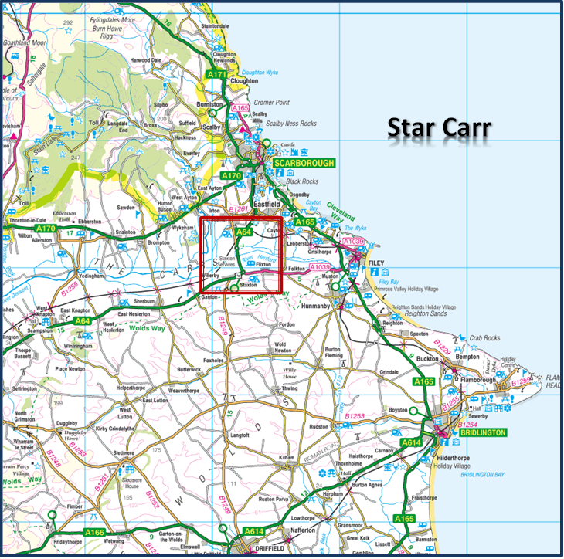
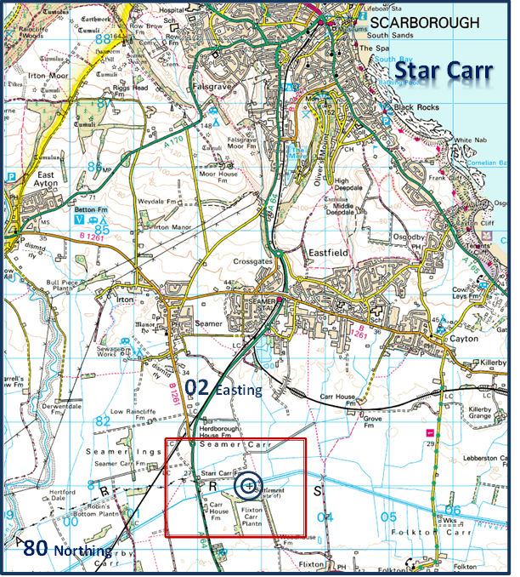

Star Carr is a Mesolithic lake site, covered in birch-wood and reed-swamp originally dated around 10,500BP, and created from the retreating Weichselian glacial melt now sealed in a waterlogged peat carr. During the Mesolithic period, birch-wood was prevalent but seasonal changes altered the landscape. The early lake formation, 9800 BP, was edged by a narrow band of reeds. The pre-occupation phase 9650 BP saw the formation of a reedswamp, the great reed extending well into the lake. During the early occupation period, 9600 BP, the reedswamp almost vanished being replaced by fen and by 9300 BP peat was established creating an anaerobic (without air) environment, with abundant willow. The settlement was located on the marginal wetland at the foot of a hillock. Sedimentary cores (Fig. 4) from the lake site provide pollen and lithic evidence and with ¹⁴C analysis provide a dating sequence for local vegetation (Cloutman and Smith, 1988). Originally, this was not considered a major habitation site, but, a winter hunting camp (Hunter and Ralston, 1999, p.45; Dark, 2000).

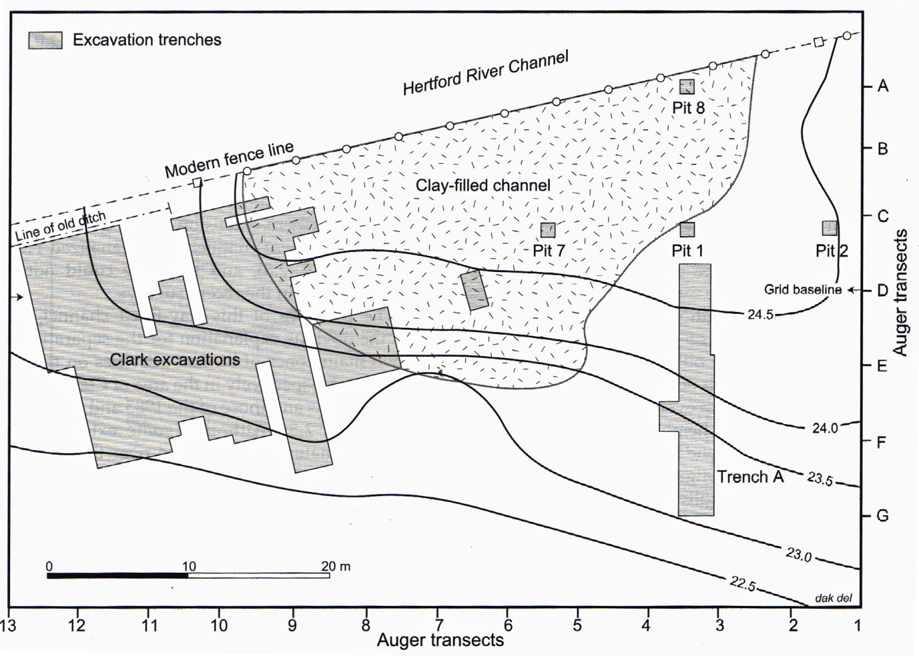

Fig. 4

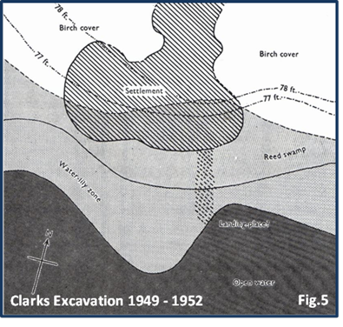
Artefacts found here include wooden tools, animal bones and antlers, barbed for hunting, rare red deer headdresses, amber jewellery, either deposited by the ice or traded from the Baltic, and lithic pieces. The antlers, possibly, had been worked at the site, moved to a different location for finishing and then returned for disposition in the lake. Ninety-seven percent of all Mesolithic artefacts found in Britain are found here, making Star Carr an important site (Fig. 5) (Star Carr, 2017). These include a birch brushwood living platform discovered in the reed swamp (Mellars, 2009) and a wooden structure of six metres found along the lake side, preserved in anaerobic conditions, originally believed to have been a mooring platform for boats from an oar find, but now interpreted as a site for ritual practice (Stringer, 2006, p.224). New research by Conneller et al (2012), suggests as only a few artefacts were discovered nearby, it could have been a walkway to the wetlands and a boat mooring. The planking, split and shaped by tools, shows evidence of the earliest carpentry in Europe (Star Carr, 2017; Mellars, P. and Dark, P., 1998). A new excavation in 2008 examined a larger area of dryland to the north and revealed a dense deposit of Lithics ploughed out by modern agriculture. Clark’s original finds were revisited and his understanding of the platform of birch stems laid down as a walkway and occupation zone. The new study proved that split-timbers had been worked and followed the shore line and not into the lake (Fig. 6) (Conneller et al, 2012, p.1007-1009).

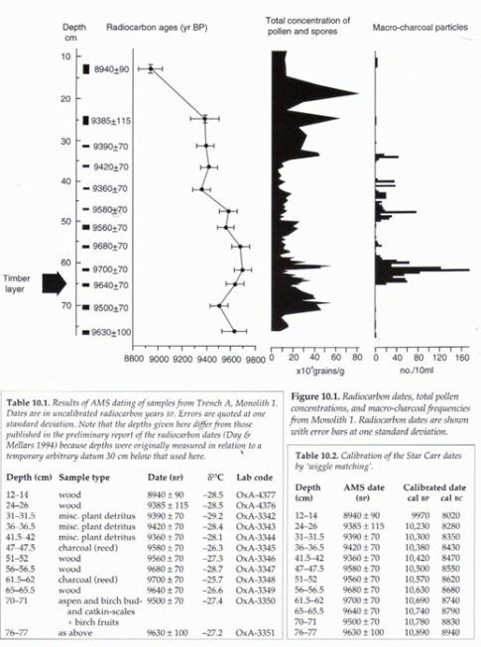
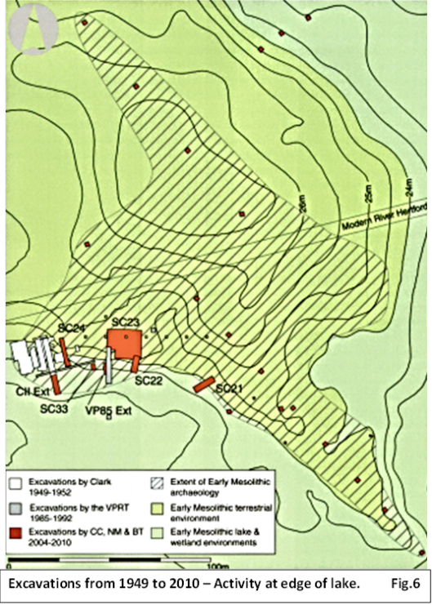
Wood: Mellars and Dark (1998) state, ‘Probably the most important archaeological discovery during the recent excavations at Star Carr was the concentration of large timbers’. Degradation of organic material occurs in damp conditions from oxidisation of soil through its ecosystem. Activity that disturbs the burial horizon, like ploughing or biological turbation, aerates the soil and degradation of artefact occurs. Wood is best preserved in anaerobic, waterlogged environments as at Star Carr (Kibblewhite et al, 2015). Once extracted the wood needs to be frozen and treated with polyethylene glycol (PEG) for conservation (Crumlin-Pedersen and Olsen, 2002, p70-78). Bone: Composed mainly of mineral and protein, hydroxyapatite (natural form of calcium) and collogen, which gives bone their elasticity. It becomes brittle over time through biological processes when bacteria and fungi colonise. Hydroxyapatite dissolves quickly in acidic soil, the greater the acidity, the faster the degradation, bones can degrade quickly and are best preserved in waterlogged alkaline or neutral pH soils (Kibblewhite et al, 2015; Wilkinson and Stevens, 2003, p.128-129; Andersen et al, 1977). Pollen: the rate of growth of vegetation and similar species is derived from pollen. Sediment accumulation sequences, together with charcoal analysis, from deposits found along the lake edge which produced ¹⁴C chronologies (Fig. 7) (Mellars and Dark, 1998, p.119-121). High and Penkman (2016) infer, that bone has been demineralised and timbers damaged due to land drainage and climate change. Dark (2000) revisits the original carbon dating of the site stating, ‘In the 1990s high-resolution pollen and charcoal analyses were undertaken on deposits from this trench, designed to shed light on the date and length of the occupation and the nature of any impact on the local environment’. A two phase occupation became apparent, the first phase identifying with the wood structure at 10,720 cal BP and the next at 10,540 cal BP. Since 1993, the dendrochronological sequence has been revised pushing the dating back two centuries (Dark, P., 2000). Star Carr is under threat from cultural and natural sources from drainage ditches to climate change. A suggestion to place a bund to protect the site from the River Hertford drainage scheme would assist (Durham et al, 2012). In contrast to Star Carr, Sutton Hoo, Suffolk presents a dichotomy of preservation.
Fig. 6
Fig. 7
Figs. 8 and 9
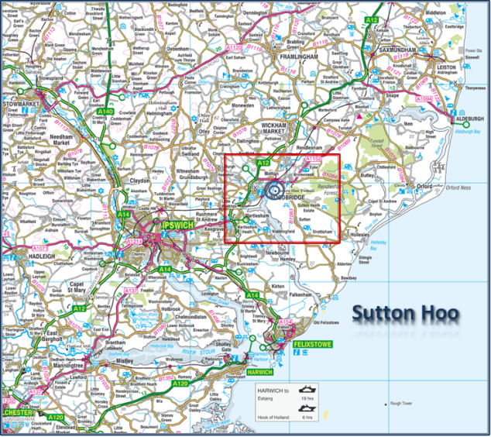
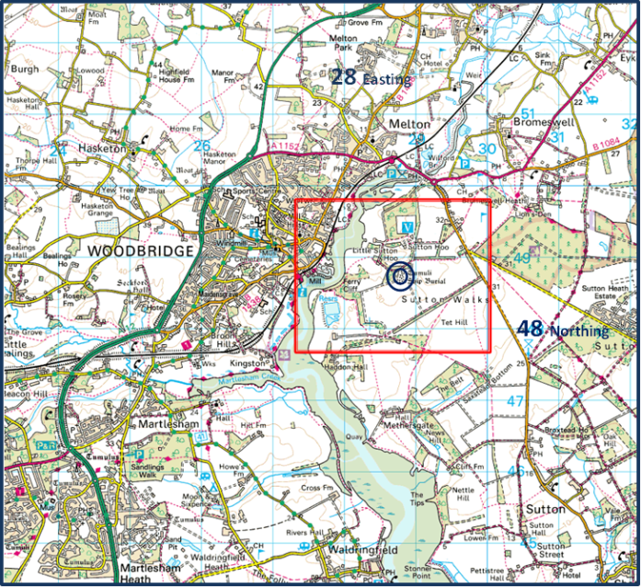
Sutton Hoo (TM 2878 4867)
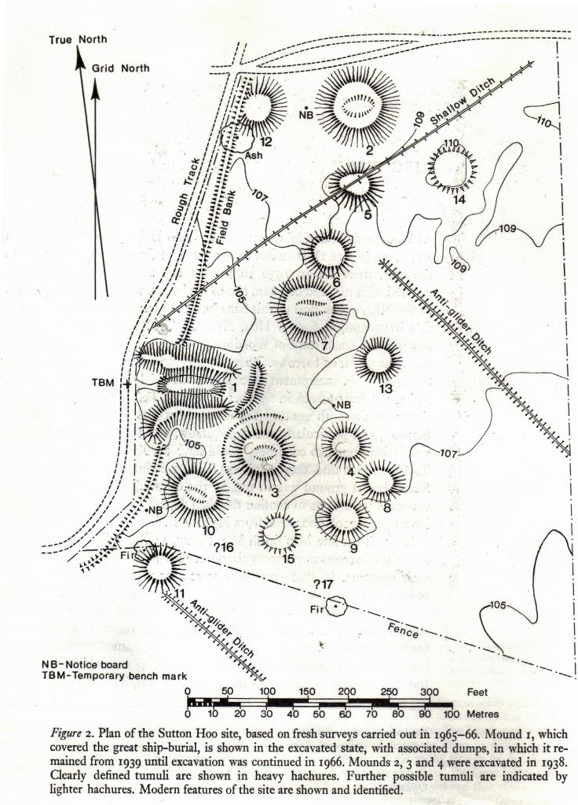
Sutton Hoo is an Anglo-Saxon burial site, rich in artefacts; it stands 105 feet above the tidal River Deben, a well-drained sandy, acidic-soil heathland plateau, bracken covered (Bruce-Mitford, 1972, p.15; Longworth and Kinnes, 1980, p7). In 1939, the first excavation by Mrs Pretty, the land owner, a long boat burial was discovered under mound one of the site (Fig. 10). Bruce-Mitford (1972) re-enacted the burial ship’s deposition. The 90 foot long craft was hauled on rollers from the River Deben, over land, to a specially constructed enclosed ditch. The ship was then lowered into position and back filled with acidic soil between ship and trench encapsulating the craft, until the discovery, of an impression in the soil of the ship.
Fig. 10

Only the impression of the vessel remained (Fig. 11), the timbers having been eaten away by the ‘very acidic sandy soil’ condition states Bethel and Smith (1989). To protect the find they covered the impression with a fine layer of orange tinted oxidated sand from the trench which had been in contact with the ship (Martin-Parraga and Torralbo-Caballero, 2015, p.58).
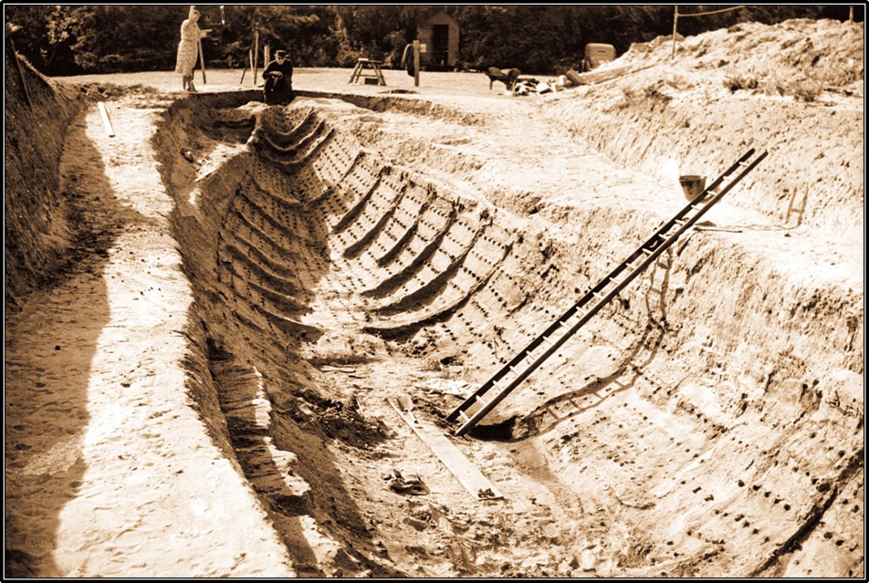
Fig. 11

Arid soils preserve organic matter due to the lack of microbial activity; seasonal weather patterns, wet then dry, encourage microbial activity causing decay. The metal rivets of the Hoo Mill vessel were in situ defining the ships outline, preserved by the arid condition of the acidic soil. Longworth and Kinnes (1980) describe ‘the iron-rich sand with high acidity, pH values ranging…from 5.1 to 4.2’. Within the ship, a burial chamber was found, containing precious metals, and grave goods, in varying condition (Hunter and Ralston, 1999, p.184). Evidence of a body, was not found but soil analysis suggests otherwise (British Museum, 2017). There are no personal artefacts, but Bruce-Mitford (1972, p.40-41) considers that a burial may have taken place because of phosphates discovered with a sword. Marchini (2017) infers, other inhumations, proved interesting, the destruction of tissue and bone creating sand formation body preservation (Hummel and Roe, 2017). The impression of the ship was coated in glass fibre and transported for display at the British Museum (Martin-Parraga and Torralbo-Caballero, 2015, p.59; Carver, 2004). In contrast to Sutton Hoo, and Star Carr, an unusual preservation of artefacts occurs at Flag Fen and Must Farm, Suffolk.

Flag Fen (TL 2280 9890) and Must Farm (TL 2370 9760)
Figs. 12 and 13
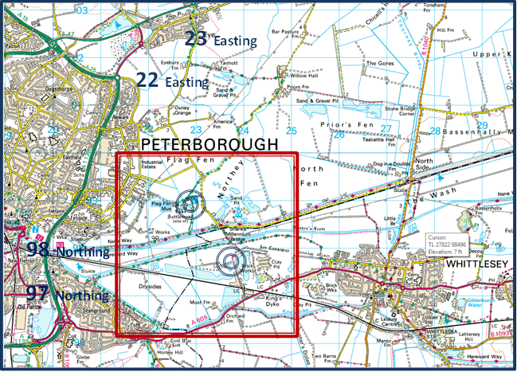
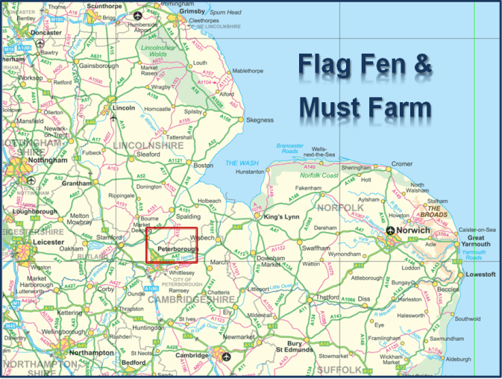

Flag Fen and Must Farm are two Bronze Age crannog (artificial islands) settlements (Fig. 14) which lie on the edge of the fenlands of eastern England, east of Peterborough, along the River Nene; once a great expanse of wetland (Malim, et al, 2014). The archaeology here is buried deep in the sedimentary silts, clays and peat. ‘Different aspects or facets of the Bronze Age occur at discernible different levels’ (Knight, 2012).

‘At the beginning of the Bronze Age, the River Nene flowed along the southern edge of what we now call the Flag Fen Basin. Then the North Sea entered the picture. The low lying contours were inundated by rising water. The ground became saturated, peat began to form, and the Fens were created. What was once dry land became marshland’ (Must Farm, 2017).

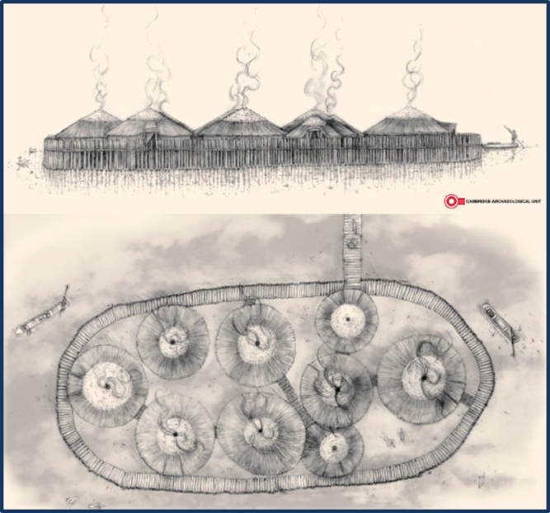

Fig. 14
The landscape has changed through drainage, industry and agriculture resulting in a five metre reduction of the western fen edge. The archaeological record is at varying depths each site providing ecosystem evidence of, ‘settlement, field systems, stock handling, woodland clearance and land-use, exploitation of riverine resources and communications, domestic and ritual activity’ (Malim, et al, 2014). In contrast to the riverine theory, Evans (2017) suggests an inland sea environment with fishing and salt production furthering a metallurgy industry, inferring occupation along the length of the palaeo-Nene and not localised. Knight (2012, p.9) suggests that, during repair of a partially collapsed crannog platform, a damaged fish trap containing freshwater snail shells was found, possible evidence of occupation in both freshwater and marine chronological environments (Must Farm, 2017).

Flag Fen described by Malim, et al (2014) ‘as a timber alignment, a crannog/island/platform, settlement, and ritual site’ (Fig. 15), consisting of timber causeways constructed over several centuries from 1300 - 900 BC. Artefacts discovered here mainly of Iron Age ritual deposition and not contemporary with the timbers. Must Farm, also a crannog, revealed discoveries spanning Neolithic, Bronze and Iron Ages containing amazing organic remains, weaponry and preserved footprints of cattle, deer, pigs and humans. There has been a recent find of nine log boats with fish and eel traps. Dendrochronology confirms a contemporary chronology with Flag Fen from the deposits, termed the “cultural horizon” after the destruction, by fire, of the settlement. The charred organic remains collapsed in the water, settled in the mud, with other artefacts, before sedimentary processes encapsulated them (Malim, et al, 2014; Must Farm, 2017). Pollen analysis of soils relates to a landscape of woodland, grasses and grains, and infers water and land occupation. ‘Occupation was extensive rather than intensive, and overall there was a sense of mobility rather than permanent residency’ (Knight, 2012).
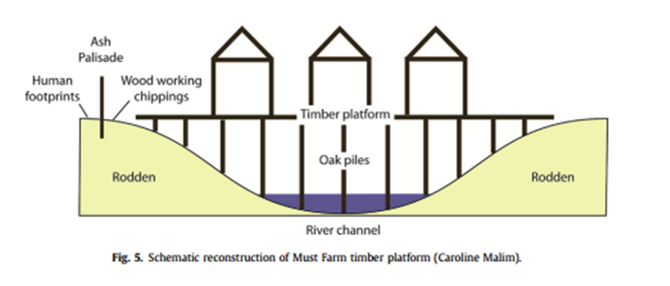

Fig. 15

‘Flag Fen and Must farm are not waterlogged in the conventional understanding of organic remains’ (Malim et al, 2014). A recent discovery found that surviving timbers in the old Nene palaeochannel were locked in palaeosols, sealing an anaerobic peat deposit, preventing biological dynamics, but, allowing the sand and gravel aquifer, the capillary fringe, (Fig. 16) (Klenk and Grathwhol, 2002) into action which kept the wood moist, thus preserving it. The capillary fringe kept the anaerobic moisture constant, through the more arid seasons assisting conservation of timbers and metallic artefacts. Preservation continues, although the capillary fringe is three metres under the timber remnants, there have been significant anthropogenic disturbances to the site and the water table is lower than the 3000 year old wood platform. Both sites have been protected from further decay, Flag Fen by an artificial lake and a barrier around Must Farm to keep the water levels constant (Malim et al, 2014; Knight, 2012).
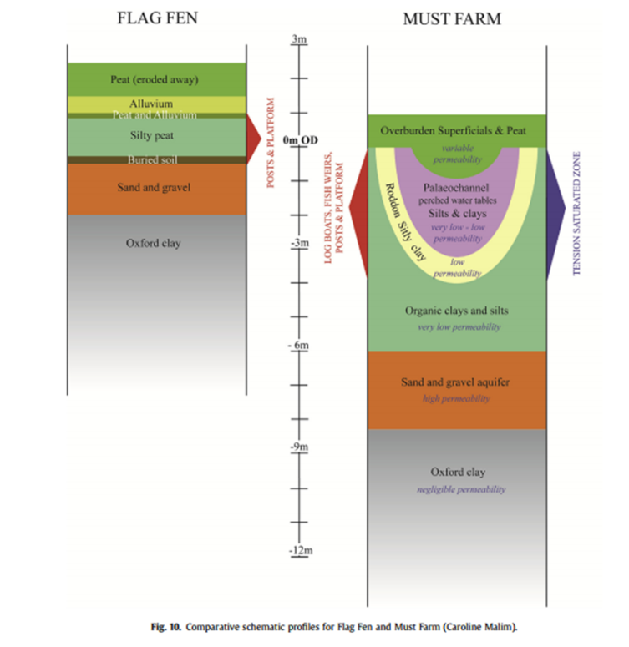

Fig. 16

The above sites, collectively in the future, may endure drier weather, agricultural and industrial abstraction causing shrinkage of soil, subsidence and degrading of organic artefacts destroying the archaeological record (Daly, 2011, p.4). Argilliturbation (Wilkinson and Stevens, 2003, p.42) of the soil through drying will increase the oxygenation allowing microbial dynamics to attack organic materials while metals will be oxidated. Increased precipitation in northerly waterlogged regions, however, may assist in preservation. Discovery of new archaeological sites may become prevalent through soil erosion, but, many sites could become irreplaceably damaged (Daly, 2011, p.4).

Conclusion
There are many environmental differences between Star Carr, Sutton Hoo, Flag Carr and Must Farm including, the landscape, soil formation and the preservation of archaeological record. Their commonality is the concern over waterlogged anaerobic environments due to climate change and agricultural methods. There is still debate among academics whether the occupants were mobile or sedentary. Preservation of artefacts has shown that unusual ground conditions preserved the archaeological record in varying ways, Flag Fen being a good example, and, an understanding of what possibly the future may hold.

Appendix
Wood Conservation Process
Water-logged wood degrade, warps and shrinks during dehydration, so immediate conservation was required to preserve the original timbers. Experimental conservation processes started in 1957 produced varying results: Linseed oil and kerosene treatment left wood distorted, the Alum method proved unsatisfactory, however, initial experimentation with polyethylene glycol (PEG) in 1962 showed some success. The PEG 4000 method used had many side effects which produced new thoughts on conservation. Tertiary butanol (TBA) replaces water in timber, has a boiling point lower than water and a solidification temperature higher than zero degrees. TAB, water and PEG are miscible impregnating the damaged wood cells while heat evaporation of the water and solidification of the chemicals under freezing conditions, preserve the wood. The process is carried out in a strictly controlled environment due to flammable gasses. PEG unfortunately does not impregnate deep into well-preserved materials and so cause shrinkage. Other issues with PEG are evident if the relative humidity changes after preservation, causing PEG to leak out of the timbers (Crumlin-Pedersen and Olsen, 2002, p70-78; Mortensen et al, 2007). ‘If the molecular weight gets too low, PEG turns into a liquid’ (Mortensen et al, 2007, p1212).

Work reduced due to over-count (2000 words).
‘Physical weathering includes: cycles of heating and cooling, and of wetting and drying, which can bring about the disintegration of rock surfaces; crystallisation, when the formation of crystals of ice or soluble materials like gypsum expands cracks in the substratum thus exposing fresh surfaces to attack’(O’Connor and Evans, 2005, p.31).

References
Andresen, J. M., 1981. The Deer Hunters: Star Carr Reconsidered. World Archaeology, [online] Vol.13, (1), p.31-46, Available at: http://www.jstor.org.ezproxy.uwtsd.ac.uk/stable/pdf/124211.pdf [Accessed 7th November 2017].
Bethel, P.H., and Smith, J.U., 1989. Trace-element analysis of an inhumation from Sutton Hoo, using inductively coupled plasma emission spectrometry: An evaluation of the technique applied to analysis of organic residues. Journal of Archaeological Science, [online] Vol.16 (1), p.47-55. Abstract only. Available through: http://www.sciencedirect.com.ezproxy.uwtsd.ac.uk/science/article/pii/0305440389900551
British Museum, 2017. Anglo-Saxon: Sutton Hoo. Available at: http://www.britishmuseum.org/search_results.aspx?searchText=sutton+hoo&q=sutton+hoo [Accessed 3rd November 2017].
Bruce-Mitford, R., 1972. The Sutton Hoo Ship-Burial. London: British Museum.
Cambridge Archaeology Unit, 2016. Must Farm. [Drawing] Available at: http://www.sci-news.com/archaeology/must-farm-bronze-age-settlement-04031.html [Accessed: 9th November 2017] Fig 14, illus.
Clark, J. G. D., 1971. Excavations at Star Carr. London: Cambridge University Press.
Clark, J. G. D., 1971. Excavations at Star Carr. London: Cambridge University Press, p.13, illus.
Carver, M. 2004. Volume 2 of the Field Reports Fieldwork Before 1983. Sutton Hoo Field Reports, [online] Available Through: Archaeological Data Service website http://archaeologydataservice.ac.uk/archiveDS/archiveDownload?t=arch-404-1/dissemination/field_reports/pdf/fr02_before_1983_nov04.pdf. [Accessed: 18th November 2017].
Cloutman, E. W. and Smith, A. G., 1988. Palaeoenvironments in the Vale of Pickering. Part 3: Environmental History at Star Carr.
Conneller, C. et al, 2012. Substantial Settlement in the European Early Mesolithic: New Research at Star Carr. Antiquity, [online] Vol. 86 (334), Available at: https://search-proquest-com.ezproxy.uwtsd.ac.uk/docview/1266509623/fulltextPDF/F738139F63924904PQ/1?accountid=130472 [Accessed 7th November 2017].
Conneller, C. et al, 2012. Substantial Settlement in the European Early Mesolithic: New Research at Star Carr. Antiquity, [online] Vol. 86 (334), Available at: https://search-proquest-com.ezproxy.uwtsd.ac.uk/docview/1266509623/fulltextPDF/F738139F63924904PQ/1?accountid=130472 [Accessed 7th November 2017], illus, Fig.6.
Crumlin-Pedersen, O. and Olsen, E. eds, 2002. The Skuldelev Ships 1. Denmark: The Viking Ship Museum.
Daly, C., 2011. Climate Change and the Conservation of Archaeological Sites: a Review of Impacts Theory. Dublin Institute of Technology, [online] Vol.13, (4) p.1-20 Available at: https://arrow.dit.ie/cgi/viewcontent.cgi?referer=https://www.google.co.uk/&httpsredir=1&article=1009&context=beschrecart [Accessed: 6th November 2017].
Dark, P., 2000. Revised ‘Absolute’ Dating of the Early Mesolithic Site of Star Carr, North Yorkshire, in the Light of Changes in the Early Holocene Tree-ring Chronology. Antiquity, [online] Vol.74,(284). Available through: file:///C:/Users/Kenny's%20Computer/Downloads/ProQuestDocuments-2017-10-26.pdf [Accessed: 2nd November 2017].
Durham, B. et al, 2012. Organic Loss in Drained Wetland Monuments: Managing the Carbon Footprint. Conservation and Management of Archaeological Sites. Vol.14. (1-4) [online]. Available at: https://books.google.co.uk/books?id=1S4rDwAAQBAJ&pg=PA93&dq=star+carr+preserving&hl=en&sa=X&ved=0ahUKEwi40IOp9MPXAhXrJMAKHRpNDdAQ6AEIPzAE#v=onepage&q=star%20carr%20preserving&f=false [Accessed: 16th November 2017].
Evans, C., 2015. Wearing Environment and Making Islands: Britain's Bronze Age Inland North Sea. Antiquity, [online] Vol.89, (347), 1110-1124. Available through: https://search-proquest-com.ezproxy.uwtsd.ac.uk/docview/1756944455/fulltextPDF/7766B8B9681D4342PQ/1?accountid=130472 [Accessed: 8th November 2017].
High, K. and Penkman, K., 2016. Environmental Change could be Damaging Some of the World’s Most Precious Archaeology. Available at: https://theconversation.com/environmental-change-could-be-damaging-some-of-the-worlds-most-precious-archaeology-67999 [Accessed: 7th November 2017].
Goldberg, P. and Macphail, R. I., 2006. Practical and Theoretical Geoarchaeology. Oxford: Blackwell Publishing.
Hummler, M. and Roe, A., 2017. Sutton Hoo Burials: Reconstructing the Sequence of Events [online] Available at: https://www.york.ac.uk/archaeology/strat/pastpub/96ch6.pdf [Accessed: 9th November 2017].
Hunter, J. and Ralston, I., 1999. The Archaeology of Britain. London: Routledge.
Klenk, I.D. and Grathwhol, P., 2002. Transverse Vertical Dispersion in Groundwater and the Capillary Fringe. Journal of Contaminant Hydrology, [online] Vol.58 (1-2). Available through: http://www.sciencedirect.com/science/article/pii/S0169772202000116 [Accessed: 8th November 2017].
Knight, M., 2012. Must Farm. Cambridge Archaeology Unit: Cambridge.
Longworth, I.H. and Kinnes, I.A., 1980. Sutton Hoo Excavations 1966, 1968-70. London: British Museum.
Longworth, I.H. and Kinnes, I.A., 1980. Sutton Hoo Excavations 1966, 1968-70. London: British Museum, p.6, illus.
Malim, T. et al, 2014. Suspended Preservation: Particular Preservation Conditions Within the Must Farm – Flag Fen Bronze Age Landscape. Quaternary International, [online] Available at: http://www.sciencedirect.com/science/article/pii/S104061821400799X [Accessed: 8th November 2017].
Malim, T. et al, 2014. Suspended Preservation: Particular Preservation Conditions Within the Must Farm – Flag Fen Bronze Age Landscape. Quaternary International, [online] Available at: http://www.sciencedirect.com/science/article/pii/S104061821400799X [Accessed: 9th November 2017], Fig. 15, illus.
Malim, T. et al, 2014. Suspended Preservation: Particular Preservation Conditions Within the Must Farm – Flag Fen Bronze Age Landscape. Quaternary International, [online] Available at: http://www.sciencedirect.com/science/article/pii/S104061821400799X [Accessed: 9th November 2017], Fig. 16, illus.
Marchini, L., 2017. Secrets of Sutton Hoo. Available at: https://www.archaeology.co.uk/articles/secrets-of-sutton-hoo.htm [Accessed: 7th November 2017].
Martin-Parraga, J. and Toralbo-Caballero, J de D. ed, 2015. New Medievalisms. Cambridge: Cambridge Publishing Scholars.
Mellars, P. and Dark, P., 1998. Star Carr in Context. Oxford: McDonald Institute for Archaeological Research.
Mellars, P. and Dark, P., 1998. Star Carr in Context. Oxford: McDonald Institute for Archaeological Research, p.23, Fig 4.
Mellars, P., 2009. Moonshine over Star Carr: Post-processualism, Mesolithic Myths and Archaeology Realities. Antiquity [online] Available at: https://search-proquest-com.ezproxy.uwtsd.ac.uk/docview/217555453/fulltext/C76A667CD77439CPQ/1?accountid=130472 [Accessed: 2nd November 2017].
Must Farm, 2017. Must Farm. Available at: http://www.mustfarm.com/ [Accessed: 8th November 2017].
O’Connor, T. and Evans, J.G., 2005. Environmental Archaeology, Principals and Methods. Stroud: Sutton Publishing.
Ordnance Survey, 2016. North York Moors – Eastern Area. Explorer Series, Sheet OL27, 1:25,000, Fig2, Southampton: Ordnance Survey.
Ordnance Survey, 2016. Scarborough Bridlington and Filey. Landranger Series, Sheet 101, 1:50,000, Fig3, Southampton: Ordnance Survey.
Ordnance Survey, 2002. Ipswich and the Naze. Landranger Series, Sheet 169, 1:50,000, Fig8, Southampton: Ordnance Survey.
Ordnance Survey, 2005. Woodbridge and Sexmundham. Explorer Series, Sheet 212, 1:25,000, Fig9, Southampton: Ordnance Survey.
Ordnance Survey, 2003. Peterborough. Explorer Series, Sheet 227, 1:25,000, Fig12, Southampton: Ordnance Survey.
Ordnance Survey, 2002. Peterborough. Landranger Series, Sheet 142, 1:50,000, Fig13, Southampton: Ordnance Survey.
Star Carr, 2017. Star Carr Archaeology Project. Available at: http://www.starcarr.com/history.html [Accessed: 2nd November 2017]
Stringer, C., 2006. Homo Britannicus. London: Penguin Group.
Ullstein, B., 2017. The Ghostly Treasure Ship of Sutton Hoo. National Geographic [online] Available at: https://www.nationalgeographic.com/archaeology-and-history/magazine/2017/01-02/sutton-hoo-england-anglo-saxon-treasure-ship/#/sutton-hoo-afterlife-journey-ship.jpg [Accessed: 9th November 2017].
Wilkinson, K. and Stevens, C., 2003. Environmental Archaeology, Approaches, Techniques & Applications. Stroud: Tempus Publishing.
Turenne, J., 2017. Soil Horizons. [Illustration] (Welcome to NE soil.com), Fig.1.

SELF-REFLECTION SHEET.

PLEASE COMPLETE BEFORE SUBMISSION AND ATTACH TO YOUR WORK

Date: 12/12/2017 Module: Palaeoenvironmental Archaeology Name: Kenny Owen

Guidance: You might consider the following elements:

- Argument: does it have one/ is it backed by sufficient evidence/ how lucid is it?
- Structure: how clear is it /is my essay easy to follow/ does it help my argument?
- Analysis: is more/less analytical than narrative/ does it address the question?
- Reading: was this sufficiently broad/ have I referenced properly?
- How might I improve my performance in future?

Strengths
Enthusiasm and hard work, I’m stressed!

Weaknesses:
Understanding questions. This is version 5, part f.

General Comments:
Phew!
Please give a mark for your work: 69-60?

(for eg: 1st = 70+: 2/1 = 69-60: 2/2 = 59-50: 3rd = 45-49: pass = 40-44: fail = 39- )

