

Name: Heena Khan
Student number: 2419590
Module Name: Changemakers - Building your Personal Brand for Sustainable Employment
Module Code: BMHP5015
Lecturer Name: Parese Ahmed
Title: Component 1 - Online Portfolio of Set Exercises

Task 1 – Personal Brand
Write about your own person brand and how you could develop this to enable you to reach your employment goals (250 words- Minimum of 2 referenced sources)
According to Rachmad (2023), personal branding supports employment goals by acting as a "dynamic resume" that highlights an individual's authentic value and sets them apart in competitive job markets. By building credibility and strong professional networks, it opens doors to new job opportunities and ensures long-term career stability.
My aim in the future is to become an adult mental health nurse. To achieve this goal, I need to develop a professional identity that clearly shows I am a respectful, reliable and caring individual that has a willingness to learn. These qualities are important in the mental health sector due to patients needing to feel respected, understood and supported.
Furthermore, to enhance my personal brand I need to improve my time management, communication and teamwork skills. These attributes can grow through my studies at university, activities within groups, and work placements in the near future. Continuous learning is vital as it helps individuals work towards their career goals and recognise their developmental needs (CIPD, 2026).
Additionally, another way to upgrade my personal brand is by creating a well-documented CV that contains my skillset, achievements and education. I could also develop profiles on networking platforms such as LinkedIn, to connect with healthcare professionals and gain further knowledge on career opportunities. In addition, I need to maintain a positive and professional attitude both in person and online.
The Nursing and Midwifery Council (NMC, 2018) explains that nurses must prioritise people, practise effectively, preserve safety and promote professionalism and trust. I will use these values to guide my behavior and development throughout my nursing education.

Task 2 - Network Map and Rationale
Create a map of your own network considering career, support, social and community dimensions. Additionally you should provide a supporting rationale explaining and critically assessing this (250 words-Minimum of 2 referenced sources).

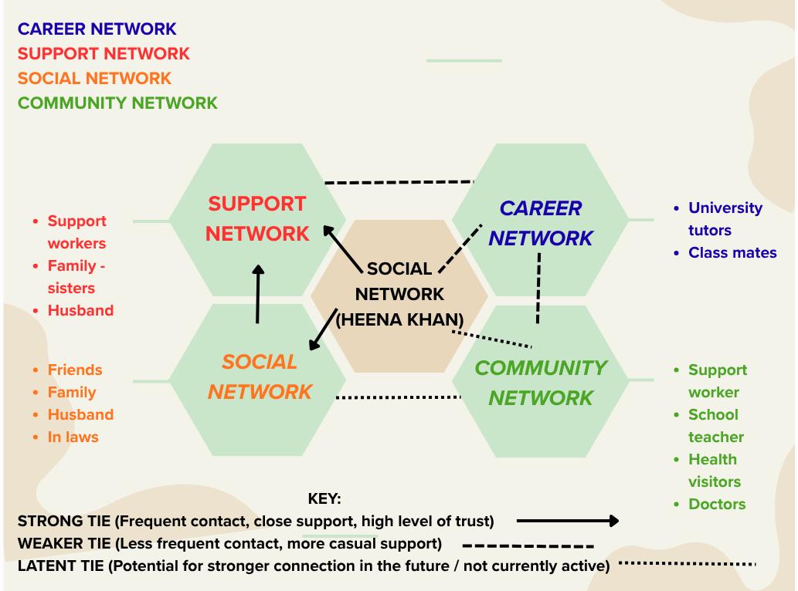
My network map illustrates the career, support, social and community relationships in my life. My support network includes my husband, sisters and support workers, who may provide emotional and practical assistance. However, the availability of support can vary, highlighting that having connections does not always mean support is consistent. My social network includes friends, family and in-laws, helping me maintain relationships while balancing university and family responsibilities.
My career network includes university tutors and classmates who can support my learning and development towards becoming an adult mental health nurse. Granovetter (1973) explains that weaker ties can provide access to new information and opportunities beyond close relationships. My community network includes support workers, teachers, health visitors and doctors, who can connect me with useful services and advice.
Critically, although strong ties provide trust and close support, relying heavily on them may limit access to wider opportunities. Weak and latent ties may offer new connections but may not always provide immediate support. Therefore, developing a balanced network could strengthen my wellbeing, education and future career prospects (House, 1981).

Task 3- Blog
Write a blog exploring a current topic or issue of your choice within the health and social care sector in the UK. The purpose of this is to inform a specific target audience of your choosing (400 words) Referencing of your sources of information is not a compulsory requirement but could be beneficial.
Mental Health Matters: Is the UK Doing Enough to Support Young People?
Target audience: Young adults and university students
Introduction
Mental health is an important issue within the UK health and social care sector. Many young people experience stress, anxiety and low mood while managing education, relationships, work and family responsibilities. However, accessing professional support can be difficult when services are under pressure. Mental health should be treated as equally important as physical health.
Why is mental health support important?
Mental health difficulties can affect a person's education, relationships, confidence and everyday activities. According to the Care Quality Commission (2026), referrals to secondary mental health services in England increased by 7% between 2024/25 and 2025/26. This highlights the growing demand for support and the pressure placed on services.
Long waiting times can leave people feeling unsupported and may allow their difficulties to worsen. The Care Quality Commission (2026) also reported that 39% of respondents to its 2025 community mental health survey felt the waiting time between assessment and their first treatment appointment was too long.
What support is available?
There are several ways to seek help. University students can contact their university's wellbeing or counselling service. People can also speak to their GP about their mental health or access NHS Talking Therapies through self-referral in many areas (NHS, 2026.). Charities and community organisations may also offer information and emotional support.
It is important to remember that asking for help is not a weakness. Speaking to someone you trust can be a useful first step while exploring professional support.
How can we improve mental health care?
Earlier intervention, better access to counselling and increased investment in mental health services could help people receive appropriate support sooner. Universities, healthcare professionals and community organisations should work together to raise awareness and reduce stigma.
Conclusion
Mental health support should be accessible, timely and appropriate for everyone who needs it. Although services are available, increasing demand and waiting times remain concerns. By encouraging open conversations and improving access to support, we can help create a society where people feel comfortable seeking help before their difficulties become overwhelming.

Task 4- NHS Equality, Diversity and Inclusion Quiz (250 words equivalent)
- What is the primary goal of the NHS Equality, Diversity, and Inclusion Improvement Plan?
(Answer in one or two sentences.)

The primary goal of the NHS equality, diversity and inclusion improvement plan is to reduce inequalities, tackle discrimination within the healthcare sector, and create a fairer, more inclusive environment. Their goal is to ensure that the patients and NHS staff are treated fairly, with equal opportunities and maintain access to appropriate care regardless of their background or characteristics.

- How does the NHS EDI Improvement Plan propose to tackle the gender pay gap?
(Answer in one to two sentences.)

The plan tackles the gender pay gap by implementing the recommendations of the independent Mend the Gap review across medical and senior non-medical staff, supported by board-monitored improvement plans based on sex pay data. Additionally, it requires NHS organisations to establish flexible working policies and advertise flexible options across all recruitment campaigns.

- What is meant by the term ‘intersectionality’ as used in the NHS EDI Improvement Plan?
(Answer in one to two sentences.)

In the plan, intersectionality refers to the recognition that individuals possess complex, overlapping identities and that no person is defined by a single protected characteristic alone. Consequently, multiple forms of inequality or bias can combine to create unique obstacles that cannot be resolved by focusing on one characteristic in isolation.

- Why is it important for the NHS to create a psychologically safe work environment?
(Answer in one to two sentences.)
Creating a psychologically safe work environment is essential because it enables staff to safely raise concerns, ask questions, and admit mistakes without fear. This boosts morale and team engagement, which directly leads to more efficient, high-quality, and safer patient care.

- How does the NHS EDI Improvement Plan suggest improving the experience of internationally recruited staff?
(Answer in one to two sentences.
The plan proposes implementing comprehensive onboarding, induction, and pastoral support packages alongside clear pre-joining guidance on employment conditions and immigration policies. Additionally, line managers are required to maintain cultural awareness to foster psychological safety and ensure international recruits have equal access to career development and progression opportunities.

- What role does leadership play in advancing EDI objectives according to the NHS Improvement Plan?
(Answer in one to two sentences.)
According to the plan, leaders set the tone and organizational culture by role-modelling inclusive behaviours and embedding equality, diversity, and inclusion as a personal responsibility to end discrimination. Furthermore, chairs, chief executives, and board members are held individually and collectively accountable through specific, measurable (SMART) EDI objectives assessed in annual appraisals.

- Identify one way the NHS EDI Improvement Plan aims to reduce health inequalities within the workforce.
(Answer in one to two sentences.)
The plan aims to reduce workforce health inequalities by requiring line managers to conduct regular, effective wellbeing conversations with their teams using the national NHS health and wellbeing framework. Additionally, it addresses root causes of ill health by tackling workplace bullying and harassment and partnering with local community organisations to offer accessible employment and career development opportunities.

- Why does the NHS EDI Improvement Plan emphasise the importance of collecting and analysing data on protected characteristics?
(Answer in one to two sentences.)
The plan emphasises collecting and analysing data on protected characteristics because reliable data is essential to identify specific areas of inequality, understand workplace disparities, and guide targeted interventions. Furthermore, it enables NHS boards and organisations to monitor progress over time, hold leaders accountable, and ensure equitable outcomes across all staff groups.

- Explain how flexible working policies can contribute to equality and inclusion in the NHS workforce.
(Answer in one to two sentences.)
Flexible working policies contribute to equality and inclusion by supporting staff work–life balance, health, wellbeing, caring responsibilities, and career development while helping to close gender pay gaps. Embedding flexible options across recruitment, retention, and phased retirement plans removes systemic barriers that might otherwise deter recruits or force staff—particularly women and older workers—out of the workforce.

- What is one strategy mentioned in the NHS EDI Improvement Plan to combat bullying and harassment in the workplace?
(Answer in one to two sentences.)
One strategy mentioned in the plan is adopting a proactive approach that prioritises early, informal intervention and provides comprehensive psychological support to anyone who reports experiencing bullying or harassment. Additionally, organisations must review employee relations and disciplinary processes to ensure staff involved in formal procedures are treated with compassion, equity, and fairness.

Task 5- A Letter to Yourself
Think of a time in the past when you may have been experiencing issues or difficulties, and after considering what you have learned in this module about emotional intelligence and resilience write a letter to your younger self explaining how these attributes were important at that time and perhaps how developing these areas could have been useful (300 words)

Dear Younger Me,

I want you to understand that life will not always be easy, and there will be times when you feel overwhelmed by personal problems and responsibilities. During difficult periods, you may feel emotionally drained and struggle to balance everything happening around you. However, these experiences will teach you important lessons about emotional intelligence and resilience.

Emotional intelligence is the ability to recognise, understand and manage your own emotions while understanding the feelings of others. Looking back, developing this skill could have helped me recognise when I was becoming stressed instead of keeping my feelings inside. I could have taken time to reflect on my emotions, communicated my needs more clearly and asked for support when necessary. Understanding my emotions would also have helped me respond calmly to difficult situations rather than allowing stress to affect my decisions.

Resilience is the ability to cope with challenges, adapt to change and continue moving forward despite difficulties. During challenging times, I sometimes focused on the problems rather than recognising my own strength. Developing resilience would have helped me view setbacks as opportunities to learn rather than failures. I would also have understood that taking a break and asking for help are signs of strength, not weakness.
These qualities remain important in my life today, particularly when balancing family responsibilities with my university studies. They remind me to be patient with myself, maintain realistic expectations and celebrate small achievements. Developing emotional intelligence and resilience will also help me in my future career as an adult mental health nurse, where understanding emotions, managing stress and showing empathy are essential.

My advice to you is to believe in yourself, accept that you cannot control everything and remember that difficult experiences do not define you. You are allowed to struggle, learn and grow. Always treat yourself with the same kindness you offer others.
With kindness,

Your older self.

Task 6- GANTT Chart (200 words equivalent)
Compile a Gantt chart which illustrates the tasks you have to complete to achieve your future employment goals

Task 7- Making Changes- Report
You are the manager of a care home and want to make changes your workplace. Identify one specific change that you want to implement and write a brief report on how this is going to be achieved considering the necessary skills needed and addressing possible barriers to success. Relevant change models can be highlighted (350 words Minimum of - 3 referenced sources).
1. Introduction
This report proposes introducing a digital care planning system in a care home. The change aims to improve record accuracy, make information easier to access and support person-centred care. As the manager, it is important to plan the implementation carefully and ensure staff receive appropriate support.
2. Planning the Change
Kotter’s eight-step change model provides a structured approach to implementing change (Kotter, 2011). Initially, staff will be informed about the reasons for introducing digital care planning and the benefits for residents and employees. A small team of managers and care staff will help guide the change. Staff will receive training before the system is introduced gradually, allowing time to practise using it. Feedback will be collected during implementation to identify problems and make improvements. The Department of Health and Social Care (2026) explains that digital social care records can improve access to up-to-date information and support the quality and safety of care records.
3. Skills Required
Effective leadership and communication are essential to explain the purpose of the change and encourage staff participation. Active listening and emotional intelligence will help the manager understand staff concerns. Planning and time management will ensure training and implementation are organised effectively. Risk management skills are also needed to protect confidential information and maintain safe care during the transition.
4. Barriers and Solutions
Staff resistance may arise because employees feel anxious about technology or worry about making mistakes. This can be addressed through practical training, individual support and involving staff in decisions. Time pressures may also make it difficult to attend training while maintaining care standards. The manager should organise staggered training sessions and ensure sufficient staff cover. Limited equipment or unreliable internet access could delay implementation; therefore, these resources should be checked beforehand. Lewin’s (1951) approach to understanding driving and restraining forces can help the manager identify factors supporting or preventing change and develop suitable solutions.
5. Conclusion
Introducing digital care planning could improve record keeping and support person-centred care. Careful planning, effective leadership, staff involvement and appropriate training will help overcome barriers and make the change sustainable.

Reference List
CIPD (2026) Develop and progress: how to excel in your role as a people professional. Available at: https://www.cipd.org/uk/the-people-profession/careers/career-guidance/excel-in-your-role/ (Accessed: 13 September 2026).
Department of Health and Social Care (2026) Digital social care records: choosing and implementing solutions. Available at: https://www.gov.uk/guidance/digital-social-care-records-choosing-and-implementing-solutions (Accessed: 23 October 2026).
Granovetter, M.S. (1973) ‘The strength of weak ties’, American Journal of Sociology, 78(6), pp. 1360–1380. (Accessed: 19 September 2026).
House, J.S. (1981) Work stress and social support. Reading, MA: Addison-Wesley. (Accessed 19 September 2026).
Kotter, J.P. (2011) HBR’s 10 must reads on change management. Boston, MA: Harvard Business Review Press. (Accessed: 23 October 2026).
Lewin, K. (1951) Field theory in social science: selected theoretical papers. New York: Harper & Brothers. (Accessed: 23 October 2026).
Nursing and Midwifery Council (NMC) (2018) The Code: professional standards of practice and behaviour for nurses, midwives and nursing associates. London: NMC. Available at: https://www.nmc.org.uk/standards/code/ (Accessed: 15 September 2026).
Rachmad, Y.E. (2023) Personal Branding Theory. Ras Al Khaimah: Mountain Kitab Nashr. Available at: file:///C:/Users/heena/AppData/Local/Temp/d73c6796-9376-4990-aa39-549f8b8d055a_urwq2-osfstorage-archive.zip.55a/YOESOEP%20EDHIE%20RACHMAD%202023%20THEORY%200043%20PERSONAL%20BRANDING.pdf/ (Accessed: 19 September 2026).

