

University of Wales Trinity Saint David (UWTSD)
MSc Cybersecurity and Digital Forensics
Module: Digital Forensics Analysis
Module code: ACCA7031
Name: Hari Barot
Student Id: 2520160
Table of Contents
No. | Contents | Page No.
1 | Task 1: Digital Forensics: Current State, Trends, Challenges, and Career Landscape | 3
1.1 | Introduction | 4
1.2 | Current State of the Field: Tools, Features and Capabilities | 5
1.3 | Intersection of Digital Forensics and Cybersecurity | 6
1.4 | Emerging Trends | 7
1.4.1 | Artificial Intelligence and Automation | 7
1.4.2 | Cloud and Distributed Forensics | 7
1.4.3 | IoT, Vehicular and Non-Traditional Devices | 7
1.4.4 | Regulatory-Driven Adoption | 7
1.5 | Key Challenges | 8
1.6 | National and International Job Market | 9
1.7 | Conclusion | 10
2 | Task 2: Digital Forensic Investigation Report | 11
2.1 | Case Background | 12
2.2 | Evidence Inventory and Chain of Custody | 13
2.3 | Methodology | 14
2.3.1 | Tools Used | 14
2.3.2 | Mobile Device Acquisition Process (Cellebrite UFED) | 14
2.3.3 | Analysis Approach | 19
2.4 | Findings | 20
2.4.1 | Device Attribution | 20
2.4.2 | Communication Analysis — WhatsApp (Emma ↔ Joe) | 21
2.4.3 | Communication Analysis — Facebook Messenger (Joe ↔ Norman) | 22
2.4.4 | Call Log Correlation | 23
2.4.5 | Location and File Evidence | 24
2.5 | Suspect Profiling | 26
2.6 | Conclusion | 27
2.7 | Recommendations | 28
2.8 | Limitations and Notes | 29
3 | References | 30
4 | Appendix A — Supporting Evidence Screenshots | 31
4.1 | Device Extraction Summaries | 31
4.2 | WhatsApp Conversation — Emma and Joe | 32
4.3 | Facebook Messenger Conversation — Joe ("Peter Dover") and Norman ("Norman Smith") | 34
4.4 | Call Log — Emma's Device | 35
4.5 | Geolocation and Photographic Corroboration | 36

Task 1: Digital Forensics: Current State, Trends, Challenges, and Career Landscape

1.1 Introduction
Digital Forensics is applied science that has to do with the identification, preservation, collection, analysis, and presentation of electronic evidence to the legal community in a way that would be acceptable to the law. From policing to become a niche support area, the discipline has been embraced to form a central component of enterprise incident response, litigation support and regulatory compliance as a whole. This report will provide a summary of current landscape, explore the relationship between the digital forensic and cybersecurity industry, highlight existing trends and emerging challenges, and provide an overview of the national and global opportunities and threats for digital forensics practitioners, specifically the field of mobile device forensics.

1.2 Current State of the Field: Tools, Features and Capabilities
An increasing number of cybercrimes, cloud adoption and strictening data protection laws, is responsible for this surge of the global digital forensics market, which was valued at USD 12.9 – USD 14.9 billion in 2025 and expected to exhibit a CAGR of approximately 11 – 14% till 2030 [1] [2]. There are a number of commercially available imaging solutions – including EnCase, FTK, Cellebrite UFED, Magnet AXIOM and X-Ways Forensics – that offer extraction, imaging, artefacts, timeline analysis and reporting features [3] and [4]. OSS tools like Autopsy or SIFT provide an affordable option [6]. The fastest growing area is cloud forensics, but for mobile forensics, there is a proliferation of incidents demanding the need for more than one tool to get an evidentiary cover since there is no single solution that will do it all [1], [2], [8].

1.3 Intersection of Digital Forensics and Cybersecurity
Cyber-fuensics is identified as a critical field in the development of cyber security practice and not as a downstream activity [2]. The Digital Forensics and Incident Response (DFIR) team includes both forensic evidence gathering and current incident containment; and using forensic artefacts to help identify timeline of events for the attackers as well as initial attack vector, to aid with post-incident remediation. Forensic investigations had to be as precise as possible because using the forged credenza or social engineering was the source of 68% of the breaches, as identified in the 2024 Verizon Data Breach Investigations Report [3].
Institutionally, the FBI has recently introduced a special program for its DFIR training, aiming to improve law enforcement capabilities in the field of digital forensics [3] and job-market analysis of postings reveals that cybersecurity skill wording was used in about 71% of job postings pertaining to DFIR jobs in 2024, up from 59% in 2023, placing it as the single most cited skill for these positions [9].

1.4. Emerging Trends

1.4.1 Artificial Intelligence and Automation
As the volume of evidence increases rapidly, AI assisted triage and automated artefact classification as well as machine learning based anomaly detection are integrated into commercial platforms, such as Nuix's 2025 artificial intelligence enhanced analysis tool [5]. For mobile forensics, AI and automation will be especially useful in gaining quicker and more accurate extraction from more complex and encrypted devices, such as automated decryption assistance workflows [7].

1.4.2 Cloud and Distributed Forensics
Organisations are moving workloads to hybrid / public clouds, and forensic practice is transitioning from disk imaging to an API-based approach to evidence collection, log federation and jurisdiction-aware chain-of-custody methodology [1][2].

1.4.3 IoT, Vehicular and Non-Traditional Devices
There is an ever-expanding surface of evidence as a result of proliferation of the Internet of Things and connected vehicles. Proprietary vehicular security protocols and logs for over-the-air update features from vehicles are now becoming integrated into the e-discovery workflow for high-profile investigations like vehicle telemetry [6].

1.4.4 Regulatory-Driven Adoption
Organisations have to keep audit-ready records of previous interactions (evidence trails) of their activities, as mandated by a variety of regulations, including GDPR, CCPA and the EU's Digital Operational Resilience Act (DORA), just to name a few – and this is creating a stronger demand for forensic tooling in compliance-driven sectors like financial services, healthcare and government [1][3].

1.5 Key Challenges
Although this field is experiencing growth, it is stumbling at the same time. In the absence of trained, court qualified forensic examiners, organisations may have difficulty in carrying out timely investigations when forensic tools are available [1]. The challenge most technically relevant is encryption, whether it's full-disk encryption or file based, with such hardware-based key stores as Apple's Secure Enclave and Android Secure Keystore providing significant hurdles to the extraction of lawful evidence without compromising user privacy or vendor security assurances [10].
Add to this the problem of data fragmentation, with evidence now broken up all over the world: across cloud storage, SIM cards, touching devices, and third-party application backends—and data volumes expected to quadruple to 175 zettabytes by 2025 [11]. The combination of device heterogeneity, the presence of anti-forensics that make it harder for investigators to extract information, and the ambiguous nature of jurisdiction over the legality of mobile and cloud evidence materials further heighten the complexity of mobile and cloud investigations [8], [11]. Lastly, small and medium-sized organisations are limited due to lack of exclusive tooling, specific hardware and constant examiner training, all of which cost significant amounts of money [12].

1.6 National and International Job Market
Although this field is experiencing growth, it is stumbling at the same time. In the absence of trained, court qualified forensic examiners, organisations may have difficulty in carrying out timely investigations when forensic tools are available [1]. The challenge most technically relevant is encryption, whether it's full-disk encryption or file based, with such hardware-based key stores as Apple's Secure Enclave and Android Secure Keystore providing significant hurdles to the extraction of lawful evidence without compromising user privacy or vendor security assurances [10].
Add to this the problem of data fragmentation, with evidence now broken up all over the world: across cloud storage, SIM cards, touching devices, and third-party application backends—and data volumes expected to quadruple to 175 zettabytes by 2025 [11]. The combination of device heterogeneity, the presence of anti-forensics that make it harder for investigators to extract information, and the ambiguous nature of jurisdiction over the legality of mobile and cloud evidence materials further heighten the complexity of mobile and cloud investigations [8], [11]. Lastly, small and medium-sized organisations are limited due to lack of exclusive tooling, specific hardware and constant examiner training, all of which cost significant amounts of money [12].

1.7 Conclusion
Over the past twenty years, digital forensics has become a rapidly evolving, highly technical field and an integral part of current cybersecurity activities. The use of commercial and open-source tooling has continued to grow, especially in the capacity to use artificial intelligence to analyze trends and the use of cloud-based acquisitions, as seen in the mobile device forensic industry. Still, two other areas need to be strengthened to overcome challenges of encryption and data fragmentation, and a shortage of skills. The field can provide ample job openings for experts with a technical forensic background, combined with relevant knowledge about cybersecurity and the legal landscape, as opportunities in the industry are projected to grow well and pay above average in the national and international job market.

Task 2: DIGITAL FORENSIC INVESTIGATION REPORT
Case: Unauthorized Access and Attempted Sale of Patent QT-AI-2025
Quantum Tech's Proprietary AI Chip Design Patent
Field | Details
Case Reference | QT-AI-2025 / IP-Theft-01
Investigator | Digital Forensic Examiner (Lead Investigator)
Client | Quantum Tech's — Corporate Security & Legal
Evidence Custody Start | 28/10/2025
Analysis Tool | Cellebrite Physical Analyzer v7.73.0.11
Report Status | Final Draft — For Legal Review
Classification | Confidential — Attorney Work Product

2.1 Case Background
The company's IT security team was able to identify that unauthorized users had gained access into the company's proprietary patent database, including patent details for the AI chip design patent, QT-AI-2025. Initial investigations revealed that there was one major suspect, Emma, a new senior engineer on staff. It was suspected that Emma had tried to exfiltrate and sell technical details of the patent to a competing organisation, NexGen Circuits through a third party called Joe.
The three mobile devices that were seized and sent for forensic analysis were: Emma's (suspected insider) Smartphone, Joe's (suspected intermediary/broker) Smartphone and Norman's (suspected buyer on behalf of NexGen Circuits) Smartphone. Another flash expert analysis was also performed on Emma's USB flash drive.
This report details the acquisition, examination and analysis of the three smart phones, and the resulting findings that demonstrate roles, communications and intent of each party involved in the alleged theft and attempted sale of QT-AI-2025 via the three smart phones.

2.2 Evidence Inventory and Chain of Custody
Exhibits were all received intact in evidence bags, and with chain of custody forms completed. Before unpacking the each device, each device image was taken and immediately verified to be correct after imaging using hash checking. The table below summarises the exhibits examined.
Exhibit ID | Device / Role | Make & Model | OS / Chipset | Extraction Type | Acquisition Window (UTC)
EXH-01 | Emma (Insider) — Smartphone | Huawei POT-LX1 P Smart | Android 10 / Kirin 710 | File System (Android ADB) | 28/10/2025 16:12:56 – 16:53:34
EXH-02 | Joe (Intermediary) — Smartphone | Samsung SM-A137F Galaxy A13 | Android 14 | File System (Android Backup) | 28/10/2025 11:57:02 – 12:36:47
EXH-03 | Norman (Buyer) — Smartphone | Nokia C2 2nd Edition (HMD Global) | Android 11 | File System (Android Backup) | 28/10/2025 16:01:06 – 16:03:26
EXH-04 | Emma — USB Flash Drive | N/A (removable media) | N/A | Physical / Logical Image | Per Autopsy write-blocked acquisition

All the smartphone images were hash verified when they were completed. All three extractions of the devices used CELLEBrite Physical Analyzer which returned 'Extraction images are verified' and no discrepancy was discovered between the acquisition hash value and the hash value for the verified images. Directly from each extraction summary collected include device identifiers (IMEI, Android ID, chipset) and these are maintained in the case file for continuity documentation.
  - Emma's device (EXH-01): IMEI 860962043462662 / 860962043422658, Android ID 4e2147b661afad7a.
  - Joe's device (EXH-02): IMEI 357898921470825 / 357712351470827, Android ID f50a68ff1f9da28.
  - Norman's device (EXH-03): IMEI 353766763818217 / 353766763818209, Android ID aa01d97caa8c1336.
In addition, a write blocked forensic image of Emma's USB flash drive (EXH-04) was acquired for file-level review as the need to review all patent related files locally stored on the hard drive and DIN files (e.g. PDFs, CAD design files) existed and to capture file metadata including the creation and modification times.

2.3 Methodology
The examination was carried out in the standard manner of a digital forensic examination: preserve, acquire, analyse and report, while at the same time maintaining good documentation of the examination process to ensure that the evidential integrity was maintained.

2.3.1 Tools Used
- Cellebrite Physical Analyzer v7.73.0.11 — main tool for the parsing of mobile devices, deciphering artefacts and reviewing Insights.
- Cellebrite UFED — during the acquisition process, espace les systèmes de fichiers pour chaque smartphone sont générés, ce que Cellenbrite UFED réalise.
- Autopsy / write-blocked imaging tools — were used to conduct the acquisition and file analysis of Emma's UFD.
- Extracts an image and verifies it using hash (MD5) against the source device for every image extracted.

2.3.2 Mobile Device Acquisition Process (Cellebrite UFED)
These smartphones were seized with Cellebrite UFED 4PC (v7.76.0.24) before they were plugged into Physical Analyzer for analysis. The acquisition was conducted on a stand alone forensic workstation and the device was connected through a certified UFED USB cable, to ensure that it would not be at risk of remote wipe during imaging or being synced with other data. The following steps were taken for each handset during acquisition, and a screen measurement was made at each step and recorded in the data log.
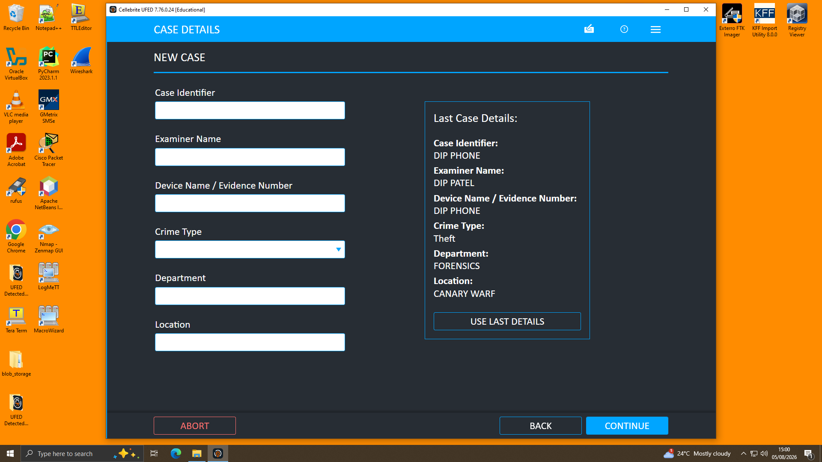
Figure A — UFED 4PC home screen. 'Mobile device' is selected as the source type before connecting the exhibit.
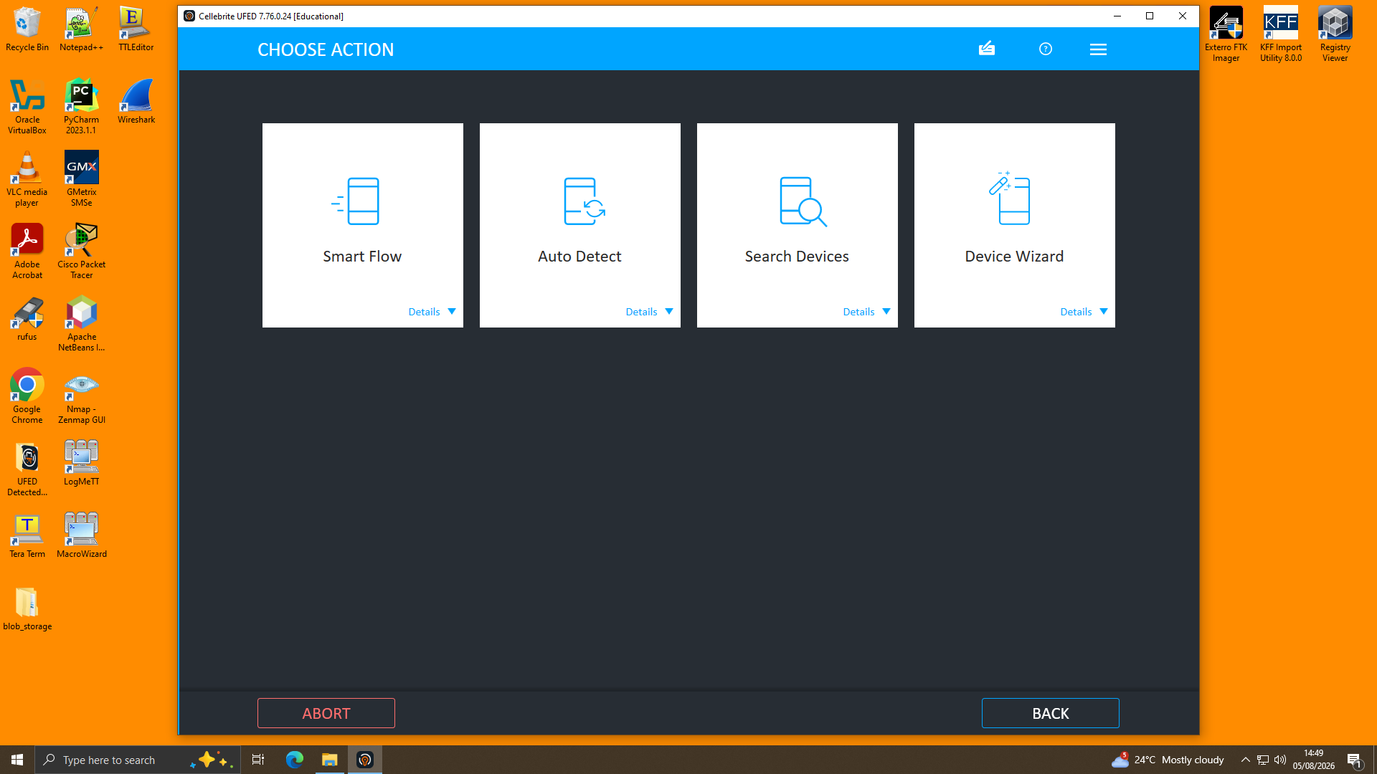
Figure B — 'Choose Action' screen. 'Auto Detect' was selected to allow UFED to automatically identify the connected handset rather than manually selecting a profile, reducing the risk of misconfiguration.
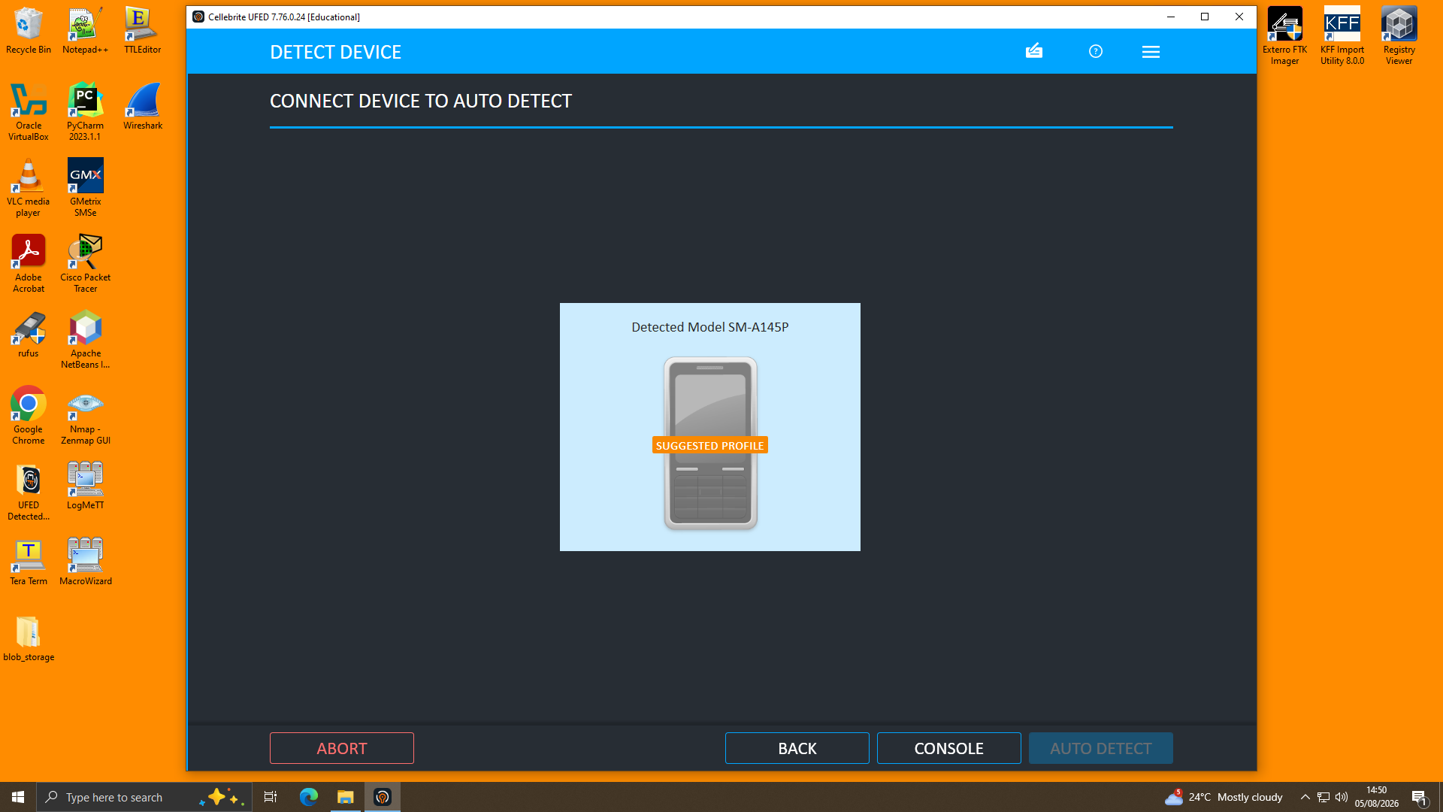
Figure C — 'Detect Device' screen. UFED identifies the connected exhibit and proposes a suggested device profile (here, Detected Model SM-A145P) based on the USB signature returned by the handset.
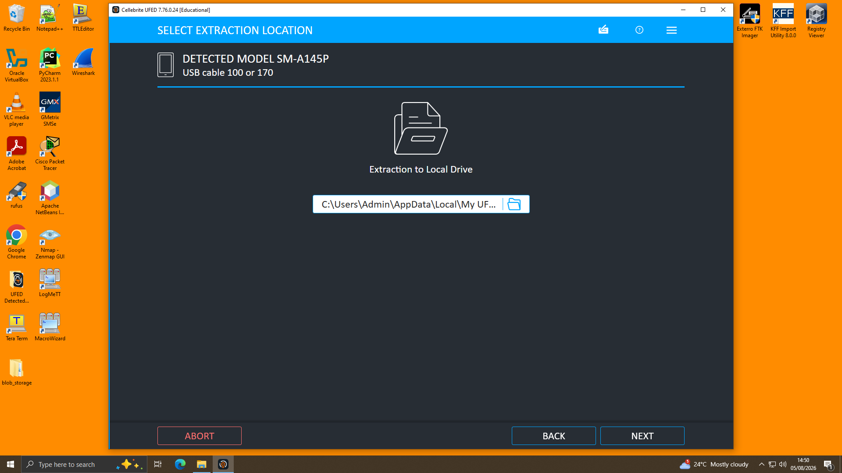
Figure D — 'Select Extraction Location' screen. The destination folder for the forensic image is confirmed on the local, write-protected examiner workstation before proceeding.
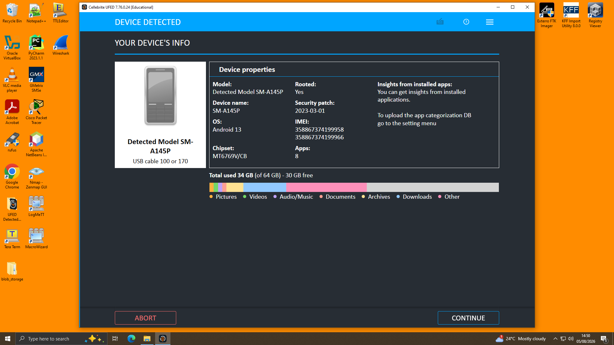
Figure E — 'Device Detected — Your Device's Info' screen. UFED displays confirmed device properties (model, OS version, security patch level, IMEI numbers, chipset and installed app count) which are logged against the exhibit reference before extraction begins.
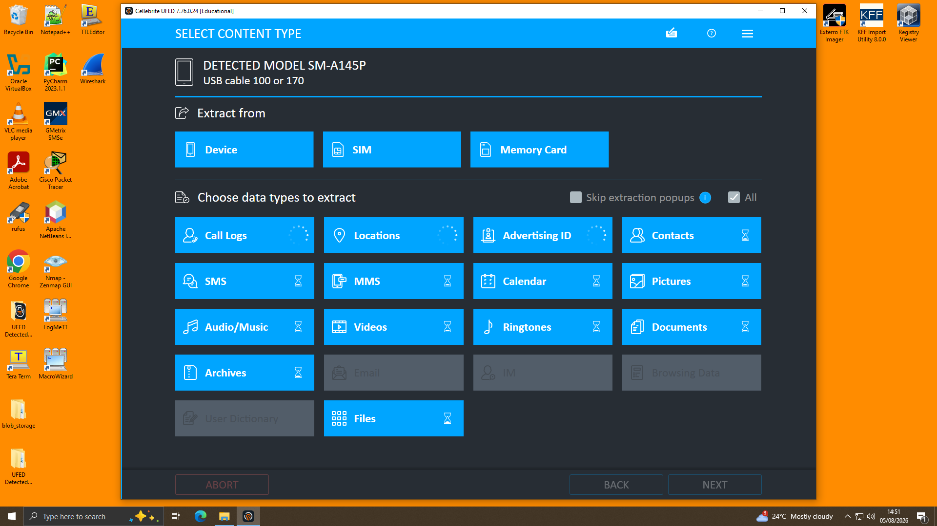
Figure F — 'Select Content Type' screen. The extraction source (Device / SIM / Memory Card) and the specific data categories to extract (Call Logs, Locations, SMS, Pictures, Documents, etc.) are selected. 'All' was used to ensure no relevant artefact category was omitted.
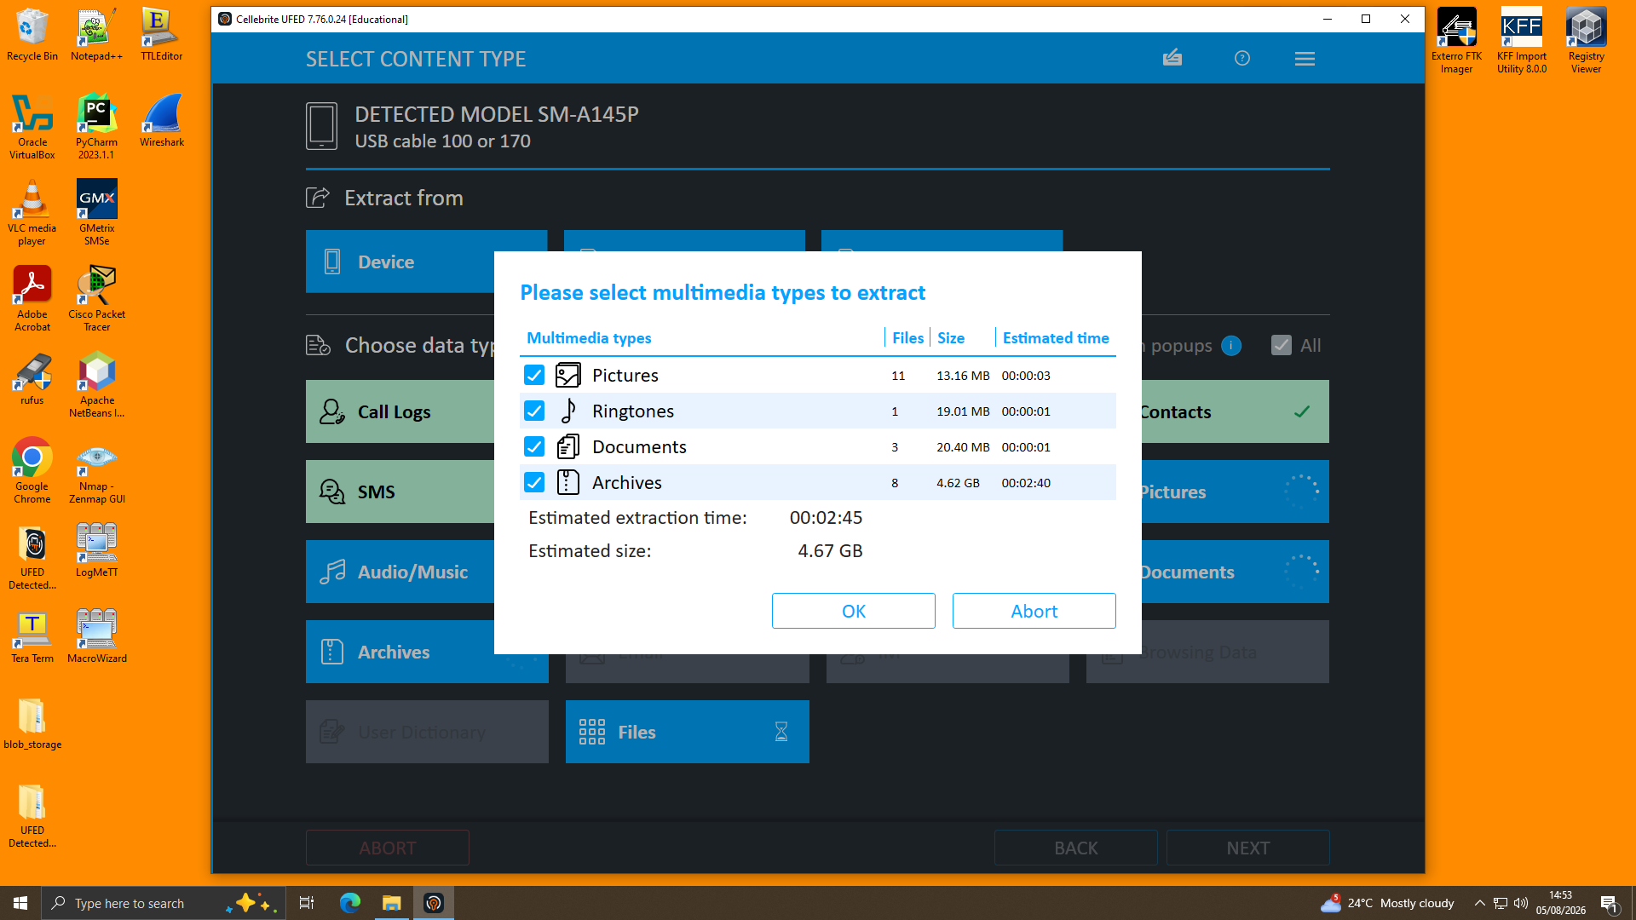
Figure G — Multimedia selection dialog. UFED reports the file count, size, and estimated extraction time for each multimedia category (Pictures, Ringtones, Documents, Archives) prior to confirming the extraction scope.
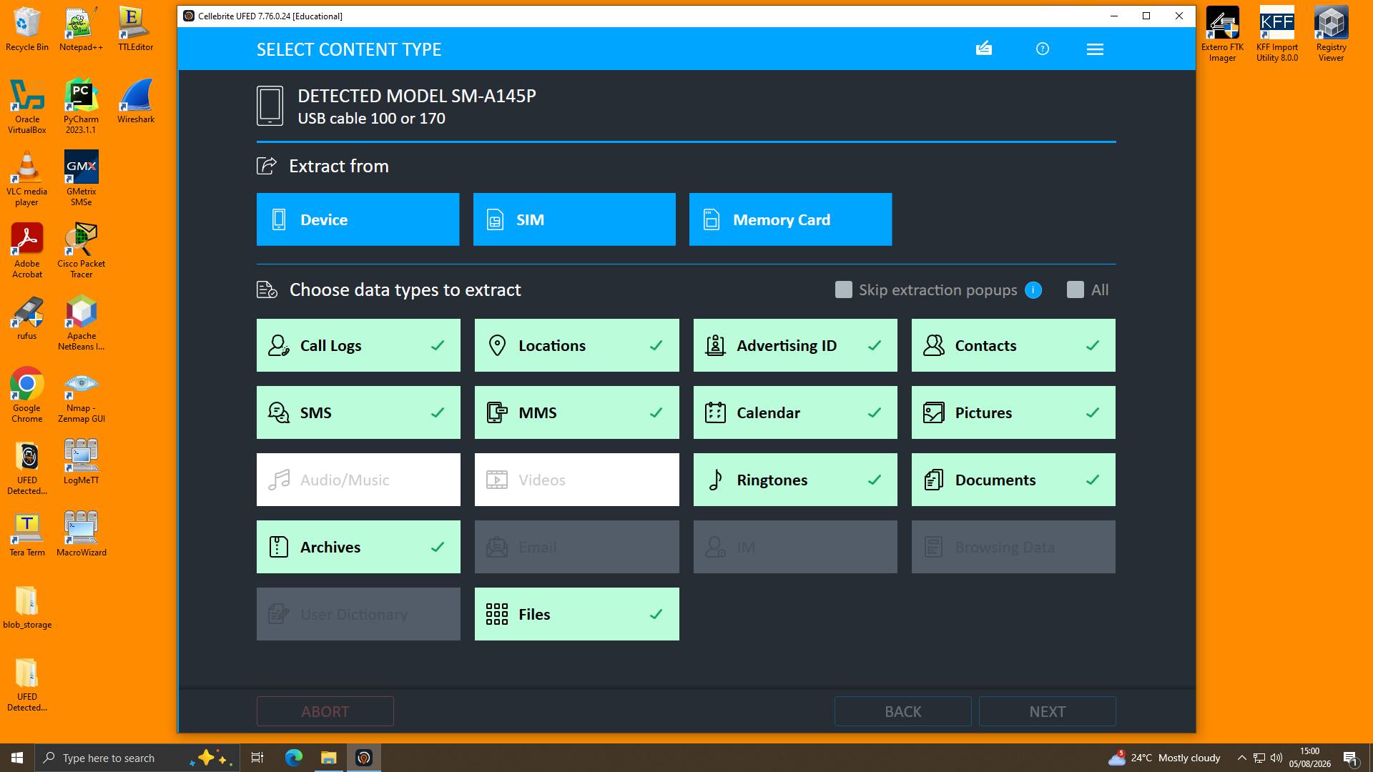
Figure H — Confirmed content-type selection. Each category selected for extraction is marked with a green check, providing a documented record of exactly what was collected from the device.
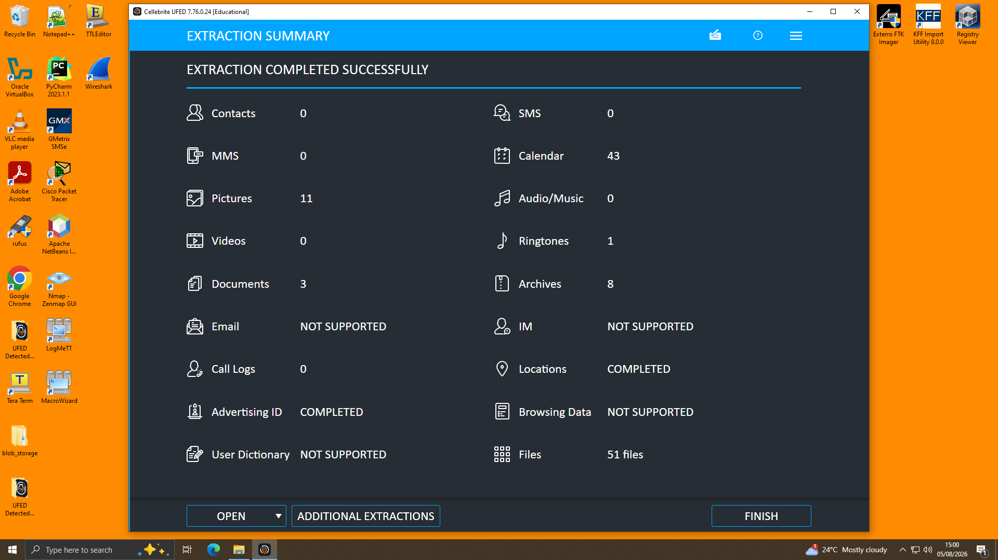
Figure I — 'Extraction Summary' screen. UFED confirms extraction completed successfully and reports item counts per category (e.g. Pictures: 11, Calendar: 43, Files: 51), alongside categories reported as COMPLETED (Locations, Advertising ID) or NOT SUPPORTED (Email, IM, Browsing Data) for this handset.
The resulting extraction (.ufdx/.ufd package) was immediately hash-verified and loaded into Cellebrite Physical Analyzer v7.73.0.11 for parsing, decoding and review as detailed in Section 3.1 and throughout Section 4. This two stage workflow (or what Cellebrite calls UFED acquisition and Physical Analyzer analysis) is standard practice and helps to keep the acquisition and analysis log files separately auditable.

2.3.3 Analysis Approach
- Analysed the Extraction Summary and Device Info panel each mobile to verify the model number, OS version, IMEI number and verification of extraction status of the same.
- Accessed Manual Data Collection > Genie: Chats to access WhatsApp and Facebook Messenger chats and extracted the information in chronological order per chat.
- Cross-referenced the Call Log (Analyzed Data > Calls) with numbers that were mentioned in chat threads to find events that were associated with that number.
- Assessed Location Related information (Device Locations), and Media (geotagged photographs) for correlation between invited meeting destinations (on the chat) and GPS information and image capture times.
- Touchpoints involved in investigations included comparing Android IDs, IMEI and photograph subject/location data with the three devices to determine device-to-person attribution.
- Created an overview timeline of the events on all three devices (based on UTC) generated by Cellebrite.

2.4 Findings

2.4.1 Device Attribution
Attribution was made based on a combination of contact data, geolocation data and photographic content, NOT based on the device being owned by an individual.
- The device (Huawei POT-LX1 P Smart, EXH-01) belongs to Emma, and has the entire WhatsApp communication with 'Joe' (which appears as a contact with name Top-up and phone number +447917162788) showing a full thread of 273 messages, in which the sender reveals herself.
- It was collected from a device (Samsung SM-A137F, EXH-02) via a cross-referencing exercise which has correlated geotagged photos to locations and dates mentioned in the WhatsApp chat text. A photo was found on Instagram that has a time/date stamp of 29/08/2024 18:28:44, which appeared to be geolocated to central Glasgow - near Glasgow Royal Infirmary, matching the information from a message posted on Instagram at the same time which reads: ‘flying to Glasgow to meet a contact. A subsequent image, dated 20/11/2024, 20:16:20, was geolocated to Manchester city centre, in line with a message from Joe last night that he had a meeting with his client 'this week in Manchester'. A hotel keycard photograph dated 04/09/2024 was also recovered and in line with travel which would be required for in person meetings.
- The device (Nokia C2 2nd Edition, EXH-03) was cross matched with a facial picture recovered from the device, which was geolocated near Swansea, Wales on 04/09/2024 (when they believed they were travelling to Swansea) to identify it as being owned by Norman. This device contained far fewer artefacts (29 locations, 119 media items, 72 applications) than the other two, likely because of minimal every day use - possibly a secondary device, or one that was used less frequently.
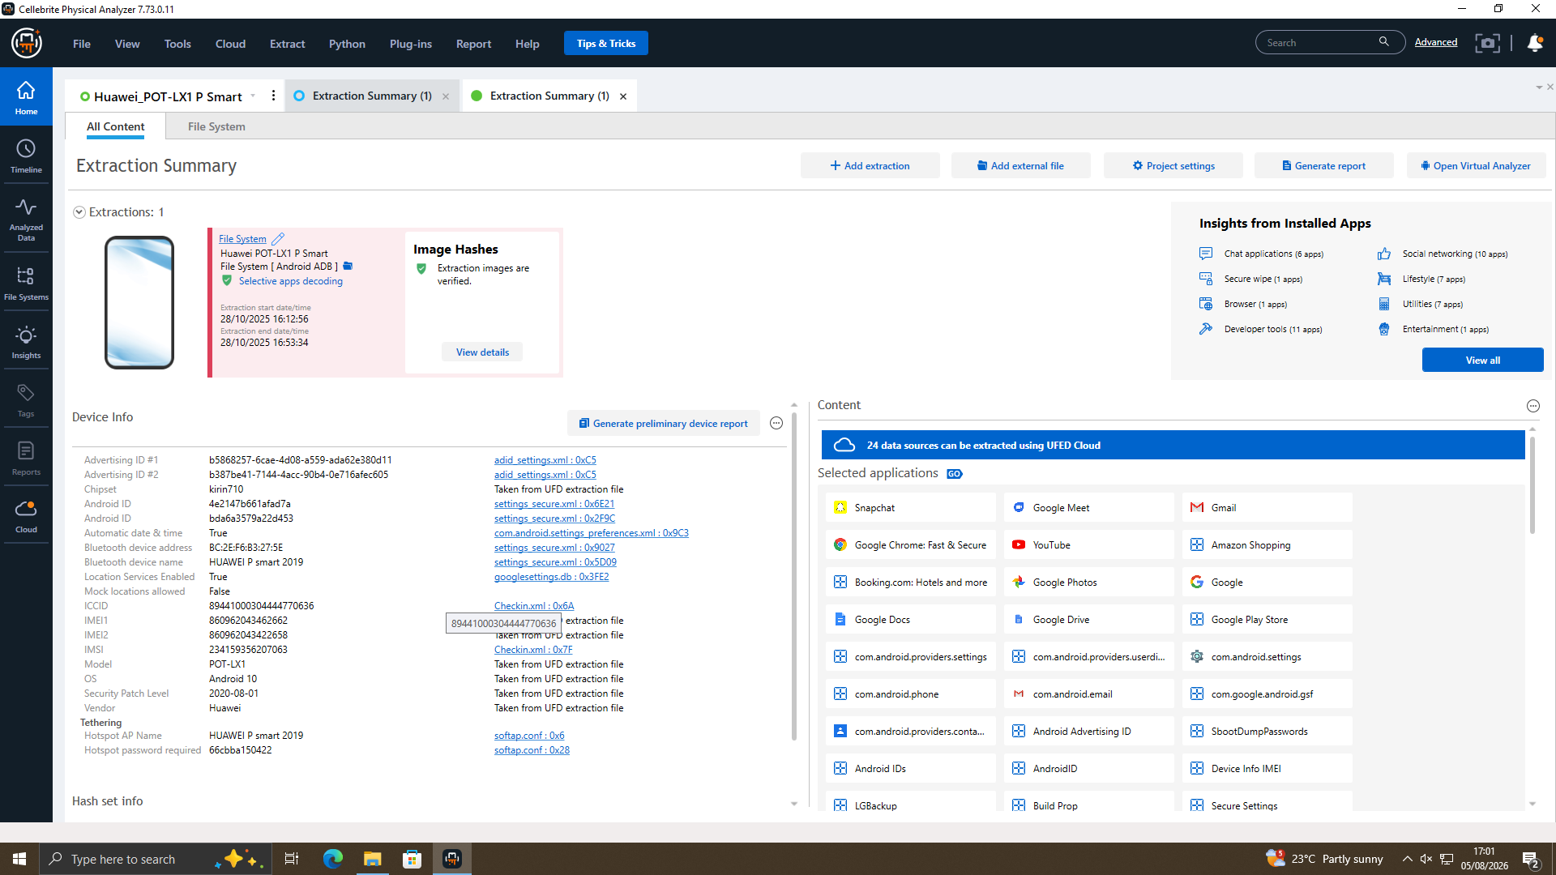
Exhibit 4.1 — Extraction Summary confirming Emma's device (Huawei POT-LX1 P Smart, EXH-01) as the source of the recovered WhatsApp thread.

2.4.2 Communication Analysis — WhatsApp (Emma ↔ Joe)
The WhatsApp conversation is labelled 'Genie: WhatsApp' with contact 'Top-up' (+447917162788), and covers a period from 21/08/2024 to 31/01/2025 with 273 messages. Read through, the conversation documents an obvious progression from the initial contact to negotiating a sales contract.
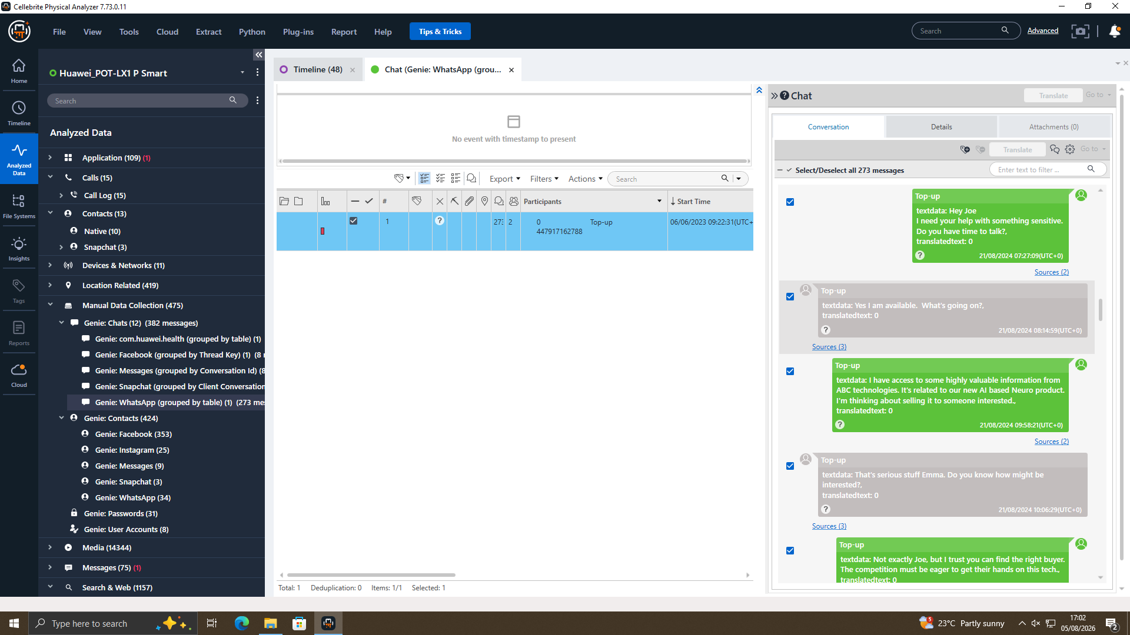
Exhibit 4.2 — WhatsApp message, 21/08/2024: Emma discloses possession of proprietary AI product information and proposes selling it to Joe.
Date/Time (UTC) | Sender | Message Summary | Significance
21/08/2024 05:03–07:27 | Emma | Initial contact; requests to discuss something sensitive. | Establishes covert intent to communicate outside normal channels.
21/08/2024 09:58 | Emma | States she has 'highly valuable information' from ABC Technologies related to a new AI-based Neuro product and is considering selling it. | Direct admission of possession of proprietary data and intent to sell.
21/08/2024 10:10 | Emma | Asks Joe to find the right buyer. | Confirms Joe's role as broker.
21/08/2024 11:13 | Joe | States he is meeting clients at a hotel meeting room to discuss the offer. | Confirms active solicitation of buyers.
21/08/2024 11:47 | Emma | 'Let's keep this under wraps. This could be huge for both of us.' | Demonstrates awareness of wrongdoing and shared financial motive.
29/08/2024 14:10 | Joe | Travelling to Glasgow to meet a contact. | Corroborated by geotagged photo on Joe's device.
14/10/2024 18:57 | Joe | Travelling to Paris to pursue deals. | Corroborated by geotagged photo (Samsung device, 14/10/2024).
20/11/2024 10:01–10:03 | Emma / Joe | Emma pressures Joe for progress and threatens to approach 'someone else'; Joe cites ongoing talks, meeting a client in Manchester. | Shows urgency and multiple negotiation tracks; corroborated by Manchester geotagged photo.
31/01/2025 10:15–10:24 | Emma / Joe | Buyer requests a demo sample (declined) but agrees to a 'detailed breakdown'; discussion of an 'offshore arrangement'; £5M reported as secured pending confirmation. | Establishes a concrete financial figure and payment structure discussion tied to the data sale.
31/01/2025 11:28 | Joe | 'We'll be watching…' | Final message; ambiguous but consistent with ongoing surveillance/monitoring of the arrangement.
A mixture of unrelated messages is included between the messages - news of football/sports, shared ‘real-time location' link and general greetings. The messages are not seen to be coded content; these seem to be regular personal messages, but the message with the location details (22/08/2024) and a function message 'Herr Flick' (22/08/2024) were captured and preserved for completeness and did not provide any additional investigative leads.

2.4.3 Communication Analysis — Facebook Messenger (Joe ↔ Norman)
A second Facebook Messenger thread, ‘Genie: Facebook’, was found on Joe's device between the sender listed as ‘Peter Dover’ and the recipient as ‘Norman Smith’ (the same contact and date as the heightened WhatsApp interaction with Emma's device). The names 'Peter Dover' and 'Norman Smith' – instead of 'Joe' and 'Norman' – are an indication of the fact that the parties used aliases in using this platform, which is often a sign of concealing super shedding in the transaction.
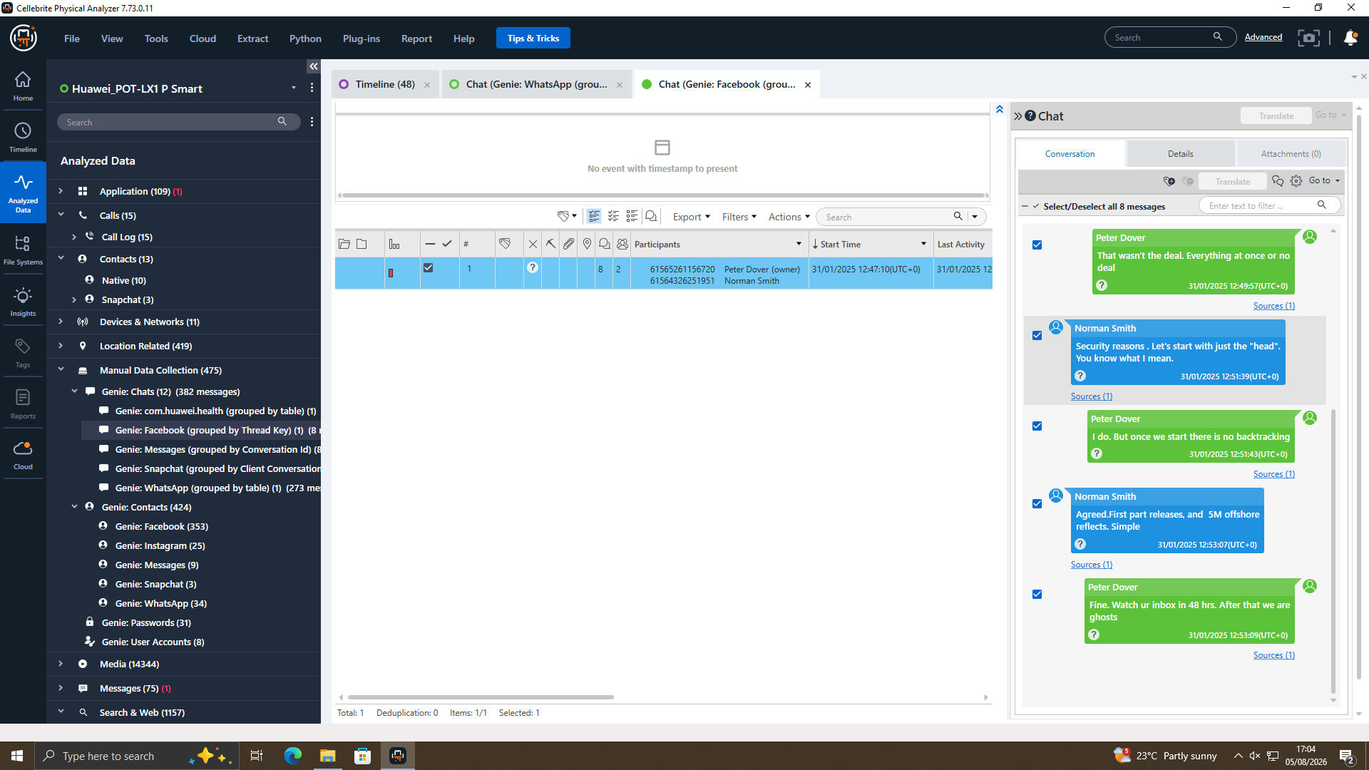
Exhibit 4.3 — Facebook Messenger, 31/01/2025: confirmation of the £5,000,000 offshore payment and instruction to 'watch ur inbox in 48 hrs. After that we are ghosts.'
Time (UTC) | Sender | Message | Interpretation
12:47:10 | Peter Dover (Joe) | 'Norman, Joe told me u r ready to proceed. Lets keep this clean and quick.' | Confirms Joe personally facilitated the introduction to Norman as buyer.
12:49:52 | Norman Smith | 'We need the blueprint in chunks. Too risky in one go.' | Norman requests staged delivery of the stolen design material ('blueprint') to reduce detection risk.
12:49:57 | Peter Dover (Joe) | 'That wasn't the deal. Everything at once or no deal.' | Joe insists on a single bulk transfer.
12:51:39 | Norman Smith | 'Security reasons. Let's start with just the head.' | Compromise proposed — partial delivery of core/critical design data first.
12:53:07 | Norman Smith | 'Agreed. First part releases, and 5M offshore reflects. Simple.' | Directly links the release of the data to a £5,000,000 offshore payment.
12:53:09 | Peter Dover (Joe) | 'Fine. Watch ur inbox in 48 hrs. After that we are ghosts.' | Confirms an imminent electronic transfer and intent to cease all contact once complete — consistent with covering tracks.

There are several similarities on the WhatsApp conversation on Emma's phone, with both setting up an ‘offshore arrangement' and both mentioning a like sum of £5,000,000, and both taking place in a 24-hour period on 31/01/2025, which would suggest that this is not two independent conversations but that they are a coordinated transaction and there is a time pressure component involved.

2.4.4 Call Log Correlation
Fifteen call records from Emma's calling log were retrieved that were made in between 02/08/2024 and 19/08/2024, all of which occurred before the first date of a WhatsApp message to Joe on 21/08/2024. They are all assigned to a small group of numbers related to each other: 07917162891, +447917162891 (or +447917162788), and international variants of these numbers; the majority of them are loops as outgoing and 'Not answered', while also showing one incoming 'Missed' call from +447917162891 on 17/08/2024. This is also a pattern matching Emma trying to reach out to Joe several times via voice before starting written communication over WhatsApp, and a record of communication testified to prior to the conversation in the recovered WhatsApp log also confirms that the relationship between Emma and Joe was in effect before the offer to sell Joe's data.
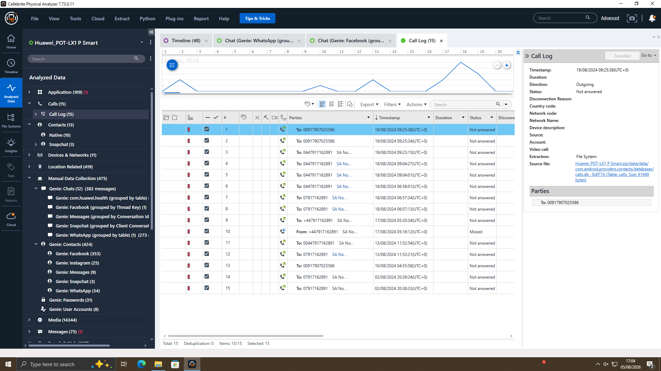
Exhibit 4.4 — Call log from Emma's device (15 calls, 02/08/2024–19/08/2024), showing repeated outgoing contact attempts to Joe's numbers prior to the first WhatsApp message.

2.4.5 Location and File Evidence
The assertions of travel and travel made within the WhatsApp intended to be confirmed utilizing area and media proof from a Samsung gadget utilized by Joe (1465 overall area factors and 1239 media things). Geotagged photographs showed the device in Glasgow on 29th August 2024, which is close to London/Home Counties where Joe corroborated travelling to in his messages to Emma on 04th September 2024 and Manchester city centre on 20th November 2024. This is third party corroboration which is computer-generated, to which Joe has communicated his whereabouts, giving credibility to the chat evidence.
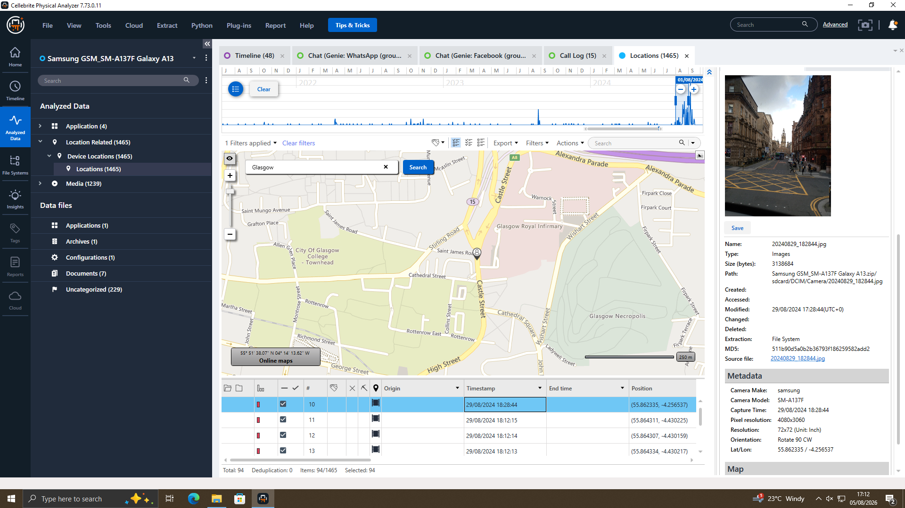
Exhibit 4.5 — Geotagged photograph from Joe's device, 29/08/2024, located in central Glasgow, corroborating his WhatsApp message about travelling to meet a contact.
Joe's device saw activity (from his device) in the same time period (04/09/2024) and area as one of the photos we recovered from Norman, showing an adult male was geotagged. This is considered as evidence but not a definite meet: bottle required for further evidence (e.g. travel or hotel bookings) if any exists.
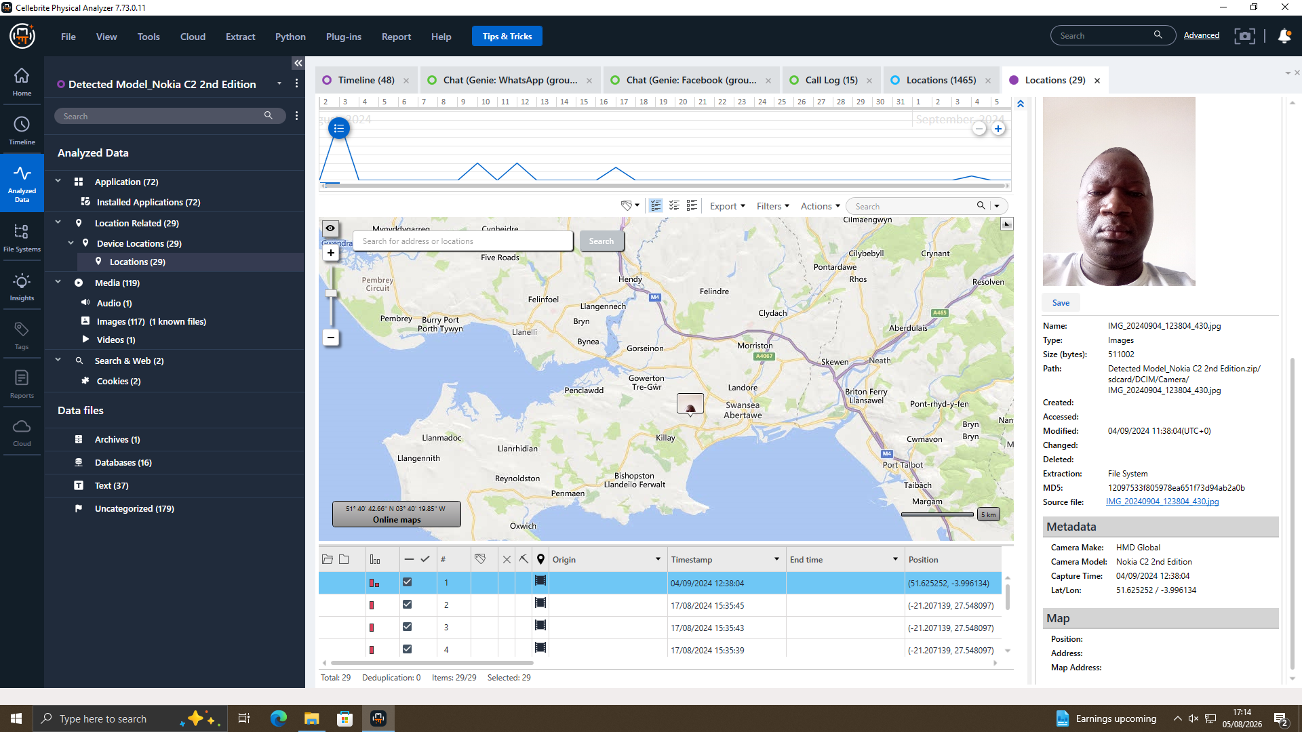
Exhibit 4.6 — Photograph recovered from Norman's device, 04/09/2024, geolocated near Swansea, Wales, used to cross-reference Norman's presence against Joe's device activity for the same period.
An examination of Emma's USB flash drive (EXH-04) was performed to determine if there were any files of any kind that referenced the patents on her device, whether it be a PDF, CAD or another iPad class design document, and to review the metadata/exif data embedded in any files to see if they were created or modified in the period she suspects that her design was stolen. This phase of investigation should be handled and reported separately in the file-analysis annex – where any document time should be compared to the dates of WhatsApp conversations and any documents that could have been duplicated from the corporate data system around the time of the commencement of communications put up to Joe.

2.5 Suspect Profiling
Individual | Device | Role | Supporting Evidence
Emma | Huawei POT-LX1 P Smart (EXH-01) | Perpetrator / Insider | Self-identifies as possessing proprietary AI product information; initiates contact with Joe; explicitly proposes selling the data; discusses payment structure and urgency.
Joe (aka 'Peter Dover') | Samsung SM-A137F (EXH-02) | Intermediary / Broker | Acts as go-between for Emma and Norman; solicits and meets buyers in person (Glasgow, Manchester); negotiates terms and confirms payment amount on Facebook Messenger; instructs on delivery timing.
Norman (aka 'Norman Smith') | Nokia C2 2nd Edition (EXH-03) | Buyer (NexGen Circuits) | Negotiates staged delivery of the 'blueprint' for security reasons; confirms £5,000,000 offshore payment; device geolocation places him in the same region as Joe around the same date.

Putting the pieces together against this backdrop suggests the following sequence of events: that Emma provided the information relating to the design of a proprietary AI chip, and, through Joe that information was transferred to another buyer, Norman, as part of an exchange involving a payment of £5,000,000 with Joe being the intermediary, and that payment was made through an offshore arrangement. The repeated and consistent use of the terms (e.g. ‘blueprint', and ‘offshore' and the £5M) and the dates between the WhatsApp and Facebook Messenger also suggest these are part of a single, coordinated transaction as opposed to coincidental or unrelated.

2.6 Conclusion
The evidence thanks to the forensic analysis of the three phones has been consistent and mutually corroborating with respect to the allegation that Emma was attempting to obtain and sell proprietary AI chip design information (patent QT-AI-2025)—which is critical for the upcoming product cycle—to a competitor, NexGen Circuits, with Joe as the negotiant and Norman as the named negotiating buyer.
- Key evidentiary conclusions:
- Points are directly inferred from Emma's own messages that she had, and planned to sell, confidential company information.
- The fact that Joe solicited buyers, was seen traveling by others (confirmed by his own geotagged photographs) and that he interacted with Norman on different platform under a fake name clearly points to the involvement of an active broker.
- The buyer's involvement is reflected in Norman's negotiations of delivery terms and confirmation of a £5,000,000 payment terms are connected with the release of the data.
- The chat content, as well as the call-log, geolocation and photographic evidence, all corroborate each other, which further increases the evidential weight of the findings from the chat content.
However, some information has yet to be added to the report before it can be submitted for legal action – such as a complete metadata analysis of the files on Emma's USB flash drive and confirmation of any e-mail correspondence mentioned in the original task brief, or formal verification of acquisition hash values in an appendix. The excavations are not described as 'speculated', but as noted, consistent with good forensic practice.

2.7 Recommendations
- Summary: Quantum Tech's should take disciplinary measures against Emma, such as temporary or permanent ban of her use of the database or other systems, depending on what the legal process determine, and discipline measures should be taken internally.
- The complete extraction reports, hash verification logs, and this report should be shared with law enforcement in the case of charges for corporate espionage, theft of trade secrets and conspiracy to commit fraud against Emma, Joe, and Norman.
- A proper request held to have Financial Records for the Offshore Account provided in the conversation on Facebook Messenger, to be able to track the proposed £m5 payment as well as identify any associated NexGen Circuits Accounts.
- Continue the remaining work on file-level analysis of Emma's USB flash drive to confirm if the files of the design for QT-AI-2025 were worked on or copied, and to find the specific times that this took place in relation to the communications chronology.
- Maintain all three devices and their forensic images under continued chain of custody and get sworn statements confirming ownership of devices where there is currently only circumstantial (photographic/location) evidence, instead of direct evidence through logon accounts.
- Discuss with them the possibility of obtaining travel, hotel and financial data to provide further support to the in person meetings for which geolocation evidence is provided for Glasgow, Manchester and Swansea area.

2.8 Limitations and Notes
This investigation was carried out based on the data provided for extractions. No problems were encountered during encryption content or deleted-message recovery of the three phones analyzed, but if such problems do occur in the final USB flash-disk analysis they will be recorded individually and provided with suggestions for recovery. There is a distinction between device attribution (for which we have relied on corroborating circumstantial evidence – photographs, geolocation and timing – in the case of Joe's and Norman's phones) and confirmed account ownership, which is why we have done this reasonably. This report shows analysis of digital evidence only and does not extend beyond the evidence provided.

References
[1] Grand View Research, "Digital Forensics Market Report 2025–2030, by Application, Geo, Tech," MarketsandMarkets, 2025. [Online]. Available: https://www.marketsandmarkets.com/Market-Reports/digital-forensics-market-230663168.html
[2] Market Research Future, "Digital Forensics Market Size, Trends and Growth Analysis – Forecast to 2035," 2025. [Online]. Available: https://www.marketresearchfuture.com/reports/digital-forensics-market-1522
[3] Knowledge Sourcing Intelligence, "Digital Forensics Market: Size, Growth, Trends, Forecast 2030," 2025. [Online]. Available: https://www.knowledge-sourcing.com/report/digital-forensics-market
[4] The Insight Partners, "Digital Forensics Market Forecast & Industry Trends 2024–2031," 2025. [Online]. Available: https://www.theinsightpartners.com/reports/digital-forensics-market
[5] Market Research Future, "Q2 2025 Industry Development: Nuix Launches AI-Powered Forensic Analysis Tool," 2025. [Online]. Available: https://www.marketresearchfuture.com/reports/digital-forensics-market-1522
[6] SalvationDATA, "Key Trends in Digital Forensics 2025: Challenges and Innovations," 2025. [Online]. Available: https://www.salvationdata.com/knowledge/key-trends-in-digital-forensics-for-2025/
[7] Oxygen Forensics, "3 Solutions for Mobile Forensics Challenges in 2025," 2025. [Online]. Available: https://www.oxygenforensics.com/en/resources/mobile-forensics-challenges-2025-solutions/
[8] A. Patel et al., "A Survey on Mobile Digital Forensic: Taxonomy, Tools, and Challenges," Security and Privacy, Wiley Online Library, 2025. doi: 10.1002/spy2.470
[9] Career.com, "How Much Does a Digital Forensics Analyst Make? (2025)," 2025. [Online]. Available: https://www.career.com/salary-guide/digital-forensics-analyst
[10] T. T. Hoang et al., "Technical Challenges of Encryption in Mobile Forensics," International Journal of Multidisciplinary and Innovative Research, vol. 2, no. 6, pp. 178–183, 2025.
[11] "Recent Challenges and Strategies in Mobile Device Forensic Investigation," Journal of Internet Services and Information Security, vol. 14, pp. 68–84, May 2024. doi: 10.58346/JISIS.2024.12.005
[12] Business Research Insights, "Digital Forensics Market Size | Research Report, 2025 to 2033," 2025. [Online]. Available: https://www.businessresearchinsights.com/market-reports/digital-forensics-market-118408
[13] Research.com, "2026 Computer Forensics Analyst Careers: Skills, Education, Salary & Job Outlook," 2026. [Online]. Available: https://research.com/advice/computer-forensics-analyst-careers-skills-education-salary-job-outlook
[14] EC-Council University, "Why Digital Forensics Is One of the Fastest-Growing Careers in Cybersecurity," 2026. [Online]. Available: https://www.eccu.edu/blog/digital-forensics-career-guide/
[15] CyberSecurityGuide, "From Classroom to Career: Digital Forensics Degrees Explained," 2026. [Online]. Available: https://cybersecurityguide.org/careers/digital-forensics/

Appendix A — Supporting Evidence Screenshots
The findings discussed in Section 4 are supported by the following screenshots of the device examined by Cellebrite Physical Analyzer. In Section 4, key exhibits are also displayed in-line with the finding they relate to; this appendix lists all of the key exhibits in one spot for ease of reference. Fully resolution extraction reports and corresponding .ufdx case files are kept in the digital case file and provided upon request.

A.1 Device Extraction Summaries
Figure 1 — Extraction Summary, Emma's device (Huawei POT-LX1 P Smart, EXH-01), confirming verified file-system extraction and device identifiers.
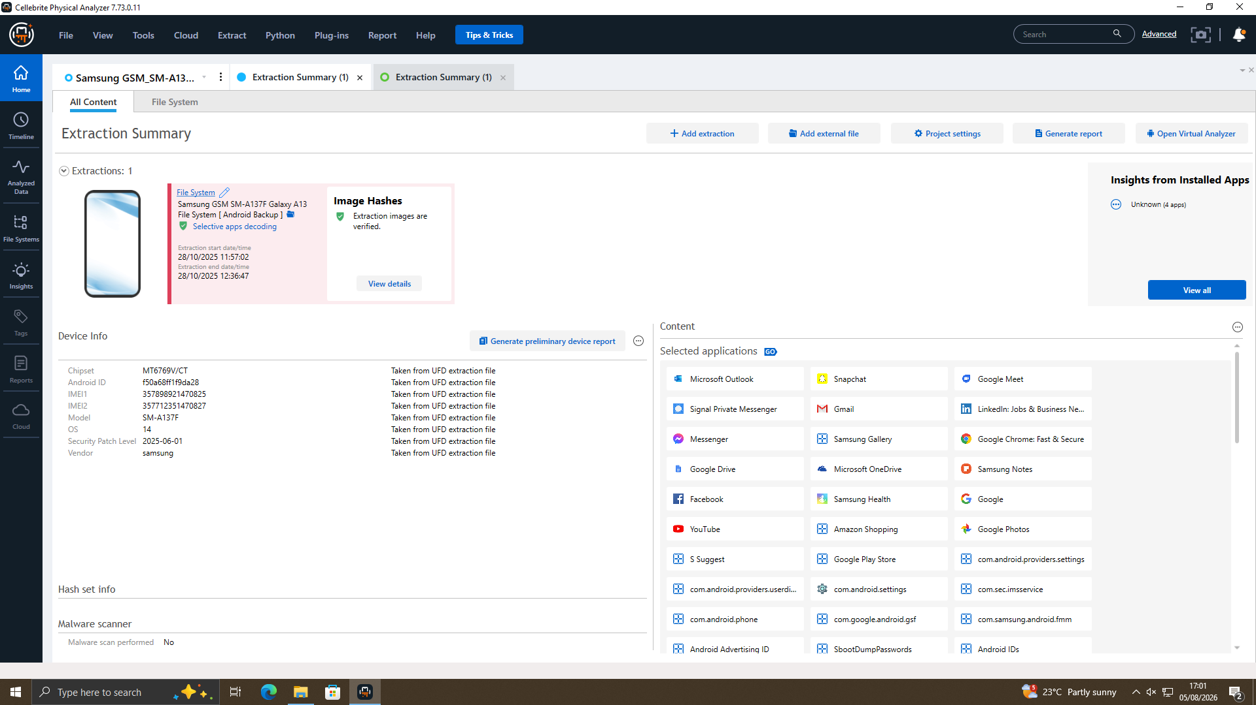
Figure 2 — Extraction Summary, Joe's device (Samsung SM-A137F Galaxy A13, EXH-02), Android Backup extraction, verified.
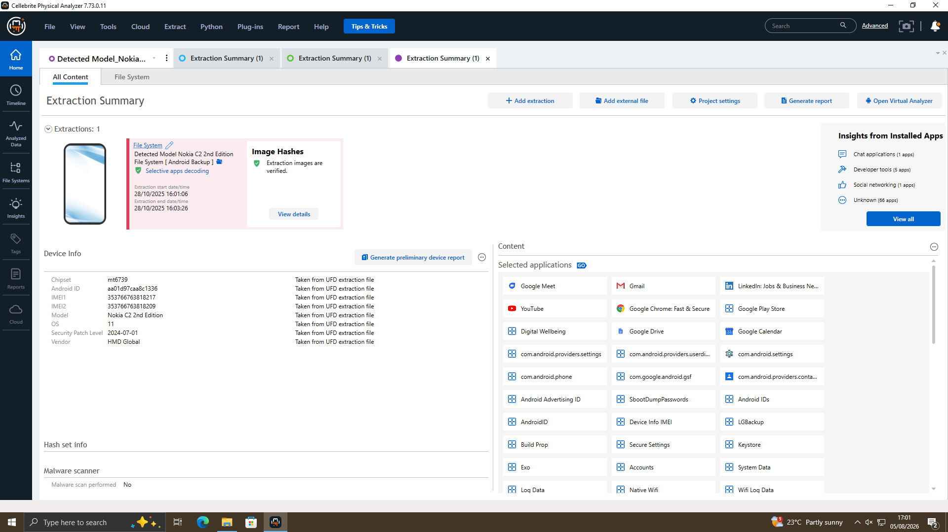
Figure 3 — Extraction Summary, Norman's device (Nokia C2 2nd Edition, EXH-03), Android Backup extraction, verified.

A.2 WhatsApp Conversation — Emma and Joe
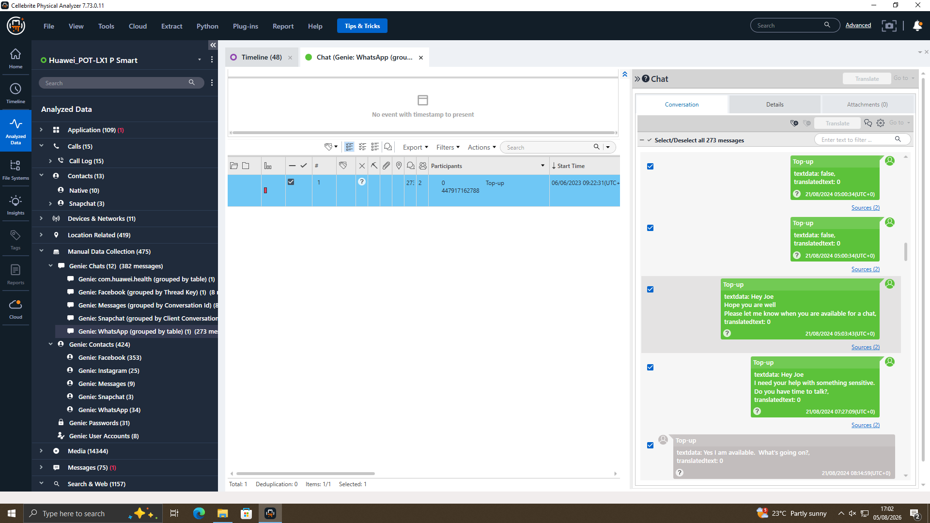
Figure 4 — Initial contact message, 21/08/2024: Emma opens communication with Joe.
Figure 5 — Emma discloses possession of proprietary AI product information and proposes selling it, 21/08/2024.
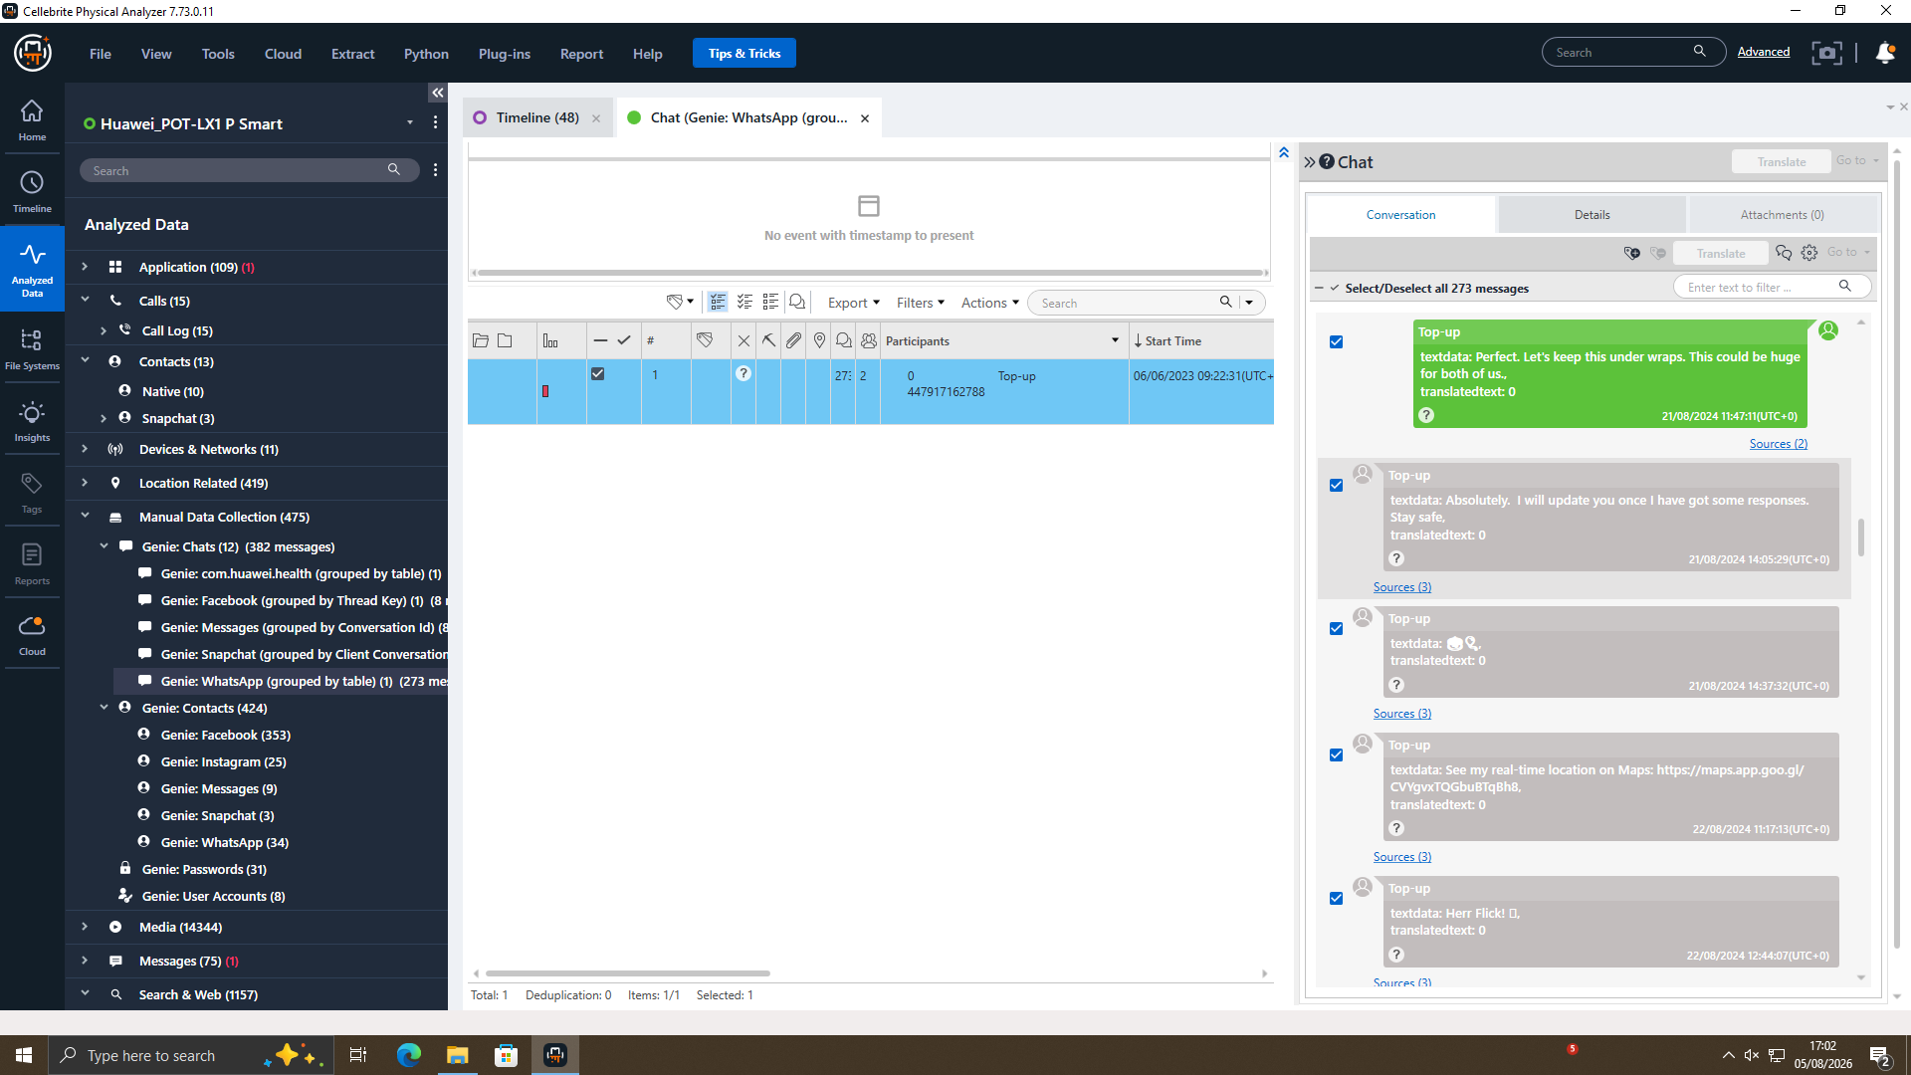
Figure 6 — Emma instructs Joe to 'keep this under wraps,' evidencing shared awareness of wrongdoing, 21/08/2024.
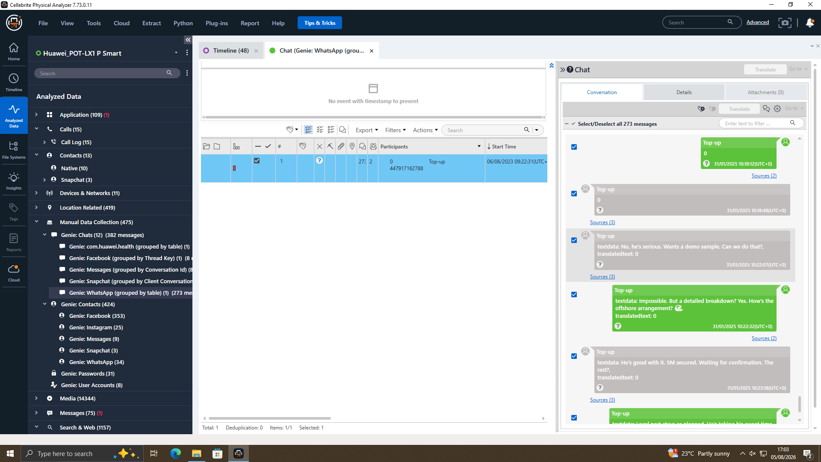
Figure 7 — Negotiation of an 'offshore arrangement' and confirmation that £5M is secured, 31/01/2025.

A.3 Facebook Messenger Conversation — Joe ("Peter Dover") and Norman ("Norman Smith")
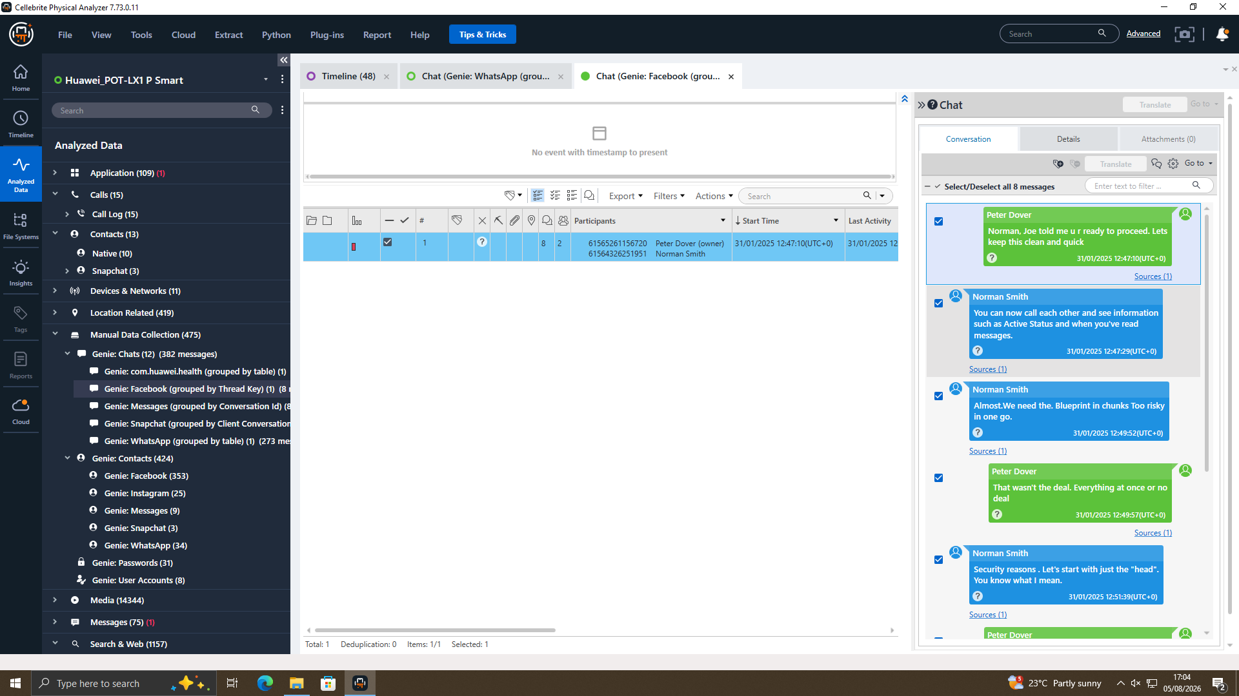
Figure 8 — Joe introduces Norman as a ready buyer and requests the 'blueprint' be delivered in chunks, 31/01/2025.
Figure 9 — Confirmation of £5M offshore payment structure and instruction to 'watch ur inbox in 48 hrs. After that we are ghosts,' 31/01/2025.

A.4 Call Log — Emma's Device
Figure 10 — Call log from Emma's device (15 calls, 02/08/2024–19/08/2024) showing repeated outgoing contact attempts to Joe's numbers prior to the first WhatsApp message.

A.5 Geolocation and Photographic Corroboration
Figure 11 — Geotagged photograph from Joe's device, 29/08/2024, located in central Glasgow, corroborating his WhatsApp message about travelling to meet a contact.
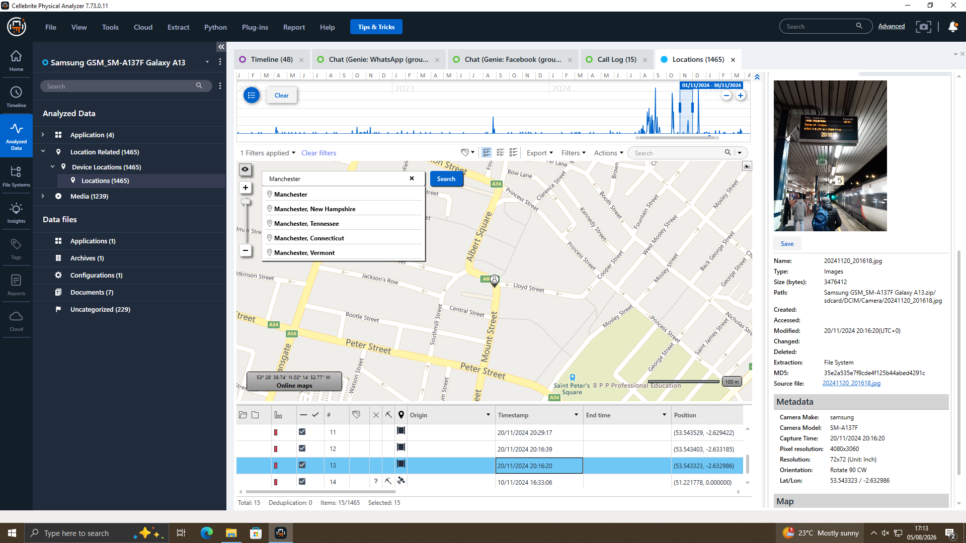
Figure 12 — Geotagged photograph from Joe's device, 20/11/2024, located in Manchester city centre, corroborating his message about meeting a client in Manchester.
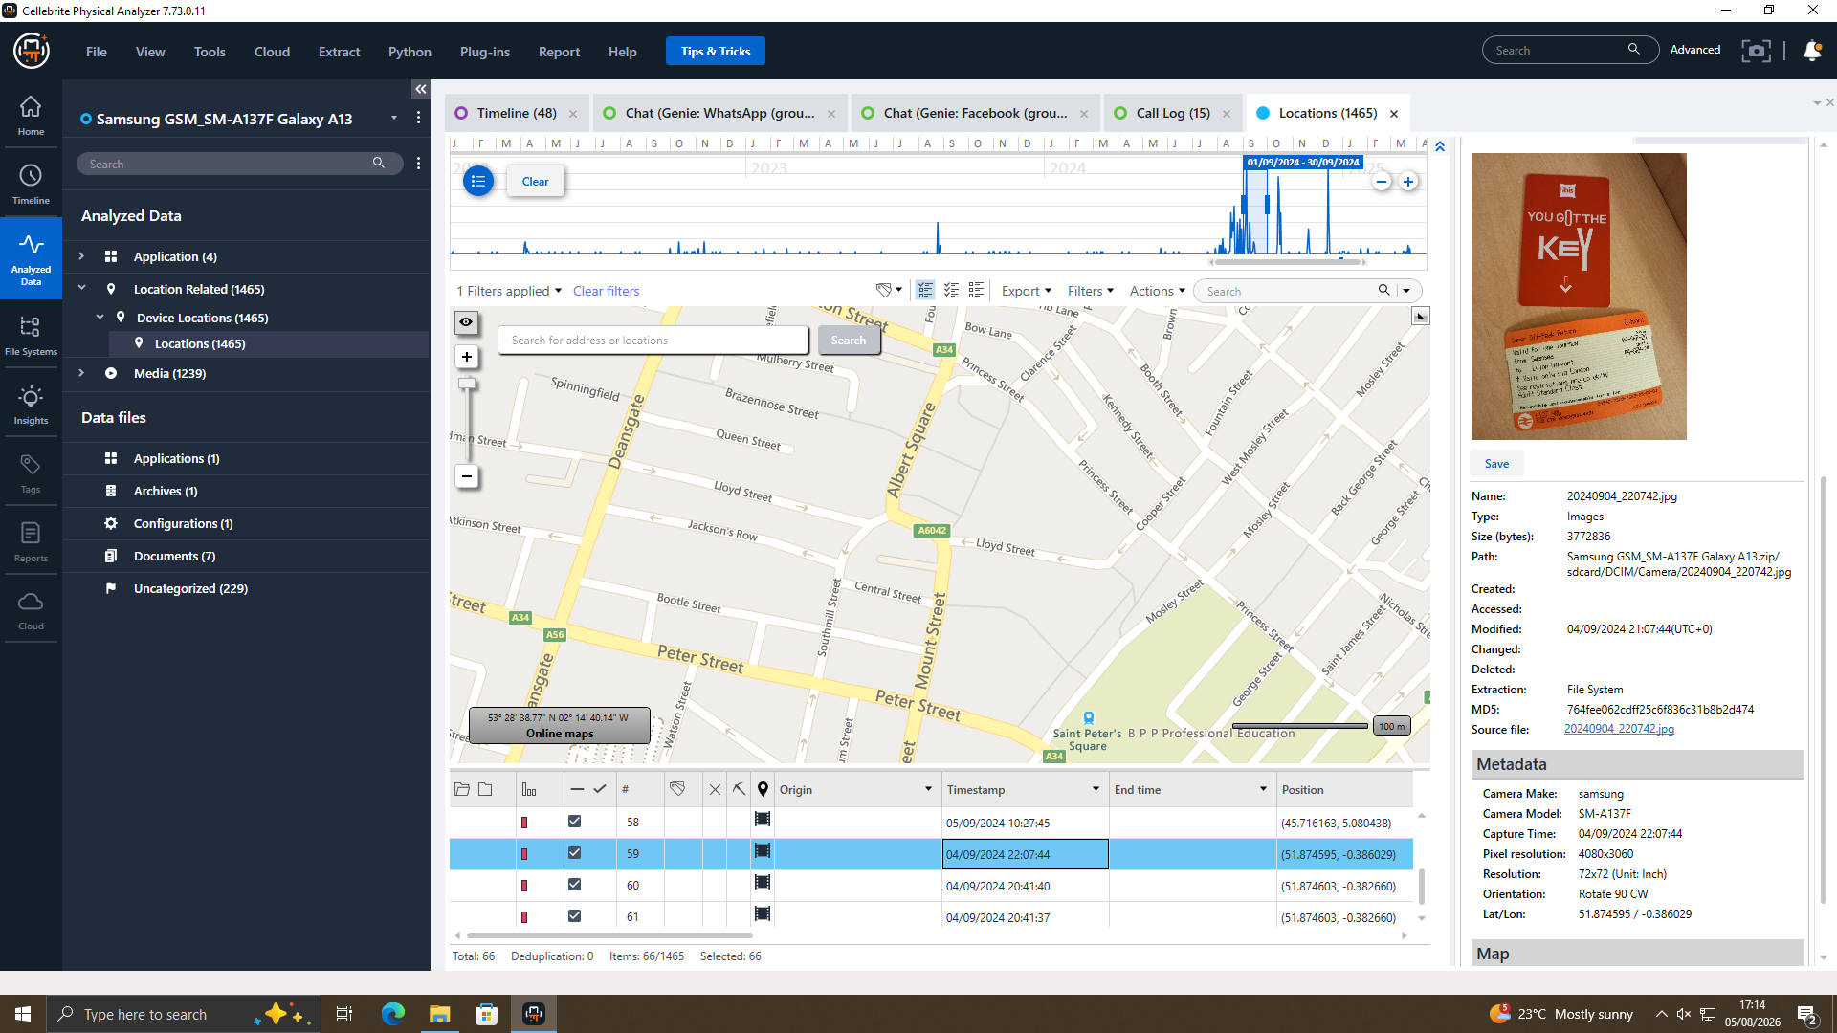
Figure 13 — Hotel key-card photograph recovered from Joe's device, 04/09/2024, consistent with travel for an in-person meeting.
Figure 14 — Photograph recovered from Norman's device, 04/09/2024, geolocated near Swansea, Wales, used to cross-reference Norman's presence against Joe's device activity for the same period.

