

Programme: Master of Business Administration
Module: Marketing Management
Module code: LCMB7024
Assignment Title: Assessment component 2
Marketing Portfolio (Costa Coffee)
Lecturer: Dian Mayasari
Student name: Darvin Sabhaya
Student ID number: 2505280
Submission date: 19th of November 2025 by 2pm

Table of content

Element 1: STDP Analysis for a New Brand Concept……………………………………..03
Segmentation……………………………………………………………………..03
Targeting…………………………………………………………………….…….05
Differentiation………………………………………………………………,,……06
Positioning………………………………………………………………………...06
Element 2: Marketing Mix (4Ps/7Ps) Analysis……………………………………………...07
ELEMENT 3:Marketing Strategy Pitch………………………………………………………11
ELEMENT 4: Reflection……………………………………………………………………….12
References……………………………………………………………………………………..14

Element 1: Segmentation, Targeting, Differentiation & Positioning

Introduction & Concept
Costa ReCharge is a new energy drink that emphasizes both health and sustainability. It is plant-based and uses natural stimulants like guarana, which is known to increase alertness, and green tea, which offers antioxidants and consistent caffeine, in contrast to traditional energy drinks. Its environmentally friendly packaging uses recyclable or biodegradable cans to lessen its impact on the environment. This strategy supports ethical and sustainable consumption trends while also directly appealing to modern consumers who seek clean energy sources free of artificial additives. In the market for energy drinks, Costa ReCharge presents itself as a conscientious and inventive substitute.

Segmentation

1. Eco-conscious Young Adults (aged ~18-35)
Psychographic: Sustainability and environmental values greatly inspire this group. They frequently use eco-friendly products to demonstrate their social consciousness and sense of responsibility, viewing their consumption decisions as an extension of who they are. Younger consumers are more likely to embrace pro-environmental attitudes and incorporate them into lifestyle choices, according to academic studies.
Behavioral: They actively seek out brands that demonstrate transparency and authenticity in their sustainability claims. Marketing campaigns that highlight ethical sourcing, green credentials, and lower carbon footprints are well received by them. Peer networks and social media, where environmental consciousness is frequently praised, have an impact on their purchasing decisions.
Demographic: They are a trend-sensitive and socially influential group that is generally urban, educated, and digitally connected. They are a perfect fit for the launch of Costa ReCharge because of their openness to trying out new products.

2. Health-motivated Functional Drink Consumers
Psychographic: This group places a higher value on wellbeing, health, and eco-friendly living. The goal of maintaining energy levels without sacrificing long-term health is what drives them. These customers appreciate natural ingredients and believe that plant-based options are healthier, according to research on functional foods and beverages.
Behavioral: They are prepared to shell out more money for goods that blend sustainability and usability. According to research on green purchasing practices, consumers are more inclined to spend money on eco-friendly drinks because they frequently associate them with superior quality. They actively study the nutritional advantages of products and are impacted by certifications and labeling.
Demographic: These include fitness enthusiasts, professionals looking for long-lasting energy at work, and students juggling academic obligations. Costa ReCharge's clean, plant-based energy promises perfectly match their lifestyle requirements.

3. Sustainable Lifestyle Advocates (e.g. Gen X / Z)
Psychographic: Long-term sustainability issues and the desire to leave a positive legacy for future generations are the main motivators for this group. They place a high importance on corporate responsibility, ethical production, and durability. According to scholarly research, older consumers may embrace sustainability from a more logical, forward-thinking standpoint than younger ones.
Behavioral: They make responsible and sensible decisions by striking a balance between product quality and environmental benefits. Proven impact, certifications, and brand reputation have a greater influence on them than trends. Their commitment to sustainability and holistic living are frequently reflected in their purchasing decisions.
Demographic: This group includes mixed-age cohorts that frequently have more established purchasing power and disposable income. They are a steady and devoted clientele because they may be professionals or parents who incorporate sustainability into household consumption.

Targeting
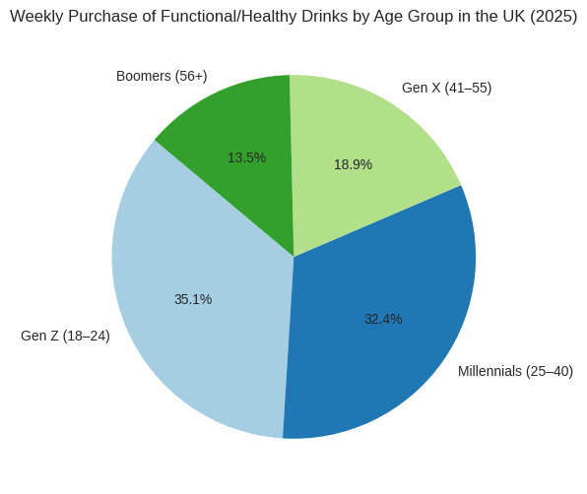
Costa ReCharge’s targeting strategy emphasizes two distinct consumer groups, with Eco-conscious Young Adults (18–35) identified as the primary audience. Younger consumers are frequently at the forefront of sustainability movements, incorporating environmental responsibility into their daily decisions, making this market segment strategically significant. They actively look for goods that reflect their values and are very open to companies that show that their green claims are genuine. Social media

,peer networks, and educational institutions are the main factors influencing the adoption of eco-friendly consumption patterns by younger, educated, and urban populations, according to academic research. With its recyclable or biodegradable packaging and natural energy sources like guarana and green tea, Costa ReCharge directly meets their need for clean energy without sacrificing environmental responsibility. This audience is likely to be highly responsive to marketing messages that highlight transparency, eco-certifications, and Costa Coffee's larger sustainability initiatives.

Differentiation
1. Product Innovation / Quality: A plant-based formula with green tea and guarana offers a natural energy boost, free from synthetic additives. This supports perceived product quality and aligns with green strategy used by companies to enhance brand value.
2. Sustainable Packaging: Biodegradable or recyclable cans communicate environmental responsibility, addressing consumer demand for eco-packaging.
3. Brand Values / Identity: Costa ReCharge positions itself as not only a functional drink but also a mission-driven, eco-conscious brand, thereby building emotional connection and loyalty. Academic work shows green marketing can strengthen brand loyalty.
4. Marketing Communications: Leveraging green advertising and transparent messaging about environmental credentials can enhance purchase intentions.

Positioning
The positioning of Costa ReCharge combines emotional appeal, lifestyle relevance, and competitive edge. Because of its unique plant-based ingredients and environmentally friendly packaging, it appeals to customers who are concerned about sustainability. It complements contemporary lifestyles that prioritize morality and well-being. The brand establishes trust and an emotional bond by highlighting openness and common values. Among health-conscious, environmentally conscious consumers, Costa ReCharge's market presence and loyalty are reinforced by this three-pronged approach: differentiation, alignment with consumer habits, and emotional resonance.

Element 2: Marketing Mix (7Ps)

1. Product:

Costa ReCharge is marketed as a high-end, environmentally friendly energy drink that satisfies consumers' increasing desire for ethical, clean consumption. Green tea and guarana, two plant-derived stimulants that provide a natural energy boost without the use of artificial additives or too much sugar, are the foundation of its formulation. Customers' preferences for functional beverages that promote wellness and health are in line with this.

The brand's environmentally conscious image is strengthened by the packaging. Costa ReCharge minimizes its impact on the environment and promotes the circular economy by using cans that are 100% recyclable or biodegradable. According to scholarly studies on green marketing, consumers' perceptions of environmentally conscious brands are largely influenced by eco-labels and sustainable packaging.
Costa ReCharge offers a brand experience that is based on advocacy and education in addition to the tangible product. The brand disseminates information about sustainability, ethical sourcing, and environmental impact via its website and social media accounts. This creates a story that extends beyond the drink itself, encouraging brand loyalty and an emotional bond among environmentally conscious customers.

2. Price:
Costa ReCharge charges a little more than traditional energy drinks because it uses a value-based pricing approach. The premium quality of the product—natural ingredients, eco-friendly packaging, and ethical sourcing—is reflected in the price. According to studies on green consumer behavior ,many buyers are prepared to pay more for goods with environmental labels, particularly if they believe the product to be reliable and of high quality.
Costa ReCharge provides specific discounts, like student pricing, to guarantee accessibility for younger customers. This strategy acknowledges that younger audiences might have less money to spend even though they frequently have strong environmental values. Costa can draw in this market without sacrificing its premium positioning by providing incentives.

3. Place (Distribution):
The distribution strategy of Costa ReCharge is made to fit the values and lifestyles of its target markets. The product is sold through environmentally conscious retail outlets such as organic supermarkets, health food stores, and cafés owned by Costa. Customers who are already interested in sustainable and health-conscious products frequent these stores.
Additionally, Costa ReCharge is distributed through vending machines on college campuses and fitness centers to appeal to younger and more active consumers. For students, young professionals, and fitness enthusiasts—important target groups that look for functional beverages during hectic or active routines—this guarantees visibility and convenience.
Costa ReCharge can also be ordered online, offering discounts for large purchases and carbon-offset shipping. By providing environmentally friendly fulfillment options, this not only improves convenience but also supports the brand's green credentials.

4. Promotion:
The foundation of Costa ReCharge's marketing strategy is green marketing communication. The brand's messaging emphasizes its environmental advantages, including its transparent carbon footprint, recyclable packaging, and ethical sourcing. According to academic research, consumers who pay attention to green marketing are more likely to make green purchases, which makes this strategy both successful and in line with what customers expect.
Campaigns on social media, particularly on sites like YouTube, Instagram, and TikTok, are crucial. Fitness advocates and sustainability influencers are featured in these campaigns, helping to spread the word about the product's dual appeal of ethical consumption and clean energy. Particularly with younger audiences who place greater trust in peer recommendations than in traditional advertising, influencer marketing expands reach and authenticity.
Additionally, Costa ReCharge sponsors events like campus sustainability fairs, eco-events, and marathons. Through these sponsorships, the brand is able to establish meaningful connections with its target audience and strengthen its reputation as a lifestyle product that promotes environmental and health values.

5. People:
The Costa ReCharge team, which includes both brand promoters and café employees, is essential to providing the brand experience. Staff members receive eco-values and product knowledge training, which empowers them to confidently communicate the brand's mission, environmental credentials, and product benefits. Customers' trust is increased at every touchpoint and messaging consistency is guaranteed.
Additionally, Costa makes investments in online customer service, where agents are prepared to respond to inquiries regarding packaging, carbon offset options, sustainability, and other topics. This openness increases the brand's credibility and fortifies the emotional bond with its customers.

6. Process:
The way Costa ReCharge operates demonstrates its dedication to sustainability. The production process minimizes environmental harm by using renewable energy whenever possible and following a zero-waste policy. Sustainable supply chains are tracked, and ingredients are sourced ethically.
Costa encourages customers to support the brand's sustainability initiatives by providing carbon-offset delivery options and promoting a can recycling program. These procedures not only lessen their impact on the environment but also strengthen the integrity and authenticity of the brand.

7. Physical Evidence:
The visual identity of Costa ReCharge is intended to convey sustainability in a concise manner. In order to evoke nature, purity, and environmental care, the packaging uses white and green hues in a minimalist, earthy design. This design sets the product apart from more aggressive, artificial-looking energy drinks and appeals to consumers who care about the environment.
The brand's environmental claims are visually supported by the cans' prominent display of eco-labels, such as recyclable logos and FSC certification. These certifications validate the product's green positioning and increase consumer trust.
Costa uses branded displays, shelf-talkers, and posters at the point of sale in its eco-stores and Costa cafés. By emphasizing the product's natural ingredients, environmental advantages, and brand mission, these materials assist customers in making well-informed decisions that are consistent with their values.
The 7Ps strategy developed by Costa ReCharge provides a thorough road map for introducing a plant-based, sustainable energy drink that appeals to contemporary consumers. Every component, from pricing, distribution, and promotion to product formulation and packaging, is intended to strengthen the brand's environmentally conscious identity. Costa ReCharge not only satisfies customer expectations but also establishes a strong, unique position in the cutthroat energy drink market by incorporating sustainability into every element of the marketing mix.

Element 3 – Marketing Strategy

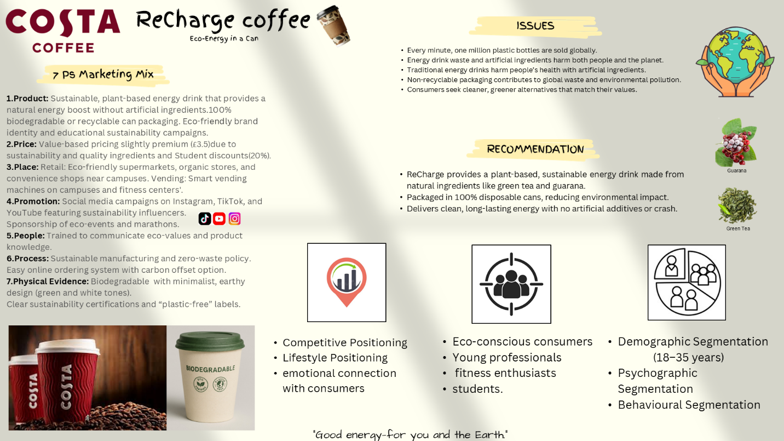
The Costa ReCharge marketing strategy focuses on tackling the health and environmental concerns outlined in the poster, including the overabundance of plastic waste, the conventional energy drinks' dependence on artificial ingredients, and the growing demand from consumers for greener, cleaner options. The new product concept presents Costa ReCharge as a plant-based, sustainable energy drink that contains natural stimulants like guarana and green tea and is available in recyclable or biodegradable cans. The brand can now follow the broader market trend toward ethical and environmentally responsible consumption thanks to this strategy.
The strategy targets consumers between the ages of 18 and 35, with a focus on students, young professionals, and fitness enthusiasts—groups that have been found to be more aware of environmental responsibility and health-motivated functional beverages. In order to increase accessibility for younger demographics, Costa ReCharge uses value-based pricing, which is somewhat premium due to the high quality of its ingredients and environmentally friendly packaging, but is bolstered by student discounts.
Promotion emphasizes digital sustainability communication through YouTube, Instagram, and TikTok, with influencers and sponsorship of eco-events to strengthen authenticity. Distribution channels that guarantee convenience and high visibility where the target market is most active include Costa cafés, eco-friendly supermarkets, campus vending machines, and online ordering.

Element 4 – Reflection

The opportunity to comprehend the challenges of creating a new sustainable product within an established company was made possible by the development of the Costa ReCharge brand concept. Keeping the new energy drink consistent with Costa Coffee's current brand identity while making a significant difference in the cutthroat energy drink market was one of the initial challenges. Realistic knowledge of how environmentally conscious consumers assess brands was shaped by reading scholarly works on sustainability, consumer attitudes, and green marketing. The "attitude–behaviour gap," in which consumers voice concerns about sustainability but do not always convert these concerns into actual purchases, was also noted by the research. To ensure practical relevance, this necessitated incorporating not only eco-friendly features but also quality, convenience, and reliable communication.
The STDP analysis was one of the most insightful components of the process. Younger consumers in particular exhibit strong environmental motivations, but they are also motivated by convenience and product performance, as demonstrated by the market's segmentation based on demographic, psychographic, and behavioral characteristics. In order to reach these people, a balance between sustainability pledges and practical value had to be struck. This strategy was backed by research demonstrating that consumers view eco-labels, natural ingredients, and transparency as markers of product quality and credibility. By using natural stimulants, biodegradable packaging, and ethical sourcing, differentiation helped create a distinctive brand position that aligned with consumer expectations and sustainability objectives.
Developing the 7Ps marketing mix further deepened the understanding of how integrated a brand strategy must be. Pricing decisions, for example, needed careful thought because the production costs of sustainable products are often higher. Although this willingness varies, academic research has shown that some consumer groups are willing to pay more for environmentally friendly products. Therefore, it became crucial to include student discounts and provide clear explanations for premium pricing. The operational ramifications of sustainability claims, such as supply chain issues, manufacturing procedures, and the authenticity needed to prevent greenwashing, were also made clear by the process component.
Preparing the marketing strategy elements emphasised the need to communicate sustainability in a compelling yet credible manner The significance of clarity and consistency was emphasized by distilling complicated topics like packaging waste, environmental impact, and the sourcing of natural ingredients into messages that were easy to understand. My understanding of how brands must successfully engage a modern audience by striking a balance between emotionally compelling storytelling and educational communication has grown as a result of this experience.
Overall, this project enhanced several skills, including critical analysis, application of academic research, strategic thinking, and sustainable brand development. In future projects, I aim to to investigate lifecycle assessment data, integrate more thorough consumer research, and expand the use of empirical evidence in order to bolster the veracity of sustainability claims. The experience also made it clear how crucial it is to consistently match consumer expectations with brand values in order to develop strategies that are both ethical and profitable.

References

1.Cheng, L., Cui, H., Zhang, Z., Yang, M. & Zhou, Y., 2024. Study on consumers' motivation to buy green food based on meta-analysis. Frontiers in Sustainable Food Systems, 8. DOI:10.3389/fsufs.2024.1405787.
2. Correia, E., Sousa, S., Viseu, C. and Larguinho, M., 2023. Analysing the influence of green marketing communication in consumers’ green purchase behaviour. International Journal of Environmental Research and Public Health, 20(2), p.1356. DOI:10.3390/ijerph20021356.
3.Lopes, P.R., Rosário, A.T., Rosário, F.S., 2024. Sustainable Brand Advertising — The Green Advertising for Generation Z, a Qualitative LRSB Analyze. Platforms, 2(2), pp.84–100. DOI:10.3390/platforms2020006.
4. Furman, A., Maison, D. and Sekścińska, K., 2020. Segmentation based on attitudes toward corporate social responsibility in relation to demographical variables and personal values–Quantitative and qualitative study of Polish consumers. Frontiers in psychology, 11, p.450.
5.Shahid, S., Nauman, Z., Jawad, L. and Ayyaz, I., 2024. Relationship between Green Advertising Receptivity and Consumer Intention to Purchase Eco-labeled Product: Role of Trust as a Mediator. The Business & Management Review, 15(2), pp.112-130.
6.Tüz, A. & Sertyeşİlısİk, B., 2022. An investigation into the green marketing effects on green consumerism. Journal of Applied and Theoretical Social Sciences, 4, pp.64–77. DOI:10.37241/jatss.2022.57.
7. Gawshinde, S., Al-Aflak, A., Khurana, A., Bisht, V. and Lawande, N., 2025. Linking green orientation and environmental concerns in shaping purchasing behaviour among different generations. Discover Sustainability, 6(1), p.1178.

7. Young, W., Hwang, K., McDonald, S. and Oates, C.J., 2010. Sustainable consumption: green consumer behaviour when purchasing products. Sustainable Development, 18(1), pp.20–31. DOI:10.1002/sd.394. (Same as #1, but used for different arguments.)
8. Warren, V., Bell, R. and Bruning-Mescher, S., 2024. Plant-based milk alternatives: Consumer needs and marketing strategies. In Plant-based food consumption (pp. 153-177). Woodhead Publishing.
9. Kardos, M., Gabor, M.R. and Cristache, N., 2019. Green marketing’s roles in sustainability and ecopreneurship. Case study: Green packaging’s impact on Romanian young consumers’ environmental responsibility. Sustainability, 11(3), p.873.
10. Ashraf, A., Khalid, N., Saleem, A. and Bakhtiyar, M.R., 2024. Impact of Green Advertising on Consumer Purchase Intentions in the Beverage Industry: The Moderating Role of Product Quality. International Journal of Experiential Learning & Case Studies, 9(2), pp.327-351.
11. Mohammadi, E., Barzegar, M. and Nohekhan, M., 2023. The green advantage: Analyzing the effects of eco-friendly marketing on consumer loyalty. arXiv preprint arXiv:2312.16698.
12. Shah, A., Mehmood, H., Shahzad, M.Z., Hussain, S. and Ali, M., 2025. Achieving Sustainable Financial Performance through the Integration of Green HRM and Green Marketing: An Empirical Analysis. The Critical Review of Social Sciences Studies, 3(3), pp.1235-1249.13. Asikis, T., 2021. Multi-Objective Optimization for Value-Sensitive and Sustainable Basket Recommendations. arXiv.
14. Takagi, S., Saijo, M. and Ohashi, T., 2024. Consumer Segmentation and Participation Drivers in Community-Supported Agriculture: A Choice Experiment and PLS-SEM Approach. arXiv preprint arXiv:2411.00010.
15.Poobalan, A.S., Aucott, L.S., Clarke, A. and Smith, W.C.S., 2012. Physical activity attitudes, intentions and behaviour among 18–25 year olds: A mixed method study. BMC public health, 12(1), p.640.
16. Duque Oliva, E.J., Sánchez-Torres, J.A., Arroyo-Cañada, F.J., Argila-Irurita, A., Fuente, J.G.L., Palacio-López, S.M. and Arrubla-Zapata, J.P., 2024. Green buying behaviour: an integrated model. Sustainability, 16(11), p.4441.
17. Antonides, G., 2017. Sustainable consumer behaviour: A collection of empirical studies. Sustainability, 9(10), p.1686.
18.Xulu, L. and Parumasur, S.B., 2023. Understanding talent management challenges in changing times and workforces. Corporate Governance and Organizational Behavior Review, 7(2), pp.360-372.

