UNIVERSITY OF WALES TRINITY SAINT DAVID

Population Health and Digital Health Promotion
Component 2

Poster Presentation Report -
DiaWell: An AI-Powered Digital Health Coach for the Prevention of Type 2 Diabetes
Module Title: Population Health and Digital Health Promotion
Module Code: LCHS7009
Student Name: Azmir Hossain
Student Number: 2510683
Lecturer's Name: Dr Ping Wu

Table of Contents
1. Background 2
1.1 Public Health Problem 2
1.2 Existing Interventions 2
1.3 DiaWell Intervention 3
2. Health Promotion Values and Principles 4
2.1 Health Promotion Values 4
2.2 Alignment with DiaWell 4
3. Behavioural Change Theory 4
3.1 COM-B Model 4
3.2 Application to DiaWell 5
4. Digital Health Inequality 5
4.1 Challenges 5
4.2 Reducing Inequalities 6
5. Expected Outcomes 6
5.1 Anticipated Impact 6
5.2 Critical Perspective 7
6. Policy, Education and Research Implications 7
6.1 Policy 7
6.2 Education 7
6.3 Research 8
7. Conclusion 9
References 10

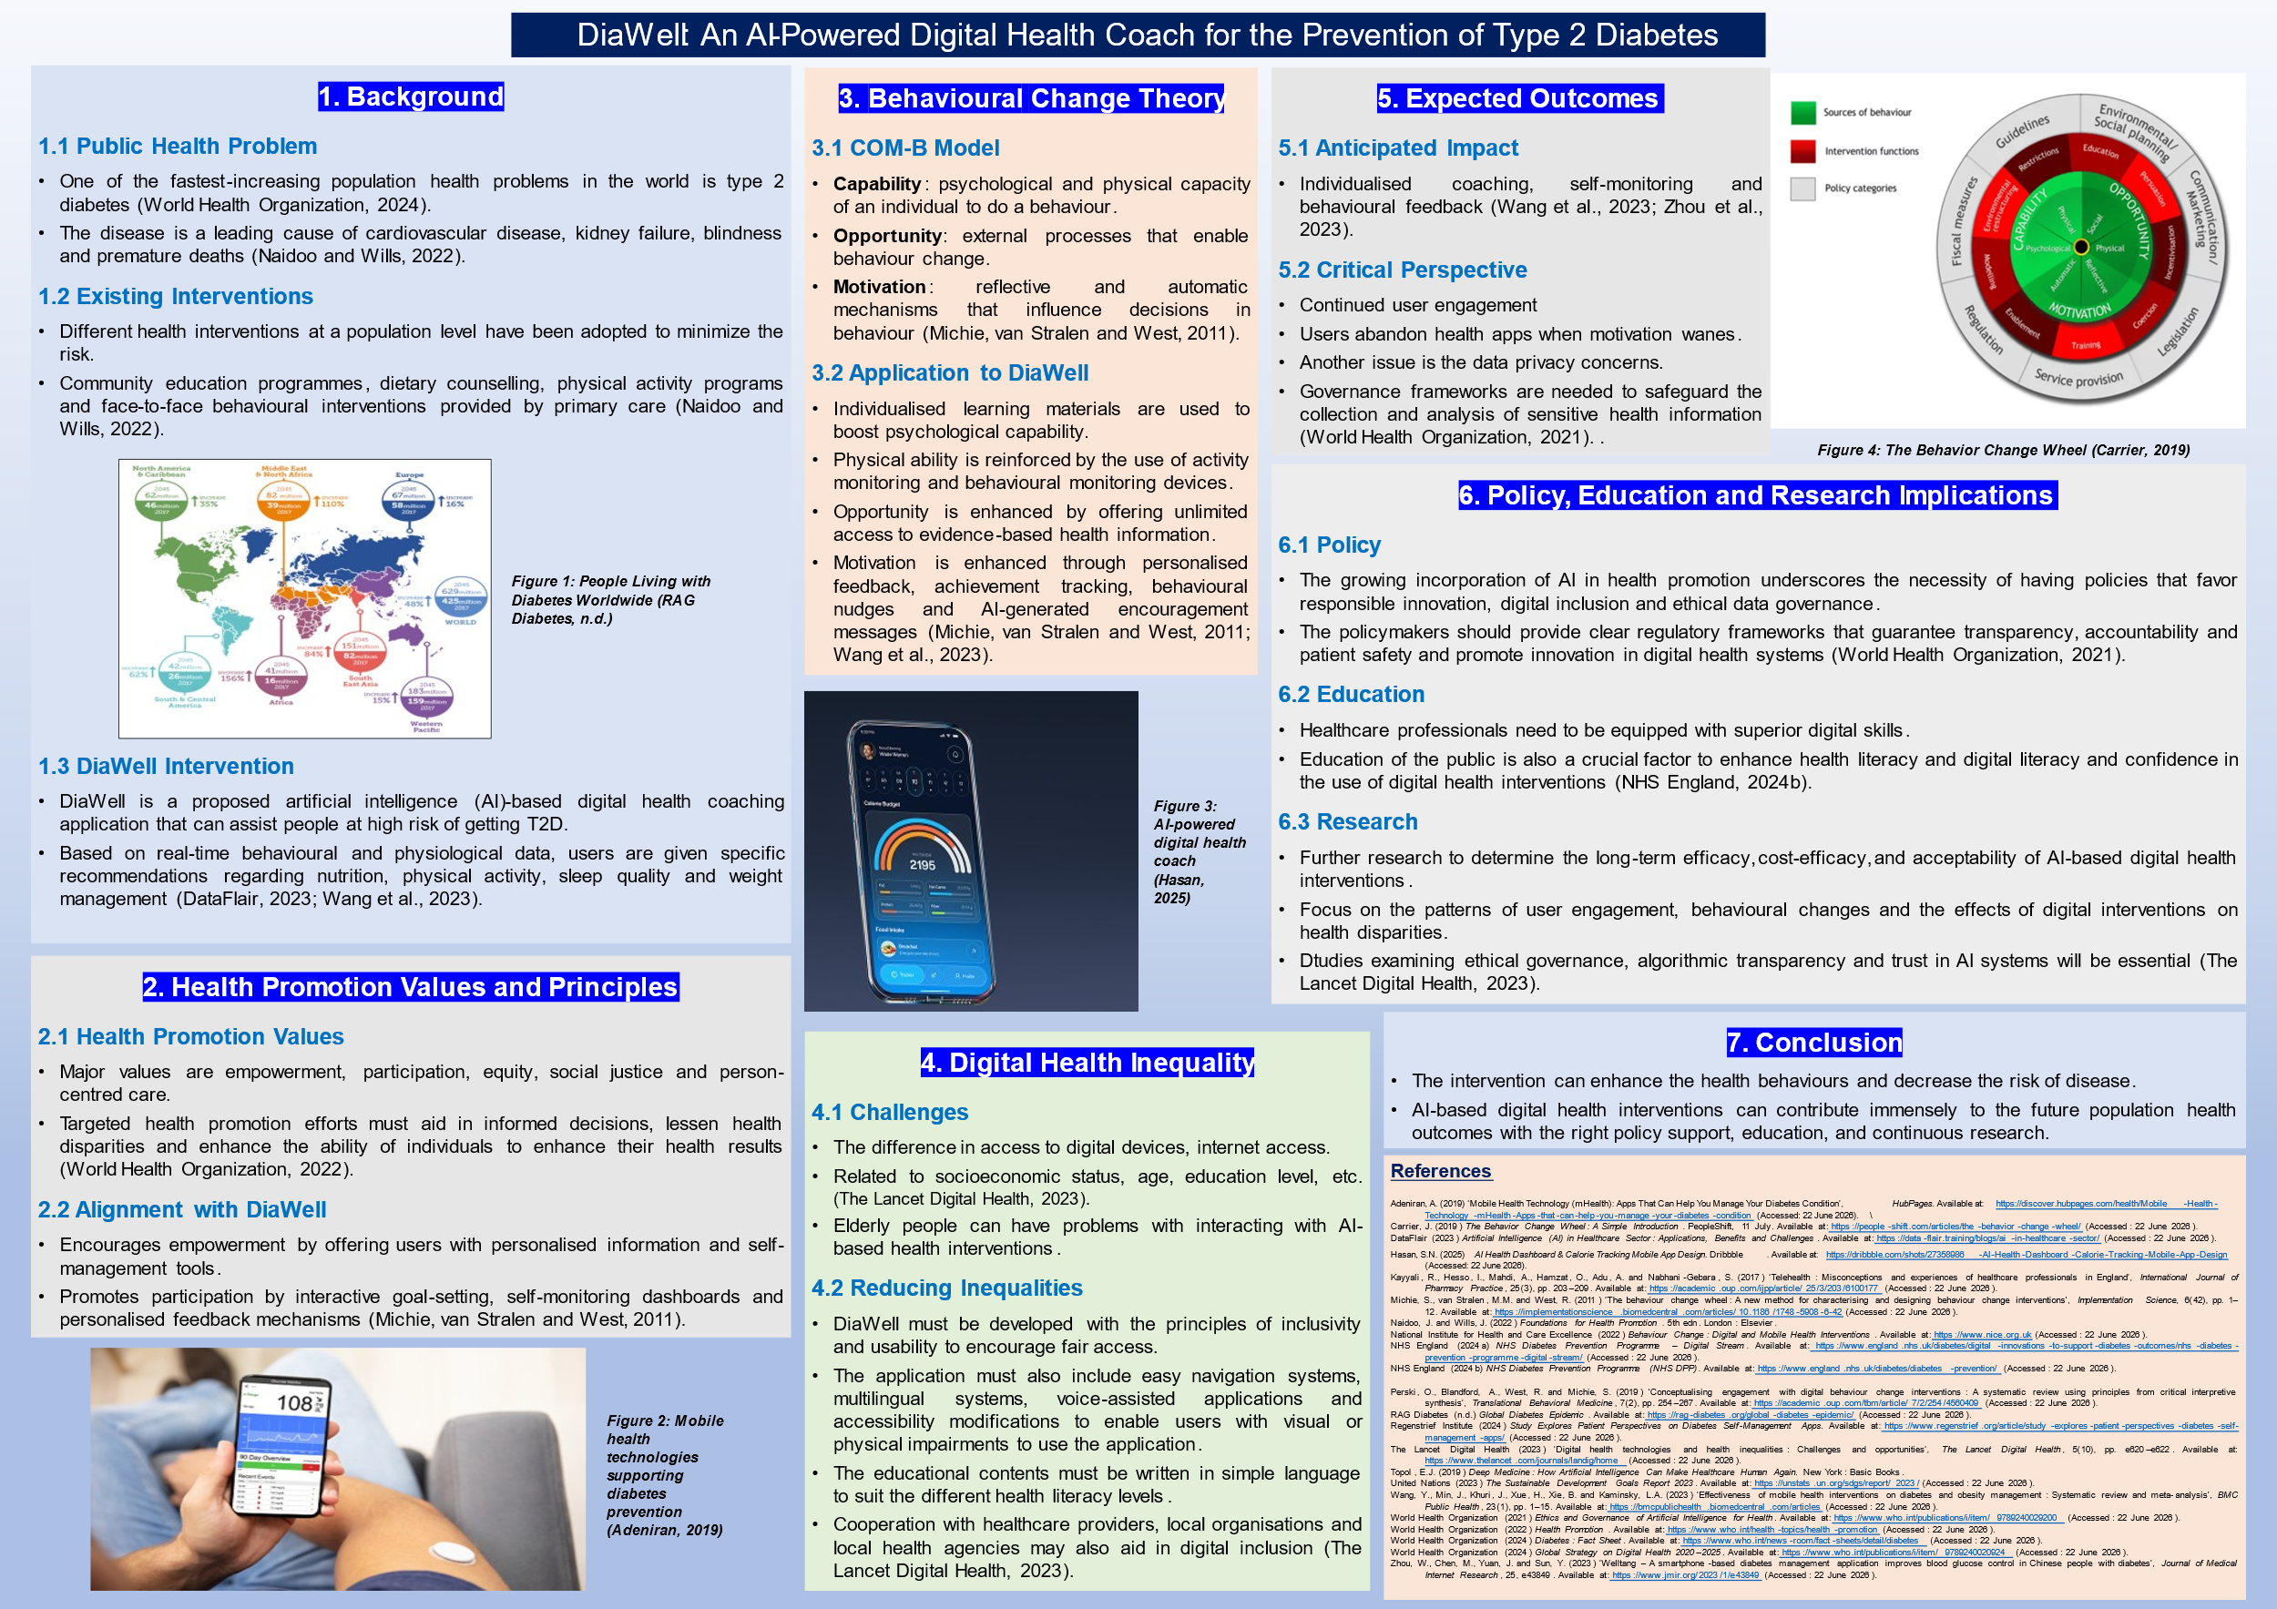

1. Background

1.1 Public Health Problem
One of the most important and fastest-increasing population health problems in the world is type 2 diabetes (T2D). The disease is a leading cause of cardiovascular disease, kidney failure, blindness and premature deaths and is a significant burden on health care systems and economies (World Health Organization, 2024). More recent estimates suggest that over 800 million adults globally are impacted by diabetes, and the prevalence is expected to rise as a result of sedentary lifestyles, poor dietary habits and the increase in obesity levels (World Health Organization, 2024). The increasing incidence of T2D underscores the significance of scalable and sustainable prevention efforts that can assist individuals to adopt healthier behaviours prior to developing the disease (Naidoo and Wills, 2022).

1.2 Existing Interventions
Different health interventions at a population level have been adopted to minimize the risk of T2D. Non-digital methods, such as community education programmes, dietary counselling, physical activity programs and face-to-face behavioural interventions provided by primary care and community-based health services, are traditional (Naidoo and Wills, 2022). Even though these interventions have proved to be effective, they are usually restricted to geographical, financial and workforce limitations.

1.3 DiaWell Intervention
DiaWell is a proposed artificial intelligence (AI)-based digital health coaching application that can assist people at high risk of getting T2D. The intervention is a combination of wearable technologies, predictive analytics, personalised health education and behavioural coaching, all integrated into one mobile application. Based on real-time behavioural and physiological data, users are given specific recommendations regarding nutrition, physical activity, sleep quality and weight management.
The AI system is always processing user-created data to detect behavioural risks and give personalised feedback, goal-setting and motivational prompts. Combining health education, self-monitoring and behaviour modification strategies (DataFlair, 2023; Wang et al., 2023).

2. Health Promotion Values and Principles

2.1 Health Promotion Values
Health promotion is also interested in empowering individuals and communities to have more control over health and wellbeing determinants (Naidoo and Wills, 2022). Major values are empowerment, participation, equity, social justice and person-centred care. Targeted health promotion efforts must aid in informed decisions, lessen health disparities and enhance the ability of individuals to enhance their health results (World Health Organization, 2022).

2.2 Alignment with DiaWell
DiaWell is in line with these values and principles. To begin with, the platform encourages empowerment by offering users with personalised information and self-management tools which can be used to make informed lifestyle choices. Secondly, the intervention promotes participation by interactive goal-setting, self-monitoring dashboards and personalised feedback mechanisms that actively engage users in self-health management (Michie, van Stralen and West, 2011).
The intervention also promotes the principle of prevention since it focuses on individuals prior to the onset of diseases thus minimizing the future health risks and healthcare costs (NHS England, 2024a).

3. Behavioural Change Theory

3.1 COM-B Model
The DiaWell intervention is based on the theoretical framework of the Behaviour Change Wheel and its COM-B framework. The model by Michie, van Stralen and West (2011) suggests that behaviour is affected by three interacting elements: Capability, Opportunity and Motivation.
Capability is the psychological and physical capacity of an individual to do a behaviour. Opportunity refers to external processes that enable behaviour change such as environmental and social processes. Motivation involves reflective and automatic mechanisms that influence decisions in behaviour (Michie, van Stralen and West, 2011).

3.2 Application to DiaWell
DiaWell realises the three elements of COM-B. Individualised learning materials are used to boost psychological capability by increasing the knowledge of risk factors of diabetes and healthy lifestyle habits. Physical ability is reinforced by the use of activity monitoring and behavioural monitoring devices which promote frequent practice of health promoting behaviours.
Opportunity is enhanced by offering unlimited access to evidence-based health information and behaviour support using mobile technology. Wearable devices can be integrated to enable users to access preventive interventions at any time and place, which removes the traditional barriers to accessing healthcare (NHS England, 2024b).
Motivation is enhanced through personalised feedback, achievement tracking, behavioural nudges and AI-generated encouragement messages. These characteristics strengthen the positive behaviours and contribute to maintaining engagement in the long-term. Evidence shows that digital health interventions that are based on behavioural science frameworks tend to be more effective in leading to meaningful and sustained health behaviour change than interventions that are not based on theoretical frameworks (Michie, van Stralen and West, 2011; Wang et al., 2023).

4. Digital Health Inequality

4.1 Challenges
Even though there are significant opportunities of disease prevention through digital health technologies, they can also be the source of digital health inequalities. Digital inequality is the difference in access to digital devices, internet access, digital literacy and capacity to effectively use health technologies (The Lancet Digital Health, 2023). Such disparities are usually related to socioeconomic status, age, education level, disability and geographical location.
Elderly people, those in less affluent families and those with low levels of digital literacy can have problems with interacting with AI-based health interventions. Moreover, the issues of privacy, cybersecurity and mistrust in artificial intelligence can decrease the adoption by some groups (World Health Organization, 2021). Unless such barriers are appropriately tackled, digital interventions will run the risk of favoring already privileged groups at the expense of vulnerable groups.

4.2 Reducing Inequalities
DiaWell must be developed with the principles of inclusivity and usability to encourage fair access. The application must also include easy navigation systems, multilingual systems, voice-assisted applications and accessibility modifications to enable users with visual or physical impairments to use the application. The educational contents must be written in simple language to suit the different health literacy levels.
Cooperation with healthcare providers, local organisations and local health agencies may also aid in digital inclusion by providing digital skills training and alternative access channels to underserved audiences. Also, financial barriers to participation can be minimized by ensuring compatibility with cheaper mobile devices (The Lancet Digital Health, 2023).

5. Expected Outcomes

5.1 Anticipated Impact
It is anticipated that the implementation of the COM-B framework in DiaWell will support the sustainable behaviour change in people who are at risk of developing T2D. The intervention will promote adherence to healthy dietary behaviours by increasing physical activity levels, strengthening self-efficacy and weight management in the context of making health-related decisions (Michie, van Stralen and West, 2011).
The digital health research evidence indicates that individualised coaching, self-monitoring and behavioural feedback may be effectively used to positively affect health behaviours and clinical outcomes in populations at risk of chronic illness (Wang et al., 2023; Zhou et al., 2023). Therefore, DiaWell can facilitate a decrease in the incidence of T2D, decrease healthcare use and enhance the quality of life.

5.2 Critical Perspective
Although such benefits are expected, continued user engagement is crucial to the success of the intervention. Past research shows that a significant portion of users abandon health apps when motivation wanes, and behavioural results cannot be sustained (Perski et al., 2019). Moreover, AI-generated suggestions might be less useful when perceived by users as intrusive, repetitive or not relevant to them personally.
Another issue is the data privacy concerns. Governance frameworks are needed to safeguard the collection and analysis of sensitive health information, clear data management procedures and adherence to ethical and legal norms (World Health Organization, 2021). Thus, even though DiaWell has a lot of potential, its success in the long term will be determined by the good governance, user trust, accessibility and continuous engagement measures.

6. Policy, Education and Research Implications

6.1 Policy
The growing incorporation of AI in health promotion underscores the necessity of having policies that favor responsible innovation, digital inclusion and ethical data governance. The policymakers should provide clear regulatory frameworks that guarantee transparency, accountability and patient safety and promote innovation in digital health systems (World Health Organization, 2021). Digital infrastructures and digital literacy programmes will also have to be invested in to reduce inequalities and maximize population-level benefits.

6.2 Education
The digital health technologies are changing the manner in which health information is provided and accessed. Healthcare professionals thus need to be equipped with superior digital skills to make them effectively use AI-enabled tools in preventive healthcare services. Education of the public is also a crucial factor to enhance health literacy and digital literacy and confidence in the use of digital health interventions (NHS England, 2024b).

6.3 Research
It needs to be followed up by further research to determine the long-term efficacy, cost-efficacy, and acceptability of AI-based digital health interventions. Future research ought to focus on the patterns of user engagement, behavioural changes and the effects of digital interventions on health disparities among various population groups. Also, studies examining ethical governance, algorithmic transparency and trust in AI systems will be essential as digital health technologies start to become more integrated into the practice of public health (The Lancet Digital Health, 2023).

7. Conclusion
DiaWell is a novel AI-based digital health promotion program that can help reduce the increasing burden of Type 2 diabetes by providing personalised behavioural support. Following the principles of health promotion and focusing on empowerment, prevention and equity, the intervention can enhance the health behaviours and decrease the risk of disease. Nevertheless, in order to be successful, it is crucial to address digital inequalities, keep users engaged and ethically governed. AI-based digital health interventions can contribute immensely to the future population health outcomes with the right policy support, education, and continuous research.

References
Adeniran, A. (2019) ‘Mobile Health Technology (mHealth): Apps That Can Help You Manage Your Diabetes Condition’, HubPages. Available at: https://discover.hubpages.com/health/Mobile-Health-Technology-mHealth-Apps-that-can-help-you-manage-your-diabetes-condition (Accessed: 22 June 2026).\
Carrier, J. (2019) The Behavior Change Wheel: A Simple Introduction. PeopleShift, 11 July. Available at: https://people-shift.com/articles/the-behavior-change-wheel/ (Accessed: 22 June 2026).
DataFlair (2023) Artificial Intelligence (AI) in Healthcare Sector: Applications, Benefits and Challenges. Available at: https://data-flair.training/blogs/ai-in-healthcare-sector/ (Accessed: 22 June 2026).
Hasan, S.N. (2025) AI Health Dashboard & Calorie Tracking Mobile App Design. Dribbble. Available at: https://dribbble.com/shots/27358986-AI-Health-Dashboard-Calorie-Tracking-Mobile-App-Design (Accessed: 22 June 2026).
Kayyali, R., Hesso, I., Mahdi, A., Hamzat, O., Adu, A. and Nabhani-Gebara, S. (2017) ‘Telehealth: Misconceptions and experiences of healthcare professionals in England’, International Journal of Pharmacy Practice, 25(3), pp. 203–209. Available at: https://academic.oup.com/ijpp/article/25/3/203/6100177 (Accessed: 22 June 2026).
Michie, S., van Stralen, M.M. and West, R. (2011) ‘The behaviour change wheel: A new method for characterising and designing behaviour change interventions’, Implementation Science, 6(42), pp. 1–12. Available at: https://implementationscience.biomedcentral.com/articles/10.1186/1748-5908-6-42 (Accessed: 22 June 2026).
Naidoo, J. and Wills, J. (2022) Foundations for Health Promotion. 5th edn. London: Elsevier.
National Institute for Health and Care Excellence (2022) Behaviour Change: Digital and Mobile Health Interventions. Available at: https://www.nice.org.uk (Accessed: 22 June 2026).
NHS England (2024a) NHS Diabetes Prevention Programme – Digital Stream. Available at: https://www.england.nhs.uk/diabetes/digital-innovations-to-support-diabetes-outcomes/nhs-diabetes-prevention-programme-digital-stream/ (Accessed: 22 June 2026).
NHS England (2024b) NHS Diabetes Prevention Programme (NHS DPP). Available at: https://www.england.nhs.uk/diabetes/diabetes-prevention/ (Accessed: 22 June 2026).
Perski, O., Blandford, A., West, R. and Michie, S. (2019) ‘Conceptualising engagement with digital behaviour change interventions: A systematic review using principles from critical interpretive synthesis’, Translational Behavioral Medicine, 7(2), pp. 254–267. Available at: https://academic.oup.com/tbm/article/7/2/254/4560409 (Accessed: 22 June 2026).
RAG Diabetes (n.d.) Global Diabetes Epidemic. Available at: https://rag-diabetes.org/global-diabetes-epidemic/ (Accessed: 22 June 2026).
Regenstrief Institute (2024) Study Explores Patient Perspectives on Diabetes Self-Management Apps. Available at: https://www.regenstrief.org/article/study-explores-patient-perspectives-diabetes-self-management-apps/ (Accessed: 22 June 2026).
The Lancet Digital Health (2023) ‘Digital health technologies and health inequalities: Challenges and opportunities’, The Lancet Digital Health, 5(10), pp. e620–e622. Available at: https://www.thelancet.com/journals/landig/home (Accessed: 22 June 2026).
Topol, E.J. (2019) Deep Medicine: How Artificial Intelligence Can Make Healthcare Human Again. New York: Basic Books.
United Nations (2023) The Sustainable Development Goals Report 2023. Available at: https://unstats.un.org/sdgs/report/2023/ (Accessed: 22 June 2026).
Wang, Y., Min, J., Khuri, J., Xue, H., Xie, B. and Kaminsky, L.A. (2023) ‘Effectiveness of mobile health interventions on diabetes and obesity management: Systematic review and meta-analysis’, BMC Public Health, 23(1), pp. 1–15. Available at: https://bmcpublichealth.biomedcentral.com/articles (Accessed: 22 June 2026).
World Health Organization (2021) Ethics and Governance of Artificial Intelligence for Health. Available at: https://www.who.int/publications/i/item/9789240029200 (Accessed: 22 June 2026).
World Health Organization (2022) Health Promotion. Available at: https://www.who.int/health-topics/health-promotion (Accessed: 22 June 2026).
World Health Organization (2024) Diabetes: Fact Sheet. Available at: https://www.who.int/news-room/fact-sheets/detail/diabetes (Accessed: 22 June 2026).
World Health Organization (2024) Global Strategy on Digital Health 2020–2025. Available at: https://www.who.int/publications/i/item/9789240020924 (Accessed: 22 June 2026).
Zhou, W., Chen, M., Yuan, J. and Sun, Y. (2023) ‘Welltang – A smartphone-based diabetes management application improves blood glucose control in Chinese people with diabetes’, Journal of Medical Internet Research, 25, e43849. Available at: https://www.jmir.org/2023/1/e43849 (Accessed: 22 June 2026).

