Business model canvas concept and entrepreneurial reflection

Student Name: Andreea Balanescu
Student ID: 2211130
Module: Entrepreneurship (BMIH 5001)
Lecturer name: Neil Dyer
Word count: 2140
Date: 5 February 2024

Part one - Hospitality Business Concept
This essay is a proposal to launch a unique fine dining restaurant concept in Nord-Est of England, specially designed to offer an exceptional dining experience for dog lovers and their canine companions. This innovative restaurant will combine high-quality gastronomy with specialized services for dogs, including a dedicated menu, play and relaxation areas, and care services such as grooming and walking. This personal concept supported by Business Model Canvas (BMC), (see Appendix A), is aimed at dog owners who do not want to compromise the quality of the dining experience when accompanied by their pets. This concept responds to the growing need for inclusive hospitality experiences for animal lovers, creating an environment where quality and attention to detail extend beyond the plate to the well-being and happiness of the dogs.
The best methods for determining feasibility and the next steps for entrepreneurs have been the subject of research and debate in recent years. Additionally, there are now various ways to access a faster revenue stream. It is crucial to realise that what will work best will depend mostly on the target audiences and the sector it will compete in, putting into perspective the beginning of the company planning process by making a "business model canvas" (Mariotti and Glackin, 2016, p. 64).
In the world of hospitality, innovation and adaptability are critical aspects of the success of any business, defining the target market, market research, segmentation, and taking into legal and financial consideration, are all setting goals through success (FasterCapital, 2024).
The proposed concept of integrating a dedicated space for dogs in a fine dining restaurant not only responds to the growing demand for pet-friendly hospitality experiences but also redefines the way pet owners can enjoy dining in town. This unique concept proposes a holistic approach to hospitality, paying attention to the needs of both humans and their canine companions.
The heart of any business model is its value proposition, and in this case, providing a high-quality dining experience for dog owners while their pets are cared for, pampered and socialised. This value proposition addresses a specific and unmet need in today’s market: the desire of dog owners to spend their free time in the company of their pets without compromising the quality of the dining experience. The restaurant will not only serve quality food for humans, but it will also offer a specialised menu for dogs, ensuring that all customers, regardless of species, have a memorable experience.
Value creation is the central focus of entrepreneurship. This is achieved by leveraging the enterprise's core resources and capabilities to identify and mine customers' value needs, adjust stakeholders' transaction structures, and improve transaction efficiency. Products or services are delivered to customers as the value carrier, completing the value acquisition and transmission process and allowing customers to obtain value through the value distribution mechanism (Xiong, 2022).
The ideal customer segment for this innovative restaurant is undoubtedly the dog lover who appreciates quality food and is looking for new and exciting leisure experiences with their pet. This market segment includes families with children, professionals with busy lifestyles and, in general, people who believe that pets are members of the family and deserve to be treated as such. Therefore, business communication and offerings must be tailored to meet the needs and expectations of these customers (Hayes, 2023).
To realise this value proposition, strategic collaborations for the proposed business idea are essential. Partnerships with pet-related businesses, such as pet shops, grooming centres and veterinary clinics will be crucial. These collaborations will allow the restaurant to offer high-quality services and products for dogs, from specialised menus to grooming and health services. Also, partnerships with local suppliers of fresh and sustainable produce will underline the business’s commitment to quality and sustainability. Also, partnerships with the veterinary clinics will not only ensure the health status of the dogs during their entire stay in the restaurant, but they can even help provide specific menus for dogs.
For a long-term relationship delivering value and satisfaction, offering loyalty programs, collecting the necessary feedback to adjust the services offered, brochures to attract customer attention, engagement in social media, using data systems to create a real bond, using marketing channels such as display ads, emails, guest posting, events, involving the community, viral and customer engagement marketing, creating a community of loyal customers (Kotler et al., 2020 p. 10-30).
A well-defined marketing strategy is essential to attract target customers and build brand awareness. Using social networks, platforms such as Instagram and Facebook, which allow the visualisation of culinary experiences and moments spent by dogs and owners, will play an important role in the marketing strategy. Themed events, collaborations with pet influencers, and targeted advertising campaigns are also effective ways to draw attention to the restaurant. Additionally, creating valuable content such as pet care tips and healthy dog recipes can improve customer engagement and loyalty.
The infrastructure of this innovative business idea is the key activities, resources, and partnerships (Osterwalder, Pigneur and Pijl, 2010, p. 34-39). To create business success the team will need to be trained not only in exceptional culinary service but also in caring for and understanding the needs of dogs, ensuring a pleasant experience for all customers, and maintaining peace and safety all the time.
To better understand the context in which this business concept will be launched, it is essential to analyse the current market and identify how the restaurant can be positioned to differentiate itself from the competition (Patel, 2022). According to Statista (2024a, b) the increase in the number of pet owners, along with increased attention to their welfare and care, indicates a significant opportunity for businesses that cater to these needs. In addition, consumers’ tendency to seek unique and personalised dining experiences provides fertile ground for the implementation of this innovative concept.
Analysing local competitors (see Appendix B), is important to identify gaps in the market and provide a truly unique value proposition (Hotjar, 2024). While there are pet-friendly restaurants, there is a gap in the market offering a dedicated dog menu or additional grooming services while owners enjoy their meals. This aspect of the service is a major differentiator, underscoring the business’s commitment to a complete and integrated hospitality experience for both people and their pets.
Regarding sustainability and social responsibility, in the current context where consumers are becoming more aware of the impact of their actions on the environment and the community, adopting a sustainable and socially responsible approach becomes essential (Tong et al., 2023). Collaboration with local suppliers and commitment to green practices in the selection of products on offer, from food to dog care products, will help strengthen the business’ positioning as a leader in responsible hospitality. This not only attracts customers who share the same values, but also helps build a strong brand image recognised for its commitment to quality, innovation, and responsibility (University of Central Florida, 2024).
Using technology to improve customer experience and streamline operations is another key aspect of this business concept (Leachman and Scheibenreif, 2023). From online booking systems that allow customers to select specific services for their dogs during their visit, to mobile apps that offer loyalty rewards and promote special events, technology integration can provide significant added value. This not only simplifies the process of interacting with the business but also creates opportunities for long-term customer engagement and retention (Gupta, 2023).
For this business concept to achieve success and maintain its long-term relevance, strategic implementation and careful planning are important. This involves not only successfully launching the restaurant, but also continuously adopting market trends, customer feedback and technological developments (Reimão and Fauvelet de Brito, 2019).
In terms of adaptability and innovation, a business must be adaptable to survive and thrive. This is even more relevant in hospitality, where customer preferences can change rapidly. Therefore, it is important to collect and analyse customer feedback regularly, allowing for adjustments to the menu, service, and overall experience (AIContentfy, 2023).
On the other hand, the finance area is also important, cost structure and revenue streams are two essential components for understanding the financial viability of the proposed business model (Lopes et al., 2023).
According to (Dieffenbacher, 2022), the cost structure in a business model describes all the costs involved in operating the business.
The cost structure for the business concept includes the following elements:
Cost for the physical restaurant space, including rent and utilities (electricity, water, gas, internet).
Cooks, waiters, dog groomers and other staff expenses.
The purchase of ingredients for the preparation of food for both humans and dogs, as well as any other products necessary for the care of the dogs.
Expenses for promoting the business, including digital marketing campaigns, advertising, and promotional materials.
Costs to ensure the business and any licenses or permits required to operate.
Costs associated with setting up and equipping the restaurant, including the dog area.
Periodic expenses for maintaining space and equipment.
According to CFI Team (2022), revenue streams, describe how the business generates money. For the business concept, these might include:
Revenue from the sale of food and beverages to people, and special dog food.
Revenue from dog care services provided to customers while they eat (grooming, walking).
Organising special events or workshops (dog training classes) that can generate additional income.
Selling branded products such as dog toys, accessories, and packaged food that carry the restaurant’s brand name.
Revenue from partnerships with pet product brands or sponsorships for restaurant events.
In conclusion, this proposed concept of combining a high-quality dining experience for dog owners with care and socialization services for their canine companions represents a significant innovation in hospitality. Through the nine stages of BMC, strategic implementation, adaptability, financial sustainability and commitment to social and environmental responsibility, this concept has the potential to set new standards in the industry.

Part two
Self-reflection is important to understand and develop entrepreneurial and managerial capabilities. By using Graham Gibb’s (1998) reflective cycle model, I am going to explore my personal entrepreneurship test scores and reflect on the key traits. With the help of these scores, I will critically evaluate my entrepreneurial and managerial motivations and characteristics. I will also integrate relevant academic models and frameworks to better understand my strengths and areas of development.
Gibb's reflective cycle model is a framework designed for learning from experiences through six stages. These stages are description, feelings, evaluation, analysis, conclusion, and action plan (The University of Edinburgh, 2020).
A trait is a dimension of personality consisting of multiple components “The Big Three: need for achievement, locus of control, and risk-taking behaviour (Chell et al., 2008). Looking and describing my entrepreneurship test results, (see Appendix C), include a score of 70 per cent, indicating potential in some entrepreneurial characteristics; a high score of 83 per cent on “Achieve”, showing a high need for achievement; a moderate score on “Autonomy” of 50 per cent, 58 per cent “Creativity”; 75 per cent “Risk Taking” and 75 per cent “Control”. These results provide insight into my entrepreneurial abilities and limitations.
The results evoked mixed feelings. A high score on General Measure Enterprising Tendency suggests entrepreneurial potential, while moderate Autonomy and Creativity scores indicate a need for development in these areas. My feelings are a balance between optimism for my strengths and recognition of the need for growth in other areas.
Critically evaluating the high score highlights a predisposition towards motivation, supported by McClelland’s theory of needs, a model which emphasizes the importance of the need for achievement, affiliation, and power (Mind Tools Content Team, 2022).
Analysis of the high score on Achieve underlines a strong motivation and commitment to success, as described by MCGregor’s Theory X and Y, this can improve performance in an entrepreneurial context but requires balance to avoid burnout (Mind Tools Content Team, 2023). Moderate scores on Autonomy and Creativity indicate a more pragmatic approach, suggesting that they may benefit from a transformational leadership style, as proposed by Bass, that encourages personal development and innovation (Ugochukwu, 2023).
Concluding my strengths, such as the need for achievement and a strong results orientation, are essential for entrepreneurial success. However, I need to focus on developing autonomy and creativity to improve my ability to innovate and lead independently. Attending courses such as those offered by the University can be an important step in this direction.
To develop these skills an action plan is needed, I will take online courses to improve my management and creativity skills, read more books, and watch videos about entrepreneurship, I will also look to start small projects in my community to practice autonomy and leadership.
Reflection on entrepreneurial characteristics and motivations in an ongoing and vital process for personal development. By integrating test results with theoretical models, I gained deeper insight into my strengths and areas for improvement. This critical analysis and established action plan are essential steps in my entrepreneurial and managerial journey.

Reference list:

AIContentfy (2023) ‘The Importance of Adaptability in the Startup World’, AIContentfy, 6 November. Available at: https://aicontentfy.com/en/blog/importance-of-adaptability-in-startup-world#:~:text=Facilitates%20experimentation%3A%20Adaptability%20allows%20startups (Accessed: 31 January 2024).
Chell, E. et al., (2008) The entrepreneurial personality A social construction. 2nd ed. Hove, East Sussex; Routledge.
Conceptboard (2024) Business Model Canvas. Available at: https://app.conceptboard.com/board/asnp-hpm7-xzq0-93y5-nk3k (Accessed: 23 January 2024).
CFI Team (2022) Revenue Streams. Corporate Finance Institute. Available at: https://corporatefinanceinstitute.com/resources/accounting/revenue-streams/ (Accessed: 25 January 2024).
Dieffenbacher, S. (2022) Cost Structure in the Business Model Canvas. Digital Leadership. Available at: https://digitalleadership.com/blog/cost-structure/ (Accessed: 27 January 2024).
FasterCapital (2024) Crafting Your Path: Tips for Launching a Successful Creative Industries Business. Available at: https://fastercapital.com/startup-topic/Launching-a-Successful-Creative-Industries.html (Accessed: 30 January 2024).
General Measure Enterprising Tendency (2024) Get2 Test Results. Available at: file:///C:/Users/User/Desktop/General%20Measure%20of%20Enterprising%20Tendency%20v2%20-%20GET2.pdf (Accessed: 9 January 2024).
Gibbs, G. (1998) Learning by Doing: A Guide to Teaching and Learning Methods. Oxford: Further Education Unit, Oxford Polytechnic.
Gupta, D. (2023) ‘Boosting engagement, retention, and revenue with loyalty apps.’ Appinventiv, 24 March. Available at: https://appinventiv.com/blog/loyalty-and-rewards-app-development/ (Accessed: 1 February 2024).

Hayes, A. (2023) How Market Segments Work: Identification and Example. Available at: https://www.investopedia.com/terms/m/market-segment.asp(Accessed:1 February 2024).
Hotjar, (2024) ‘8 ways to spot market gaps in 2024’. The Hotjar Blog, 26 January. Available at: https://www.hotjar.com/blog/market-gaps/ (Accessed: 1 February 2024).
Kotler, P. et al., (2020) Principles of marketing. Eighth European edition. Harlow, England: Pearson.
Leachman, L., and Scheibenreif, D. (2023) Using Technology to Create a Better Customer Experience. Available at: https://hbr.org/2023/03/using-technology-to-create-a-better-customer-experience (Accessed: 1 February 2024).
Lopes, H. E. G., Rodrigues, V. C., Leite, R. S., and Gosling, M. (2023) ‘Business Model Canvas and Entrepreneurs: Dilemmas in Managerial Practice’. BBR. Brazilian Business Review, 20(3), 260–280. Available at: https://www.redalyc.org/journal/1230/123075340002/html/
Mariotti, S. and Glackin, C. (2016) Entrepreneurship: starting & operating a small business. Fourth edition, Global edition. Boston: Pearson
Mind Tools Content Team (2022) McClelland’s Human Motivation Theory. Available at: https://www.mindtools.com/aznjntj/mcclellands-human-motivation-theory (Accessed: 25 January 2024).
Mind Tools Content Team (2023) Theory X and Theory Y. Available at: https://www.mindtools.com/adi3nc1/theory-x-and-theory-y (Accessed: 25 January 2024).
Osterwalder, A., Pigneur, Y. and Pijl, P. van der (2010) Business model generation a handbook for visionaries, game changers, and challengers. Edited by T. Clark. Hoboken, New Jersey: John Wiley & Sons, Inc.
Patel, S. (2022) ‘A Complete Guide to Successful Brand Positioning’, Hubspot, 28 September. Available at: https://blog.hubspot.com/sales/brand-positioning-strategy Accessed: 1 February 2024).
Reimão, S. and Fauvelet de Brito, P. (2019) Strategic Plan for A New Restaurant Business. Available at: https://repositorio.iscte-iul.pt/bitstream/10071/18957/4/master_sara_fauvelet_brito.pdf (Accessed: 31 January 2024).
Similarweb (2024) Website performance, Website analysis. Available at: https://pro.similarweb.com/#/digitalsuite/websiteanalysis/overview/website-performance/*/999/3m?webSource=Total&key=restaurantpine.co.uk,dobsonandparnell.co.uk,houseoftides.co.uk (Accessed: 4 February 2024).
Statista (2024a) Dog population in the UK 2011-2023. Available at: https://www.statista.com/statistics/515379/dogs-population-in-the-united-kingdom-uk/ (Accessed: 31 January 2024).
Statista (2024b) Consumer spending on pets and related products in the United Kingdom. Available at: https://www.statista.com/statistics/308266/consumer-spending-on-pets-and-related-products-in-the-united-kingdom-uk/ (Accessed: 31 January 2024).
The University of Edinburgh (2020) Gibbs’ reflective cycle. Available at: https://www.ed.ac.uk/reflection/reflectors-toolkit/reflecting-on-experience/gibbs-reflective-cycle (Accessed: 26 January 2024).
Tong, J. et al., (2023) ‘Promoting Responsible Sustainable Consumer Behaviour through Sustainability Marketing: The Boundary Effects of Corporate Social Responsibility and Brand Image’, Sustainability 15, no. 7: 6092. Available at: https://doi.org/10.3390/su15076092
Ugochukwu, C. (2023) Transformational leadership theory. Available at: https://www.simplypsychology.org/what-is-transformational-leadership.html
University of Central Florida (2024) Sustainability in Hospitality: Why is important and how industry leaders can help. Available at: https://www.ucf.edu/online/hospitality/news/sustainability-in-hospitality-why-it-is-important-and-how-industry-leaders-can-help/ (Accessed: 1 February 2024).
Xiong L (2022) ‘Entrepreneurship in a Different Era’, IntechOpen. Available at: http://dx.doi.org/10.5772/intechopen.99797.
Appendix A Business Model Canvas (Conceptboard, 2024).
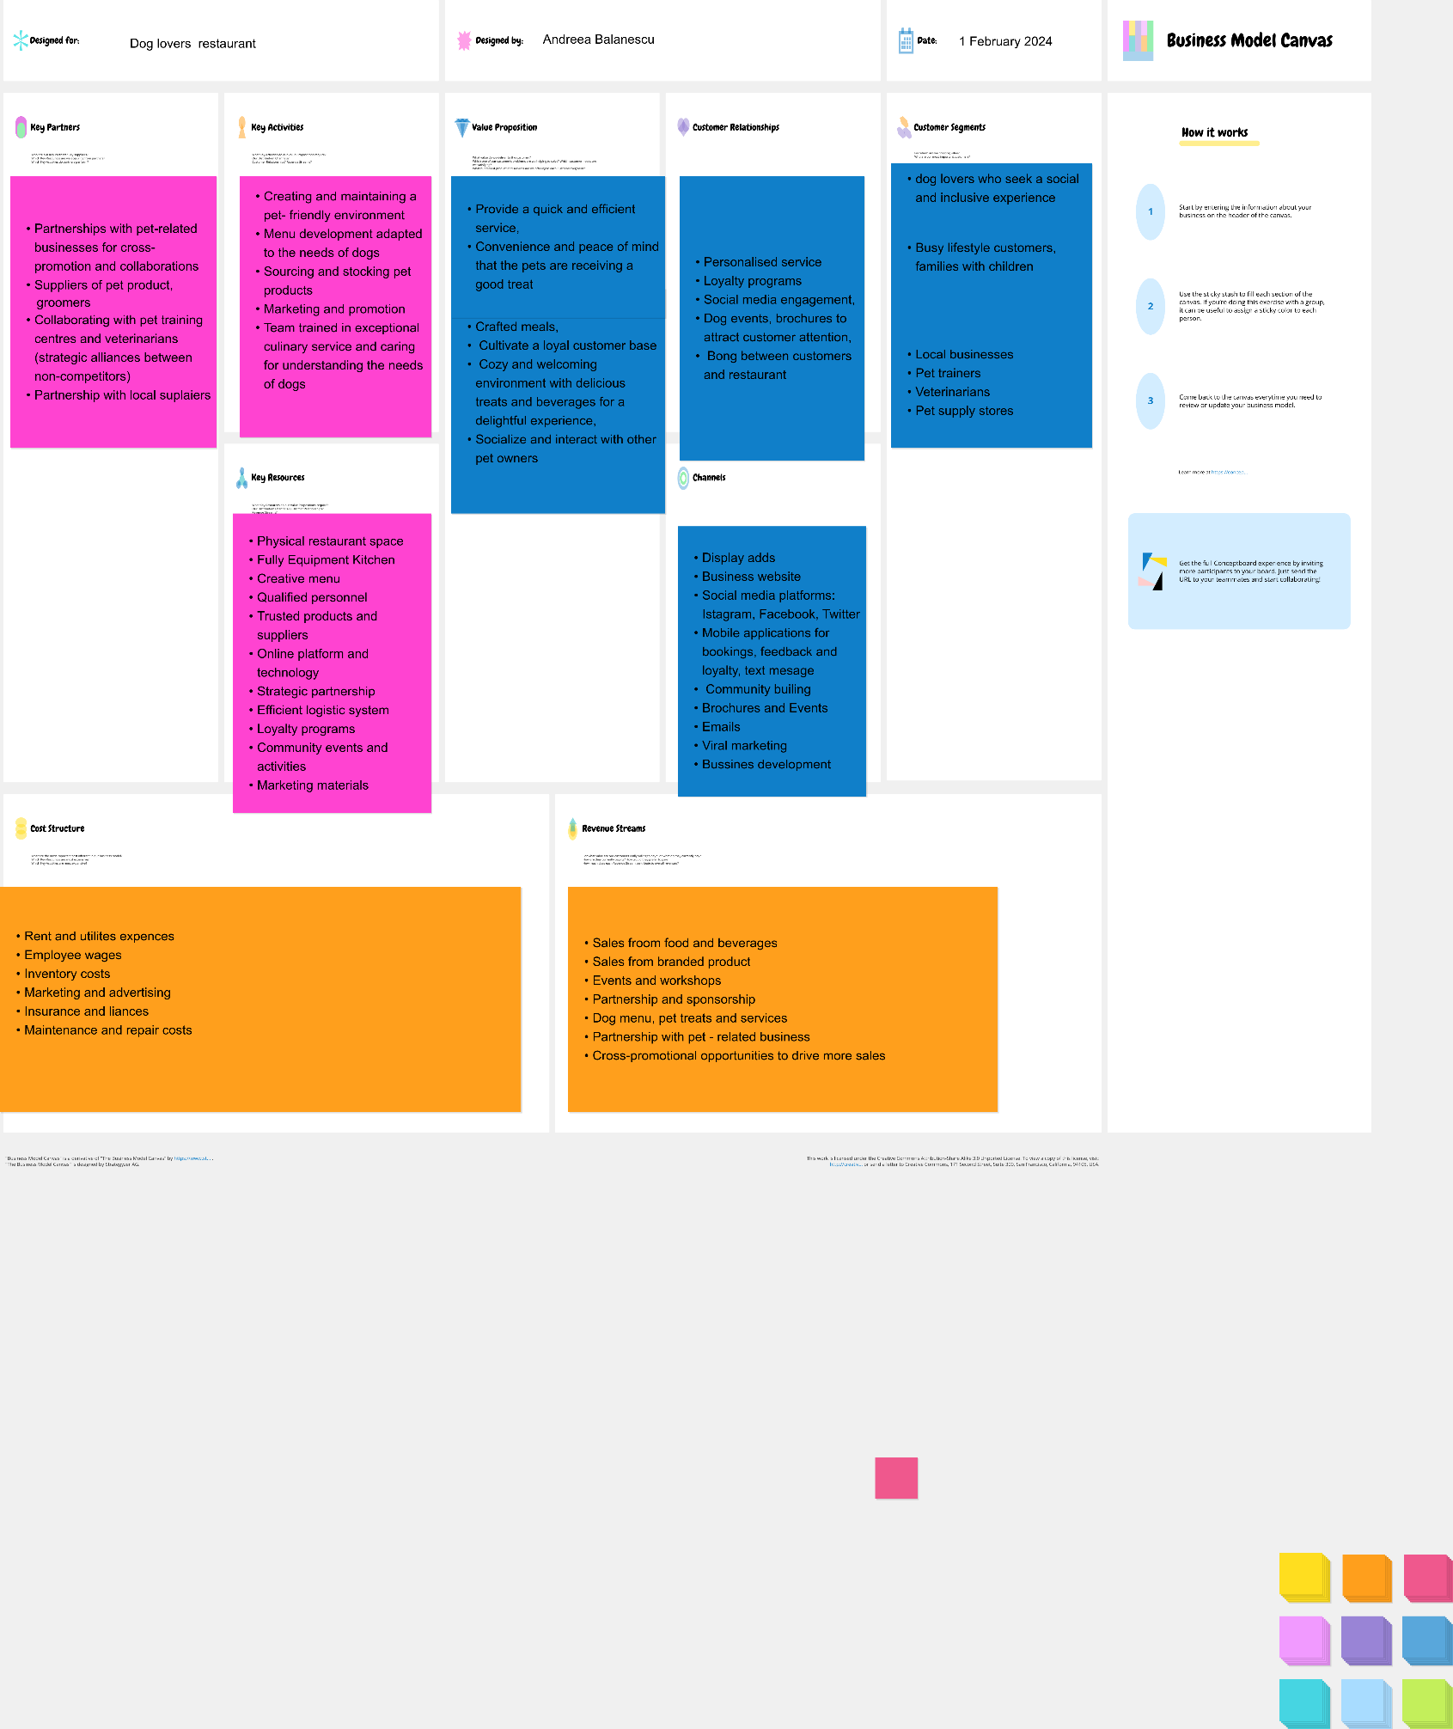
Appendix B Competitors
Fine Dining Restaurants in North East England, UK | Living North

Analysing three of the fine dining Website performance possible competitors from Nord East of England, on the last three months according to Similarweb (2024), the low marketing channels that has been used and no enough data to see the audience interest, this can be a key to use on the business concept propose, to engage more customers.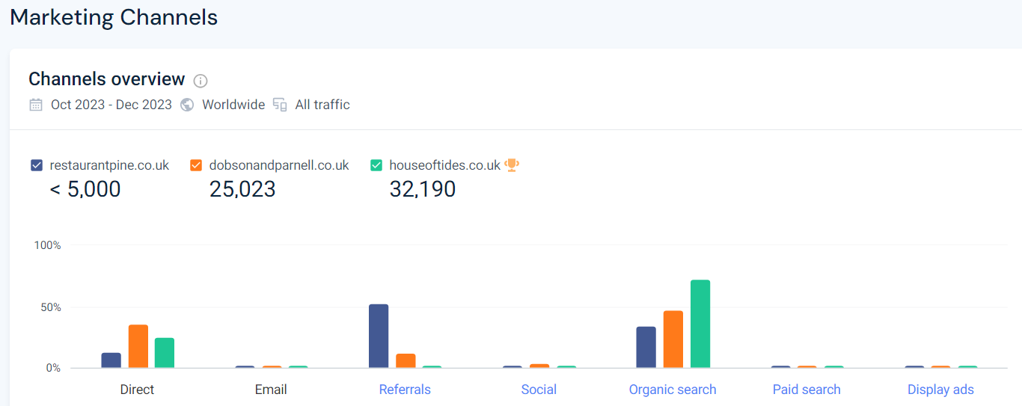.
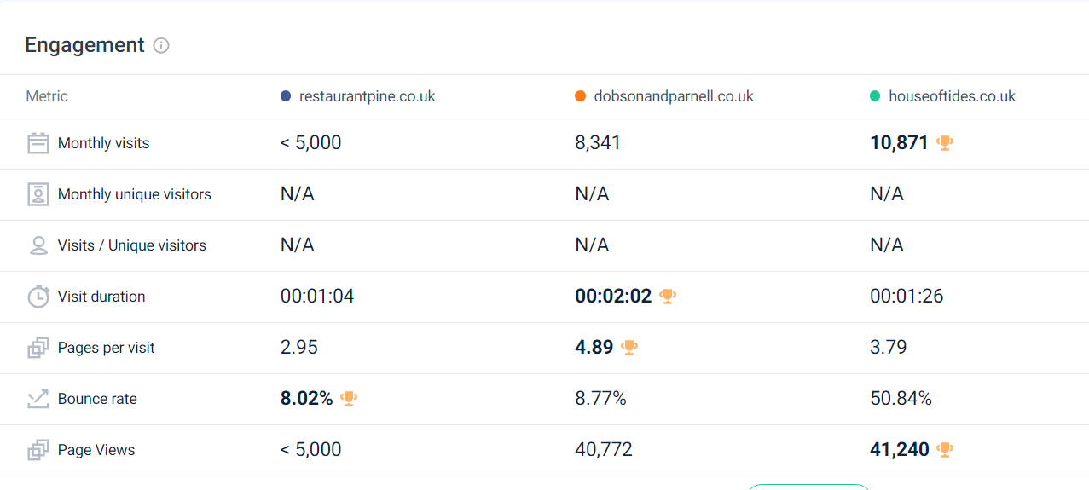

Appendix C (General Measure Enterprising Tendency, 2024).


