L5 Games design_ assest creation 2 solo write up
Harry Hixson 2005116 Ba games design 2nd year

For this project we worked in groups to create a fps horde mode style game, my group settled on the decision to base the game around Black Friday because that is the closest real world equivalate of a horde attacking a place. When a theme was reached, we all went into our assigned roles mine being enemy assest creator, logo designer and doing the enemy textures.
Firstly, after talking to my group, I was able to come up with 3 enemies plus a boss enemy these were our tank enemy which would be based on quite large people, a fast enemy which was based on gym going people in this intents a women, for the regular enemy would just be based on an average person and finally the bosses enemy would be based on the meme word of Karan which is used to describe women who typically like to course issues for others. With this in mine I got to doing research mainly looking at anatomy that I could use for the enemies and their textures except the Karan which was inspired by one of the bosses in the game Dead Rising 3. 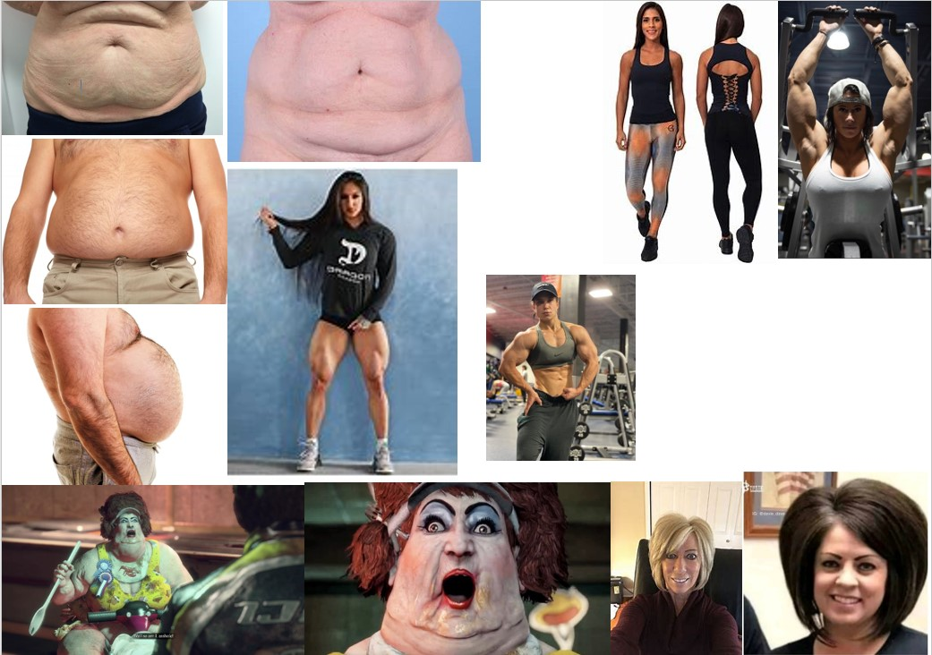

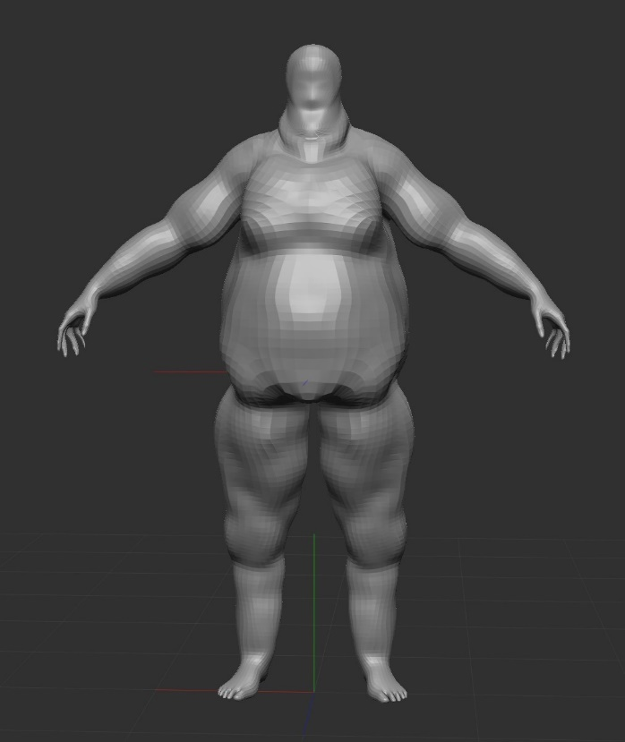
Next, when I finished with my research I moved on to make my enemy assests within zbrush a 3d model sculpting program, within this program there are human model pressets which I could use as bases saving me hours of work time I spent on making my models, I started with the tank style enemy which was based off larger people so when I was working on the model I began to inflate key parts of the model like the stomach, arms and thighs to give me more to work with when I began to hard bake textures into the model to give it the look of fat folding on a body like it would on a real person.

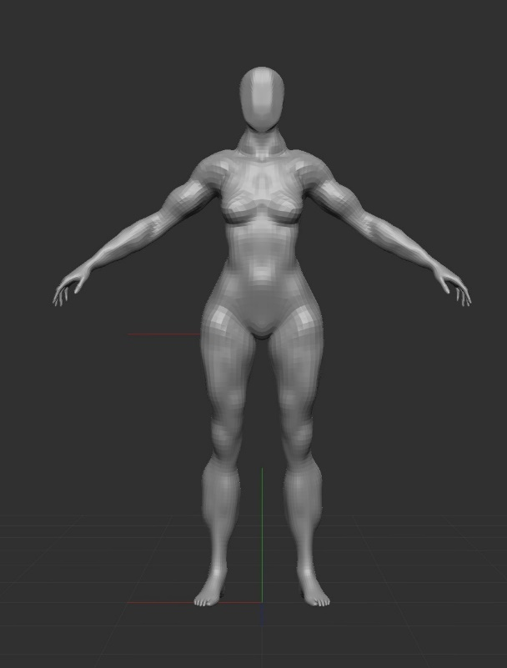
The next enemy I worked on was the fast enemy which I used the hard bake method to apply muscle definition within the legs, arms and torso to make it seem like the enemy frequents the gym quite a lot.

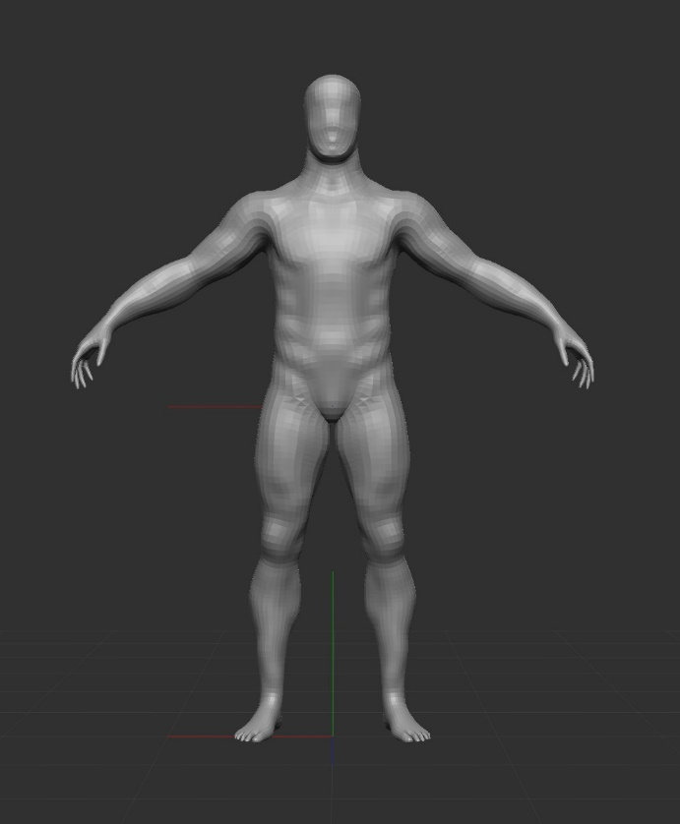
After finishing the fast enemy I moved on to the normal enemy which I didn’t really add much to this enemy in terms of the hard baked textures but when I got to this enemy I asked my team what they think about me getting rid of the faces on the models to give them a more creepy look and they were in favour of it so after finishing the normally enemy I took the flattening tool on zbrush and got rid of the models faces but still defining the bone structure of the faces.

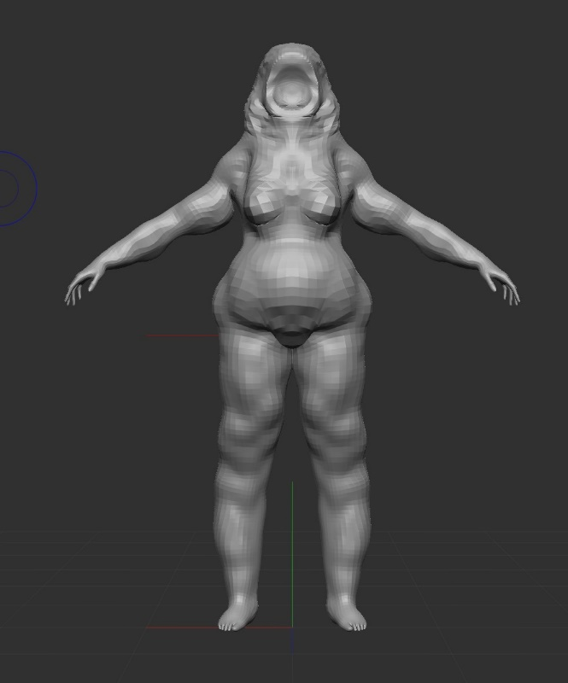
Then after doing the 3 main enemy types I began work on the Karan boss enemy using the similar style to the fat enemy hard baking fat fold onto the model mainly on the legs and arms but with this model, I added hair to help define the face because with a Karan they typically like to scream and shout at people so I decided instead of flattening the face I created just a mouth that took up the entire face.

Then after getting all the models done, I moved straight to texturing clothes onto the model’s hand painting them in substance 3d painter I started with the Karan because it was the model that had the most textures applied to it.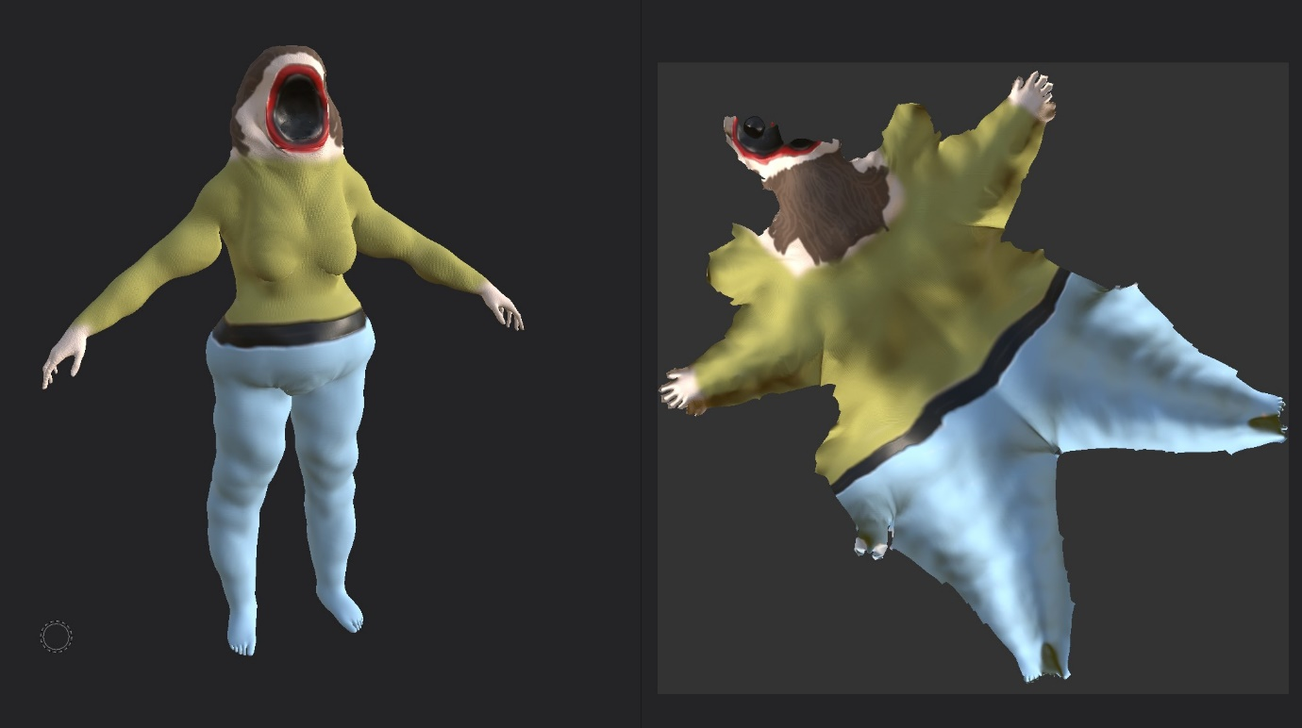
With the Karan I used a human back skin texture as a based this texture was also used as a base for the other models to, for the clothes and hair I used a cloth texture changing the colour of it each time but making sure the colours worked with each other and not colliding I then used a plastic texture for the lips and inside of the mouth.
The next model was the tank enemy and with it I did the skin base making it slightly tan in colour then with a blue jean texture I drew overalls on to the models as its cloths. 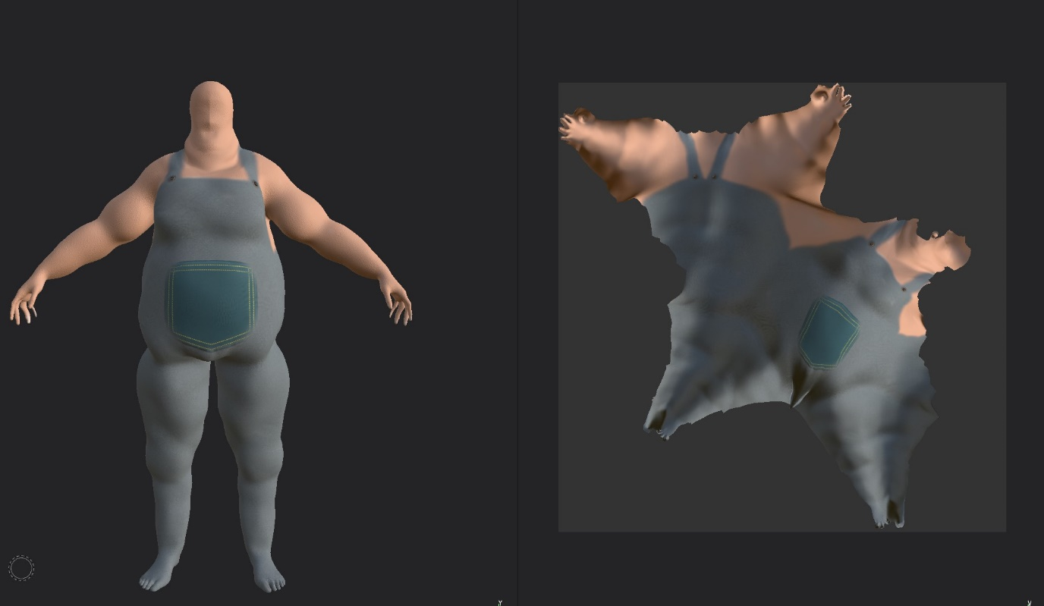

The fast enemy was the next model I worked and with that I decided to typical gym style clothes with legging shorts and a sport bra which I did in a bright vibrant colour. 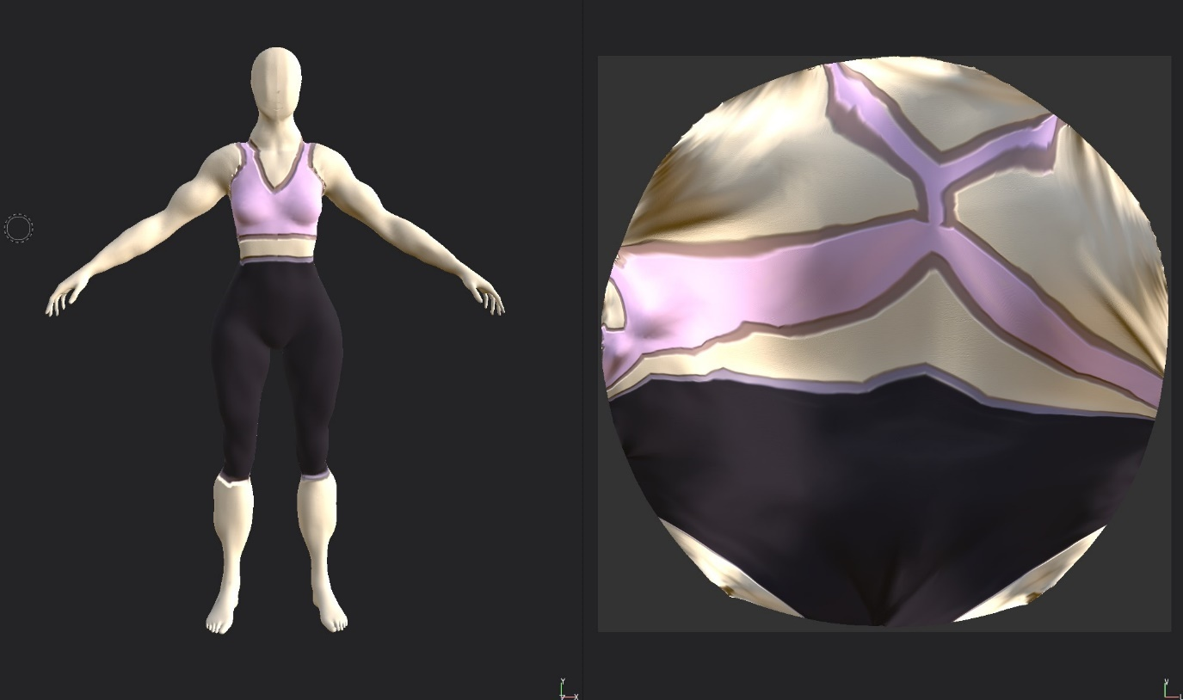
The final model that I textured was the normal enemy which I just kept it nice and simple with cool colours and simple clothing with the t shirt and shots using the same cloth texture for both. 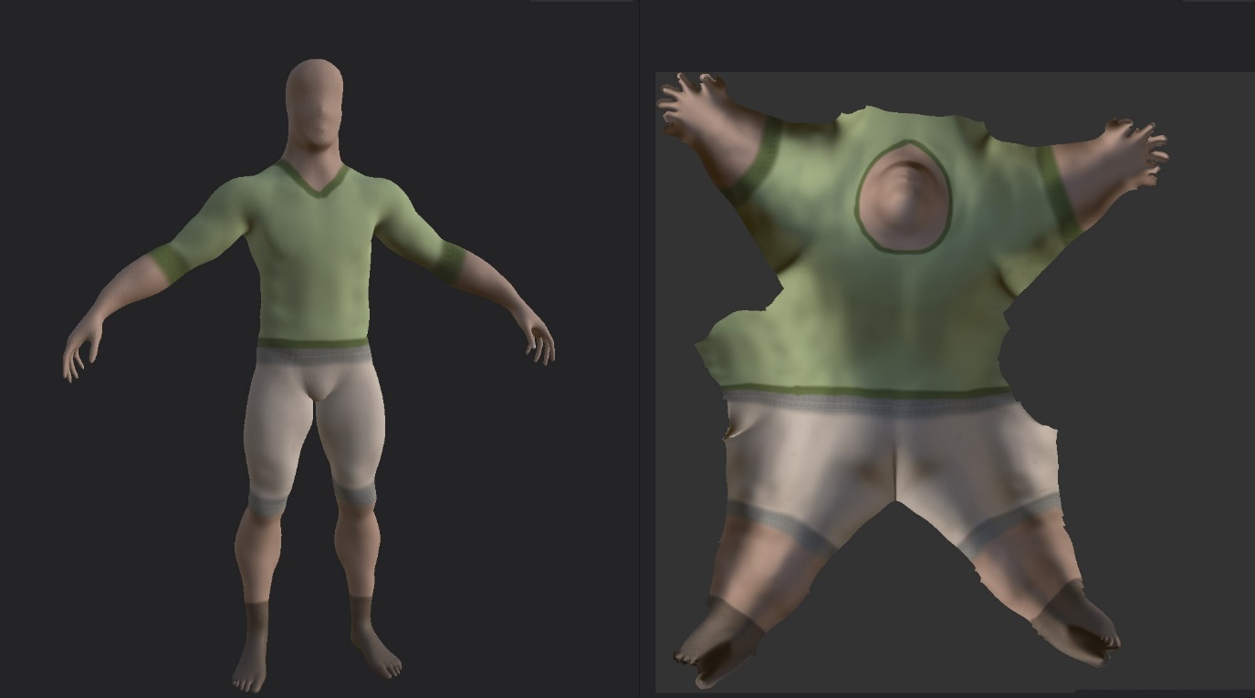

After getting all the textures done, I took the finished models into maya to rig the models ready to be animated and with this I discovered that in maya that there is an auto rigger function that applies the skeleton and control points to the model to make the job of the animator easier so there where no bottle necks on my side of the project. 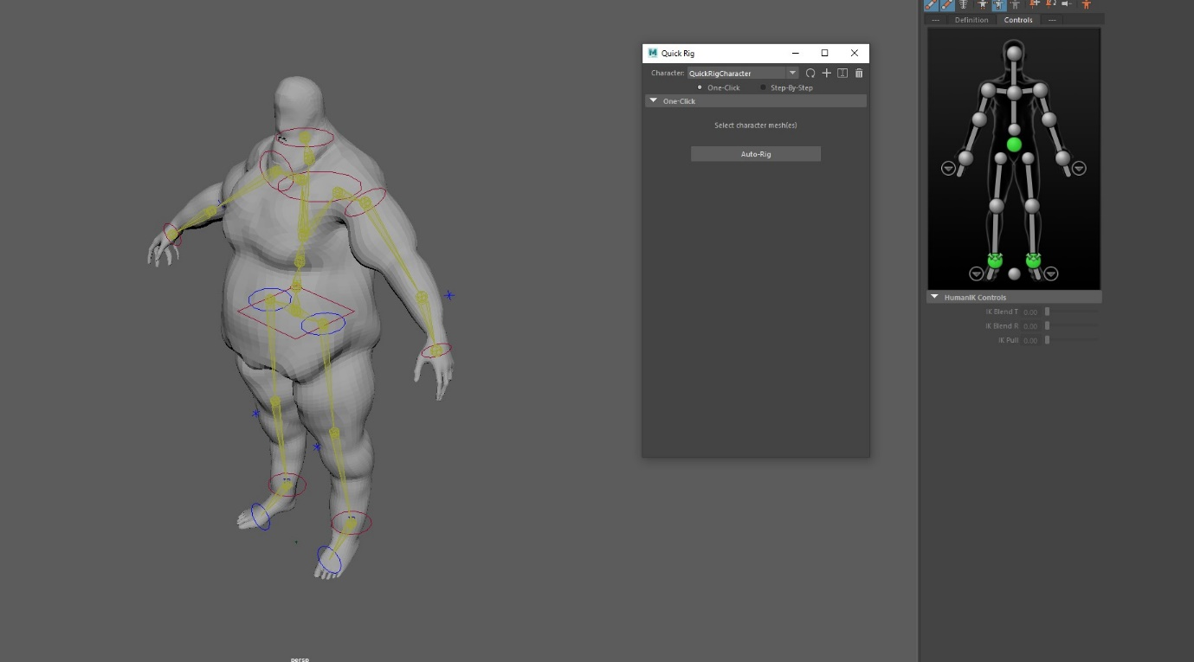

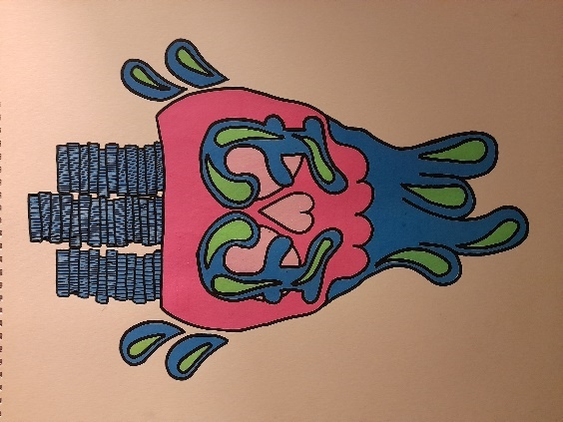
Now after finishing all of the modelling and texturing I had realised while looking at the brief we needed a logo for the game, so I began to look at different shop logos while out shopping because I wanted to make a logo that could be used as the logo for the game and for the shop within the game as well, so while looking at different shop logos while shopping the designs were quite simplistic but had eye catching colour so while coming up with a design I had all these in mind.

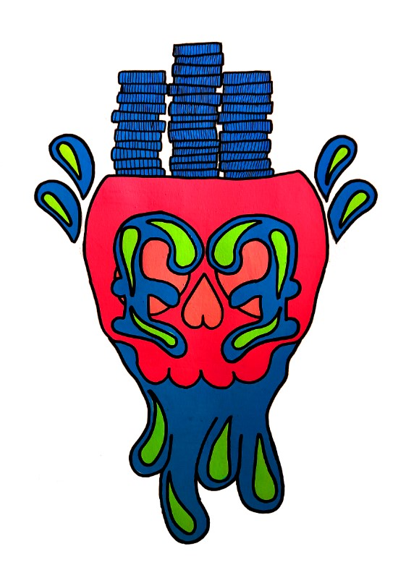
I came up with this as my design with a skull having money fed through the top of its head with blood the same colour of the money coming through the bottom and I used a combination of 3 complementary colours of pink, blue and green which I believed look quite well but I realised that if I am just making one design I need different colour ways so I imported the design into photoshop and used the eye drop tool to pick the same colour on the design and reapply them to the design to make it more vibrant.

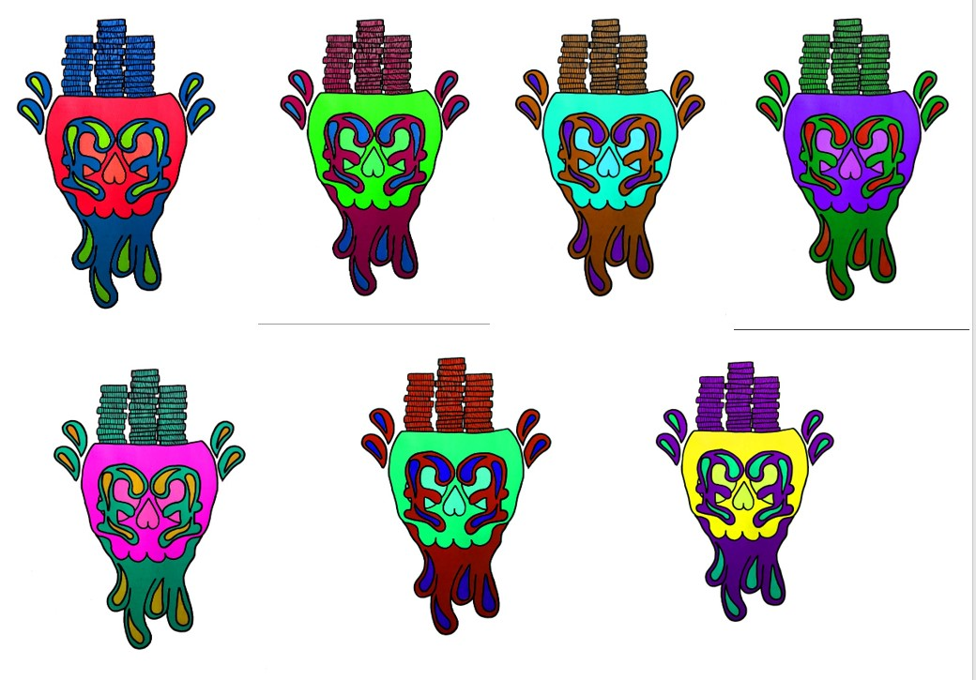
After doing that I then made 6 different colour ways using the hue and saturation menu in photoshop making sure that complementary colours were being used with each one.

This was the final part I was in charge of when it came the project.

In conclusion I believe that the elements I was in charge of within the project when well but there were problems with communication within the team it self where there was communication with come of the members of the team but then with others they wouldn’t really talk withy the others at all so that is one thing I hope is improved with the next group I work with, the next thing I would say could of gone better even though I did like the look of the textures on the enemy models I think it would of looked better with actual modelled on clothing similar to tf2 so I would like to add and improve on my modelling techniques for future projects.
With the presentation I wish I had prepared more screen shots of the models with them in different positions so its easier to see the different ways I applied the hard baked textures and also screen shots of the tools I used to make the different textures and also the prosses I went through to make each of the models, these are all things I hope to improve upon working on my next project.
But all in all I am very happy with my individual work and how it all came together in the end and with the new technique I learnt with the hard baking of the textures before applying the textures in substance I can hopefully apply this to future work.

Bibliography
Brown hair karan image Pin on Damn Karen (pinterest.com) [1]
Side profile fat person linking2yourhealth: Why You Have A Big Belly (pinterest.com) [2]
Front profile fat person Genetic Clue Into Brown Fat Energy Burning May Lead To Obesity Therapies (medicaldaily.com) [3]
Fat textures Cryolipolysis Liverpool | Contrast Lipolysis Liverpool (cryoliverpool.co.uk) [4]
Dead rising 3 Darlene Fleischermacher image 7 Deadly Video Game Sins - Gluttony (whatculture.com) [5]
Dead rising 3 Darlene Fleischermacher image Darlene Fleischermacher | Dead Rising Wiki | Fandom [6]
Gym girl flex Alyssa Kiessling (girlswithmuscle.com) [7]
Muscle reference Pin by Joe on Kristen Nun | Muscle women, Body building women, Muscular women (pinterest.com) [8]
Gym cloth reference Home - Women Sportswear | Gym clothing & Fitness Wear | UMBRA SPORTS | Sexy workout clothes, Womens workout outfits, Fitness fashion (pinterest.co.kr) [9]

