

MBA Dissertation

An Investigation Into How Technology Has ‘Impacted Consumer Behaviour’ During the COVID-19 Pandemic?

Course code LCMB7020
Student Name: Errol Malcolm
Student Number 1709503
Supervisor: Dr Hossein Shokri

Master of Business Administration (MBA)

Content
Dissertation: 4
Abstract: 4
Research Aim and Objectives: 4
Aim: 4
Objectives: 4
Research Questions: 4
Chapter 1. 7
Introduction: 7
Technology: 7
Online Purchasing: 8
Previous Impulse Buying Behaviour Research: 9
Consumer Buying Behaviour Satisfaction: 10
Reacting to the COVID-19 threat: 10
Consumer hoarding behaviour: 11
Research Background:. 13
Rationale: 14
Dissertation 15
Chapter 2. 15
Literature Review: 15
Research Objectives: 15
Introduction: 16
The Psychological Effects of Panic Purchasing due to COVID-19: 18
Determinants and Factors Influencing Consumer Behaviour: 18
Social Media as an Electronic Word-of-Mouth: 19
External Environmental Situations: 19
Consumer Behaviour & Financial Constraints: 20
Consumer Behaviour During a Crisis: 20
Chapter 3. 21
Introduction: 21
Introduction: 21
Methodology: 21
Research Approach: 22
The Academic Research Project Procedure: 22
Methodology Research Choice and Strategy: 23
Data Source and Collection: 24
Sampling: 25
Sampling size: 25
Data Analysis: 25
Ethics: 26
Research Methodology Conclusion: 26
Introduction: 26
Results: 27
Results of the Survey Questionnaire: 27
Consumer Purchasing Behaviour of Online Stores Before – COVID-19 55
COVID-19 Impact On Consumer Purchasing Behaviour: 56
Reasons for consumers to purchase in brick-and-mortar-stores during COVID-19. 58
Purchasing in Brick-and- Mortar-Stores During – COVID-19: 59
RQ 1 60
RQ 2 60
Discussions: 60
Recommendations for further research: 61
Conclusion: 62
References: 63
Appendix: 74
Factors Influencing Consumer Behaviour: 74
Economic factors Influencing Consumer Behaviour: 74
Personal Factors Influencing Consumer Behaviour: 74
Cultural Factors affecting Consumer Behaviour: 74
Social Factors Influencing Consumer Behaviour: 75
Psychological Factors Affecting Consumer Behaviour: 76
Determinants of Consumer Behaviour: 77
Scope of Consumer Behaviour: 77
Different Views On Consumers: 77
Economic and Passive Consumer: 77
Cognitive Versus Emotional Consumer: 78
Potential and Realized Consumer: 78
Personal Consumer Versus Organisational Consumer: 78
Final Consumer: 78
Rural Consumer: 78
Women as a Consumer and Decision Maker: 78
Applications for Consumer Behaviour: 79

Dissertation:

An Investigation into How Technology has ‘Impacted Consumer Behaviour’ During the COVID-19 Pandemic?

Abstract:
The purpose of this study is to provide an understanding of situations and impacts in-relation to the COVID-19 pandemic, pre-pandemic times and times during the pandemic, also linking consumer purchasing behaviour, in relation with technology and provide an experience account of Brick-and-Mortar-Stores Purchasing Behaviour and Online Purchasing Behaviour.

Research Aim and Objectives:

Aim:
The aim of this research is to investigate how technology has positively affected consumer buying behaviour throughout the period of the recent COVID-19 pandemic, within the global context, and In addition, taking a look at how matters were pre-COVID-19, to be able to examine the Impact on consumer purchasing decisions on business ethics.

Objectives:
The objectives necessary to achieve this aim are as follows: Carrying-out quantitative research measures and applying a deductive approach. Reviewing existing literature based on research gaps identified. Collecting data from a consumer behaviour self-completion questionnaire, and then analysing the data in order to investigate the factors influencing how technology has impacted consumer behaviour, and then to synthesise data by applying statistical/traditional analytical tools such as Google forms (Data analysis).

Research Questions:
RQ 1. How was consumer purchasing behaviour transformed during the COVID-19 pandemic because of technology?

RQ 2. What long-term lasting trends will we witness because of the current COVID-19 pandemic?

Chapter 1.

Introduction:

Technology:
The internet has been labelled “the magic of the digital age” and with this fairly current invention, has gained acceptability on a global scale, covering the developed world and a percentage of underdeveloped countries alike. However, there are teenagers and school children who are more familiar with this technology, to a degree in which the internet is very much more their world as to TV being much more their parents’ world. This ability the internet has to captivate a global audience within a few seconds makes the internet some kind of miracle/cipher for senior citizens. However, all of a sudden it has quickly become so ubiquitous that senior citizens have to get to grips with its intricacies, as to keep up the pace on the contemporary world (Mathew, 2017).
Furthermore, there are increasing numbers of consumers that purchase goods or services on-line, seek-out information, play games, or just simply utilise it for entertainment purposes. The on-line shopping arena play’s a significant role which brings together the connection of marketing-agencies & consumers. In addition, this connection assists in formulating an opinion for consumers whether to continue a relationship with a particular retailer, business, or not. Furthermore, the consequence of the on-line shopping arena linking consumer response is crucial for marketing planning and planners.
There is also an increasing amount of published works in regard to how individuals have an impact on or respond to current computer technologies (Coyle and Thompson, 2001; Li et al., 2002; Palmer and Griffith, 1998; Charumathi and Sheela Rani, 2017). However, there has been more studies in connection to on-line purchasing and environmental impacts and the way in which consumers respond. Consumer behaviour also has an involvement in the way in which individuals, groups, and organisations make selections, purchases, and utilise products and services which will fulfil their requirements (Solomon, 2018), but it is a complex and dynamic procedure. As a consequence of globalisation linking technological enhancement, and how consumers react and think is a continuous cycle of change (Jashari and Rrustemi., 2017).
Furthermore, as already highlighted above consumer behavior in connection with technology has reshaped the way consumers behave, in a significant way, e.g., ever since the days of the Industrial Revolution, and the formulation of the Motor Car Industry, appliances, and airplanes. In addition, this has progressed further with the telephone, television, internet, and at the present moment social media along-side individuals own use. Digital technology is turning wants into needs. For instance, we cope well with cell phones, however, in these current days we would not be without them. In addition, these current times the internet is as precious as electricity, and significantly more important than television. How technology has impacted our everyday wants and needs certainly has had an influence in how we develop new behavioural patterns, such as on-line browsing, on-line purchasing, or on-line dating. But more significantly it poses major factors on the family purse strings affecting vital old fundamentals, such as (Food, shelter, and clothing) and newer fundamentals such as (Mobile phones, the internet, and mobile apps) (Mathew, 2017; Seth, 2020).
In addition, with the inclusion of social media platforms, which are currently now emerging as a bullish digital communication channel by means of consumers educating themselves, and in doing so sharing knowledge with others, and effect brands they contemplate purchasing, or assessing (Chappuis et al., 2011; Qualman, 2013; Hudson, et al, 2016; Donthu et al., 2021). There are 2.7 billion individuals worldwide that are currently online, which equates to nearly 40% of the global population, however, more recent stats recorded for 2021, has seen these figures increase to 4.66 billion which currently equates to 59.5% of worldwide users, and this totals 92.6% (4.32 billion) utilised the internet using a mobile phone (ICT, 2014; Hudson et al., 2016; Johnson, 2021). Furthermore, social media platforms for instance, Facebook, Google + LinkedIn are regularly accessed for the navigation of information available on the Web, along with traditional search engines (Bughin et al., 2011; Hudson et al., 2016; Donthu et al., 2021). In addition, the 100% penetration of mobile phones on a global scale (ICT, 2014; Hudson, et al., 2016), social media is progressively evaluated and utilised at every moment and in all corners of the globe. Marketing planners are therefore carving out strategies to draw in networked consumers and are focusing their attention on how to compete for consumers social media awareness, to bring about consumer engagement (Hudson et al., 2016; Donthu et al., 2021).

Online Purchasing:
Online purchasing has become a global craze that has increased amongst growing economies such as in areas like Asia (Ganguly, Dash, Cyr and Head., 2010). e.g., the Alibaba, on-line shopping channel which started out in China in 2003, and who are a multinational technological organisation that specialises in e-commerce, retailing, internet, technology, and considered to be a rival company of Amazon, and who also operate under the same business model as Amazon (Forbes 2017). Alibaba, and Amazon both have operations that are situated in 14 countries, and both organisations have amassed profits of $26 billion, and $150 billion respectively, in 2016 (Forbes 2017; Peng et al., 2018). In addition, presently, Internet technology has now taken up the adoption of many which includes, Individuals, organisations, and the rest of the global community as already mentioned above, to seek-out growth and prosperity (Internet World Stats, 2018). Internet use is seen as a vital necessity and a fundamental basic requirement (Osama et al., 2018). However, as human citizens we all should consider ourselves as consumers. We all purchase items and services and utilise them to assist us in our day-to-day existences. We desire the purchasing and consumer procedure to be simple as well as being reasonably competitive. Furthermore, currently there are a series of new technological significances which creates new technology, technology that also creates the requirement for even more up to date technology which then involves the consumer as a connection to it all (Wuebben 2017, pp. 85-93). As a consequence, consumer value is as progressive as consumer value for businesses, which clarifies the need for adjustment and change to the current market and new technologies disrupting their status quo of technologies and becoming the creator-majority, and at the same moment be enthusiastic for the opportunities ahead and anxious of potential threats. (Kotler et al., 2017, p. 56; Kaczorowska-Spychalska, 2018).
However, according to Haung et al., (2019) Due to the increased development of technology, several businesses have acquired the Self-Service Technology (SST) model that lowers financial outgoings of labour which effects individuals initiations to process their own transactions. Self-service technology is a service process which has no requirement for service personnel to assist in the transactional procedure (Amazon, 2020; Kirk and Rifkin, 2020; Eger, et al., 2021). In current years, SST has encompassed a wide variety of industries for instance, self-checkouts, online banking, self-service checking-kiosks, online insurance etc., (Chen, 2012). Albeit, the insurance industry have merged few products and self-service, so is it correct that every insurance business products are suited for online insurance?
Furthermore, according to Holzheu et al., (2000), online insurance is not appropriate for a variety of insurance products, however, some insurance products that allow for simple and relatively easy-to-understand policies, for instance insurance in conjunction with motor insurance, that are mostly standard and appropriate, and is more inline, with online insurance. In addition, insurance products which are fairly complexed and will need meticulous prolonged introductions, for instance, pensions, financial performance goals, life insurance, etc., that also requires a special explanation service that assists individuals, to understand the contents that insurance provides on products Rossanty et al., (2018), put forward that, consumer knowledge in relation to products lend to the recouping of information, and in addition, causes a ripple effect on decision-making procedures and the enthusiasm to purchase, this is cause by the integrating of a multitude of product knowledge, or it may be the systematic procedure of purchasing leads.
Furthermore, when individuals purchase policy products which relate with their retirements, the level of involvement should be increased more so than travel insurance. However, there are various stages of product participation which can influence consumer decision-making behaviour, linking the importance of products for consumers, including the significance they connect to products which can end up allowing for a variety of stages of attention, that brings you to other types of decision-making behaviours (De Meyer and Petzer, 2014). So that pension financial planning can be carried-out, also the involvement of public citizens on these products and the volume of information will be indifferent to the travel insurance, However, it is whether the variations affects the individuals point-of-view towards online purchasing in-regards to pension financing products, and even more so effecting individuals eagerness to purchase online (Haung et al., 2019).

Previous Impulse Buying Behaviour Research:
Previous research in relation to impulse buying behaviour has revealed diverse factors which effect the buying behaviours of individuals on a global scale. Additionally, even in current times researchers from all corners of the globe still focus on the complexities in connection to this phenomenon. Several of their uncoverings have highlighted the influence of utalitarian, hedonic motivational factors, as well as external factors which links the influence of an individual’s pleasure and pain receptors on their willingness to navigate towards a certain goal or away from a threat. Therefore, activating the impulse buying behaviour of individual shoppers. In addition, some studies have uncovered the stimulus of emotions that are negative within shoppers and indistinguishable developments which take place in the external environments in regard to impulse buying behaviours. Therefore, in light of the recent event of the COVID-19 pandemic, which now assists businesses in forging new way’s forward (Khare and Rakesh, 2011; Dhamesti, et al., 2019; Bayley & Nanocrow., 1998; Dr John., 2021).
And other studies that connect this topic have discussed the emergence of e-commerce, and the way in which on-line purchasing has become the third most favoured occurrence after the e-mail, and searching the Web (Jamali, et al., 2014). Or the way in which purchase intentions, emerged from purchase intentions (Close and Kukar-Kinney., 2010). Meskaran et al., (2013) their interpretation of online purchase intention are that consumers preparedness to purchase via the internet. Consumers enthusiasm to purchase an item or service via the internet shops is stated as online purchase intention (Li and Zhang, 2002; Salisbury et al., 2001).
Furthermore, Close and Kukar-Kinney (2002) explain online purchase intentions as online shoppers intentions to purchase items or services through the internet as the intention for online purchasers, is to select and pay for items via the internet, or through virtual shopping carts. In addition, too, Iqbal et al., (2012) his explanation defines online purchase intentions as “the customers willingness to use internet services, making an actual purchase of goods and services or comparing the prices of production”. The consumers purchasing willingness is crucial in predicting consumer behaviour, however, this is determined by what influencing factors that effects the calculations inconvenience under differing circumstances (Mohan, et al., 2018).
In addition, online shopping in conjunction with social media is believed to influence millennials purchase intentions (Ladhari, et al., 2019), involving brands and product informational search’s (Benetton et al., 2018), the willingness of consumer purchase (Confetti and Vigolo, 2018), this also includes information sharing of product purchases (Dabija et al., 2018; Siddiqui et al., 2019). And some authors believe that the high usage of internet coupled with social media use for millennials are seen as crucial and desirable for e-commerce (Wu, 2003; Dhamesti, et al., 2019).

Consumer Buying Behaviour Satisfaction:
One of the challenges to online purchasing is the way in which businesses supply and support customer satisfaction. Surviving within a fiercely competitive e-commerce environment, is a key factor, alongside strategies that give emphasis to services. In order to attain buying behaviour satisfaction, the business in question must deliver a high-quality service experience to their consumers, so that these consumers will revisit, purchase, and become loyal consumers (Gournaris et al., 2010). Therefore, obtaining high-quality service levels of consumer satisfaction, is required and has a tendency of leading to favourable behavioural intentions (Brady and Robertson, 2001). In addition, a Webpage which has a good system quality, information quality, and electronic service quality, is significant to the success of e-commerce (Sharma and Lijuan, 2015; Rita et al., 2019).
A multitude of researchers have analysed the concept of e-service quality. Furthermore, the attributes of e-service have a significant connection with the entire e-service quality, consumer satisfaction, and purchase intentions, Nonetheless, not with word-of-mouth (WOM) (Blut et al., 2015). Additionally, Tsao et al., (2016) uncovered that the effects of service quality and online loyalty based on online purchasing experience in Taiwan revealed that system quality and electronic service quality had a significant influence on perceived value, which has a significant influencing factor on online loyalty. But Gounaris et al., (2010) discovered that e-service quality had a constructive effect on a trio of consumer behaviour intentions: purchase intentions, site revisits, and WOM. Blut, (2016) analysed that e-service quality has an uplifting effect on consumer satisfaction, repurchase intentions, and WOM for online purchasers based in the U.S.A. As a result, in general, the existing analysis around e-service quality have dissimilarities in both methodology as well as the results, without specific conclusions (Gounaris et al., 2010; Rita et al., 2019).

(Further additional information on consumer behaviour can be found in appendix).

Reacting to the COVID-19 threat:

Consumer hoarding behaviour:
According to Kirk and Rifkin, (2020) In the month of January 2020 the corona virus struck America, and very much the rest of the globe, bringing with it a threat to consumer behaviour. As already mentioned earlier. Additionally, this caused an alarm for certain consumers, the extreme survivalists “preppers” these individuals were always going to stock-up their food cupboards, for this type of threat, or any other threat for that matter (Austin, 2020; Yuen et al., 2020). Furthermore, a stream of prudence purchasing towards the end of February as well as the first few weeks of the beginning of March hastily turned into extreme purchasing, which saw an 845% hike in consumer household spending (NCSolutionns, 2020), these challenging levels could not be furnished by suppliers, which led to shelves being emptied, and the scarcity of stock and products, e.g., toilette-paper, bottled water, and others (NCSolutions, 2020).
On the other-hand some products such as toilette-paper is usually hoarded normally at the outset of any disaster (Kaigo, 2012), additionally, certain products, such as cleaning products may-be somewhat unique to pandemics. What type of products do consumers hoard in the COVID-19 pandemic, and why is this, poses further interesting questions for ongoing research, in-light of scientists observation of the probability of another occurrence of COVID-19 or other pandemics at a later stage. In addition, hoarding behaviour (as in accordance with compulsive hoarding; Frost & Gross, 1993) states that, the action of amassing and conserving large quantities of possessionable items (e.g., to spare needs) for use later (Chu, 2018; Kirk and Rifkin 2020). The methodology applied to analyse panic buying behaviour, is herd mentality linked with altered patterns and consumer discretionary spending (according to Maslow’s theory) (Loxton et al., 2020).
However, according to Preston (2020) who is a behavioural scientist at the University of Michigan Department of Psychology, and who also analyses the way stress and emotions affect the decision-making procedures such as hoarding, consumer behaviour including pro-environmentalism. Her view is that hoarding as already mentioned is a standard behaviour, however, individuals in question are required to be absolutely correct that it is not being carried-out for the wrong reasons. Furthermore, due to the current crisis situation of COVID-19, individuals are stockpiling goods. Are we all crazy? Research has uncovered that the inclination of stockpiling and the hoarding of necessity items is not just a peculiar behaviour, we humans proceed doing in crisis times; we are actually all hardwired in this way linked to our nervous system, which is said to be an adaptive reaction to shortages, that is shared amongst other species, e.g., birds and rodents are linked to this behaviour too (Preston, 2020). However, according to the Centene Centre for Heath and Transformation, (2020). Hoarding is a behaviour witnessed throughout the pandemic and must not be confused or connected to hoarding disorder, which is a mental health condition distinguished by the accumulation of items that may, or may not have any value e.g., newspapers, books, clothing, or animals.
In addition, this is dissimilar to compulsive purchasing disorder, which mostly occurs together with hoarding disorder and is identified, as the title demonstrates, immoderate purchasing (Norberg et al., 2019). As already mentioned hoarding behaviours are a standard human reaction that follows a large accumulation of individuals during a crisis situation like natural disasters and other events of this type of nature, already mentioned earlier; for instance, in 1973, reduced supplies of gas and electricity which saw Americans hoard toilette paper for more than a month. In addition, even though hoarding during a pandemic does not signify we have purchasing disorders, it all seems to be controlled in some way by anxiety, and the way in which we cope with uncertain times or overwhelming situations (Norberg et al., 2019). Therefore, when the pandemic retreats, many individuals will cease to engage in such behaviours. Until that moment, how can we manage our sensations of powerlessness, helplessness, and fearfulness in absence of stockpiling toilette-paper? (Centene Centre for Heath and Transformation, 2020).
Consumer buying behavior throughout the period of the COVID-19 pandemic saw several impacting factors, which has changed the way in which businesses progress and move forward, and the way in which consumers behave (Donthu and Gufstafsson., 2020; Pantano, et al., 2020). Furthermore, previous studies taken from the first outbreak has uncovered global consumers currently view brands and products in a new perspective (Accenture, 2020; McKinsey, 2020). The study, focussed on the antecedence and dynamics in-connection to impulsive purchasing behaviours in view of the pandemic COVID-19, which assessed the effects of impulsive purchasing behaviour of Czech inhabitants throughout the period backed by fear (cf. Ahmed et al., 2020; Iyer et al., 2020).
In addition, the present conditions, after the first initial out-break and at the outset of the second out-break, on mainland Europe, has changed the mindset of consumers to establish purchasing and shopping practices or adopt and establish newer ones (Seth, 2020). Because of the exceptional containment measures several consumers e.g., chose to utilise on-line shopping, selected home deliveries, in conjunction with cashless payments, which was not thought of previously (Pantano et al., 2020). Which as a result now requires managers and marketing planners to observe current changes to consumer’s behaviour and patterns to gain an understanding to which strategies are required to focus more attention on for businesses going forward (Verma and Gustafsson, 2020).
In the UK, major developments have witnessed social distancing, the wearing of masks, transport closures, global lockdowns, including a world-wide air travel ban. There has been a barrage of constant changes, including daily tv, and radio briefings by government officials and senior ministers, globally, and the topic of discussion, how do we, currently move forward and all remain safe and healthy. Any recent previous experiences of this nature had been the SARS epidemic in China in 2002 to 2003, which resulted in The World Health Organisations (WHO) involvement of taking control of matters with the inclusion and cooperation of the worlds political leaders. Additionally, the global epidemic of SARS reached a successful conclusion, by July 2003. (Gates, 2020; Mehta, 2020; Lia van der Hoek., 2004; World Health Organisation 2004). In addition, there are global conflicts, civil wars, or even global wars, for instance world war two, the cold war, also the Great Depression, and the Great Recession of 2008 – 2009. All these periods in history have all affected consumer behaviour considerably, which includes consumption, production, and supply-chain (Sheth, 2020).
In the UK, the pandemic has revealed aspects of consumer behaviour that is critically more complicated; for instance, the movements of all individuals were reduced to a minimum, which only allowed individuals to leave the home for shopping or exercises once a day for necessity items, with social distancing in mind throughout. However, these effects witnessed consumers increased volume usage to technology, including high volumes of internet usage, furthermore, for several organisations who reacted to the situation through extremely high levels of innovation, by generating sizeable areas to digital access for the purchasing of goods, and consumer support (KPMG, 2020). The working environment also experienced changes with individuals allowed to work from home through the application of computer technology, which also kept many industry sectors open for business. (Gates, 2020).
COVID-19 has brought with it new areas for research for instance: to measure global crisis situations, and how to prepare for these moments in the future.

Research Background:.
Earlier research written ten years ago on “Behavioural intentions in response to an influenza pandemic”, Gerjo Kok, and others demonstrated that the vast share of the work until this present time in relation to behavioural changes linked to a health crisis had previously been, (Spanish flu, Sars, AKA Bird flu virus). Kok, et al., (2010). And now in current times COVID-19. In addition, health professionals involved in pandemic’s as far back as 2017 had been increasingly aware of the potential dangers of a crisis such as COVID-19, highlighting that there would be no global country that would be ready or have been in the position to be quite fully prepared for such an attack of this nature. However, according to The Guardian, (2020) contagions of this kind which are able to cross contaminate from animals to humans which have a high probability of transferal to individuals and other global communities, for example where the outbreak began in China’s, city of Wuhan, in Hubei Province where the out-break eventually travelled around the globe. Previous research has identified Individuals behavioural reactions will no doubt have effects on nations as a result of a pandemic, these behavioural effects are a result of (Herd Mentality), already mentioned earlier, which may occur around circumstances such as these, which according to survival psychology accepts that persons in these moments incur behavioural transformations due to the particular crisis situation for instance natural disasters, a health crisis, terrorist attacks, or as already mentioned above, the periods in history (Loxton et al., 2020; Sheth, 2020).
Technology and consumer behaviour during the period of the pandemic saw new usage in the UK along with various changes in consumer behaviour (KPMG, 2020), for example due to the social distancing and the government’s stay at home policy, several businesses including restaurants were given the go-ahead to re-open their premises, and permission to serve food once again. Restaurants, pubs, and food outlets all welcomed these changes, If only for the survival of their business, and too for many these businesses this resulted in a reduced workforce, which was due to less workers required for operational needs, and changes to their business model in terms of how they would operate in these current times, now that pubs, restaurants, and food-outlets are able to function as a delivery service as well, which would see orders of food, placed by consumers taken over the phone, or by means of the internet through smart devices, which also saw an increase to other areas such as online-shopping, online entertainment, online education, and new ways forward for businesses, so that employees were able to work from home, these new inclusions by the British Prime Minister, Boris Johnson and his Chief Medical Officer Chris Whitty, and other government health advisors, brought on these changes that assisted consumer behaviour due to the current pandemic conditions (Donthu, and Gustafsson., 2020; Seth, 2020).
In addition, certain businesses saw an up-curve in profits, Amazon witnessed increased buying activity during this period with individuals on a global scale confined to the home, for many this resulted in a serious increase in internet shopping and increased traffic, Amazon witnessed accelerated growth in profits during this period of 200%, due to Amazons positioning in the market of online-shopping, coupled with individuals confined at home due to social distancing, these conditions were placed excellently for Amazon to gain even more market share over others (Takefman, 2021; BBC News, 2021).
Furthermore, advances within the digital environment form a business point of view is the simplicity in which to collect specific data through consumer touchpoints in connection to businesses. Data of this nature is applied to gauge efficiency and effectiveness of many online marketing reactions, which as a result optimises marketing and financial output for many marketing instruments. In this moment businesses can gage costings by obtaining consumer online that much more precisely, retention costings and various other actions can be specified to individual consumers which may also involve other segment stages. Furthermore, when individual consumers connect with several marketing channels on the road to purchasing, the question of the way all individual channel is assessed in connection to terms of contributing to sales transactions is vitally significant. “attribution” the effects of attributing conversions, acquisitions and retentions to individual channels, and also the measuring process of the carryover, as well as the spillovers influences individual channels / marketing touchpoints are viewed as a main focus of active research (Kannan, et al., 2017).

Rationale:
In this current pandemic situation, we find our-selves in, increases our acceptance to behaviours previously raising the bar, in-terms of technology usage and shopping behavioural impacts. These shopping behavioural impacts during the pandemic will have witnessed changes on local and global levels, entwining all cultures, and communities (Donthu and Gustafsson, 2020; Pantano, et al., 2020).

Dissertation

Chapter 2.

Literature Review:
The theory of consumer behaviour and the way in which it effects businesses or enlightens their strategic creation has created interest from various researchers ever-since its association with marketing and then became a main focus of exploration in the first half of the 20th century. Many studies have consequently been performed on the way how pandemics have affected the behaviour of consumers and in addition, by what means businesses are able to counter-attack these effects. This section hence provides references to some studies that supply a critical and comprehensive and thorough review of the views presented in them. In addition, online commerce delivers a multitude of favourable positions for consumers, e.g., receiving alternatives at any given moment, the comparison of products, and pricing (Pallant, Danaher, Sands, and Danaher, 2017). 65% of respondents disclosed utilising the internet to compare prices amongst other retail outlets, 61% searched the internet for products and services and 49% searched for reviews. In addition, the research by products, where 52% of consumers mentioned that one channel had no connection and 59% an online channel, which brought to view that, in-spite-of the growth of online commerce, both categories of commerce play a vital in consumer purchasing procedures (KPMG and International, 2017). In view of any changes in the quality in connection with the information, one should take-on-board that information technology, permits stores the ability to offer something of interest or advantageous which enables them to attract and keep more consumers (ACEPI, 2018). Although, one may also take-into-consideration that the utilisation of online commerce consumers started to meet some disadvantages in relation to offline commerce.

Research Objectives:
The aim of this research is to investigate how technology has positively affected consumer buying behaviour throughout the period of the recent COVID-19 pandemic?.

RQ 1. How was consumer purchasing behaviour transformed during the COVID-19 pandemic because of technology?

RQ 2. What long-term trends will we witness because of the current COVID-19 pandemic?

Introduction:
The topic of consumer behaviour is the detailed examination into the way in-which consumers, groups or organisations purchase, select, utilise, goods and services to satisfy their requirements. Additionally, it may also be referred to as acts of consumers within a particular marketplace and the fundamental motives for those acts. Furthermore, the analysis of consumer behaviour takes for granted that consumers are the main focus in the marketplace. The viewpoint of the theory assumes that consumers are seen to play various roles within the marketplace. Which begins at being the information provider, the user to the purchaser and to the disposer, consumers act out these roles in the decision procedure. Consumer Behaviour is complexed, a multidimensional procedure which consists of many different connected parts that all marketing decisions are based on, and beliefs concerning consumer behaviour that involves communicating, purchasing, and consumer interactions (Solomon et al., 2009).
According to Cruz Cardenas et al., (2019) Technology has demonstrated how it has become a tremendous force, which has significantly shaped societies, businesses and individuals, and consequently, also having an extensive socio-economic impact (Watanabe et al., 2018). Currently, over half of all households around the globe have no connection to the internet (in comparison to under 20% in 2005), and the total amount of mobile phone subscriptions far surpasses the global population (International Telecommunication Union, ITU, 2017).
Furthermore, WhatsApp, who are considered to be one of the world’s most well approved instant messaging services, these established users have seen an increase of 200 million to 1,600 million between 2013 and 2019 (Statista, 2019). Disruptive innovations which connects business and consumption – products, services, and procedures that effect and considerably alter the actions in industries, economies and social systems are now a persistent occurrence (Guo et al., 2019; Horvath and Szabo., 2019; Millar et al., 2018). However, there are some negative effects which are associated with modern technologies, evidence has suggested that the overuse of technology is a factor, alongside Social media, mobile devices, which also has the ability to bring about psychological as well as other physical concerns like strained eyes, and further challenges in connection with focussing. In addition, there are also other issues which may contribute to vital health conditions for instance depression (Johnson, 2020).
Innovations are firmly positive and simultaneously affects the image of a business and generates financial stability. Hence profitable organisations are quite operative in the area launch of innovative products and services. In addition, consumers can also assist by being a source of innovation through the sharing of ideas on social media platforms (Bhimani et al., 2019). However, with the use of innovative products and technologies which has seen incredible positive social influences, which may be applied by governments as well as non-profit organisations (Boons and Bocken, 2018; Gouvea et al., 2018). For instance, the user benefits of Facebook, YouTube, Twitter, or the variety of blogs may assist better coordinated acts among individuals, or for extreme activities such as natural disasters (Gasper et al., 2019).
However, there is scientific proof found in literatures based on behavioural predictors and alterations that are related to the constant utilisation of the Web, e.g., guilt, and the extreme needs to be continuously connected to the internet (addiction), which is associated with being out of control, and wasted hours of increased distractions (Gracia et al., 2002) indications of important agitations in the individual (Kilic et al., 2016), a separation of normal healthy actions and physical distinctive relations, substantial consumption of biased knowledge and political polarity (Mosquera et al., 2018). In similar fashion, Plaza de la Hoz (2018) draws special attention to the bad use of time as a stumbling block, which gives rise to unbefitting use of technology or unintelligence; the author has highlighted that excess reliance on electronical devises which also includes uncertainty or anxiety which individuals that use may possibly progress when technologies are utilised incorrectly by other individuals (Vasquez, et al., 2022). In addition, the acceptance and use of mobile phones within a small farming community from poorer countries may assist them receiving better price information, and lead to better decision making when selling products (Haile et al., 2019). The dynamic setting characterised by technological progression and the ongoing globalisation of economies (Kraus et al., 2018; Cardenas et al., 2019).
According to buyers orientated management processes, in functioning marketing channels, consumer relationship management depicts a metaphor for success (Laketa and Laketa., 2016). The analysis of consumer behaviour as a significant marketing speciality started by way of bidders recognising how consumers do not adopt, set behaviours on a continual basis in view of the reckoning’s of marketing theory. Although on some occasions, the approach to hi-fi and fashion several consumers possess and in addition, declined to utilise products that others have used. (Shiffman and Leslie., 2009). The receiver of an advertising campaign is a consumer or an individual that uses the service, or one who the advert was intended for, and at the same time, the point of sale, is where a business proposition is catalogued and performed (Vlada RS., 2014). Furthermore, The American Marketing Association (AMA) “defines consumer behaviour as a dynamic interaction of thinking, behaviour, and events in an environment in which human beings manage aspects of their lives in exchange, emphasizing the following aspects:
- The dynamics, i.e., of consumer behaviour occurs in a particular place (market) a particular time, and a particular marketing environment (target group), in connection to a particular product, or a group of products, services, items or ideas.
- The Interaction, i.e., that consumer behaviour is determined by the effects of their thinking, behaviour and occurrence’s that takes place in the environment (Peter and Olson., 1990).
However, according to Hovarth et al., (2021) e–commerce has experienced magnificent increases due to the development of ICT Technologies. (already mentioned above) A significant factor towards the growth of e-commerce is because of the number of individuals that are in constant contact with ICT technologies is consistently growing (Janouch, 2014). E – commerce has a significant part to play in the current world of e-commerce (Lampropooulos et al., 2019; Paunescu and Moraru, 2018, Popesko et al., 2016). Many consumers opt for purchasing goods or services on-line. The increase in e-commerce has come about because of today’s consumers use of the internet on a day-to-day basis, and they are also happy to try-out new products and services, however, these consumers are modern, demanding and convenience-orientated (Rozsa and Machova, 2020). The determining indicator in-regards to this is, the availability of the internet, the ease of access, and connectivity throughout (Gerrikagoitia, 2015; Karson et al., 2020). E – commerce provides high possibilities towards online sales, however, there are high risks involved, that may affect consumers, retail, for instance cybercrime, hacking attacks, spam, absence, or lack of personal interaction, also the lack of information asymmetry (Chatterjee and Datta., 2008; Oluwafemi and Adebiyi, 2018).
In addition, risks can affect consumer uncertainties (Goker and Ayar, 2020). In other words, this will leave consumers with the feelings of insecurity when purchasing products or services on-line as against purchasing from the equivalent brick-and-mortar department stores (Pavlou et al., 2007). Doubt and uncertainty has a way of displeasing several consumers of taking part in online purchases (Almeida et al., 2019). Uncertainty has extendedly been promoted as being a significant barrier for consumer purchases online (Pavlou et al., 2007; Kjucnikovet et al., 2019). The Wall Street Journal (Kesmodel, 2006).
Furthermore, it has been recognised that 25% of consumers that seeked products online purchased them online. A similar survey’s results revealed that 65% of online consumers who never complete their purchases because of feelings of doubt and uncertainty, trustworthiness of the seller, or information given through a website, presentation of products being sold (Kjucnikov et al., 2020; Ungerman et al., 2018). Which demonstrates that previous research reveals consumers remain some-what insecure in relation to e-commerce transactions. It also demonstrates that the managing of consumer behaviour is a significant matter for e-commerce managers (Svatosova, 2020).
However, earlier research states some issues of doubt and uncertainty simply founded on the fact that consumers are unlikely to completely witness the sellers performance: adverse selection (hidden information) including moral hazards (hidden conduct) (Pavlou et al., 2007). This demonstrates that consumer uncertainty is cause by information asymmetries because of hidden information and hazard problems. uncertainty derives from perceived information asymmetry is explained as “the perception of the buyer, and the seller has a greater amount or quality of information about his products, properties and sales practices (Pavlou et al., 2007, p. 112). For instance, it is very challenging for an online purchaser to discover if a seller is of a high or low quality (seller quality or product quality) due to, a low-quality seller could attempt to sabotage its natural condition, however, brick and mortar department stores, these purchasers are able to double check items before they purchase (Tovmasyan, 2020). Hence, because of the physical distance for purchasers and sellers, involved in e-commerce, the challenges of information asymmetry occurs, therefore, giving rise to the feeling of insecurity for online purchasers (Huston and Spencer, 2020; Ferencakova et al., 2020). Then perceived information asymmetries raises consumer unpredictability for the online environment (Dokulil et al., 2020). Furthermore, the mission for retailers is to lower unpredictability (Hovarth et al., 2021).

The Psychological Effects of Panic Purchasing due to COVID-19:
Research undertaken by Yuen et al., (2020) for the purpose of COVID-19 uncovered that there are four key indications which relate to panic buying: (1) perception, (2) fear of the unknown, (3) coping behaviour and (4) social psychology. Furthermore, in there concluding statement mention that when consumers recognise the probability and sequences that lead to developing the disease are increased, individuals are motivated to take-on the responsibility to adopt self-protective actions, which includes panic purchasing, to reduce perceived risk. Besides, panic purchasing may be activated when consumers anticipate a product or item to be unobtainable and therefore restricting their personal freedoms of not having it; or on the other-hand when they can anticipate a feeling of regret from not adopting a particular behaviour or purchase, leading them to bring forward the intended purchase (Yoon et al., 2017; Loxton et al.,). However, according to Ulpiano et al., (2021) their study focussed on the impact of COVID-19

Determinants and Factors Influencing Consumer Behaviour:
According to BBA Mantra, (2019) when businesses view market conditions, they also have to take-into account the varied consumer differences and requirements. This is due to the fact that consumers are unique and adopt varied behaviours when making purchasing decisions, which stems from the variety of factors influencing consumer behaviour. Consequently, it is also significant to understand the variety of factors influencing consumer behaviour.

Social Media as an Electronic Word-of-Mouth:
The theory of word-of-mouth (WOM), which made an introduction in the 1950’s has reawakened through the internet. In addition, according to Arndt (1967), WOM is a “person-to-person communication between a receiver and a communicator whom the receiver perceives as non-commercial regarding a brand product or service.” WOM is an original source of information for consumer purchasing decisions, that affects the forming of attitudes, perceptions and expectations towards brands, products and services (Kimmel and Kitchen, 2014), that impacts all phrases of consumer decision-making: which also links product awareness, selection, and post-purchase evaluation. WOM has attained new prominence in current times due to the vast inter-connectedness of individuals that utilise social media (Kimmel and Kitchen, 2014).
Online, or electronic-word-of-mouth (eWOM) is a type WOM were, individual internet utilisers contribute to reviews as well as ratings to various types of products, brands and services on review sites (Bronner and Hoog, 2010). This may also be defined as “any positive or negative statements made by potential, actual or former customers about a product or company, which is made available to a multitude of people and institutions via the internet” (Henning-Thurau et al., 2004). Electronic WOM has the ability to circulate in a multitude of ways, on social media, (e.g., WhatsApp, Line, Telegram) or in comment sections on e-commerce sites; furthermore, the information circulated is scarcely available on company-led marketing communications.
Additionally, content produced in this way by internet users, and who are also consumers, is normally perceived to have an independent commercial independence (Bronner and Hoog, 2010). This enables consumers to seek out forums, blogs and other impartial social media sources to receive information on purchasing decisions (Vollmer and Prescourt, 2008; Erkan et al., 2021). Furthermore, In these current times of digital messaging apps represent the perfect instrument for mobile word of mouth (m-WOM) which has been analysed by a multitude of researchers (Shen et al., 2013; Palka et al., 2009; Zhou, 2013; Erkan et al., 2021), in areas such as motivation and decision making amongst a few that have been scrutinised. However, although the standard use of mobile app research concerning this subject is without fullness of scope (Alvarez-Monzoncillo et al., 2018).

External Environmental Situations:
Currently with the sales of goods electronically, businesses now have the opportunity to connect with consumers globally, by way of individuals placing orders over the internet, as a result of this overcoming challenges connected to geographical locations (Sinkovics et al., 2013). Businesses are also able to obtain enquiries and feedback from potential consumers, including recommendations to enhance goods and services, or acquire helpful tips to introduce newer products in the global market (Berthon et al., 1998). A multitude of business analysts have the ability to foresee how the internet will attain exponential growth for the near future, and encompass a broader range of purchasers (e.g., older age groups), and grasp new forms and modes of conduct (e.g., mobile marketing), alongside international marketing schemes and strategies that are consistently transformed with a perspective of bringing these current trends into play, and therefore staying in-line with present developments.
Furthermore, online associations can also assist businesses to recognise and take-advantage of profitable possibilities in overseas markets in view of furnishing precious information that facilitates, e.g., affective understanding to consumer purchasing habits, likes and dislikes, and the multitude of phases that connects purchasing procedures of foreign buyers, the acceptability of current product concepts and the effectivity of promotional messages (Baldu et al., 2015; Gurhan-Canli et al., 2018). Alternatively, overseas purchasers can influence or effect these communities to increase their knowledge about the businesses goods and services from informational gains by other consumers, evaluations that take place by community groups, and positive comments intentionally posted by businesses to support its products and services in overseas markets (Essamri et al., 2019; Lin and Kalwani, 2018).
In addition, digitalization certainly assist businesses in developing a firm customer relationship management (CRM) strategies which will enable overseas purchasers a personalised services “around the clock” including customization of their offerings in accordance with characteristics and idiosyncrasies of al international market (Javagi et al., 2005). However, now this holds more feasibility, in-view of businesses currently having a vast array of tools to recognise individuals country of origin, demographic profiling, browsing behaviour, purchasing habits, product preferences, purchasing activities, et cetera. In addition, the customization of messages, services and products on offer for particular individuals being at the centre of CRM strategies, jointly with businesses understanding, and the adaptiveness for overseas market conditions is crucial for attaining success, proves that digitalized technologies are essentially applicable tool in-view of current-day realities (Sheth and Sharma, 2005; Katsikeas, 2020).

Consumer Behaviour & Financial Constraints:
On a daily basis consumers encounter financial constraints that inflict economic limitations which affects individuals behaviour by way of restricting intended consumption (Tully, Hershfield, and Meyvis, 2015). There are also millions of individuals that experience poverty or suffer periods of financial constraints (www.worldbank.org; Basu, 2014). Furthermore, individuals that are regarded as middle to upper-class encounter financial constraints. For instance, 25% of individuals in the USA on income levels in excess of $100,000 a year have said that they have felt the effects of financial constraints (Huffington Post, 2015), and 27% of these individuals have also said that they are not able to purchase a majority of items they require (Schor, 1998). It is significant to take-into-account how constraints affect consumer behaviour. Data has uncovered how not being financially well-off has connections with several negative life consequences, for instance lower standards of education, poorer quality of health, and even more devastating lower welfare end results (Bell and Doucet, 2003; Kawachi and Kennedy, 1999; Philips and Chin, 2004). In addition, there is less awareness on the effects on financial constraints in-relation to consumer behaviour. To some extent, this may be due to the effects of financial constraints linked to behaviour which has been analysed in various ways through many types of literatures. Which involves analysis based on resource scarcity (Cannon, Goldsmith, and Roux, 2018; Shah, Mullainathan, and Shafir, 2012), choice restriction (Botti et al., 2008), social comparison (Kraus, Piff, and Keltner, 2009) and environmental uncertainty (Chen and Miller, 2012; Hamilton et al., 2018; 2019).

Consumer Behaviour During a Crisis:
According to Mehta, et al., (2020) consumer behaviour during a crisis situation is divided into two groups (Valaskova et al., 2015): states, physically-based on the connection linking the psyche and behaviour of the consumer; sociological approach, in other words concerning the development, structure, and functioning of human society, in various situations, or how the behaviour has been influenced by social events, social leaders; which includes economic steps – based on standard knowledge microeconomics, where consumers define their specific necessities. Thereafter, consumer attentiveness are faced head on and traded on the open market. Furthermore, according to Mehta, et al., (2020), who highlights a study carried out by Amelia et al., (2012) where her discussion focusses on how individuals are not similar, and all individuals do not possess similar perceptions on circumstances relating to negative influences such as economic or various other crisis situations.
So, in situations where there is a crisis, current consumer behaviour trends will appear. In addition, the most significant factors that model consumers behaviour during a crisis, links Risk Attitude and Risk Perception. Risk attitude indicates consumers interpretation regarding the risk content in the way in which him or her loathes the actual content of that particular risk. Risk perception indicates the interpretation of consumers that take the chance of the exposure of risk. Hoon Ang et al., (2001) his analysis focusses on the differences in changes in consumption behaviour, which stems from an economic crisis that may be decreased by personality characteristics as well (Mehta, et al., 2020).

Chapter 3.

Introduction:
Scientific research embraces qualitative and quantitative methodologies for the analysis of a multitude of circumstances. The qualitative methodology highlights the understanding of complexities and reality concerned with meaningful actions of a given context. Alternatively, the quantitative methodology highlights the understanding of obtaining a precise measurement that allows for a statistical analysis. However, both these methodologies put-forward set methods, potential abilities and limitations which are then analysed by researchers. In addition, a comparative analysis which focusses on the related methods is carried-out to interpret the key strengths and limitations of both. In addition, the work carried-out aspires to be a fundamental source of information for the achievement of research studies, in which the researcher intends to use a qualitative or quantitative methodology. Furthermore, with this analysis and measures of the advantages and disadvantages of both methods, it is then possible to construct a precise informed accomplished answer.

Introduction:

Methodology:
In this section the methodology of this study will highlight the quantitative measures of this research. Furthermore, the primary research articles used have been evaluated with the sole purpose to obtain an in-depth understanding in-regards to issues in connection to the study’s objectives (Queiros et al., 2017). Which focuses on attaining measurable research outcomes (Queiros et al., 2017). The primary alternative for this research approach was the quantitative measures. This research style highlights the analysis of research subject with the use of scientific methods to achieve a measurable research answer (Bryman, 2017). This was deemed appropriate for this particular study, and it will have enabled in-depth analysis of critical research matters (Alhomaid, 2021). In addition, this section will also focus on the “Onion” model of research (Saunders et al., 2016). Which represents the layers of key actions required in deciding on a methodology for an academic research project in the field of business management.

Research Approach:
To commence the design or plan of a research study, the researcher must consider the underlying purpose of the research methodology (Creswell 2014). The following figure below will show the research onion as put-forward by Saunders et al., (2016). Furthermore, there is a trio of possibilities to theory development including project design that will be required, which are Deduction, Induction, and Abduction. This approach to the theory’s development constitutes contrasting intellectual steps for the use of data. In view of all research procedures, all facets which will include (the viewing of the literature, the collection of data) will be determined by the researcher’s approach. Furthermore, according to Crowther and Lancaster (2008), deductive research testing is empirical for observation. This is firmly based on a critical review of relevant literature. Which is conceptualised to evaluate the effects of strategic orientation of consumer purchasing behaviour. These conceptualised tests are in accordance with Jackson (2009). In the process of attaining an orderly systematic approach of assumptions and principles that will highlight on the phenomena including the connections involved. And it is for this reason this study will utilise the deductive approach method, applied by Saunders et al., (2016) which according to these authors is the quickest way forward in- view of quantitative research methods.

The Academic Research Project Procedure:

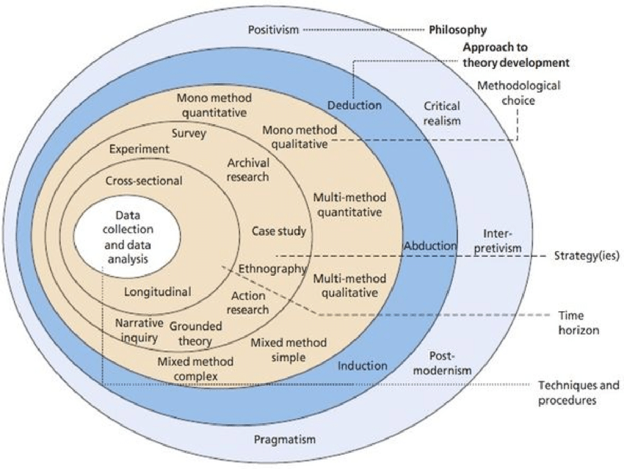Research Onion, Saunders et al., (2016).
Image above from researchgate.net

The deductive theory indicates the standard display of relations connections in relation to this research theory. Which is typically discovered in quantitative research. Additionally, quantitative research has often been described its use for attaining required data collection and displaying a transparent connection between research and result (Bryman and Bell,. 2011). Furthermore, for this quantitative research, a deductive research approach was applied to test the two vital questions steered by deduction from existing literature. By applying a deductive approach, as well as testing them in comparison with empirical observation, and studying them more so than before with an interpretive approach (Hammond and Wellington, 2013). Which was deemed appropriate for this study.

Methodology Research Choice and Strategy:
The key vital elements to all research study are the projects design in conjunction with strategy-selection for the appropriate methodology, which is viewed as a vital strategic decision. (Crowther and Lancaster, 2008). Furthermore, a researcher’s main choices for orchestrating any academic research are quantitative, qualitative, (already mentioned earlier) and mixed methods (Saunders et al., 2016). And all require taking on-board the variety of factors, that must be taken-into-account, this includes the research’s purpose and also includes the sort of data included, in determining the trio of standard approaches (Mathews and Ross, 2010). A quantitative online survey questionnaire methodology is applied in this study.
Furthermore, it is this method that has interconnections with research projects which involves surveys with experimental research (Saunders et al., 2016). And it is this type of method which is applied mostly for the collection of data for any business management research studies. In addition, online survey studies (certainly in more recent times) has frequently been applied by various scholars e.g., Zhan and He., (2012), Park and Huang (2017), and Rees et al., (2019) for the investigation to various dynamics of consumer buying behaviours. Additionally, quantitative research methodology is formed through a statistical, mathematical approach to all research projects design. However, qualitative research methodology highlights the behaviour and experiences determined by thought systems. In conclusion, the methodology known as mixed methods, this research connects both qualitative and quantitative components. Mixed method researchers gather data, for both numerical and non-numerical purpose, for cases that require a combination of the two methods which furnish the potential to a more complexed research project with the speed of attaining the objectives set out (Newby, 2014).
The deductive approach, involves testing a hypothesis along-side data or literature, is more standardly applied to quantitative research (Bryman and Bell, 2011). The high quality of quantitative method is at its capacity for appropriate generalisation, which constitutes to its reliability and justifiability as a measurement tool in various situations (Salkind 2017). The utilisation of the quantitative method is certainly a fitting strategy for this empirical study. This will furnish researchers to attain a mass of organised data from a wide range of respondents namely students and lecturers who are themselves consumers from a broad base of countries based on an online survey.
Due to lockdown being lifted and students being advised to commence their student task-work via online through the teams app, or if they see fit to return to class for their studies these respondents were selected as the target group for the survey in question, which was deemed time and cost-effective. This allowed the researcher time to collect potentially useful, original extensive data from a diversified selection of data from various participants with speed.
In addition, a quantitative online survey methodology is applied to this study (as already mentioned earlier). Furthermore, according to Salkind (2017), a research survey study attempts to find and understand the relevant frequency and relations that connects psychological, sociological, and the variables that combine the two. It also takes-into account the different variables, e.g., people, opinions, beliefs, attitudes, and the greater alternatives of one over another. This research is focussed to analyse the effects of the strategic of consumer purchasing behaviours within the global context. This empirical study test earlier anticipated results and endeavours to highlight the effects of how technology has impacted consumer purchasing behaviour before and during the time of COVID-19. Additionally, if the survey questionnaire are questions such as ‘Where?’ ‘When?’ ‘How’ or ‘What’, the survey is then deemed an appropriate strategy. Data can then be gathered for the purpose of the research from a self-completion questionnaire. This will entail an online survey managed through Google Forms. A well-structured and uncostly process of information can hastily be retrieved through this online survey (Bell and Walters, 2014). Furthermore, this tool is absolutely free, accompanied by an ease of access and use, this web-based survey tool by Google Forms was utilised for this research.

Data Source and Collection:
A vital characteristic of research projects design is the way in which strategy is applied to its highest-quality to capture data, which is appropriate, meaningful, and relevant, for the purpose of the study. Furthermore, the techniques implemented for the collection of data is decisive to enable the objectives of the research to be put-together (Adams et al., 2007). In addition, the study’s multitude of central importance’s have a significant effect on the selection of the relevant methods for the collection of data including the best arrangements for the analysis. The details and variables necessary for the information will crucially affect the decision making (Saunders, et al., 2016). This present research (as I have already mentioned) uses quantitative measures for the collection of data as well as analysis which is deemed suitable for the study’s objectives. So, for the collection of all required data, a web-based survey will be administered to discover the effects of the strategic orientation of consumer purchasing behaviour, with the use of technology and how it has impacted consumer behaviour during the period of COVID-19, and times previously.
The researcher has collected the required data from individual respondents based at the University of Wales Trinity Saint David, London Campus. Applying the cross-sectional time horizon and using Google Forms (as already mentioned) was applied for the collection of primary data, this method was preferred over others due to the COVID-19 pandemic circumstances, which saw other methods for the collection of data too challenging. So as a result, the web-based survey tool was used jointly with a questionnaire consisting of various questions has been constructed for the collection of high-quality data to achieve the accomplishment of what the researcher objectives set out to achieve. However, to formulate the online survey and to produce something which was undemanding for respondents all were asked the same questions with additional multiple choice question answers. However, some respondents may not have answered all questions set out in the survey, e.g., (Question 10. What was your payment methods for goods and services online) the choices were:
Apple pay, Google Pay, Credit card, Debit card, Amazon pay, or Crypto currency.
This left respondents without the choice of paying by cash for services due to the conditions of lockdown, set out by Government, and their advice of paying for goods and services with cards, or by phone with card apps only during this period of time. However, the use of this online service tool demonstrated individuals keen participation which empowered data collection efficiency.

Sampling:
The selection of a suitable sample in which to demonstrates the requirements to a wider audience is called sampling (Adams et al., 2007). For the researcher sampling strategy authoritatively dictates the projects viability and how useful it is, which is also viewed as one of the most significant components to any research project strategy (Cohen, et al., 2011). Additionally, various vital dimensions of sampling, e.g., sample method, and sample size, may also be taken-into consideration to establish academic research. The researcher must also establish the sample size has statistical value to enable the quality of being trustworthy. All respondents aged between (16-25) through to (66+) were considered for this particular research survey questionnaire as the target population and analysis. Additional other possibilities approaches to sampling is Snowball sampling, this is also known as network or respondent-driven sampling, which also featured in this research project. At the out-set the researcher spoke with all students, about them bringing on-board their friends, family, work colleagues, and other known associates who maybe willing to participate in the research project, this also included all respondents to post the survey on social media. All data sources for instance all (men and women over the age of 18) had an equivalent probability in the selection process to the sample in view of this method. This type of process encompasses a suitable manner in which to track connectivity (Bryman and Bell, 2011). Other researchers that have followed this process are: Goodman, (1961), Coleman, (1958) Wang and Song., (2003), Teh et al., (2019), and Dewi et al., (2020) they have all adopted these sampling methods in earlier research studies.

Sampling size:
The intended number of respondents for this particular research was 100 participants, however, the actual completed survey number stands at 58 respondents that participated in the online research project. Which amounted to being over the midway point, due to the complexity of the survey in terms of the number of questions and the time spent to finalise them. The main reason for the midway response may have been due to the scarcity of respondents attending class on that particular day, the research had taken place, however, all student respondents were sent an e-mail to take-part but on the actual day in-question there seemed to be a computer glitch which meant not all respondents received the questionnaire, however, 90% of respondents that the researcher spoke with did complete the survey questionnaire. In the survey, all participants received the same treatment throughout the process, responding to the same survey questionnaire without distinction by gender, age, or education level.

Data Analysis:
The validity of the survey was pilot tested through an experimental paper-based test to enable the survey to be refined enough, allowing for the comprehensiveness for all participants concerned. The pilot test involved 10 colleagues including some friends which supplied vital feedback of the potential imperfections of the survey. Furthermore, these particular answers were removed from the final results. The survey was developed via Google forms, (already mentioned earlier) which is an electronic survey platform. Google forms has allowed the researcher to personalize the survey to fit the requirements of this study.

Ethics:
This research has observed the strict guidelines of the University of Wales Trinity Saint David (UWTSD) London campus, with respect to all conditions such as informing the participants about the objective of the project, requesting a full agreement of the participants, explaining the content of the research and giving the respondents the right to withdrawal at any given moment. According to Saunders et al., (2019) all universities have developed their own ethics committees to make sure that the research conducted is not presenting any risk to the participants involved. Furthermore, all-through the development of this dissertation, the supervisor has revised the survey and ensured that it would not pose any risk to the respondents. In order to make the research liable, the survey informed participants about the name of the researcher, name of the university, name of the supervisor and the subject under research. It was also provided with the DBS standards of data protection e.g. “The data you provide as part of this study will be fully anonymous. I will not gather any direct personally identifying information about you”. The researcher has minimized data, requesting only the necessary information. The data collected in the survey has not asked for names or personal email addresses and the participants were all above 18 years old which enabled them to provide consent before answering the survey. Furthermore, the data protection together with an introductory explanation was sent to each individual. None of the questions in the survey required any private information that could damage the dignity of the participants.

Research Methodology Conclusion:
The research methodology design of the study was formulated for this chapter for the main purpose of this particular study. Hence, the researcher went into details of each methodological step taken to answer the research questions. For this research it was decided to follow a realism philosophy together with some insights from positivist philosophy, such as the quantitative approach. These philosophies have been chosen because they take-into consideration significant variables that can be used when observing consumer behaviour. In addition, the researcher has also opted for a deductive approach and adopted a quantitative design to conduct the study with a cross-sectional time horizon. This design was chosen due to time limitations encountered during the development of the study, but also because the researcher aimed to do a non-experimental observation of the primary research question.
In particular, this chapter highlights the main takeaways used in the elaboration of the survey, such as the measures used to assess changes in consumer behaviour before and during COVID-19. The chapter has also described the population sampling of the survey which counts 27 questions and 58 respondents from a multitude of age ranges and levels of education. Nonetheless, the population sample specifies a target age of young adults, considered as generation Z (16-25) and millennials (26- 35). When the survey was sent out, it took a few days to gather all the information from the respondents. The data collected from the participants was statistically analysed to provide a proper interpretation of the results and thus lead to a comprehensive understanding of the primary research question. In addition, the researcher followed all ethical considerations designed by the University of Wales Trinity Saint David to ensure the safety and legal obligations of all respondents concerned.

Introduction:
In this section, the key factors relating to the main research question are explained. And in addition, the interpretation of the connection between the research survey questionnaire of all respondents. The results section consists of a combination of tables and graphs that provide insights on how respondents answered the results of the questionnaire. In the questionnaire, the aim was to gain an understanding into how technology has impacted consumer behaviour during the COVID-19 pandemic. More significantly, the questionnaire was used to determine how the effects of consumer behaviour had been enhanced by the increased use of technology during the times of COVID-19. Furthermore, to address these questions effectively, a questionnaire survey was created which involved 27 questions covering consumer behaviour changes before and during the outbreak of COVID-19.
At the outset the questionnaire was sent out to all students based at (UWTSD) London campus, In the hope of achieving 100 candidates, however, as explained earlier there was a computer glitch on that particular day, so not all student respondents received the questionnaire, however, students that attended the University on the day, that the researcher spoke with many, did take-part in the study. The respondents that finally took part were 58 that did manage to mostly complete the survey questionnaire on time to be included in the data analysis (representing almost a 60% response rate). The questionnaire consists of mostly closed questions and a few open-ended questions. The open-ended questions were analyzed by categorizing the responses and grouping similarly themed answers, even though they may been worded some-what differently.
In order to gather insights and present the results as effectively as possible, a descriptive analysis method was applied to summarize the main findings of the data in an understandable 69 form. Inferential statistics were not used for this analysis because this research used a small sample size at a point in time and in a constantly changing situation. This is a recognized limitation for this research, but acceptable and acknowledged given the limited time frame involved. The analyzed and presented data in this section was used for interpretation and for discussion of the results in the subsequent sections. In addition, these results assisted to create a valuable conclusion and recommendations in-regard to how technology has impacted consumer behaviour during the COVID-19 pandemic.

Results:
The following section will focus on the results of the data collected through the quantitative design. Additionally, this section will also highlight the key factors of the data analysis and explain the findings in relation to the primary research questions. In addition, the tables and graphs were added to understand the results.

Results of the Survey Questionnaire:

As can be seen below are the survey questionnaire results conducted that were taken from 57 respondent students in relation to age.

The age of respondents was a key factor for this research, due to the primary focus on receiving in-put, from respondents who are millennials or from Xennials and the Gen Z category. Encompassed within these generations, were the greater number of changes to consumer behaviour, which was therefore compelling to carry-out research on. In view of all 58 respondents that took part the majority of (26-35) year old bracket, who are all considered to be “millennials” who equated for 38.6% of respondents. Furthermore, the second highest bracket came from respondents aged between (36-45) namely Xennials, equated to 29.8% of respondents, the third highest came from the ages between (16-25) who are labelled the Gen Z category, who equated for 21.1% of respondents, and in fourth place not surprising were the (46-55) year olds namely Generation X, who equated for 8.8% of respondents. The results of the age distribution among respondents of the questionnaire can be seen below.

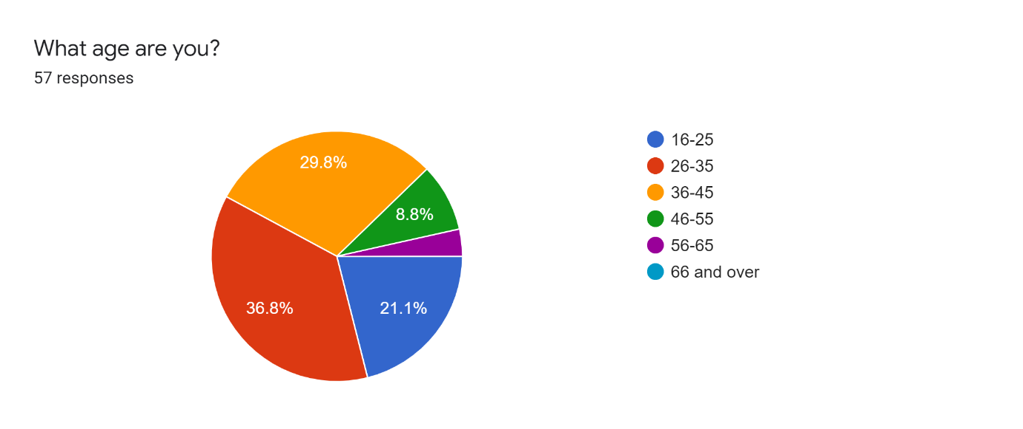

As can be seen below are the survey questionnaire results conducted that were taken from 55 respondent students on education levels.

The highest levels of education was also required in the research of this study which witnessed how consumers of various levels of education have experienced the effects of how technology has impacted consumer behaviour during the COVID-19 pandemic, and to what effect this had on consumer purchasing behaviour. Out of all the respondents that answered there were five category’s which produced 55 responses, however, only the top three will take precedence by respondents, in first place was Higher education level 5/6, this equated for 40% of the result, in second place was the college degree with a 29.1% result, in third place was school A or O level which came in with a 14.5% result, with an overall result of 83.6% who have been educated. The distribution among respondents can be seen in the pie chart below.

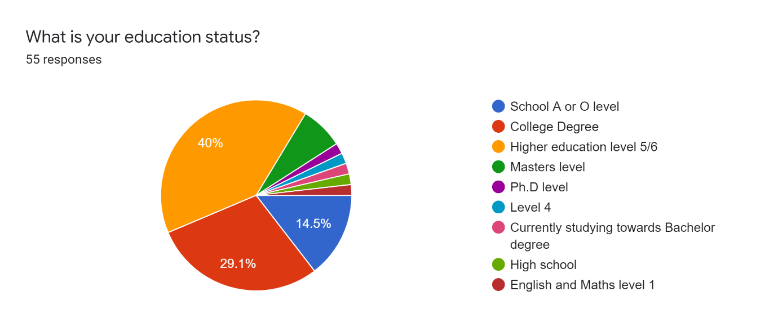

As can be seen below are the survey questionnaire results conducted that were taken from 57 respondent students in view of their marriage status.

In this study the researcher deemed significant for such questions that will help to broaden the knowledge about each individual and their status. Such survey questions are often used by researchers to gain an understanding into the types of individuals that have taken-part in the survey. However, 38.6% of respondents were married which was the highest stat, the second highest was single individuals at 36.8% and the third highest was individuals that were cohabiting at 14%. The distribution among respondents can be seen in the pie chart below.

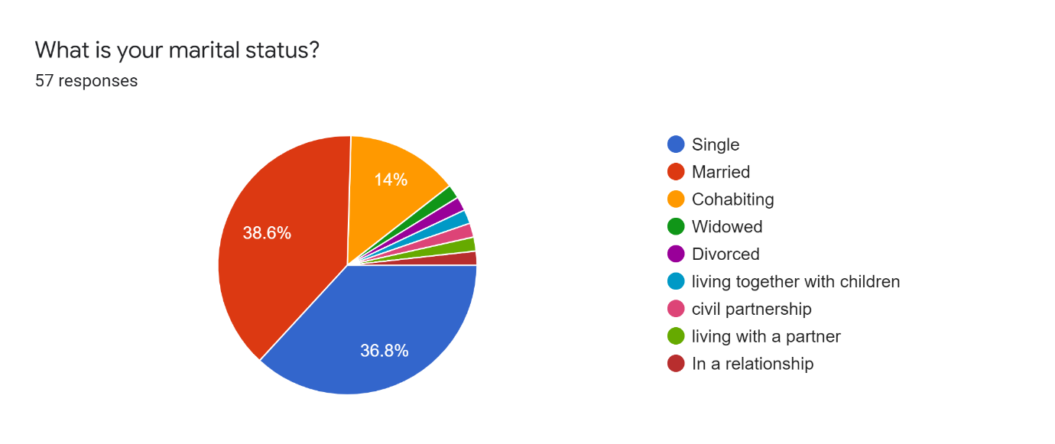

As can be seen below are the results in a graph view of the types of property respondents reside types.

For the researcher this was deemed significant to help gauge the types of individuals that reside in certain properties which coupled with income levels would help to assist and give a broader picture of the type of individuals that reside in them. Individuals that live rented houses, their statistics were 32% which was first, individuals that reside in rented flats, statistics reveal that 15% of respondents reside in them, and 6% of respondents reside in purchased houses, and 1% of respondents live with parents. The distribution among respondents can be seen in the graph below.

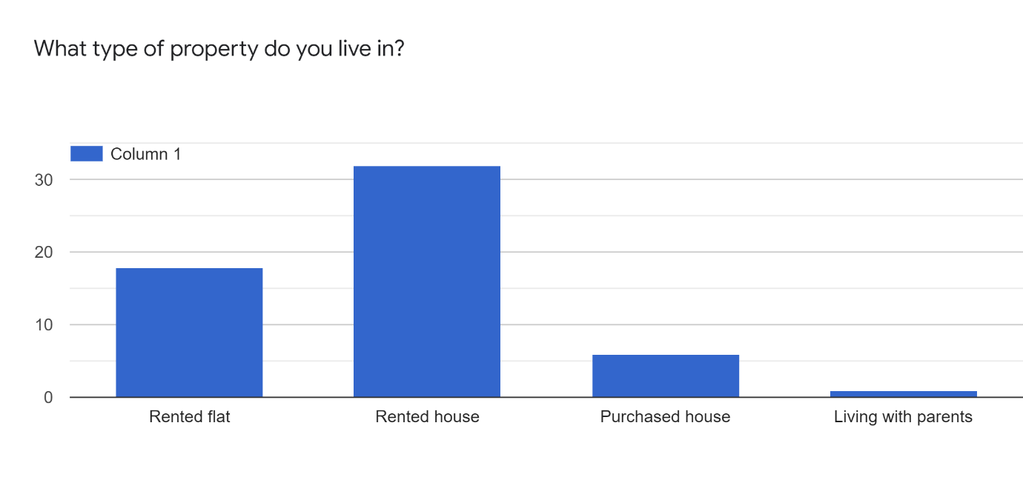

As can be seen below are the income levels of all respondents.

Income survey questions assist researchers to determine the factors that can influence the choice of respondents and also assists the understanding of the financial status of individuals. Income survey questions are one of the most important demographic survey question required in surveys for segmenting the audience and analyse the data with accuracy. Respondents with income levels of between £20,000 to £25,000, were the highest at 29%. Other, was in second place with 15%. In third place was £30,000 to £40,000, at 10%, £50,000 to £60,000 was the lowest figure at 3%. The distribution among respondents can be seen in the graph below.

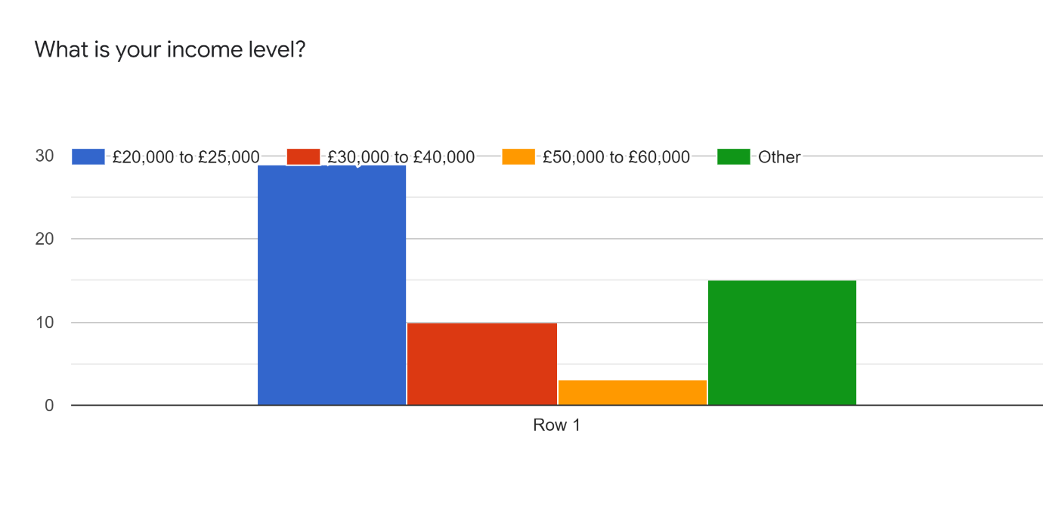

As can be seen below are 57 respondents that shop online.

This question was certainly required for the questionnaire, to enable the researcher to gauge and connect those individuals that purchase online, which links technology to the main research question, and also with how many respondents do actually purchase goods online. In view of this question 80% of respondents do purchase goods online. 7% of respondents voted (maybe) and 7% of respondents voted (No). The distribution among respondents can be seen in the pie chart below.

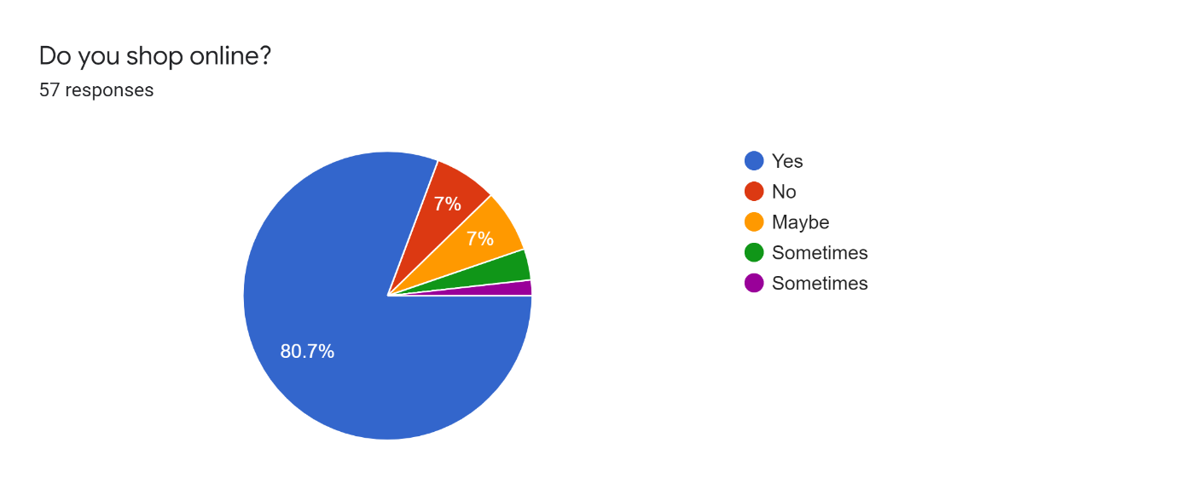

Represented in the graph below are the types of purchases that respondents prefer, in relation to consumer behaviour.

Below is the graph that represents what type of purchase respondents prefer, the respondents had three choices for this question online, in-store or other. 32% of respondents liked to purchase goods from the store, however, 31% of respondents preferred to purchase goods online, and 2% of respondents preferred to other, further for this score the researcher related this to spending cash in markets for instance. The distribution among respondents can be seen in the graph below.

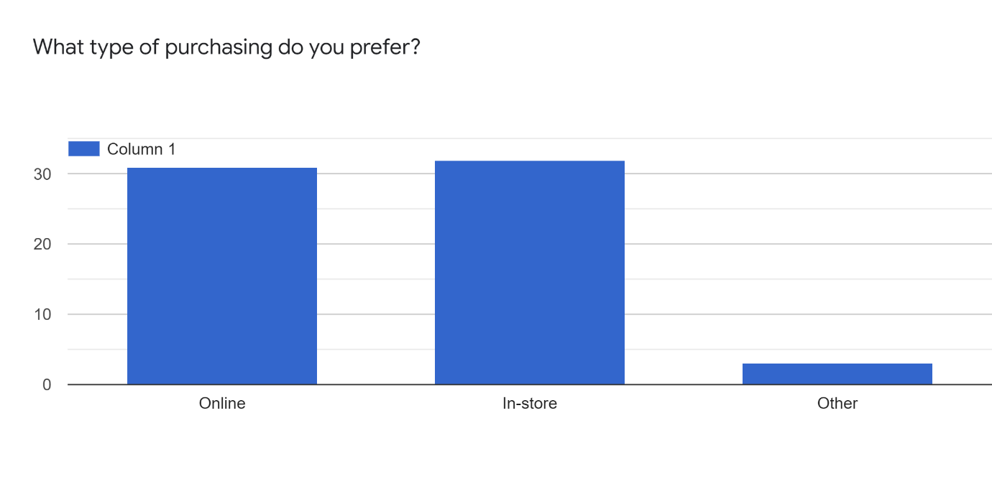

Represented in the graph below are the types of products and services respondents purchased online.

This question was deemed significant because it gives an understanding to what goods or services respondents purchased online. Clothing came out on top here with a 36% result, second was electronic goods, with 26%, next was sports-ware with 21%, following that was home entertainment at 20%, the food result was 19% similar too was other at 19%. The distribution among respondents can be seen in the graph below.

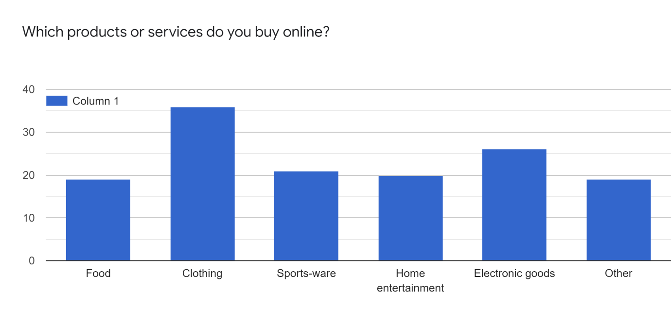

Represented in the graph below are the results of how respondents found purchasing goods online during the period of COVID-19.

This question was more related to the older respondents, such as the xennials to gauge an understanding on whether they were up to date on their computer literacy, and if they felt confident enough in using new technologies such as computers etc. However, 49% of respondents did find purchasing goods online during COVID-19 easy. 5% of respondents found purchasing goods online during this time challenging. 2% of respondents found it complicated, and 1% found it very complicated. The distribution among respondents can be seen in the graph below.

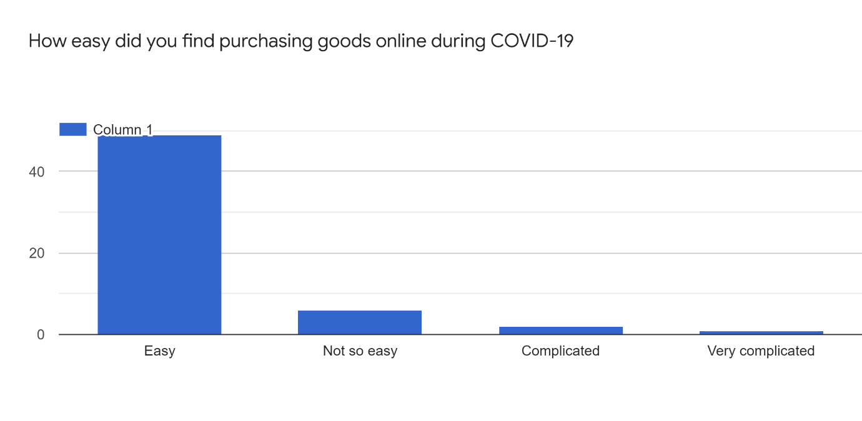

Represented in the graph below are the results of what goods and services respondents purchased mostly pre- COVID-19.

In view of identifying the impact of technology on consumer behaviour during the times of the pandemic, research was required to assess the behaviour of consumers in (pre-pandemic times) for both online as well as brick and mortar-stores. Hence respondents were asked their preference was to spend in brick and mortar-stores, or online. 30.2% of respondents preferred to shop in brick and mortar-stores, which came in at first place. In at second place was online-shopping and that came in at 30.1%. It was also significant to ask the question, in the questionnaire of (Other) which the researcher has related to cash purchases, which gives a figure of 3%. The distribution among respondents can be seen in the graph below.

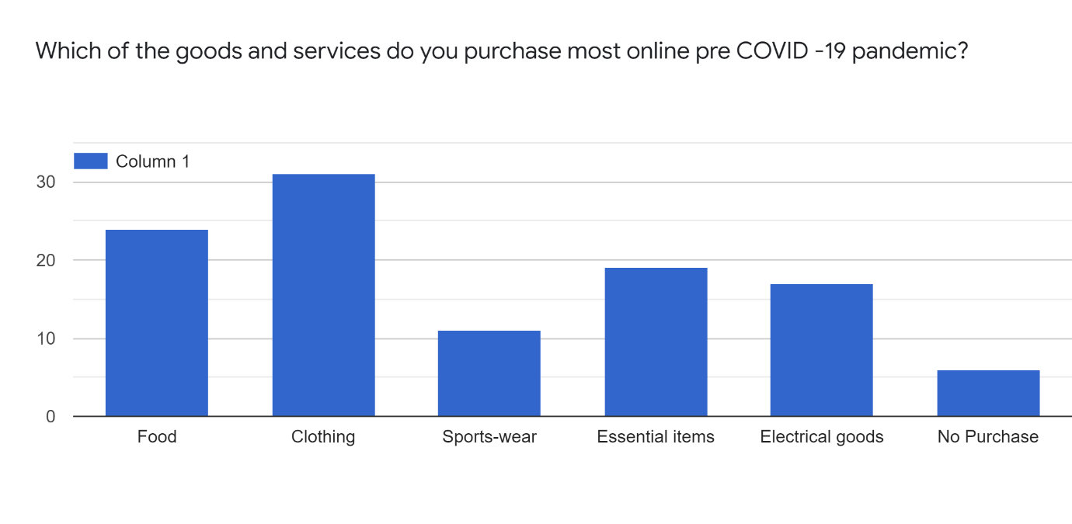

Represented in the graph below are the results of what devices respondents used mostly to purchase goods.

This question in the survey also represented another technology question to establish whether respondents used a particular type of devise to purchase their goods with. 45% of respondents used a mobile to purchase their goods. 19% of respondents used a laptop to purchase their goods. 1% of respondents used a desktop computer to purchase their goods, and 3% of respondents used a tablet to purchase their goods. This demonstrates the types of technology used for the purchasing of goods. The distribution among respondents can be seen in the graph below.

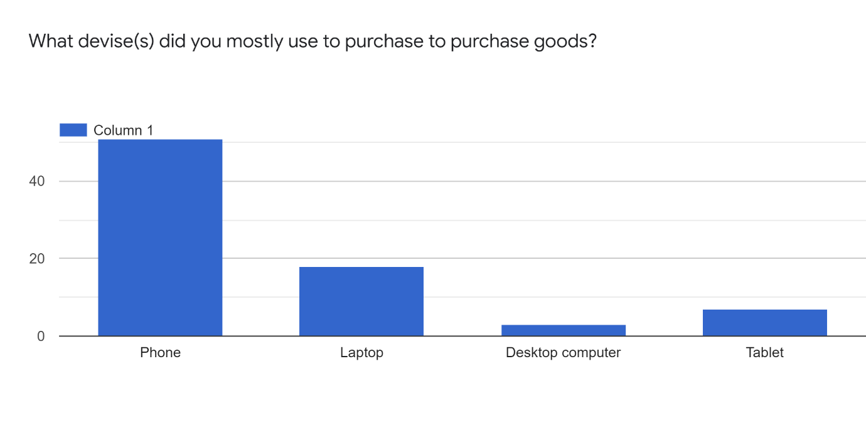

Represented in the graph are the payment methods used by respondents to pay for goods and services.

During lockdown it was advised by Government to pay for goods and services by other means in-stead of cash, this was to reduce the risk of infection from COVID-19, so in the questionnaire the researcher asked respondents to answer questions on how they payed for their goods. 40% of respondents payed by debit card, 19% of respondents payed by credit card, 18% of respondents payed by Apple pay,1% of respodents payed by Amazon pay, and 2% of respondents payed with Crypto currency. This demonstrates how these organisations apply their technologies so consumers can utilise their touch points to pay for goods and services. The distribution among respondents can be seen in the graph below.

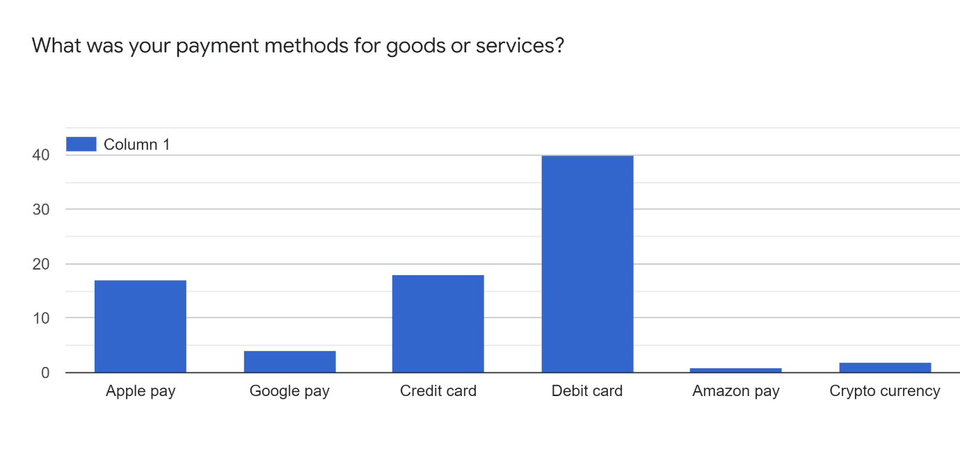

Represented below are the shopping purchases of respondents during the time of COVID-19.

During lockdown as already mentioned above individuals were advised to make their shopping purchases by card, in-stead of cash, however, there were a few selected places such as markets, news agents, and others that still accepted payments for goods or services with cash, so this question was asked to gather information from respondents. What the statistics have shown are that 24% of respondents purchased online only, 25% of respondents paid for their purchases by cash, 10% of respondents paid by other means, 8% of respondents voted for N/A, 2% of respondents were able to spend cash in news agents, and 3% of respondents spent cash through means of private sales. The distribution among respondents can be seen in the graph below.

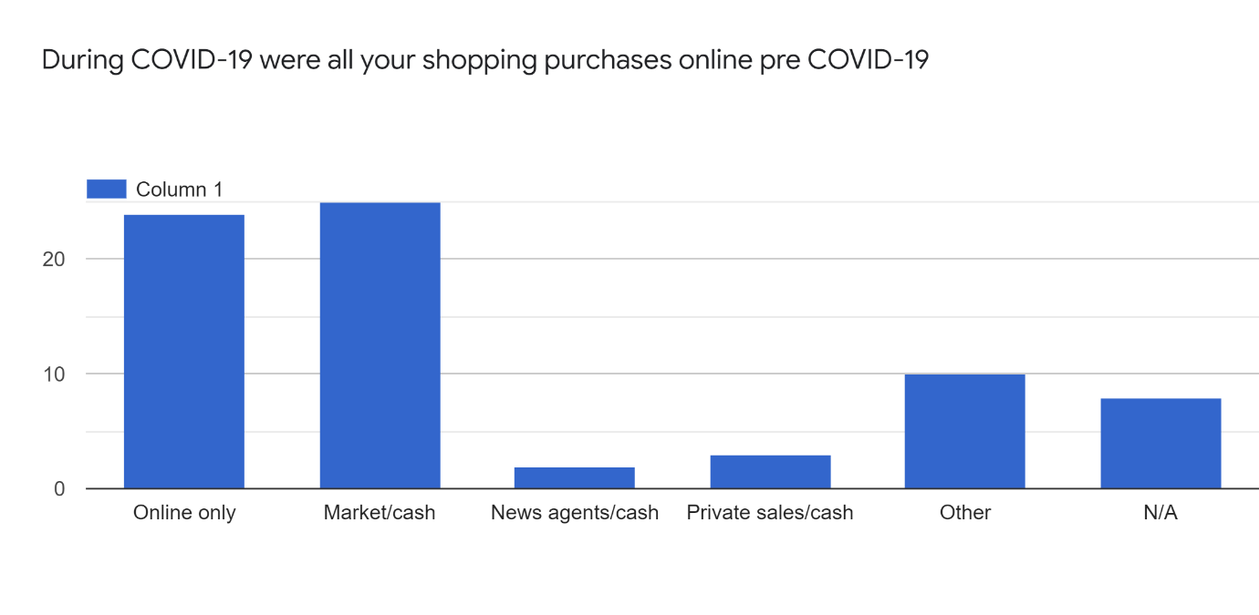

Represented below are how frequent respondents shopping purchase were pre- COVID-19

It was significant to note that respondents were specifically asked to consider their purchasing habits before COVID-19. This question was asked to gain an understanding into what these measures were. And from the statistics we can see that, 28% of respondents purchased their goods weekly, 10% of respondents purchased their goods every two weeks, 10% of respondents purchased their goods on a monthly basis, 8% of respondents purchased on a daily basis, and 6% purchased on a monthly basis. The distribution among respondents can be seen in the graph below.

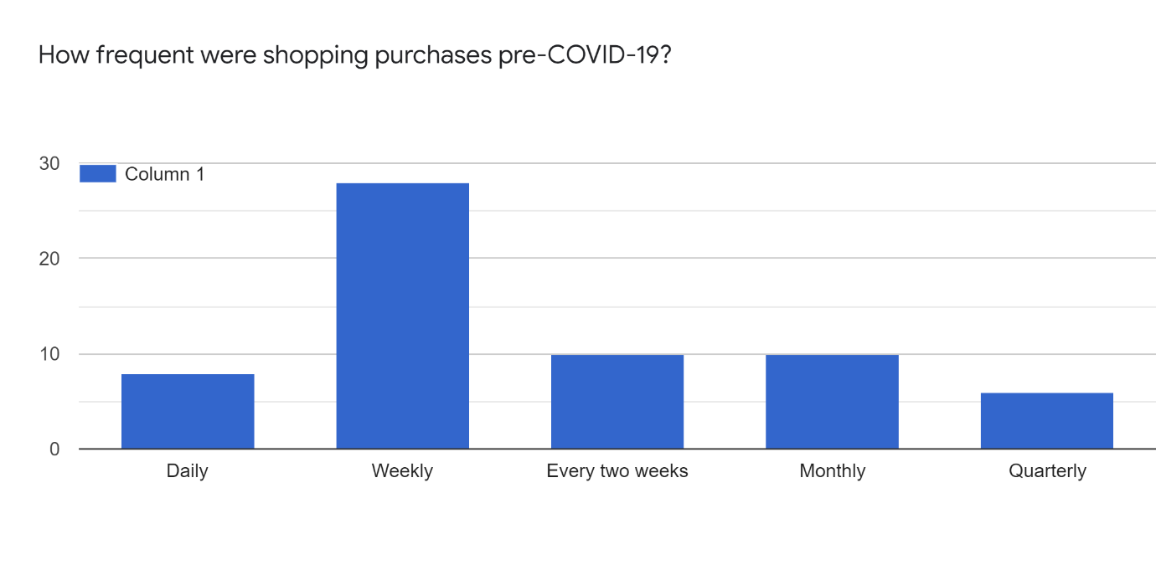

Represented below is a graph that shows if respondents continued to use their online shops during the period of COVID-19.

This closed ended question was asked to establish if respondents had discovered new online retail outlets or stores during the time of lockdown, because many retailers during this period, and main focus of attention was trying to seek new consumers due to the heavy traffic of online consumers who purchased goods during this period. Furthermore, what the statistics have shown are that 51% of respondents have voted yes, and 3% of respondents have voted no. The distribution among respondents can be seen in the graph below.

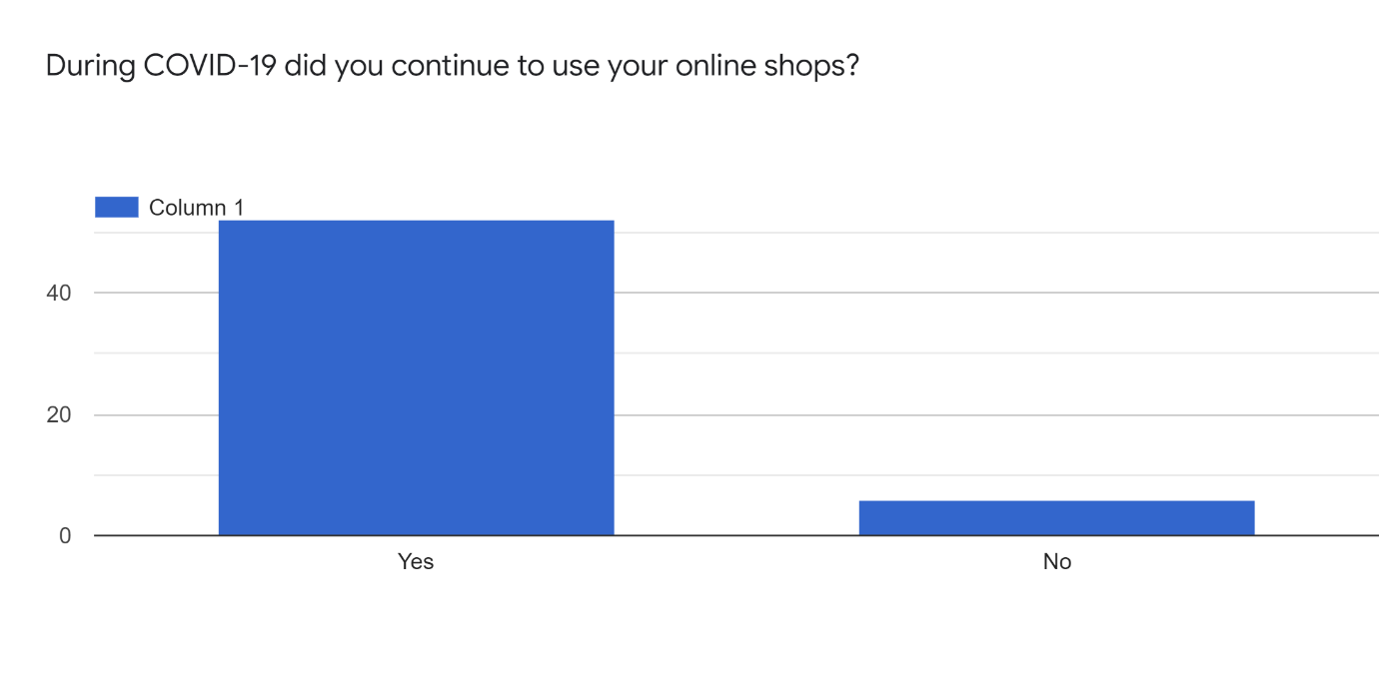

Represented in the graph below is how much time respondents spend searching for goods and products online.
These questions were asked to gain an understanding into how long individuals spent searching for goods and products online, in-view of the lockdown period many individuals found themselves with a lot of spare time on the internet. As we can see below 20% of respondents spent 20-30 minute’s searching for products online, 18% of respondents spent 30- minute’s, to an hour searching online for products, 15% spent 10-20 minute’s online searching for products, 7% of respondents spent 2 and half hours searching for products online, and 2% voted other. The distribution among respondents can be seen in the graph below.

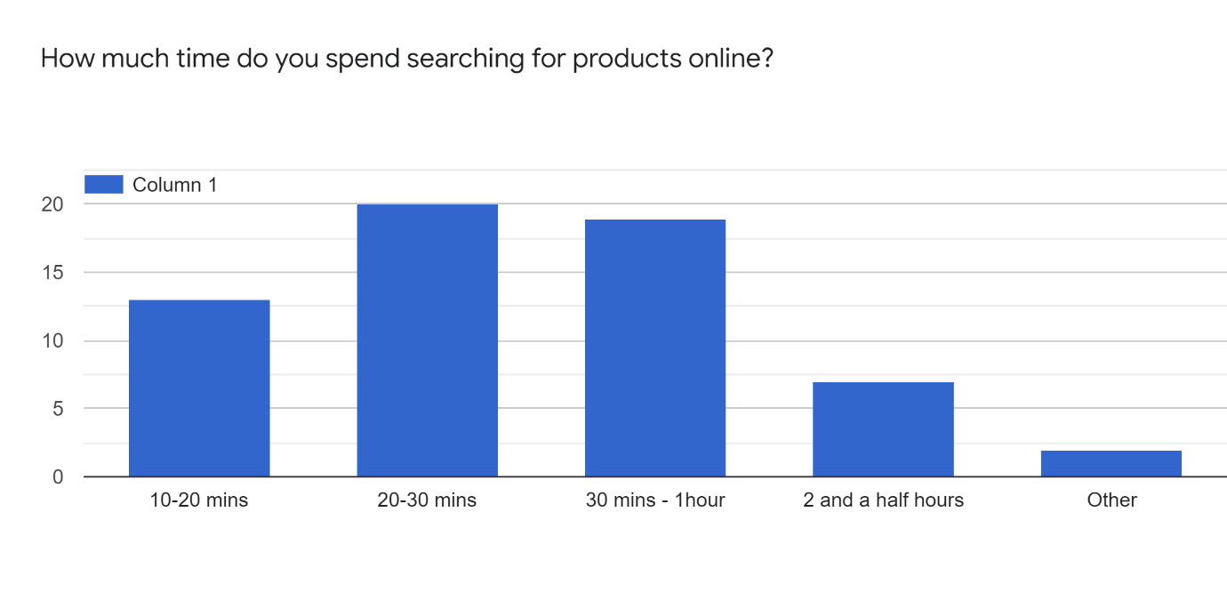

Represented in the graph below are the comparisons of respondents who compare prices of products online.

This question was considered because consumers want to easily compare products by price, reviews, and features and have become more discerning in the product selection process. For almost all product categories, consumers prefer to shop online for a greater variety. As we can see below 49% of respondents voted yes, and 8% voted no to. The distribution among respondents can be seen in the graph below.

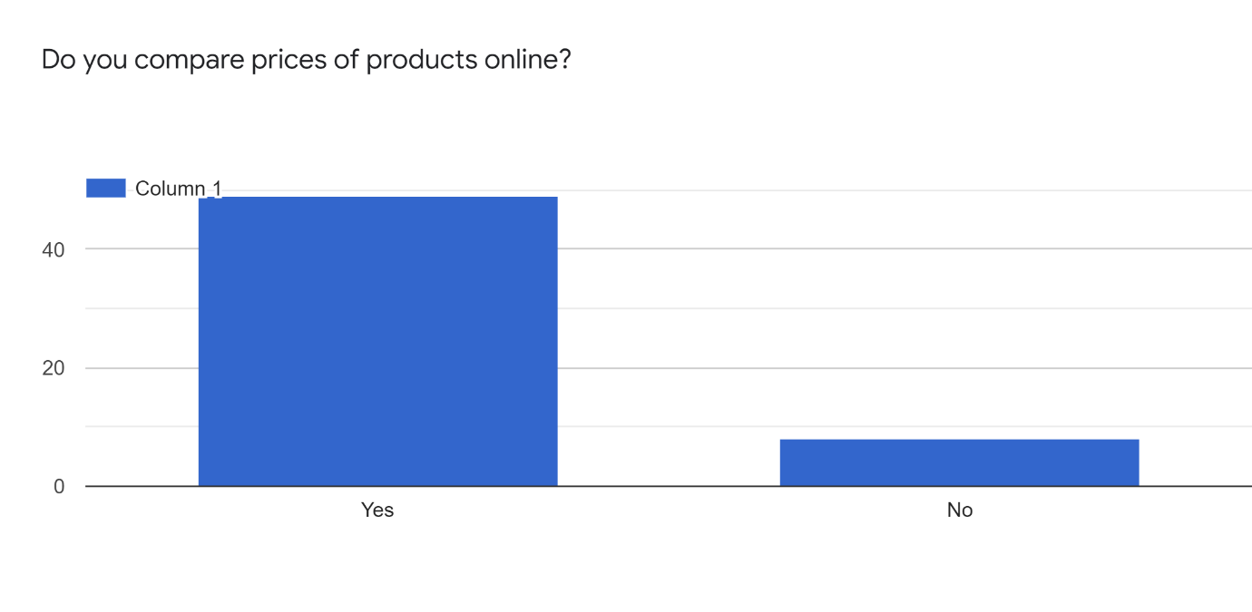

Represented in the graph relates to respondents who found a better shopping experience online.

This question was asked because retailers are indicating through huge spending on technology, that online shopping is around for the long-haul and linked to this technology enabled purchasing is a new way forward from the standard brick and mortar stores. As we can see below 41% of respondents voted yes in discovering a better shopping experience online, and 16% voted no. The distribution among respondents can be seen in the graph below.

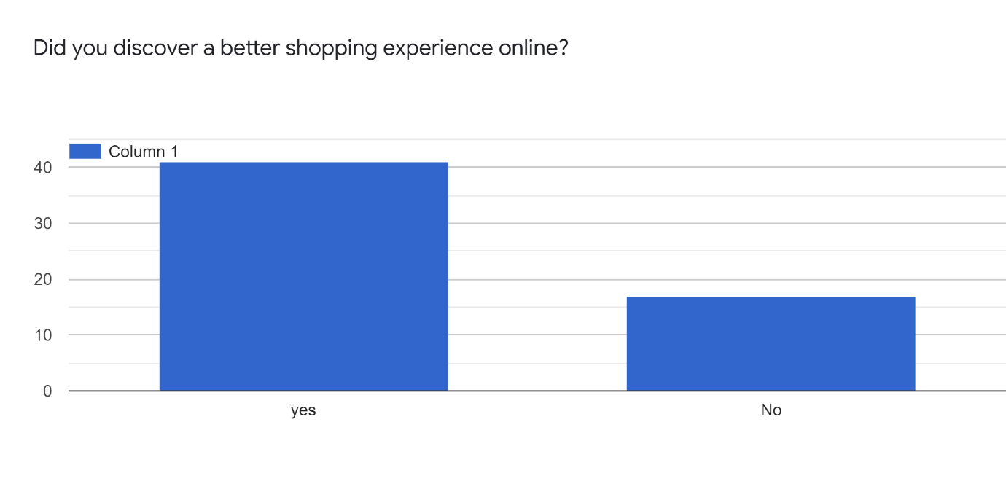

Represented in the graph below are the average spendings by respondents online pre- COVID-19.

This question was asked to gain an understanding into what consumers are spending on average monthly before the start of COVID-19. As we can see 36% of respondents spend between £100 to £200, also 7% of respondents spend between £500-£1000 a month, 1% of respondents spend £2000-£2,500 a month, and 14% voted for other. The distribution among respondents can be seen in the graph below.

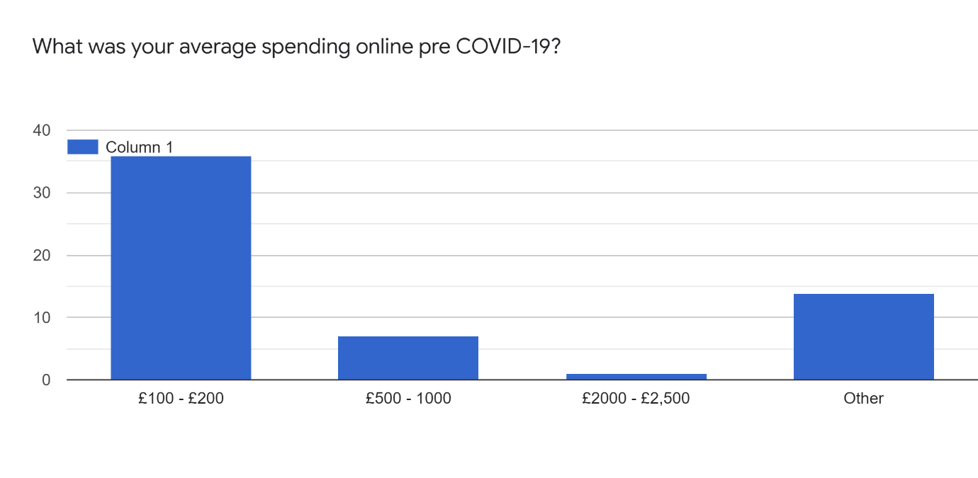

Represented in the graph below are the average spendings by respondents online during COVID-19.

This question was asked to gain an understanding if spending had differed from times during COVID 19 and as indicated in the graph below we can see that 39% of respondents spent between a £100-£200, in this period. 16% spent £500-£1000, in the same period, 2% spent between £2000-£2,500, and 12% of respondents spent on other. The increase in spending for respondents that spent in the £2000-£2,500 range maybe due to the higher earners having extra cashflow due to being off-work because of furlough. The distribution among respondents can be seen in the graph below.

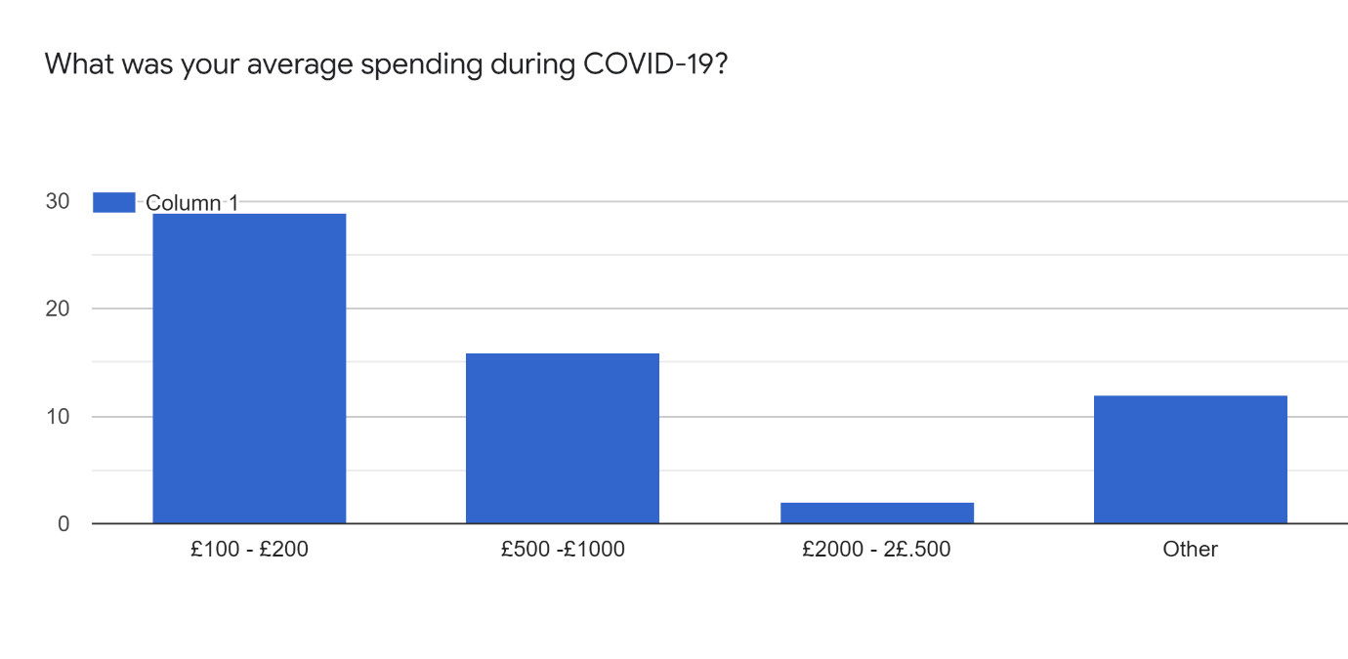

Represented below in the graph are the challenges respondents faced purchasing goods or services online.

This question was to gain an understanding if respondents faced challenges making purchases online, this question by the researcher was aimed more at the Xennials, that may not be up to speed with technology, as we see below, 31% of respondents voted yes, 27% of respondents voted no, and 1% voted never.

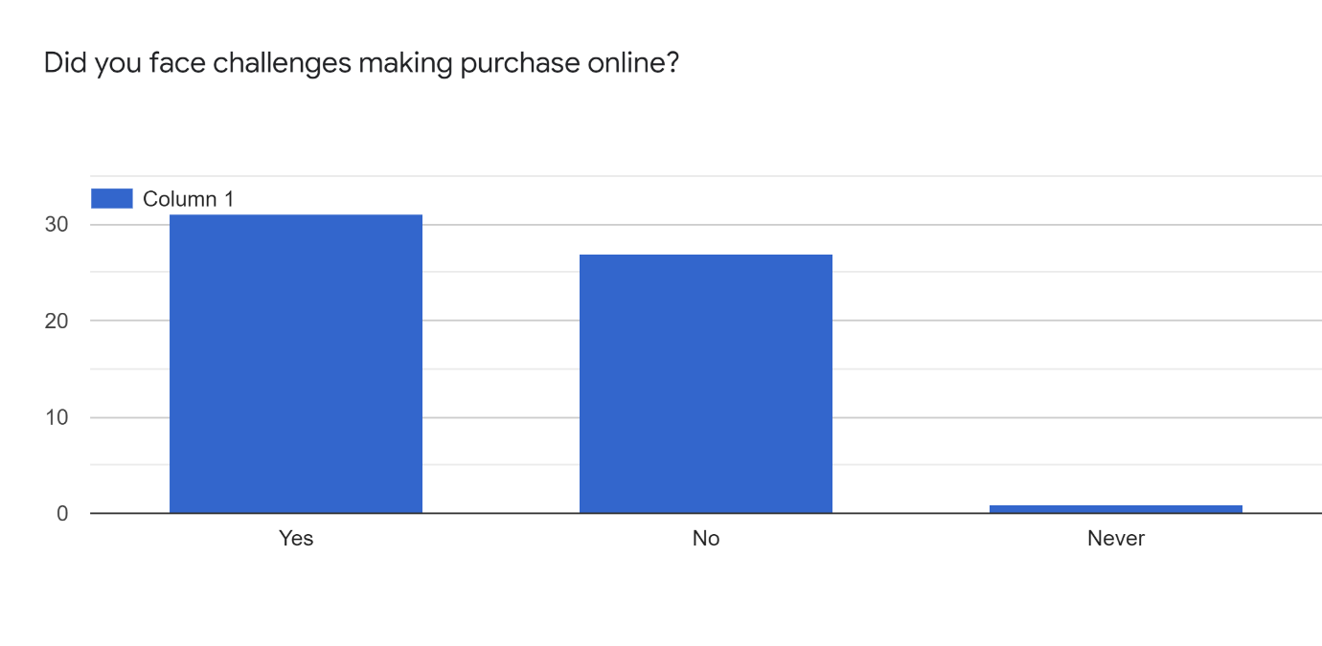

Represented below in the graph are the challenges respondents did encounter.

As we can see below the challenges faced by respondents were long delivery times at 21%, items not delivered at 16%, damaged items at 8%, and other at11%. For long delivery times, this may have been due to the high increase in online shopping volume for purchasers, that forced pressure on delivery firms to meet deadlines for deliveries but due to the increased volume may have found them extremely challenging during the period of COVID-19. The distribution among respondents can be seen in the graph below.

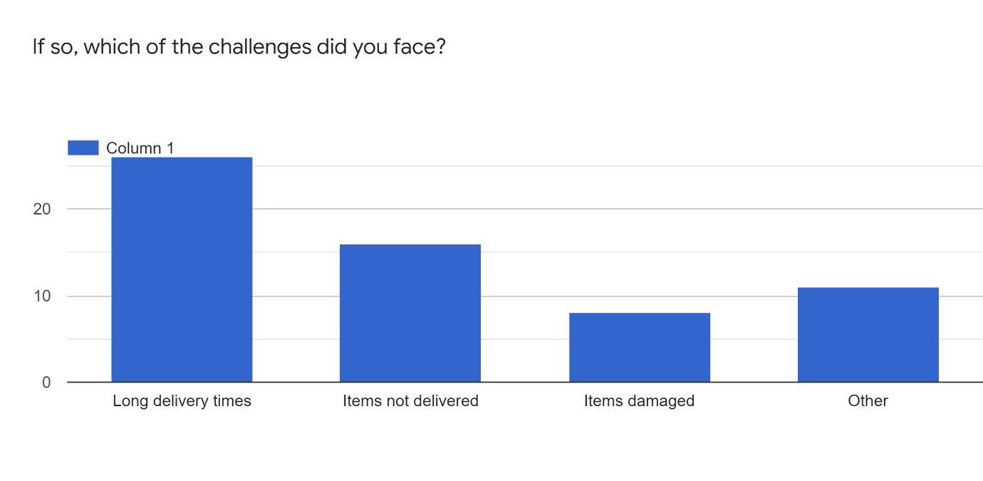

Represented in the graph below are the results of respondents who preferred working remotely.

This question was asked due to lockdown and Individuals who were allowed to work remotely and not the office, because of government stay at home policy. So, this question was deemed relevant, to gauge an understanding of who preferred to work remotely. As we can see below in the results that, 31% of respondents preferred to work remotely, however, 30% of respondents voted no to this question and 6% voted never. The distribution among respondents can be seen in the graph below.

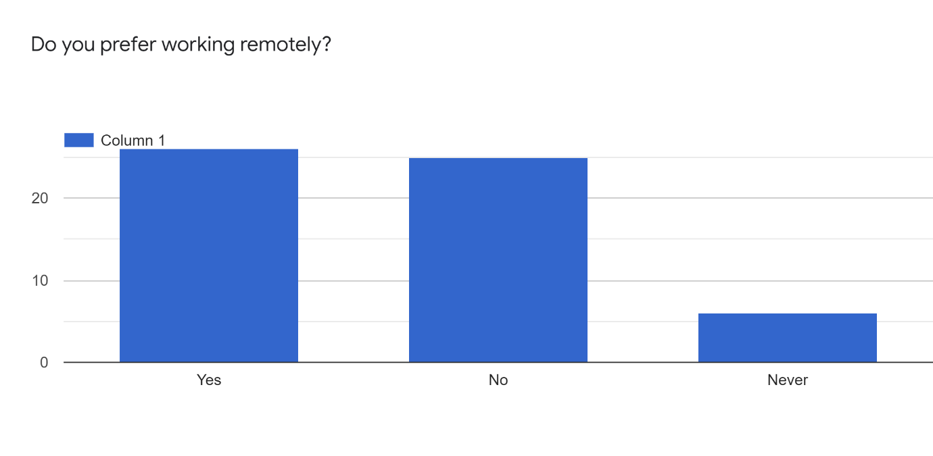

Represented in the graph below relates to respondents that like to work in the office online.

This question as you can appreciate is connected to the question above, and as we can see the results are, 31% of respondents voted yes to working in the office, 19% of respondents voted no, to working in the office, and 9% of respondents voted other. The distribution among respondents can be seen in the graph below.

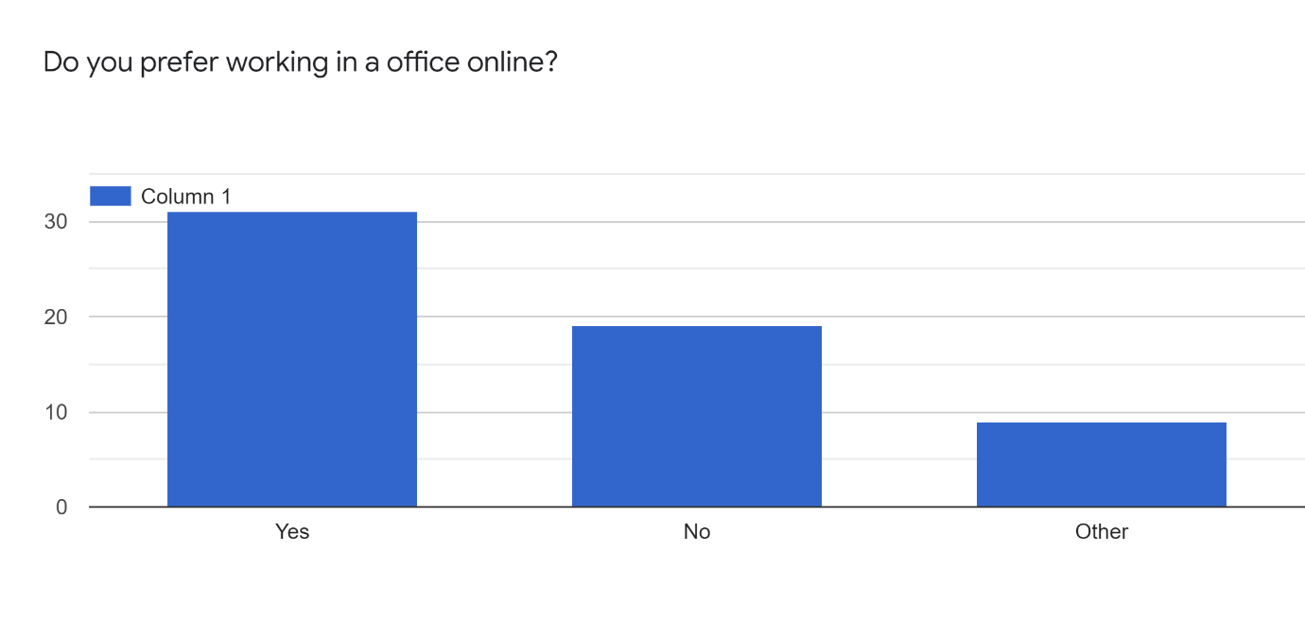

Conclusion of Questionnaire Results:
The analysis results of the survey questionnaire has delivered several answers to the research questions, which also involves how technology has impacted consumer behaviour during the time of the COVID-19 pandemic?. In addition, the questionnaire has also revealed how through times of the COVID-19 pandemic the way in which respondence purchased their goods and services, 5% of respondents found purchasing goods online during this time challenging. 2% of respondents found it complicated, and 1% found it very complicated. Furthermore, we also discovered respondence preferences, 32% of respondence would rather shop in-store, however, 30.1% of respondence where keener on using an online presence. In addition, on purchasing 28% of respondence preferred to buy their goods on a weekly basis, however, 10% preferred to shop every two weeks.
The highest levels of education was also required in the research of this study which witnessed how consumers of various levels of education have all experienced the effects of how technology has impacted consumer behaviour during the time of the pandemic, and to what effect this had on consumer purchasing behaviour. In view of all the respondents who answered this question, there were five category’s which produced 55 responses, furthermore, only the top three results will take precedence here by respondents, first was Higher education levels 5/6, this equated for 40% of the result, second was the college degree with a 29.1% result, and third was school A or O levels which came in with a 14.5% result, of who had been educated, as well as all experiencing the affects of COVID-19, in one way or another.
In view of technology, and the way in which respondents preferences towards technological devices, 45% utilised mobile phones to buy their goods, however, 19% of respondents were keener to use their laptops for the purchasing of goods, and 3% thought best on using a tablet. Further information which links the technology section of the questionnaire are 40% of respondents who paid for goods using a debit card, a further 19% of respondents decided using a credit card, and 18% paid through the Apple pay touch point.
Furthermore, 24% of respondence preferred to make their purchases online. In addition, 51% of consumers found new retailers whilst browsing online during the lockdown period, in addition, the question was put to respondents on how much time they spent browsing the internet for goods, 20% of respondents spent at least 20-30 minutes of browsing time, another 18% of respondents spent 30- minutes to an hour browsing the internet in search of products, and a further 15% of respondents that also spent10-20 minutes browsing the internet.
The question was put to respondents on whether they like to compare prices whilst browsing, Furthermore, the answer was yes 49% of respondents confirmed that they do, however, this I believe is due to organisations having discovered additional ways to draw consumers in, for instance with features, reviews, and becoming that much more acute to consumer wants and needs. However, when it came to asking respondents on whether they had a better experience online, the result was a resounding yes, with a 41% success rate. It was also significant for this research to asked respondents what they spent on a monthly basis online, before the start of COVID-19, which was 36% of respondents spent £100 to £200 a month, respondents that spent between £500 to £1000 a month amounted to 7%, however, respondents that spent £2000 to £2,500 their result was 1%.
Furthermore, 14% voted other, which the researcher will put down as a monthly figure as less than £100 a month spent by respondents. However, now we can view how spending was affected, during the times of the pandemic, which indicates that 39% of respondents spent on average £100 to £200 in that period. Furthermore, 16% was spent by respondents from the £500 to £1000 bracket, and in the same period, and In the £2000 to 2,500 bracket totalled 2% spent, this maybe due to the higher earners having extra cashflow due to being off-work because of furlough.
Furthermore, to gain an insight into the types of respondents that experienced challenges with online purchases, these questions were aimed at the older respondents e.g., Xennials that may face challenges making purchases using technology, 31% voted yes to this question, furthermore, respondents that said no, was 27%. In addition, challenges faced by respondents in view of delivery times from product purchased online received a 21% result, and for items not delivered to respondents, this result was voted 16%, also damaged items received an 8% vote.
The possible reason for the long wait for deliveries may have been because of the extra workload for parcel delivery companies, due to individuals increased traffic purchasing goods over the internet. The Individual respondents that preferred to work remotely, their vote was 31%, however, respondents that voted against this was 30%, and a further 6% of respondents voted never. Furthermore, when the question put to respondents on whether or not they preferred the office environment 31% of respondents voted yes, and on the flip side 19% of respondents voted no, and a further 9% voted other.
Areas that felt the squeeze due to the pandemic were mostly physical shops and stores, and several working environments during this period, in many ways, this played a significant part in reducing contamination from the virus, until a vaccine was introduced, in conjunction with individuals adhering to the stay-at-home policy, which left consumers with little to no choice of using technology during this period. Furthermore, respondents would be encouraged to go back to shopping in physical brick and mortar-stores when these stores can offer desirable prices and deals, improved shopping experiences, have less individuals in them, improved sanitation and, above all, guaranteed safety for consumers.

Discussion:
In this section, will give an explanation is given of the findings and how they connect with previous research and theories. will highlight the justification and interpretation of the research results in order to understand whether the objectives have been achieved and if so, whether the results of the research concur with previous findings or not. In addition, the main limitation of the study was mentioned at the end of this chapter, highlighting the strengths as well as the weaknesses of the research.

Introduction:
Even whilst this study was being compiled, COVID-19 is still causing problems around the globe, however, yesterday in the UK the government announced an ease to restrictions on individuals entering the UK boarders without being tested for the virus. However, since the virus hit these shores, we have witnessed a change to social interaction and an increasing shift to online adoption, in conjunction with social distancing which seems to be a part of this new global direction that we are all heading in. Furthermore, in the midst of the pandemic individuals were fearful and enforced to comply with this new direction or (new normal). Whether the new normal, now means staying at home, working from home, working remotely, purchasing from home or just respecting others' space doing things that much more safely, this new way of behaviour has impacted sectors of society such as brick and mortar-stores.
So, for this research the primary research question was established, “An Investigation into how Technology has ‘Impacted Consumer Behaviour’ During the COVID-19 Pandemic”. Hence, the current research aimed to investigate the impact of COVID-19 and changes to consumer behaviour during this period. This would be by observation on whether COVID-19 is predominately accountable for these present changes or is it an advancement of technological progression. In the course of this study, a research survey questionnaire was assembled, and extensive data collected and analysed, this was also presented in visual form to gather precise results that effectively and accurately interpreted. from the literature review, connecting the survey and data collected, the study also followed the correct procedure to discover a link to disagree with the previous researchers evidence. In this regard the discussion chapter will highlight the interpretation of the results formulated on the objectives set out at the start of the research. The objectives are:

Consumer Purchasing Behaviour of Online Stores Before – COVID-19
One thing which is crystal clear with all the research carried-out on the subject of consumer behaviour is that it is a continuously changing environment (Jashari and Rrustemi., 2017). Furthermore, since the mid-nineties purchasing behaviour from brick and mortar-stores to online technology had already been forecasted. Be that as it may, several organisations were slow on the up-take, and more importantly dubious of the internet and this new technology, this resulted in these organisations and businesses falling by the way-side and resulted in them going bankrupt. However, the change in consumer behaviour in times of a crisis situation witnesses consumer behaviour going through even more changes given the circumstances of a crisis or pandemic situation, in addition, these are the moments that see the emergence of new additions to consumer behaviour (Donthu and Gufstafsson., 2020; Pantano, et al., 2020).
However, these changes normally take-place as a gradual incremental procedure, in small daily changes that have a greater impact than a larger occurrence for a certain moment in time. Consequently, this clear expression constitutes and encompasses the entire findings of this research. There has been a lot already discussed concerning the influence of COVID-19 on consumer behaviour in the reviewed section of this literature, however, not that much mentioned about the discussion on the constant changes in consumer behaviour in connection to how technology has positively impacted the current situation of COVID-19. Furthermore, the results have indicated that before COVID-19 consumers had already been navigating towards online purchases, however, the results for in-store purchases showed a slight increase to online purchases. The results also further demonstrated that consumers spent more money pre-COVID-19 in comparison to times during the pandemic for those that spent £100 to £200, but the average spend for respondents in the £500 to £1000 range increased during the pandemic, likewise for respondents in the £2000 to £2,500. Consumers did respond positively to having a better experience online, which is not surprising, due to better offers being found online (already mentioned earlier). The results also uncovered that consumers like to spend a minimum of ten to twenty minutes on the internet, however, for those that spent thirty minutes to an hour on the internet came in at second place. They also like to compare prices of products too, the advantage of this is it can be viewed and purchased 24 hours a day and 7 days a week, which is an advantage for consumers and retailers, however devices used to purchase goods on the internet was the mobile phone (ICT, 2014; Hudson et al., 2016; Johnson, 2021). The research has therefore established an interconnection in comparison led by Sheth (2020), where through his observation the researcher noticed that consumers have replaced purchasing from brick-and-mortar stores before the outbreak of COVID-19, for a variety of reasons.
The main reason for this mentioned by the researcher is the introduction to the world of smartphones, with this device which has increased access to a wider selection of all populations, this technical transformation, that is broadly known to be one of the significant causes for consumer changes to their purchasing practices. Additionally, the researcher has demonstrated that e-commerce share of total worldwide sales has reached double figures in the past half decade, and is anticipated to increase that much more, for a greater duration. The findings of this study also highlight that even although consumers are increasing their spending online, the majority of spending still takes place in brick-and-mortar stores. With the exception of electronic goods that was the second most popular purchase online. The research has therefore established an interconnection in comparison led by Sheth (2020), where through his observation the researcher noticed that consumers have replaced purchasing from brick-and-mortar stores before the outbreak of COVID-19, for a variety of reasons.

COVID-19 Impact On Consumer Purchasing Behaviour:
It is clear that COVID-19 has had a definite effect in regard to consumers purchasing behaviours. Furthermore, in several countries around the globe, have experienced some kind of lockdown, which has seen the forced closures of many brick-and -mortar stores, during this time. Therefore, purchasing behaviour has definitely experienced a direct effect, that involves countries rules, and government policies. For instance, consumers who would have standardly purchased from stores were required to seek out different ways, which meant that for various consumers e.g., Xennials that were not (Tech savvy) or up to date with their phone /computer and internet skills, were in some ways, forced down the online route. However, the millennials and gen Z, who already purchase products and services online, which was their standard behaviour.
Furthermore, during this present pandemic, which has seen social distancing now become a normal every-day occurrence, with constant engaging with online activity with various social media platforms becoming a daily requirement, funnelling individuals to a basic human requirement of interaction while individuals attempt to deal with the pandemic. In addition, the internet is a significant application for individuals to bring on interaction with one another, considering the lockdown period, which had seen a considerable adoption during the COVID-19 outbreak. The results from the questionnaire have revealed that respondents found the purchase of goods easy during this period.
Which is understandable because under normal circumstances would have seen telecommunications traffic e.g., in London focused on the city, due to the large number of individuals working there that require vast amounts of it, however, due to lockdown telecommunications traffic was focussed more on individuals at home, who then required vast amounts of it during that time. Furthermore, in view of education respondents with lower education standards would have been largely affected due to the fact that individuals that have lower levels of education struggle to attain the better paying jobs, which in turn means they have lower income levels. The results also indicate that consumers are adopting their purchasing selection habits, and therefore moving in the direction of online.
The results have also revealed that during and prior to the pandemic respondents show an increase in the use of credit and debit cards during this period. The reason for the change in consumer purchasing behaviour are COVID-19, also the challenges with trying to stay safe due to fear of being contaminated whilst out shopping, another reason why there has been the increase to online purchasing. Additionally, several consumers have concerns whilst out purchasing from stores, this has now made consumers ponder deeply of where they purchase their goods and stay safe at the same time, consumers are also mindful of what they purchase and where they purchase, this has also changed purchasing behaviour.
Whilst under lockdown consumers found it easier to purchase goods online, they are also extremely chuffed at experiencing offers from online retailers more than ever. However, it must also be mentioned that consumers mostly purchased clothes, food, essentials, and electronic goods, that took part in this research and their seemed to be a very difference to pre- pandemic purchasing, whilst the pandemic was around. The results are not surprising, since other research noted that many of the younger generations were already purchasing most of their products online and therefore there was no significant change in their purchasing behaviour.

Reasons for consumers to purchase in brick-and-mortar-stores during COVID-19.
“Reality” is now played out in a lockdown situation and this sudden change to regular society has witnessed individuals having limited contact with the out-side world. Which takes place where there is little or no contact with the outside, and where the majority of individuals wear masks to enter public spaces that are often mandatory, for most individuals and excluding those individuals that have health issues, purchasing behaviours have seriously affected. The reason for consumers to shop in brick-and-mortar-stores have changed due to advice from government leaders and health officials, who have advised all citizens to restrict contact with others, and advising them to stay-at-home, this also led individuals to seek out online purchases.
One of the biggest challenges for consumers is the requirement of wearing masks in public spaces. Consumers are also conscious about being in crowded spaces, are more aware of trying on clothes and interacting with individuals because of fear of contamination. Nevertheless, as indicated by the research consumers still want to shop in brick-and-mortar-stores, this is because they can pick up and touch items they wish to purchase, however, only if businesses can guarantee safety, and less crowded spaces. Even though brick-and-mortar-stores have gone through a rough period of adapting to the technological digital age and thus the digital transformation, individuals still like to buy in these stores more often compared to online stores, as the research has shown In the survey, consumers were asked if they preferred in-store or online and purchasing in-stores became the top choice.
The primary reasons for physical stores are the in-store experience, the selection of products and the offered facilities in a shop. For online stores, the primary reasons are prices, delivery and the fact online stores are always on. The findings of this study suggest that individuals still have a strong connection to being in stores. In addition, the in-store experience is seen as an added consumer benefit when purchasing products like luxury goods. The above reasons reflects the interpretation of consumer behaviour made by Donthu and Gustafsson, stating that individuals mainly rely on internal influences and sense when they need to make decisions which generally occur as soon as people experience a brand or product in real life.
As explained by the theory of reasoned action, consumers can change their mind at any stage and shopping in brick-and-mortar stores is an important stage in the procedure. As a result, although the pandemic is a significant barrier for individuals to go to brick-and-mortar stores, consumers want to have the experience to see, touch, and try on products they buy. We can conclude that brick-and-mortar stores are popular amongst consumers and still have several advantages over online shopping.

Purchasing in Brick-and- Mortar-Stores During – COVID-19:
So, it is crystal clear that there are many advantages of purchasing goods in-store as compared to purchasing goods in online stores, consumers are not going to wholeheartedly transfer to online purchasing In an instance. It is the researchers view that consumers are inclined to go back to purchasing goods in-store, once COVID-19 has disappeared. However, who really knows what is ahead when this pandemic has finally ceased, we will witness, if that is the case if consumers return to their previous purchasing norms. In addition, consumers are unclear to what extent, the real meaning of a post-pandemic society.
Furthermore, consumers have a better online purchasing experience as mentioned earlier in the report, however, the researcher believes that if the in-store experience were able to challenge the online experience, maybe we would witness a flood of consumers back to brick-and-mortar-stores. Furthermore, in all honesty, this will not happen, in-view of this research the scale of balance is tipped more in favour of online stores, which will be the way forward. Furthermore, according to the researcher Sheth (2020) in his view there are significant changes towards purchasing behaviours that are witnessed during times where there are quarantines, and obligatory rules and restricted options towards consumer purchases. He also believes that consumers will return to previous norms, of purchasing in-store very soon, and just getting on with life as they previously did.
Nonetheless, the evidence of this study has not suggested that individuals are likely to return to their old habits, this study is currently unable to confirm or deny whether this is true. The main reason that it is not possible to confirm is the fact that research shows that prior to COVID-19, there was already an ongoing adoption happening to online shopping. In addition, many brick-and mortar-store retailers, have already had ongoing problems prior to COVID-19. Based on the interpretation of the results, it can be concluded that new habits were developed during COVID-19 of which some will remain when the pandemic is over, and some will return to previous norms. Based on the research done, people will respond differently to shopping at physical stores after the lockdown, which can be either a positive or negative trend, depending on how stores and government policies will affect these issues.

RQ 1. How was consumer purchasing behaviour transformed during the COVID-19 pandemic because of technology?

RQ 2. What long-term lasting trends will we witness because of the current COVID-19 pandemic?

Discussions:
An Investigation into how Technology has ‘Impacted Consumer Behaviour’ During the COVID-19 Pandemic?
In view of the main question in regard to this research on “How was consumer purchasing behaviour transformed during the COVID-19 pandemic because of technology” ? the results have demonstrated that through the use of technology, consumer behaviour was impacted by 45% of respondents that use mobile phones to make their purchases of goods, and according to Sheth, (2020) who said that the introduction of smartphones to a greater audience has been a technical global transformation. Which is further supported by others, that say in their explanation on technology is how its a force which has shaped societies, businesses, and individuals, (Cruz Cardenas et al., 2018). Also having an extensive socio-economic impact (Watanabe et al., 2018).
Furthermore, respondents were upbeat with their response to online purchasing and 31% of them preferred to do so, however 32% of respondents did prefer to shop in brick-and mortar-stores, which is understandable because this enables consumers to touch, try on, and see goods that they wish to purchase, which is definitely a unique selling point (USP). Online commerce, both categories of commerce play a vital in consumer purchasing procedures (KPMG and International, 2017). In addition, respondents also through the use of technology purchased and searched for in line with goods with the use of debit and credit cards, this also went a long-way to reduce contamination from the virus. We also discovered in the research that during the pandemic consumers had to seek out new ways to purchase goods for some individuals this was challenging, i.e., for the not so (technical-minded Xennials), however, for millennials and the gen Z, consumers this period for them was no different to their normal behaviour in terms of purchasing.
Weaknesses of this research are the respondents that took part who were mainly level 4 students, who may not have appreciated or fully understood the survey questionnaire, and the information sought to extract from it. Other weaknesses were the initial time constraints had to put into this research which were challenging due to working night shifts, however, this is what all students face. Further challenges were technical difficulties with the Googles forms questionnaire, which should have been emailed to all UWTSD London students but some how failed to do so. In addition, other challenges were not selecting a broader variety audience such as members of the public, which may have been collected through social media, however given the time constraints this route was not selected. Long-term trends in the researchers view cannot be answerd totally yet, yes we will still wear masks, sanitise, and social distance, however, COVID-19, has not completely dissapead, and in the researchers view depends mostly on government policy.

Recommendations for further research:
Maybe the next research should focus on how brick and mortar stores are going to compete with online stores, because if there are constant threats of COVID-19, we will see brick-and mortar-stores- completely disappear all-together, maybe research can focus on new ways forward.

Conclusion:
This report in the researchers view has carried out a thorough investigation into how technology has impacted consumer behaviour during the pandemic, and in the researchers view believes, that technology assisted consumer behaviour in so many positive way’s, as mentioned in the report and without the smartphone, and technology how would society have coped during this period.

References:
Ali, B.J. and Anwar, G., (2021) Marketing Strategy: Pricing strategies and its influence on consumer purchasing decision. Ali, BJ, & Anwar, G.(2021). Marketing Strategy: Pricing strategies and its influence on consumer purchasing decision. International journal of Rural Development, Environment and Health Research, 5(2), pp.26-39.
Almeida, F., Almeida, J. and Mota, M. (2019) Perceptions and Trends of Booking Online Payments in Tourism and Services, 10 (18), 1-15. In Hovarth et al., (2021).
Amazon (2020). Introducing the first grocery store with just walk-out shopping. Retrieved from https://www.amazon.com/b?ie=UTF8&node=16008589011. (In Kirk and Rifkin, 2020).
Amazon, (2020) Introducing the first grocery store with just walk-out shopping. Retrieved August 1, (2020) from. https://www.amazon.com/b?ie=UTF8&node=16008589011. (In Eger et al., 2021).
Alhomaid, A., (2021) How Covid-19 has impacted global consumer behaviours and the adoption of digital business strategies by companies in the UK. Turkish Journal of Computer and Mathematics Education (TURCOMAT), 12(14), pp.5395-5411.
Arndt, J. (1967) ‘Role of product-related conversations in the diffusion of a new product’, Journal of Marketing Research, Vol. 4, No. 3, pp.291–295. In Voramontri, 2019.
Álvarez-Monzoncillo, J.M., de Haro Rodríguez, G. and Picard, R.G. (2018) ‘Digital word of mouth usage in the movie consumption decision process: the role of mobile-WOM among young adults in Spain’, International Journal on Media Management, Vol. 20, No. 2, pp.107–128. (In Erkan et al., 2021).
Apedo-Amah, M.C., Avdiu, B., Cirera, X., Cruz, M., Davies, E., Grover, A., Iacovone, L., Kilinc, U., Medvedev, D., Maduko, F.O. and Poupakis, S., (2020) Unmasking the Impact of COVID-19 on Businesses.
Ariffin, S. K., Mohan, T. & Goh, Y. N., (2018) ‘Influence of consumers’ perceived risk
on consumers’ online purchase intention. Journal of Research in Interactive
Marketing, 12(3), pp. 309-327.
Baines, P.R. (2017) ‘Technological Impacts on Market Attitudes and Behaviour’s’, Psychology & marketing, 34(4), pp. 351–355. doi:10.1002/mar.20993.
Baldu, B.J., Voorchees, C. and Calantone, R. (2015), ‘Online brand community engagement: scale development and validation’, Journal of Business Research, Vol. 68 No. 5, pp. 978-985. In Katsikeas, (2020).
Basu, T. (2014) ‘How many people in the world are actually poor’? The Atlantic, June 19, Retrieved from https://www.theatlantic.com/business/archive/2014/ 06/weve-been-measuring-the-number-of-poor-peoplein-the-world-wrong/37 In Hamilton et al., 2019.
Belle, D., & Doucet, J. (2003) ‘Poverty, inequality, and discrimination as sources of depression among U.S. women’. Psychology of Women Quarterly, 27, 101–113. https://doi.org/10.1111/1471-6402.00090. In Hamilton et al., 2019.
Besson, Emilie K. (2020) COVID-19 (Coronavirus): Panic Buying and Its Impact on Global Health Supply Chains. World Bank. Available online:
Berthon, P., Lane, N., Pitt, L. and Watson, R.T. (1998), “The World Wide Web as an industrial marketing communication tool: models for the identification and assessment of opportunities”, Journal of Marketing Management, Vol. 14 No. 7, pp. 691-704. In Katsikeas, (2020).
Bhimani, H., Mention, A.L. and Barlatier, P.J., (2019) ‘Social media and innovation: A systematic literature review and future research directions’. Technological Forecasting and Social Change, 144, pp.251-269. (In Cruz-Cárdenas, J. et al. (2019).
Blut, M., Chowdhry, N., Mittal, V. and Brock, C., (2015) ‘E-service quality: A meta-analytic review’. Journal of retailing, 91(4), pp.679-700. In Rita, et al., (2019).
Blut, M., (2016) ‘E-service quality: development of a hierarchical model’. Journal of Retailing, 92(4), pp.500-517. In Rita, et al., (2019).
BofA. (2021). Preparing for the new consumer. [Online]Available at: https://www.bofaml.com/en-us/content/post-covid-insights/coronavirus-impact-onconsumer-buying-behaviors.html (Accessed 2 June 2021) |(In Alhomaid, A., 2021)
Boons, F. and Bocken, N., (2018) ‘Towards a sharing economy–Innovating ecologies of business models’. Technological Forecasting and Social Change, 137(C), pp.40-52. (In Cruz-Cárdenas, J. et al. (2019).
Botti, S., Broniarczyk, S., H€aubl, G., Hill, R., Huang, Y., Kahn, B., Kopalle, P., Lehmann, D., Urbany, J., & Wansink, B. (2008) ‘Choice under restrictions. Marketing Letters’, 19, 183–199. https://doi.org/10.1007/s11002-008-9035-4. In Hamilton et al., 2019.
Brady, M.K. and Robertson, C.J., (200) ‘Searching for a consensus on the antecedent role of service quality and satisfaction: an exploratory cross-national study’. Journal of Business research, 51(1), pp.53-60. In Rita, et al., (2019).
Bronner, F. and Hoog, R. (2010) ‘Consumer-generated versus marketer-generated websites in consumer decision making’, International Journal of Market Research, Vol. 52, No. 2, pp.231–248. In Voramontri, 2019.
Bryman, A. & Bell, E., (2011) Business Research Methods. 3 ed. Oxford University
Press: Oxford.
Cannon, C., Goldsmith, K., & Roux, C. (2018) ‘A self-regulatory model of resource scarcity’. Journal of Consumer Psychology, 29, 104–127. http. In Hamilton et al., 2019.
Centene Centre for Health and Transformation (2020) How to Manage Hoarding Behaviour During a Crisis. Available at: How to Manage Hoarding Behaviours in Times of Crisis - Centene Centre (wustl.edu) (In How to Manage Hoarding Behaviour During a Crisis 2020).
Chatterjee. S. and Datta. P. (2008) Examining Inefficiencies and Consumer Uncertainty in E-commerce. Communications of the Association Systems, 22 (29), 525-546. In Hovarth et al., (2021).
Chen, M., & Miller, D. (2012) ‘Shift-and-persist strategies: Why low socioeconomic status isn’t always bad for health’. Perspectives on Psychological Science, 7, 135–158. https://doi.org/10.1177/1745691612436694. In Hamilton et al., 2019.
Coleman JS., (1958) Relational analysis: the study of social organizations with survey methods. Hum. Organ. 17:28–36 (In Heckathorn, D.D. and Cameron, C.J., 2017).
Coyle, J.R. and Thorson, E., (2001) ‘The effects of progressive levels of interactivity and vividness in web marketing sites’. Journal of advertising, 30(3), pp.65-77.

Consumer Behavior: Meaning, Scope, Why Study Consumer Behavior? (iedunote.com)
Confente, I. and Vigolo, V. (2018) ‘Online travel behaviour across cohorts: The impact of social influences and attitude on hotel booking intention’, International Journal of Tourism Research, Vol. 20 No. 5, pp. 660-670. In Dhamesti, et al., 2019).
Creswell, J. W., 2014. Research design: Qualitative, Quantitative, and Mixed
Methods Approaches. 4 ed. London: SAGE Publications, Inc..
Crowther, D. & Lancaster, G., (2008) Research methods: A concise introduction to
research in management and business consultancy. 2 ed. Oxford: Elsevier
Butterworth-Heinemann.
Cruz-Cárdenas, J. et al. (2019) ‘Role of demographic factors, attitudes toward technology, and cultural values in the prediction of technology-based consumer behaviours’: A study in developing and emerging countries’, Technological forecasting & social change, 149, p. 119768–. doi:10.1016/j.techfore.2019.119768.
Dabija, D.-C., Bejan, B. M. and Tipi, N. (2018), ‘Generation X versus millennials communication behaviour on social media when purchasing food versus tourist services’, Economics and Management. (In Dhamesti, et al., 2019).
Dang, Ha, and Mi Lin. (2016) Herd mentality in the stock market: On the role of idiosyncratic participants with heterogeneous information. International Review of Financial Analysis 48: 247-60. (In Loxton et al., 2020).
Dangelico, R. M., & Vocalelli, D. (2017). “Green Marketing”: an analysis of definitions, strategy steps, and tools through a systematic review of the literature. Journal of Cleaner Production, 165, 1263-1279. In Ali, and Anwar, 2021).
de Araújo, M.C.B. (2017) ‘Project procurement management: A structured literature review’, International journal of project management., 35(3), pp. 353–377. doi:10.1016/j.ijproman.2017.01.008.
Determinants & Factors influencing Consumer Behaviour - BBA|mantra (bbamantra.com) 2019
Dharmesti, M., Dharmesti, T. R. S., Kuhne, S. & Thaichon, P., (2019) ‘Understanding
online shopping behaviours and purchase intentions amongst millennials. Young
Consumers, pp’. Ahead-of-print.
Donthu, N., Kumar, S., Pandey, N., Pandey, N. and Mishra, A., (2021) Mapping the electronic word-of-mouth (eWOM) research: A systematic review and bibliometric analysis. Journal of Business Research, 135, pp.758-773.
Dokulil, J., Popesko, B., and Dvorsky, J. (2020) ‘The budgeting process of Czech companies: The role of the ownership structure and foreign capital.’ Oeconomania Copernicana, 11 (4), 779 – 778. In Hovarth et al., (2021).
Erkan, I., Acikgoz, F., Elwalda, A., Rahman, M. and Akin, N., (2021) Mobile word of mouth in mobile messaging applications: an exploration of its antecedents and consequences. International Journal of Business Information Systems, 37(1), pp.45-62.
Edelman, D. C. (2010) ‘Branding in digital age. You’re spending your money in all the wrong places’. Harvard Business Review, In Laroche et al., (2013).
Elmore, Charles. (2017) Irma: Frenzied buying in Palm Beach, St. Lucie regions led state. The Palm Beach Post. Available online: https://www.palmbeachpost.com/business/data-firm-tracked-how-hurricane-irma-store-sales-boomed-went-bust/LIDVXIL3qlqJGLlaosfSiL/ (accessed on 30 June 2020). (In Loxton et al., 2020).
Essamri, A., McKechnie, S. and Winklhofer, H. (2019) ‘Co-creating corporate brand identity with online brand communities: a managerial perspective’, Journal of Business Research, Vol. 96, pp. 366-375. In Katsikeas, (2020).
Ferencakova, L., Gajdka, K., Netek, V. and Kapoun, P. (2020) ‘Engaging Customers on Facebook Coffee Shop’s Brand-Fan Pages’, International Journal of Entrepreneurial Knowledge, 8 (1), 65 – 75. In Hovarth et al., (2021).
Forbes, Sharon L. (2017) Post-disaster consumption: analysis from the 2011 Christchurch earthquake. The International Review of Retail, Distribution and Consumer Research 27: 28-42. (In Loxton et al., 2020).
- Frost, Randy O., and Tobias Hartl. (1996) A cognitive-behavioural model of compulsive hoarding. Behaviour Research and Therapy 34: 341-50

Frost, R.O. and Gross, R.C., (1993) The hoarding of possessions. Behaviour research and therapy, 31(4), pp.367-381.

Ganguly, B., Dash, S.B., Cyr, D. and Head, M., (2010) ‘The effects of website design on purchase intention in online shopping: the mediating role of trust and the moderating role of culture’. International Journal of Electronic Business, 8(4-5), pp.302-330.
Garfin, Dana, Roxanne Silver, and Alison Holdman., (2020) The Novel Coronavirus Outbreak: Amplification of Public Health Consequences by Media Exposure. Worcester: American Psychological Association.
Gerrikagoitia. J. K. et al., (2015) New Trends of Intelligent E-marketing Based on Web Mining for E-shops. Procedia – Social and Behavioural Sciences, 175, 75-83. In Hovarth et al., (2021).
Goker, G. and Ayar, I (2020) Intermediary Role of Nostalgia Tendency in The Effect of Electronic Word of Mouth Communication on Tourist’s Destination Visit Intentions. Journal of Tourism and Services, 20 (11), 44-59. In Hovarth et al., (2021).
Goodman LA. (1961) Snowball sampling. Ann. Math. Stat. 32:148–70 (In Heckathorn, D.D. and Cameron, C.J., 2017).
Gounaris, S., Dimitriadis, S. and Stathakopoulos, V., (2010) ‘An examination of the effects of service quality and satisfaction on customers' behavioral intentions in e‐shopping’. Journal of services marketing. In Rita, et al., (2019).
Gouvea, R., Kapelianis, D. and Kassicieh, S., (2018) ‘Assessing the nexus of sustainability and information & communications technology’. Technological Forecasting and Social Change, 130, pp.39-44. (In Cruz-Cárdenas, J. et al. (2019).
Gracia, M., Vigo, M., Fernandez-Perez, M. J., & Marco, M. (2002) Behavioral problems related to Internet use: An exploratory study. Anales de Psicología, 18(2), 273-292. (In Vazquea-Cano 2022).
Haile, M.G., Wossen, T. and Kalkuhl, M., (2019) ‘Access to information, price expectations and welfare’: The role of mobile phone adoption in Ethiopia. Technological Forecasting and Social Change, 145, pp.82-92. (In Cruz-Cárdenas, J. et al. (2019).
Hamilton, R.W., Mittal, C., Shah, A., Thompson, D.V. and Griskevicius, V., (2019) ‘How financial constraints influence consumer behavior’: An integrative framework. Journal of Consumer Psychology, 29(2), pp.285-305.
Hammond, M. & Wellington, J., (2013) Research Methods: The Key Concepts. 1 ed.
Abingdon, Oxon: Routledge.
Hanna, R., Rohm, A., & Crittenden, V. L. (2011)’ We’re all connected: The power of social media ecosystem’. Business Horizons, 54, 265–273. In Laroche et al., (2013)
Heckathorn, D.D. and Cameron, C.J., (2017) Network sampling: From snowball and multiplicity to respondent-driven sampling. Annual review of sociology, 43, pp.101-119.
Hennig-Thurau, T., Gwinner, K.P., Walsh, G. and Gremler, D.D. (2004) ‘Electronic word-of-mouth via consumer-opinion platforms: what motivates consumers to articulate themselves on the Internet?’, Journal of Interactive Marketing, Vol. 18, No. 1, pp.38–52. In Voramontri, 2019.
Horváth, D. and Szabó, R.Z., (2019) ‘Driving forces and barriers of Industry 4.0: Do multinational and small and medium-sized companies have equal opportunities’?. Technological forecasting and social change, 146, pp.119-132. (In Cruz-Cárdenas, J. et al. (2019).
Hudson, Simon, Martin S. Roth, Thomas J. Madden, and Rupert Hudson. "The effects of social media on emotions, brand relationship quality, and word of mouth: An empirical study of music festival attendees." Tourism management 47 (2015): 68-76. (In Hudson above Chappuis et al., 2011).
Hudson, Simon, Li Huang, Martin S. Roth, and Thomas J. Madden., (2016) "The influence of social media interactions on consumer–brand relationships: A three-country study of brand perceptions and marketing behaviours." International Journal of Research in Marketing 33, no. 1 27-41.
Huffington Post. (2015) ‘1/3 of high earners live paycheck to paycheck’. Retrieved from https://www.huffingtonpost. com/moneytips/13-of-high-earners-live-p_b_8136770.html. In Hamilton et al., 2019.
Husnain, M., Rehman, B., Syed, F. & Akhtar, M. W., (2019) ‘Personal and In-store
Factors Influencing Impulse Buying Behavior among Generation Y Consumers of
Small Cities’. Business Perspectives and Research, 7(1), p. 92–107.
Huston. J. H. and Spencer. R. W. (2002) ‘Quarterly. Uncertainty and the Internet: The Market for Cyber Lemons’. American Economist, 46 (1), 50 – 60. In Hovarth et al., (2021).
https://blogs.worldbank.org/health/covid-19-coronavirus-panic-buying-and-its-impact-global-health-supply-chains (accessed on 14 June 2020). (In Loxton et al., 2020).
Hyman, L., & Tohill, J. (Eds.). (2017) Shopping for Change: Consumer Activism and the Possibilities of Purchasing Power. Cornell University Press. http://www.jstor.org/stable/10.7591/j.ctt1x76d81
International Telecommunication Union , Measuring the information society report (2017) Vol 1. , accessed October 15, 2018, available athttps:www.itu.intenITU-DStatisticsDocumentspublicationsmisr2017MISR2017_Volume1.pdf. (In Cruz-Cárdenas, J. et al. (2019).
Jackson, S. L., (2009) Research Methods and Statistics: A Critical Thinking Approach. 3 ed. Belmont, CA: Wadsworth, Cengage Learning.
Janouch. V. (2014) Inventory Marketing. Bron: Computer Press, In Hovarth et al., (2021).
Javalgi, R.G., Radulovich, L.P., Pendleton, P. and Scherer, R.F. (2005) ‘Sustainable competitive advantage of internet firms’, International Marketing Review, Vol. 22 No. 6, pp. 658-672. In Katsikeas, (2020).
Jashari, F. and Rrustemi, V., (2017) ‘The impact of social media on consumer behavior–Case study Kosovo’. Journal of Knowledge Management, Economics and Information Technology, 7(1), pp.1-21.
Journal of Consumer Research, 42, 59–75. https://doi.org/10.1093/jcr/ucv007 In Hamilton et al., 2019.
Kaczorowska-Spychalska, D. (2018) ‘Digital Technologies in the Process of Virtualization of Consumer Behaviour – Awareness of New Technologies’, Management (Zielona Góra), 22(2), pp. 187–203. doi:10.2478/manment-2018-0031.
Kaigo, M., (2012) Social media usage during disasters and social capital: Twitter and the Great East Japan earthquake. Keio Communication Review, 34(1), pp.19-35. (In Kirk and Rifkin, 2020).

Kaplan, A. M., & Haenlein, M. (2010) ‘Users of the world, unite! The challenges and opportunities of social media’. Business Horizons, 53, 59–68. In Laroche et al., (2013)
Katsikeas, C. (2020) ‘Revisiting international marketing strategy in a digital era’, International marketing review., 37(3), pp. 405–424. doi:10.1108/IMR-02-2019-0080.
Kalyan, A.S., and DR Madhu, A., (2019) ‘A Report On Consumer Behaviour’.
Kawachi, I., & Kennedy, B. P. (1999) ‘Income inequality and health: Pathways and mechanisms’. Health Services Research, 34, 215–227. In Hamilton et al., 2019.
Kesmodel. D. (2006) Despite Growth of E-commerce. Some Retailers Remain Offline. Wall Street Journal. 2. In Hovarth et al., (2021).
Khare, A. and Rakesh, S. (2011), ‘Antecedents of online shopping behavior in India: An examination’, Journal of Internet Commerce, Vol. 10 No. 4, pp. 227-244. In Dhamesti, et al., 2019).
Kietzmann, J. H., Hermkens, K., & McCarthy, I. P. (2011) ‘Social media? Get serious! Understanding the functional building blocks of social media’. Business Horizons, 54, 241–251. In Laroche et al., (2013).
Kljucnikov, A,. Civelek, M., Voznakova, I an Krajckik, V. (2020) Can discounts expand local and digital currency awareness of Individuals depening on their characteristics? Oeconomia Copernicana, 11 (2), 239-266. In Hovarth et al., (2021).
Kljucnikov, A., Popesko, B., and Kloudova, J. (2019) Economics of the International ridesharing service-a trap for armatures. Entrepreneurship and Sustainability Issues, 6 (3), 1172-1181. In Hovarth et al., (2021).
Kilic, M., Avci, D., & Uzuncakmak, T. (2016). Internet Addiction in High School Students in Turkey and Multivariate Analyses of the Underlying Factors: Journal of Addictions Nursing, 27(1), 39-46. https://doi.org/10.1097/JAN.0000000000000110 (In Vazquea-Cano 2022).
Kimmel, A.J. and Kitchen, P.J. (2014) ‘WOM and social media: presaging future directions for research and practice’, Journal of Marketing Communications, Vol. 20, Nos. 1–2, pp.5–20. In Voramontri, 2019.
Kirk, C.P., Rifkin, L.S.,( 2020) I’ll Trade you Diamonds for Toilet Paper: Consumer Reacting, Coping and Adapting Behaviours in the COVID-19 pandemic. J. Bus. Res. 117, 124–131. https://doi.org/10.1016/j.jbusres.2020.05.028. (In Eger et al., 2021).
Knowles, J., Ettenson, R., Lynch, P., & Dollens, J. (2020). Growth opportunities for brands during the COVID-19 crisis. MIT Sloan Management Review, 61(4), 2-6. (In Alhomaid, A., 2021).
Kotler Ph., Kartajaya H., Setiawan I. (2010), Marketing 3.0, Wydawnictwo MT Bizness, Warszawa. (In Kaczorowska-Spychalska, D. 2018).

KPMG International. (2017) ‘The truth about online consumers’. 2017 Global Online Consumer Report. Suiça: KPMG International Cooperative.
Kraus, M. W., Cot ^ e, S., & Keltner, D. (2010) ‘Social class, contextualism, and empathic accuracy’. Psychological Science, 21, 1716–1723. https://doi.org/10.1177/ 0956797610387613. In Hamilton et al., 2019.
Kraus, S., Niemand, T., Besler, M., Stieg, P. and Martinez-Ciment, C., (2018) ‘The influence of leadership styles on the internationalisation of'born-global'firms and traditionally global-expanding firms’. European Journal of International Management, 12(5-6), pp.554-575. (In Cruz-Cárdenas, J. et al. (2019).
Ladhari, R., Gonthier, J. and Lajante, M. (2019), ‘Generation Y and online fashion shopping: Orientations and profiles’, Journal of Retailing and Consumer Services, Vol. 48, pp. 113-121. In Dhamesti, et al., 2019).

Lampropoulos, G., Siakas, K. and Anastasiadis, T. (2019) Internet of Things in the Context of Industry 4.0 An Overview. International Journal of Entrepreneurial Knowledge, 7 (1), 4-19. In Hovarth et al., (2021).
Laroche, M., Habibi, M.R. and Richard, M.O., (2013) ‘To be or not to be in social media: How brand loyalty is affected by social media’?. International journal of information management, 33(1), pp.76-82.
Lin, H.-C. and Kalwani, M.U. (2018) ‘Culturally contingent electronic word-of-mouth signalling and screening: a comparative study of product reviews in the United States and Japan’, Journal of International Marketing, Vol. 26 No. 2, pp. 80-102. In Katsikeas, (2020).
Loxton, M. et al. (2020) ‘Consumer Behaviour during Crises: Preliminary Research on How Coronavirus Has Manifested Consumer Panic Buying, Herd Mentality, Changing Discretionary Spending and the Role of the Media in Influencing Behaviour’, Journal of risk and financial management, 13(8), p. 166–. doi:10.3390/jrfm13080166
Ludvik, E., Kormarkova, L., Ergova, D., Micik, M., (2021) ‘The effect of COVID-19 on consumer shopping behaviour’: Generational cohort perspective. Journal of Retailing and Consumer Services
Maslow, Abraham. (1954) Motivation and Personality. New York: Harper and Row Publishers Inc. (In Kirk and Rifkin, 2020).
Mathew, S., (2017) Mass Media and the Digital Age: Paradigm Shift in Consumer Psychology.
Millar, C., Lockett, M. and Ladd, T., (2018) Disruption: ‘Technology, innovation and society’. Technological Forecasting and Social Change, 129, pp.254-260. (In Cruz-Cárdenas, J. et al. (2019).
Mosquera, R., Odunowo, M., McNamara, T., Guo, X., & Petrie, R. (2018). The Economic Effects of Facebook. Experimental Economics, 1(1), 1-28. https://doi.org/10.2139/ssrn.3312462 (In Vazquea-Cano 2022).
William M.K. Trochim, “Research Methods Knowledge Base”
2006
William M.K. Trochim, “Research Methods Knowledge Base”
NCSolutions (2020). Top categories on March 12. NCS COVID-19 Resources. Retrieved from https://www.ncsolutions.com/covid/top-cpg-categories-on-march-12/. (In Kirk and Rifkin, 2020).
Norberg, M.M., David, J., Crone, C., Kakar, V., Kowk, C., Oliver, J., and Grisham, J.P (2019) Determinants of object choice and object attachment: Compensatory consumption in compulsive buying-shopping disorder and hoarding disorder. Journal of Behavioral Addictions, 1-10. How to Manage Hoarding Behaviours in Times of Crisis - Centene Centre (wustl.edu) (In How to Manage Hoarding Behaviour During a Crisis 2020).
Oluwafemi, A. J. and Adebiyi, S. O. (2018) Customer Loyalty and Integrated Marketing Communication among Subscribers of Telecommunication Firms in Lagos Metropolis Nigeria. Journal of Competitiveness 10 (2), 132-148. In Hovarth et al., (2021).
Palka, W., Pousttchi, K. and Wiedemann, D.G. (2009) ‘Mobile word-of-mouth – a grounded theory of mobile viral marketing’, Journal of Information Technology, Vol. 24, No. 2, pp.172–185. (In Erkan et al., 2021).
Paunescu, C. and Moraru, R. (2018) Maximizing social value in the hotel online environment using an analysis hierarchy process. Journal of Competitiveness 10 (1), 106 – 124. In Hovarth et al., (2021).
Pavlou. P. A., Liang. H. and Xue, Y. (2007) ‘Understanding and Mitigating Uncertainty in Online Exchange Relationships’: A Principle – Agent Perspective. MIS Quarterly 31 (1 105 -136. In Hovarth et al., (2021).
Phillips, M., & Chin, T. (2004) ‘School inequality: What do we know’? In K. M. Neckerman (Ed.),. Social inequality (pp. 467–519). New York: Russell Sage Foundation. In Hamilton et al., 2019.
Plaza de la Hoz, J. (2018) Advantages and disadvantages of adolescent use of ICT: Students' vision. Revista Complutense de Educación, 29(2), 491-508. https://doi.org/10.5209/RCED.53428 (In Vazquea-Cano 2022).
Popesko, B., Kljucnikov, A., Hrabec, D., and Dokulil, J. (2016) Predictability of business environment within budgeting process – is it connected with fluctuations of econmomy? Economics and Sociology 9 (2), 90-100. In Hovarth et al., (2021).
Powers, T., Advincula, D., Austin, M.S., Graiko, S. and Snyder, J. (2012) ‘Digital and social media in the purchase decision process’, Journal of Advertising Research, Vol. 52, No. 4, pp.479–489. In Voramontri, 2019.
Preston, S., (2020) Hoarding is not a Strange Behaviour During a Crisis. Vice President for Communications Michigan News University of Michigan. Available Stephanie Preston: Hoarding is not a strange behavior during times of crisis | University of Michigan News (umich.edu)
Queirós, A., Faria, D., & Almeida, F. (2017) Strengths and limitations of qualitative and quantitative research methods. European Journal of Education Studies.
Rita, P., Oliveira, T. and Farisa, A., (2019) ‘The impact of e-service quality and customer satisfaction on customer behavior in online shopping’. Heliyon, 5(10), p.e02690.
Rosa, Z. and Machova, V. (2020) Factors Affecting Job Announcement Competitiveness on Job Listing Websites. Journal of Competitiveness 12 (4), 109-126. In Hovarth et al., (2021).
Roy, S. K., Balaji, M. S. and Nguyen, B. (2020) ‘Consumer-computer interaction and -store smart technology (IST) in the retail industry: the role of motivation, opportunity, and ability’, Journal of Marketing Management, 36(3/4), pp. 299-333. doi 10.1080/0267257X2020. 1736130
Salkind, N., (2017) Exploring Research. 9 ed. Essex: Pearson Education Limited.
Sahay, Arunaditya. "Peeling saunder's research onion." Research Gate, Art (2016): 1-5.
Saunders, M., Lewis, P. & Thornhill, A., (2016) Research Methods for Business
Students. 7 ed. Essex: Pearson Education Limited.
Sharma, G. and Lijuan, W., (2015) ‘The effects of online service quality of e-commerce Websites on user satisfaction’. The Electronic Library. In Rita, et al., (2019).
Siddiqui, N., Mannion, M. and Marciniak, R., (2019) ‘An Exploratory Investigation into the Consumer Use of WeChat to Engage with Luxury Fashion Brands’, in Social Commerce. Springer, pp. 213-234. In Dhamesti, et al., 2019).
Schor, Juliet. B. (1998) ‘The overspent American. New York’: Basic Books. In Hamilton et al., 2019.
Sheth, J., (2020) Impact of Covid-19 on consumer behaviour: Will the old habits return or die?. Journal of business research, 117, pp.280-283.
Sheth, N.J. and Sharma, A. (2005), ‘International e-marketing: opportunities and issues’, International Marketing Review, Vol. 22 No. 6, pp. 611-622. In Katsikeas, (2020).
Shen, X.L., Wang, N., Sun, Y. and Xiang, L. (2013) ‘Unleash the power of mobile word-of-mouth: an empirical study of system and information characteristics in ubiquitous decision making’, Online Information Review, Vol. 37, No. 1, pp.42–60. (In Erkan et al., 2021).
Sinkovics, N., Sinkovics, R.R. and Jean, R. (2013), “The internet as an alternative path to internationalization?”, International Marketing Review, Vol. 30 No. 2, pp. 130-155. In Katsikeas, (2020).
Solomon, M, R., Russell-Bennett, R., Previte, J., (2009) Consumer Behaviour Buying, Having, Being. 3rd Edition Australia: Publisher Pearson
Statista, ‘Most popular global mobile messenger apps’ (2019), accessed August 10, 2019, available athttps:www.statista.comstatistics258749most-popular-global-mobile-messenger-apps. (In Cruz-Cárdenas, J. et al. (2019).
Svatosova, V. (2020) ‘The Importance of Online Shopping Behaviours in the Strategic Management of E-Commerce Competitiveness’. Journal of Competitiveness 12 (4), 143-160. In Hovarth et al., (2021).
Tovmasyan, G. (2020) ‘Evaluating the quality of hotel service based on tourists perceptions and expectations’: The case study of Armenia. Journal of International Studies 13 (1), 93-107. In Hovarth et al., (2021).
Trafimow, D. (2020) ‘The (im)precision of scholarly consumer behavior research’, Journal of business research, 114, pp. 93–101. doi:10.1016/j.jbusres.2020.04.008.
Tsao, W.C., Hsieh, M.T. and Lin, T.M., (2016) ‘Intensifying online loyalty! The power of website quality and the perceived value of consumer/seller relationship’. Industrial Management & Data Systems. In Rita, et al., (2019).
Tully, S. M., Hershfield, H. E., & Meyvis, T. (2015) ‘Seeking lasting enjoyment with limited money: Financial constraints increase preference for material goods over experiences’.
Ulpiano, J. Vasquez-Martinez, PhD., Javier Morales-Mediano, Antonio L. Leal-Rodriguez, PhD. (2021) The Impact of COVID-19 Crisis on Consumer Purchasing Motivation and Behaviour. European Research on Management and Business Economics Volume 27, Issue Number 3.
Vázquez-Cano, E. and Parra-González, M., ª E., Segura-Robles, A., & López-Meneses, E.(2022). The negative effects of technology on education: a bibliometric and topic modeling mapping analysis (2008-2019). International Journal of Instruction, 15(2), pp.37-60.
Verma, M., and Naveen, B, R., (2021) ‘COVID-19 Impact on Buying Behaviour’ Journal for Decision Makers. Volume, 46 Issue / 1. p. 27- 40
Vilas Boas, V., Sousa, B. and Fernandes, P.O., (2019) ‘Trust and perceived risk in consumer behaviour: A preliminary study in electronic commerce’. In International Business Information Management Association Conference, IBIMA (pp. 4883-4894). International Business Information Management Association Conference, IBIMA.
Vollmer, C. and Precourt, G. (2008) Always On: Advertising, Marketing, and Media in an Era of Consumer Control (Strategy+ Business), McGraw-Hill, New York, NY, USA.
Voramontri, D. and Klieb, L., (2019) ‘Impact of social media on consumer behaviour’. International Journal of Information and Decision Sciences, 11(3), pp.209-233.
Wang, C., Chen, C., & Jiang, J. (2009). The impact of knowledge and trust on E-consumers’ online shopping activities: An empirical study. Journal of Computers, 4(1), 11-18. In Vilas Boas et al.,
Wang, W., Wang, Y., & Liu, E. (2016). The stickiness intention of group-buying websites: The integration of the commitment–trust theory and e-commerce success model. Information and Management, 53(5), 625-642. In Vilas Boas et al.,
Watanabe, C., Naveed, K., Tou, Y. and Neittaanmäki, P., (2018) ‘Measuring GDP in the digital economy: Increasing dependence on uncaptured GDP’. Technological Forecasting and Social Change, 137, pp.226-240. (Cruz-Cárdenas, J. et al. 2019).
Wu, S.-I. (2003), ‘The relationship between consumer characteristics and attitude toward online shopping’, Marketing intelligence & planning, Vol. 21 No. 1, pp. 37-44. In Dhamesti, et al., 2019).
Wuebben J. (2017), Future Marketing. Winning in the prosumer age, Content Launch Press, USA. (In Kaczorowska-Spychalska, D. 2018).
Zhou, T. (2013) ‘An empirical examination of the determinants of mobile purchase’, Personal and Ubiquitous Computing, Vol. 17, No. 1, pp.187–195 (In Erkan et al., 2021).
Yoon, Jiho, Ram Narasimhan, and Myung K. Kim., (2017) Retailer's sourcing strategy under consumer stockpiling in anticipation of supply disruptions. International Journal of Production Research 56: 3615-35. (In Loxton et al., 2020).
Yuen, Kum F., Xueqin Wang, Fei Ma, and Kevin X. Li. (2020) The psychological causes of panic buying following a health crisis. International Journal of Environmental Research and Public Health 17: 3513. (In Loxton et al., 2020).
Yuen, K.F. et al. (2020) ‘The Psychological Causes of Panic Buying Following a Health Crisis’, International journal of environmental research and public health, 17(10), p. 3513–. doi:10.3390/ijerph17103513.
ZOLFAGHARIAN, M. and YAZDANPARAST, A., (2019) Immediacy pandemic: consumer problem-solving styles and adaptation strategies. European Journal of Marketing, 53(6), pp. 1051-1072.

.

Appendix:

Factors Influencing Consumer Behaviour:
The various factors Influencing consumer behaviour are placed into 4 categories:
- Economic Factors
- Personal Factors
- Cultural and Social Factors
- Psychological Factors

Economic factors Influencing Consumer Behaviour:
- Personal Income – Total Income of Consumer
- Discretionary Income – Income available to a consumer after deducting taxes and basic costs of living.
- Disposable Income – Income available with consumer to spend according to his or her wishes.
- Family Income – Income of the family. Lower Income families have less demand than prosperous families.
- Consumer Expectations Regarding Future Income
- Availability of Liquid Assets with the consumer
- Consumer Credit Availability – of consumer, Credit policies
- Level of standard of living
Certain consumers will demand that much more with the growth in his or her income and expectations of future interests in profits or the availability of cash or the availability of credit, however, saves and requests less when not around. In addition, the nature of consumption and purchasing pattern of consumers may also be Influenced by family income and standard of living.

Personal Factors Influencing Consumer Behaviour:
- Age – People of different ages have different requirements.
- Occupation – Professionals, businessman, salaried-workers, have different demands.
- Life Cycle Stages – Newly born, Teenagers, Batchelors, Married, Grand Parents,
- Lifestyle – Achievers, Strugglers, Strivers, Makers
- Personality – Aggressive, Shy, Introvert, Extrovert, Conservative, Experimental
- Self-Concept – Ones perception towards themselves.

Cultural Factors affecting Consumer Behaviour:
- Culture – Is simply the way of living and thought patterns which is followed by generation to generation in a society.
e.g., Indian cultures is completely different from Asian, Arabic, and Western countries
- Sub-culture is a sector of culture that assists marketeers to understand another individuals culture which maybe psychologically, socially or by mass identification. Sub-culture consist of a group of Individuals within a culture who show similar behaviours and adopt similar beliefs.
e.g., In India purchasing behaviour of Muslims of the North of India can be differentiated from the Muslims of the South of India.
- Social Class- Social class separates the market on the basis of Income criteria and standard of living.
It represents the divisions of members of society on the basis of education, occupation, income etc.
e.g., Buying behaviours of the upper-class can easily be differentiated from middle and lower class.

Social Factors Influencing Consumer Behaviour:
Social Group – A group is a collective of individuals with the same interests, opinions and activities. An Individual collects cues in-regards to consumption and the disposal of products from a variety of social groups that they belong to. The variety of social groups an individual forms a part of are:
- Reference Group – This refers to all individuals that have a direct effect purchasing patterns and decisions of consumers as the serve as a point of reference or comparison of the consumer while making purchasing decisions.
- Contractual Groups – This involves friends, family, peers, that have a direct face to face interaction with an individual. They are a significant source of Influence on consumer behaviour.
- Avoidance Groups – Represents individuals that have a negative effect on consumer. A consumer disassociates himself from these groups and avoids using products and services used, recommended, or promoted by them.
- Opinion Leaders – Represents a key individual in a group that inspires the behaviour of members of a group by furnishing them with information on current trends and products in the market.
- Role and status – All individuals play a variety of roles in society i.e., an employee to their boss, parents to their siblings, referee to young ones, an adviser to peers, etc. and their purchasing pattern relies upon the role they play in society. Individuals also choose and purchase products in accordance with their status in society. Social status of individuals refers to his or her standing in society depending on his or her income, occupation, etc.
e.g., The CEO of an organisation may prefer to purchase branded items from the larger stores, while an employee for the same company may prefer value for money items from local stores.

Psychological Factors Affecting Consumer Behaviour:
Consumers adopt different behaviours towards a similar marketing mix (product) due to their respective psychological makeup. The psychological factors that affect consumer behaviour are:
- Motivation – A motive is an internal force which drives an individual to do something i.e., fulfil and need, achieve an aim, solve problems. Different motives of a consumer can be comprehended by Maslow’s Hierarchy of needs. Every consumer responds differently towards a product determined by their standing within the hierarchy. i.e., an individual will at first satisfy their basic needs and then progress upwards in the hierarchy with the satisfaction of all wants
- Involvement – Refers to the extent of interest or importance the consumer shows in regard to a product. A consumer may adopt high or low involvement in a product.
e.g., a cricketer will have high significance and will be highly involved in the purchase of a cricket bat, while at the same time may adopt low involvement and interest while purchasing luggage bags.
- Perception – is the procedure of choosing, organising and interpretating information from our internal and external environments to interpret a meaningful picture. Every consumer perceive similar products differently in accordance with their own perceptions.
e.g., Wrestling is perceived differently by a variety of individuals some perceive it as meaningless fighting, while others perceive it as a considered sport.
- Learning – is a procedure that brings about lasting change in the behaviour in an individual. learn from past experiences and become advanced towards a certain product or service.

Personality – Represents the entire total and physical, mental and moral characteristics of an individual.
Consumers purchase products which favours their personality, for instance some individuals prefer wearing normal clothes, others prefer formal clothes, and some others prefer wearing casual clothes, which all depends on what suits the individuals personality

- Lifestyle – An individual’s lifestyle consists of his or hers activities, opinions and interests. However, the lifestyle of an individual may also depend on their position in the lifecycle stage i.e., Teenager, Bachelor, Married, etc.
e.g., While teenagers, or children are free from responsibility and spend on recreational activities and parents are money conscious and spend mainly on consumer durables
- Attitude – Relates to an individual’s predisposition to act favourable or unfavourable towards a product, service, event, or individuals etc. It is about the way in which an individual thinks, or their feelings towards an item.
Consumers possess a positive or negative attitude in connection to a product or service, which is caused by marketing stimuli, and situation variables, experiences, or advertising and then bring to a resolution upon an intended action for that particular product or service.
e.g., entrepreneurs attitude towards risk, some take risks and some play safe.

Determinants of Consumer Behaviour:
Factors Influencing consumer behaviour can also be categorised into individual Determinants and External Determinants. The individual determinants shape and determine the requirements and motives of consumers and lead them into a purchase, while external determinants indirectly affect the purchase process by filtering through Individual determinants (BBA Mantra, 2019; Kalyan and Madhu., 2019).
.

Scope of Consumer Behaviour:
The analysis of consumer behaviour defines the understanding of consumption desires and behaviours. It also includes within the scope the following answers:
- ‘What’ consumers purchase: goods and services.
- ‘Why’ consumers purchase: desires and requirements.
- ‘When’ they purchase: day, week, month, year, and instances, etc.
- ‘Where’ they purchase: place.
- ‘How’ often they purchase: time interval.
- ‘How’ often they utilise: frequency of utilisation.
The scope of consumer behaviour includes within its entirety not just a purchasers role but is linked to various other individuals. Modern marketing is now adjusted or located in relation to surroundings or circumstances; Hence, the analysis of consumer behaviour is crucial for shaping product policies, price policies, and decisions in relation to sales promotion. The logic or reason for any business is to furnish value to their consumers. Consequently, the analysis of consumer behaviour is of great importance from a marketing view-point, and also assists marketeers with the ability to produce value for their consumers. (Chaudhuri and Buck 1995; Petty, Caioppo, and Schuman 1983: Del Barrio Garcia, et al., 2019).

Different Views On Consumers:
According to Kalyan and Dr Madhu., (2019) scientists in connection with marketing have uncovered that consumers do not permanently react to recommended analysis. Thus, the consumer is further analysed through other means. On occasions a consumer will purchase because of an emotional involvement, or their purchase may have been decided upon by various other reasons.

Economic and Passive Consumer:
The economic viewpoint describes the consumer as being an economic man who purchases with a degree of rationality to make the best use of utility (benefits) obtained from products or services. The passive consumer describes the consumer as being some-what submissive and serving one’s own interests along-side promotional efforts of marketeers.

Cognitive Versus Emotional Consumer:
The cognitive viewpoint of a consumer is described as a consumer that thinks in conjunction with being a problem solver. Emotional man is the reality which connects all of us through extremely deep feelings of emotions.

Potential and Realized Consumer:
There are three probabilities in which to recognise the state of consumers: [1] non consumers [2] potential consumers and [3] realised consumers. A non-consumer represents an individual that has no requirement for any particular product or service and is highly unlikely to possess the need in the foreseeable future. However, Individuals that are not presently purchasing maybe persuaded to purchase at a later-date, which is alluded to as a potential consumer. Realized consumers normally observe the earlier interpretation of purchaser or shopper, in view of their engagement of buying.

Personal Consumer Versus Organisational Consumer:
The expression consumer has repeatedly been explained to describe two different types of consuming entities: First is the personal consumer, and secondly is the organisational consumer. The personal consumer purchases goods and services for themselves, for their household, for one individual, or as a present for a friend. In circumstances such as these goods are purchased and finally used by persons who are namely termed as “end users” or either “ultimate consumers.” or in contrast organisational consumers purchase to amend, improve, or for the purpose of reselling products/services.

Final Consumer:
All Individuals involved in the consumption procedure are consumers, however, purchasers will also be able to be recognised from the type of markets they are affiliated to. Two significant kinds of market to which they are affiliated are final consumer and Industrial purchaser. The final consumer market comprises of Individuals that purchase for personal consumption or meeting the cooperative requirements of a family or household unit.

Rural Consumer:
The rural market is a sector which has had a considerable amount of appeal for a variety of Indian marketeers in a considerable way. In addition, marketeers believe catering for the rural market lucky chance, or an antidote unhurried growth they encountered in urban India. Rural consumers as a sector, has multiple characteristics, values, aspirations, and requirements of this huge heterogeneous culture of rural consumers which are mostly different in comparison to the urban consumers.

Women as a Consumer and Decision Maker:
Gender is viewed as a significant characteristic in connection to consumer behaviour analysis for marketeers for the past many years now. Women are treated as an exception instead of as normal average is a backwards retrograde gap. A multitude of professional experts adopt the attitude that, it is a fact of life that women consumers display special traits and behaviours (Kalyan and Dr Madhu., 2019).

Applications for Consumer Behaviour:
According to iEduNote, (2022) Consumer behaviour is linked to several types of forms, or otherwise labelled a diverse, complicated socially significant, social science. The analysis of consumer behaviour entails scrutinising the everyday lives and activities of the individual, that includes important and minor social difficulties and a multitude of behaviours that consists of Individuals and organisations. A satisfactory perception of consumer behaviour linking its theories is crucial for attaining prosperity of marketing and non-marketing ventures, which maybe selling soap, a political candidate, or following a social policy. Consumer behaviour is connected to social activities. Advancement of such understandings in the area of social activities can affect private and public organisations as well as individual consumers, and in the process enhancing the quality of consumption-related behaviours.
Furthermore, the practical understanding of consumer behaviour and its theories can also be implemented for both public and private agencies, who manage initiatives that respond to questions such as, ‘how should consumers purchase? In current times, national and local legislation as well as regulations, and schemes that consists of consumer groups, have acquired new character responsibilities, that conforms to their idea of what consumers should do. (iEduNote, 2022). In addition, Knowledge of this kind can assist consumer protection efforts, and also helps to gain a finer understanding in relation to what impact these effects have in-relation to individual consumers. Consumer behaviour knowledge and theories are seen as significant from an intellectual viewpoint. And in addition, it is also said that this discipline is a field of social science that is unexplored. However, this is a perfect situation to develop and experiment theories from all scientific areas in connection to human behaviours.
It is also apparent that consumer behaviour studies links possibilities to be applied to real life/real world problem solving – for both micro and macro marketing complexities. Decisions that are successful by marketing organisations, commercial firms, nonprofit organisations, regulatory bodies, require considerable consumer behaviour information. In addition, researchers from other branches of knowledge connected to social science, may also deem this information beneficial (iEduNote, 2022).
- Solving micro – marketing complexities e.g., managerial related problems, research problems and
- Solving macro-marketing problems for instance on public policy decisions.

.

