Changemakers: Creativity and Value Creation

Module Code :BMHP5014
Student Name: Robert Nzeyimana
Lecturer Name:Tsiwani Khumalo
Student ID: 2329949
Table of Contents
Task 1 Poster 3
Task 2: Pitch 7
References 11

Task 1 Poster
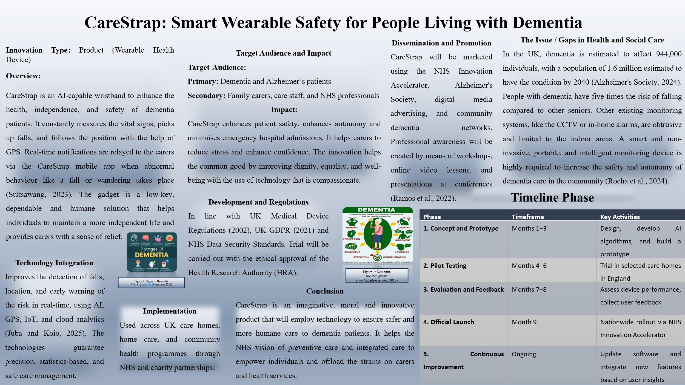

Task 2: Pitch
1. Introduction
Dementia is one of the UK's most pressing public health problems, which has a profound effect on patients and families, along with care systems. The Alzheimer's Society (2024) have estimated that there are currently more than 1 million people living with dementia in the UK, and this figure is projected to rise to 1.6 million by 2040. As the population ages, this increase will place increasing pressure on the NHS and local authorities for community-based and preventive care.
To help overcome some of these challenges, CareStrap has been designed as an innovative, technology-driven approach to helping to improve safety, independence and quality of life for those living with dementia. This AI description explains how a wearable wristband provides real-time health monitoring, GPS tracking, and automatic alerts to carers, delivering a proactive, compassionate approach to care (Paul, 2025).
2. The Problem and Need for Innovation
Dementia affects a lot more than memory - it affects movement and coordination and spatial awareness, and that leads to frequent falls and wandering. Individuals who have dementia have a five times greater risk of falling than other older people. The NHS spends millions of pounds every year dealing with dementia related injuries and emergencies (Hopkinson et al., 2021).
In the UK, dementia is estimated to affect 944,000 individuals, with a population of 1.6 million estimated to have the condition by 2040 (Alzheimer's Society, 2024). People with dementia have five times the risk of falling compared to other seniors. Other existing monitoring systems, like the CCTV or in-home alarms, are obtrusive and limited to the indoor areas. A smart and non-invasive, portable, and intelligent monitoring device is highly required to increase the safety and autonomy of dementia care in the community (Rocha et al., 2024).

Carers, both formal and informal, are suffering from enormous stress. 79% of unpaid carers report that they are adversely affected by negative mental health because of constant anxiety and workload (Carers UK, 2023). Current systems, such as home alarms or CCTV, are reactive, intrusive and are limited to an indoor environment.
CareStrap fills this gap with non-invasive and portable continuous monitoring. It allows the people who use the service to live more independently and gives carers the ability to quickly respond to behaviour that is in line with the focus on prevention and community-based support within the NHS.
3. Description of the Innovation
Care Strap is a smart wristband that includes artificial intelligence (AI), Global Positioning System (GPS) and Internet of Things (IoT) technology to monitor health and safety. It tracks critical signs such as heart rate, temperature and movement. If one experiences some irregular activity like a fall or wandering, the system automatically sends alerts to carers or healthcare professionals using a mobile app.
AI algorithms work by analysing motion data and removing false alarms by separating the real emergencies from regular motion. The wristband is lightweight, unobtrusive, waterproof and comfortable, which makes people wear them every day. Data is securely stored and used for transmission in order to allow carers and professionals to look at patterns and intervene early (Al Falasi, 2024).
4. Target Group and Community Impact
The key users are older people with dementia, especially those who want to stay in their homes or in supported living. Secondary users are family carers, care staff and NHS community nurses.
Impact: For patients, Care Strap means protection, without being undignified. For carers, it brings reassurance, reduces stress and helps them to respond better in an emergency. On a societal level, it helps support health equality and inclusivity by supporting safety and the accessibility of care technology.
5. Alignment with UK Policy and Legislation
Care Strap supports several national frameworks that guide UK health and social care innovation:
- NHS Long Term Plan: Encourages digital and preventive health tools to reduce hospital admissions and improve community care (Hampson et al., 2023).
- Health and Care Act (2022): Promotes integrated systems and collaboration between NHS bodies, local authorities, and innovators.
- Care Act (2014): Emphasises prevention and independence for adults with care needs.
- UK GDPR (2021): Protects personal health data and user privacy.
CareStrap is also in line with UK Medical Device Regulations (MDR 2002) and follows CQC Digital Care Principles (2023) to ensure ethical, safe, and person-centred technology.
By aligning itself in line with these policies, CareStrap can fit into the UK's health innovation ecosystem, helping drive the goals of the country as well as individual wellbeing.
6. Technological and Ethical Considerations
The key to CareStrap's success has been trust and responsible innovation. The device uses encrypted data cloud servers and anonymised data to ensure the privacy of data users. Carers retain control of information sharing on a consent basis.
In accordance with the NHS Digital (2025) framework, its algorithms are open, checked routinely and designed in such a way to prevent bias or misuse. The product's "privacy by design" framework ensures that although technology can be a source of safety and efficiency, it never acts as a replacement for the human connection that is a necessary part of caregiving (Perrault, 2021).
7. Public Involvement and Dissemination
The secret to CareStrap's success is public participation. The initiative will be promoted through a partnership with the Alzheimer's Society, Age UK and the NHS Innovation Accelerator. Campaigns will involve the promotion through social media, video demonstrations and community events to build trust and awareness.
The public can contribute towards CareStrap by participating in dementia awareness programmes or volunteering in pilot studies or making donations to charity organisations that distribute devices to low-income families. This approach transforms CareStrap not just as an innovation in medicine, but a community movement that will encourage empathy, safety and inclusion.
Timeline
Phase | Timeframe | Key Activities
1. Concept & Prototype | Months 1–3 | Design, develop AI algorithms, and build a prototype
2. Pilot Testing | Months 4–6 | Trial in selected care homes in England
3. Evaluation & Feedback | Months 7–8 | Assess device performance, collect user feedback
4. Official Launch | Month 9 | Nationwide rollout via NHS Innovation Accelerator
5. Continuous Improvement | Ongoing | Update software and integrate new features based on user insights

8. Feasibility and Long-Term Benefits
CareStrap is cheap and scalable and is designed to be part of the NHS care systems and implemented on an individual basis. It provides a rechargeable battery, long-lasting parts and updates over the cloud, which results in cost-effectiveness and sustainability.
Long-term benefits are Fewer falls and emergency hospital visits, better independence and well-being of the users, better data collection for healthcare planning and decisions for policy, and minimised strain on the NHS as a result of early intervention and monitoring in the community.
It also helps the UK's Net Zero and Sustainable Healthcare Goals by reducing unnecessary travel and hospital stays, and it also reduces the carbon emissions from healthcare.
9. Conclusion
CareStrap is a revolutionary breakthrough for the dementias - technology meets empathy. It is protecting people who are vulnerable but allowing their independence, such as supporting carers emotionally and practically, and it fits in with the NHS's digital and preventive health priorities.
By ensuring adherence to UK regulations and encouraging ethical usage of AI, CareStrap proves that health technology need not be either innovative or inhumane. Its potential to improve quality of life, reduce inequalities and take the pressure off the system makes it a useful addition to the UK's health and social care landscape.

References
Al Falasi, H.A., (2024) Predictive Rescue System Through Real-time Accident Monitoring Leveraging Artificial Intelligence. Rochester Institute of Technology.
Alzheimer’s Society (2024). Dementia Statistics Hub. [online] Available at: https://www.alzheimers.org.uk/statistics [Accessed 11 November 2025].
Carers UK (2023) State of Caring 2023 — The impact of caring on health. [online] Available at: https://www.carersuk.org/media/xgwlj0gn/soc23-health-report_web.pdf [Accessed 12 November 2025].
Hampson, G., Neri, M., Napier, M. and Cookson, G., (2023). Reimagining Prevention for a Healthier, More Prosperous Society (No. 002465). Office of Health Economics.
Hopkinson, J.B., King, A., Mullins, J., Young, L., Kumar, S., Hydon, K., Muthukrishnan, S., Elliott, F. and Hopkinson, M., (2021). What happens before, during and after crisis for someone with dementia living at home: A systematic review. Dementia, 20(2), pp.570-612.
Juba, I. and Koio, M., (2025). Wearable IoT for Dual Monitoring: Real-Time Occupational Hazard Detection and Resident Fall Prevention. INTERNATIONAL JOURNAL OF AGEING, SAFETY, HEALTHCARE & SCIENCE INNOVATION, 1(3), pp.69-86.
NHS Digital (2025) AI knowledge repository. [online] Available at: AI knowledge repository - NHS England Digital [Accessed 12 November 2025].
Paul, J., (2025). Real-time predictive health monitoring using AI-driven wearable sensors: Enhancing early detection and personalized interventions in chronic disease management.
Perrault, S., (2021). Towards Inclusive Design of Mobile Privacy and Security for Older Adults (Doctoral dissertation, Ph. D. Dissertation. Singapore University of Technology and Design).
Ramos, J.L., Cattaneo, A.A., de Jong, F.P. and Espadeiro, R.G., (2022). Pedagogical models for the facilitation of teacher professional development via video-supported collaborative learning. A review of the state of the art. Journal of Research on Technology in Education, 54(5), pp.695-718.
Rocha, I.C., Arantes, M., Moreira, A., Vilaça, J.L., Morais, P., Matos, D. and Carvalho, V., (2024). Monitoring Wearable Devices for Elderly People with Dementia: A Review. Designs, 8(4).
Suksawang, S., (2023). Designing Smart Tech Solutions for Enhanced Aging in Place: A Caregiver Evaluation (Master's thesis, University of Pittsburgh).

