COMPARISON OF MARRIOTT INTERNATIONAL AND HYATT HOTEL'S APPROACHES TO FINANCIAL MANAGEMENT

Name -Ionela Violeta Baicu
Student ID- 2122260
Financial Management for the Hotel Industry
BMIH 5002
Lecturer-Dale Clarke

Table of Contents
Introduction 3
Total revenue 3
Market position 5
Growth potential 7
Financial commitment to Corporate Social Responsibilities (CSR) 8
Conclusion 10
Recommendation 11
Reference list 12

Introduction
The Marriott International and Hyatt Hotels are known as repudiated hotel networks with various countries for its presence. Their method for managing financial management basically influences their overall performance and ability to deliver possible turn of events. This study is to take a gander at the frameworks of the two associations in key financial management, for instance, total revenue, pay, market position, improvement potential, and financial commitment to CSR.

Total revenue
Total revenue is a key financial pointer that reflects an organization's overall presentation and ability to make revenue. Because of Marriott International and Hyatt Hotel, both the organizations have displayed reasonable financial performance of managing their overall fundamental concern. In view of its wide picture portfolio and overall presence, Marriott International has dependably conveyed interesting and quick system. As of September 2021, the organization outright payment of $10.6 billion. Different components can be credited to this immense turnover (Zhang, 2023). Marriott International works with a wide association of more than 7,800 lodgings all over the planet, empowering it to show up at a broad assortment of market sections and deal with various client tastes. Since the association can offer various brands and comfort decisions, it can attract a greater client base and produce higher pay.
Moreover, Marriott International has executed practical revenue systems to enhance everyday pay. The association uses data assessment and development to progress in assessing and paying the leaders and stock portion across its workplaces. This approach unequivocally sets room rates, development and pay, and further creates in everyday association money-related execution (POPȘA, 2021). Hyatt Hotels works fewer lodgings than Marriott around the World, yet overall, it has achieved estimable pay. As of September 2021, outright Hyatt dwelling pay is represented at $3.4 billion. The association's salaries are most likely going to be lower and appeared differently in relation to Marriott International, but it is basic to consider the association's accentuation on the luxury and upscale market pieces.
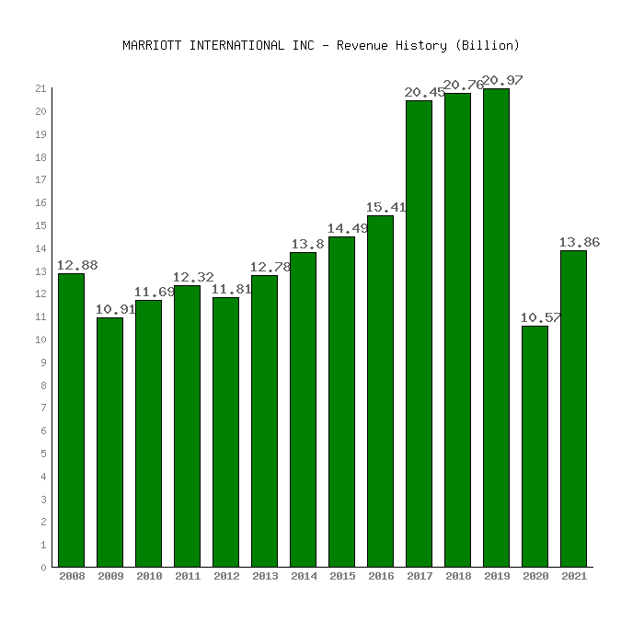
Figure 1: Marriott international revenue
(Source: https://www.netcials.com)
Hyatt Hotels conclusively positions itself as an extraordinary hotel brand to resolve the issues of realizing pilgrims searching for quality offices and organization. This drawing in arranging has enabled the association to achieve top-level room rates and produce immense pay per open room (RevPAR) from excess properties (Bourke et. al. 2020). Also, Hyatt Hotels has completed strong pay and the leader's strategies to smooth out overall pay. We use dynamic assessing strategies that change room rates considering revenue and monetary circumstances. This approach licenses Hyatt Hotels to charge higher rates during top periods and stay aware of serious rates during off-top periods, expanding pay potential.
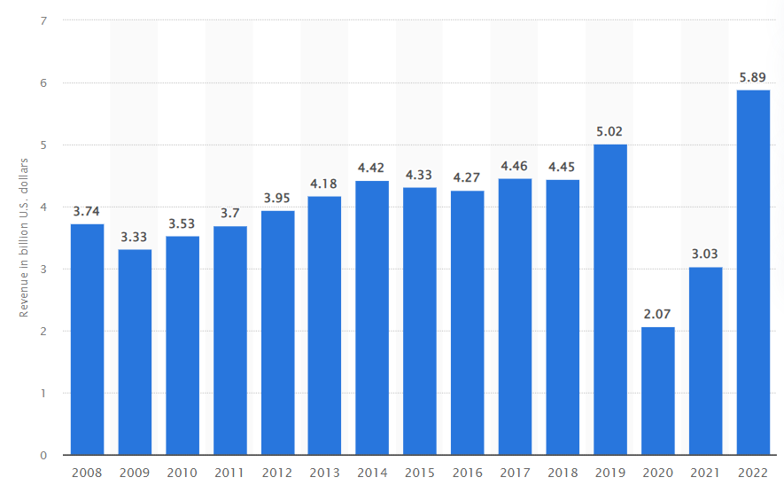
Figure 2: Hyatt international revenue
(Source: https://www.statista.com)
In overview, Marriott International and Hyatt Hotels have executed practical money-related organization approaches while pondering hard and fast pay (DeFrancoet. al. 2020). Marriott International's expansive picture portfolio, overall presence, and revenue strategies position the association as a trailblazer in the paid age in the housing industry. Meanwhile, Hyatt Hotels strong arranging in the luxury and style segments got together with its revenue management technique engaged it to achieve excellence as a rule while working fewer hotels.

Market position
Marriott International and Hyatt Hotels are spread-out convenience associations known by and large for their capacity as hotel and resort leaders. With respect to financial organization and considered market positions in unambiguous locales, the two associations take on a fundamental methodology to extend efficiency and a slice of the pie (Sharma et. al. 2021). One of the world's driving hotel associations, Marriott International relies upon a separate portfolio and strong brand presence. We have areas of strength for an organizational procedure spun around three key points of view:
Asset light philosophy, brand division, client support.
Marriott's asset-light philosophy is to act essentially as a franchisor and hotel boss rather than guaranteeing the real properties. This approach grants you to make a steady progression of pay through the foundation and the board charges without paying the huge costs related to guaranteeing land (Krupskyiet. al. 2019). Impact your picture reputation and fitness to attract and collaborate with monetary sponsors and land proprietors to develop your market presence. To the extent that brand division, Marriott has a widened plan of brands covering different market segments like luxury, polish, mid-reach, and economy. They warily assess neighborhood market potential and select the most fitting brands to spread out or develop their presence. This division strategy grants us to attract numerous clients and serve the necessities of different market segments. Marriott Bonvoy, Marriott's persistent program, expects a huge part in our financial organization approach (Čelićet. al. 2021). Increase client constancy and make repeat business by offering select offers, compensates, and modified experiences to your ardent clients. Unwavering quality projects furthermore give huge data and pieces of information that help you with understanding client tendencies and architect your organizations suitably, in like manner driving pay advancement.
Another enormous player in the housing industry, Hyatt Hotels, embraces a similar technique to financial organization, but for specific wonderful characteristics. Hyatt bases this on its three key strategies. Overall turn of events, brand detachment, useful efficiency. Hyatt's overall improvement methodology integrates recognizing and entering creating business areas and underserved regions with high advancement potential. They circumspectly explore market examples and set targets consistent with brand arranging and advancement goals (Ghannadian and Vahlberg, 2022). This approach licenses you to spread out significant solid areas for a presence in different regions and catch a slice of the pie preceding fighting.
Brand detachment is a middle piece of Hyatt's money-related organization approach. They have an alternate game plan of brands, each serving a specific piece and offering an original experience. By highlighting the brand's uncommon selling suggestion, including creative arrangement, redid organization, and certifiable close-by experiences, Hyatt plans to attract knowing travelers who regard quality and particularity.

Growth potential
Given the region's improvement potential, Marriott International and Hyatt Hotels will apply a fundamental money-related organization method for managing quickly making the most of possibilities, and lifting benefits. Here is a blueprint of their philosophy:
As an overall leader in the kind disposition business, Marriott International bright lights on evaluating a district's improvement potential and definitively apportioning resources to get a slice of the pie. They direct all-around factual looking over and assessment to assess factors, for instance, monetary conditions, the movement business designs, structure headway, and contention.
Considering that getting it, Marriott seeks informed theory decisions to enter new business areas or foster its presence in existing business areas. They give land headway, rebuild, and promote resources for arranging stamps as a matter of fact (Chu and King, 2019). By means of warily surveying advancement potential, Marriott hopes to improve money-related adventures and produce long-stretch returns. Marriott uses associations and joint efforts to find significant opportunities for growth. They work with property fashioners, monetary supporters, and neighborhood councils to recognize and get ideal spots for motels. Such an association will allow the two associations to assuage the possibility and proposition money-related commitment while exploiting new business areas with high improvement potential. Hyatt Hotels similarly uses a key financial organization method for managing review and advantage from neighborhood improvement potential. They lead a broad market assessment, considering factors, for instance, market drenching, demand models, and client tendencies. Hyatt circumspectly evaluates market examples to recognize the most fitting brands for a particular space. Factors, for instance, target client section, ferocious environment, and market position are thought of. By changing its picture portfolio to common advancement potential, Hyatt hopes to improve money-related hypotheses and drive pay advancement.
Likewise, Hyatt is successfully searching for advanced open entryways in creating business areas and underserved districts. They eagerly screen overall examples, monetary markers, and government systems to recognize districts with gigantic advancement potential. By entering these business areas early, Hyatt hopes to gain an advantage and spread out solid areas before its adversaries (Simões, 2021). Both Marriott International and Hyatt Hotels underline financial organization approaches that engage them to apportion resources and gain from the area's improvement potential in fact. They impact brand strength, market data, and key associations to make informed decisions and smooth out money-related returns. These associations see the improvement ability of the area, pull out all the stops and attempt to stay aware of their managerial job in the kind disposition business.
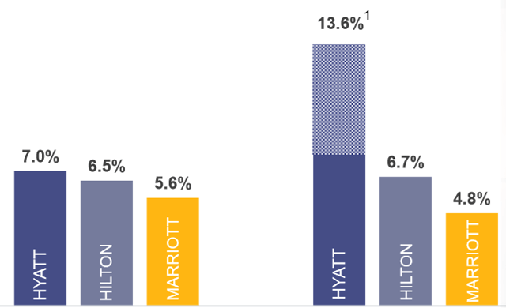
Figure 3: Growth rate of Hyatt, Hilton, and Marriott
(Source: https://seekingalpha.com)

Financial commitment to Corporate Social Responsibilities (CSR)
As global hospitality companies, Marriott International and Hyatt Hotels see the meaning of Corporate Social Responsibilities (CSR) and have made it their own, especially given their market position in the locale. Shows solid areas for embedding in financial organization moves close (Franco et. al. 2020). Marriott International treats CSR in a serious manner and has spread out a total legitimacy and social impact stage called Serve 360. As a part of this work, Marriott is focusing on its four key locales:
Draw in the existence, ensure liability, connect through an astounding entryway, welcome all, and advance fundamental freedoms.
According to a financial organization perspective, Marriott facilitates CSR considerations by giving resources to help plausible and proficient practices. They put assets into energy-capable headways, waste-lessening drives, and water security activities to restrict their biological impression. By executing sensible practices, Marriott means to reduce costs long term while comparing the presumptions of normally mindful explorers and accomplices (Gürlek and Kılıç, 2021). The commitment to CSR at Marriott goes past regular reasonability. They regard neighborhood and social impact by supporting close-by drives, propelling assortment and thought, and propelling normal freedoms. Marriott places assets into laborer planning and improvement undertakings to connect with individuals and develop open entryways for the capable turn of events. The association's money-related organization approach consolidates relegating monetary designs to neighborhood affiliations, noble causes, and social impact projects agreed with CSR targets (Maqalika, 2021). Hyatt Hotels moreover sees the meaning of CSR and has its own establishment called Hyatt Thrive. This obligation revolves around environmental reasonability, neighborhood, and trustworthy key approaches.
Moreover, Hyatt facilitates CSR thoughts by placing assets into viable establishments and executing energy capability measures at all properties. They revolve around resource efficiency, waste abatement, and the use of the feasible ability to reduce working costs while restricting regular impact. By using resources constantly, Hyatt tries to achieve money-related hold assets and overhaul its remaining green brand. Hyatt's commitment to CSR loosens up to neighborhood and social commitment. They work together with neighboring affiliations, support guidance and progression tries, and are worth supplier assortment (Calisto et. al. 2021). As an element of our method for managing money-related organizations, Hyatt circulates resources for neighborhood, liberality, and laborer volunteer tasks. By placing assets into the organizations in which we work, Hyatt attempts to vehemently influence society and collect strong relationships with our accomplices.
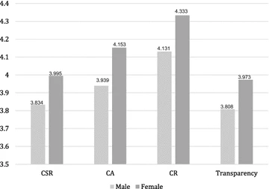
Figure 4: Corporate social responsibilities
(Source: https://springerplus.springeropen.com)

Conclusion
In conclusion, both Marriott International and Hyatt Hotels have increase branches of the organization to move close to the customers. Marriott International's size, upgraded plan of brands and essential acquisitions have enabled the association to get a basic overall piece of the general business. The association's reasonable pay-the leaders procedure and continued interest in new store openings add to its money-related accomplishment. Moreover, Marriott International’s commitment to CSR mirrors an understanding of the meaning of possible practices in the current business environment.
No matter what its more unobtrusive size, Hyatt Hotels has isolated itself in the market by focusing on the excess segment. The association's strong market position and money-related security are verification of its productive financial organization procedure. Hyatt Hotel's accentuation on practicality and neighbourhood reflects our commitment to reliable vital methodologies.

Recommendation
Considering the assessment worked out, these recommendations are proposed for every association:
- Marriott International ought to continue to broaden its overall impression by using its size and brand portfolio. We need to explore open entryways in creating business areas and put assets into advancement-driven drives to moreover additionally foster the client experience.
- Hyatt Hotels should focus on bracing its market position with lavishness and premium parts. Key associations and acquisitions should be considered to develop the portfolio and attract first-in-class clients.
- The two associations should continue to zero in on CSR attempts. They should spread out forceful legitimacy goals and successfully work with neighborhood organizations to influence society determinedly.

Reference list
Bourke, J.G., Izadi, J. and Olya, H.G., 2020. Failure of play on asset disposals and share buybacks: application of game theory in the international hotel market. Tourism Management, 77, p.103984.
Calisto, M.D.L., Umbelino, J., Gonçalves, A. and Viegas, C., 2021. Environmental sustainability strategies for smaller companies in the hotel industry: doing the right thing or doing things right?.Sustainability, 13(18), p.10380.
Čelić, I., Milićević, S. and Đorđević, N., 2021. Staff training and development: A comparative analysis of national hotels in Serbia and international hotel chains. Megatrend revija, 18(3), pp.89-110.
Chu, A.M.C. and King, B.E., 2019. Hotel industry leadership in greater China—A biographical comparison. Journal of China Tourism Research, 15(4), pp.563-588.
DeFranco, A., Koh, Y., Prem, P. and Love, B., 2022. Inclusion of condominium units in luxury hotels as a diversification strategy: Property performance perspective. Cornell Hospitality Quarterly, 63(1), pp.108-118.
Franco, S., Caroli, M.G., Cappa, F. and Del Chiappa, G., 2020. Are you good enough? CSR, quality management and corporate financial performance in the hospitality industry. International Journal of Hospitality Management, 88, p.102395.
Ghannadian, F.F. and Vahlberg, M.A.L., 2022. THE IMPACT OF THE COVID-19 PANDEMIC ON THE US LUXURY HOTEL MARKET. QRBD, p.119.
Gürlek, M. and Kılıç, İ., 2021. A true friend becomes apparent on a rainy day: corporate social responsibility practices of top hotels during the COVID-19 pandemic. Current Issues in Tourism, 24(7), pp.905-918.
Krupskyi, O.P., Dzhusov, O., Meshko, N., Britchenko, I. and Prytykin, A., 2019. Key sources when formulating competitive advantages for hotel chains. Tourism: An International Interdisciplinary Journal, 67(1), pp.34-46.
Maqalika, L.R., 2021. Corporate Social Responsibility (CSR) implementation in the KwaZulu-Natal hotels-barriers and drivers (Doctoral dissertation).
POPȘA, R.E., 2021. CONCEPTUALIZING BUSINESS MODELS OF INTERNATIONAL HOTEL CHAINS. RevistaEconomica, 73(2).
Sharma, A., Shin, H., Santa-María, M.J. and Nicolau, J.L., 2021. Hotels' COVID-19 innovation and performance. Annals of Tourism Research, 88, p.103180.
Simões, A.V.C., 2021. Equity valuation of Marriott International (Doctoral dissertation).
Zhang, J., 2023. Analysis of Strategic Human Resource Management Practices: A Case Study of Hilton Worldwide. Frontiers in Business, Economics and Management, 8(3), pp.204-211.

