Introduction to Web and Database Concepts
Assignment: Database Analysis and Design
Tirion Jane Baker Wall
Student number: 2023509
BSC-PT Computing (Software Engineering)

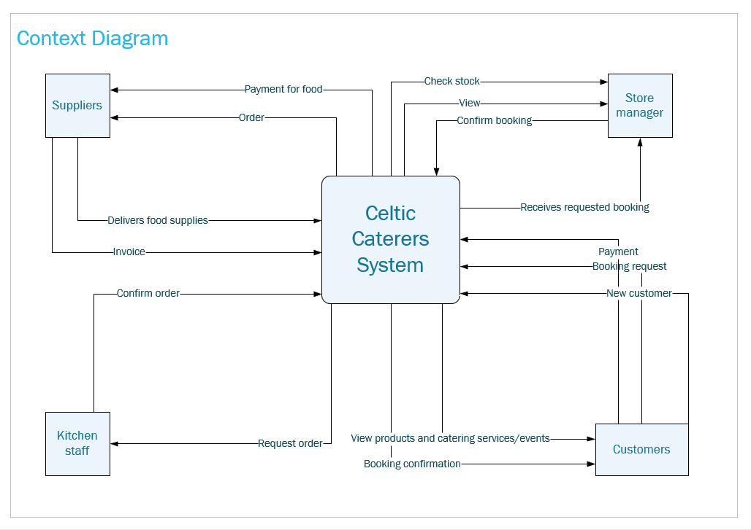
Context Diagram
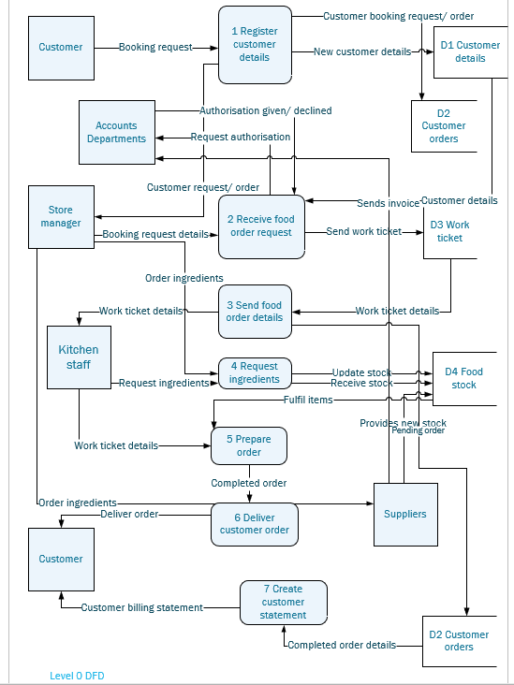
Level 0 DFD

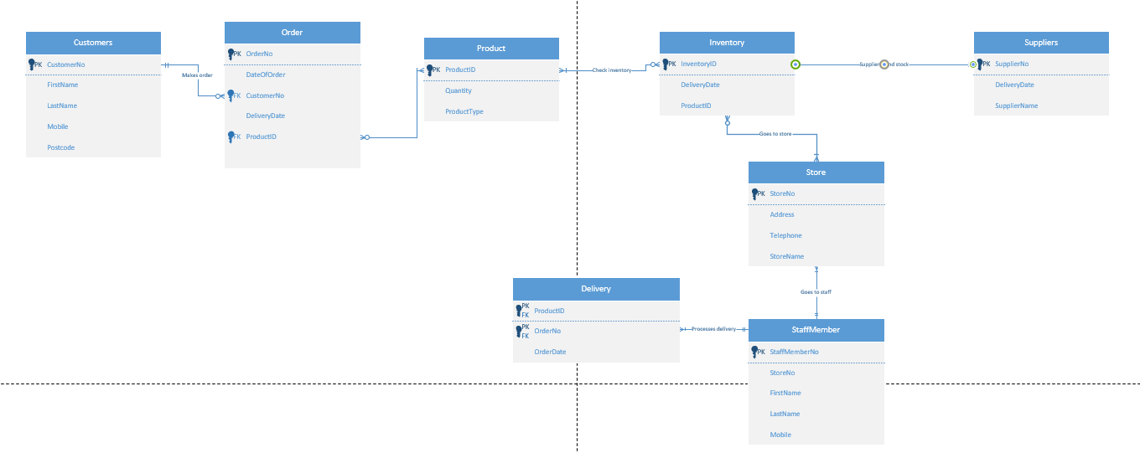
ERD

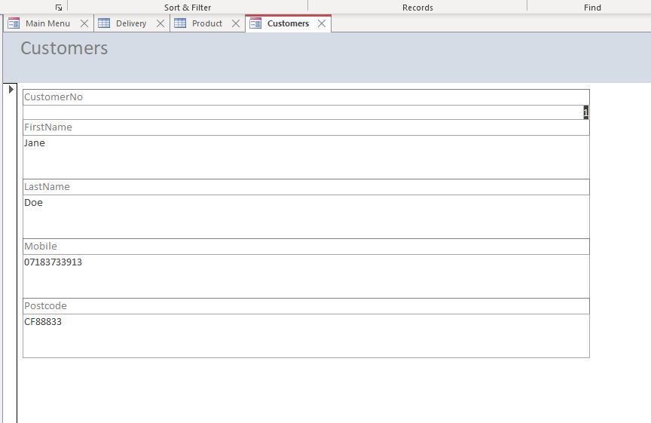
Macro query

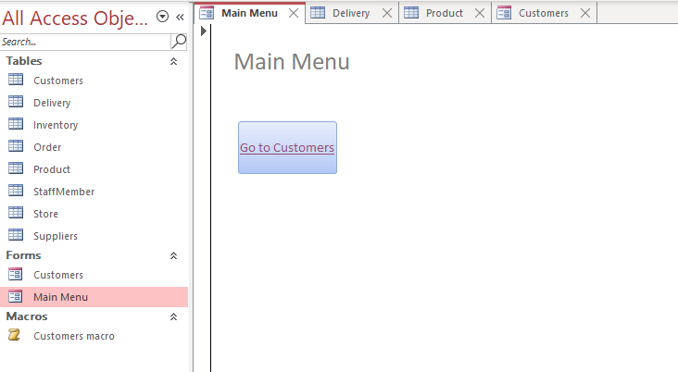
Main menu form – selecting ‘Go to Customers’ takes you directly to the customer’s forms. I have made it so it is read only, meaning customer information cannot be accidentally deleted by users.

