Transmission Matching Report
Name – Danielle Haynes
Student Number - 1901219
Lecturer - Abi Summerfield

Contents
List of Figures 3
Introduction 4
Experimental Procedure 5
Calculations 6
Results Analysis 10
Conclusion 11
References 12

List of Figures
Figure 1. Transmission Efficiency 6
Figure 2. Torque at the Wheels 6
Figure 3. Graph - Wheel Torque vs Engine Speed 6
Figure 4. Tractive Effort 7
Figure 5. Graph – Tractive Effort vs Road Speed 7
Figure 6. Final Drive 7
Figure 7. Maximum Tractive Effort 8
Figure 8. Speed Ratio 8
Figure 9. Theoretical intermediate gear ratios 8
Figure 10. Maximum Road Speed 9
Figure 11. Graph - Maximum Road Speed 9
Figure 12. Maximum Road Speed per Gear 9

Introduction
During this investigation performance data will be collected and analysed by part of a transmission analysis team. Data collection will be conducted on a BMW 1000rr on a chassis dynamometer to assess results. A specific gear ratio will be chosen as well as a different engine, road speeds, recorded tractive effort and the power at the road wheels. Once this data has been gathered it will be calculated and converted into an excel spreadsheet. Graphs will then be created and compared.

Experimental Procedure
The first part of this assignment was to conduct a chassis dynamometer test in order to collect data. This task was completed in a small group to ensure that all members collected accurate results whilst not having too many participants that the test may become unsafe.
The vehicle was set upon the dynamometer and had already been warmed up prior to the group entering. The motorbike was strapped down so that it could not move, and a barrier was placed so that a minimum safe distance was used. Ear protection was provided and the air extractor was switched on. The technician set up the computer data to show the group what each part was used for and the test began. The data on the dynamometer was steadily increasing as the bike was revved higher and a graph showed the results increase. As it reached its peak the bikes revs were slowly and safely decreased to idle speed. Once it has reached idle speed the bike was left to run for a few minutes and then switched off to look at the recorded data.
Once the test was complete the data was given to each individual so that the data could be calculated.
Working in groups, it was decided that 5th gear would achieve the best results for the task. The motorbike that was used is a BMW S1000 RR that is a 4-cylinder in-line engine with 999cc. At its peak the output is 207 HP at 13,500rpm and the maximum engine speed is at 14200rpm. (bmw motorrad S1000RR, 2020)

Calculations
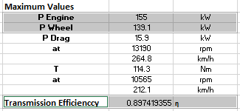
An excel spreadsheet was used to calculate the results of the engine dynamometer. To calculate the transmission efficiency of the motorbike the power at the wheels is divided by the power at the engine. Transmission efficiency is a measurement of how well the drivetrain is able to put power down through the wheels from the powertrain.
Figure 1. Transmission Efficiency

The torque at the wheels is calculated by multiplying the torque at the engine, the primary gear ratio, the final drive ratio, the 5th gear ratio and the transmission efficiency.
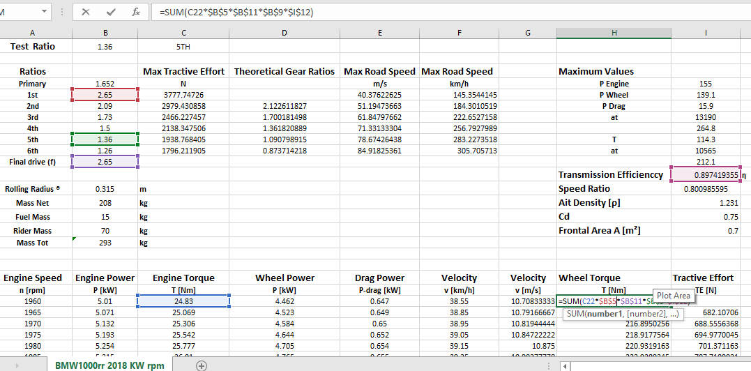

Figure 2. Torque at the Wheels
This graph shows as the engine speed increases the torque also slightly increases until it reaches its peak and then it evens out until it drops down drastically. This shows that when the bike is at its lowest engine speed which is 2000rpm the wheel torque is at 200Nm and as it increases 3000rpm the torque is 400Nm and as it increases steadily from 4000rpm – 600Nm until it reaches 10000rpm and 1000 Nm which is where the torque reaches its peak until 14000 and it drops substantially.
Figure 3. Graph - Wheel Torque vs Engine Speed
The Tractive effort is calculated by the torque at the wheels divided by the rolling radius. A graph was made to show these results. The tractive effort is the force that is used to turn the roller on the dynamometer for traction.
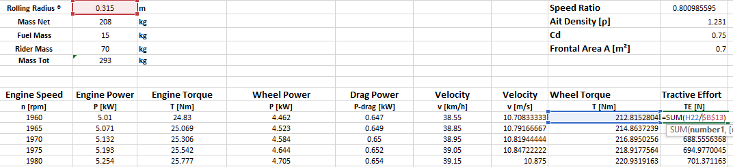
Figure 4. Tractive Effort
This graph shows the same pattern as the wheel torque graph, as the rpm increases so does the tractive effort until it reaches its peak at 10000 rpm which is just over 3000N until the rpm reaches14000 the tractive effort drops.

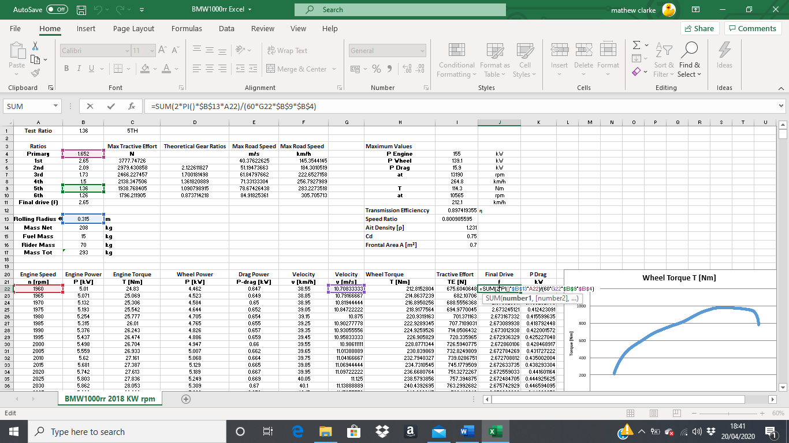
The differential ratio must be confirmed as 4.1:1 by using the formula $\frac{2πRN}{60Vnp}$ and rearranging it to make final drive the subject so, 2 multiplied by π, the rolling radius, engine speed the divide by 60, the velocity the gear ratio of the 5th ear and the primary. The average is then taken to see the variation from 2.65 which is a little higher at 2.698247835 one of the reasons this could be the result is that the test conditions were inside without any outside contributing factors.
Figure 5. Graph – Tractive Effort vs Road Speed

Figure 6. Final Drive

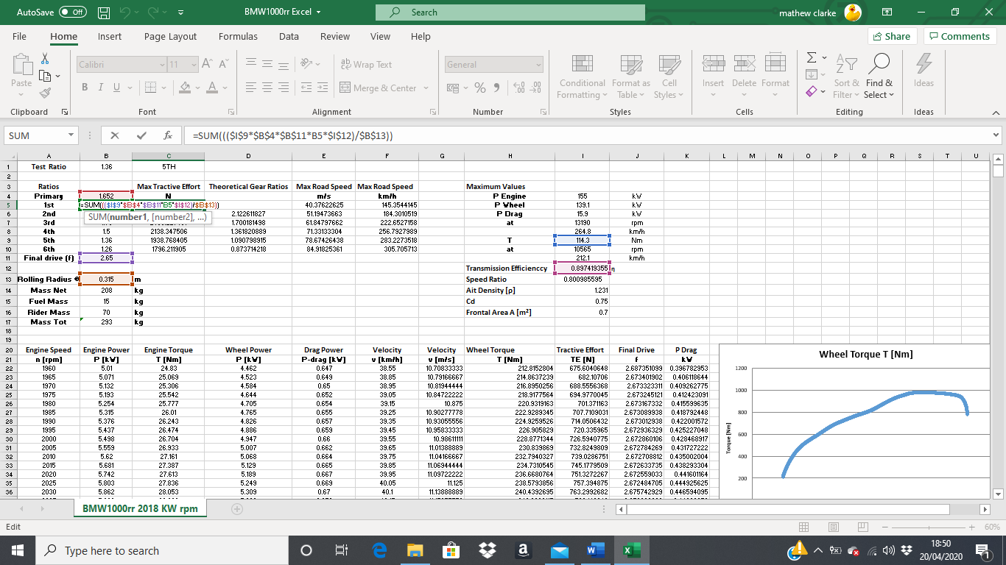
The maximum tractive effort in each of the gears once they are at their maximum torque, to work this out the maximum torque is multiplied by the primary, final drive, the 1st gear ratio, transmission efficiency, which is then divided by the rolling radius. This figure is then changed for each of the gears.
Figure 7. Maximum Tractive Effort
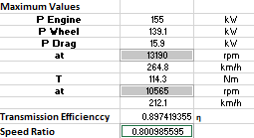
To find the speed ratio the maximum torque engine speed is divided by the maximum power of the engine speed. This shows how fast the teeth can move in response to each other.

Figure 8. Speed Ratio

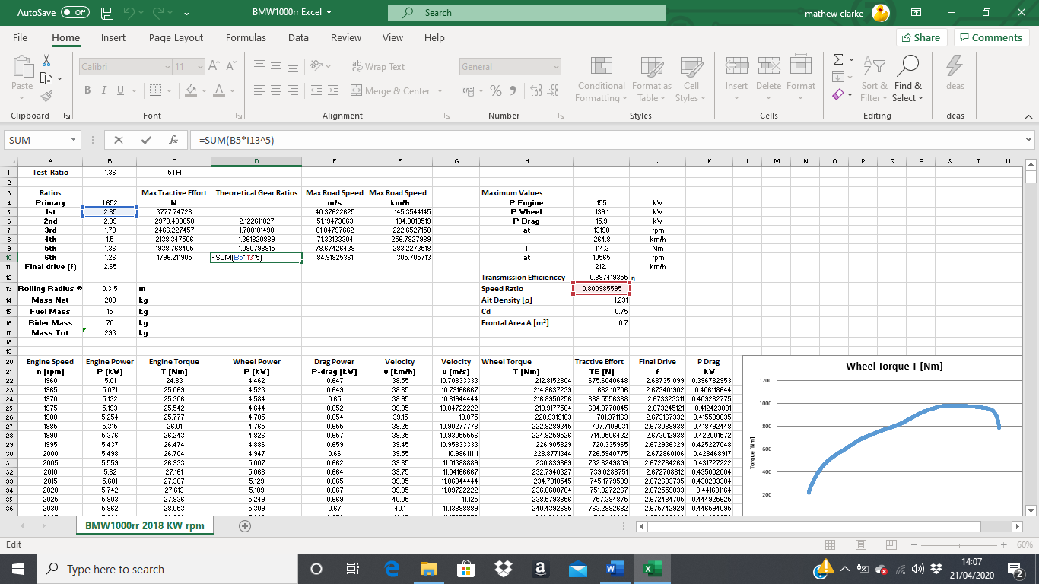
The theoretical intermediate gear ratios are worked out for each gear, the first calculation for the 2nd gear is the 1st ratio multiplied by the speed ratio, for the 3rd gear ratio it is the 1st ratio multiplied by the speed ratio twice and so on for each ratio.
Figure 9. Theoretical intermediate gear ratios

The equation to work out the maximum road speed that it achievable is ½ multiplied by rho, the coefficient of drag, the frontal area of the vehicle including the rider, the velocity cubed.
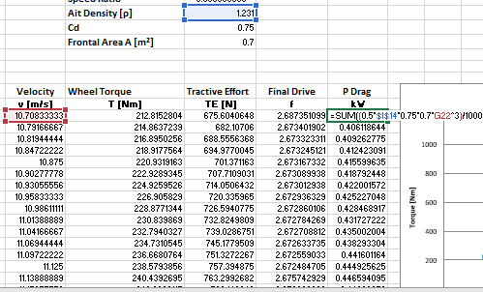
The rho or ρ was worked out for the area of Llanelli during a slightly sunny day (BBC Weather, 2020) and the area is near a beach to there is substantial wind. To work out this figure the weather was found with the wind speed, temperature and air pressure which was then converted using (Air Density Calculator, 2020).
Figure 10. Maximum Road Speed
This chart shows that the faster that the vehicle is travelling the more drag is creates, this is because the harder the vehicle is working the more power is being exerted as the speed increase. At the beginning of the test the Power Drag shows not to be increasing by much but as the velocity reaches between 30-40 m/s it starts lifting.
Figure 11. Graph - Maximum Road Speed

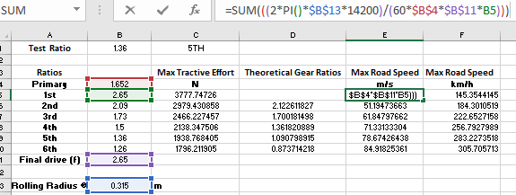
The maximum road speed is lastly calculated in all gears if N is at 6000rpm so it is 2 multiplied by π the rolling radius, the maximum engine speed then divided by 60 times by primary, final drive and the 1st gear ratio.

Figure 12. Maximum Road Speed per Gear

Results Analysis
The goal of being part of a transmission analysis team and collection of the performance data that is used for the BMW S1000RR shows to be successful. The data received was imputed and calculated and shows that the results of this experiment that the BMW S1000RR is still running efficiently as the data has come back close to that of the results given from factory.

Conclusion
This assignment has been beneficial to the understanding into the uses of a dynamometer, the information that can be gained by using it, the safety and appropriate use of using it and the different vehicles that can use it. Using Microsoft excel to calculate results and see how all the different figures affect characteristics and how similar the results are with the specification that were given for the motorbike helped to understand the concept of transmission matching.

References
Air Density Calculator. (2020, 02 16). Retrieved from omnicalculator: omnicalculator.com
BBC Weather. (2020, 02 12). Retrieved from BBC Weather Llanelli: https://www.bbc.co.uk/weather
bmw motorrad S1000RR. (2020, 03 10). Retrieved from amw motorrad: https://www.bmw-motorrad.co.uk/en/models/sport/s1000rr-2019.html

