
DIGITAL SKILLS AND RESEARCH METHODS.
Report to DSR requirements for exploring the learning environment.
(BMSW4003-LON). (Suneth Fernando).
Monther Al Jaradat | ID (2009450) | The impact of Virtual

INTRODUCTION
This report covers a university to research the course I took, for information about what I learned in my course and what I learned from methods in purely, as well as the experience that was in the course, what was the study process that was and the things that were explained in the chapter. And the things included in the unit I learned.
I will talk and extract what I took in my course and apply it.
- OINTRODUCTION
1. What is virtual learning environment. It is an education platform, it is an online system for teachers, it is a system that allows the sharing of education materials over the internet for the students. Using tools to create educational content for students to learn. This is what I learned in a course on how to integrate with tools to create educational content for the purpose of learning in the use of the internet and added looking at ways to make materials accessible to student 24/7 as it’s a good thing for us, for me. Because there are also benefits, as I can access my work at any time, and I also have time to study and use internet anywhere and anytime 24/7, and I can commit to my time.
2.1 When was this concept introduced. Michalis Xeons states that “the term virtual classroom was introduced in 1986”. Starr Roxanne Hiltz, in the 1986 paper “Virtual Classroom”: Using Computer-Mediated Communication for University Teaching investigated the use of computers for education.
3.1 Who is using this technology. Those who use this technology are teachers and student, as it is an online education that teaches the lecture how to teach online and gives opportunities for student with an online learning problem to learn how to use the internet and how to use time effectively in study and even at work and other in the programs and how to use and work and how to search in different information.
4.1 Why it is important to research on this topic.
- It's flexible, it provides a special opportunity or pace between me and the stadium, and also flexibility in setting and coordinating dates or meetings between us. As a result, a better balance me and the teacher, the teacher, and the student, it also allows me to better control and manage my time in my work and personal life.
- It’s accessible, as online education allows me to study as I want, as I can study from any place and time, even if I am in a place, for example, on vacation or otherwise. I can study and search for a lot information, other than that, it is a study at home, too. I can save money for traveling to the university, and I can save it on something else.
- It allows for a customized learning experience, I mentioned before how flexibility helps determine the pace of study, but online learning is flexible and easy, and each student differs in their ability to learn, as the online classes are not bigger than the traditional class, but the online learning allows in the use of video, picture, books, library, teaching and discussion dynamic education.

2.0 BACKGROUND
2.1 What type of services this technology is providing. As virtual learning allows the teacher and student to communicate with each other at the same time in the lessons, and also as we can share each other’s screens to share information and also discuss between us in the study and also allow me and my friends to talk to each other in the fields of study and other many things.
2.2 Benefits how student are benefited and how the lectures. Online learning can benefit students learn a lot of new things, including using the laptop better, as some students suffer from a problem that they do not know how to use the laptop, and when they use it more, the harm will improve quickly for them, otherwise it helps in learning purely and expanding memory, and I speak from what I know, and I have learned. As for teachers, getting opportunities to teach students, we are now in covid 19, without the internet, they would not have been able to teach the students. Otherwise, the lecture can save time in preparing the information that he will explain during the class, and also learn new things such as learning technical skills.
2.3 What types of challenges faces by students.
- Distractions Everywhere, distraction could be present in a student’s room, I mean the sound of dog screaming, or something else that would stop the class, or some sounds that could be from the same students who didn’t pay attention to the mic.
- Technical Issues, what I mean is some students suffer from many problems in using their devices, problems with the mic, the camera, or sometimes the sound, as this is not good for any student, and sometimes the whole class stops because of a problem with one person, and it must have a solution.
- Some Students Being Left Behind, I mean some of the students may be shy or they don’t want to talk and that’s not a good thins because some of the students listen to what the lecture is saying and then they don’t understand a word and that’s a mistake.
2.4 What type of technologies required for virtual learning environment.
- Quality audio-video technology, with regard to virtual learning, and what are the tools or thins that help in online learning, which is the quality of the image and sound in the laptop or any other device, because if the image and sound are not good, the switch will not be able to communicate effectively in order to send information to each other, student and teacher, so everything must always be in device well.
- Ability to record sessions and videos, one of the advantages of online learning is that the student can memorize or record the class they or I took. If I want to watch the class again, I can do that and I can or we can also enter chat conversation and collect all the things that were sent by the teacher, and this is a very good thing.
- IT service options, as the IT service is very useful if there is any problem or anything we face in the class, not only we students and lecture can ask for support other than that they respond quickly to any question we ask, which makes them have a role in helping us in our studies.
2.5 What type of risks associated with this technology.
- Computer Knowledge, the lack of education is the use of the computer a source of concern because otherwise now there are people who cannot deal with the computer and this is a mistake as they cannot even use word, or power point and other programs.
- Self-Motivation, some students lose hope in learning online is possible from some difficult things or it is caused by they do not understand and this is not a good thing.
- Communication, students lack effective communication skills while learning online, lectures give assignments to improve reading and writing skills, but some students cannot do or avoid doing the work and this is a mistake.
2.6 What types opportunities associated with this technology.
Effective online learning environment engage students toward higher levels of thinking, promote active student involvement, accommodate individual difference, and motivate learners. And teaching online is flexible and convenient and the lecture can hold office house on weekends or at night and teach anywhere that there is internet access. Most online instructors fell they become better teachers In general because of a heightened awareness of what they do in the classroom.

- AMIS AND OBIJECTIVES OF THE RESEACH.
- To improve my skills and learn more.
- To demonstrate skills in learning use word and power point and others.
- To improve digital skills and employability skills.

OBJECTIVES.
- Research questions, hypotheses and objectives.
- To learn, practice and improve the research report skills.
- To learn and understand the research.

- METHOD
During my research I use the second search method to collect data and understand the services available in VLE, so I sent to my friends to collect some information from them, find out the faults and challenges they face, and I sent each person the questions so that I can collect from them the answers so that I can be able to complete my research.
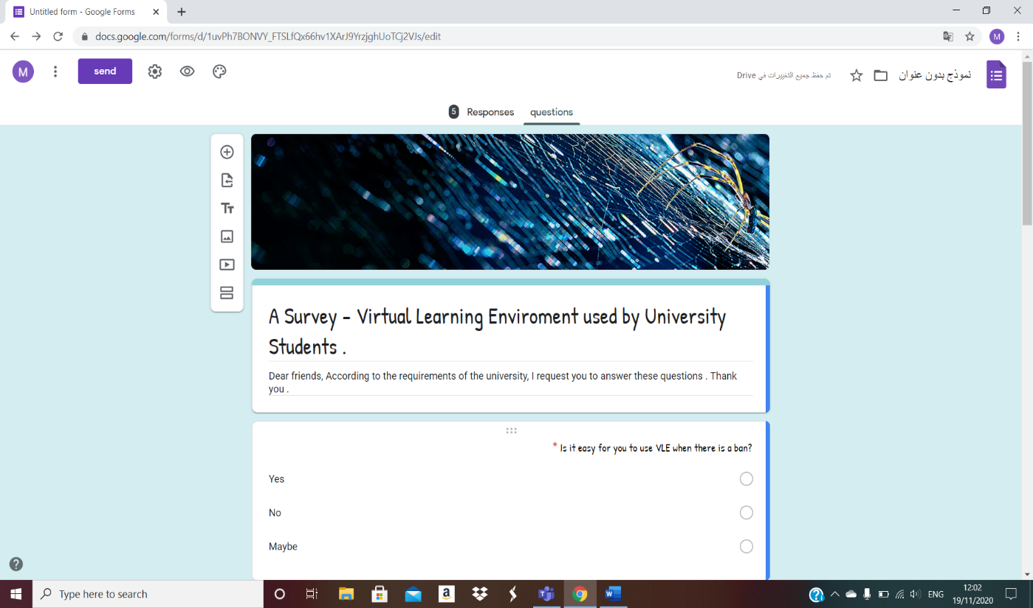
It was an enjoyable experience, in fact I learned new things and communicated with my friends and they did, like.

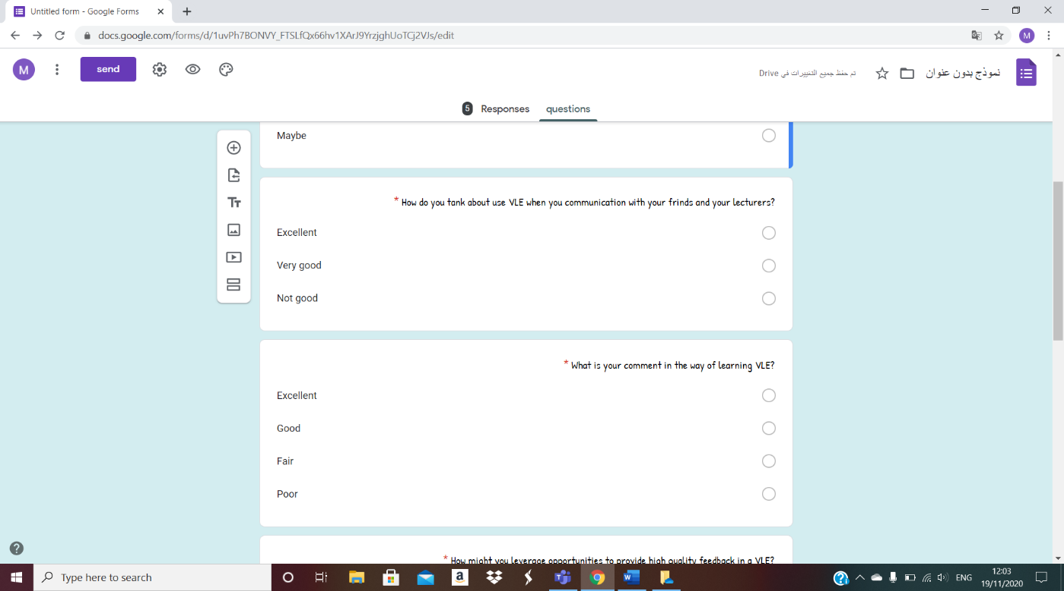

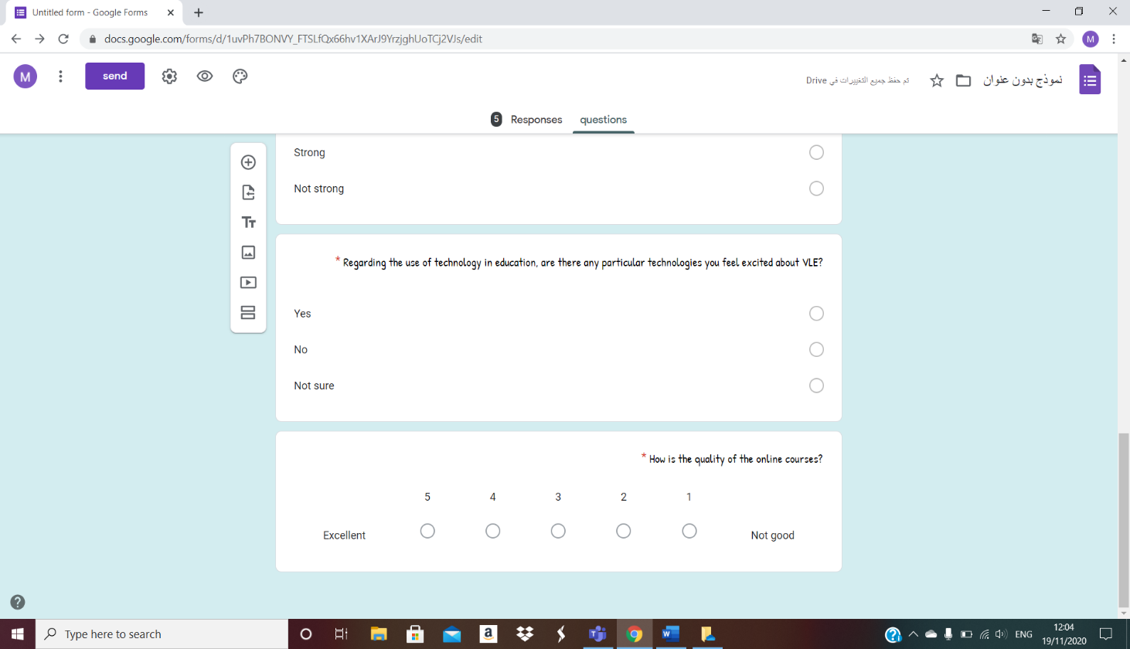
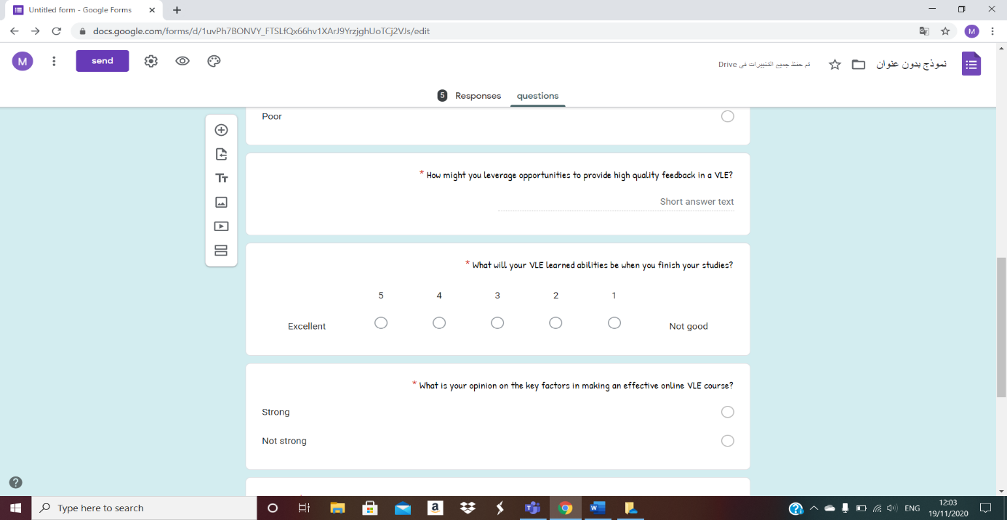
5.0 RESULTS
I collected the answers from my friends in order to be able to complete the report, and I divided the questions randomly, but there were numbers to know the questions.

note, this is a report from the first semester, but the problem is that I did not submit it correctly, and I spoke to the London assessment about this. And this is the explanation that you explained to us in the first chapter as you told us and what we should do after collecting 10 or 15 people from my class. And after you said we need to go to green excel and putting the tables with everything that you said, and other than that, the existing explanation, and the questions that we were asked, in order to answer and search for them and save them for ourselves.

Here I have collected the information of the first, seventh and sixth question with each other to find out the answer that I extracted from my friends.

A Questions | Yes | No | Maybe | Not sure | Strong | Not strong
Question 1 | 11 | 1 | 3
Question 7 | 8 | 5 |  | 2
Question 6 |  |  |  |  | 13 | 2

I collected the second and third question information together to extract the following information.

A Questions | Excellent | Not good | Very good | Fair | Good | Poor
Question 2 | 11 | 2 | 2
Question 3 | 2 |  |  | 4 | 9 | 0

I collected the fourth question and extracted the information from it on its own.

A Questions | Good things | Not good | Medium
Question 4 | 10 out of 10 | Do not, know | Good
Question 4 | Great | I do not know | Maybe
Question 4 | Opportunities | No idea | Good
Question 4 | Nice | Nothing

The fifth question is also alone with the information I extracted.

A Questions | 1 | 2 | 3 | 4 | 5
Question 5 |  |  | 4 | 8 | 3

The eighth question alone with its information.

A Questions | 1 | 2 | 3 | 4 | 5
Question 8 |  |  | 1 | 12 | 2

6.0 DISCUSSION

- I asked questions to my friends to find out the positives and negatives and it was interesting to know what they think, what is important to them, how they learned, and did they benefit from this pleasure experience, I got beautiful positives and some negative positive on some of the questions, but the excellent answers were also present and so on.
- It was an enjoyable experience for me. I learned a lot from the beautiful things in this course, and I shared with my friends working with each other, and I gained experience from this course.
- I learned from the course to use more than one program and divide my time and purely typing, and also that I can ask questions and answers, and there are many things that now helped me more and developed my skills in this course, such as using word and power point and others.
- I collected questions from the internet, it was not difficult or easy, but I searching for, I read it, I understood it before everything and wrote it.
7.0 CONCLUSION
It was enjoyable and important experience for me, and I learned many important and useful thing that helped me improve my skills in writing, the way I search for information and share topics, I learned how to use word and power point better, and how to think and use my time efficiently.
Some of the sties that I searched.
- Available at https://epale.ec.europa.eu/en/blog/what-vle-virtual-learning-environment
- Available at https://lightbulbmoment.info/2017/02/05/history-of-the-virtual-classroom/
- Available at https://www.educations.com/articles-and-advice/5-reasons-online-learning-is-future-of-education-17146
- Available at https://tophat.com/glossary/v/virtual-classroom/
- Available at https://blog.neolms.com/5-benefits-of-online-learning-for-educators/
- Available at https://www.meratas.com/blog/5-challenges-students-face-with-remote-learning
- Available at https://www.fenews.co.uk/fevoices/60658-7-technologies-to-successfully-migrate-to-the-virtual-classroom
- Available at https://www.embibe.com/exams/online-learning-challenges-and-solutions/
- Available at https://www.slideshare.net/pembertona/module-2-challenges-and-opportunities-in-online-teaching

Thank you.

