
‘AdventureWorks Cycles’ Database Design & Implementation’
Database and Application Development (ACCA5026)

Jonathan Lesmond (2300728)
BSc Applied Computing

Table of Contents
Table of Figures 3
Introduction 4
Database Design 5
Database Implementation 6
Creating the Tables 6
Adding Data to the Tables 8
Triggers, Transactions, Procedures and Savepoints 9
Performance Enhancements 11

Table of Figures
Figure 1 - Image of Proposed Entity Relationship Diagram 5
Figure 2 - Products Table. 6
Figure 3 - Customers Table. 6
Figure 4 – Orders Table. 7
Figure 5 - Manufacturers Table. 7
Figure 6 - Reviews Table. 7
Figure 8 - Inserting Values into Products Table. 8
Figure 9 - Inserting Values into the Customers Table. 8
Figure 10 - Inserting Values into Manufacturers Table. 9
Figure 11 - Trigger for Updating Stock. 9
Figure 12 - Results from Testing Code in Figure 11. 10
Figure 13 - Procedure for New Stock Delivery. 10
Figure 14 - Products Table Before and After Calling the Procedure in Figure 13. 10
Figure 15 - Updating Order Status with Transactions. 11
Figure 16 – Orders Table Before and After Executing Code from Figure 15. 11
Figure 17 - Rolling Back an Order. 11
Figure 18 - Creation of Indexes for Customer and Products Information. 11

Introduction
AdventureWorks Cycles are a well known retailer that specialises in the sale of a wide variety of bicycles and accessories produced by themselves or by other manufacturers. This report will be focused on the design and creation of a database to extend AdventureWorks’ reach to customers and also to renew their operations.

Database Design
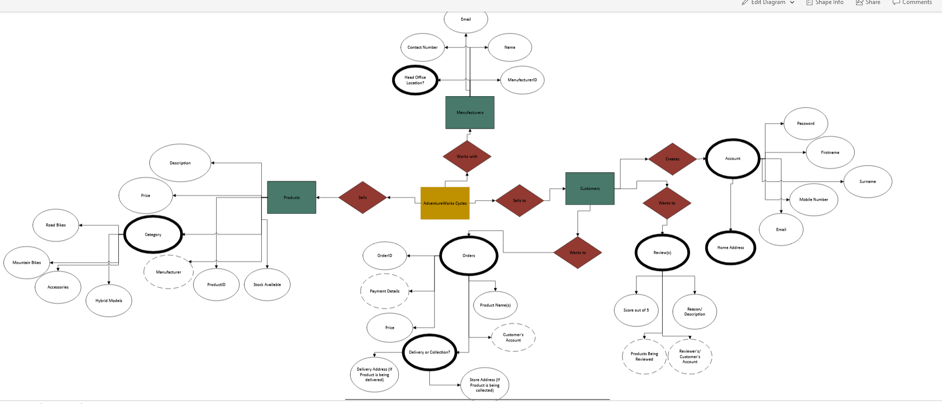
Figure 1 - Image of Proposed Entity Relationship Diagram
In my entity relationship diagram I plan the primary keys to be ID related e.g. Product ID, Order ID etc. which will help with easier retrieval of data. Foreign keys will mainly exist within the products, orders and Reviews table. In particular the foreign key in the products table will be the Manufacturer, in the orders table it will be the price of the product(s) and the customer’s account details (If they made an account), and in the reviews table it will also be the customer's account details alongside the details of the product that the customer wants to review.
The database will follow the 1st, 2nd and 3rd normal form design approaches. The 1st normal form (1NF) approach requires each row in a database to have one unique value and each row must be identifiable via a primary key, the 2nd normal form (2NF) approach includes 1NF with the addition of removing partial dependencies which includes creating separate tables for values that are related to multiple other values and then connecting the tables with foreign keys, Lastly, 3rd normal form (3NF) implements both 1NF and 2NF with the addition of requiring the removal of columns that don’t rely on a primary key and tables in 3NF can only be dependant on one primary key.[1][2]

Database Implementation

Creating the Tables
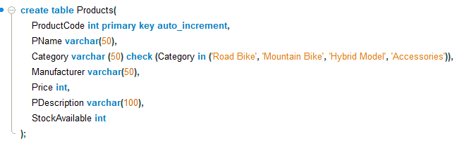
Figure 2 - Products Table.
Figure 2 shows part of my SQL code for the creation of the tables in the AdventureWorks database, a detail that I decided to use in the entire SQL program was giving unique labels for similar named columns, for example, ‘PName’ is short for Product Name as other tables such as the Manufacturers table in figure 3 will has similarly named column (‘MName’), doing this will be useful for tracking which products are owned certain manufacturers, Name is also a reserved word in SQL so labelling a column ‘Name’ will interrupt basic querying.
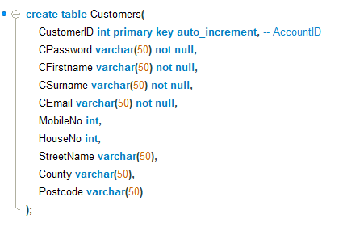
Figure 3 - Customers Table.
The customers table in figure 3 will allow customers to create an account with AdventureWorks. The password, first name, surname and email address columns are required to successfully create an account, this is because these values will be used to confirm orders.
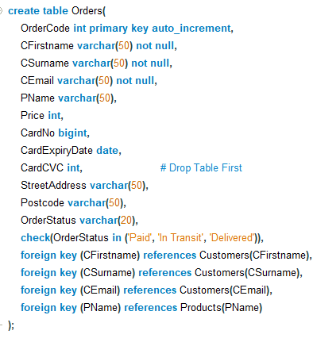
Figure 4 – Orders Table.
Figure 4 shows the orders table which will be the biggest and most complex table in the database due to the amount of information needed to complete an order, the table will also have foreign keys which are the customer’s first and last name as shown in figure 3.
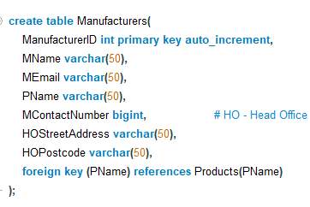
Figure 5 - Manufacturers Table.
Having a table dedicated to the manufacturers can help AdventureWorks in terms of ease of access to contact information, this will be useful if a product is reported as broken or if products have been recalled due to a defect etc.
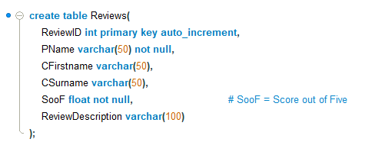
Figure 6 - Reviews Table.
A table for feedback will be created within the database to help AdventureWorks see what is going well and wrong with the quality of products or services that they offer, the reviews will use the popular format of a five-point Likert scale presented as ‘SooF’ in figure 5 to score the quality of products, ‘SooF’ will also be a required value as it is the most important part of the review it will also be defined as a float to help with more accurate ratings. The reviews table will also use foreign keys referring to the Product’s name and Customer’s first and last name.

Adding Data to the Tables
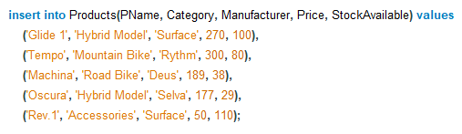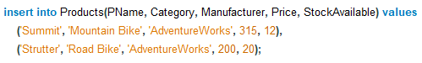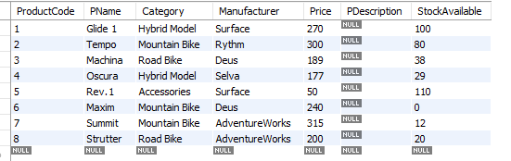
Figure 8 - Inserting Values into Products Table.
I decided to leave out the product’s descriptions so that it is easier to read and create, the product descriptions will be added as a separate line of code.
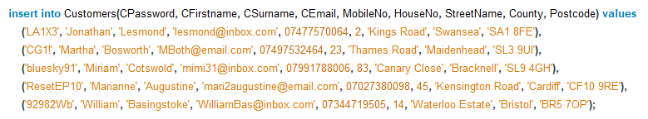
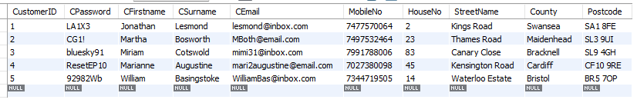
Figure 9 - Inserting Values into the Customers Table.
Because of AdventureWorks’ website, we should assume that they sell to customers across the UK and having multiple stores across the UK hence the widespread of customer’s home locations.
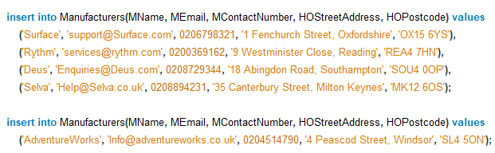
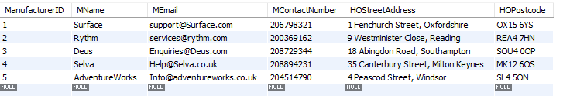
Figure 10 - Inserting Values into Manufacturers Table.
Similar to the Customer’ s table, we should assume that AdventureWorks work with companies based in different areas, for ease of implementation we will use UK locations.

Triggers, Transactions, Procedures and Savepoints
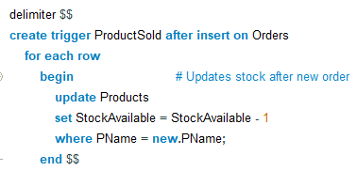
Figure 11 - Trigger for Updating Stock.
Figure 10 is a trigger to update the stock available for a specific product which initiates when a new record in the Orders table is made.
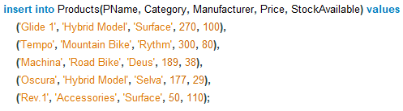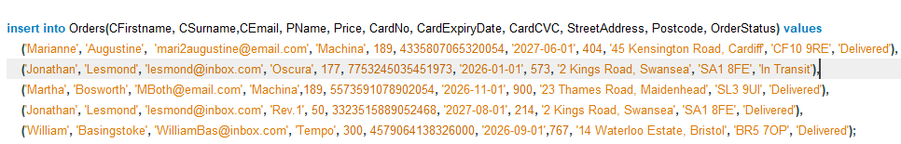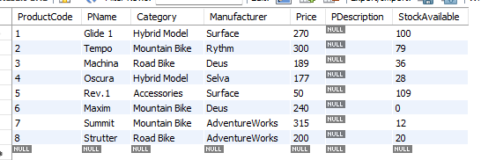
Figure 12 - Results from Testing Code in Figure 11.
Figure 12 demonstrates the effect of the trigger in figure 11 after inserting 4 records into the Orders table
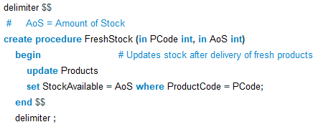
Figure 13 - Procedure for New Stock Delivery.
The procedure shown in figure 11 refreshes the amount of stock available in the products table to reflect the amount of fresh products received in the delivery.
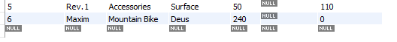
Before
After
Figure 14 - Products Table Before and After Calling the Procedure in Figure 13.
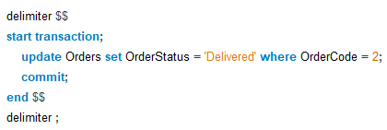
Figure 15 - Updating Order Status with Transactions.
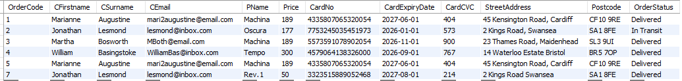
Before
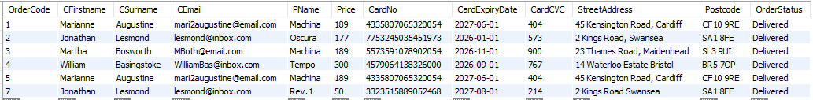
After
Figure 16 – Orders Table Before and After Executing Code from Figure 15.
Figure 14 shows an example of a transaction to change the order status of a specific record as shown in figure 15 after the execution of figure 14 every order has now been delivered.
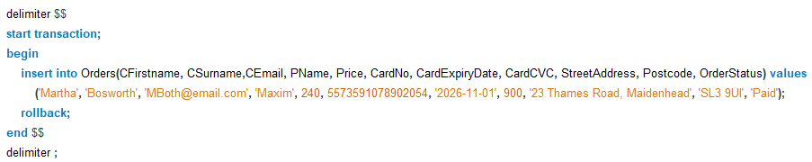
Figure 17 - Rolling Back an Order.

Performance Enhancements
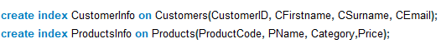
Figure 18 - Creation of Indexes for Customer and Products Information.
Indexes are useful for finding data quickly by making a pointer to the data into the table, this is especially useful in a table with a lot of records and have a set of columns that are frequently accessed, otherwise a normal SQL program will search each row one-by-one to fulfil a select query. [3] [4]

References
[1] M. Sarkar, "Database Normalization," [Online]. Available: https://uowtsd-my.sharepoint.com/personal/2300728_student_uwtsd_ac_uk/Documents/My%20Laptop/Database%20Application%20Development/Divya/Lectures/Normalization%20UWE%20Bristol.pdf?CT=1734697057926&OR=ItemsView
[2] D. Chidambaram, "Functional dependency and Normalization," [Online]. Available: https://uowtsd-my.sharepoint.com/personal/2300728_student_uwtsd_ac_uk/Documents/My%20Laptop/Database%20Application%20Development/Divya/Lectures/Week%202_Functional%20dependency%20and%20Normalization%20.pdf?CT=1734697062886&OR=ItemsView
[3] MySQL, "10.3.1 How MySQL Uses Indexes," Accessed: Dec 26, 2024, [Online]. Available: https://dev.mysql.com/doc/refman/8.4/en/mysql-indexes.html
[4] D. Chidambaram, "Advanced MySQL Concepts," [Online]. Available: https://moodle.uwtsd.ac.uk/pluginfile.php/1003066/mod_resource/content/1/Week%206_stored%20procedures%2C%20triggers.pdf

