30.03.2023
BSc, Coastal, Marine and WC

The Role of Zoos in Wildlife Conservation
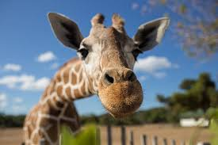
Lia Silva
2015055

Table of Contents
1
Introduction 3
What makes a zoo? 5
Conservation 5
In situ Conservation 7
Ex situ Conservation 7
Holocene 8
Recent extinction 9
Conclusion 11
Bibliography 13

Introduction

The first zoos originated from private collections of kings and nobles in the 19th century, whose main purpose was to demonstrate status, power, wealth, and personal entertainment for housing wild animals (Phillips, 2015). Zoos became taxonomic collections of species exhibited in cages for research and recreational purposes. Excavations point out that in 3500 BC, the site housed a zoo with about 113 animals, including baboons, elephants and even a hippopotamus calf (Phillips, 2015).

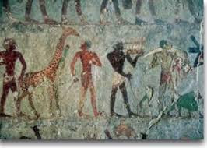
Figure 1: Wall Art of an Ancient Egyptian of the first zoos or animals exhibitors.

When they opened for visitation, about 200 years ago, restricted and privilege access collections were gradually transformed into public and cultural institutions, an environmental education centre, a place responsible for saving and protecting species, but still focused on entertainment (Phillips, 2015).

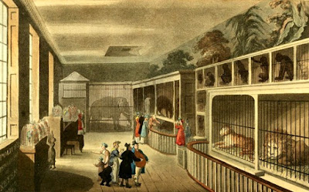
Figure 2: Royals menageries in/from France, in the first modern zoo in 1793.

In the 20th century, they were referred to as "living museums" due to their focus on displaying the various behaviours and habitats of animals. This historical period was marked by the beginning of a social and scientific movement that questioned the necessity and the true purpose of such institutions. As a result, zoos diversified their roles to also encourage conservation and further education.

Nowadays, due to environmental and social pressure, the role of zoos in the 21st Century has changed dramatically and are based on four (4) pillars:
- Conservation of species.
- Support for scientific research.
- Public awareness of environmental education.
- Providing leisure and entertainment to visitors.

Despite the criticism, keeping some species in captivity is the only solution to try to promote the recovery of endangered or already extinct populations (Kelly & Bartos, 1998).

According to Dr. Nigel Rothfels, author of Savages and Beasts: The Birth of the Modern Zoo, zoos had previously been founded in Vienna, Paris, and Madrid, but the London Zoo, founded in 1826, was the first step in the creation of the modern zoo (Phillips, 2015).

What makes a zoo?

Conservation

According to the World Association of Zoos and Aquariums (WAZA), the leading goal of modern zoos is conservation.

Zoological gardens require specialized professionals such as veterinarians, biologists and zootechnicians, who take care of food, setting up the enclosures, mental and physical health of the animals, among many other activities.

The morality of their existence in zoos is questioned on the grounds that they would be animal prisons, where the animals would live in degrading conditions. Zoos evolved a long time ago and left these aspects behind. Today, the conservation of biodiversity must be the mission that guides these spaces: they must provide well-being for animals, education for the conservation of fauna, research and, in addition, leisure and contemplation of nature (Clayton, 2016).

Society today does not recognize a zoo that does not carry out fauna research and conservation. It is a demand because the fauna needs it, and it is a demand because society demands it. The end of the zoo was the exhibition decades ago, today the end activity of the zoo is research and conservation. Exposure is a medium. A means of promoting environmental education, for us to maintain the reproduction of animals in captivity, it is a means for us to have resources to invest in conservation, it is not the end (Clayton, 2016).

The loss of their natural habitats is no doubt the greatest threat to the world's faunal species. Given the impossibility of life in nature due to the devastation of ecosystems, keeping individuals in captivity is a way to avoid the complete extinction of the species. There are numerous, well-documented examples of species extinct in the wild that have been recovered thanks to the work of captive breeding done by zoos (Clayton, 2016).

There is a global trend towards the adoption of methods that also encompass fragments of natural habitats (in situ conservation), but zoos generally benefit prominence for the conservation of species in captivity (ex situ conservation) (WAZA, 2005).

Most of these animals have fallen prey to mishaps like being ran over and burned as well as trafficking, illicit breeding, circuses, predatory hunting, and other crimes. After being sent to the facility, a trained staff attempts to rehabilitate these creatures and, where practical, returns them to the natural world (Tribe & Booth, 2003). The golden lion tamarin (Leontopithecus rosalia), which was nearly extinct between 1970 and 1980 with only 200 individuals living, is an excellent example. In the wild, captive-bred lion tamarins were reintroduced, and the population grew to over 1,000 individuals as a result of the collaboration between zoos (Tribe & Booth, 2003).

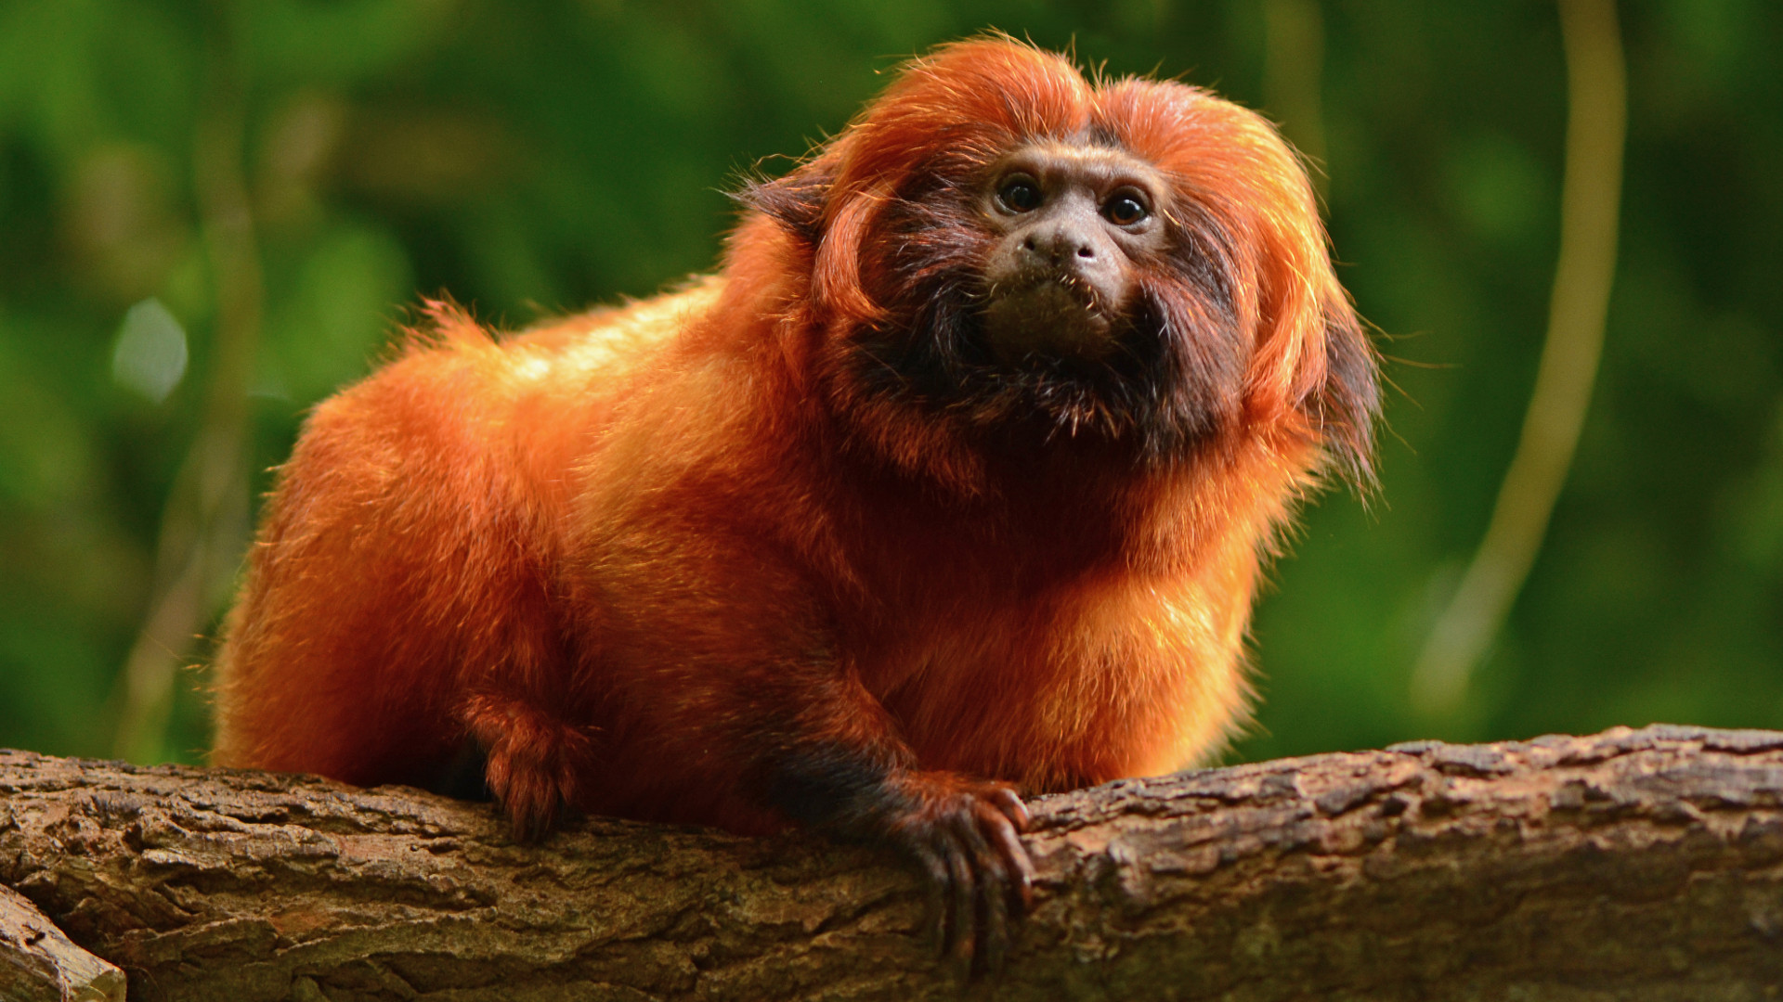
Figure 3: Golden Lion Tamarin from coastal Brazil.

For the preservation of biodiversity and the restoration of vulnerable ecosystems, integrated efforts that combine in situ and ex situ are essential.

The attitude of zoo employees and visitors in various nations regarding the institution's goals was examined in a study conducted in 2014 under the direction of researcher Katia Roe (Roe, 2014). The findings showed that both sides saw teaching as one of a zoo's primary purposes. In addition to the assumption that learning will take place in these settings, many urban dwellers lack access to nearby natural places where they might watch animals in their native habitats. Under these circumstances, zoos turn into the most practical possibilities for the populace to interact with environment and discover the value of conservation (Roe, 2014).

These locations often feature a team of environmental educators qualified to create instructional activities for the public. Such activities offer a great deal of potential to discuss environmental concerns and encourage tourists to act in a sustainable way, in addition to providing information about the fauna and flora from a biological point of view.

This becomes even more important when we take into account the potential impact of zoos, which, according to a WAZA estimate, along with aquariums, receive almost 700 million visitors each year. The majority of the institutions are open to the public, easily accessible, and situated in metropolitan areas, which increases their potential as settings for instruction, learning, and connecting with nature (WAZA, 2005).

Studies like Susan Clayton's (2011) suggest that visits to zoos may boost conservation support by encouraging a connection between people and wildlife in addition to offering educational opportunities (Clayton, 2011). According to the author, this connection happens when a person understands his dependency and sense of belonging to the natural world. It is therefore more probable that these people will cultivate a culture of respect for wildlife and the environment and adopt conservation-minded behaviours as a result (Clayton, 2011).

In situ Conservation

The preservation of biodiversity in the original natural settings is referred to as "in situ conservation." The management of the landscape using zoning and agroforestry systems, landscape rehabilitation or restoration, protected areas, and conservation units are some of the options that might be used (Clayton, 2011).

According to the International Union for Conservation of Nature (IUCN), a protected area is "an area of land or sea specially dedicated to the protection and maintenance of biological diversity, as well as associated natural and cultural resources, and managed or managed by legal or other effective institutional means".

There are some benefits to in situ conservation, including the following:
- Allowing species to continue their evolutionary processes.
- Favouring the protection and maintenance of wildlife.
- Providing better conditions for the conservation of wild species, especially plants and animals.
- Providing greater security in the conservation of species with recalcitrant seeds.
- Conserving pollinators and seed dispersers of plant species.

However, it should be remembered that this approach is expensive since it relies on effective and continuous management and monitoring, may call for extensive regions, which are not always feasible, and requires the preservation of a species in only one or a few sites where it occurs. does not imply that all its genetic diversity will be preserved.

Ex situ Conservation

Ex situ conservation, on the other hand, entails the upkeep of a biodiversity representation of scientific or socioeconomic relevance outside of its native environment, especially for the creation of research programmes, particularly those associated to genetic advancement (Clayton, 2011).

Ex situ conservation refers to maintaining species outside of their natural habitat and has the following main characteristics:
- Preserving genes for centuries.
- Enabling the collection of genetic material from various origins in one location, thereby facilitating the process of genetic improvement.
- Ensuring better protection of intraspecific diversity, especially of species with a wide geographic distribution.

Holocene

The Holocene extinction is often referred to as the "sixth extinction," as it may be the sixth mass extinction event overall, following the Ordovician-Silurian, Late Devonian, Permian-Triassic, and Triassic-Triassic extinction events. the Cretaceous-Paleogene extinction catastrophe, and the Jurassic. A mass extinction is defined as the extinction of at least 75% of the species within a geologically brief time frame. There is a lack of consensus about the boundaries between the Quaternary extinction event, which encompasses the end of the last ice age due to climatic change, and the Holocene, or human, extinction (Faheem, 2019).

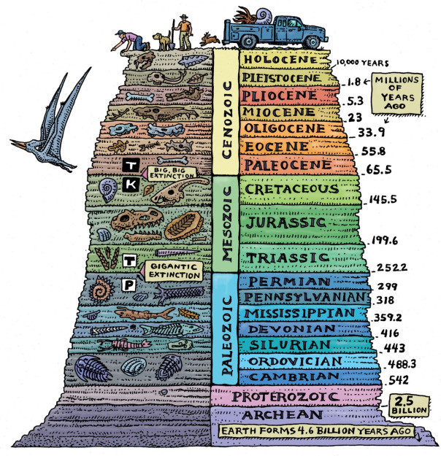
Figure 4: The Holocene extinction over the years.

The rapid extinction of megafauna following recent human colonization in Australia, New Zealand, and Madagascar supports the theory that anthropogenic extinctions may have begun as early as the first modern humans left Africa between 200,000 and 100,000 years ago. This is expected when any large, adaptable predator (invasive species) enters a new ecosystem. It is often claimed that even light hunting pressure, especially on isolated islands, was sufficient to eradicate big animals. Plants did not suffer significant losses until the most recent phases of the extinction.

Megafauna, or extinct huge terrestrial creatures, have been a feature of the Holocene extinction since the end of the last Ice Age. Megafauna outside of Africa, which did not evolve with people, proved to be extremely vulnerable to the introduction of new predators, and many perished soon after the first humans started to expand and hunt on Earth (additionally, many species African species also became extinct during the Holocene). Some people refer to these extinctions, which happened close to the Pleistocene–Holocene border, as the Quaternary extinction event.

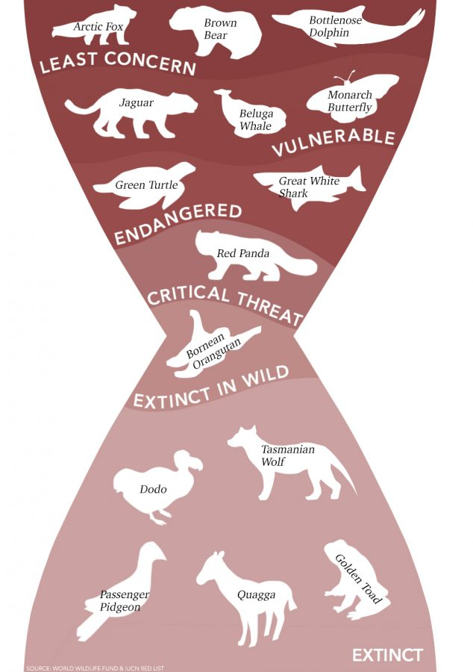
Figure 5: Holocene extinction threatens biodiversity.

Recent extinction

While past extinctions can be ascribed to other variables like global climate change, recent extinctions are more directly linked to human impacts. At least 875 species have vanished since 1500, according to the International Union for Conservation of Nature (IUCN), which defines "recent" extinctions as those that happened after that date. Several species, like the Hawaiian crow and Père David’s deer (Elaphurus Davidianus), are extinct in the wild and only exist in captive colonies.

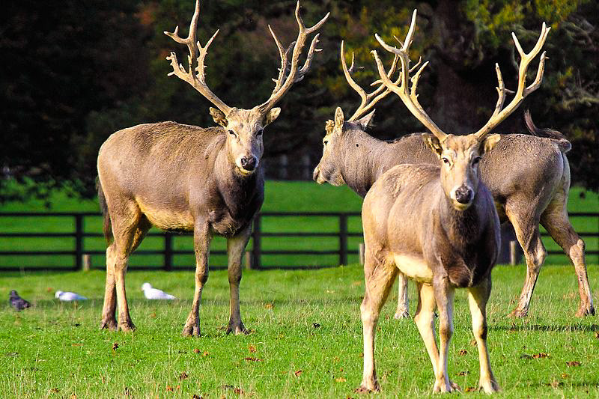
Figure 6: Père David's Deer (Elaphurus Davidianus).

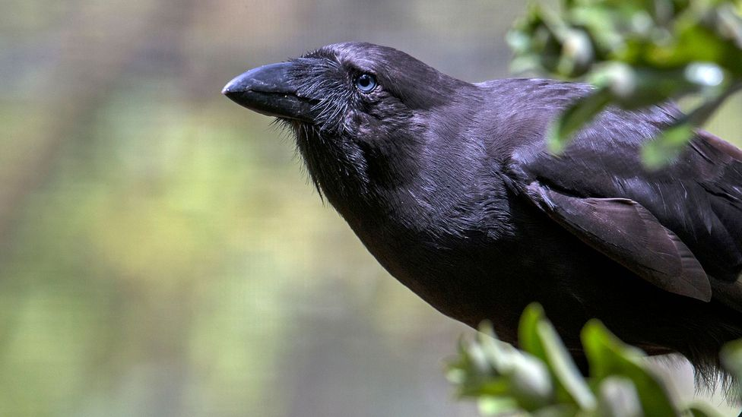
Figure 7: Hawaiian Crow (Alalā)

Some species, like the Florida panther, are ecologically extinct because they are so rare and have little effect on the ecology. Some populations, like the extinction of the leatherback turtle in Malaysia and the grey whale in the Atlantic, are merely regionally extinct (extirpated), still persisting elsewhere but with a smaller distribution.

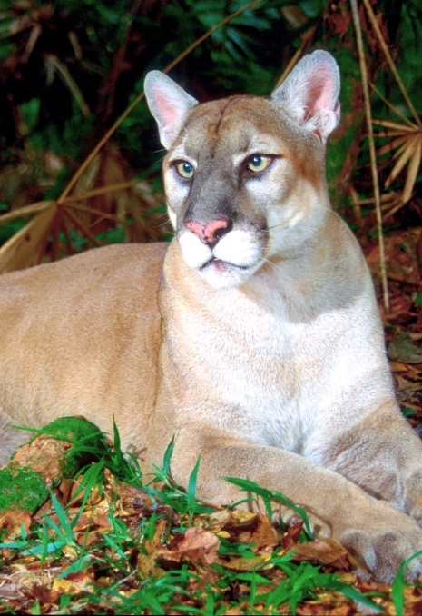
Figure 8: Florida Panther U.S National Refuge.

Yet beyond the books, things are a little trickier. Zoos serve as both cruel detention facilities and entertainment hubs, as well as locations where animals are killed, and species are saved. With incidents like the gorilla Harambe, the debate over these institutions' many faces is constantly reopened. In a zoo in Cincinnati, Ohio, where a 4-year-old child accidentally entered the animal's cage. When Harambe was put to death in front of everyone, it prompted the debate whether or not zoos are a good place for animals to be maintained.

Conclusion

Zoos play a crucial role in the protection of several species, particularly endangered ones. In a perfect world, animals would stay in their natural settings, negating the necessity for zoos. However, these habitats are being divided and damaged, and creatures are becoming extinct and being brought in illegally. As a result, these animals need a suitable location with qualified staff to ensure the proper management and wellbeing of everyone.

To satisfy the societal needs of zoos (such as those for teaching, research, and recreation), it is important to consider how to do so without jeopardising the welfare of the animals housed there.

In fact, merging these obligations is a significant task for zoos, made much more difficult when considering the limited financial resources. In order for these areas to have the structure and resources necessary to carry out their purpose and operate in the four pillars of conservation, education, research, and leisure, it is vital to advocate for higher investments and better circumstances in these areas.

People for the Ethical Treatment of Animals Australia campaign coordinator Claire Fryer states, "PETA doesn't think that animals are ours to utilise for pleasure. "All animals kept in zoos are deprived of their natural needs and wants”. They are instructed what to eat, when to eat, when they can sleep, and who they can mate with. Every element of their existence is regulated and controlled. Under the pretence of protecting the species, breeding operations produce an excess of less adorable adult animals, which are frequently exchanged, lent, sold, or put down when they are no longer desirable (Phillips, 2015).

Bibliography

Clayton, S. (2011) ‘The role of zoos in fostering environmental identity’, Ecopsychology Magazine.

Clayton, S. (2016) ‘Learning to Care about Animal Conservation’, Center for Humans and Nature.

Faheem, M. S. (2019) ‘Père David’s Deer (Elaphurus Davidianus) Endangered Animals Pictures, The Dynamic Nature. Available at: https://www.thedynamicnature.com/endangeredanimals/peredavidsdeer/elaphurus-davidianus-4/.

Gusset, M. & Dick, G. (2010) ‘The global Reach of Zoos and Aquariums in Visitor Numbers and Conservation Expenditures’, Zoo Biology Magazine.

Leite-Young, M. (2002) ‘Leaving the ark: Project Lobo-guará (maned Wolf) at the Belo Horizonte Zoo Brazil’, International Zoo News Magazine.

Phillips, K. (2015) ‘The Ethical evolution of Zoos’, ABC. Available at: https://www.abc.net.au/radionational/programs/rearvision/the-ethical-history-of-zoos/6869776.

Platt, J. R. (2018) ‘How the Golden Lion Tamarin is Helping to Heal Brazil’s Rainforest’, The Revelator Wild, Incisive, Fearless.

Roe, K. (2014) ‘A comparison of zos reported priorities and what visitors believe they should be’, Anthrozoös Magazine.

Schocklee, M. (2019) ‘The History of Zoos’, Heroes, Heroines & History. Available at: https://www.hhhistory.com/2019/05/the-history-of-zoos.html.

Tribe, A. & Booth, R. (2003) ‘Assessing the Role of Zoos in Wildlife Conservation’, Human Dimensions of Wildlife, 8:1, 65-74, DOI: 10.1080/10871200390180163

U.S Fish &Wildlife Service (2008) ‘Florida Panther National Wildlife Refuge. Available at: https://www.fws.gov/refuge/florida-panther.

WAZA (2005) ‘Building a future for wildlife: a global zoo and aquarium conservation strategy.

Wianecki, S. (2016) ‘The rare bird that screams and growls’, BBC. Available at: https://www.bbc.com/travel/article/20160602-the-return-of-a-rare-charismatic-bird

