

Module Name: Learning In the Digital Era
Module Code: BMBM4008
Assignment Name: EPortfolio
Topic: The Role of Influencers in Modern Marketing
Student Name: Lidia Ciszynska
Student Number: 2505186
Lecturer: Ffion Cumberpatch
Deadline: 24/11/2025

Wordcount:
CAARP analysis: 514
Presentation: 350
Essay: 990

I confirm that I have not submitted any materials generated by AI as my own work.
I confirm that I have kept copies of my drafts, notes, and other resources I used, and I can provide them if needed.

Contents
Task 1 – Research and Synthesis 5
Task 2 – Essay 6
Task 3 – Presentation 7

Task 1 – Research and Synthesis

1. Gabhane et al. (2024)
Currency
The article was published in 2024. The article is current and concerns recent trends in influencer marketing.
Relevance
The source addresses the effectiveness of influencer marketing. It shows that reach and engagement are not enough to assess results and highlights the role of measuring return and risk. It gives a general idea of how to measure influencer campaigns and the dangers that come with them and makes it suitable as a general background.
Authority
The text appeared in a scientific journal reviewed by peers, making it a credible source. However, in recent years, doubts have arisen about the quality of this review.
Accuracy
The authors show that companies often primarily measure reach and engagement. They emphasise that without profit data, it is difficult to assess real ROI and that reputational risk also arises.
Purpose
The aim of this article is to demonstrate both the possibilities and limitations of influencer marketing. Is addressed to researchers and practitioners.
2. Leung et al. (2022)
Currency
This article was published in 2022. This makes it still relevant and applicable to modern influencer campaigns.
Relevance
This source is examining how influencer marketing effectiveness and ROI are measured. It further shows that a systematic approach based on data
allows for better evaluation of effectiveness.
Authority
The Journal of Marketing is an authoritative journal in this field, published the text. Consequently, the authors' findings are considered credible, and their arguments are well supported.
Accuracy
The authors use real data and statistical models to show that influencer spending connects to specific audience responses. This makes it possible to predict campaign results and shows that influencer marketing can be measured and predicted.
Purpose
In terms of purpose, this article shows how companies can more effectively measure and improve their influencer spending. It argues that decisions should be based on data rather than intuition.
The analysis finds both sources effective, but each offers a different perspective. Gabhane et al. (2024) provide a comprehensive and current literature review. It covers metrics, risks, and best practices related to influencer marketing. One of the main advantages of this source is its current perspective and practical approach to measuring key indicators of campaign effectiveness and image threats. At the same time, the article relies solely on secondary sources and offers a general perspective on the topic. As a result, its authority and accuracy are lower than those of studies based on real data. Leung et al. (2022), on the other hand, present detailed evidence based on data published in the prestigious Journal of Marketing. This significantly enhances the authority of this source. The authors use real campaign data and statistical models to connect influencer spending with specific audience responses, defining effectiveness as engagement elasticity. This approach provides a clear way based on data, to measure performance and return on investment. The main purpose is to build a scientific concept from influencer marketing data. This source should be considered stronger, as it combines the high authority of the journal with reliable data analysis and a clear approach to the effectiveness of influencer marketing.

Reference List

Gabhane, Dr.D. et al. (2024) Influencer marketing effectiveness: Metrics, risks, and best practices, Migration Letters. Available at: https://migrationletters.com/index.php/ml/article/view/7249 (Accessed: 30 November 2025).
Leung, F.F. et al. (2022) (PDF) Influencer Marketing Effectiveness, ResearchGate. Available at: https://www.researchgate.net/publication/360603543_Influencer_Marketing_Effectiveness (Accessed: 30 November 2025).

Task 2 – Essay

The continuous growth of the influencer marketing industry reflects commercial potential and the increasing psychological dependency between influencers and their audiences.
This expansion demonstrates that consumers’ behaviour is increasingly shaped by social media relationships. To understand the commercial and psychological impact of influencer marketing, it is necessary to define who a social media influencer is. Lou, C. and Zhou, X. (2024) explain that “social media influencers (SMIs) are content generators who enjoy popularity among a sizable number of captive followers and who wield influence over followers’ behaviours”. Having a large and loyal audience with the ability to influence your followers’ actions is a key part of this definition. These factors help show how effective influencer marketing can be. They also reveal the psychological connection between influencers and their fans. My thesis explores how influencer marketing’s commercial potential relates to the increasing psychological dependence that audiences have on influencers.
The analysis will show how the process takes place in Formula 1. Joshi et al. (2025) explain that a strong psychological connection with influencers can significantly affect commercial outcomes. This connection is especially important in Formula One, where drivers are like influencers. The content they share shapes how fans view the sport and its brands. As social media becomes more important, investing in drivers’ online presence helps this growth. To better understand this dependency, it is important to look at how people interact on social media. These interactions can turn into psychological connections between influencers and their followers. Lacap et al. (2023) examine how social media interactions and parasocial relationships influence brand trust and loyalty. Their study shows that a bond with an influencer increases trust and loyalty toward the brands they promote. This suggests that psychological dependency can directly affect consumer choices. In summary, this pattern is also seen in Formula 1, where fans form parasocial relationships that can strengthen their attachment to teams and sponsors.
Influencers play an important role in changing the demographics of Formula 1. However, this authenticity is not organic, it is manufactured. Research by Ali & Alqudah (2022) confirms that influencers increase brand value by building customer awareness and engagement. Higher awareness and stronger engagement translate into a stronger brand position from the customers’ perspective, which helps maintain for long time relationships with them. F1 is successful because drivers who are also influencers strategically control their personal development and image. Because they also create online content, they reach a target that was previously lacking, which is younger audiences and women. Their social media presence has made the community more interested in their daily lives off the track. This directly strengthens the value over time of the F1 brand and its sponsors. On the other hand, Pradhan et al. (2022) show that influencers are not required to build loyalty and may sometimes lead to avoidance of the influencer and the brand. Fans may avoid Formula 1 influencers if they are perceived as too controlled by the brand and not authentic. In this situation, social capital and community loyalty become weaker. Influencers do play a big role in changing the demographics of F1 and can enhance brand value. However, the role of influencers in building social capital and loyalty is not straightforward.
The success of influencer marketing in F1 depends on how the brand and influencer work together. It is also crucial that audiences see the message as authentic. When planned and measured effectively, influencer marketing can be a reliable part of a business strategy, offering both broad digital reach and a clear return on investment (ROI). Patrocínio (2024) explains that ROI is a common way to measure a company's profitability by comparing profits over time to the original investment. Looking at influencer marketing from this angle highlights some key challenges in measuring its impact. Leung et al. (2022) state that marketing can become a predictable and manageable channel if companies measure it similarly to other marketing investments. A Business, at first, needs to be clear about what it wants to measure. The article says that this instability is more due to a lack of measurement than to the nature of influencer marketing itself. For Formula 1 this could mean more ticket sales for a specific Grand Prix or more F1TV subscriptions, allowing for later analysis to see whether these numbers increase during the influencer's campaign. Nevertheless, Gabhane et al. (2024) argue that reach and engagement represent only one aspect of influencer marketing. They also point out that it is hard to measure the real profit made from influencer campaigns. They also note that influencer marketing faces huge reputational risks that can lead to trust issues and public crises. Currently, drivers are also brands and influencers with their own social media teams and millions of fans. If any driver behaves in a way that is perceived as inauthentic, hypocritical, or controversial, it simultaneously damages their personal brand, the team, their sponsors, and F1 itself. Research shows that the perceived instability of influencer marketing stems from how it is used, rather than from the channel itself. When Formula 1 focuses only on social media reach and engagement, influencer marketing may appear to have uncertain benefits. This is often the case if campaign results are not linked to revenue or reputational risk. However, if the money spent on influencers is systematically linked to audience behaviour data, models can be created that predict campaign outcomes. This approach makes influencer marketing in F1 a stable and measurable tool.
In the conclusion, Formula 1 shows that the role of influencers really affects the way viewers perceive the sport. The online presence of drivers is becoming one of the main factors shaping fan engagement, alongside their decisions regarding Formula 1 brands. However, the effectiveness of this strategy depends on the skilful combinations of influencer actions with reliable measurement of effects and a conscious approach to reputational risk. Consistently and authentically used of influencer marketing can enhance the value for the organisation over the long term.

Reference List

Ali, H. and Alqudah, O.M.A. (2022) (PDF) the effects of influencer marketing on overall brand equity through brand awareness and Customer Brand engagement, Research Gate. Available at: https://www.researchgate.net/publication/360153590_The_effects_of_influencer_marketing_on_overall_brand_equity_through_brand_awareness_and_customer_brand_engagement (Accessed: 01 December 2025).
Gabhane, Dr.D. et al. (2024) Influencer marketing effectiveness: Metrics, risks, and best practices, Migration Letters. Available at: https://migrationletters.com/index.php/ml/article/view/7249 (Accessed: 30 November 2025).
Joshi, Y. et al. (2023) Social Media Influencer Marketing: Foundations, trends, and ways forward - electronic commerce research, SpringerLink. Available at: https://link.springer.com/article/10.1007/s10660-023-09719-z (Accessed: 01 December 2025).
Lacap, J.P.G. et al. (2023) Parasocial relationships and social media interactions: Building brand credibility and Loyalty | Spanish Journal of Marketing - ESIC | Emerald Publishing, Emerald Insight. Available at: https://www.emerald.com/sjme/article/28/1/77/1212729/Parasocial-relationships-and-social-media (Accessed: 01 December 2025).
Leung, F.F. et al. (2022) (PDF) Influencer Marketing Effectiveness, ResearchGate. Available at: https://www.researchgate.net/publication/360603543_Influencer_Marketing_Effectiveness (Accessed: 30 November 2025).
Lou, C. and Zhou, X. (2024) What else is new about social media influencers? uncovering their relation and content strategies, and the downsides of being famous, Frontiers. Available at: https://www.frontiersin.org/journals/psychology/articles/10.3389/fpsyg.2024.1437384/full?gad_source=1&gad_campaignid=23178707225&gbraid=0AAAAAC_sJ7mzZGVhK12cYp4a9rMAC5LQs&gclid=Cj0KCQiA0KrJBhCOARIsAGIy9wC2GotI49BPI1Pbi44QqCiSae2G3FL-oWuOWkTELMJNQwJkFLhIlGwaAh4NEALw_wcB (Accessed: 29 November 2025).
Patrocínio, T., Madaleno, M. and Nogueira, M.C. (2024) Does the way variables are calculated change the conclusions to be drawn? A study applied to the ratio roi (return on investment), MDPI. Available at: https://www.mdpi.com/1911-8074/17/7/266 (Accessed: 29 November 2025).
Pradhan, D. et al. (2022) Influencer marketing: When and why gen Z consumers avoid influencers and endorsed brands - pradhan - 2023 - psychology & marketing - wiley online library, Wiley Online Library. Available at: https://onlinelibrary.wiley.com/doi/abs/10.1002/mar.21749 (Accessed: 28 November 2025).

Task 3 – Presentation



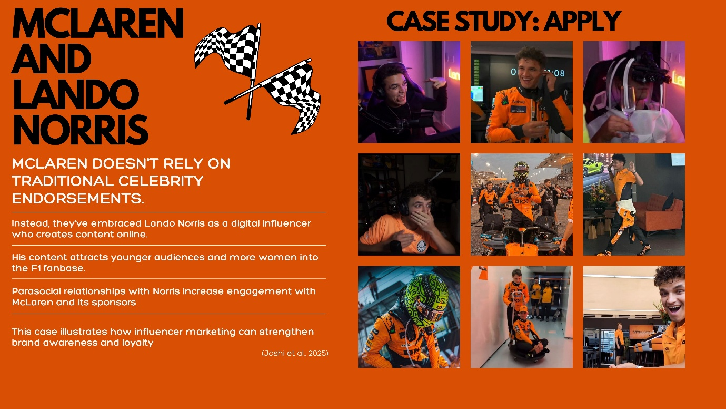
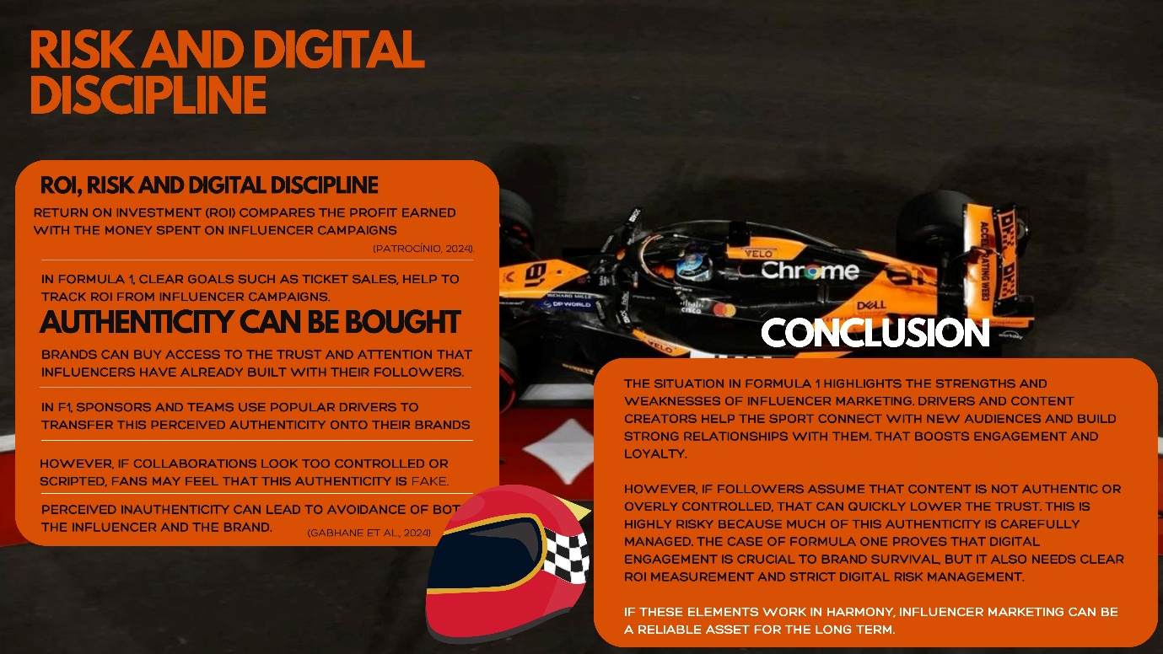
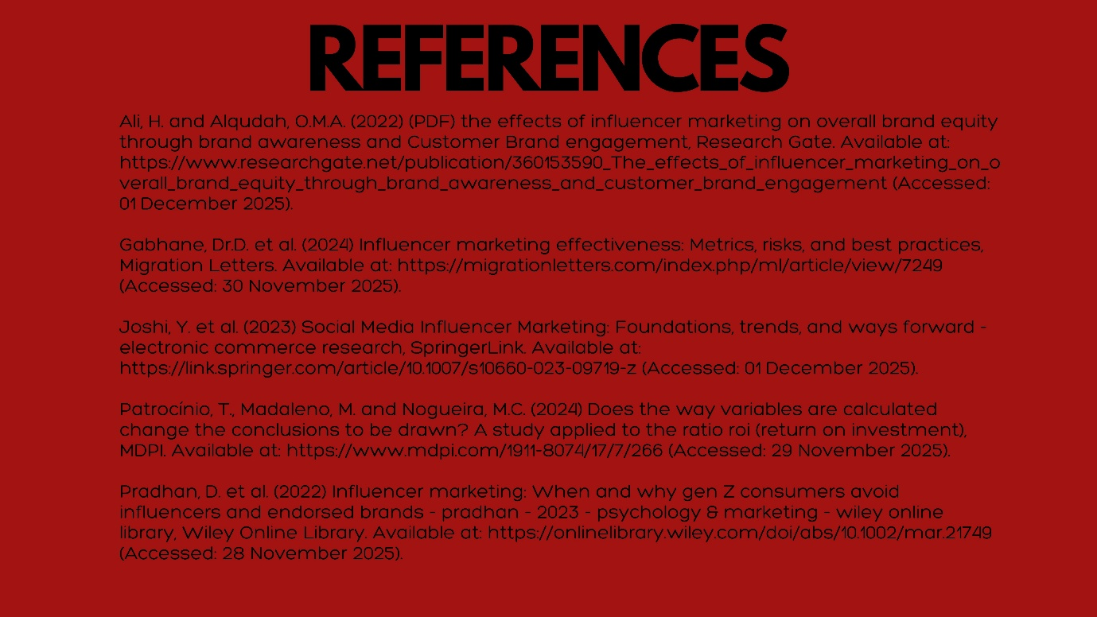

Presentation - Learning in The Digital Era - Formula 1.pptx

