Contents
Section 1. Introduction 1
Coffee consumption data 2
Mean, Mode and Median. 2
Data spread 3
Statistical Analysis with Excel 4
Statistical Analysis with SPSS 8
Conclusion 9
Section 2. Introduction 10
Advantages of Excel 10
Disadvantages of Excel 11
Data Mining 11
Conclusion 13
Appendix for Section 1 13
References 16

Section 1. Introduction

Business intelligence systems combine analytical tools and operational data to provide planners and decision-makers with complex and competitive information. Improving the promptness and calibre of inputs for the decision-making process is the main goal. Business Intelligence (BI) serves to comprehend the firm’s capabilities, the current state of the market, technological trends, and regulatory environments. Additionally, it analyses competitor actions and their implications. (Negash, 2004)

Collecting information from both internal and external business sources forms the foundation of a valuable resource known as data or a database. Within this database, data can be categorized based on their origin and chronological context, resulting in distinct data elements. These individual data elements can then be combined with related elements to form data sets. Computer programs like Excel or SPSS utilize these data sets to analyze and extract valuable insights. (Alamaki, Rantala and Valkokari, 2018)
Microsoft Excel is everywhere. It is the most commonly used desktop application for data analytics. (Knight, 2006). While Excel offers robust capabilities for BI, it has limitations in handling large volumes of data and advanced analytics compared to dedicated BI platforms. However, it remains a widely used tool due to its familiarity, accessibility, and versatility in various BI tasks.

The aim of this report is to show the basic and most effective ways to analyse data, using Excel and SPSS, by taking a look at the coffee consumption and health index of 40 different people.

Coffee consumption data

Mean, Mode and Median.

The Coffee Consumption table shares the results of the coffee consumption habits of 40 different people. It also presents the people’s health index score. This report will analyse the data by calculating Mean, Mode and Median, and by looking at the corelation between the cups of coffee per day drinking and the health index score.

Mean: By adding up all of the numerical values and dividing by the total number of values, the mean, also known as the average, is computed. The average daily Consumption of Coffee in this sample is 3.625 cups.

Median: When the data points are sorted ascending, the median is the middle value. The median is the average of the two middle values when the number of observations is even. The median in this instance is 3.5 C/D.

Mode: The mode is the value that appears most frequently in the data set. When it comes to Coffee Consumption, the mode is 2, according to the table. (BBC Bitesize, n.d.)

Data spread

Standard Deviation: This is a measure of the amount of variation or dispersion in a set of values. A high standard deviation suggests that the values are dispersed over a larger range, whereas a low standard deviation suggests that the values tend to be close to the mean. In Coffee Consumption dataset, the standard deviation for the Coffee Consumption variable is approximately 2.08, and for the second variable, Health Index Score, it’s approximately 13.41. This suggests that the first variable has a tighter cluster of data points around the mean compared to the second variable, which shows more spread.

Variance: The average difference between each data point and the mean, or average of all data points, is measured by variance. It’s calculated as the average of the squared differences from the Mean. In the Coffee Consumption table,, the variance for the first variable (Coffee Consumption) is about 4.34, and for the second variable (Health Index Score), it is 179.89. Since variance is measured in the units squared, it does not directly relate the data. However, it presents us the spread of the data points. The higher the variance, the more spread out the data is.

  - Give detail interpretation of the standard deviation and variance.

For the first variable, a standard deviation of 2.08 and a variance of 4.34 suggest that the values are relatively close to the mean, indicating a more consistent or homogeneous set of data.

For the second variable, a standard deviation of 13.41 and a variance of 179.89 suggest that the values are more spread out from the mean, indicating a more diverse or heterogeneous set of data.

Statistical Analysis with Excel

To begin with, by using a simple IF function in Excel, we can determine whether the coffee consumption for each person is lower or higher than the average, which is 3.6, and bring Low Intake or High intake as a result.

Another useful Excel function Pivot Tables and Charts. Excel Pivot Tables and Pivot Charts are powerful tools used for summarizing, analysing, exploring, and presenting large sets of data in a dynamic and user-friendly manner. (support.microsoft.com, n.d.)

Excel can also be used for creating scatters.

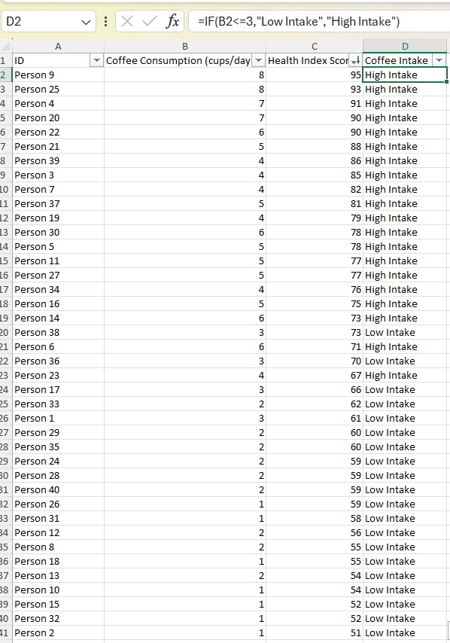

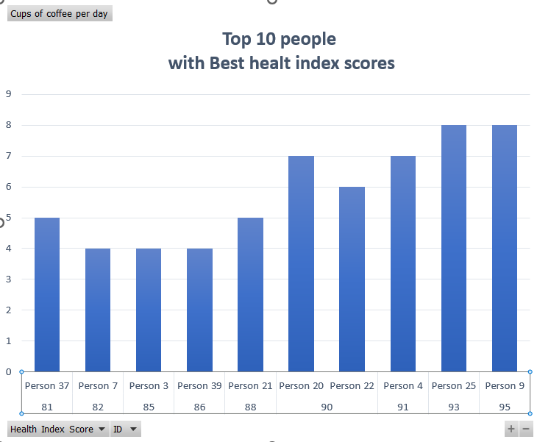

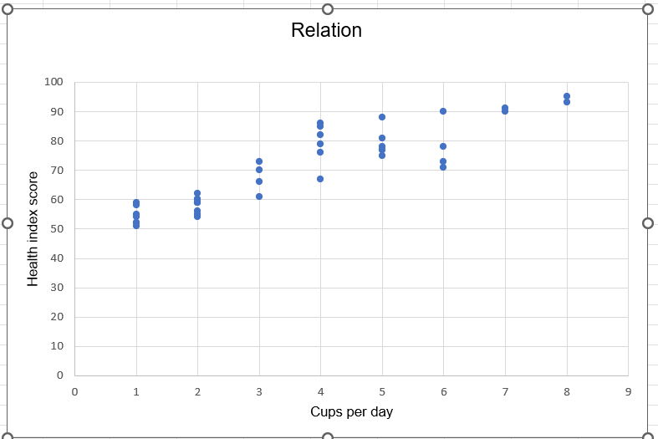

Statistical Analysis with SPSS

- According to the correlation analysis, the Pearson Correlation Coefficient of .905 suggests a very strong positive linear relationship between the two variables. This means that as coffee consumption increases, the health index score also tends to increase, and vice versa.
- Significance (Sig. 2-tailed): The significance value is <.001, which is less than the conventional alpha level of .05. This indicates that the correlation between the two variables is statistically significant, and the likelihood that this correlation is due to chance is less than 0.1%.

- Sample Size (N): The sample size for both variables is 40, which is sufficient to provide a reliable estimate of the correlation coefficient.

In conclusion, the analysis indicates that among the 40 people analysed, coffee consumption and health index scores indicate a statistically significant and strong positive connection. This could imply that individuals who consume more coffee tend to have higher health index scores.

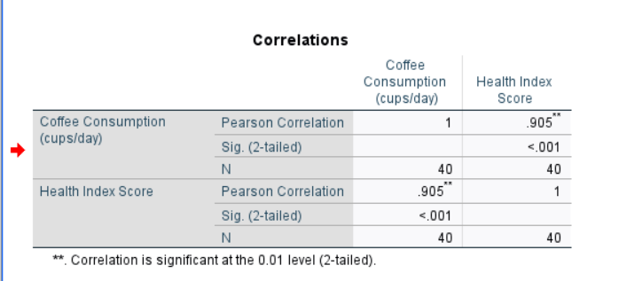

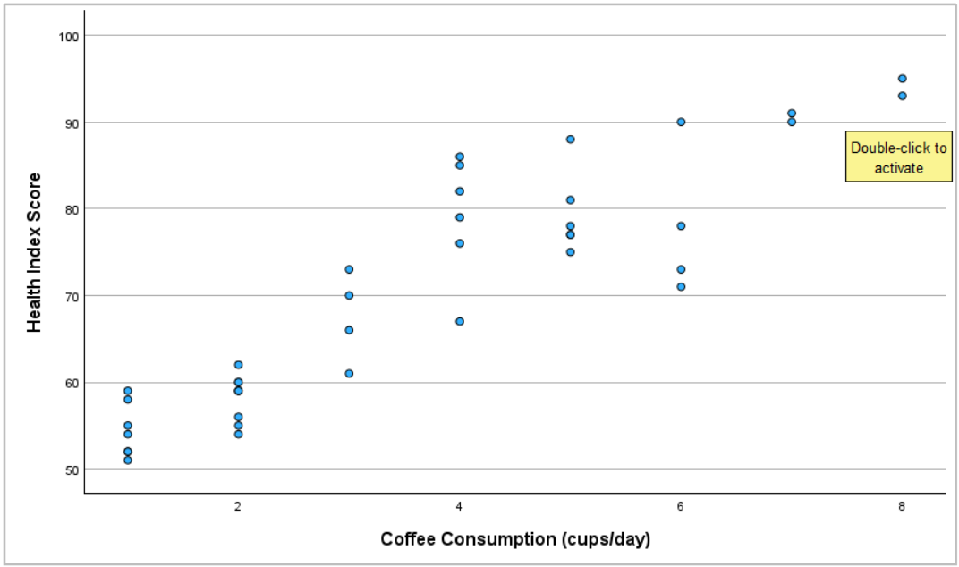

Conclusion

In conclusion, this report has covered aspects of statistical analysis, Excel data tools, and correlation interpretation, providing insights into data analysis techniques and their applications. It has also looked at SPSS and its data analysis implementation. It has analysed coffee consumption and health index by calculating Mean, Mode and Median, Standard Deviation and Variance, as well as looking into the correlation between the given variables.

Section 2. Introduction
One of the most widely used spreadsheet applications available is Microsoft Excel. Furthermore, it's a very strong programme with many applications beyond budgeting and invoicing. Working with huge data sets is only one of the numerous aspects that set Microsoft Excel apart from other spreadsheet programmes. (Prasanna, 2022) The aim of this report is to discuss the advantages and disadvantages of Microsoft Excel, give practical examples for it and to explain the meaning and importance of Data Mining Cycles.

Advantages of Excel
Excel's sophisticated data analysis features, such as pivot tables, filters, and statistical functions, are among its most important advantages. With the aid of these tools, users may quickly summarise enormous datasets and identify outliers, trends, and patterns. For example, a marketing analyst may use pivot tables to analyse customer demographics and preferences based on sales data. (Puneet, 2023)
Secondly, One of Excel's primary advantages is its user-friendly interface. Basic functionalities like entering data, performing calculations, and creating charts are intuitive and require minimal training. For instance, creating a simple budget spreadsheet involves entering income and expenses in rows and using basic formulas to calculate totals. (www.linkedin.com, n.d.)

Integration with Other Software: Excel's seamless integration with Word and PowerPoint, as well as other Microsoft Office programmes, makes sharing data and presentation smoother. Users can copy data from Excel and paste it directly into Word or PowerPoint for creating reports and presentations. Additionally, Excel supports importing and exporting data from external sources like databases and CSV files. (Arshad, 2023)

Disadvantages of Excel
On the other hand, Excel has its cons too. First of all, it comes the limited scalability, Excel can handle small to medium-sized datasets well, but it could have trouble processing larger datasets or complicated calculations. Large datasets can slow down performance, leading to delays and inefficiencies. Moreover, Excel's row and column limitations can restrict the amount of data that can be analysed efficiently. For instance, analysing millions of rows of customer transaction data may require more robust tools like database management systems. (Raymond, 2023). In this aspect, users may prefer MS Access or MySQL.
Secondly, the data visualization creating complex visualizations or interactive dashboards may require additional tools like business intelligence software or programming languages. For example, a business analyst may need to use dedicated data visualization tools to create interactive dashboards for executive reporting. Both Tableau and Excel allow you to create straightforward, visually appealing charts and graphs, but Tableau has a more straightforward user interface. Tableau only requires a few fields, drags and drops to create intricate charts. Once created, the chart or graph can be changed to a new visualisation with only one click. (Pan and Blankley, 2020) In this regard, Excel is still behind, although the newest versions of Excel has definitely tried to improve and make the visualisation charts and diagrams easier and more user-friendly.
Lastly, Excel can only be used on devices that have Microsoft Office installed because it is a proprietary application. Users who do not have Microsoft Office or who use a computer without enough storage space to install Microsoft Office may find this to be a drawback. While Excel offers shared workbooks and online collaboration features, they may not be as seamless as other platforms. Collaborating on Excel spreadsheets can be challenging, especially when multiple users need to make simultaneous edits because version control issues may arise, leading to confusion and data inconsistencies. (Prasanna, 2022)

Data Mining
Finding valid, unique, perhaps helpful, and comprehensible correlations and patterns in current data is the primary objective of data mining. (Chung and Gray, 1999). The iterative process of extracting significant patterns, trends, and insights from huge datasets is known as the "Data Mining Cycle". It involves several sequential steps, each aimed at extracting valuable knowledge from raw data. Understanding and effectively executing the data mining cycle is crucial for deriving actionable insights and making informed decisions in various fields, including business, healthcare, finance, and marketing. According to (Polamuri, 2023),
the Data Mining Cycle consists of few steps:
- Data Collection.
In this step, relevant information must be gathered from a variety of sources, such as websites, data warehouses, social media platforms, databases, and sensors. Accurate and comprehensive data collection ensures that the subsequent analysis is based on high-quality information. For example, a retail company collects transaction data from its stores, including customer purchases, product details, and sales dates.
- Data Preprocessing.
It involves cleaning, transforming, and formatting the collected data to prepare it for analysis. Clean and well-pre-processed data improves the accuracy and reliability of the subsequent analysis. In the retail dataset, preprocessing involves removing duplicate entries, filling in missing values for certain attributes like product prices, and converting different date formats into a standardized format.
- Exploratory Data Analysis (EDA).
EDA involves exploring and visualizing the pre-processed data to gain insights into its distribution, relationships, and patterns. It helps identify trends, outliers, and potential correlations within the dataset, guiding further analysis. Using data visualization techniques such as scatter plots and box plots, analysts examine sales trends over time, identify peak seasons, and explore correlations between different product categories.
- Modeling
Modeling entails applying various data mining techniques and algorithms to build predictive or descriptive models based on the prepared dataset. It helps uncover hidden patterns and relationships in the data, enabling accurate predictions or valuable insights (www.sciencedirect.com, n.d.). For instance, analysts use machine learning algorithms such as decision trees, logistic regression, or neural networks to predict customer churn, forecast sales, or classify product preferences based on historical data.
- Evaluation.
Evaluation involves assessing the performance and validity of the constructed models using appropriate metrics and validation techniques. IT ensures that the developed models are reliable, generalizable, and suitable for real-world applications.
It is used to predict the accuracy of a customer churn model using metrics such as accuracy, precision, recall, or area under the ROC curve (AUC), and validate its performance through cross-validation or holdout testing.
- Deployment.
It involves integrating the validated models into operational systems or decision-making processes to derive actionable insights and drive business outcomes. Organisations may make data-driven decisions, streamline workflows, and obtain a competitive edge with the help of deployed models. The retail company implements the customer churn prediction model into its customer relationship management (CRM) system to identify at-risk customers and take proactive retention measures.

Conclusion
The Data Mining Cycle is a structured process for discovering valuable insights and patterns from large datasets. Each step plays a crucial role in extracting insights and driving informed decision-making across various domains. By following the Data Mining Cycle iteratively, organizations can derive knowledge from their data, optimize processes, and gain a competitive advantage in today's data-driven world.

Appendix for Section 1

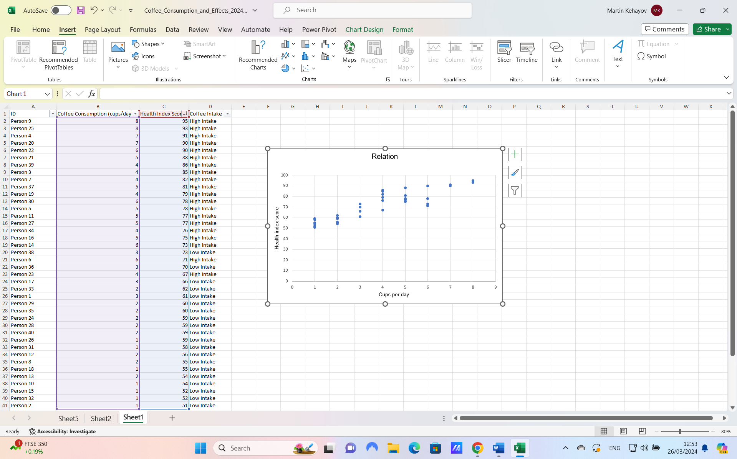

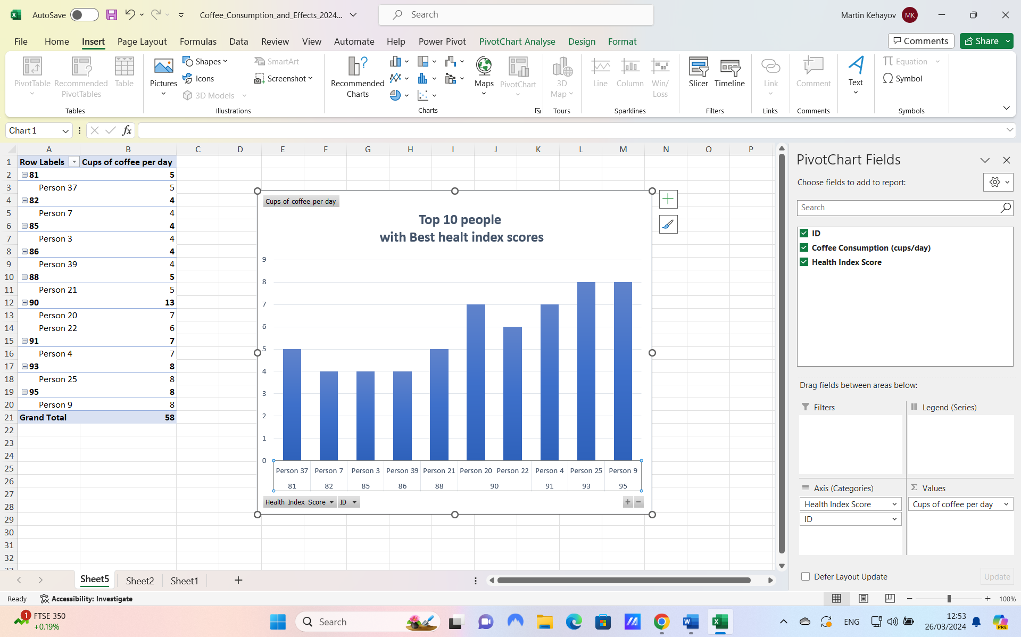

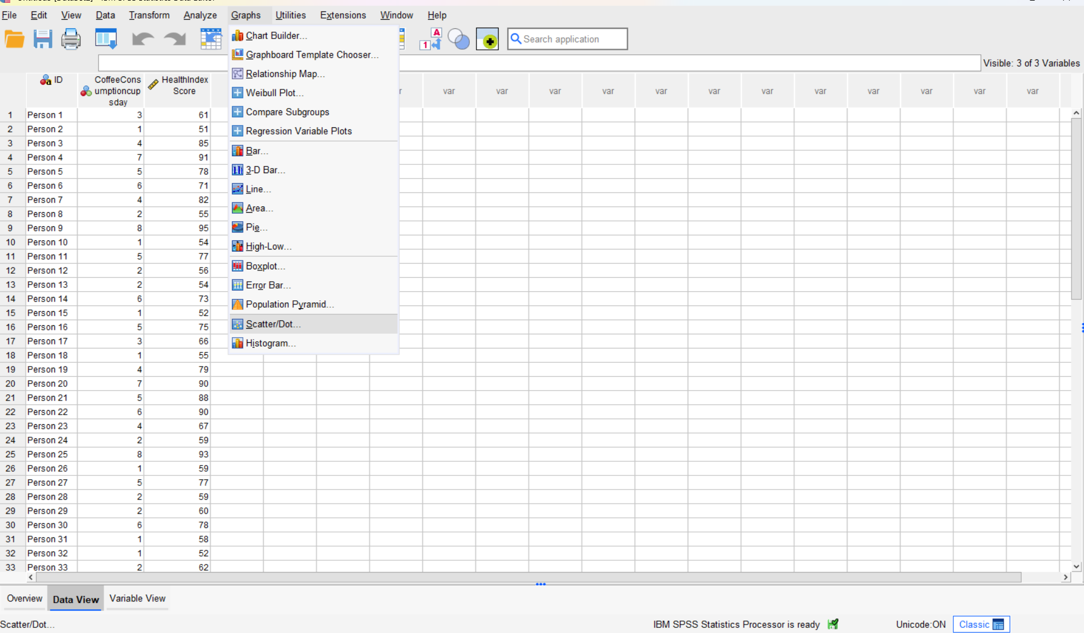

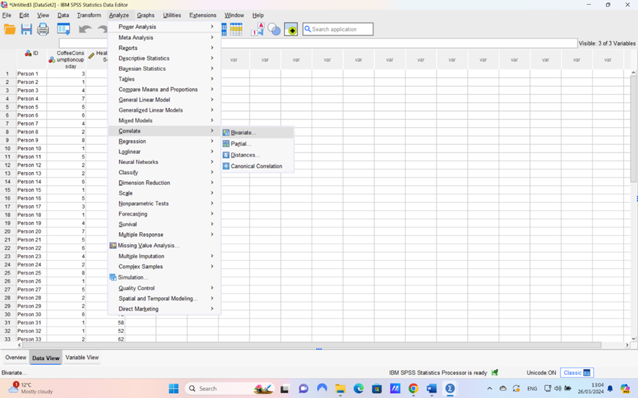

References
Alamäki, A., Rantala, T., Valkokari, K. and Palomäki, K., 2018, September. Business roles in creating value from data in collaborative networks. In Working Conference on Virtual Enterprises (pp. 612-622). Springer, Cham.

Arshad, S. (2023). 10 Benefits of Excel that Everyone Needs to Know. [online] OffiDocs. Available at: https://www.offidocs.com/blog/10-benefits-of-excel-that-everyone-needs-to-know/ [Accessed 26 Mar. 2024].

BBC Bitesize. (n.d.). Mean, median, mode, range. [online] Available at: https://www.bbc.co.uk/bitesize/articles/zj6nb7h#:~:text=The%20mean%20is%20the%20most%20commonly%20used%20average. [Accessed 26 Mar. 2024].

Chung, H. M., Gray, P. (1999), “Special Section: Data Mining”. Journal of Management Information Systems, (16:1),11-17.

Jackson, J. (2002). Data Mining; A Conceptual Overview . pp.267–296. doi:https://doi.org/10.17705/1CAIS.00819.

Knight, G. (2006). Analyzing Business Data with Excel. ‘O’Reilly Media, Inc.’

Negash, S. (2004). Business Intelligence. Communications of the Association for Information Systems, 13(13). doi:https://doi.org/10.17705/1cais.01315.

Pan, K. and Blankley, A. (2020). Excel vs. Tableau: See your data differently. [online] Journal of Accountancy. Available at: https://www.journalofaccountancy.com/issues/2020/mar/microsoft-excel-vs-tableau.html#:~:text=COMPARING%20TABLEAU%20TO%20EXCEL%201%20Analysis%20of%20large [Accessed 26 Mar. 2024].

Polamuri, S. (2023). Exploring the Essential Five Stages of Data Mining - Dataaspirant. [online] Dataaspirant. Available at: https://dataaspirant.com/data-mining-stages/#:~:text=The%20data%20mining%20process%20generally%20involves%20six%20main [Accessed 29 Mar. 2024].

Prasanna (2022). Advantages And Disadvantages of MS Excel | What are Advantages And Disadvantages of Microsoft Excel? [online] CBSE Library. Available at: https://cbselibrary.com/advantages-and-disadvantages-of-ms-excel/#:~:text=Following%20are%20the%20advantages%20and%20disadvantages%20of%20MS [Accessed 26 Mar. 2024].

Puneet (2023). Top 10 Benefits of Microsoft Excel – Why YOU Should Learn it in 2020. [online] Excel Champs. Available at: https://excelchamps.com/benefits-of-microsoft-excel/#10_Benefits_of_Microsoft_Excel.

Raymond, D. (2023). 10 Disadvantages of Managing your Projects with Excel. [online] AceProject. Available at: https://www.aceproject.com/blog/top-10-cons-disadvantages-of-managing-your-projects-with-excel-9387815/

support.microsoft.com. (n.d.). Overview of PivotTables and PivotCharts. [online] Available at: https://support.microsoft.com/en-gb/office/overview-of-pivottables-and-pivotcharts-527c8fa3-02c0-445a-a2db-7794676bce96.

www.linkedin.com. (n.d.). What Are the Pros and Cons of Using Excel for Data analysis? [online] Available at: https://www.linkedin.com/advice/3/what-pros-cons-using-excel-data-analysis-skills-data-analysis.

www.sciencedirect.com. (n.d.). Data Mining Model - an overview | ScienceDirect Topics. [online] Available at: https://www.sciencedirect.com/topics/computer-science/data-mining-model.

