Radio Frequency Systems
Investigating the Effect of noise in ssb-sc and dsb-sc
Jacob Smelt (2215291) – Beng2-PT embedded electronics systems

Table of Contents
Abstract 3
Introduction 3
Background research 3
Amplitude Modulation (AM) 3
Double Sided Band Suppressed Carrier (DSBSC) 3
Single Sided Band Suppressed Carrier (SSBSC) 4
Method and Results 5
Global set up 5
Task 1 6
Task 2 9
Task 3 11
Task 4 Analysis of AM, DSB-SC, and SSB-SC Systems 13
Conclusion 16
Further work 16
References 16

Figure 1 DSBSC with suppressed carrier [3] 4
Figure 2 SSBSC diagram [5] 4
Figure 3 Message and Carrier Signal Set Up 5
Figure 4 Shows the Simulink model for amplitude modulation. 6
Figure 5 Amplitude modulation with an index of 0.1. 6
Figure 6 Amplitude modulation with an index of 1.5. 7
Figure 7 Amplitude modulation with an index of 1. 8
Figure 8 Example of perfect modulation [6] 8
Figure 9 DSBSC system built in Simulink. 9
Figure 10 Oscilloscope view for DSBSC. 9
Figure 11 DSB SC system with AWGN. 10
Figure 12 DSB SC after adding noise. 10
Figure 13 SSB SC modulator demodulator system. 11
Figure 14 Oscilloscope view of SSBSC. 11
Figure 15 SSB SC modulator demodulator system with noise added. 12
Figure 16 Oscilloscope Values for SSBSC 12
Figure 17 AM Spectrum Analysis 13
Figure 18 DSBSC Spectrum Analysis 14
Figure 19 SSBSC Spectrum Analysis 15

Abstract
This report investigates the effects of noise on different amplitude modulation (AM) techniques, including standard AM, double-sideband suppressed carrier (DSBSC), and single-sideband suppressed carrier (SSBSC). Using Simulink, three modulator and demodulator systems were designed and evaluated under different modulation index values and white Gaussian noise has been added. The analysis focused on power efficiency, bandwidth utilisation, and noise resilience.
The results show that SSBSC is the most efficient technique with superior bandwidth and power efficiency and demonstrating excellent noise tolerance.AM however is the least efficient and most susceptible to noise, making it suitable only for low-complexity, noise-free environments. DSBSC provides better efficiency and noise resilience than AM making it a good for use where simplicity needed. These findings highlight that SSBSC is best for performance and noise resilience.

Introduction
In this assignment I have investigated the effects of noise using different amplitude modulation (AM) techniques. To do this I have used a piece of design and simulation Computer Aided Design (CAD) software, Simulink (MATLAB) to design and create three AM modulators and demodulators. I then investigated what different modulation index values do to the modulated signal, and I also introduced some random noise to analyse and compare which modulation system works best with the introduction of noise.

Background research

Amplitude Modulation (AM)
“Amplitude modulation, is one of the earliest modulation methods that is used in transmitting information.” [1] It works by varying the amplitude of a high-frequency carrier wave in proportion to the amplitude of the message signal while making sure that the carrier frequency is constant. The AM signal contains three components. These three components are a carrier signal that represents the unmodulated, high-frequency wave. The upper sideband which contains the sum of the carrier frequency and the message signal frequency and finally the lower sideband that contains the difference between the carrier frequency and the message signal frequency.
According to Keysight AM signals “wastes power because it broadcasts over multiple channels by adding additional baseband frequency components to the signal” [2] this means that I am expecting it to be the least power efficient of the three types of modulation discussed in this report.

Double Sided Band Suppressed Carrier (DSBSC)
DSBSC is a type of modulation where “The modulated wave has the information only in the sidebands” [3] This means that this method of modulation is much more power efficient than normal AM modulation as all the power Is used for the sidebands where information is present.
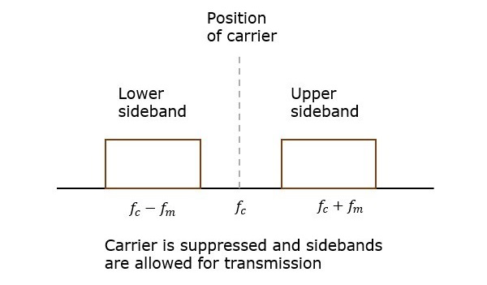
Figure 1 DSBSC with suppressed carrier [3]

Single Sided Band Suppressed Carrier (SSBSC)
An SSBSC modulator is a modulation technique that supresses one of the sidebands and the carrier wave. This “results in a low spectral range and low bandwidth, which increases the efficiency of the signal.” [4] SSBSC is used to transmit high quality audio signals over long distances. The side band that is transmitted can either be the upper side band or the lower side band and SSBSC is perfect for use when high power is needed.
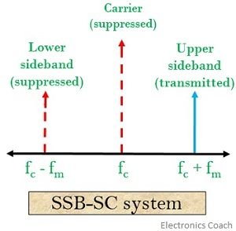
Figure 2 SSBSC diagram [5]

Method and Results

Global set up
In all the tasks below the message wave and carrier waves have been set up as follows. The message signal seen in Figure 3 has the amplitude value of 1 and the frequency is set to 2*π*10 (10Hz) this is duplicated and shifted by π /2 for use in the SSBSC model. The carrier signal also seen in Figure 3 has the amplitude value set at 2 and the frequency set to 2* π *100 (100Hz), again this is phase shifted in the SSBSC model by π /2.
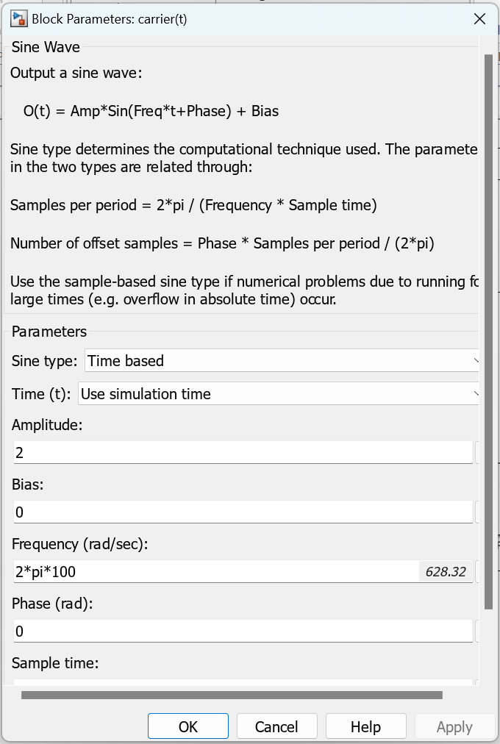
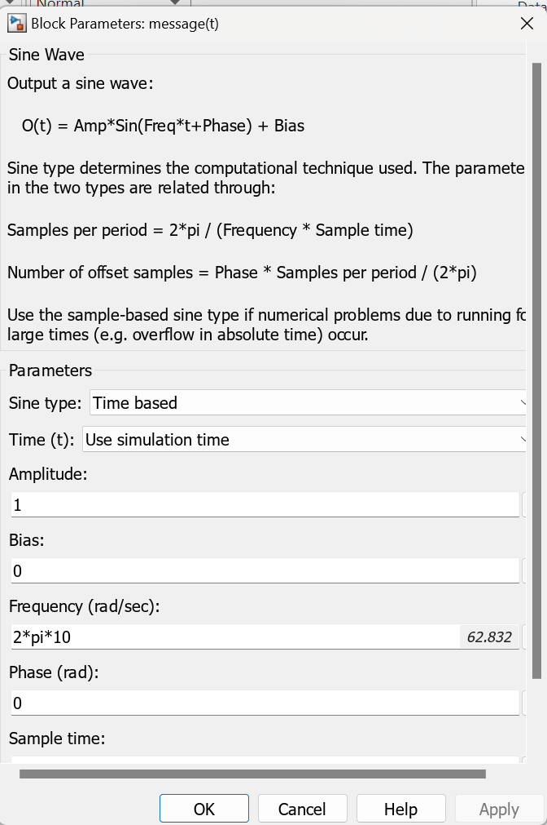
Figure 3 Message and Carrier Signal Set Up

Task 1
In this task I examined the amplitude modulation system using a time scope. I used the table below to choose the modulation index depending on the numbers of my student ID, for this case my last number is one so the corresponding modulation index I have used is 0.1. Figure 4 below shows the Simulink model I have used with the correct values in for the modulation index of 0.1 in the constant box.
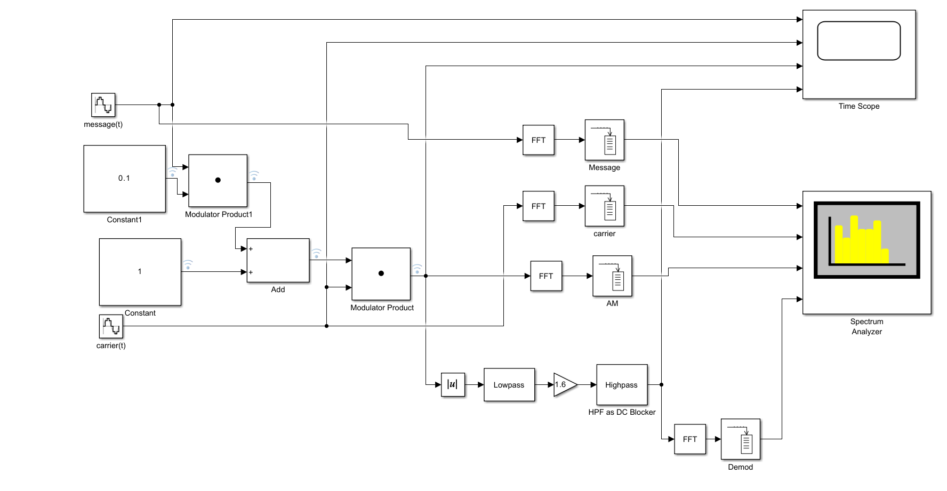
Figure 4 Shows the Simulink model for amplitude modulation.
Figure 5 below shows the time scope results when the modulation index has been set to 0.1. we can see on the modulator product signal (green) that there has been under modulation as there is a very narrow modulation envelope that does not reach the deep values of the message signal meaning that this signal is being under modulated. We can also tell it has been under modulated as the demodulated signal has a very low amplitude that only peaks at 0.2 meaning it needs to have a large gain value on it to make it into a useable signal again, this will also multiply the additive noise giving a much worse signal to noise ratio (SNR)
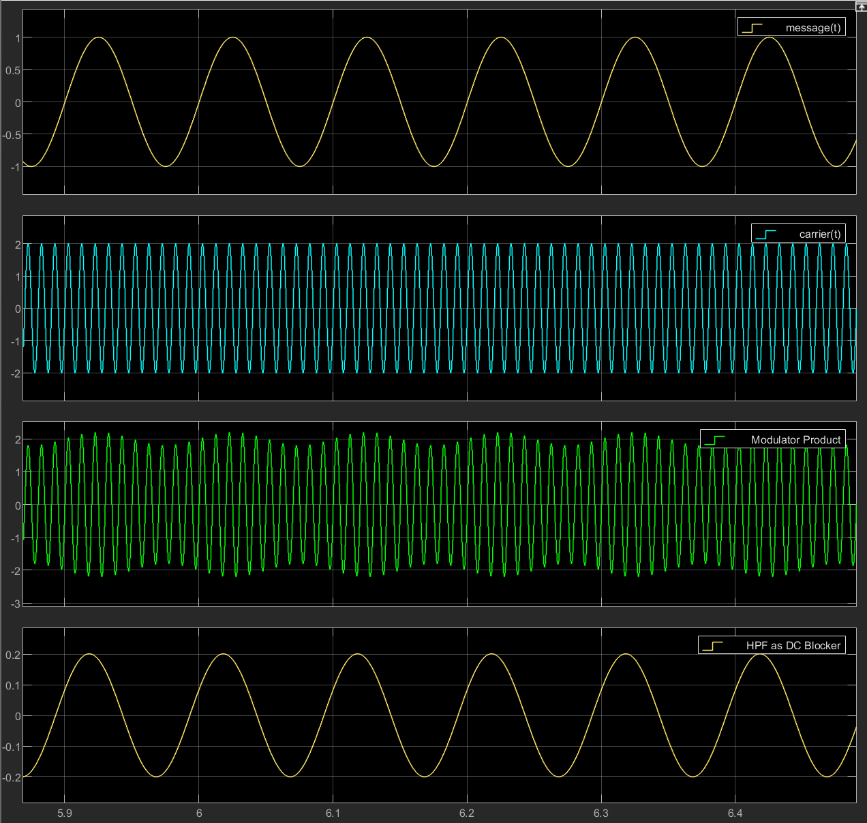
Figure 5 Amplitude modulation with an index of 0.1.
Figure 6 shows the results when the modulation index is set to the value of 1.5 ,by analysing the modulation product signal I can tell that this signal has been overmodulated as the demodulated signal is not the same as the message signal and has been distorted, this is seen in the lower troughs of the demodulated signal which are more curved than that of the message signal. As physics and radio electronics states “Over-modulation occurs when the maximum amplitude of the message signal or modulating signal is greater than the maximum amplitude of the carrier signal” [6] This signal has been overmodulated due to the modulation index value being used which is 1.5. This is over one meaning our modulating signals amplitude is greater than the carrier signal.

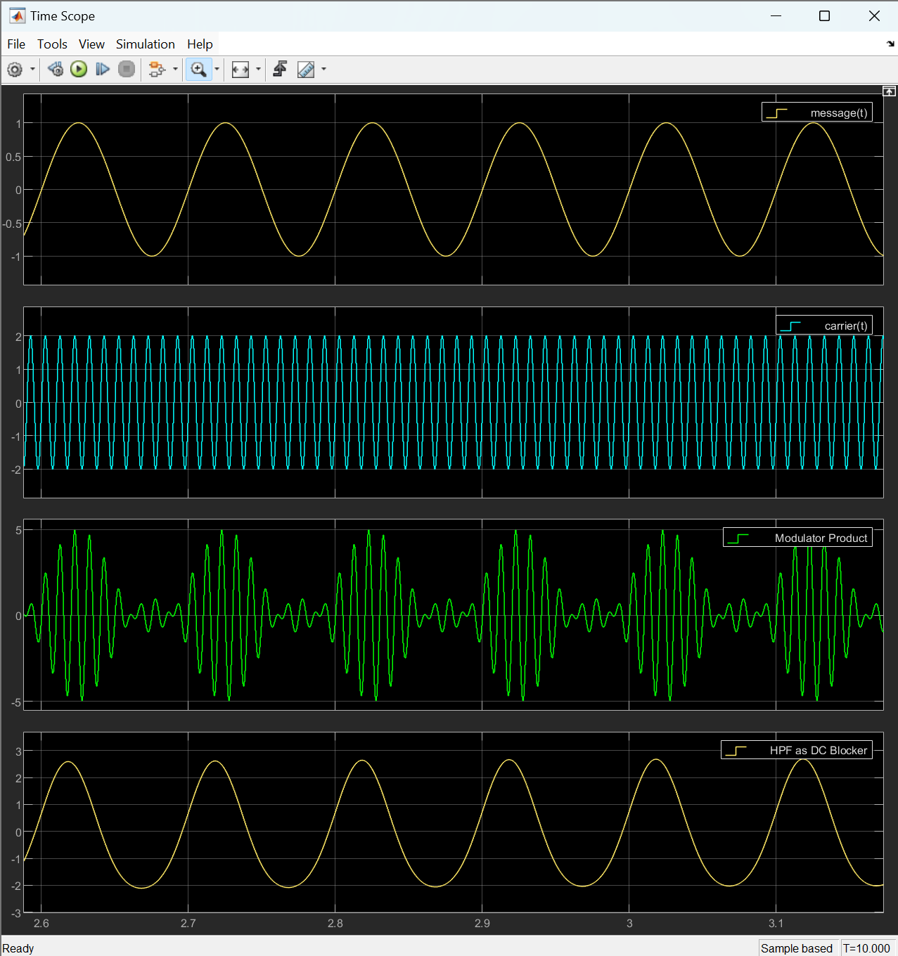
Figure 6 Amplitude modulation with an index of 1.5.

Below in Figure 7 is the signal when the modulation index of 1 is applied, I can tell by looking at both the modulated carrier (modulator product) and the demodulated signal and after doing a zero crossing that this signal has been critically modulated. The modulator product has a perfect modulation packet, and the peaks and troughs of the wave are well defined, they also hit zero for a short time. By looking at the demodulated signal we can also see that it is nearly identical to the message signal however it has doubled in amplitude.
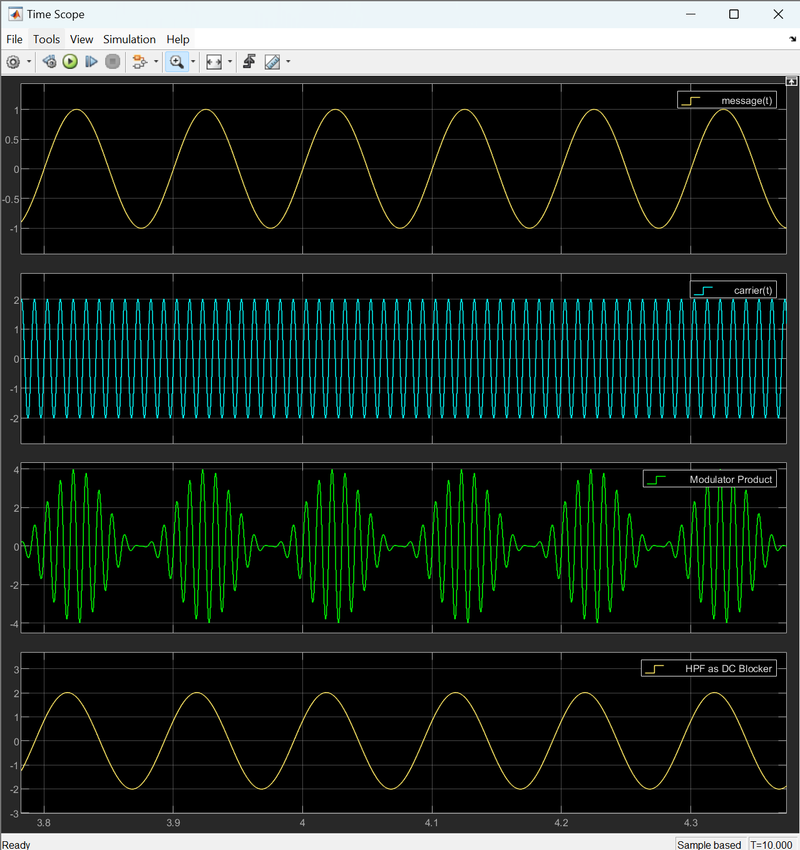
Figure 7 Amplitude modulation with an index of 1.
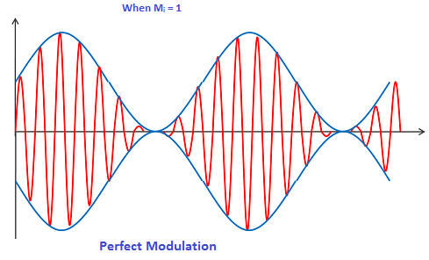
Figure 8 Example of perfect modulation [6]

Task 2
In this task I will create a DSBSC modulation system (Double-sideband suppressed-carrier) in Simulink and then add some white gaussian noise to see how it affects the DSBSC system, below in Figure 9 is the DSBSC system in Simulink. To create the DSBSC modulation I used multiple blocks such as the message and carrier signals and some sum and product blocks.
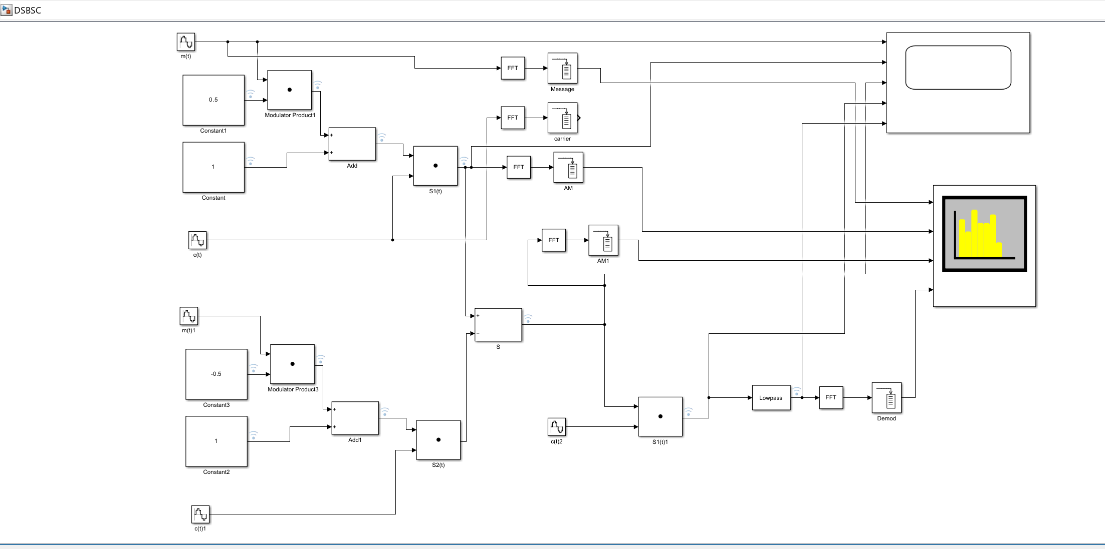
Figure 9 DSBSC system built in Simulink.
Shown below in Figure 10 are the results on the scope for the DSBSC system, here we can see that the message signal is the same as the demodulated signal meaning that the balanced modulator is working correctly.
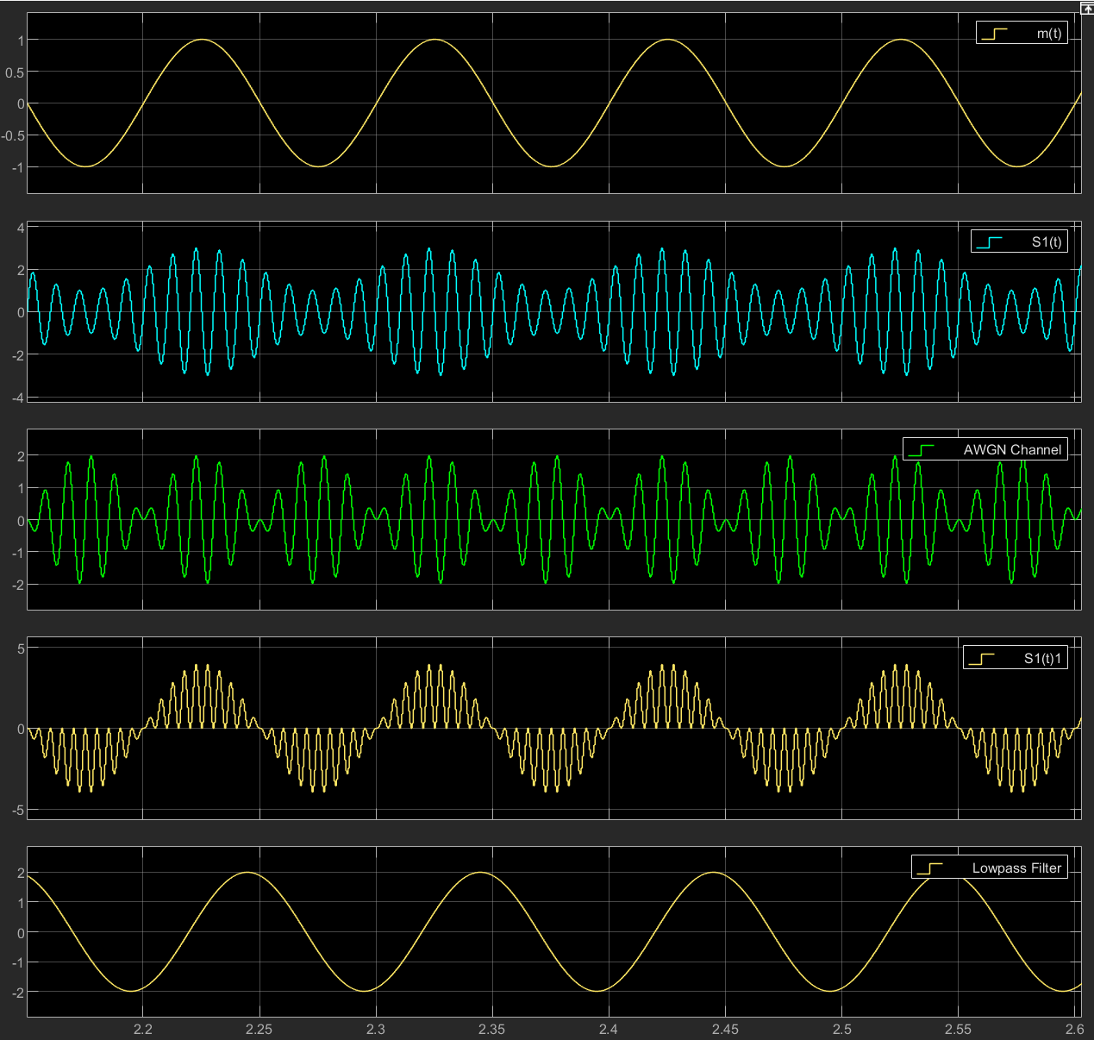
Figure 10 Oscilloscope view for DSBSC.

I then added some noise, to add noise into the system I implemented an AWGN block (additive white gaussian noise) and set the SNR value to -10dB this was added after the modulation to simulate noise in the real world and is shown below in Figure 11.
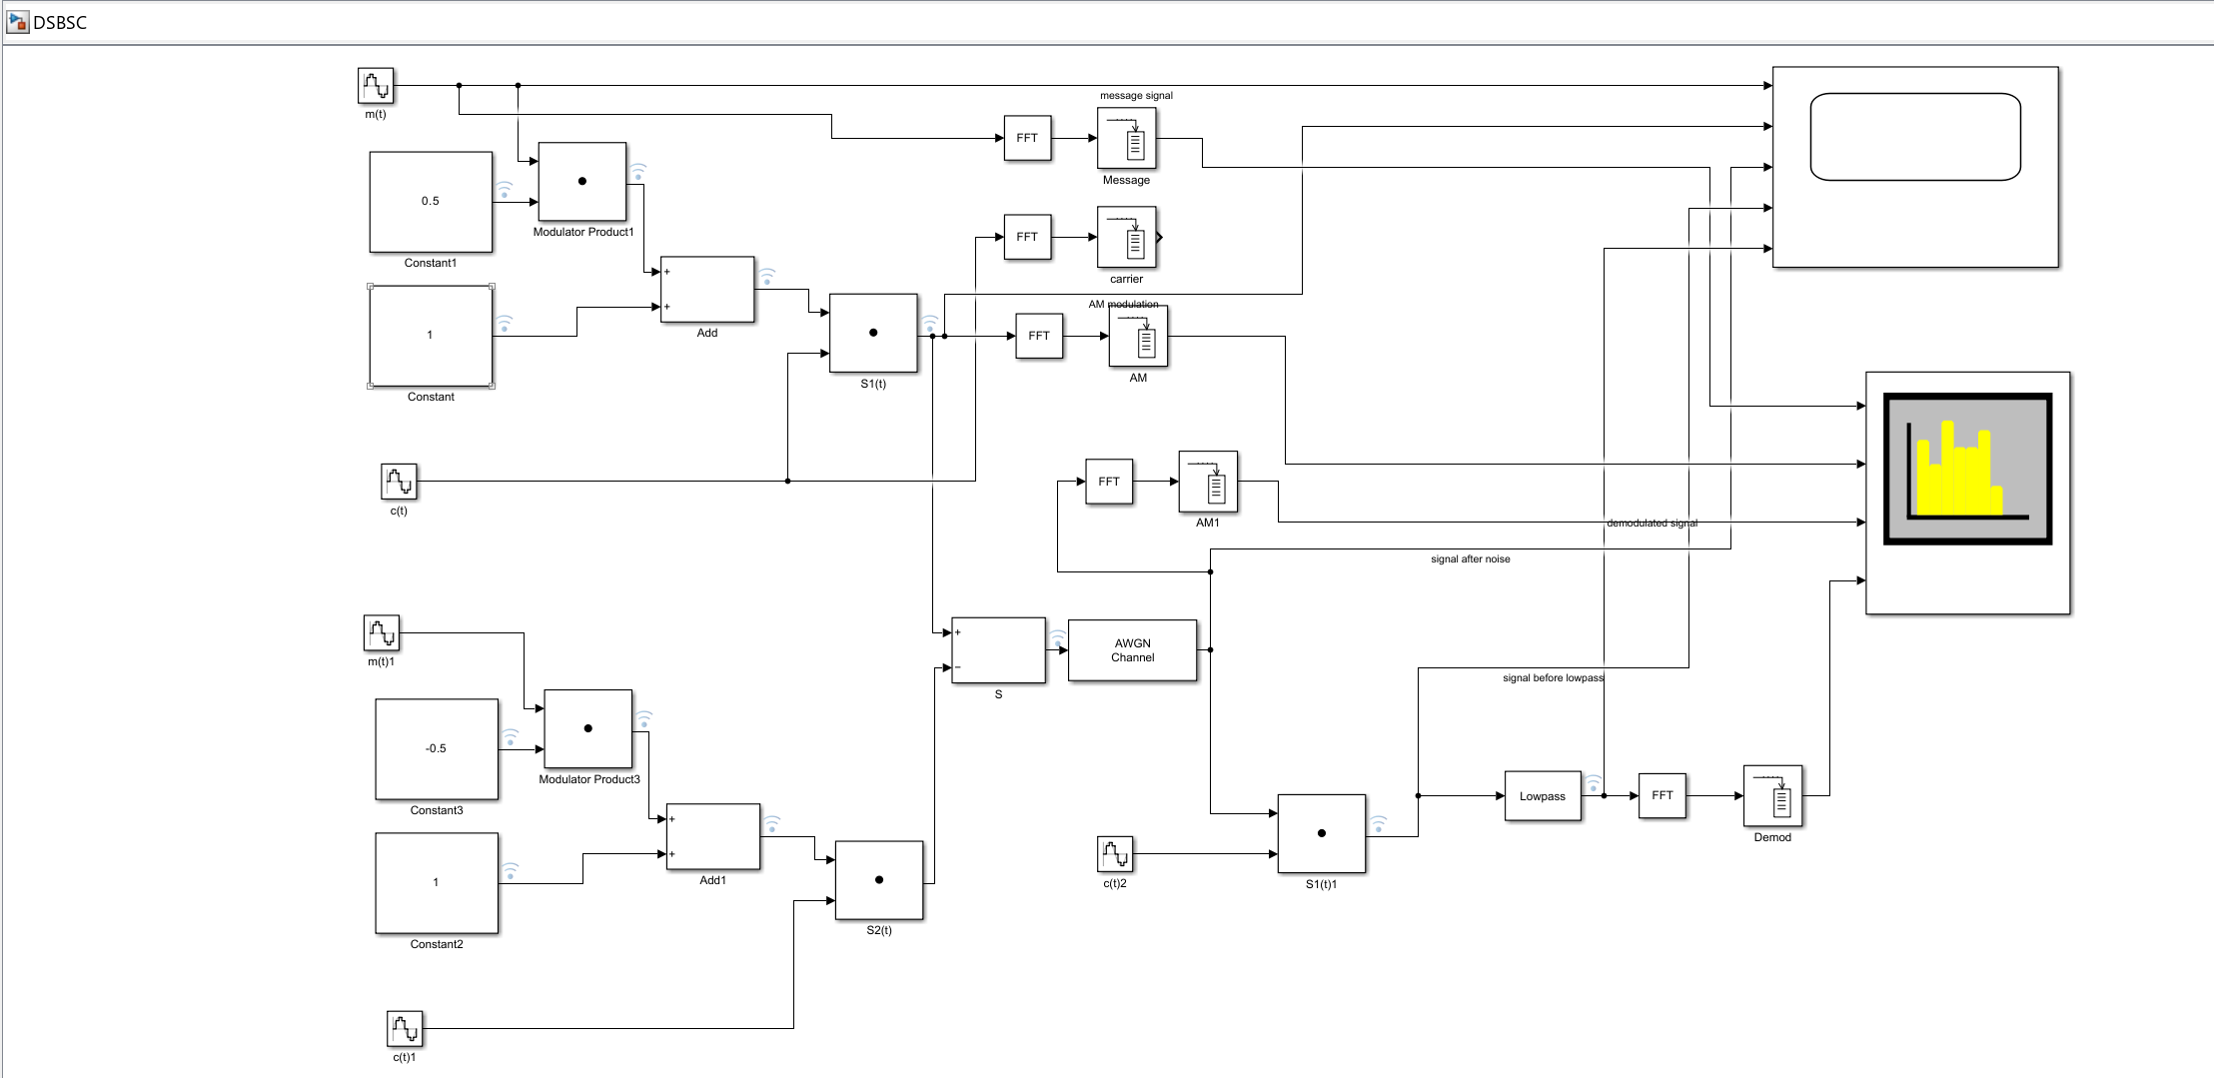
Figure 11 DSB SC system with AWGN.
Figure 12 shows the scope after random noise has been added, as seen below the demodulated signal is severely distorted, this shows that noise in the DSBSC system is detrimental to the modulation and demodulation.
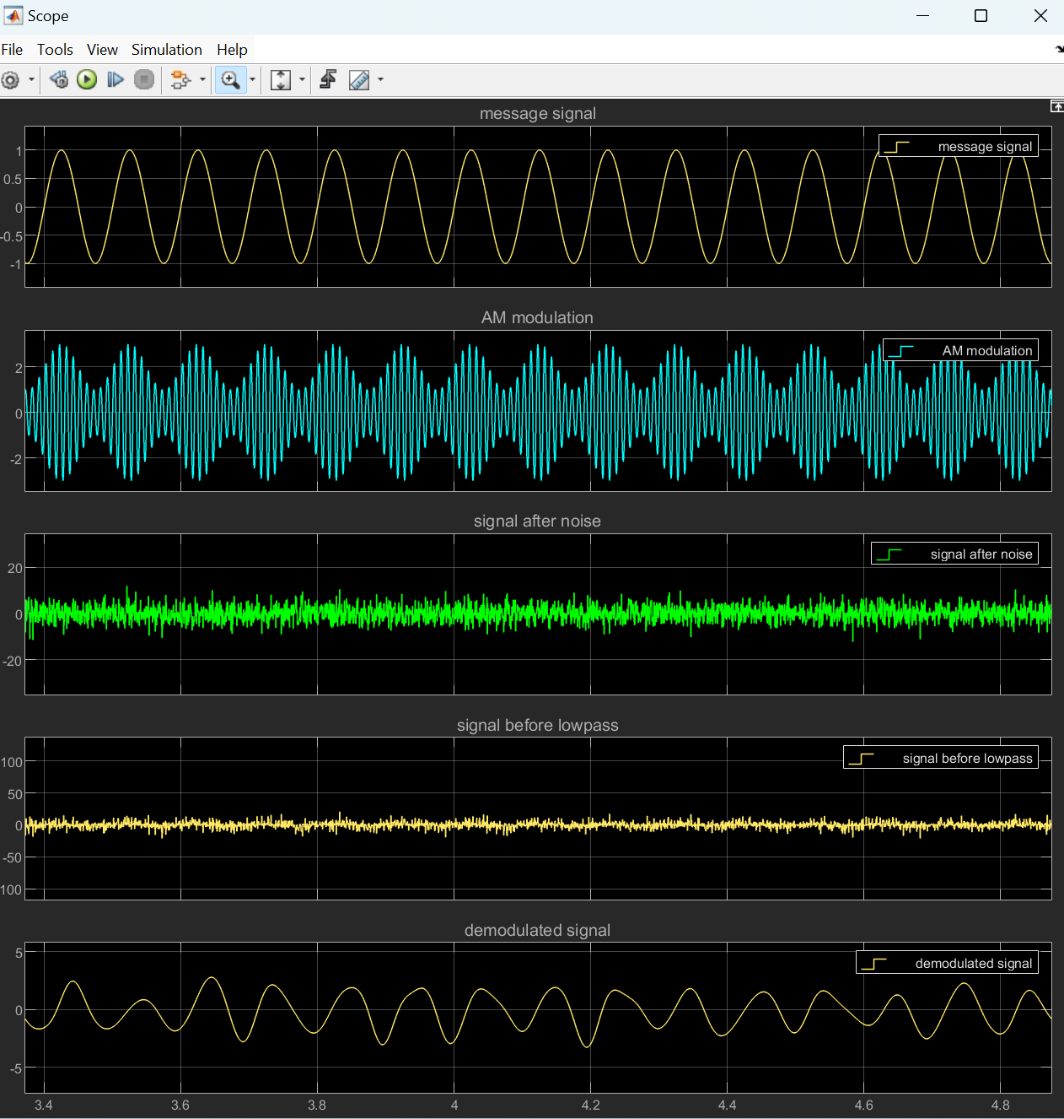
Figure 12 DSB SC after adding noise.

Task 3
In task 3 I have created an SSBSC modulator (single-sideband suppressed-carrier), and demodulator shown in Figure 13 below. For the SSBSC modulator to work I have used a second phase shifted carrier and message signal, there is then also a bandpass filter used to isolate one of the sidebands. I have also set the modulation index to 0.5.
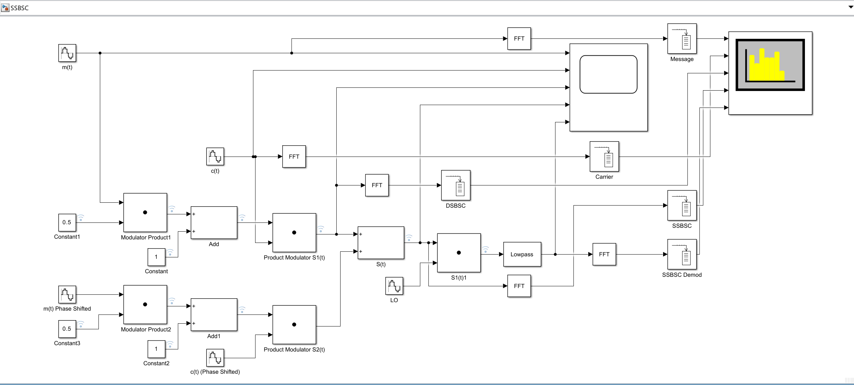
Figure 13 SSB SC modulator demodulator system.

The oscilloscope view of the SSBSC modulator demodulator is shown below in Figure 14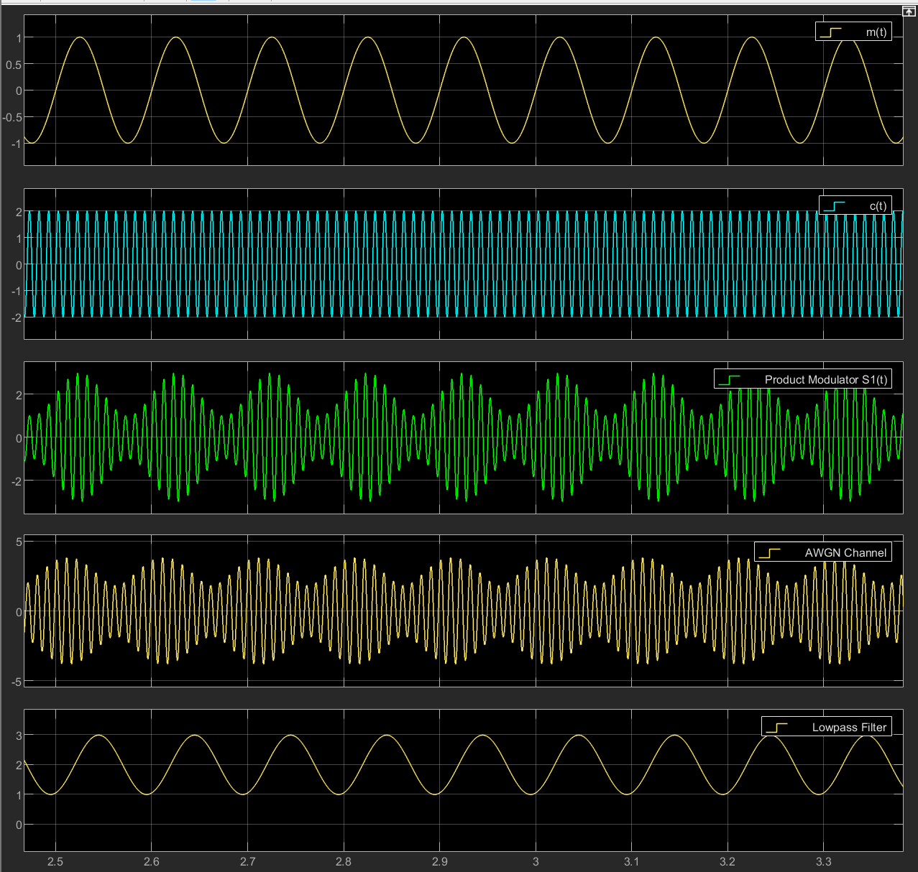
Figure 14 Oscilloscope view of SSBSC.

Below Figure 15 shows the SSBSC system with added White Gaussian Noise, again this is added after the modulation.
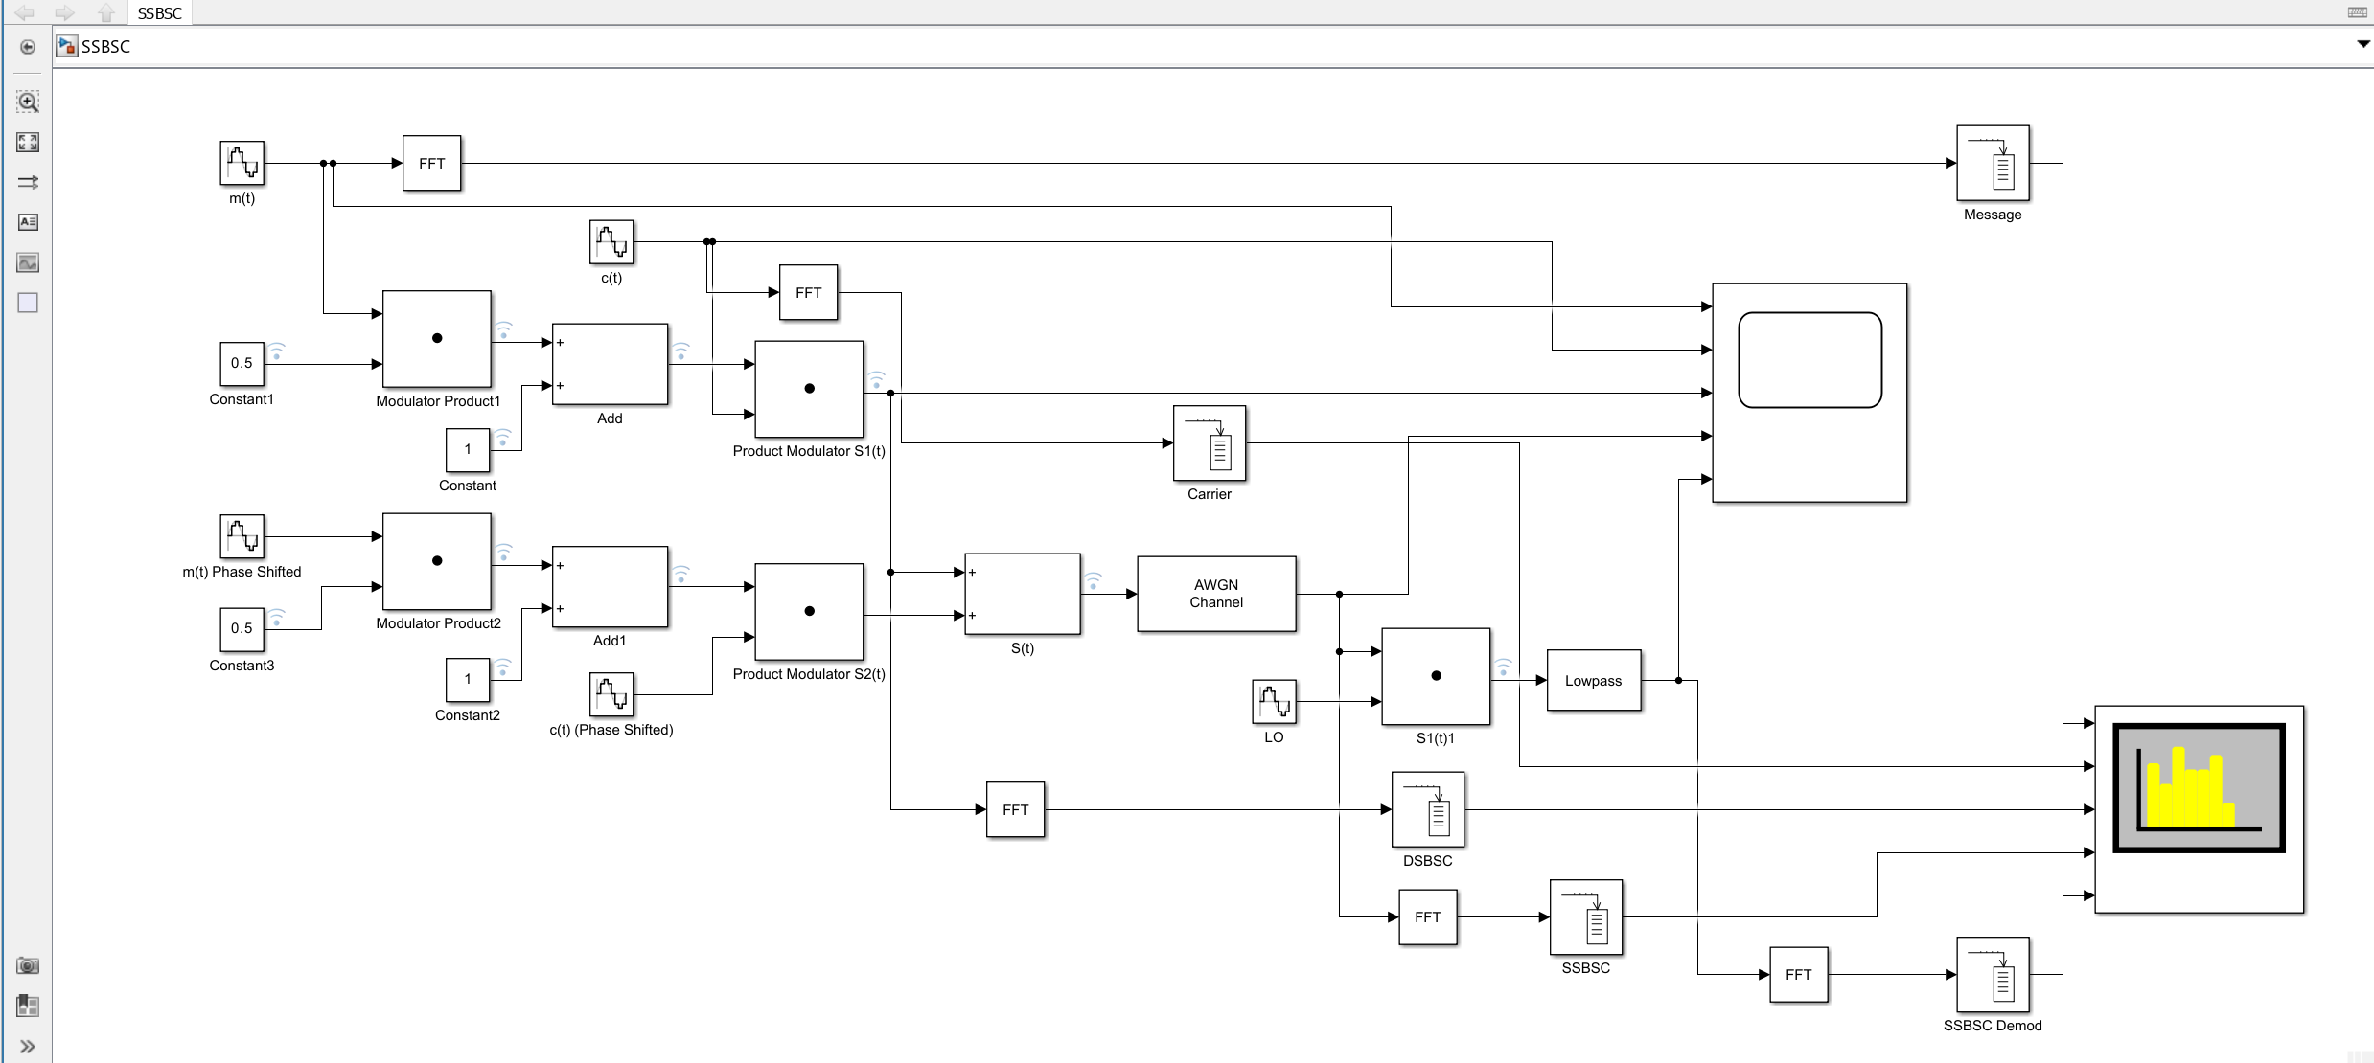
Figure 15 SSB SC modulator demodulator system with noise added.

Shown below in Figure 16 are the oscilloscope values for the SSBSC as we can see the final demodulated signal is also severely distorted again like in the DSBSC system.
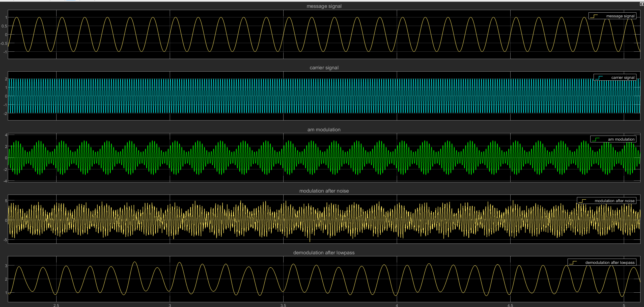
Figure 16 Oscilloscope Values for SSBSC

Task 4 Analysis of AM, DSB-SC, and SSB-SC Systems
In this task, the three modulation techniques that have been looked into previously have been compared. These three systems are, Amplitude Modulation (AM), Double Sideband Suppressed Carrier (DSB-SC), and Single Sideband Suppressed Carrier (SSB-SC). These systems will be analysed under two key performance factors, power efficiency, and noise tolerance. For this analysis, the spectrum analysis of each modulation system has been used to compare how each modulation system behaves in terms of these factors for these tests the Modulation index has been set to 0.5 and the random noise to -10dB for all models to give a fair representation.

Below in Figure 17 is the spectrum analyser view for the AM modulation system, this has a carrier signal and two side bands, these sidebands are the upper and lower side bands and contain the same information.
The power for the AM model is divided between the carrier and the two sidebands, this reduces the power efficiency as only a fraction of the total power used carries the useful information and the carrier signal is also transmitted.
The AM model is also not very resistant to noise, the AM signal is highly susceptible to noise because both the carrier and sidebands are affected. As we can see in the noise can cause severe distortion in the demodulated signal.
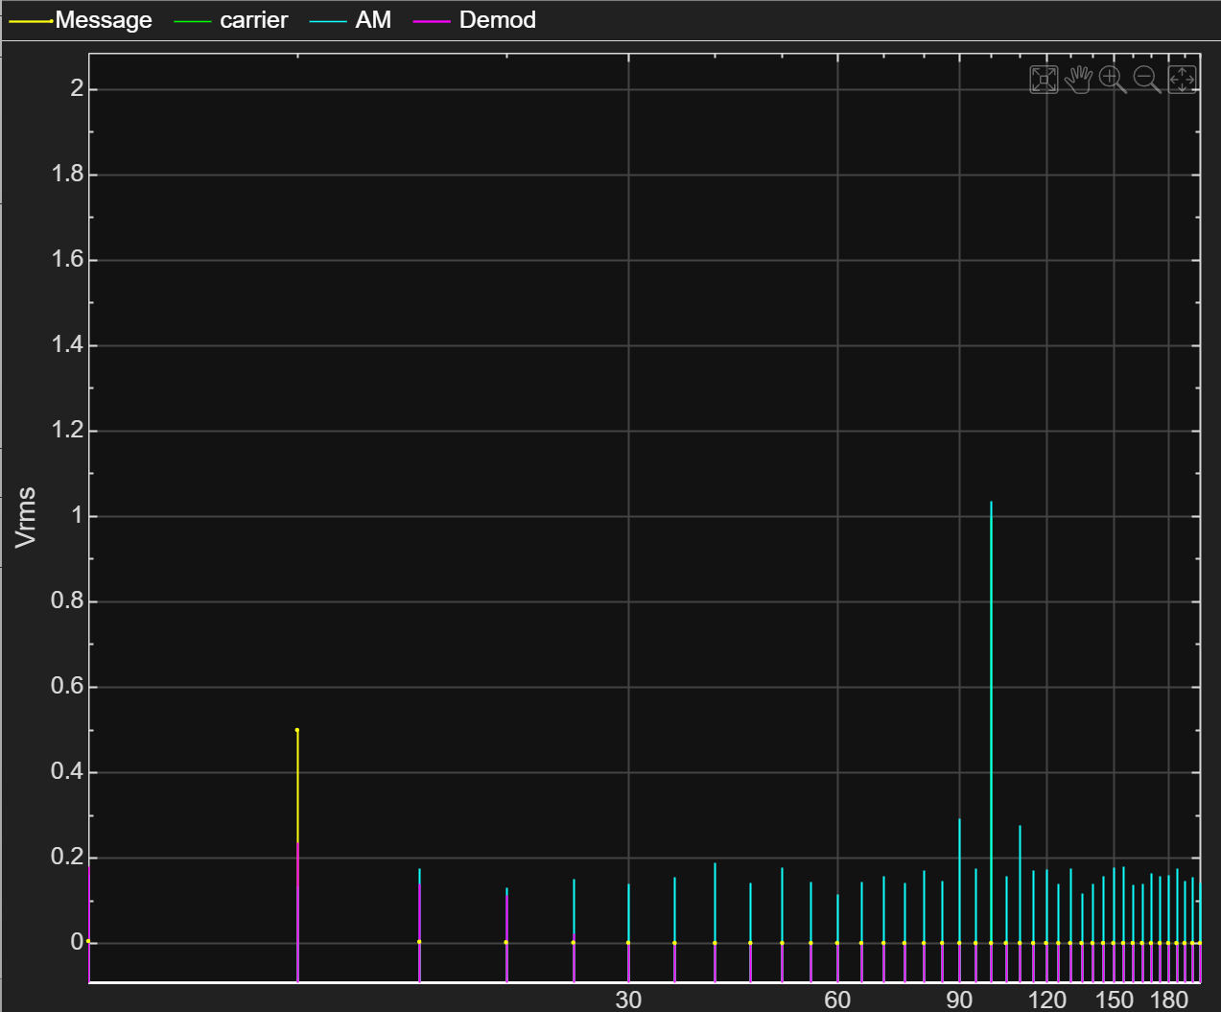
Figure 17 AM Spectrum Analysis

In Figure 18 the spectrum analysis is shown for the DSBSC modulation, demodulation method. We can see from the image that the DSBSC signal uses the same bandwidth as the AM modulation, but the carrier wave is not transmitted meaning that the bandwidth is used more efficiently power wise but still uses very similar bandwidth. DSBSC like AM modulation also still transmits both the upper and lower sidebands meaning it is not the most efficient.
DSBSC is much more power efficient than the AM model as it uses all the power to transmit both the upper and lower sidebands and does not use any for the carrier signal as this is not transmitted.
The DSBSC modulation is more resilient to noise interference than the Amplitude Modulation. This is because the carrier is suppressed, however the side bands can still be susceptible to the noise.
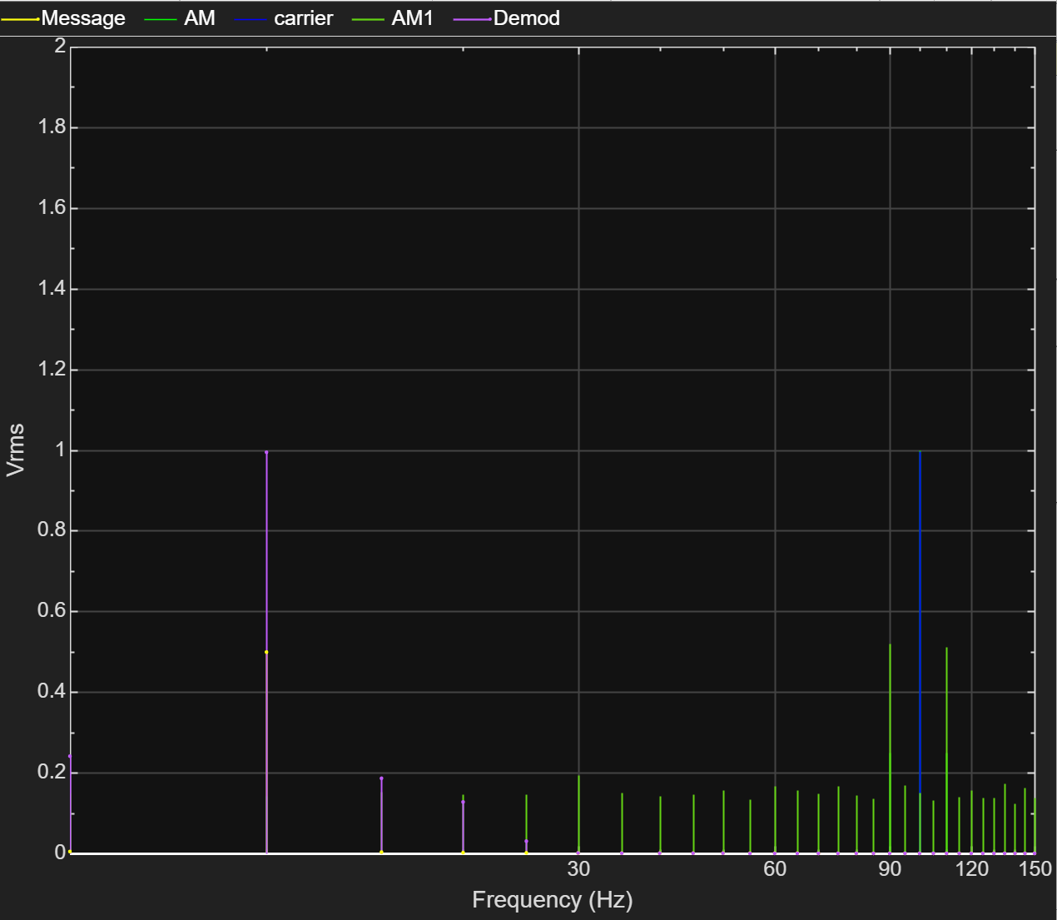
Figure 18 DSBSC Spectrum Analysis
The SSBSC spectrum analysis shown below in Figure 19 shows that the bandwidth used is much smaller than both the AM and DSBSC modulation. This is because in SSBSC only one of the sidebands is transmitted depending on the filter added at the end. This model also supresses the carrier signal just like DSBSC. SSBSC is the most bandwidth efficient modulation method of the three tested in this report.
SSBSC is also the most power efficient of all three modulation techniques as all the power is used to transmit the singular chosen sideband, this means that it uses all the power to transmit only the most useful and wanted information.
The SSBSC also has the best noise resistance because only one of the sidebands is transmitted, this makes the signal more immune to noise and good for use in a noisy environment.
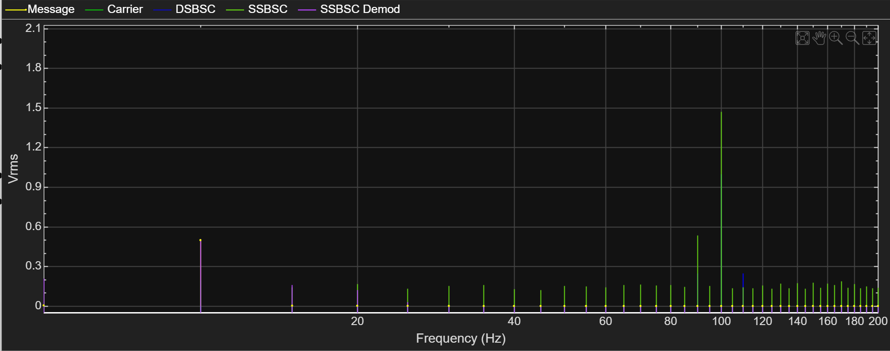
Figure 19 SSBSC Spectrum Analysis

In conclusion, SSB-SC proves to be the most efficient modulation technique in terms of bandwidth and power utilisation while also exhibiting the best noise tolerance. It is ideal for environments where spectrum efficiency and resilience to noise are crucial, such as in high-quality radio communication and broadcast systems.
AM, on the other hand, is the least efficient and most susceptible to noise, making it suitable only for applications where simplicity is needed, and noise is at a minimum. DSB-SC is in the middle, providing better efficiency and noise tolerance than AM but it is still inferior to SSB-SC in terms of both bandwidth and power utilisation.
For practical applications where performance in terms of efficiency and noise tolerance is paramount, SSB-SC is the better choice.

Conclusion
In this assignment, I have explored the effects of noise on various RF modulation systems, specifically AM, DSB-SC, and SSB-SC. Using Simulink, I have successfully designed and simulated the modulation models, analysed the AM models behaviour under different modulation indexes and looked at each of their performances when random noise has been added.
The results demonstrate that SSB-SC is the most efficient modulation system in terms of power utilisation, bandwidth efficiency, and noise tolerance. Its ability to transmit only one sideband, suppress the carrier, and resist added noise makes it ideal for applications requiring high performance and reliability.
DSB-SC, while more efficient than AM due to carrier suppression, still transmits both sidebands, resulting in less bandwidth and power efficiency compared to SSB-SC. However, it is more resilient to noise, making it a viable option for systems that do not need to be as complex.
AM is the simplest of the three but is also the worst in terms of utilisation and noise resilience so should only be used where simplicity is key, and noise interference is minimal.
Overall, the findings show the importance of selecting the appropriate modulation technique based on the requirements, with SSB-SC being the optimal choice for systems because of its efficiency and robustness in noisy environments.

Further work
For further work it may be good to investigate hybrid modulation techniques or also other modulation techniques such as Frequency modulation. I could also test to see how resilient these models are to different noise types.

References
[1] byjus, “Amplitude Modulation,” BYJUS, Oct. 07, 2019. https://byjus.com/jee/amplitude-modulation/ (accessed Jan. 01, 2025).
[2] Keysight, “What is Amplitude Modulation? — Keysight Oscilloscope Glossary - Keysight Technologies,” Keysight.com, 2022. https://www.keysight.com/used/us/en/knowledge/glossary/oscilloscopes/what-is-amplitude-modulation (accessed Jan. 02, 2025).
[3] TutorialsPoint, “Analog Communication - DSBSC Modulation - Tutorialspoint,” Tutorialspoint.com, 2019. https://www.tutorialspoint.com/analog_communication/analog_communication_dsbsc_modulation.htm (accessed Jan. 01, 2025).
[4] “SSBSC (Single Sideband Suppress Carrier) Transmission - javatpoint,” www.javatpoint.com. https://www.javatpoint.com/ssbsc-single-sideband-suppress-carrier-transmission (accessed Jan. 04, 2025).
[5] “What is Single sideband (SSB) modulation? definition, generation, advanatages, disadvantages and applications of Single sideband modulation,” Electronics Coach, Jul. 26, 2018. https://electronicscoach.com/single-sideband-modulation.html (accessed Jan. 02, 2025).
[6] A. Shaik, “Amplitude Modulation – Physics and Radio-Electronics,” www.physics-and-radio-electronics.com. https://www.physics-and-radio-electronics.com/blog/amplitude-modulation/ (accessed Jan. 03, 2025).

