Developing critical awareness of the key issues undertaking vocal research and which are the most relevant research methodologies for voice research in MPA?
Arisa Kusumi Sullivan, student ID# 2320830
Cohort M - Module 2: BMPF 7323
Word count: 4065

Table of Contents
Introduction 3
The Ontology, Epistemology, Axiology, and the Reasoning Behind the Paradigm 3
The Positivism and Postpositivism Paradigms 5
The Interpretivism/Constructivism Paradigm 7
The Pragmatism Paradigm 9
Ethics and Issues of Insider Research 11
Conclusion 12
References 14
Appendix 18

Introduction
Researchers in the field of vocal pedagogy are faced with a vast spectrum of variables in how singers experience issues, why they experience them, and what is most effective in treating them. They must carefully choose a topic, assess their perspectives on what defines the reality at hand, effectively gather knowledge, answer pertinent questions, and ultimately reveal the truth while attempting to prevent their own biases from influencing the results (Acharyya & Battacharya, 2019) . Every researcher has their own way of defining what their idea of truth, reality, and knowledge is, and these views guide their beliefs, thinking, and how they view society and themselves to form what social scientists call a paradigm (Schwandt, T.A. 2001). The paradigm, or philosophical framework includes ideas, beliefs and biases that guide the research process and identify how the research should be conducted (Ulz, J. 2023). Without deciding upon a paradigm, the basis for subsequent choices in research design would lack direction and purpose (Mackenzie, N. & Knipe, S. 2006). This paper will first look at how a researcher’s reality is defined through understanding the foundational concepts of research: ontology, epistemology, and axiology. I will then explore various types of paradigms pertinent to singing research, including positivism/postpositivism, constructivism/interpretivism, and pragmatism. From the lens of a voice researcher intending to find the most appropriate perspectives and research processes, I will look at inductive, deductive, and inductive-deductive reasoning which determine the type of methodology a researcher chooses - quantitative, qualitative, or mixed methods. In addition, I will describe the common methods of data collection used in vocal research and how to identify which would be most relevant for research of singing issues based on the researcher’s paradigm. Lastly, I will introduce the ethical considerations most relevant to research topics surrounding the field of singing, particularly music performance anxiety (MPA). By clearly defining and understanding their perspective on being and reality from the vocal research angle, researchers can reflect and inquire into this reality, engage with one’s research topic, and gain the useful and pertinent knowledge they are seeking (Bracken, S. 2010).

The Ontology, Epistemology, Axiology, and the Reasoning Behind the Paradigm
Every researcher arrives at a topic of study with their own predisposition and philosophical assumptions on how they view reality (ontology), their own beliefs about how we know what we know (epistemology), and their ethical views and values about their topic (axiology) (David & Sutton, 2004) These form their world view or paradigm which serves, as Mertens succinctly describes, “metaphysical frameworks that guide researchers in the identification and clarification of their beliefs with regard to ethics, reality, knowledge, and methodology” (Mertens 2010).
Figure 1: Belief Systems of a Paradigm (Denzin & Lincoln 2005)
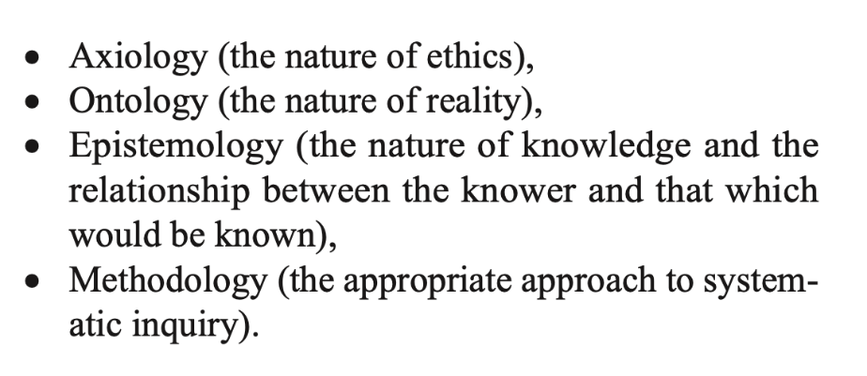
In order to decide upon a paradigm, a researcher must be familiar with their philosophical definition of being known as their ontology (Craig, 1998). This ontology paired with their beliefs about knowledge, or epistemology, enable them to make sense of the reality at hand (Craig, 1998). Researchers’ paradigms arise from their varying styles of reasoning. Whichever paradigm a researcher chooses as their framework for their study, more often than not, the paradigm informs a researcher’s methodology, or how one aims to study the world (Cohen et al., 2018). A methodology is an approach to finding answers that is appropriate to the systematic inquiry of the study (Mertens, 2010). As Hitchcock and Hughes suggest, one’s ontological assumptions bring about one’s epistemological assumptions, and in turn result in a researcher’s methodological considerations, which then give rise to data collection methods (Hitchcock & Hughes, 1995).
A researcher strives to make sense of the world around them by using deductive reasoning, inductive reasoning, and/or the combined inductive-deductive approach (Cohen et al., 2018). Deductive reasoning is based on Aristotle’s syllogism that consists of two linked premises exemplifying a particular instance, and a conclusion based on those premises (Cohen et al.,2018). In essence, a conclusion can be deduced from a sequence of formal logical steps for example, “All planets orbit the sun. The earth is a planet. Therefore, the earth orbits the sun” (Cohen et al., 2018). This reasoning, however, fell under scrutiny for its vague scope and how observation and experience became superseded by authority and preconceived notions. In the 1600s, the history of reasoning was challenged by a new model by Bacon stressing the observational aspect of science. Instead of the Aristotelian deductive reasoning, with its preconceived notions which inevitably can bias the conclusion, he created the notion of inductive reasoning by which the study of many individual cases leads to a hypothesis and eventually a generalization (Mouly, 1978). Bacon’s approach was then followed by a combination of the Aristotelian deduction and Baconian induction known as the inductive-deductive approach involving a back-and-forth process from induction with moves from observation to hypothesis and deduction which moves from hypothesis to implications. It is from these philosophers’ views on reasoning that led to the creation of various paradigms.

The Positivism and Postpositivism Paradigms
Positivists believe that there are facts that can be proven through observation and measurement, and that reality is the same for all persons (Ryan, 2018). The deductive approach to reasoning is in line with the positivist paradigm or “scientific method” [see glossary] (www.britannica.com, 2024). Positivism is based on the rationalistic philosophy engendered by philosophers such as Aristotle, Locke, Bacon, Kant (Mertens, 2005), in which cause determines effects or outcomes (Creswell, 2018). Park et al. describe positivists as those who look at things through a hypothetico-deductive [see glossary] lens, starting with a theory with which one can (1) build a hypotheses that can be tested, (2) design an experiment by systematically examining the effect of variables and (3) conduct experiments to draw empirical conclusions (Park et al., 2020). They value an objective approach to research, where the researcher is neutral. Validity is a key part of the process and “the methodology must be systematic, replicable and generalizable” (Winter,2023; Kawulich, 2012).
After World War II, with the influence of physicists Heisenberg and Bohr, positivism was replaced by postpositivism, and moved from an emphasis on certainty and a rigid adherence to scientific method, toward an emphasis on probability, portraying the researcher as taking part in constructing knowledge rather than passively observing the natural laws of science (Kawulich & Chilisa, 2012). Postpositivism operates under the assumption that any piece of research is influenced by several well-developed theories apart from, and as well as, the one which is being tested (Cook & Campbell, 1979; Mackenzie & Knipe, 2006).
In allowing the hypothesis to guide the methodology of the research, positivist and postpositivist paradigms lean most commonly on a quantitative research methodology, meaning that human behavior can be studied and predicted quantitatively and must be conducted in a controlled environment such as a laboratory (Saliya, 2023). Quantitative methods of data collection include tests, observations, experiments, questionnaires, and surveys (Kawulich & Chilisa, 2012). These methods provide a numerical means to mathematically draw conclusions, see patterns and legitimize them quantifiably using analysis of statistics to prove hypotheses (O’Leary, 2021; Mackenzie & Knipe, 2006).

From the lens of vocal pedagogy research, positivism could be beneficial for those searching affirmation about a hypothesis through proof by numbers. If a researcher has a particular theory about singers or singing and can apply a quantitative research approach via tests and their results, questionnaires and their metrics, and other observations and experiments, then positivism could play a key role in helping prove this hypothesis, such as with Diana Kenney’s highly regarded MPA research on opera choristers using multiple assessments and inventories, including her own Kenny Music Performance Anxiety Inventory aka the K-MPAI (Kenny et al., 2004). Since her hypothesis involved the singular goal of proving that opera choristers had a higher incidence of occupational stress and MPA than normative groups, her positivist approach was a good one for proving her theory, because she could support it with statistics and metrics from multiple questionnaires and tests [see Figure 2] (Kenny et al., 2004). However, given that a singer’s MPA may be difficult to capture in a controlled setting (Saliya, 2023), and recognizing the very complex nature of studying MPA in singers, with its human subjectivity, inconsistencies and multiple variables, a voice researcher looking to conduct research purely from a positivistic paradigm may run into issues if they are trying to test how successful a treatment for MPA would be. For example, if one is researching MPA it would be difficult to compare vital signs and psychological symptoms before and after MPA treatment, if they are in, for example, a laboratory and not in the real context of a performance. They would likely benefit from the less rigid research approach of postpositivism or other paradigms, which allow for observations, values, and influences from the researcher and the research process itself to be included in finding answers.
Figure 2 - Kenny's means and standard deviations in opera choristers vs normative group on the PSQ (Kenny et al., 2004)
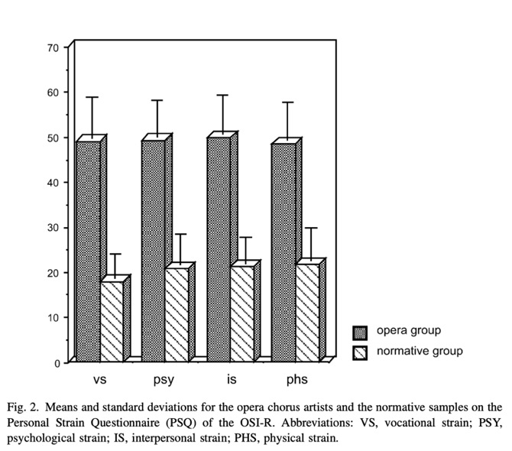

The Interpretivism/Constructivism Paradigm
Interpretivism is a range of perspectives on interpreting social reality with a focus on understanding instead of prediction, on multiple possibilities instead of universal axioms, and on reflexivity instead of objectivism (Oxford, 2020). Constructivism and interpretivism, often synonymously associated with each other, are concepts related by the view that reality is “understanding the world as others experience it” (Kawulich & Chilisa, 2012). Interpretivism, sometimes known as “antipositivism” (Flick, 2014), is based on a subjective lens of truth and knowledge based on people’s experiences and how they interpret them. (Ryan, 2018). Human experience, both as individuals and in interactions with each other, and their behaviors are all influenced by culture, history, situational factors and environment. Therefore, it would be false to believe that all humans would experience the same phenomena without considering the mentioned factors and especially in vocal research (Saliya, 2023). In conducting research, a concept may seem to be an ideal solution to the problem, but when confronted with the influences of various environments and people, the results can be as varied as the number of people being tested (Gray, 2004). Interpretive research therefore uses a qualitative, inductive d approach as its research methodology, allowing for all the variances and complexities to guide making conclusions in the study. Data is collected through open-ended interviews, observations, field notes, personal notes, documents, and recordings, among other methods (Sol & Heng, 2022).
Interpretivism is based around Husserl’s philosophy of phenomenology – the belief that the world is subjective, socially constructed, that the observer is part of what is being observed, and that science is powered by human interests, the key being to gain insight into the subjective experience of the test subject (Gray, 2004). In phenomenological research, one strives to study the “lifeworld human experience,” by studying the individuals and their worlds, whereas in contrast ethnography would focus on culture of the subjects (Gray, 2004).
In addition to phenomenology, hermeneutics also come into play for interpretivists. Originating from Dilthey and others’ 19th Century German philosophy and oft associated with phenomenology and Freudian analysis, hermeneutics theory views social reality as constructed socially, rather than being founded upon objective fact (Gray, 2004).
Based on these perspectives, constructivists/interpretivists do not begin with a hypothesis or theory as positivists do, but instead use inductivism to gather meaning and reality from the research process itself (Mackenzie & Knipe, 2006). Constructivists/interpretivists therefore approach research through a qualitative methodology, valuing in-depth interviews, focus groups, interpreting meaning in human actions through observations of smaller groups of subjects in their social constructions (hermeneutics) and the subjective experience and observation of the test subject (phenomenology) to make conclusions about a research topic (Sol & Heng, 2022; Kawulich & Chilisa, 2012).
In terms of vocal MPA research its many manifestations, inclusion of qualitative experiences of the individuals would seem to be crucial to finding answers and solutions to the problem. My own experiences with MPA as a performer have included both psychological and physical issues ranging from shaking, sweaty palms, and nausea to avoidance of performing, memory lapses, and decreased vocal quality. Interpretivism could be an appropriate approach to researching MPA in singers, but due to the time-consuming process of interviewing test subjects to gather in-depth qualitative feedback, researchers can only test a limited number of subjects which makes it difficult to generalize about the overall population of singers with MPA (Sol & Heng, 2022). Paese & Egermann used this fully qualitative approach in their research study of meditation as a tool to counteract MPA and gathered qualitative feedback from subjects through interview questions (Paese & Egermann, 2023). Given the wide range of personal and psychological aspects of MPA, it would seem beneficial to conduct vocal MPA research from an inductive and interpretivist approach. However, leaning heavily on qualitative data to interpret a smaller group of test subjects limits the ability to generalize and make overarching conclusions about MPA amongst singers (Paese & Egermann, 2023; Sol & Heng, 2022).
This leads us to explore a third paradigm that could incorporate the personal and detailed documentation of a subject’s experience in order to draw a conclusion, but with the added reinforcement of quantitative data that supports the qualitative data gathered in order to make broader generalizations about singers suffering from MPA as a whole.
Table 1: 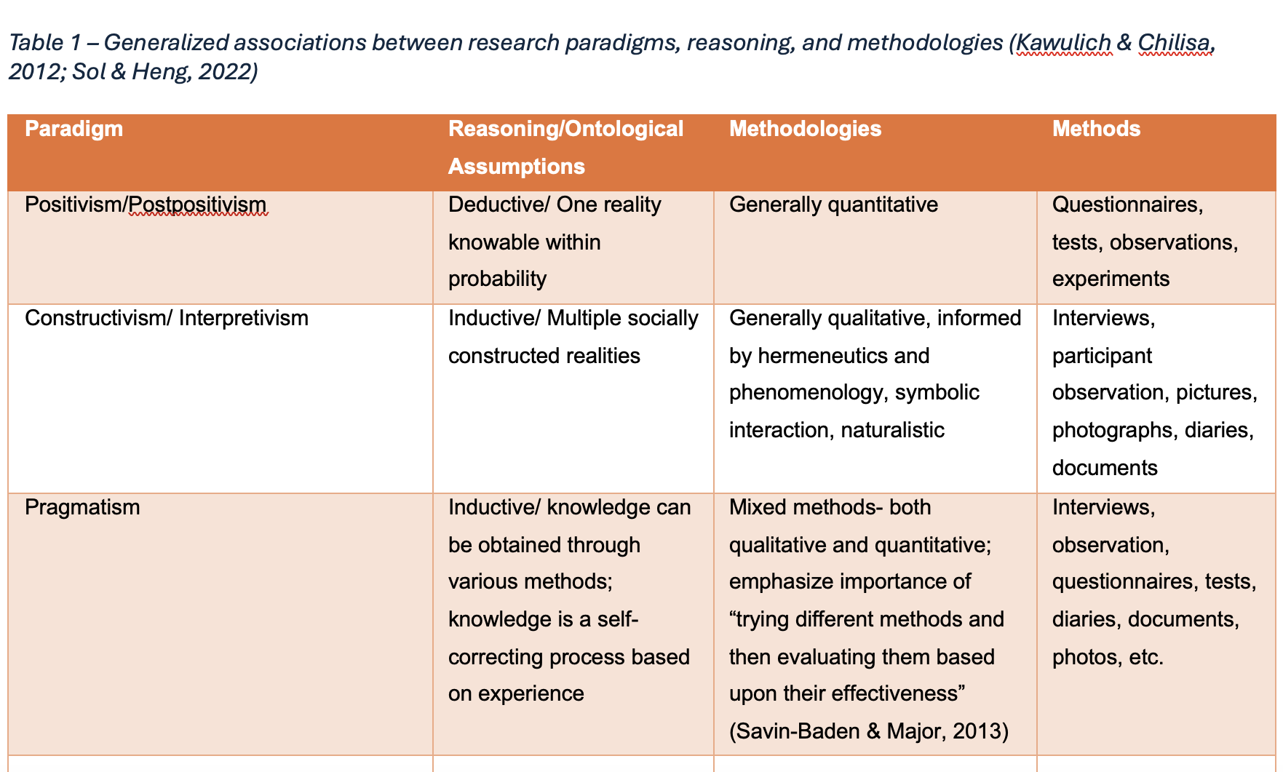

The Pragmatism Paradigm
Pragmatism is a research approach based on the late 19th Century American philosophy of Pierce, James, and Dewey that assesses the value of theories and truth by how well they can be practically applied to the research topic (Kaushik & Walsh, 2019; Sol & Heng, 2022). The philosophy of pragmatism was a rejection of the traditional notions of knowledge and the belief that reality can be defined from investigating social science through a single scientific method. It is generally associated with remaining open to what is practical for the situation (Kaushik & Walsh, 2019). So that can mean an inductive-deductive approach and mixed methods, both quantitative and qualitative methodology in data collection (Kaushik & Walsh, 2019). Pragmatists accept that there is no single reality since reality is open to question depending on the situational context of a study; knowledge and reality are socially constructed and are based on human experience (Creswell & Clark, 2011).
For the researcher studying MPA in singers, this paradigm seems to provide the most complete and holistic approach to understanding how to best relieve symptoms of MPA in singers. Since MPA presents itself cognitively, somatically, and behaviorally in singers (Kenny, 2011), with a complex web of symptoms including avoidance, memory slips, and increased heart rate, a pragmatic, mixed method approach with both quantitative test results and qualitative feedback has proven successful among the studies of treatments for singers with MPA. Qualitative data combined with supporting quantitative data can greatly strengthen a researcher’s argument for or against treatments that alleviate symptoms in singers. The truth about MPA and how symptoms can be alleviated can be socially constructed by investigating the issue in vocalists and identifying potential treatments through this pragmatic approach. This is exemplified in David Juncos’ ACT research on opera choristers suffering MPA (Juncos et al., 2018) and Judith Stern’s yoga intervention for conservatory students with MPA (Stern et al., 2012). In Juncos et al.’s research, they were able to pinpoint specific truths about each individual’s manifestation of MPA through therapy sessions and exercises using the ACT method to alleviate MPA. In turn, they could make more general conclusions about the effectiveness of the ACT treatments using statistics from scores on the K-MPAI, and other assessment tools (Juncos et al., 2018). In Judith Stern’s study on yoga therapy for MPA relief, the effectiveness of meditation, breathwork, and physical poses on singers with MPA was measured by asking students to provide subjective feedback by keeping a home log and filling out an evaluative questionnaire, as well as conducting quantitative tests such as the Performance Anxiety Questionnaire (PAQ), and other comparable quantitative tools (Stern, 2012). By learning from what worked best for each individual through the qualitative feedback, she could then construct practical tools for the subject that resulted in a general trend of improvement in the quantitative test scores (Stern, 2012).
While pragmatic research seems to provide the most complete picture of what proved successful in treating MPA, it is important to be aware of potential issues. Juncos et al. expressed that if the researcher wants to succeed in collecting accurate data, they need to be aware of cultural differences, such as how comfortable the singers are at expressing emotion, and musician-specific considerations, such as the need for the researcher to defer to the instruction of the musician’s teacher, which music students usually prioritize over any kind of MPA training (Juncos et al., 2018). According to Stern’s study, some of the quantitative data was less successful than expected in exhibiting significant proof of improvement when comparing test scores before and after therapy due to the small pool of subjects and a need to recruit more randomized test subjects and a control group (Stern, 2012). There are certainly issues in every type of methodology, but the pragmatist research approach of gaining an understanding of how each individual experiences and suffers from MPA through qualitative data in combination with constructing relevant solutions for each individual based on which treatments showed most significant improvement in quantitative test scores seems to provide the most holistic and complete approach to providing answers for vocal research in MPA .

Ethics and Issues of Insider Research

A major consideration for researchers who are studying a community of which they are a member, known as an “insider researcher,” are the potential pitfalls that can arise as a researcher studying a community of which they are a member (Larrabee, 2002). Due to the very nature of vocal pedagogists studying vocalists with MPA, a deeply personal subject matter associated closely with mental health, ethics and bias (see glossary) must be seriously considered when conducting sensitive MPA research involving sensitive test subject information (Costley et al., 2010). Ethics concerns the appropriateness of a researcher’s behavior in relation to the test subjects in the researcher’s study (Gray, 2004). An important step to beginning a research study is for an insider researcher to compose a positionality/reflexivity statement (see glossary) to identify their personal or cultural background and how it may impact their research (Roberts et al., 2020). This will also enable a researcher to contemplate any bias, axiological perspectives, and/or preconceived notions the researcher has in entering into the study and strive for as objective an approach to their methodology as possible.

Because of the need for regulation in sensitive topics and ethical issues involving human research, The Belmont Report was created in 1976 by the United States government to provide ethical guidelines and principles regarding research using human subjects in the US, and many countries have similar guidelines for the ethical treatment of subjects in biomedical and behavioral research (United States, 1978). Since research on vocalists, particularly those facing psychological challenges like MPA, involves sensitive topics of a personal nature, recruiting participants, human to human interaction, recording and storing confidential information, among other things, it is essential to maintain the proper respect and ethical protocol for the subjects outlined in the five Belmont Principles and the American Psychological Association (APA): 1) beneficence 2) respect for persons 3) justice with the addition of 4) fidelity and responsibility as well as 5) integrity (United States, 1978; APA.com, 2017). An effective way to follow these guidelines is to receive not just consent from the participant, but informed consent, written agreement preceded by a debrief of the contents between researcher and participant to ensure clarity of purpose and intention of the study (Lambert, 2019; Gray, 2004). The following topics should be discussed as part of receiving informed consent, according to David E. Gray:

Figure 3 Informed Consent Checklist from David E. Gray's Doing Research in the Real World (Gray, 2004)
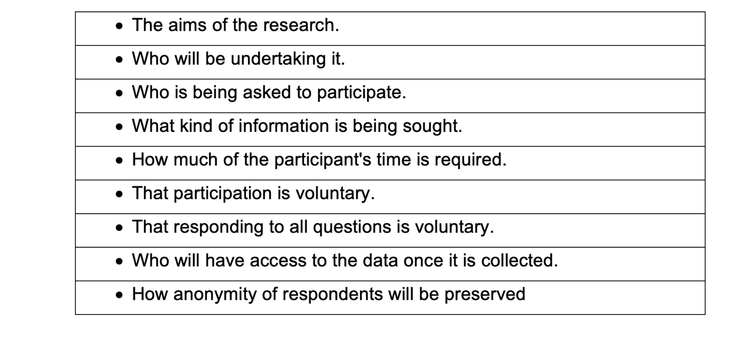
It is important to note that for test subjects, especially in environments involving school children or university students where a minor or student is in a subordinate position to an authority figure, a researcher should avoid making a participant feel coerced into participation, making clear to a participant that there will be no repercussions to their position in the environment by not participating (Lambert, 2019). Questionnaires and test results can also be of a problematic nature due to the collection and storage of personal information. In order to avoid issues, questions asked in surveys or questionnaires should be carefully stored and constructed in order to avoid the sense of an invasion of privacy, a breach of privacy, embarrassment for the participant, or the risk of causing them offence (Lambert, 2019).

To ensure the ethical treatment of human test subjects, professional researchers should follow guidelines set forth by the institution of which they are a part and/or the appropriate regional or subject-driven professional agencies in fields such as, sociology and psychology, particularly in researching vocal MPA, which involves deeply personal information being collected and places subjects in a vulnerable position (Gray, 2004).

Conclusion
In surveying various research paradigms and methodologies with the objective of identifying which aspects of positivism/postpositivism, interpretivism/constructivism, and pragmatism would best suit research in vocal MPA, I have uncovered many of the pros and cons of each type of paradigm. In preparation for a research study, it behooves the researcher to identify their ontological, epistemological, and axiological stance on the subject matter, evaluate one’s potential biases as an insider researcher, follow the guidelines of the Belmont report (or the appropriate regional guidelines), and receive informed consent to prevent any ethical transgressions . This due diligence process, in turn, can help reveal the best paradigm and methodological approach for gathering data and conducting the study. The questions one should ask oneself are: A) Do I start with a hypothesis and set out to prove a theory [positivism]? B) Do I aim to understand and interpret the subjective meanings of people in studied domains [interpretivism], or C) Do I believe that I should use the philosophical and/or methodological approach that works best for the particular research problem that is being investigated [pragmatism] (Goldkuhl, 2012; Kaushik & Walsh, 2019)? In answering these questions and understanding one’s main objective, the appropriate paradigm, methodologies, and methods for one’s study begin to reveal themselves organically.
From the study of the presence of MPA among singers (Kenny, 2004), one sees that she could successfully conduct research from a postpositivist viewpoint, since she had a hypothesis that singers did in fact have higher incidences of MPA than normative groups. The positivist type approach, however, can present issues since the metrics alone wouldn’t provide enough data to understand the details of the effects of the study on the participants.
The qualitative and interpretivist study conducted by Paese and Egermann on meditation used as a tool to counteract MPA is an example of an effective paradigm and methodology to understand the personal effects on a deeper level (Paese & Egermann, 2024). However, due to the limited sample sizes of participants, the researchers themselves concluded that combining qualitative and quantitative methods in the future for studies of meditation on MPA might provide a more complete picture enabling them to generalize that meditation can be used as an effective tool for MPA in musicians (Paese & Egermann, 2024). While having a larger pool of subjects may introduce more factors into the study and increase the complexity of the data, a mixed methods approach would enable researchers to recommend meditation to the broader population of singers suffering from MPA as a possible treatment.
Lastly, we explored the pragmatist paradigm, combining a mixed methods approach to gathering data in vocal MPA research. This seemed to be the most successful paradigm for providing an all-encompassing view of how a researcher’s experimental methods alleviate MPA symptoms in research involving both physical and psychological aspects. The researcher can obtain feedback about MPA treatments through qualitative data collection and when used in conjunction with inventories like the KMPA-I, the researcher can provide statistical evidence that treatment methods were effective.
Given the precedence set by past experiments and studies on this subject matter, I have created a possible research approach outline (see Appendix 1) for my future study on testing combined methods of mindfulness, energy medicine, and ACT for treating MPA. My ontological, epistemological, and axiological stances will contribute to constructing an appropriate research study for my vocal research in MPA and can also guide others doing similar insider research.

References

Acharyya, R. and Bhattacharya, N. (eds) (2019) Research methodology for social sciences. Abingdon, Oxon ; Routledge.

Anon, (2024). Scientific Method. [online] Available at: https://www.britannica.com/science/scientific-method [Accessed 29 Jun. 2024].

Anon, (2024). Ethics [online] Available at: https://www.britannica.com/science/scientific-method [Accessed 29 Jun. 2024].
American Psychological Association (2017). "Ethical Principles of Psychologists and Code of Conduct". www.apa.org [Accessed 11 Jul. 2024]

Bogdan, R. and Biklen, S.K. (2007). Qualitative research for education: an introduction to theory and methods. Boston, Mass.: Pearson A & B.

Bracken, S. (2010) Discussing the importance of ontology and epistemology awareness in practitioner research. Worcester Journal of Learning and Teaching (4).

Chandler, D. and Munday, R. (2020). Dictionary Of Media and Communication. 3rd ed. S.L.: Oxford Univ Press.
Cohen, L., Manion, L. and Morrison, K. (Keith R.B.) (2018) Research methods in education. Eighth edition. London: Routledge.

Cook, T.D. and Donald Thomas Campbell (1979). Quasi-experimentation: Design and analysis issues for field settings. Chicago: Rand McNally.
Costley, C., Elliott, G. and Gibbs, P. (2010) Doing work-based research : approaches to enquiry for insider-researchers. Los Angeles: SAGE.

Craig, E. (1998). 'Ontology' In: Routledge Encyclopedia of Philosophy, Taylor and Francis, viewed 4 June 2024, <https://www.rep.routledge.com/articles/thematic/ontology/v-1>. doi:10.4324/9780415249126-N039-1

Creswell, J.W. and Plano Clark, V.L. (2011). Designing and Conducting Mixed Methods Research. 2nd ed. Los Angeles: Sage Publications.

Creswell, J.W. and Creswell, J.D. (2018). Research design: Qualitative, quantitative & mixed methods approaches. 5th ed. Los Angeles: Sage.

David, M. and Sutton, C.D. (2004) Social research: the basics. London: SAGE
Denzin, N. K., & Lincoln, Y. S. (2005). (Eds.). The Sage handbook of qualitative research (3rd ed.) Thousand Oaks, CA: Sage.

Flick, U. (2014). An Introduction to Qualitative Research. SAGE.
Goldkuhl, G. (2012) ‘Pragmatism vs interpretivism in qualitative information systems research’, European journal of information systems, 21(2), pp. 135–146. Available at: https://doi.org/10.1057/ejis.2011.54.

Gray, D.E. (2004). Doing research in the real world. London; Thousand Oaks, Ca: Sage Publications.
Heidegger, M., Macquarrie, J. and Robinson, E. (1962) Being and time. Oxford: Basil Blackwell.

Hitchcock, G. and Hughes, D. (1995). Research and the Teacher A Qualitative Introduction to School-based Research. London Routledge And Kegan Paul Limited.

Juncos, D.G. and de Paiva e Pona Elvire (2018) “Acceptance and commitment therapy as a clinical anxiety treatment and performance enhancement program for musicians,” Music & science, 1. Available at: https://doi.org/10.1177/2059204317748807.

Kaushik, V. and Walsh, C.A. (2019) ‘Pragmatism as a Research Paradigm and Its Implications for Social Work Research’, Social sciences (Basel), 8(9), pp. 255-. Available at: https://doi.org/10.3390/socsci8090255.

Kawulich, B. and Chilisa, B. 2012 ‘Selecting a Research Approach, Methodology and Methods.’ Doing Social Research: A Global Context 5 (January 2012): 51-56.
https://www.researchgate.net/publication/257944787.

Kenny, D.T., Davis, P. and Oates, J. (2004) “Music performance anxiety and occupational stress amongst opera chorus artists and their relationship with state and trait anxiety and perfectionism,” Journal of anxiety disorders, 18(6), pp. 757–777. Available at: https://doi.org/10.1016/j.janxdis.2003.09.004.
Kenny, D.T. (2011) The psychology of music performance anxiety. Oxford: Oxford University Press.
Kinsinger, F.S. (2019). Beneficence and the professional’s moral imperative. Journal of Chiropractic Humanities, [online] 16(1), pp.44–46. doi:https://doi.org/10.1016/j.echu.2010.02.006.

Lambert, M. (2019). Practical research methods in education: an early researcher’s critical guide. Abingdon, Oxon; New York, Ny: Routledge.
Mackenzie, N. and Knipe, S. (2006) ‘Research dilemmas: paradigms, methods and methodology’, Issues in educational research, 16(2), pp. 193–205.

Labaree, R.V. (2002) ‘The risk of “going observationalist”: negotiating the hidden dilemmas of being an insider participant observer’, Qualitative research : QR, 2(1), pp. 97–122. Available at: https://doi.org/10.1177/1468794102002001641.

Mertens, D.M. (2010) ‘Transformative Mixed Methods Research’, Qualitative inquiry, 16(6), pp. 469–474. Available at: https://doi.org/10.1177/1077800410364612.

Mertens, D.M. (2014). Research and evaluation in education and psychology: integrating diversity with quantitative, qualitative, and mixed methods. Thousand Oaks: SAGE Publications, Inc.

Mouly, G.J. (1978). Educational Research. Allyn & Bacon.
www.theneuron.ai. (2023). The Neuron. [online] Available at: https://www.theneuron.ai/write/statements/positionality-statement#:~:text=A%20positionality%20statement%20is%20a%20statement%20that%20explains%20your%20personal [Accessed 11 Jul. 2024].

O’Leary, Z. (2021) The essential guide to doing your research project. 4th edition. London: SAGE.

Paese, S. and Egermann, H. (2024). Meditation as a tool to counteract music performance anxiety from the experts’ perspective. Psychology of Music, p.030573562311559. doi:https://doi.org/10.1177/03057356231155968.

Pannucci, C.J. and Wilkins, E.G. (2011). Identifying and Avoiding Bias in Research. Plastic and Reconstructive Surgery, [online] 126(2), pp.619–625. doi:https://doi.org/10.1097/PRS.0b013e3181de24bc.

Park, Y.S., Konge, L. and Artino, A.R. (2020). The Positivism Paradigm of Research. Academic Medicine, [online] 95(5), pp.690–694. doi:https://doi.org/10.1097/ACM.0000000000003093.
Patton, M.Q. (2002). Qualitative research and evaluation methods (3rd ed.). Thousand Oaks: Sage.

Roberts, S.O., Bareket-Shavit, C., Dollins, F.A., Goldie, P.D. and Mortenson, E. (2020). Racial inequality in psychological research: Trends of the past and recommendations for the future. Perspectives on Psychological Science, [online] 15(6), pp.1295–1309. doi:https://doi.org/10.1177/1745691620927709.
Ryan, G. (2018) ‘Introduction to positivism, interpretivism and critical theory’, Nurse researcher, 25(4), pp. 14–20. Available at: https://doi.org/10.7748/nr.2018.e1466.

Saliya, C.A. (2023) Social Research Methodology and Publishing Results : A Guide to Non-Native English Speakers. 1st ed. Edited by C.Arachchige. Saliya. Hershey: IGI Global.

Stern, J.R., Khalsa, S.B.S. and Hofmann, S.G. (2012). A Yoga Intervention for Music Performance Anxiety in Conservatory Students. Medical Problems of Performing Artists, 27(3), pp.123–128. doi:https://doi.org/10.21091/mppa.2012.3023.

Savin-Baden, M. & Major, C.H. (2010). New approaches to qualitative research : wisdom and uncertainty. London ; New York: Routledge.

Schwandt, T.A. (1997) Qualitative inquiry : a dictionary of terms. Thousand Oaks; Sage.

Sol, K. & Heng, K. (2022) Understanding epistemology and its key approaches in research. Cambodian Journal of Educational Research (December 2022) p.4. Available at: https://www.researchgate.net/publication/367310471.

Ulz, J. (2023) What is a Research Paradigm? Types of Research Paradigms with Examples. Researcher.life. [online] Available at: https://researcher.life [Accessed 30. May 2024].

United States (1978). The Belmont Report: Ethical Principles and Guidelines for the Protection of Human Subjects of Research. [online] University of North Texas Libraries. UNT Libraries Documents Department. Available at: https://digital.library.unt.edu/ark:/67531/metadc1213679/ [Accessed 11 Jul. 2024].

Walliman, N. (2006) Social research methods. London: SAGE.

Winter, D. (2023). Exploring the Narrative: Voice Practitioner Research and the Literature Review Process. Voice & Speech Review, 17(2), 131–150. https://doi.org/10.1080/23268263.2022.2144971

Wyse, D. et al. (eds) (2017) The BERA/SAGE handbook of educational research. London: Sage.

Appendix

Appendix 1: Proposed Research Design for Study on the Effects of MPA
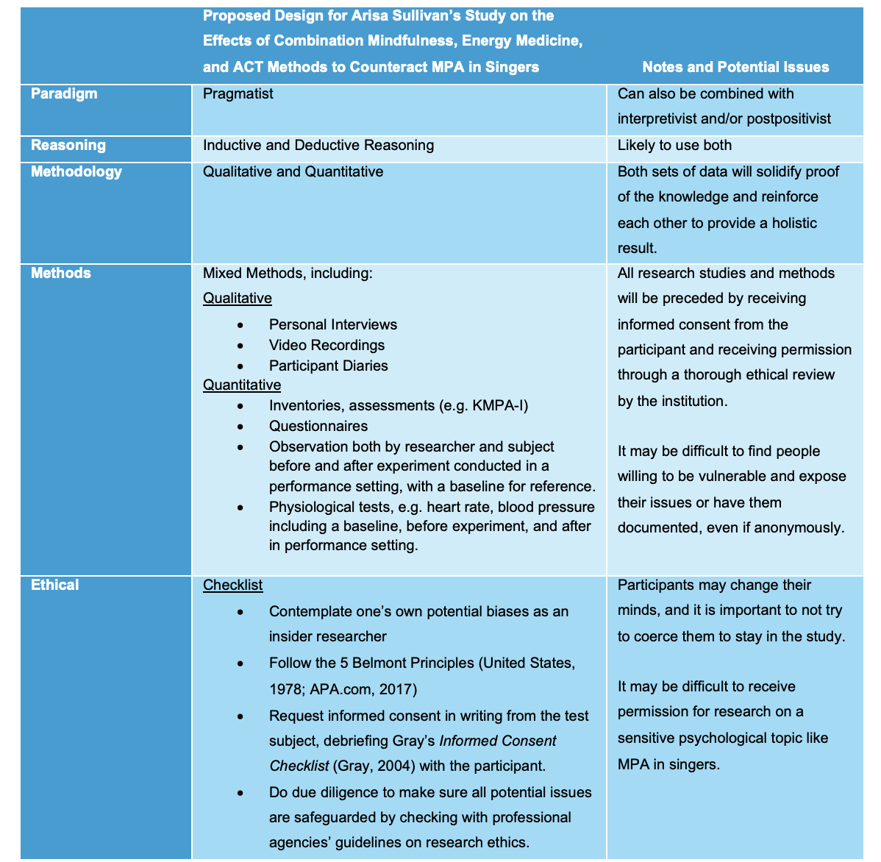

Appendix 2: Glossary of Terms
Beneficence - an act of charity or kindness with a strong connotation of doing good for others including moral obligation (Kinsinger, 2019).
Bias - A tendency which prevents unprejudiced consideration of a question which in turn affects sampling and testing (in research) by encouraging one outcome over another (Pannucci & Wilkins, 2011).
Hypothesis – A statement or idea derived from theory that can be tested through experimentation (Park et al., 2020)
Hypothetico-deductive model – Scientific model based on forming a testable hypothesis and developing an empirical study to confirm or reject the hypothesis (Park et al., 2020)
Positionality/Reflexivity – A positionality or reflexivity statement is a written document outlining an individual's social, cultural, political, and personal backgrounds, specifying their values and biases (Roberts et al., 2020).
Scientific Method – “the technique used in the construction and testing of a scientific hypothesis. The process of observing, asking questions, and seeking answers through tests and experiments” (Brittanica.com, 2014).

