

Student Name: Naitiksinh Pareshbhai Parmar

Student ID: 2525945

Module Name: International Marketing: Principles and Practices

Module Code: LCMB7026

Lecturer’s Name: Tola Odugbesan

Work Count: 5498

Term 2

Table of Contents
Section 1: International Market Entry Strategy and Marketing Mix Report 6
1.0 Introduction 6
1.1 Background to Cadbury 6
1.2 Selection of the UK and India 7
1.3 Report Purpose and Scope 7
2.0 Comparative Market and Macro-environmental Analysis 7
2.1 Overview of the UK and Indian Confectionery Markets 7
2.2 Comparative PESTEL Analysis 9
2.2.1 Political Factors 9
2.2.2 Economic Factors 10
2.2.3 Social Factors 11
2.2.4 Technological Factors 12
2.2.5 Environmental Factors 13
2.2.6 Legal Factors 14
2.2.5 Comparative Implications for Cadbury 15
2.3 Hofstede Cultural Comparison 15
2.3.1 Relevant Cultural Dimensions 16
2.3.2 Influence on Consumer Behaviour and Marketing 16
2.3.3 Strategic Implications 17
3.0 Comparative STP Analysis 17
3.1 Market Segmentation 17
3.2 Target-Market Selection 19
3.3 Positioning Strategy 19
3.4 Critical STP Comparison 20
4.0 Comparative International Marketing Mix Analysis 20
4.1 Product Strategy 20
4.2 Pricing Strategy 22
4.3 Place and Distribution Strategy 23
4.4 Promotion Strategy 24
4.5 People Strategy 25
4.6 Process Strategy 25
4.7 Physical Evidence Strategy 26
4.8 Overall Standardisation–Adaptation Evaluation 27
5.0 Cadbury’s Market-Entry Strategy in India 28
5.1 Historical Entry and Development 28
5.2 Entry Mode and Strategic Rationale 29
5.3 Effectiveness of the Entry Strategy 30
5.4 Limitations and Alternative Entry Options 30
6.0 Ethical Issues in Cadbury’s Indian Marketing Mix 31
6.1 Identification of Ethical Issues 31
6.2 Stakeholder Impact 32
6.3 Cadbury’s Response and Ethical Evaluation 32
6.4 Implications for the Marketing Mix 33
7.0 Strategic Recommendations 33
7.1 Product and Portfolio Development 33
7.2 Pricing and Distribution Improvement 34
7.3 Culturally Responsive Communication 34
7.4 Ethical and Sustainable Marketing 34
8.0 Conclusion 35
Section 2: Reflective Account Using Gibbs’ Reflective Cycle 35
9.0 Introduction to the Reflective Account 35
10.0 Gibbs’ Reflective Cycle 36
10.1 Description: What I Did 36
10.2 Feelings: My Initial Reactions 37
10.3 Evaluation: What Worked and What Did Not 37
10.4 Analysis: What I Learned 38
10.5 Conclusion: What I Could Have Done Differently 39
10.6 Action Plan: Future Improvement 39
11.0 Reflective Summary 40
References 41

List of Tables
Table 1: Cadbury’s Market Opportunities, Threats and Responses 15
Table 2: Cadbury’s 7Ps Adaptation in the UK and India 28
Table 3: Stakeholder Impacts of Cadbury’s Child-Focused Marketing 32
Table 4: Personal and Academic Development Action Plan 40

List of Figures
Figure 1: Cadbury Brand Logo 6
Figure 2: Cadbury’s Origins at Bull Street, Birmingham 7
Figure 3: UK and Indian Chocolate Market Size and Growth 8
Figure 4: UK HFSS Promotion and Advertising Restrictions 9
Figure 5: UK Cost-of-Living Inflation 10
Figure 6: Projected Growth of the Indian Confectionery Market, 2025–2033 11
Figure 7: Cadbury India Festival Gift Packs 12
Figure 8: Growth of the UK Online Grocery Market, 2019–2026 13
Figure 9: Cadbury Dairy Milk Packaging Using Certified Recycled Plastic 14
Figure 10: Hofstede’s Cultural-Dimension Scores for India and the UK 16
Figure 11: Cadbury Celebrations’ Relationship-Focused Diwali Campaign 17
Figure 12: Cadbury Product Portfolio 18
Figure 13: Cadbury Dairy Milk India’s Friendship-Focused Campaign 20
Figure 14: Cadbury’s UK Christmas Seasonal Product Range 21
Figure 15: Cadbury Dairy Milk’s Affordable Pack in India 23
Figure 16: Cadbury’s UK Easter Egg Hunt Campaign 24
Figure 17: Automated Production and Packaging of Cadbury Dairy Milk 26
Figure 18: Cadbury Dairy Milk Packaging 27
Figure 19: Cadbury’s Initial Market Entry into India in 1948 29
Figure 20: Strategic Benefits of a Joint-Venture Market-Entry Mode 30
Figure 21: Child-Focused Promotion of Cadbury Dairy Milk Milkinis in India 31
Figure 22: Gibbs’ Reflective Cycle 36

Section 1: International Market Entry Strategy and Marketing Mix Report

1.0 Introduction

1.1 Background to Cadbury

Figure 1: Cadbury Brand Logo
Source: (Seeklogo, 2026)
Founded in Birmingham, UK in 1824, Cadbury started as a family business with a cocoa trading operation and is now a global confectionery company (Cadbury, 2026-a). The company is now owned by Mondelēz International and its business has a global manufacturing and distribution network, which encompasses Dairy Milk, Wispa, Twirl, Bournville, and products for seasonal gifting (Mondelēz International, 2026).
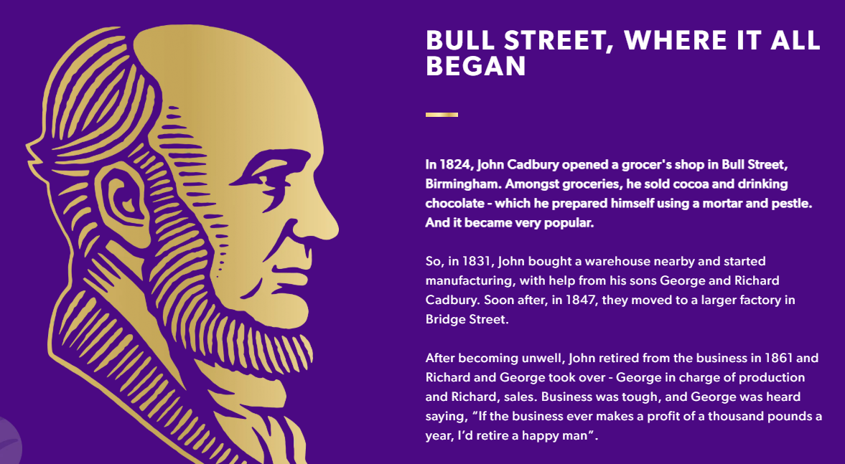
Figure 2: Cadbury’s Origins at Bull Street, Birmingham
Source: (Cadbury, 2026-a).

1.2 Selection of the UK and India
The UK is Cadbury's mature home market with strong brand heritage, supermarket routes and an increasing health-conscious consumer. On the other hand, India offers a high-growth host market characterized by heightened price sensitivity, the growing importance of festival gifts, family-based consumption and the rapid growth of traditional markets as well as modern and quick-commerce retail channels (Del Prete et al., 2020; Siwach, 2026).

1.3 Report Purpose and Scope
A critical comparison of the two macro environments and cultures is undertaken before an evaluation of Cadbury's segmentation, targeting and positioning and the seven elements of the marketing mix. It then examines the company's strategy for entering the Indian market, explores marketing related ethical issues, and offers data-supported recommendations for future marketing strategies that would be both locally appropriate and globally consistent, responsible and sustainable.

2.0 Comparative Market and Macro-environmental Analysis

2.1 Overview of the UK and Indian Confectionery Markets
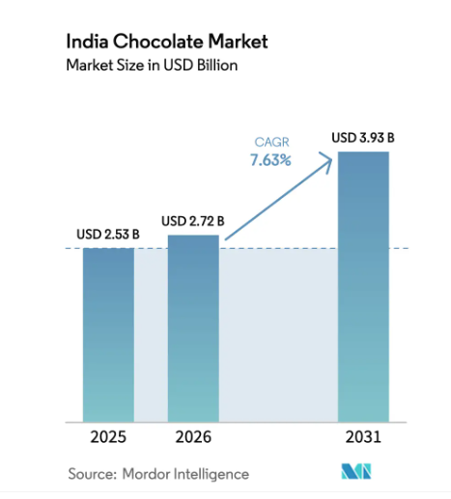
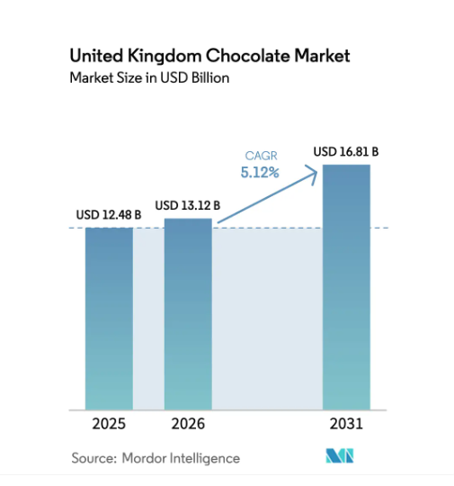
The chocolate market in the UK is a mature and high-consumption market, and is expected to reach around £6.63 billion by 2034, growing at 4.55% annually from 2025 (IMARC Group, 2026b). Cadbury has strong brand heritage and is widely available in supermarkets, convenience stores and online, but is in competition with Mars, Nestlé, Lindt and retailer-owned brands. Instead, the growth is increasingly related to premiumisation, innovation in reduced sugar and ethical sources of cocoa.

Figure 3: UK and Indian Chocolate Market Size and Growth
Source: (Mordor Intelligence, 2026)
India offers stronger volume potential. In 2025, the confectionery market recorded a value of INR398.7 billion, and is forecast to expand to INR618.1 billion by 2034, with economy products accounting for the largest price segment (IMARC Group, 2026a). Cadbury faces competition from Nestlé, Mars, Ferrero, Amul and local candy manufacturers. Urbanisation, treats and festival gifting, and affordable prices are the key drivers of consumption, with e-commerce and quick commerce also offering out-of-supermarket shopping opportunities (Siwach, 2026). However, lower purchasing power, rural distribution costs and cocoa-price volatility make small packs and local production strategically necessary. In both markets, there has been an increasing consumer trust and product development towards health, recyclable packaging, and responsible sourcing (Begum et al., 2025; Pokharel, Keerthi and Abunamous, 2023).

2.2 Comparative PESTEL Analysis

2.2.1 Political Factors
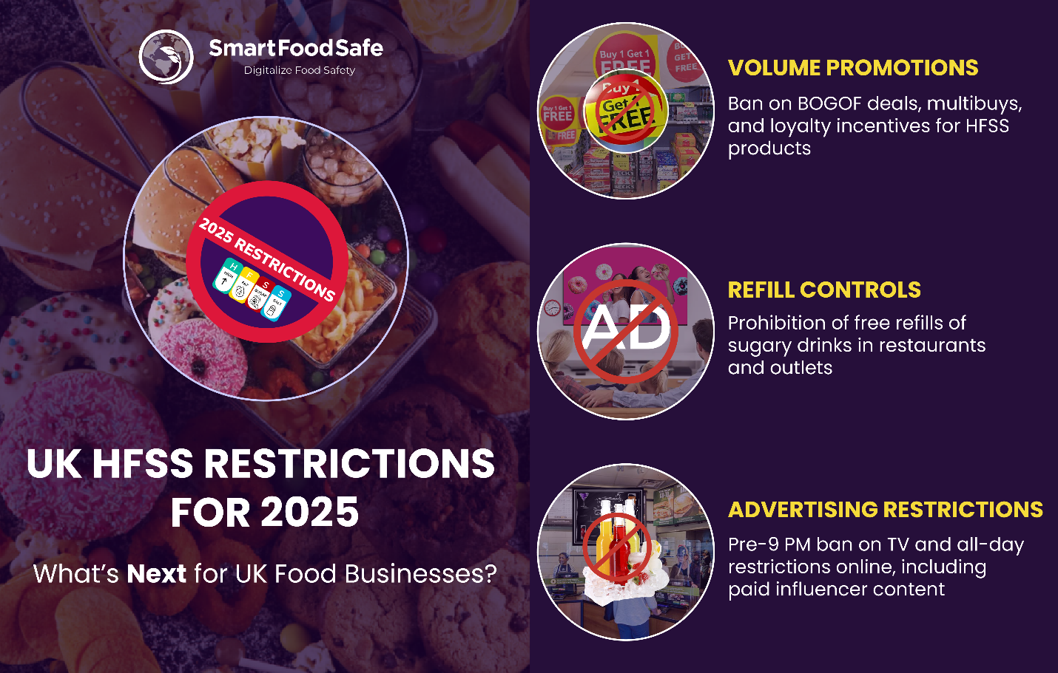
Figure 4: UK HFSS Promotion and Advertising Restrictions
Source: (SmartFoodSafe, 2025)
UK: Political stability and predictable institutional governance in the UK helps Cadbury to long planning. But government policies on obesity, sustainable packaging and responsible supply chains put pressure on reformulation and proof of ethical sourcing of cocoa. International trade agreements can also influence the import costs of cocoa and continuity of supply (Begum et al., 2025).
India: India allows foreign direct investment and domestic food processing, which enables Mondelēz to establish local manufacturing and distribution. Thus, it decreases the reliance on imports of finished goods. But the different infrastructure and policy implementation in every state adds to the complexity of operation, which Cadbury has to manage with effective relationships with national and regional authorities (Mordor Intelligence, 2026).

2.2.2 Economic Factors
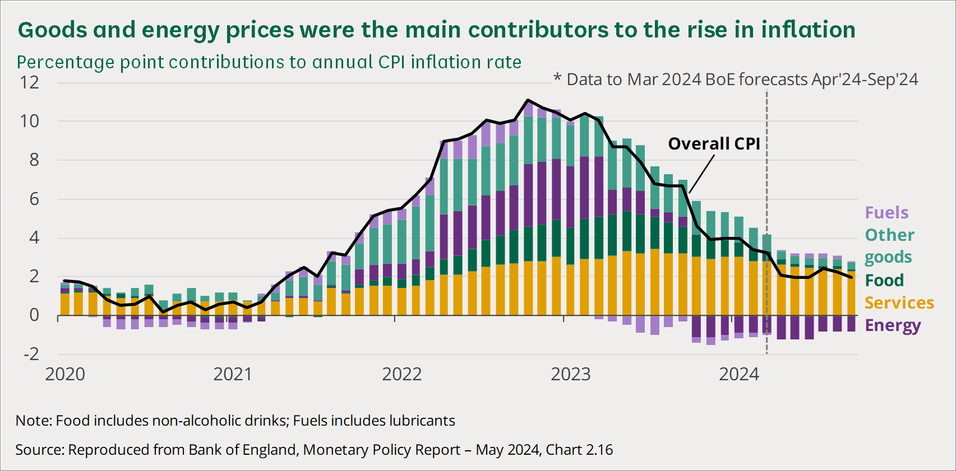
Figure 5: UK Cost-of-Living Inflation
Source: (House of Commons Library, 2024)
UK: High purchasing power supports premium bars, sharing products and seasonal Easter and Christmas ranges. However, inflation and cost of living pressures have a negative impact on discretionary spending, provoke promotional buying, and drive switching to retailer brands (Stone et al., 2024). Cadbury has to keep prices competitively low whilst not compromising pricing in a manner that deprives the company of sales and profits.
India: Rapid growth of the confectionery market offers significant scale, while lower average incomes and income inequality drive high price sensitivity. Cadbury thus needs small packs with low unit prices and high-quality Silk and Celebrations products.
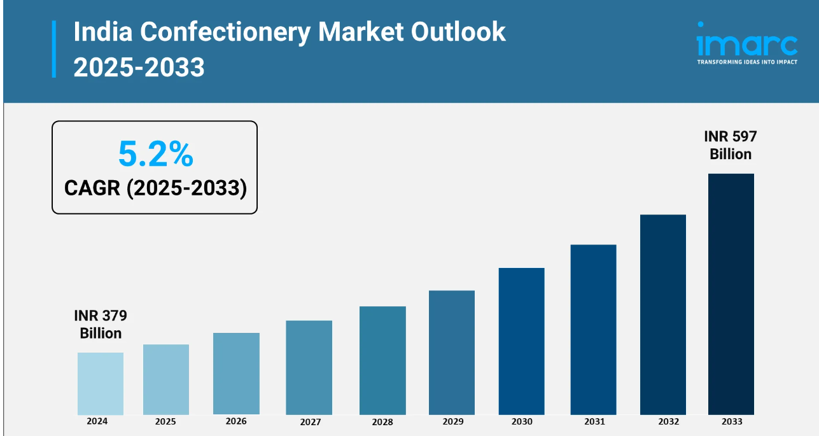
Figure 6: Projected Growth of the Indian Confectionery Market, 2025–2033
Source: (IMARC Group, 2025)
The exposure of margins to currency and commodity price volatility due to rupee depreciation and dependence on imported cocoa makes local production and flexible pack sizes and tiered pricing strategically important (IMARC Group, 2026-a).

2.2.3 Social Factors
UK: Chocolate is linked to personal indulgence, sharing, gifts and seasonal eating. Cadbury have the advantage of being well established and of British origin but there are more people becoming aware of obesity and over eating which is driving the demand for smaller portions and less sugar. Mood and sensory properties continue to play a role as purchase drivers (Mielmann et al., 2022).
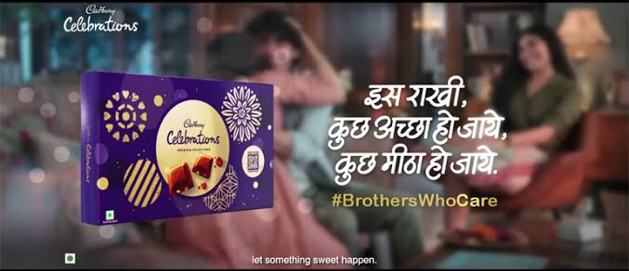
Figure 7: Cadbury India Festival Gift Packs
Source: (Media Infoline, 2022)
India: Family relationships, weddings and festivals like Raksha Bandhan and Diwali have a major impact on consumption. Cadbury has managed to shift chocolate from being a ‘sweet alternative'. But different formulations, labelling and communication are needed for vegetarian preferences and for regional tastes and linguistic diversity. Child targeted promotion also poses public health and morality risks (Rajarajan et al., 2025).

2.2.4 Technological Factors
UK: Automated manufacturing, supermarket analytics, e-commerce and digital advertising enhance demand forecasting, inventory administration, and client focusing on (Wolniak et al., 2024). But privacy concerns can limit data collection and tech vulnerabilities can jeopardize online orders, leading to loss of customer confidence.
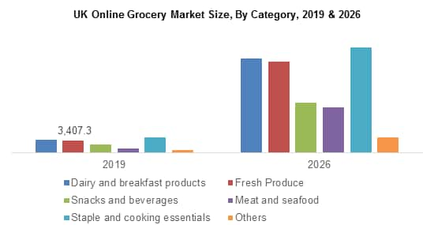
Figure 8: Growth of the UK Online Grocery Market, 2019–2026
Source: (Global Market Insights, 2026)
India: Rapid delivery and festival promotions are made possible by mobile marketing and quick commerce solutions like Blinkit, Zepto and Swiggy Instamart (Siwach, 2026). However, the cold-chain monitoring, heat-resistant packaging and more advanced distributor technologies are needed due to fragmented retail networks and high temperatures.

2.2.5 Environmental Factors
UK: Rising consumer demand for recyclable packaging, lower emissions, less waste, and traceable cocoa. Cadbury's need to back up sustainability claims, as inadequate evidence may lead to allegations of greenwashing (Begum et al., 2025).
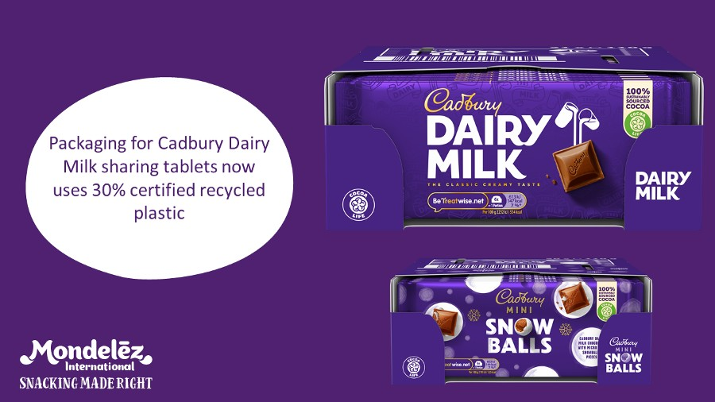
Figure 9: Cadbury Dairy Milk Packaging Using Certified Recycled Plastic
Source: (ConfectioneryNews, 2022)
India: Single serve packs are more convenient but create more waste. This is compounded by risks to cocoa supplies from climate change and heat-sensitive distribution. The packaging should be lightweight, recyclable and the suppliers are responsible, but not at the cost of making products unaffordable (Pokharel et al., 2023).

2.2.6 Legal Factors
UK: Strict food-safety, nutrition-labelling, and IP systems benefit consumers and existing brands but drive up compliance costs. Limits on high-fat, salt and sugar products placement, promotion and child directed advertising compel Cadbury to reformulate their products and advertise responsibly (Dhuria et al., 2025).
India: FSSAI requirements include ingredients, food safety, claims and nutritional labelling as well as compulsory vegetarian identification. Clear front of pack information is important due to consumer's difficulties to interpret the food labels (Pahlani et al., 2025). There are also quality, reputation and IPR risks from the counterfeiting and lack of enforcement, which necessitates retailer monitoring and product-authentication controls.

2.2.5 Comparative Implications for Cadbury
Market | Main opportunity | Main threat | Required response
UK | Premium, healthier and sustainable products | HFSS controls and mature demand | Reformulate and use responsible brand communication
India | Market growth, gifting and quick-commerce | Price sensitivity and distribution complexity | Localise prices, packs, festivals and supply chains
Table 1: Cadbury’s Market Opportunities, Threats and Responses
Source: (Author, 2026)

2.3 Hofstede Cultural Comparison
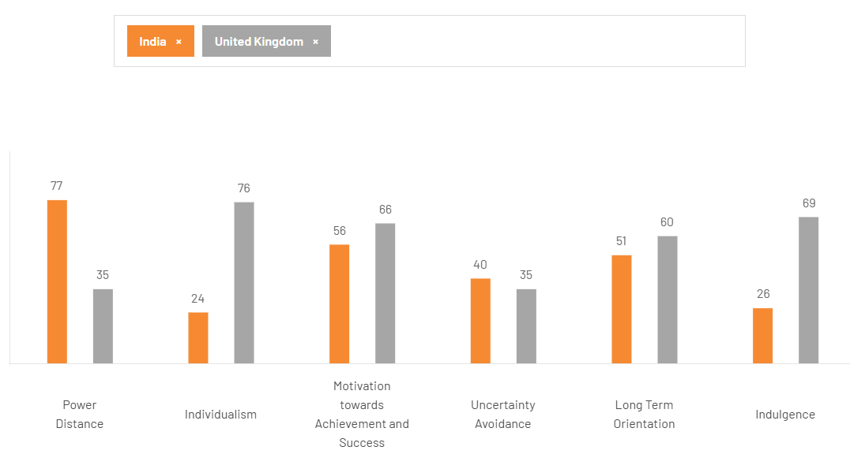
Figure 10: Hofstede’s Cultural-Dimension Scores for India and the UK
Source: (The Culture Factor Group, 2026)

2.3.1 Relevant Cultural Dimensions
UK: The UK ranks low on power distance (35) and high on individualism (89), meaning that equality is preferred, autonomy and personal choice are valued. Its masculinity score (66) indicates achievement and success orientation and low uncertainty avoidance (35) indicates openness to innovation and new products. The long-term orientation score of 51 suggests a mix of tradition and pragmatic change (The Culture Factor Group, 2026).
India: With a score of 77, India is a high-power distance (HPD) country, which means that it has a higher tolerance for hierarchy and authority. It has a lower individualism index (48), which means that family and social groups have a stronger influence on purchasing. Masculinity (56) supports aspiration and visible success, while relatively low uncertainty avoidance (40) permits experimentation when trusted brands reduce perceived risk. Long-term orientation (51) is also a mix of tradition and adaptation (The Culture Factor Group, 2026).

2.3.2 Influence on Consumer Behaviour and Marketing
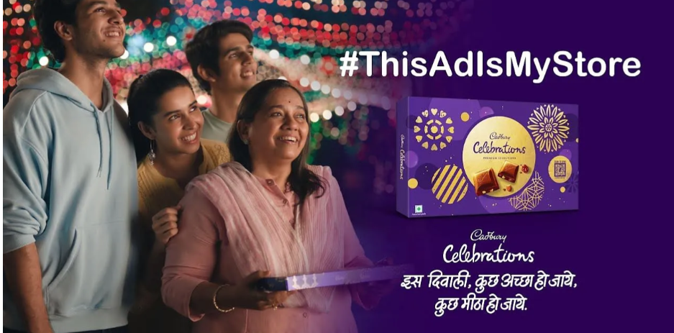
Figure 11: Cadbury Celebrations’ Relationship-Focused Diwali Campaign
Source: (Afaqs, 2024)
Cadbury can stress individual indulgence and personal generosity, humour and informal storytelling, in the UK. Heritage is valued, but consumers can easily try new taste and limited offerings. In India the social connectivity to the purchase is more pronounced hence sharing with family, giving during festivals, trusted celebrities and collective celebration have a greater resonance. Cadbury Celebrations and festival marketing is a testament to this cultural disposition, as Cadbury advertising chocolate as a symbol of relationships more than personal consumption. Culture thus affects the entire consumer experience, from product selection to consumer trust, buying opportunities, and sensory perception of the message (Shavitt et al., 2020).

2.3.3 Strategic Implications
Cadbury should standardize its purple identity, quality promise and generosity positioning and adapt its pack sizes, flavours, languages, endorsers, gifting occasions, and distribution channels. This selective adaptation has the benefit of retaining global brand equity without being too culturally homogeneous. This relational fit is strategically better than total or partial standardisation or fragmentation of localisation, as it is a harmonization of consistent brand meaning with country-specific relationships to consumers (Poulis, 2024).

3.0 Comparative STP Analysis

3.1 Market Segmentation
Cadbury divides UK consumers into children, Adults & families, with income designating mainstream Dairy Milk consumers versus premium gifting consumers. As regards geographical elements, supermarkets are present throughout the country and displays are available seasonally and online too. Psychographic segmentation addresses consumers seeking indulgence, nostalgia, generosity or ethically produced chocolate. Behavioural segments comprise of frequent self-consumers, family sharers and occasional Easter and Christmas buyers. Taste, familiarity, mood and sensory experience strongly influence chocolate choice, supporting variants such as Dairy Milk, Twirl, Wispa and Bournville (Mielmann et al., 2022).
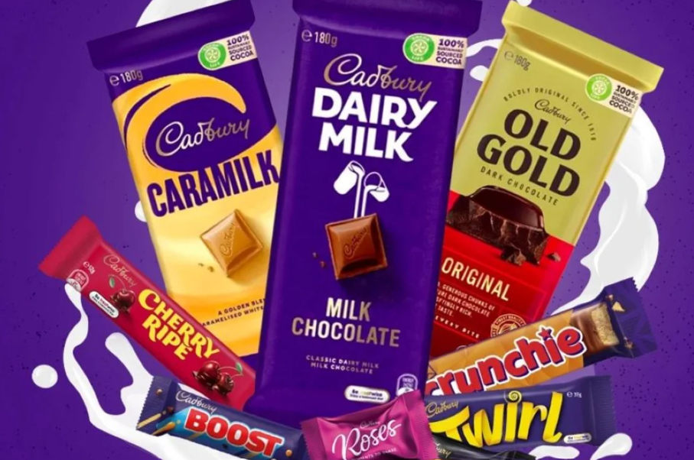
Figure 12: Cadbury Product Portfolio
Source: (Amcor, 2024)
There is a need for more differentiated segmentation in India. Cadbury has a demographic customer base of children, youth, families and an increasingly upscale urban market. Geographic segmentation distinguishes metropolitan premium demand from price-sensitive Tier-2, Tier-3 and rural markets. Psychographically, products resonate with aspiration, affection, and social connection; and behaviourally, they are focused on everyday affordable indulgences, sharing with family members, and weddings and festivals like Diwali and Raksha Bandhan. Accordingly, small Dairy Milk and 5 Star packs provide affordability, whereas Celebrations boxes replace traditional sweets in gifting occasions. The segmentation is a reflection of the evidence that price, product attributes, and availability and purchase occasions influence chocolate decisions (Del Prete et al., 2020).

3.2 Target-Market Selection
Targeting is wide and varied in the UK. Dairy Milk aims for families and mainstream adults, while countlines like Twirl cater to individual consumption, Bournville appeals to dark-chocolate fans and seasonal ranges are for those who like to buy gifts. Health-conscious consumers remain comparatively underserved because Cadbury’s portfolio is strongly associated with sugar and indulgence. It is important to note that direct targeting of children is becoming more challenging due to regulatory measures (Dhuria et al., 2025).
Cadbury focus on children, young adults, families and those that buy Cadbury as festival gifts in India. Affordable products are for mass penetration and Silk and Celebrations are for the affluent consumers and for premium gifting. Quick Commerce enhances the access of digitally connected urban customers (Siwach, 2026). However, there is an ethical issue as the extensive targeting of children and the use of social media during holidays can increase the demand for high-sugar foods amongst vulnerable populations (Rajarajan et al., 2025).

3.3 Positioning Strategy
Cadbury's emotional promise is universal: happiness, generosity and connection. This is highlighted in the UK via Britishness, sentiment, touch on pink wrapping and self-entitlement. In India, it is placed as an affordable manner to express affection and celebration, as seen in the ongoing correlation of Dairy Milk with Kuch Meetha Ho Jaaye and the replacement of conventional festive sweets with chocolate. Therefore, the brand–culture alignment proved to play a significant role in the success of Dairy Milk in India (Fernandes et al., 2017).
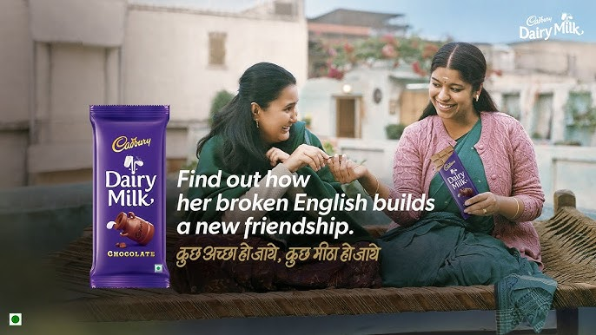
Figure 13: Cadbury Dairy Milk India’s Friendship-Focused Campaign
Source: (Cadbury Dairy Milk India, 2024)

3.4 Critical STP Comparison
Cadbury’s differences extend beyond translated advertising: Indian prices, pack sizes, gifting formats, distribution and consumption occasions demonstrate substantive localisation. However, large-scale targeting can make segment targeting less precise, and a focus on emotion can make it easier to forget health and sustainability issues. Cadbury needs to stick to the globally recognised brand but, with customer data, create regional and ethical and healthier propositions. This selective adaptation offers a better fit in terms of relationships than an outright standardisation (Poulis, 2024).

4.0 Comparative International Marketing Mix Analysis

4.1 Product Strategy
UK: Cadbury has a wide range of products, including Dairy Milk, Twirl, Wispa, Crunchie, Flake, Bournville, Heroes, and seasonal Easter and Christmas products. Self-consumption, households & gifting are facilitated in individual bars, multipacks, sharing bags & selection boxes.
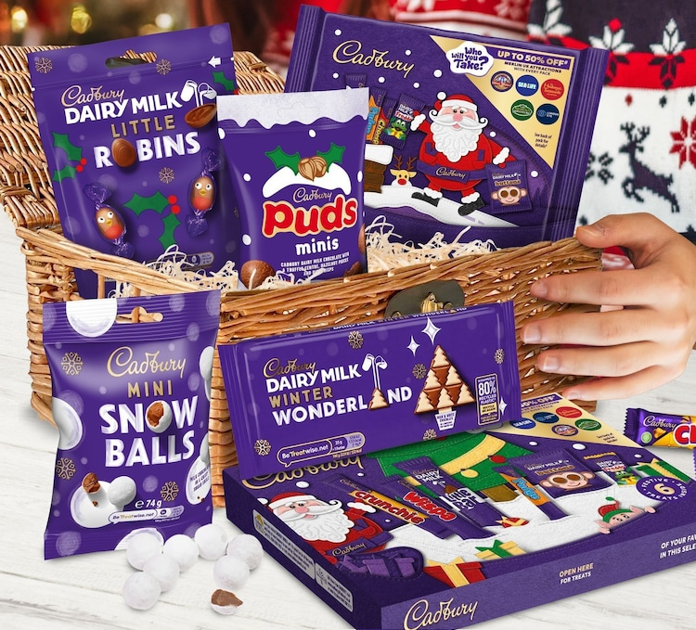
Figure 14: Cadbury’s UK Christmas Seasonal Product Range
Source: (Next, 2026)
Purple packaging, the Cadbury brand and the Dairy Milk recipe contribute to consistency across the world, while familiar products evoke British heritage. Nevertheless, increasing health awareness requires smaller portions, clearer nutritional information and reduced-sugar alternatives (Mišević et al., 2020).
India: Cadbury has a core business of the Dairy Milk product, retaining brand elements around the globe, while adapting its portfolio with 5 Star, Dairy Milk Silk, Celebrations, Gems and locally appropriate gifting formats. Low-priced individual packs enable trial and routine consumption, whereas Silk and Celebrations serve premium consumers and festivals. Products need to be more resistant to warmer temperatures and be visibly labeled as vegetarian. Chocolate packaging changes at festivals to replace the conventional mithai. This product adaptation is commercial significant because product familiarity, sensory properties and cultural acceptance impact on emotional reactions (Mielmann et al., 2022). However, continued sugar dependence limits appeal among health-conscious consumers.

4.2 Pricing Strategy
UK: Cadbury is a mix between competitive and value pricing. The competition in mainstream bars is Mars, Nestlé, and larger format and seasonal boxes fetch a higher price due to convenience and emotional value. Promotions in the form of psychological pricing and short-term supermarket discounts and multipacks encourage purchases. But with inflation, fluctuating cocoa prices and rising cost of living, there is tension between the word affordability and word margin-protect; too much shrinkflation or too much reliance on promotions makes it hurt the trust (Stone et al., 2024).
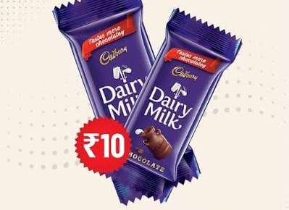
Figure 15: Cadbury Dairy Milk’s Affordable Pack in India
Source: (Amazon India, 2026)
India: Market penetration is of greater importance as there is increasing income disparity. Small packs at accessible rupee price points reduce financial risk for children, students and lower-income consumers, while Silk and premium Celebrations boxes apply value-based pricing to affluent urban and gift segments. Local production eliminates import taxes, transportation expenses and foreign exchange risks. Economy products continue to dominate India's confectionery price segment, and pack sizes and prices in the UK cannot be easily adopted (IMARC Group, 2026-a). However low prices can lead to high consumption and raise the ethical issues about marketing sugary products to children.

4.3 Place and Distribution Strategy
UK: Cadbury's intensive distribution strategy involves distributing products via Tesco, Sainsbury's, Asda, Morrisons, convenience stores, petrol stations, vending machines and online grocery delivery. National visibility and efficient replenishment are provided by centralised retail and advanced inventory systems. However, the limitation of high-fat, salt and sugar items near the checkout counter diminishes the possibility of impulse purchases, necessitating the need for improved category navigation and compliant digital merchandising (Dhuria et al., 2025).
India: Distribution needs to span supermarkets, local kirana shops, wholesalers, kiosks and street retailers in geographically dispersed markets. Traditional retail stores continue to play an important role in supplying the low-priced single bars, and Amazon, BigBasket and quick commerce stores like Blinkit, Zepto and Swiggy Instamart cater to instant shopping in cities and gift-giving during festivals. Quick commerce provides customer data and availability, along with raising dependency on platforms and discounting (Siwach, 2026). Heat, infrastructure variation and rural reach also require temperature-sensitive storage, resilient packaging and distributor investment.

4.4 Promotion Strategy

Figure 16: Cadbury’s UK Easter Egg Hunt Campaign
Source: (Campaign, 2016)
UK: Promotion focuses on heritage, humour, generosity and sharing through TV, outdoor media, social media and retailer activities. The “There’s a Glass and a Half in Everyone” platform converts the product proposition into an emotional promise of human generosity. Seasonal demand is supported by Easter eggs, Christmas selection boxes and personalised gifting. But with the introduction of stricter regulations for HFSS advertising, there is a need for responsible scheduling, brand-centric communication, and a reduction in child-directed and product-led promotion (Dhuria et al., 2025).
India: Cadbury adopts the medium of tv, YouTube, social media, regional languages, celebrity endorsement, festival campaigns. Kuch Meetha Ho Jaaye is a campaign that connects Dairy Milk to the cultural act of celebrating by consuming something sweet, and Celebrations campaigns are about associations between gifting and family relationships. This localisation facilitates brand–culture fit and not just a translation of British advertising (Fernandes et al., 2017). However, marketing for kids through social media, posits the issue of informed choice and problematic consumption (Rajarajan et al., 2025).

4.5 People Strategy
UK: Staff, supermarket staff, customer-service staff and digital community managers influence their availability and complaint resolution. Training needs to be provided to ensure that nutritional claims and statements about sustainability are correct. The brand ambassador must be inclusive and a representative of being responsible in consumption, not just reach (Mondelēz International, 2026).
India: Sales people, wholesalers and many independent retailers are more influential as they affect the shelf visibility, freshness and availability in rural areas. Local employees share their language and cultural expertise, and celebrities drive trust and awareness. However, celebrity credibility creates responsibility: inappropriate health or child-oriented claims could amplify reputational harm. Distributor training is important for storage quality and genuine products, therefore (Fernandes et al., 2017).

4.6 Process Strategy
UK: Consistent quality and availability are ensured through automated manufacturing processes, supermarket forecasting, traceability and integrated fulfilment. Easy ordering, via websites and retailers, and formal complaints systems offer the opportunity for recalls and refunds. Data-driven forecasting can minimize seasonal shortages; however, the control of privacy and cyber-risk must be implemented (Wolniak et al., 2024).
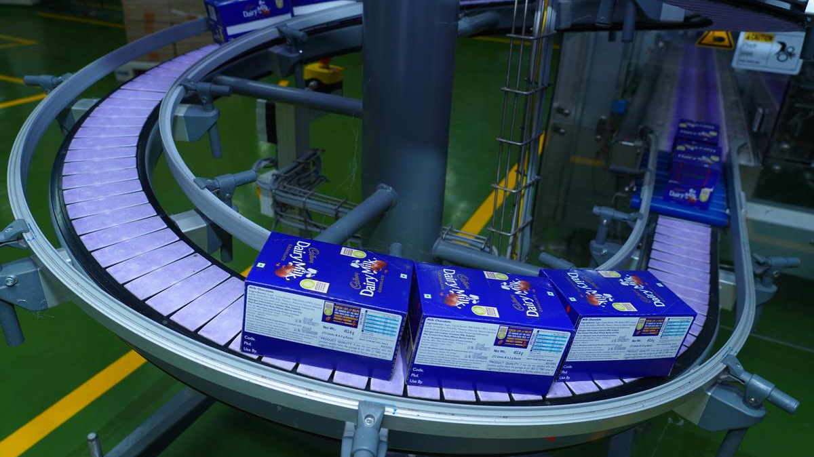
Figure 17: Automated Production and Packaging of Cadbury Dairy Milk
Source: (The Hindu, 2024)
India: Local manufacturing allows for more rapid replenishment and price control as per festival demand needs flexible manufacturing and inventory planning. Quality processes should include consideration of heat damage, counterfeit and segregated storages. Quick-commerce shortens ordering and delivery, although unavailable or poorly stored products can damage brand equity. Effective FSSAI adherence and the open management of complaints are thus strategic rather than administrative needs (Pahlani et al., 2025).

4.7 Physical Evidence Strategy
UK: In the UK, purple wrappers, the glass and a half symbol, branded displays as well as Cadbury's website all convey the concept of heritage and reliability. Corporate responsibility is becoming more evident through packaging that is designed to be sustainable (Cadbury, 2026-b).
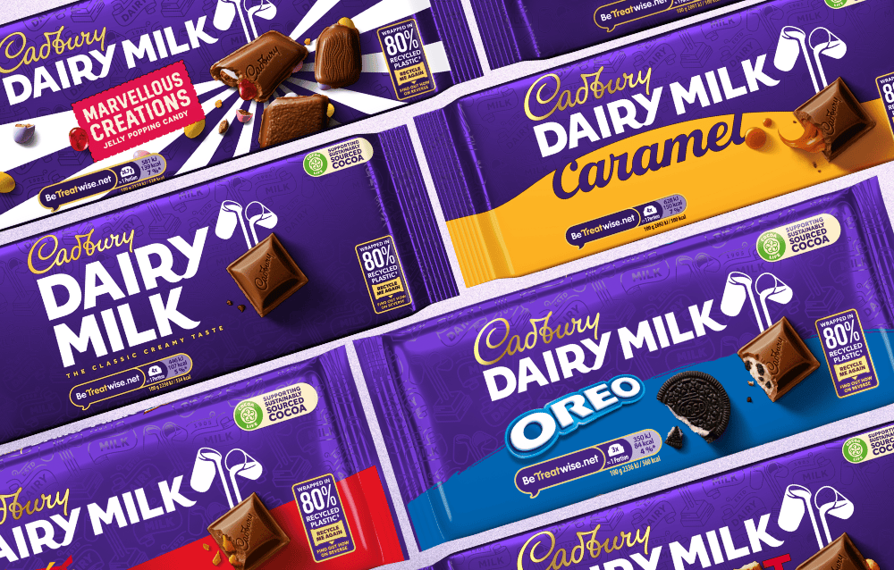
Figure 18: Cadbury Dairy Milk Packaging
Source: (ConfectioneryNews, 2021)
India: The same purple identity ensures recognition, while festival boxes, personalised sleeves, local-language advertising and retailer displays provide cultural relevance. Branded refrigerator and undamaged heat-resistant packaging indicate freshness. While attractive packaging can have an impact on consumer perception, too much gifting material can pose a challenge for sustainability commitments (Pokharel et al., 2023).

4.8 Overall Standardisation–Adaptation Evaluation
Element | Standardised foundation | UK adaptation | Indian adaptation
Product | Dairy Milk, quality and purple identity | Heritage and seasonal ranges | Small packs, Silk and festival gifts
Price | Branded-value logic | Multipacks and supermarket promotions | Low-unit prices and premium tiers
Place | Intensive availability | Concentrated modern retail | Kiranas, wholesalers and quick-commerce
Promotion | Happiness, sharing and generosity | Humour and British heritage | Festivals, family and celebrities
People | Brand and service standards | Retail and digital teams | Local salesforces and distributors
Process | Quality control and traceability | Automated retail integration | Heat-resistant logistics and local production
Physical evidence | Logo and purple packaging | Heritage displays | Culturally adapted gifting boxes
Table 2: Cadbury’s 7Ps Adaptation in the UK and India
Source: (Author, 2026)
Cadbury ultimately does a good job of standardising its core identity and adapting its execution to local conditions. This is not a standardisation–adaptation decision, but rather a relational fit (Poulis, 2024). But, in both markets it is needed to have stronger nutrition reformulation, ethical promotion and sustainable packaging.

5.0 Cadbury’s Market-Entry Strategy in India

5.1 Historical Entry and Development
Cadbury has been introduced in India in 1948 through Cadbury Fry (India), with import entry since then, that started building up the manufacturing facilities with a gradual growth in both sales and distribution. The company's physical facilities, such as manufacturing plants, located in regions where it was active, allowed the company to transcend an import footprint toward developing cocoa-related skills. After Cadbury was acquired by Kraft Foods in 2010 and the corporate restructuring that ensued, the Indian business was part of the Mondelēz International and today is known as Mondelēz India Foods (Mondelēz International, 2026).
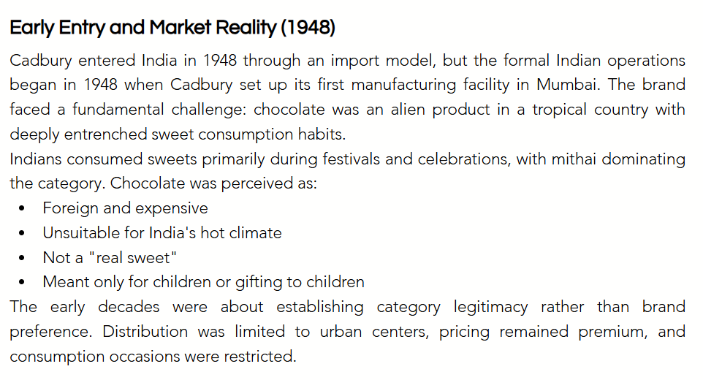
Figure 19: Cadbury’s Initial Market Entry into India in 1948
Source: (MarkHub24, 2026)

5.2 Entry Mode and Strategic Rationale
The company has, in fact, followed a WOFE approach via local incorporation, local manufacturing and controlled market development. This mode entailed higher capital investment than exporting or licensing, but offered more control over the recipe, quality, brand, IP and LTC. Domestic production lowered import taxes, shipping expenses and foreign currency risk, and local hired personnel and distributors provided invaluable insights into the taste variation, retail structure, and festival demand for products. These features enabled low-cost pack sizes, 5 Star, Silk and Celebrations formats of gifting (Hıdıroğlu, 2019; Mondelēz International, 2026).

5.3 Effectiveness of the Entry Strategy
The strategy has worked well as Cadbury Dairy Milk is now widely recognized and is culturally linked with happiness, gifting and celebration rather than being a foreign luxury brand (Fernandes et al., 2017). This mass availability via supermarkets, wholesalers, kirana stores, and quick-commerce helps boost the presence in urban and smaller markets (Siwach, 2026). Local adaptation has thus been an addition to manufacturing scale and uniform brand. The confectionery market in India, which was valued at INR398.7 billion in 2025, offers sustained growth opportunities (IMARC Group, 2026-a).

5.4 Limitations and Alternative Entry Options
The strategy nevertheless faces FSSAI compliance, counterfeit products, price-sensitive consumers, cocoa-cost volatility, heat-sensitive distribution and quality-control risks. Exporting would have increased costs and restricted mass-market affordability, while licensing or franchising could have weakened quality and brand control.
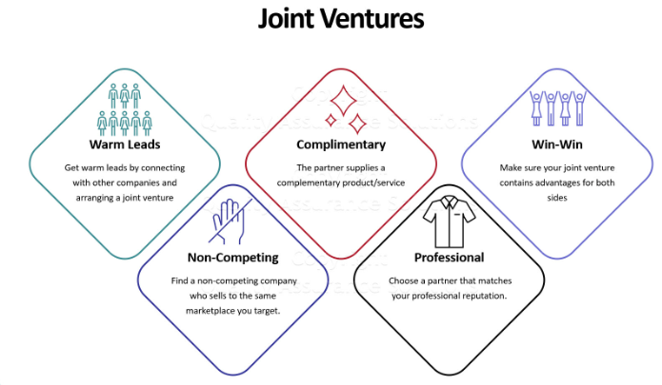
Figure 20: Strategic Benefits of a Joint-Venture Market-Entry Mode
Source: (Quality Assurance Solutions, 2026)
A JV may have been able to provide local knowledge and the sharing of risk but it would also have involved a governance conflict. Wholly owned local operations therefore were strategically superior, but better cold-chain monitoring, supplier traceability and regionally responsive distribution were still needed (Pahlani et al., 2025).

6.0 Ethical Issues in Cadbury’s Indian Marketing Mix

6.1 Identification of Ethical Issues
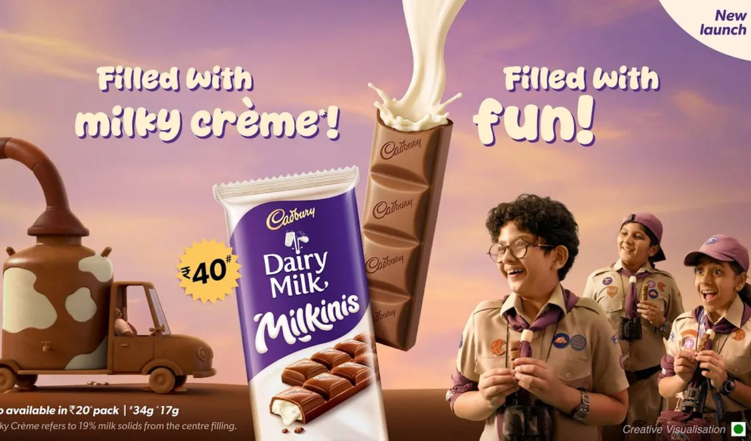
Figure 21: Child-Focused Promotion of Cadbury Dairy Milk Milkinis in India
Source: (Indian Retailer, 2026)
Cadbury's targeting of children with its products through colourful packaging, emotive messages, social media and seasonal campaigns is a major ethical concern. The study on Chennai focuses on Cadbury's social media strategy on children purchasing behavior during a specific season. Children have limited advertising literacy, and may not be able to differentiate between entertainment and commercial persuasion. Hence, although such promotion can meet the minimum legal standards, there are ethical problems with regards to vulnerability, informed choice and harm to diet. This concern is supported by evidence from children showing that they are exposed to unhealthy commodity marketing to a significant degree in real time (Worters et al., 2025).

6.2 Stakeholder Impact
Stakeholder | Potential consequence
Children and parents | Increased purchase pressure, frequent consumption and health risks
Retailers and employees | Higher sales, but responsibility for appropriate placement and communication
Regulators and communities | Greater public-health costs and pressure for tighter advertising controls
Suppliers and shareholders | Short-term demand, but longer-term regulatory and reputational risk
Table 3: Stakeholder Impacts of Cadbury’s Child-Focused Marketing
Source: (Author, 2026)

6.3 Cadbury’s Response and Ethical Evaluation
Cadbury and Mondelēz share pledges with respect to responsible marketing, portion guidance and sustainability (Cadbury, 2026-b; Mondelēz International, 2026). In a stakeholder's theory view, however, children's welfare would have to be treated in a similar fashion to sales growth; otherwise, they are not taken seriously. Small portions can maintain the demand stimulus, while child-attractive designs and intense digital marketing can also help keep it alive. The answer thus not only reflects harm but legitimises the Corporation as well. The strategy is commercially reasonable, but ethically incomplete as responsibility should lessen children's exposure rather than just shift control of consumption to the parent.

6.4 Implications for the Marketing Mix
Cadbury should consider the reformulation of sugar content, bigger portion-controlled alternatives and clear front of pack nutritional information on Indian products (Pahlani et al., 2025). Promotion should not involve behaviourally targeting children, influencers whose primary audience is children or misleading health associations. Packaging should communicate moderation rather than encourage collection or overconsumption. Quality-control processes must verify nutritional claims, while supplier management should combine food safety, traceable cocoa and labour standards. All these actions would combine product, promotion, process and packaging decisions to substantive corporate responsibility.

7.0 Strategic Recommendations

7.1 Product and Portfolio Development
Cadbury should launch low-sugar versions of Dairy Milk, multipacks with portion control, and high-quality dark chocolate products in the UK, as there is a growing awareness of health issues and a demand for more responsible indulgence (Mišević et al., 2020). In India, it should keep providing on the budget-friendly side and create some new lower sugar bars and nut-based products and regional flavours of fruits like cardamom, saffron type options. Recyclable and reduced material packaging should be used for celebrations boxes. Sensory testing is vital as familiarity, flavour and acceptability play a role in emotional response (Mielmann et al., 2022).

7.2 Pricing and Distribution Improvement
UK pricing should prioritise everyday affordability and specific promotions while refraining from overcutting the price to preserve brand equity amidst the ongoing cost-of-living crisis. There is a need of tiered product architecture, low unit price packages for mass reach, medium sharing segment and Silk and gifting high-end product. Cadbury should broaden its quick-commerce alliances in urban India, and enhance temperature-assisted distribution to the lesser-served towns (Siwach, 2026).

7.3 Culturally Responsive Communication
Cadbury should keep its 'generous' theme of the world but give it a local touch in purple. A focus on heritage, humour and responsible indulgence should be key features of campaigns in the UK. Family relations and festivals should be included in Indian communication using regional languages, but not equating chocolate with traditional culture. Customer data should support regional relevance rather than intrusive targeting, reflecting selective adaptation (Poulis, 2024).

7.4 Ethical and Sustainable Marketing
Cadbury should not use behavioural advertising for kids, front-of-pack sugar and portion information should be clearer and they should independently audit responsible sourcing of Cadbury's cocoa. To avoid broad sustainability statements, there should be measurable packaging, emissions and supplier-labour outcomes, which should be reported publicly. Clear labelling can bolster informed buying and trust (Pahlani et al., 2025).

8.0 Conclusion
In summary, the analysis suggests that Cadbury is operating in two different markets which are both different in terms of structure and culture. The UK is seen as high purchasing power and has good retail presence and brand heritage, while maturity, health regulation and sustainability demands are growth limiting. Urbanisation, festival gifting and quick commerce represent more growth opportunities in India, which comes with price sensitivity, fragmented distribution and regulatory complexity. Cadbury's global consistency is maintained through its shared purple identity, quality promise and emotional positioning, local relevance is achieved through affordable packs, local manufacturing, culturally relevant products and promotion around celebratory events. Hence, the adaptation in India has resulted in a greater competitive advantage than the one that could be gained from a more UK-standardised approach.

Section 2: Reflective Account Using Gibbs’ Reflective Cycle

9.0 Introduction to the Reflective Account
This reflective account utilises Gibbs' Reflective Cycle to assess the method I used to research, analysis, and prepare the comparative report with Cadbury in the United Kingdom and India. It analyse my action, reaction, success, limitation and learning as well as the possible practical improvements in conducting an international marketing research, critical evaluation, evidence selection and academic writing.

Figure 22: Gibbs’ Reflective Cycle
Source: (Crowe Associates, 2026)

10.0 Gibbs’ Reflective Cycle

10.1 Description: What I Did
I first interpreted the brief as requiring critical comparison rather than two independent country descriptions. Cadbury was chosen due to its British origin and its longtime presence in India which provided a framework for a comparison of home–host brand standardisation and adaptation. I gathered data from Mondelēz and Cadbury literature, market data and peer-reviewed research on consumption, regulation, culture, sustainability and digital retail. I then used the same PESTEL, Hofstede, STP and 7Ps criteria for both markets. Finally, the report was set up from environmental diagnosis to strategic evaluation, Indian entry, ethics and recommendations, where the similarities, differences and managerial implications are immediately apparent to the reader by the use of comparative tables.

10.2 Feelings: My Initial Reactions
I was confident at first as Cadbury was a familiar brand and it seemed there was a lot of information available. I got worried, though, about trying to limit a broad topic down to a word count. I also noticed that evidence from the UK was sometimes easier to come by, with evidence from India sometimes lumped together with other confectionery types, such as chocolate. This made the direct comparison quite complicated, and I was less confident in some market estimates. I anticipated that the frameworks would make analysis easier, but knew that only listing factors wouldn't really showcase critical strategic judgement.

10.3 Evaluation: What Worked and What Did Not
Recent company and market evidence helped me connect theory and commercial realities, including India's confectionery market valued at INR398.7 billion and UK regulatory pressure and quick-commerce development (IMARC Group, 2026-a; Siwach, 2026). Comparative tables worked especially well as they showed the differences in purchasing power, channels and strategic responses without having to repeat the discussion on these. Peer reviewed research furthered arguments about culture, consumption and ethics. But occasionally, commercial reports provided different market definitions, currencies, base years and forecasting periods, restricting strict comparability. Company sources supplied useful operational information but naturally presented Cadbury positively. However, the time and word count constraints limited in-depth analysis of competition and regional differences in India. The overall composition of the report was well balanced between frameworks and practical examples, but evidence of industry-level trends was used in some places to reflect Cadbury's performance.

10.4 Analysis: What I Learned
I learned that market comparison has to be done on the bases of the same criteria, dates, and units. It could be misleading to compare a UK chocolate estimate with an Indian confectionery estimate if this fact is not recognised. Evidence should, therefore, be interpreted, not reproduced.
The study also revealed that the macro environment and culture influence all marketing mix decisions. UK purchasing power, concentrated retail and HFSS restrictions support premium, reformulated and responsibly promoted products. On the other hand, the price sensitivity of Indian consumers, the influence of family, festival gifting and fractured distribution networks warrant smaller packs, local manufacturing and culturally relevant communication. Culture influences the entire process of the consumer journey and not advertising alone (Shavitt et al., 2020).
I thought of standardisation and adaptation as alternatives. Additional analysis revealed Cadbury can streamline its purple positioning, quality promise and generosity positioning whilst adjusting the pricing, formats, channels and consumption occasions. This relational-fit view is shared by Poulis (2024) who states that effective international marketing is a response to the relationships between the market, not an outright choice for complete uniformity or localisation.
Evidence also improved my strategic judgement. For instance, quick commerce growth seemed like an opportunity, but evaluation revealed reliance on platform discounts and delivery quality. Likewise, the promotion that relies on children can boost sales but erode trust and open the door to regulation (Worters et al., 2025). So, I found myself realising that ethics is not an isolated thing from strategy but it impacts on reputation, on legitimacy and competitiveness over time. Overall, the process helped me to be more questioning of evidence, recognize trade-offs and to be more likely to move from findings to justified recommendations.

10.5 Conclusion: What I Could Have Done Differently
I could have created the comparative evidence framework prior to initiating detailed research. This would have avoided obtaining sources that are credible but not directly relevant. Primary regulatory documents, consumer survey and Cadbury's India specific performance evidence should have been prioritised as well. Greater time should have been devoted to competitor benchmarking and ethical analysis, especially in the area of children's exposure to digital. Lastly, I might have recorded some uncertainties next to each statistic, making sure that the variations in market scope, currency, coverage year, and methodology are consistently spelled out before strategic conclusions are drawn.

10.6 Action Plan: Future Improvement
For future assignments, I will use the following SMART-oriented plan:
Development area | Future action | Success measure and timeframe
Research skills | Use academic databases and evaluate sources for credibility, relevance and currency. | Select mostly peer-reviewed sources in every future assignment.
Critical thinking | Compare perspectives and identify implications, limitations and trade-offs. | Include critical evaluation in each main section.
Data interpretation | Practise analysing statistics, trends and methodological limitations. | Complete one data-analysis exercise monthly.
Academic writing | Improve paragraph structure, argument development and formal language. | Review two academic articles weekly.
Time management | Divide assignments into research, drafting and editing stages. | Finish drafts seven days before deadlines.
Referencing | Maintain an accurate reference record while researching. | Achieve error-free citations through a final pre-submission audit.
Table 4: Personal and Academic Development Action Plan
Source: (Author, 2026)
This plan will make my research more efficient, transparent and analytically consistent while reducing rushed descriptive writing.

11.0 Reflective Summary
The completion of the report added to a greater understanding of the impact of evidence, culture, ethics and external factors upon international marketing decisions. I learned to compare markets systematically, distinguish adaptation from simple translation and evaluate commercial opportunities alongside stakeholder risks. Most importantly, I became more confident in the process of translating all kinds of evidence into succinct strategic recommendations that are realistic and defensible.

References
Begum, S., Askri, S., Gilani, S., Tantry, A., Tiemo, T., Iqbal, N., Peel, R. and Armosh, F. (2025) ‘The role of sustainability for managing chocolate manufacturing businesses in the UK’, in Sustainability in global business operations, pp. 295–332. Available at: https://doi.org/10.4018/979-8-3373-2858-4.ch012.
Cadbury (2026-a) Our story. Available at: https://www.cadbury.co.uk/about/history/our-story/.
Cadbury (2026-b) Sustainability. Available at: https://www.cadbury.co.uk/about/impact/sustainability/.
Del Prete, M. and Samoggia, A. (2020) ‘Chocolate consumption and purchasing behaviour review: Research issues and insights for future research’, Sustainability, 12(14), Article 5586. Available at: https://doi.org/10.3390/su12145586.
Dhuria, P., Muir, S., Shaw, S. et al. (2025) ‘“It will sort of drive us to rethink our approach to high fat salt sugar products”: A qualitative analysis of businesses’ reactions to the landmark Food (Promotion and Placement) Regulations in England’, BMC Medicine, 23, Article 576. Available at: https://doi.org/10.1186/s12916-025-04384-5.
Fernandes, S., Chaudhuri, S. and Vidyasagar, A. (2017) ‘Success crowns Cadbury Dairy Milk: Brand and culture analysis’, International Journal of Applied Business and Economic Research, 15(2), pp. 177–189.
Hıdıroğlu, D. (2019) ‘An application of SWOT analysis as a strategic planning tool: A case of Cadbury, Inc. in the confectionery industry’, Uluslararası İktisadi ve İdari İncelemeler Dergisi, 25, pp. 153–164. Available at: https://doi.org/10.18092/ulikidince.579949.
IMARC Group (2026-a) India confectionery market: Industry trends, share, size, growth, opportunity and forecast. Available at: https://www.imarcgroup.com/confectionery-market-india.
IMARC Group (2026-b) United Kingdom chocolate market: Industry trends, share, size, growth, opportunity and forecast. Available at: https://www.imarcgroup.com/uk-chocolate-market.
Mielmann, A., Le Roux, N. and Taljaard, I. (2022) ‘The impact of mood, familiarity, acceptability, sensory characteristics and attitude on consumers’ emotional responses to chocolates’, Foods, 11(11), Article 1621. Available at: https://doi.org/10.3390/foods11111621.
Mišević, P., Volarević, H. and Perić, M. (2020) ‘The trend analysis of less sugar chocolate confectionery markets’, in Economic and Social Development: Book of Proceedings of the 52nd International Scientific Conference on Economic and Social Development, pp. 654–662.
Mondelēz International (2026) 2025 annual report. Available at: https://www.annualreports.com/HostedData/AnnualReports/PDF/NASDAQ_MDLZ_2025.pdf.
Mordor Intelligence (2026) India industrial chocolate market size and share analysis: Growth trends and forecasts. Available at: https://www.mordorintelligence.com/industry-reports/india-industrial-chocolate-market.
Pahlani, M., Talati, K.N., Lopez-Arana, S. and Narayanan, P. (2025) ‘Food labelling in India: A scoping review of consumer engagement, comprehension and purchase behaviour’, Global Health Action, 18(1). Available at: https://doi.org/10.1080/16549716.2025.2574132.
Pokharel, B., Keerthi, R. and Abunamous, Z. (2023) ‘Sustainable chocolate production: From farming practices to packaging’, 5, pp. 2582–5208.
Poulis, K. (2024) ‘Standardization and adaptation as a coconstituted process: The pursuit of relational fit in international markets’, Journal of International Marketing, 32(2), pp. 12–32. Available at: https://doi.org/10.1177/1069031X231212414.
Rajarajan, D.M. and Harshini, R.M.P. (2025) ‘Marketing strategies adopted by Cadbury Chocolate and Biscuits Company to influence children in seasonal buying through social media platforms: A study with reference to Chennai City’, TPM – Testing, Psychometrics, Methodology in Applied Psychology, 32(S6), pp. 1790–1796. Available at: https://tpmap.org/submission/index.php/tpm/article/view/2646.
Shavitt, S. and Barnes, A.J. (2020) ‘Culture and the consumer journey’, Journal of Retailing, 96(1), pp. 40–54. Available at: https://doi.org/10.1016/j.jretai.2019.11.009.
Siwach, S. (2026) ‘Quick commerce in India: Trends, challenges and growth opportunities’, International Journal of Research and Innovation in Social Science, 10, pp. 10–13. Available at: https://doi.org/10.47772/IJRISS.2026.10190002.
Stone, R.A., Brown, A., Douglas, F., Green, M.A., Hunter, E., Lonnie, M., Johnstone, A.M. and Hardman, C.A. (2024) ‘The impact of the cost-of-living crisis and food insecurity on food purchasing behaviours and food preparation practices in people living with obesity’, Appetite, 196, Article 107255. Available at: https://doi.org/10.1016/j.appet.2024.107255.
The Culture Factor Group (2026) Country comparison tool: India and the United Kingdom. Available at: https://www.theculturefactor.com/country-comparison-tool?countries=india%2Cunited+kingdom.
Wolniak, R., Stecuła, K. and Aydın, B. (2024) ‘Digital transformation of grocery in-store shopping—scanners, artificial intelligence, augmented reality and beyond: A review’, Foods, 13(18), Article 2948. Available at: https://doi.org/10.3390/foods13182948.
Worters, T., McKerchar, C., Watkins, L., Gage, R. and Signal, L. (2025) ‘Public health and harmful advertising: The nature and extent of children’s real-time exposure to unhealthy commodity marketing’, Social Science & Medicine, 375, Article 118055. Available at: https://doi.org/10.1016/j.socscimed.2025.118055.

