Feasibility plan for an International Meeting
Mihaela Masca
ID: 2126876

BMIH6007
Lecturer: Jemma Smith

Slide 1

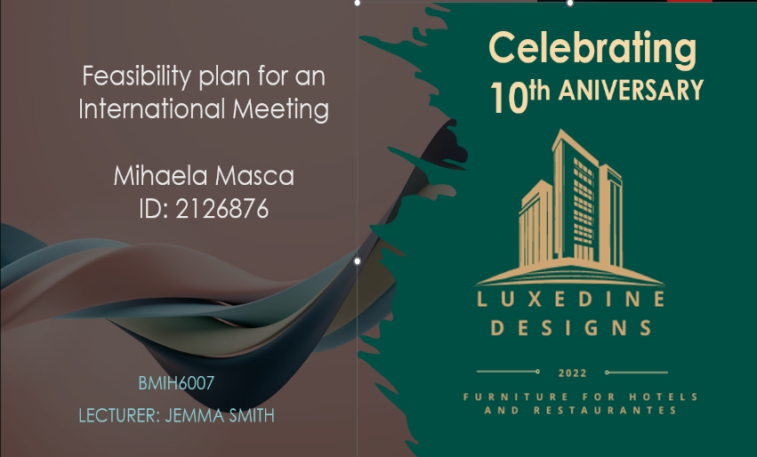

Feasibility plan for an International Meeting
Celebrating
10^{th ANIVERSARY}

Slide 2
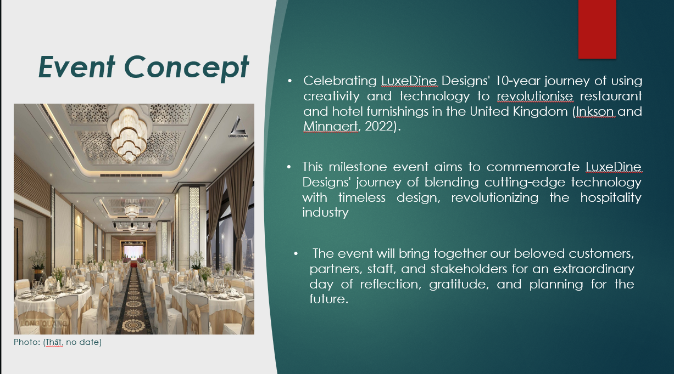
Event Concept
- Celebrating LuxeDine Designs' 10-year journey of using creativity and technology to revolutionise restaurant and hotel furnishings in the United Kingdom (Inkson and Minnaert, 2022).

- This milestone event aims to commemorate LuxeDine Designs' journey of blending cutting-edge technology with timeless design, revolutionizing the hospitality industry.

- The event will bring together our beloved customers, partners, staff, and stakeholders for an extraordinary day of reflection, gratitude, and planning for the future.

Slide 3
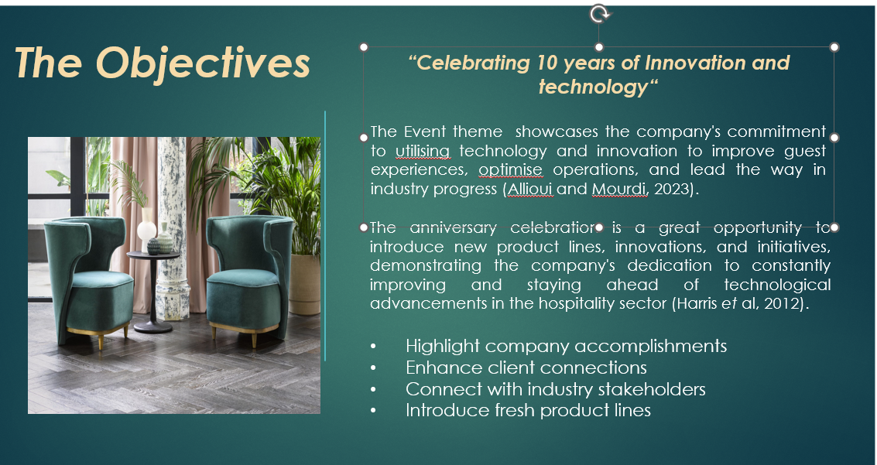
The Objectives
Celebrating 10 years of Innovation and technology
The Event theme showcases the company's commitment to utilising technology and innovation to improve guest experiences, optimise operations, and lead the way in industry progress (Allioui and Mourdi, 2023).
The anniversary celebration is a great opportunity to introduce new product lines, innovations, and initiatives, demonstrating the company's dedication to constantly improving and staying ahead of technological advancements in the hospitality sector (Harris et al, 2012).

- Highlight company accomplishments,
- Enhance client connections,
- Connect with industry stakeholders,
- Introduce fresh product lines.

Slide 4
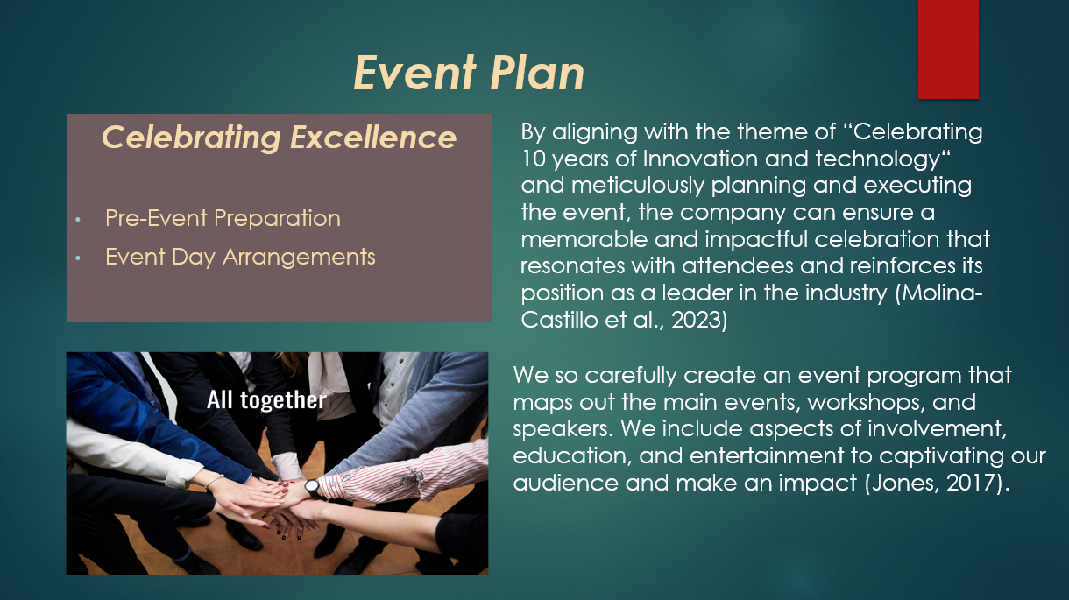
Event Plan
Celebrating Excellence

Pre-Event Preparation
Event Day Arrangements
- By aligning with the theme of “Celebrating 10 years of Innovation and technology“ and meticulously planning and executing the event, the company can ensure a memorable and impactful celebration that resonates with attendees and reinforces its position as a leader in the industry (Molina-Castillo et al., 2023)
- We so carefully create an event program that maps out the main events, workshops, and speakers. We include aspects of involvement, education, and entertainment to captivating our audience and make an impact (Jones, 2017).

Slide 5
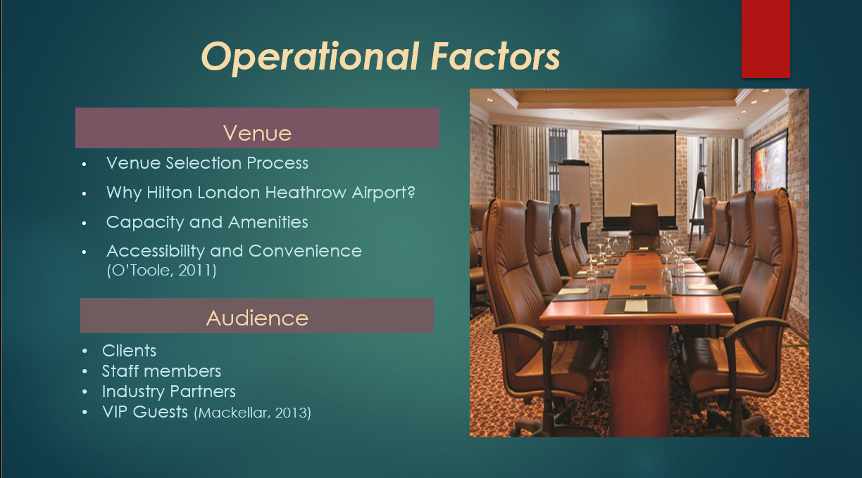

Operational Factors
Venue
- Venue Selection Process
- Why Hilton London Heathrow Airport?
- Capacity and Amenities
- Accessibility and Convenience (O’Toole, 2011)

Audience
- Clients
- Staff members
- Industry Partners
- VIP Guests (Mackellar, 2013)

Slide 6


Agenda
- Registration and Welcome Reception
- Opening Remarks
- Company Journey
- Keynote Address
- Panel Discussion
- Showcase of Innovative Products
- Networking Reception (Foley, et al., 2014)

Slide 7
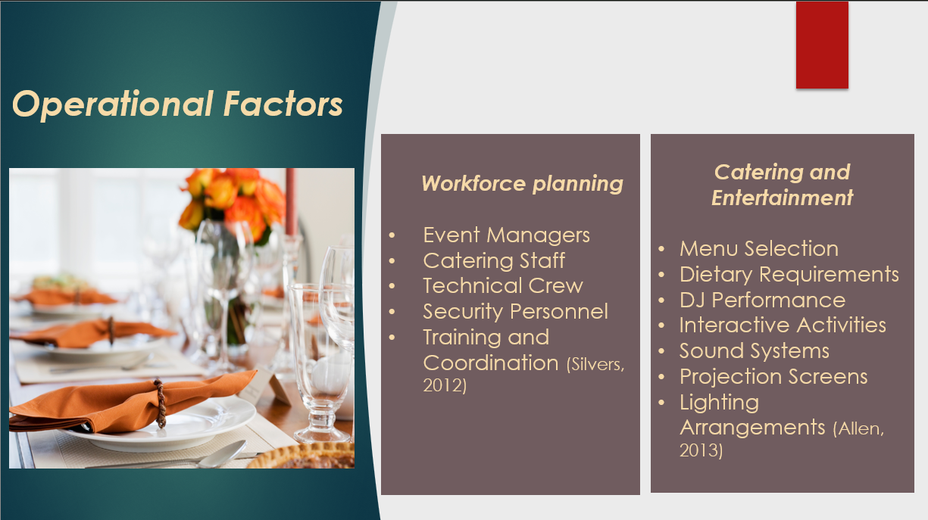
Operational Factors
Workforce planning
- Event Managers
- Catering Staff
- Technical Crew
- Security Personnel
- Training and Coordination (Silvers, 2012)

Catering and Entertainment
- Menu Selection
- Dietary Requirements
- DJ Performance
- Interactive Activities
- Sound Systems
- Projection Screens
- Lighting Arrangements (Allen, 2013)

Slide 8
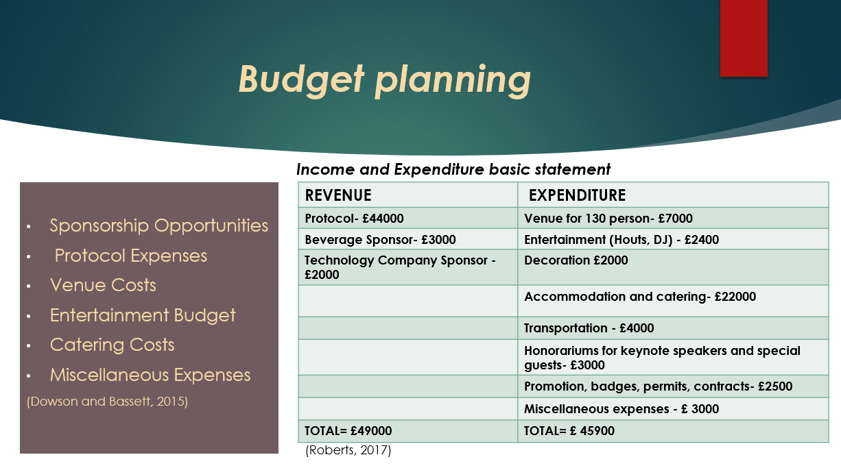
Budget planning
• Sponsorship Opportunities
• Protocol Expenses
• Venue Costs
• Entertainment Budget
• Catering Costs
• Miscellaneous Expenses (Dowson and Bassett, 2015)
Income and Expenditure basic statement
REVENUE | EXPENDITURE
Protocol- £44000 | Venue for 130 person- £7000
Beverage Sponsor- £3000 | Entertainment (Houts, DJ) - £2400
Technology Company Sponsor - £2000 | Decoration £2000
 | Accommodation and catering- £22000
 | Transportation - £4000
 | Honorariums for keynote speakers and special guests- £3000
 | Promotion, badges, permits, contracts- £2500
 | Miscellaneous expenses - £ 3000
TOTAL R.= £49000 | TOTAL E.= £ 45900
(Roberts, 2017)

Slide 9

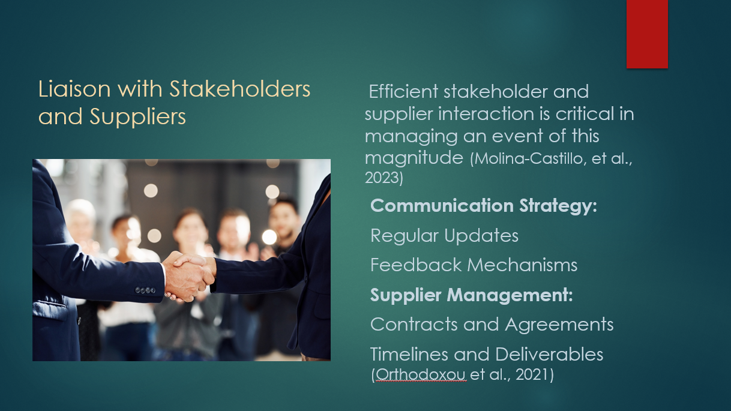
Liaison with Stakeholders and Suppliers
Efficient stakeholder and supplier interaction is critical in managing an event of this magnitude (Molina-Castillo, et al., 2023)
Communication Strategy:
Regular Updates
Feedback Mechanisms
Supplier Management:
Contracts and Agreements
Timelines and Deliverables (Orthodoxou et al., 2021)

Slide 10
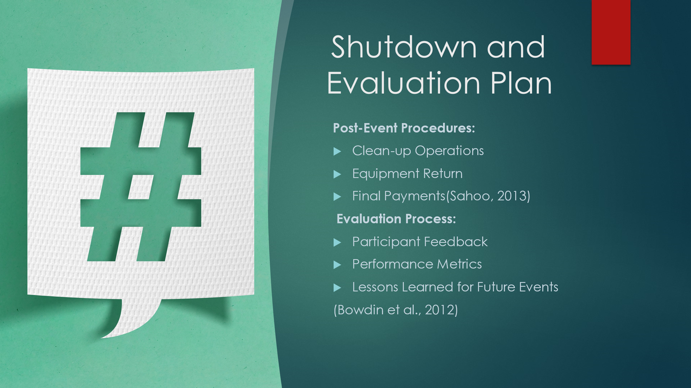
Shutdown and Evaluation Plan
Post-Event Procedures:
- Clean-up Operations
- Equipment Return
- Final Payments (Sahoo, 2013)
Evaluation Process:
- Participant Feedback
- Performance Metrics
- Lessons Learned for Future Events (Bowdin et al., 2012)

Slide 10
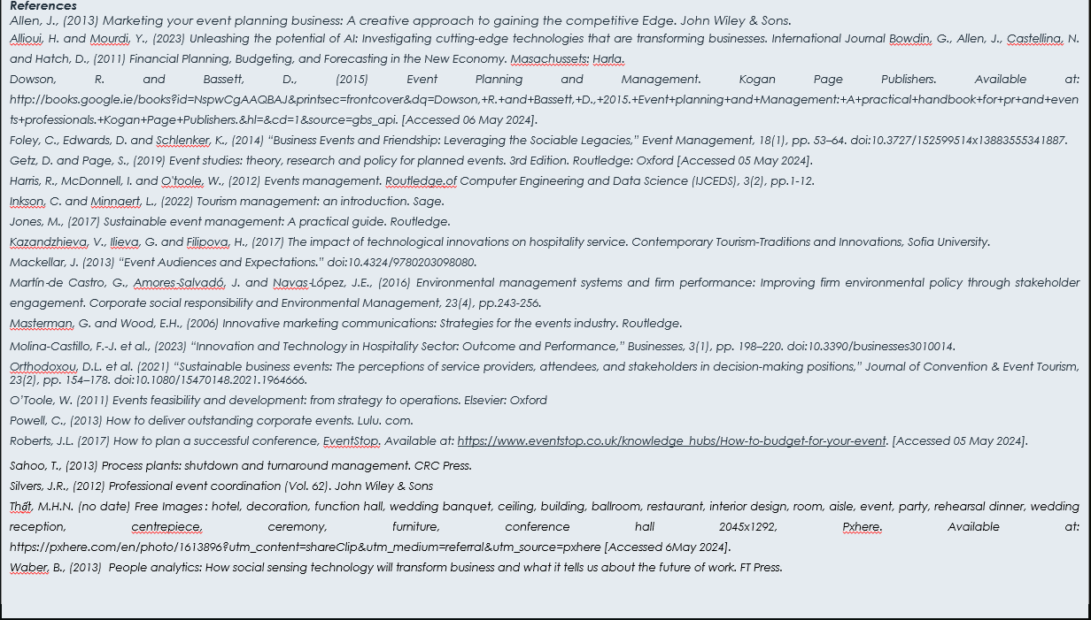
References
Allen, J., (2013) Marketing your event planning business: A creative approach to gaining the competitive Edge. John Wiley & Sons.
Allioui, H. and Mourdi, Y., (2023) Unleashing the potential of AI: Investigating cutting-edge technologies that are transforming businesses. International Journal Bowdin, G., Allen, J., Castellina, N. and Hatch, D., (2011) Financial Planning, Budgeting, and Forecasting in the New Economy. Masachussets: Harla.
Dowson, R. and Bassett, D., (2015) Event Planning and Management. Kogan Page Publishers. Available at: http://books.google.ie/books?id=NspwCgAAQBAJ&printsec=frontcover&dq=Dowson,+R.+and+Bassett,+D.,+2015.+Event+planning+and+Management:+A+practical+handbook+for+pr+and+events+professionals.+Kogan+Page+Publishers.&hl=&cd=1&source=gbs_api. [Accessed 06 May 2024].
Foley, C., Edwards, D. and Schlenker, K., (2014) “Business Events and Friendship: Leveraging the Sociable Legacies,” Event Management, 18(1), pp. 53–64. doi:10.3727/152599514x13883555341887.
Getz, D. and Page, S., (2019) Event studies: theory, research and policy for planned events. 3rd Edition. Routledge: Oxford [Accessed 05 May 2024].
Harris, R., McDonnell, I. and O'toole, W., (2012) Events management. Routledge.of Computer Engineering and Data Science (IJCEDS), 3(2), pp.1-12.
Inkson, C. and Minnaert, L., (2022) Tourism management: an introduction. Sage.
Jones, M., (2017) Sustainable event management: A practical guide. Routledge.
Kazandzhieva, V., Ilieva, G. and Filipova, H., (2017) The impact of technological innovations on hospitality service. Contemporary Tourism-Traditions and Innovations, Sofia University.
Mackellar, J. (2013) “Event Audiences and Expectations.” doi:10.4324/9780203098080.
Martín‐de Castro, G., Amores‐Salvadó, J. and Navas‐López, J.E., (2016) Environmental management systems and firm performance: Improving firm environmental policy through stakeholder engagement. Corporate social responsibility and Environmental Management, 23(4), pp.243-256.
Masterman, G. and Wood, E.H., (2006) Innovative marketing communications: Strategies for the events industry. Routledge.
Molina-Castillo, F.-J. et al., (2023) “Innovation and Technology in Hospitality Sector: Outcome and Performance,” Businesses, 3(1), pp. 198–220. doi:10.3390/businesses3010014.
Orthodoxou, D.L. et al. (2021) “Sustainable business events: The perceptions of service providers, attendees, and stakeholders in decision-making positions,” Journal of Convention & Event Tourism, 23(2), pp. 154–178. doi:10.1080/15470148.2021.1964666.
O’Toole, W. (2011) Events feasibility and development: from strategy to operations. Elsevier: Oxford
Powell, C., (2013) How to deliver outstanding corporate events. Lulu. com.
Roberts, J.L. (2017) How to plan a successful conference, EventStop. Available at: https://www.eventstop.co.uk/knowledge_hubs/How-to-budget-for-your-event. [Accessed 05 May 2024].
Sahoo, T., (2013) Process plants: shutdown and turnaround management. CRC Press.
Silvers, J.R., (2012) Professional event coordination (Vol. 62). John Wiley & Sons
Thất, M.H.N. (no date) Free Images : hotel, decoration, function hall, wedding banquet, ceiling, building, ballroom, restaurant, interior design, room, aisle, event, party, rehearsal dinner, wedding reception, centrepiece, ceremony, furniture, conference hall 2045x1292, Pxhere. Available at: https://pxhere.com/en/photo/1613896?utm_content=shareClip&utm_medium=referral&utm_source=pxhere [Accessed 6 May 2024].
Waber, B., (2013) People analytics: How social sensing technology will transform business and what it tells us about the future of work. FT Press.

