
APPENDIX GA36d

LEVEL 7 ASSESSMENT SPECIFICATION

Student name: | Albert YS CHIU | Student ID number: | 2235236
Programme: | DBA
Module: | Approaches to Research and Academic Communication
Module code: | HKBM7000 | Contribution to Overall Module Assessment (%): | 60%
Lecturer: | Dr Chammy Lau | Internal Verifier: | Prof Peter Fong
Assignment Title: | Assignment 1 –  Research Portfolio | Word count (or equivalent): | 5,000 words
Submission deadline: | 11 September 2023 | Return date of provisional marks & written feedback: | 10 October 2023
Submission method: | All written assessments, where practical and possible, must be submitted via Turnitin unless otherwise instructed by the Lecturer. (Please DO NOT put this assessment specification into Turnitin or it will match many similarities with other students’ submissions.)  Alternative submission method (if applicable):  Late submission of the assessment will result in a late penalty mark. Penalties for late submission: Up to one week late, maximum mark of 50%. Over one week late, 0%. Only the Extenuating Circumstances Panel may approve a change to submission dates.
Academic honesty / referencing: | Academic honesty is required. In the main body of your submission you must give credit to authors on whose research and ideas your work is based. Append to your submission a reference list that indicates the books, articles, etc. that you have used, cited or quoted in order to complete this assessment.

Table of Content:

1) Selection of Subject Area from ABS Journal List of Business and Management 3
2) Introduction 3
2.1 InsurTech 3
2.2 Life Insurance Mortality Protection Gap 4
2.3 Proposed Research Topic 5
3) Research Portfolio 5
3.1 Key Theory Related to Insurance Mortality Protection Gap and Adaptation of InsurTech 5
(i) Concept of Insurance: “Risk Pooling” and Law of Large Numbers 5
(ii) Human Life Value Theory 5
(iii) Economies of Scale 6
(iv) Theory of Planned Behaviour 6
(v) Expected Utility Theory 6
(vi) Trust Theory 6
3.2 Major Contributions on Mortality Protection Gap and Adaptation of InsurTech and its Weakness 7
(i) International Finance Corporation, World Bank Group 7
(ii) The Geneva Association 7
(iii) Swiss Re Institute 8
(iv) The Insurance Authority, Hong Kong 9
3.3 The Importance of Reviewing the Insurance Mortality Protection Gap and Adaptation of InsurTech for Hong Kong 10
(i) Huge Protection Gap in both Asia and Hong Kong: 10
(ii) The Importance of Narrowing the Gap 11
(iii) Insufficient attention is given to Mortality Protection Gap 11
3.4 New Insights in Combining Insurance Mortality Protection Gap and Adaptation of InsurTech for Hong Kong 12
(i) Insurance Regulator’s Initiatives to Promote InsurTech 12
(ii) Digital Insurers adopts InsurTech 12
(iii) Use Bowtie as a case study for Hong Kong 14
3.5 The Integration of Theory and Data into my Proposed Research Area 15
3.6 Future Research Suggestions for Proposed Research Area 17
Reference 18

Selection of Subject Area from the ABS Journal List of Business and Management

There are four journals that focus on “insurance” under the ABS Journal List of Business and Management, as shown in below:

 | Field |  | Journal Title
1 | ECON | Geneva Risk and Insurance Review
2 | FINANCE | Insurance: Mathematics and Economics
3 | FINANCE | Journal of Risk and Insurance
4 | FINANCE | Geneva Papers on Risk and Insurance: Issues and Practice

The first one, the Geneva Risk and Insurance Review (“GRIR”), is an academic journal published by the Geneva Association and the European Group of Risk and Insurance Economists (EGRIE).

The GRIR focuses on promoting knowledge of risk and insurance economics through the publication of original researches. This international journal serves as a forum for exchange of academic discoveries and perspectives on various aspects of risk and insurance economics, with an emphasis on empirical, theoretical and experimental research conducted in these domains.

My proposed research topic on the insurance gap, which is considered to be most relevant to this international journal.

Introduction

2.1 InsurTech

InsurTech is a word combine from "insurance" and "technology”, means “Insurance Technology”. It refers to the use of technology and innovation to enhance and transform the insurance industry (Chang, 2023). There are different types of InsurTech, which encompass various technological advancements, such as artificial intelligence (“AI”), machine learning, big data analytics, Internet of Things (IoT), blockchain and online/mobile applications, etc. InsurTech aims to improve various aspects of the insurance value chain and enhance customer experience (Chang, 2023; Stoeckli et al. 2018), through streamlined processes, lower operational cost, enhance customer experience, create new insurance products and business models, and explore unreached markets/insurance needs.

The history of InsurTech can be traced back to the early 2000s, when online insurance platforms began to gain popularity. These platforms allow customers to compare insurance quotes, purchase policies online, and access insurance-related information conveniently.

InsurTech has the potential to transform the insurance industry by making it more customer-centric, efficient and cost-effective. Traditional insurers recognized the potential benefits of incorporating technology into their operations and customer offerings. InsurTech further improves the distribution of insurance products and enhancing customer experience. It leveraged digital channels, data analytics, IoT devices and AI, which enabled insurers to gather real-time data for risk assessment and personalized pricing, thus creating personalized insurance offerings and simplifying the insurance purchasing process. As the industry continues to evolve, InsurTech becomes increasingly important in delivering value to consumers.

Separately, insurance regulators also moved away from reactive manual checking and start adopting proactive big data monitoring. To accommodate technology advancements, regulators offered regulatory sandboxes and initiatives aimed at fostering innovation and facilitating InsurTech experimentation was introduced in various jurisdictions.

Life Insurance Mortality Protection Gap

The Life Insurance Mortality Protection Gap (“MPG”) refers to the difference between the amount of life insurance coverage that individuals or households should ideally have and the actual coverage they currently possess. It is a measure of “under-insurance” or inadequate protection against the financial risks associated with premature death.

The concept of MPG arises from the understanding that life insurance is meant to provide financial support to dependents or beneficiaries in the event of a policyholder premature death. The coverage should be sufficient to replace the policyholder's income, cover outstanding debts, and meet the financial needs of the family or dependents left behind.

The financial impact of the policyholder unexpected death can be significant, especially if the policyholder is the breadwinner for the family. This may lead to financial hardship, an inability to maintain the same standard of living, or even the loss of assets such as a home.

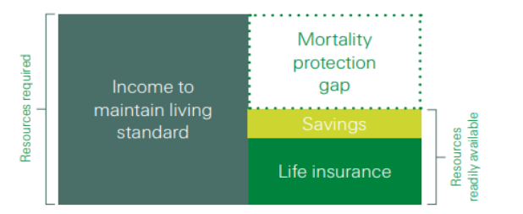

Figure 1: Asia-Pacific 2015 Mortality Protection Gap (Swiss Re, 2015)

Proposed Research Topic

With my insurance background, I am interested to conduct my research topic on “The Use of InsurTech to Narrow Insurance Mortality Protection Gap – A Hong Kong Case Study”.

Research Portfolio

Key Theory Related to Insurance Mortality Protection Gap and Adaptation of InsurTech

(i) Concept of Insurance: “Risk Pooling” and Law of Large Numbers
Risk Pooling is the fundamental principle in the insurance business. By spreading the risk among a large group of individuals, the financial burden of an unexpected event, such as death, can be shared amongst the members. Risk pooling allows insurers to estimate the frequency and severity of potential losses more reliably, enabling them to set appropriate premiums and provide coverage at a reasonable cost.

Risk pooling is rooted from the Law of Large Numbers (which is the fundamental concept of Probability Theory). As the number of independent and identically distributed risks increases, the average loss per participant would concentrate around its means, and therefore more easy to predict (Denuit & Robert, 2021).

(ii) Human Life Value Theory
The Human Life Value theory is a concept used in life insurance to determine the appropriate amount of coverage a person should have based on their economic value to their dependents or beneficiaries (Huebner, 1959). The theory assumes that the primary purpose of life insurance is to replace the income and financial support that would be lost in the event of the policyholder's death.

By quantifying the economic value of an individual's life, the theory helps determine the appropriate amount of life insurance coverage needed to bridge the mortality protection gap.

(iii) Economies of Scale
Economies of scale refer to the cost advantages that a business or organization can achieve as it increases its level of production or scale of operations. These cost advantages arise from spreading fixed costs over a larger output or taking advantage of certain efficiencies that come with producing at a larger scale.

The economies of scale improvement may come from production technologies and processes as output increases. For example, with the use of InsurTech, it allows insurance company to process more new insurance applications by using digital distribution platform, real time chatbox, AI underwriting technology, better risk identification, more accurate unit pricing, automated processes (low staff cost) with higher efficiency, lower marketing cost by spreading expenses over a broader customer base, which all leads to lower average insurance premium.

(iv) Theory of Planned Behaviour
The Theory of Planned Behaviour is a social psychological theory that seeks to explain and predict human behaviour based on an individual's beliefs, attitudes, intentions, and perceived behavioural control. The theory was developed by Icek Ajzen in the late 1980s as an extension of the earlier Theory of Reasoned Action.

This theory can be applied to understand the influence, individuals' different behaviours and the change of decision-making when buying insurance through on-line platform compare to traditional insurance intermediary sales channel.

(v) Expected Utility Theory
Expected Utility Theory is a normative economic theory that seeks to explain how individuals make decisions under by considering the expected utility, or the overall value or satisfaction they expect to derive from different alternatives. It was developed by Daniel Bernoulli in the 18th century and later formalized by John von Neumann and Oskar Morgenstern in the mid-20th century.

The theory explains how individuals consider insurance coverage based on their preferences for risk (e.g. potential financial losses) and potential outcomes (accidents, illnesses or premature death). In particular, the theory recognizes individuals may be risk-averse, meaning they generally prefer to transfer the risk of potential losses to an insurance company in exchange for paying premiums. In addition, the theory also elucidates the cost of insurance premiums in relation to the expected utility (i.e. Individuals evaluate whether the cost of insurance premiums is worth the potential benefits in terms of risk reduction and improved financial security), and how this utility change when they buy insurance through digital channel.

(vi) Trust Theory
Trust theory explores the concept, dynamics, and consequences of trust in various social, psychological, and organizational contexts. It seeks to understand how trust develops, influences relationships, and affects behaviour and decision-making.

The use of trust theory in the realm of e-commerce revealed that a combination of individual characteristics and contextual factors contributes to the development of trust, ultimately leading to habitual behaviours and collaborative consumption (Zarifis & Cheng, 2022). This approach effectively captures the consumer's viewpoint within each specific context, highlighting the importance of trust in facilitating online transactions and establishing long-term relationships between consumers and e-commerce platforms.

These theories and concepts provide different perspectives on understanding and addressing the MPG and how the customer purchasing behaviour changes on InsurTech.

Major Contributions on Mortality Protection Gap and Adaptation of InsurTech and its Weakness

The MPG is often measured at a national or regional level to assess the extent of under-insurance within a population. It helps insurance industry professionals, policymakers, regulators and researchers understand the level of risk exposure and the potential need for interventions to address the gap. By closing the gap and adequately protecting individuals and households against premature death, it is possible to mitigate the financial consequences that may arise from such events.

Here are a few key publications issued by prominent organisations that have contributed related to my proposed research area:

(i) International Finance Corporation, World Bank Group
International Finance Corporation published a paper on “How Insurtech Can Close the Protection Gap in Emerging Markets” in 2019 (Holiday, 2019), which highlights the rapid growth of InsurTech industry has disrupted the traditional insurance market, and offered significant opportunities in emerging markets with low insurance penetration and a large “protection gap”. The paper also list out areas how InsurTech can help to close the protection gap such as:
- Popularity of mobile banking and payments
- Tech-enabled agents and call centres to (a) resolve the “trust” issue and save and (b) provide better customer experience
- On-demand or short term policies are more attractive to young or lower income customers
- InsurTech allows faster claims, better customer service, reduce costs, lower insurance fraud, lower insurance premiums, and is more affordable to customers

(ii) The Geneva Association
The Geneva Association is the leading international insurance think tank for strategically important insurance and risk management issues. It published a report on “Understanding and Addressing Global Insurance Protection Gaps” in 2018 (The Geneva Association, 2018), it listed out the root causes for MPG, provided an analysis on high, middle and low income countries MPG, which represents different stages of economic development. The paper also provided potential solutions and inputs from insurance companies, regulator and governments and business partnerships.
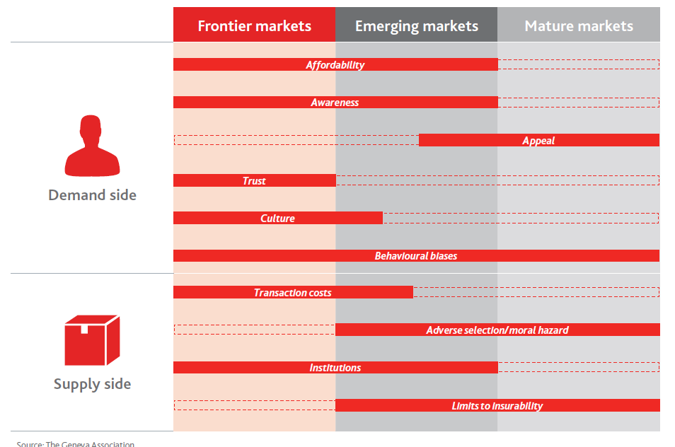

Figure 2: Root Causes of Insurance Protection Gaps - Main Areas of Relevance
(The Geneva Association, 2018)

(iii) Swiss Re Institute
Swiss Re Institute is the research arm of Swiss Re, a leading global reinsurance company. It published the report on “Closing Asia’s mortality Protection Gap” in July (Swiss Re, 2020). Its 2019 Resilience Index indicated Asia is lack of resilience to adverse events such as Mortality, health crises and natural catastrophes. The report estimated the mortality protection gap is USD 83 trillion in 2019 (compare to USD 42 trillion in 2010) across the Asia-Pacific region, and is increasing in a rate of 4% per year. The closing of the MPG across the Asia would bring business opportunities of additional life insurance premium of USD 292 billion annually. The report is considered as the most comprehensive study on consumer attitudes and preferences towards MPG for Asia region, covering over 14,000 consumers across 10 markets. This allows us to understand the human behaviour and how insurance decisions were made, which is particular useful in addressing the MPG issue.

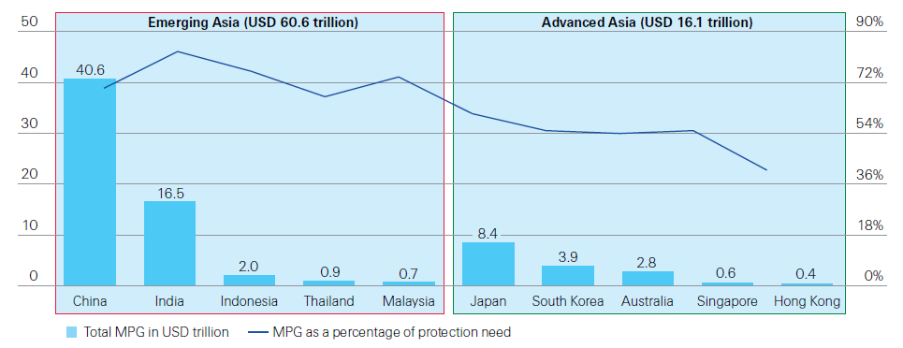

Figure 3: Mortality Protection Gap and percentages of Protection Need
In the Asian Markets (Swiss Re, 2022)

(iv) The Insurance Authority, Hong Kong
The Insurance Authority is the regulator for Hong Kong insurance market. It issued a report on “Mortality Protection Gap Study 2021” (Insurance Authority, 2021), which identified Hong Kong has a total MPG of HKD 6.9 trillion in 2019, which means each working adult has an individual MPG of HKD 1.9 million or 5.7 times average annual income. The report acts a consumer educational material, which reminds general public to purchase life protection early to enjoy cheaper premium and review their insurance coverages regularly against MPG (due to changes in different life stages and financial resource). In this way, general public can achieve better protection for themselves and their families.

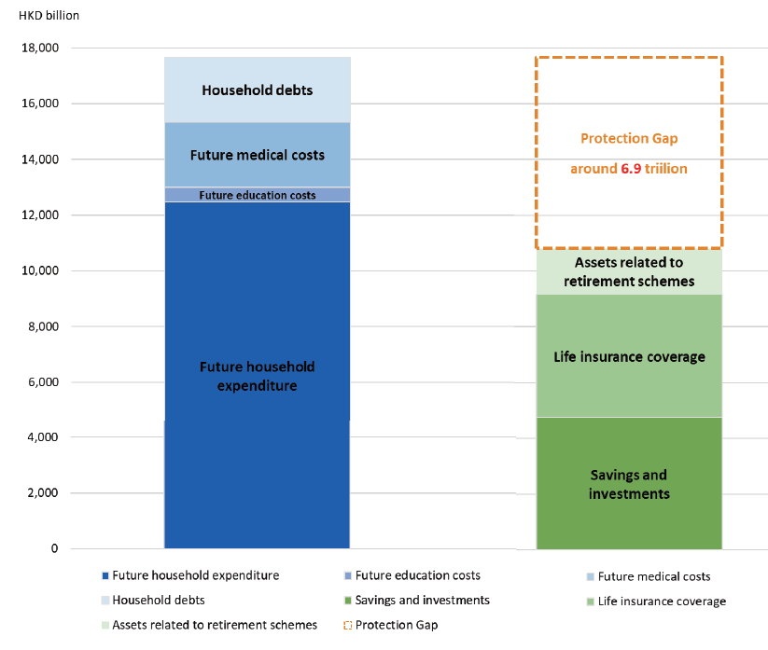

Figure 4: Hong Kong Mortality Protection Gap in 2019 Insurance Authority, 2021)

Many researches and above papers/reports issued by scholars and institutions have made significant contributions to our understanding of the MPG, highlighting its causes, consequences, and potential solutions. Their research provides valuable insights for policymakers, insurance professionals, and academics working to address the challenges associated with inadequate insurance coverage.

The current researches focus on (a) the understanding of the trends and issues of MPG in Asia and Hong Kong; (b) possible solutions to closing the MPG; and (c) the benefits of adopting InsurTech to narrow the MPG and possible future development on this area.

However, very few search had focus on the effectiveness between (a), (b) and (c) above (i.e. how much of the MPG has been narrowed due to the adoption of InsurTech). In particular, there is no research has been done on this area for Hong Kong insurance market.
My Proposed Research Topic
- Research on Understanding MPG

(d) Specific Case Study for HK
(b) Solution in
Closing MPG

(c) Adoption of InsurTech

Figure 5: Concept of Covering all Four Elements for the Proposed Research Topic

The Importance of Reviewing the Insurance Mortality Protection Gap and Adaptation of InsurTech for Hong Kong

(i) Huge Protection Gap in both Asia and Hong Kong:

As mentioned in Section 3.2, Swiss Re (Swiss Re, 2020) estimated:
- The MPG is USD 83 trillion in 2019 (compared to USD 42 trillion in 2010) across the Asia-Pacific region, and is increasing at a rate of 4% per annum;
- Hong Kong’s MPG is USD 0.4 trillion with a 41% total protection need is uncovered;
- Over 75% of households across Asia were under-protected, with a gap of eight times of its annual income;
- 27% of families in Asia worry about their financial future

The Insurance Authority’s MPG Study (Insurance Authority, 2021) revealed:
- Premiums for life insurance in-force policies reached HKD 511 billion (USD 66 billion) in 2019;
- Estimated Hong Kong has a total MPG of HKD 6.9 trillion (USD 0.88 trillion);
- On average, each working adult has a MPG of HKD1.9 million
- The average size of the gap is 5.7 times of their annual income

(ii) Importance of Narrowing the Gap

The purpose of “life insurance” is to protect consumers against unexpected events by providing their dependents with financial support if the breadwinner passes away prematurely.

The trends below contribute to an increasing MPG:
- growing health consciousness(e.g. better medical quality, rising medical cost);
- higher cost of living (e.g. household expenditure, education, etc.)
- longer life expectancy (e.g. longevity and retirement expense);
- aging population (e.g. higher dependency ratio);
- lower insurance penetration;
- rising household debt;
- no/low social security protection, etc.

For a high MPG, it mean that more dependent(s) would not be able to maintain the same living standard in an unexpected event (e.g. critical illness, accident or death of the breadwinner, etc.). This could even lead to a huge social cost on the entire economy.

(iii) Insufficient Attention is Given to Mortality Protection Gap

MPG is a global issue, but there is not enough attention has been paid to this issue, especially in emerging markets (Klein, 2020). Compared to other financial instruments, life insurance provides an effective and efficient way for consumers to narrow their protection gaps.

We raise the awareness of MPG and promote the use of insurance to narrow the MPG, possible solutions include:

- To attract more consumers to buy insurance, insurance policies could provide more value-added services (e.g. health care education, wellness program, etc.) in addition to cash payouts;
- Digitalizing the process for effectiveness (“InsurTech”);
- Enhance financial literacy (Mahdzan & Victorian, 2013; Dalkilic & Kirkbesoglu, 2015);
- New product innovation that is more affordable, flexible and tailored to different demographic groups;
- Enhance consumer experience (e.g. simply underwriting, faster claims, etc.);
- Utilizing digital platforms, online tools, and data analytics can streamline the insurance process, simplify policy administration, and make insurance more accessible and convenient for individuals;
- Increase consumer awareness of MPG and the potential financial consequences of inadequate insurance coverage;
- Leverage on behavioural economics principles to nudge individuals toward closing the protection gap (Thaler & Sunstein, 2008);
- Educating consumer to make more informed decisions;
- Lower insurance cost;
- Review public policy and regulation in promoting/incentivizing adequate insurance coverage (e.g. tax incentives or penalties for being underinsured) ;
- Ensuring transparent and fair practices within the insurance industry, which can enhance consumer trust and confidence; and
- Collaborate and partner with insurance providers, policymakers, employers and financial advisors to develop comprehensive strategies to address the protection gap.

New Insights in Combining Insurance Mortality Protection Gap and Adaptation of InsurTech for Hong Kong

The World Bank highlights the substantial potential of InsurTech in emerging markets, where a significant MPG persists as a result of limited insurance penetration (Holliday, 2019).

(i) Insurance Regulator’s Initiatives to Promote InsurTech

In Hong Kong, the insurance regulator has set out their initiatives to promote InsurTech as part of its strategy to strengthen the role of Hong Kong as an international financial center (Insurance Authority, 2023a). The Insurance Authority has been closely monitoring the development and application of InsurTech and proactively assisting market participants to tackle InsurTech-related regulatory issues (Insurance Authority, 2023b).

The Insurance Authority has launched various initiatives to promote InsurTech development in Hong Kong, such as the launch such as InsurTech Sandbox, fast track authorization of digital insurers and digital onboarding. In particular, the Insurance Authority offers fast track authorization to support the growth of insurers using solely digital distribution channels (i.e. the insurer cannot use any conventional channels such as insurance agents, banks or brokers). The insurers must demonstrate an innovative and robust business model, while satisfying all prevailing regulatory requirements.

(ii) Adoption of InsurTech by Digital Insurers

Bowtie Life Insurance Co. Ltd (“Bowtie”) was established in 2018, and is the Hong Kong's first virtual insurer approved under the fast track authorization. According to its website, Bowtie claimed it has reimagined the entire insurance experience, so customers can enjoy stress-free and truly customer-centric protection.

- Commission-free Products:
As the first virtual insurer in Hong Kong, Bowtie does not have any insurance intermediaries and offers insurance products with commission-free directly through digital distribution. Customer can choose their desired insurance protection at their own pace at anytime, anywhere.
- Instant quote without any personal data:
Customers can get an insurance quote instantly online by inputting their gender, age, smoking status and simple medical history.
- Full transparency:
Bowtie offers full transparency to its customers, all products and policy information are available online. All product related fees are clearly listed on its website and application platform for transparency.
- Flexible Contract:
Bowtie products offers “pure protection" products with no savings element (i.e. no product cash value), customers can cancel their policies anytime without penalty fees with high flexibility.
- Adoption of InsurTech:
Bowtie’s key operating systems, including underwriting, policy services, and claims, are operated on the cloud to ensure the highest level of data security and stability. There are regular reviewed and testing to ensure the customer data is properly stored and protected.
- Fully Automated Processes to Save Time and Money:
Bowtie leverage on InsurTech to modernize and simplify the online process, customers can use their smartphone or computer to complete the online application process in as quick as 10 minutes with no medical exam. Customer can get instantly result on whether or not they can be insured. Once approved, policy is effective immediately.
- Digital Claims Process:
Customers can manage their policies and file a claim through Bowtie’s online platform directly. Friends and family member can file a claim as quick as 5 mins on the behalf of customer easily without any login.

Through the adoption of latest InsurTech, Bowtie is able to reduce its operating costs through efficiencies. Together with the elimination of commission fees, Bowtie is able to pass on the savings to its customers while offering the same level of protection.
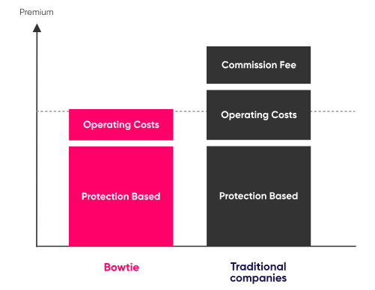

Figure 6: Bowtie Offer Cheaper Premiums to its Customer
Through the Adoption of InsurTech

(iii) Bowtie as a Case Study for Hong Kong

The adoption of InsurTech is likely to increase Hong Kong's insurance penetration rate by tapping into underserved market segments, such as young consumers. The development of online insurance platform can simplify traditional manual processes, lower administrative costs, thus support the innovation of new types of insurance products.

InsurTech can also provide the Hong Kong's insurance market with more personalized insurance products with different level of protections and premium levels. This allows people with different ages, health status and income level to obtain the insurance protection they need, and promotes insurance inclusiveness in the long run to close the protection gap in Hong Kong.

This also tied perfectly with the regulator’s strategy to promote the InsurTech development by the Hong Kong’s (Insurance Authority, 2023) and its publication of “Mortality Protection Gap Study 2021”.

With Bowtie has demonstrated all characteristics we learnt from previous researches, being the digital insurer that offers competitive and affordable products, which led to our research questions:
- Does the operation of Bowtie (and other digital insurers) actually improvement the MPG in Hong Kong?
- What are the key obstacles (for example, Trust for on-line insurer) and external factors encountered by Bowtie from preventing it from to improving the MPG in Hong Kong?

This links back to Section 3.2, where Bowtie would be a good case study for our proposal research target, which can testify “the benefits of adopting InsurTech to narrow the MPG” with the research focus is on Hong Kong data.

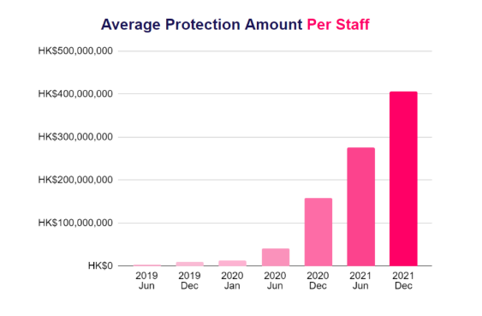
Figure 6: Average Insurance Coverage Generated per Bowtie’s Staff from 2019 to 2021
(Bowtie, 2023)

The Integration of Theories and Data into My Proposed Research Area

The data below provide the amount of sum assured (i.e. insurance protection coverage) of Bowtie and the aggregate Hong Kong insurance market from annual insurance statistic published by the Insurance Authority.

 | Bowtie’s Number of Policies | Bowtie’s Sum Assured  (HKD ‘000) | Hong Kong Aggregative Sum Assured  (HKD ‘000) | % of Bowtie’s Market Share (by Sum Assured)
2019 | 80 | 1,165 | 7,890,593,938 | 0%
2020 | 5,600 | 4,568,881 | 8,253,473,773 | 0.06%
2021 | 16,322 | 22,931,200 | 8,626,103,504 | 0.27%
2022 | 23,748 | 34,396,427 | 8,741,083,225 | 0.39%
2023-Q2 | 23,137 | 38,976,513 | 8,913,166,827 | 0.44%

Table 7 – The Amount of Sum Assured Captured by Bowtie and Hong Kong Insurance Market between 2019 to 2023

It is clear that Bowtie’s business has growth significantly in the past few years. The concept of InsurTech can offer more affordable products and tap into underserved market segments seems to be valid. However, it is apparent that Bowtie only account for immaterial market share compare to other major insurers in Hong Kong. Further work has to be done to research on this area.

With the information about, this summarise our primary objectives of this research proposal are as follows:
- To explore the potential of InsurTech in reducing the MPG in Hong Kong using Bowtie as a case study
- Through Bowtie, try to identify the challenges and opportunities associated with implementing InsurTech solutions in Hong Kong
- To develop recommendations (for regulator, insurers and customers) how to narrow the MPG in Hong Kong effectively through the adoption of InsurTech

Conceptual Framework
Customers

Price

Awareness of MPG

Trust on InsurTech

Can Narrow MPG
InsurTech

This research proposal would likely to adopt a mixed-methods approach to achieve the research objectives above. The proposed methodology includes the following steps:
- Qualitative Case Study by conducting interviews with around 10 representative samples:
  - Regulator – to understand from their perspective on managing the MPG and regulatory challenge on supervising digital insurers;
  - Bowtie’s senior management – to understand the view on MPG, their business philosophy and upcoming business opportunities as well as challenge;
  - Bowtie’s InsurTech team – to understand the current InsurTech employed by Bowtie and how this can assist customer to make informed decision; analyze the effectiveness of these solutions and their impact on MPG and customer satisfaction;
  - Bowtie’s customer(s) – their considerations (e.g. loss of trust on other insurers/intermediaries, the use of advanced InsurTech, product pricing, convenient, etc.) on choosing Bowtie as their insurance provider; and their expectation on what Bowtie can deliver to them.
  - Other insurer management – do they view Bowtie as a threat; their view on HK MPG, and how to turn it into business opportunity; the current adoption of InsurTech (if any) and the obstacle for not adopting InsurTech (e.g. cost, system integration, etc.)?
  - Non-Bowtie’s customer(s) – their personal view on MPG, why Bowtie cheaper products do not appealing to them (e.g. financial needs and coverage, no trust on InsurTech / online platform, prefer to have professional advice from intermediary, etc.)
- Gather quantitative data from Hong Kong citizens through surveys including their demographic information, personal insurance coverage data to get better understanding on :
  - Their understand of concept of MPG and their personal MPG;
  - Their perceptions, behaviors, and attitudes towards the use InsurTech solution;
I will analysis the collected data using appropriate statistical techniques, such as regression analysis and descriptive statistics, to identify patterns, trends, and associations.

- The research paper will present my findings on whether the implementation of InsurTech solutions can narrow the MPG in the case of Hong Kong.

- The expected outcomes of this research proposal include:
  - A comprehensive understanding of the insurance MPG in Hong Kong and its implications for individuals and society.
  - Insight into the potential of InsurTech in reducing the MPG, including the benefits and challenges associated with its implementation.
  - Identification of key success factors for the adoption and implementation of InsurTech solutions in Hong Kong.
  - Develop recommendations for regulator, insurers, regulators and customers in Hong Kong on the effective way to narrow the insurance MPG in Hong Kong, including any change on regulatory frameworks, consumer education, and incentives to facilitate the narrowing of the MPG in Hong Kong.

- This research proposal will adhere to ethical guidelines, ensuring the privacy and anonymity of participants. Informed consent will be obtained, and data will be handled securely and confidentially.

To conclude, this research proposal aims to contribute to the understanding of MPG in Hong Kong and the role of InsurTech in addressing this gap. By investigating the challenges and opportunities associated with InsurTech implementation, this research will provide valuable insights and recommendations for stakeholders in the insurance industry and customers of Hong Kong. Narrowing the MPG will enhance financial security and resilience for individuals and society as a whole.

Future Research Suggestions for Proposed Research Areas
The above proposed search area on MPG only focuses on the premature death of the breadwinner. There are other studies and researches to study the protection gap in terms of health coverage, properties and nature disaster.

Also, the adoption of InsurTech is more common for non-life insurance business (e.g. travel insurance, motor insurance, home insurance, etc.) compared to life insurance as the products are more standardised and unaffected by the health of the insured. We may consider comparing the effectiveness of the adoption of InsurTech in narrowing the MPG and property / nature disaster protection gap.

We can also consider to look at the impact of COVID19 and how it drives the adoption of InsurTech due to non face to face touchpoint.

Reference

- Baranauskas, G., & Raišienė, A. G. (2021). Reflections on the customer decision-making process in the digital insurance platforms an empirical study of the baltic market. Applied sciences, 11(18), 8524.
- Bowtie (2023). Corporate Website. Available at: https://www.bowtie.com.hk/ [Accessed: 11 August 2023].
- Chang. (2023). Do InsurTech startups disrupt the insurance industry? Finance Research Letters, 57, 104220.
- Dalkilic, N., & Kirkbesoglu, E. (2015). The role of financial literacy on the development of insurance awareness. International Journal of Economics and Finance, 7(8), 272-280.
- Denuit, M., Robert, C. (2021). From risk sharing to pure premium for a large number of heterogeneous losses, Insurance: Mathematics and Economics vol. 96, p116–126.
- Holliday, s. (2019). How Insurtech Can Close the Protection Gap in Emerging Markets, EMCompass Note 70, International Finance Corporation, World Bank Group.
- Insurance Authority (2021). Mortality Protection Gap Study 2021. Available at: https://ia.org.hk/en/infocenter/files/Mortality_Protection_Gap_Report_eng.pdf [Accessed: 11 August 2023].
- Insurance Authority (2023a). Promotion of Insurtech development. Available at: https://www.ia.org.hk/en/digital_onboarding/promotion_of_insurtech_development.html [Accessed: 12 August 2023].
- Insurance Authority (2023b). Insurtech Corner. Available at: https://www.ia.org.hk/en/aboutus/insurtech_corner.html [Accessed: 12 August 2023]
- Klein, R. (2020). Life Insurance Protection Gaps - What they are and why they exist. International Insurance Society.
- Khare, A., Dixit, S., Chaudhary, R., Kochhar, P., & Mishra, S. (2012). Customer behavior toward online insurance services in India. Journal of Database Marketing & Customer Strategy Management, 19, 120-133.
- Swiss Re (2020). Closing Asia’s mortality protection gap, Swiss Re Institute.
- Swiss Re (2015). Asia-Pacific 2015 Mortality protection gap, Swiss Re.

- FutureCIO (2020). “Hong Kong: no market for virtual insurance?”. Available at: https://futurecio.tech/hong-kong-no-market-for-virtual-insurance/ [Accessed: 12 August 2023].
- Mahdzan, N. S., & Victorian, S. M. P. (2013). The determinants of life insurance demand: A focus on saving motives and financial literacy. Asian social science, 9(5), 274.
- Stoeckli, E., Dremel, C. & Uebernickel, F. (2018). Exploring characteristics and transformational capabilities of InsurTech innovations to understand insurance value creation in a digital world. Electron Markets 28, 287–305.

- Premkumar, M. D. (2022). Influence of the Marketing Strategies on the Mortality Protection Gap of the Life Insurance Policyholders: A Mediation Analysis. International Transaction Journal of Engineering, Management, & Applied Sciences & Technologies, 13(7), 1-8.
- Huebner, S. S. (1959). The economics of life insurance: human life values, their financial organization, management, and liquidation. (No Title).
- Rozar, T. (2017), Who do you trust – How InsurTech is bridging the industry’s trust gap, presentation at the Presidents’ Forum of the International Actuarial Association, Chicago, 7 October 2017
- The Geneva Association (2018). Understanding and Addressing Global Insurance Protection Gap. Available at:
https://www.genevaassociation.org/sites/default/files/research-topics-document-type/pdf_public/understanding_and_addressing_global_insurance_protection_gaps.pdf
[Accessed: 12 August 2023].

Thaler, R.H. and Sunstein, C.R. (2008) Nudge: The Gentle Power of Choice Architecture, New Haven, CT: Yale University Press.

Zarifis, A., & Cheng, X. (2022). A model of trust in Fintech and trust in Insurtech: How Artificial Intelligence and the context influence it. Journal of Behavioral and Experimental Finance, 36, 100739.

Meara, Richards, S., & Cutler, D. M. (2008). The gap gets bigger: Changes in mortality and life expectancy, by education, 1981 - 2000. Health Affairs, 27(2), 350–360. https://doi.org/10.1377/hlthaff.27.2.350

Braun, A., Schmeiser, H., Schreiber, F., & Steinmann, L. (2014). Term Life Insurance in Germany: The Consumers' Perspective-A Need for Preferences-Orientated Product Design?.

Redzuan, H., Yakob, R., & Isa, Z. (2016). Underinsurance in Malaysia: The application of the Monte Carlo simulation. Journal Pengurusan, 47(1), 131-142.

蘇薰璇. (2013). 市場, 國家與社會: 從制度論探討臺灣戰後壽險市場的發展. Market, State and Society: The Institutionalist Research on Postwar Life Insurance Market in Taiwan

