Qualification: CIPD Diploma in Applied Human Resources
Module Name: Contributing to Employee Engagement in the Organisation 5AEEG

Word Count: 3300

Student Name: Catherine Thomas
Student Number: 2012743
CIPD Membership Number: 57612349

By signing below, I confirm that the work/evidence presented is my own, unaided work.
I understand the regulations pertaining to candidate malpractice and the action that may be taken as a result.

Signed: C Thomas
Date: 11 February 2022
Contents
Details Page No
Evidence Matrix 5-8
Personal Statement for LO1 including Reference List and Evidence 9-20
EV1 Screenshot from OD Directorate paper May 2021 showing Culture and Workforce Experience Structure 25
EV1a Email to and from Assistant Director of Workforce & OD (Resourcing & Utilisation), Head of Culture & W/F Experience 14-15
& Senior Nurse
EV1b Meeting date with the person who provides surveys 16
EV1c Email to Workforce Manager about survey questions 16-17
EV1d Email to B.I Lead to ask how 2021 Staff Engagement was sent 18
EV1e December 2021 Survey and Findings 19
Personal Statement for LO2 including Reference List and Evidence 21-60
EV2 Employee Appreciation Competition 26
EV3 Employee/Team of the Month 26
EV4 Hapi App for staff benefits 27
EV5 Details within the Workforce Collaborate teams from the Consultant Psychologist by Oliver Burkeman 28
EV6 Staff Psychological Wellbeing Service intranet page 28
EV7 Celebrating Success intranet page 29
EV8 Team Brief 29
EV9 Hywel’s Voice 29
EV10 Culture department promoting a webinar caring for people with hearing loss or carers with hearing loss themselves 30
EV11 Digital Champions Network 30
Contents
Details Page No

EV12 Well-Being Champions Network 31
EV13 Global Menopause Café 31
EV14 Induction pack guidance 32
EV15 Logo for HDUHB relating to Organisation Values and the nine Personal Values 33
EV16 Framework for Values 33
EV17 Corporate Health Standard Criteria Pack below 34-37
EV18 Mental Health and Wellbeing Globals 38
EV19 Workforce, Organisational Development & Education Strategy 2020-2030 39-46
EV20 Letter from Welsh Government regarding pay and annual leave arrangements for employees covered by the AfC 47-49
EV20a AfC pay scales showing increments for each banding from band 1 to band 12 49-51
EV20b Electronic Staff Record which shows pension details 52
EV21 Organisational Development Dashboard 53
EV22 Workforce Profile 54-56
EV23 Transforming Clinical Services 57
EV24 Old Staff Exit Interview Questionnaire 58
EV25 Global link for monkey survey to capture staff who are thinking of leaving the Health Board 59

Contents
Details Page No

Personal Statement for LO3 including Reference List & Evidence 61-77
EV26 Email from managers re setting up café & recommendation for an award 65-67
EV27 Menopause Café – Teams 68-71
EV28 Email from Annmarie to stop rolling out 71-72
EV29 Email from Assistant Director of WOD re an award 72-73
EV30 Email to Millie re BAME announcement on Electronic Staff Record 74
EV31 Implementation Plan and Staff Costing for Menopause Café 75-76

Candidate name: Catherine Thomas |  |  |  |  | CIPD Membership/registration No.:  5762349
Qualification title: CIPD Diploma in Applied Human Resources |  |  |  |  | Unique Learner No. (ULN):  2012743
Unit code | Unit title |  | Assessment criteria no. | Evidence description | Evidence reference number | Assessor  initials | I/V initials if sampled
5AEEG | Contributing to Employee Engagement in the Organisation |  | 2.1, 3.2, 3.3 | Screenshot from OD Directorate paper May 2021 showing Culture and Workforce Experience Structure | EV1
5AEEG | Contributing to Employee Engagement in the Organisation |  | 1.2 | Email to and from Assistant Director of Workforce & OD (Resourcing & Utilisation), Head of Culture and Workforce Experience & Senior Nurse | EV1a
5AEEG | Contributing to Employee Engagement in the Organisation |  | 1.2 | Meeting date with the person who provides surveys | EV1b
5AEEG | Contributing to Employee Engagement in the5 Organisation |  | 1.2, 1.3, 1.4 | Email to Workforce Manager about survey questions | EV1c
5AEEG  5AEEG | Contributing to Employee Engagement in the Organisation  Contributing to Employee Engagement in the Organisation |  | 1.3  1.3 | Email to B.I lead to ask how 2021 Staff Engagement was sent  December 2021 Survey and Findings | EV1d  EV1e
5AEEG | Contributing to Employee Engagement in the Organisation |  | 2.1 | Employee Appreciation Competition as promoted via the Workforce teams’ channel | EV2
5AEEG | Contributing to Employee Engagement in the Organisation |  | 2.1 | Employee/Team of the Month | EV3
5AEEG | Contributing to Employee Engagement in the Organisation |  | 2.1 | Hapi App for staff benefits | EV4
5AEEG | Contributing to Employee Engagement in the Organisation |  | 2.1 | Details within the Workforce Collaborate teams from the Consultant Psychologist by Oliver Burkeman | EV5
5AEEG | Contributing to Employee Engagement in the Organisation |  | 2.1 | The Staff Psychological Wellbeing Service has its own intranet page | EV6
5AEEG | Contributing to Employee Engagement in the Organisation |  | 2.1 | Celebrating Success intranet page | EV7
5AEEG | Contributing to Employee Engagement in the Organisation |  | 2.1 | Team Brief | EV8
5AEEG | Contributing to Employee Engagement in the Organisation |  | 2.1 | Hywel’s Voice | EV9
5AEEG | Contributing to Employee Engagement in the Organisation |  | 2.1 | Culture department promoting a webinar caring for people with hearing loss or carers with hearing loss themselves | EV10
5AEEG | Contributing to Employee Engagement in the Organisation |  | 2.1 | Digital Champions Network | EV11
5AEEG | Contributing to Employee Engagement in the Organisation |  | 2.1 | Well-Being Champions Network | EV12
5AEEG | Contributing to Employee Engagement in the Organisation |  | 2.1 | Global Menopause Café | EV13
5AEEG | Contributing to Employee Engagement in the Organisation |  | 2.1 | Induction pack guidance | EV14
5AEEG | Contributing to Employee Engagement in the Organisation |  | 2.1 | Logo for HDUHB relating to Organisation Values, and the nine Personal Values | EV15
5AEEG | Contributing to Employee Engagement in the Organisation |  | 2.1 | Framework for Values | EV16
5AEEG | Contributing to Employee Engagement in the Organisation |  | 2.1 | Corporate Health Standard Criteria Pack below | EV17
5AEEG | Contributing to Employee Engagement in the Organisation |  | 2.1 | Mental Health and Wellbeing Globals | EV18
5AEEG | Contributing to Employee Engagement in the Organisation |  | 3.1, 3.2, 3.3 | Workforce, Organisational Development & Education Strategy 2020-2030 | EV19
5AEEG | Contributing to Employee Engagement in the Organisation |  | 2.1 | Letter from Welsh Government regarding pay and annual leave arrangements for employees covered by the Agenda for Change, Medical and Dental and Executive and Senior Pay terms and conditions | EV20
5AEEG | Contributing to Employee Engagement in the Organisation |  | 2.1 | AfC pay scales showing increments for each banding from band 1 to band 12 | EV20a
5AEEG | Contributing to Employee Engagement in the Organisation |  | 2.1 | Details from the Electronic Staff Record showing pension details | EV20b
5AEEG | Contributing to Employee Engagement in the Organisation |  | 2.1 | Organisational Development Dashboard | EV21
5AEEG | Contributing to Employee Engagement in the Organisation |  | 1.1, 1.2, 1.3, 1.4, 2.2 | Workforce Profile | EV22
5AEEG | Contributing to Employee Engagement in the Organisation |  | 2.2 | Transforming Clinical Services | EV23
5AEEG | Contributing to Employee Engagement in the Organisation |  | 2.2 | Old Staff Exit Interview Questionnaire | EV24
5AEEG | Contributing to Employee Engagement in the Organisation |  | 2.2 | Global link for monkey survey to capture staff who are thinking of leaving the Health Board | EV25
5AEEG | Contributing to Employee Engagement in the Organisation |  | 3.2, 3.3 | EV26 Email from managers re setting up café & recommendation for an award | EV26
5AEEG | Contributing to Employee Engagement in the Organisation |  | 3.2 | EV27 Menopause Café - Teams | EV27
5AEEG | Contributing to Employee Engagement in the Organisation |  | 3.2, 3.3 | EV28 Email from Annmarie to stop rolling out | EV28
5AEEG | Contributing to Employee Engagement in the Organisation |  | 3.2 | EV29 Email from Assistant Director of WOD re an award | EV29
5AEEG | Contributing to Employee Engagement in the Organisation |  | 3.3 | EV30 Email to Millie re BAME announcement on Electronic Staff Record | EV30
5AEEG | Contributing to Employee Engagement in the Organisation |  | 3.3 | EV31 Implementation Plan for Menopause Café and Staff Costing | EV31
- I confirm that the work/evidence presented for assessment is my own unaided work.
- I have read the assessment regulations and understand that if I am found to have ‘copied’ from published work without acknowledgement, or from other candidate’s work, this may be regarded as plagiarism which is an offence against the assessment regulations and leads to failure in the relevant unit and formal disciplinary action.
- I agree to this work being subjected to scrutiny by textual analysis software if required.
- I understand that my work may be used for future academic/quality assurance purposes in accordance with the provisions of the Data Protection Act 1998.
- I understand that the work/evidence submitted for assessment may not be returned to me and that I have retained a copy for my records.
I understand that until such time as the assessment grade has been ratified through internal and external quality assurance processes it is not final.
Signature: C Thomas
Date |  | 11 February 2022

  - Identify, and justify selection of, suitable diagnostic tools for measuring employee engagement in the organisation (333 words) 326
Gallup (2022a) state that having strength produces the basis for setting goals, whilst engagement and wellbeing assist in outlining the type of goals to be set. Moreover, employee engagement within the organisations is measured, and there is existing evidence as HDUHB is part of NHS Wales that benchmarking against other Welsh Health Boards is standard and (EV22) shows this.

There are different types of surveys and these include the tiny pulse survey (Tiny Pulse, 2020), and Gallup Q12 survey (Gallup, 2022b). Furthermore, all of them want to reach the same goal so they need to be the right type of questions, and in order to get honest feedback having them weekly or biweekly is the key (Tiny Pulse, 2020). Surveys are normally related with the logical approach as it is well-liked and a familiar plan in business and management research (Saunders et al, 2000, p.93). Bennett (1983, cited in Marchington et al, 2009, p.533) explains that surveys are also cheap, quick to manage and deliver a much wider coverage, than a trial or case study. The data is not the same as what can be collected by qualitative methods due to the limit on the number of questions asked, WERS surveys is an example of data collected with a sample of 2,000 workplaces on various aspects of employee relations (Kersley et al, 2006, within Marchington et al, 2009, p.533). There are however a number of other methods to gather data; observation (the advantage being it as the researcher gets involved sharing everyday life) interviews (raw data is analysed later) focus groups (are like interview that use numerous people to produce data (Marchington et al, 2009, p.533-36).

John Bersin disputes that the old style annual engagement survey is out of date and archaic and welcomes a new approach to gauging and pushing high levels of employee dedication and passion. With Gallup being one survey provider who created the engagement survey over 30 years ago Leadership Review (2022).

  - Liaise with key people to plan and agree the application of diagnostic tools. (333 words) 376

I emailed my manager for confirmation that doing another survey due to the pandemic was appropriate. I asked whether a survey to the BAME Network with questions similar to that of Gallup Q12 Survey could be used. She confirmed she was mindful that the Culture team were producing lots of surveys and that the BAME Network may have just completed one. A report had recently been presented to PODCC on employee engagement, which had lots of information regarding the Workforce Profile, Age and Gender, Turnover Rate, Employee Relations, Recruitment, Sickness, PADR and Staff Engagement (EV22).

The Head of the Culture provided me with contact details for those who dealt with BAME and surveys (EV1a). A meeting was setup with three of my work colleagues also doing the CIPD course about how HDUHB uses data regarding pulse surveys. This was for the 9th February and if there was nothing that was of relevance that could be used, would mean this would leave little time to organise and sent out the survey, to then get a reply in time for submission of the assignment (EV1b). Also in (EV1c) my manager had confirmed that I was to use the data from the 2021 December engagement survey.

In the Harvard Business Review Analytic Services report, it states that employee engagement is a high priority within businesses as it is vital for expansion and survival in having a high performing workforce. The research found that even though the majority of leaders saw the significance of engagement three quarters of the people surveyed said that most of employees within their business are not highly engaged (HBR, 2016).

After examining the Workforce Profile dashboard showing details of a recent staff survey; 2021 Sample in December with 1,173 being sent the survey, 266 completed the survey, response rates 23 percent and the Engagement Score 76 percent (EV22). I had a discussion with my manager for me to investigate the survey further. In the email it was made clear that my manager was happy for me to examine the seven questions and the results as many surveys have recently been done, and due to work pressures this would be best practice at this moment in time in assisting me with the employee engagement survey (EV1c).

  - Apply diagnostic tools accurately and to an appropriate sample of employees to give meaningful results. (333 words) 259

The Workforce Profile Dashboard showed previous staff engagement surveys (EV22).

2016 NHS Wales Survey sent to 4,535, number completed 1,550, Response Rate 34%, Engagement Score 74%.

2018 NHS Wales Survey sent to 9,484, number completed 2,401, Response Rate 25%, Engagement Score 77%

2020 NHS Wales Survey sent to 10,533 number completed 1,759 Response Rate 17%, Engagement Score 76%

2021 NHS Wales Survey sent to 1,173, number completed 266, Response Rate 23%, Engagement Score 76%

Above don’t show details of a survey being sent in 2017 or 2019. When analysing these it was transparent that, even though the samples sent were to a larger amount of staff than that of 2021 (sample), the engagement score was relatively even. With a response rate of 23 percent for the 2021.

The December 2021 survey was conveyed by the Culture team, and was done via Microsoft Forms as they said it was simple to use and did the job. The team are looking at the software but said that Microsoft Forms did what was required (EV1d). Due to the survey being sent out in December 2021 (EV22) and taking into consideration my manager being happy for me to work with the seven questions that had been sent (EV1c), I used tools to collate the findings and results (EV1e).

Being a manager I wanted to know how many that were asked out of the 226 that responded were “happy to go the extra mile at work when required”. Even though I was only working with the seven questions, there were another ten questions and these and the findings are shown below. One of interest was “I have had a PADR in the last 12 months that has supported my development etc.”, the findings are shown in 1.4. The Shades of Grey report state engagement in work teams is greyed, different to teams being either engaged or disengaged. Identified were Zone of Contentment, Zone of Pseudo-Engagement, Zone of Disengagement and Zone of Engagement (Ashridge Hult Research, 2018).

  - Analyse resulting data and draw reasoned conclusions about levels of employee engagement in the organisation. (333 words) 456

The turnover dashboard wasn’t part of any questionnaire, although the pandemic would have had an impact on turnover, especially December 2021 with staff employed for Covid-19 and these may have found jobs elsewhere those on a fixed term contract. This showed the turnover rate was over 5% regardless of whether it was HDUHB only or NHS Wales. In particular the turnover dashboard shows Turnover vs NHS Wales (excluding bank and locum assignments, and junior doctors) this only includes people who have left NHS Wales. Therefore, staff movement between organisations is excluded. In some case NHS Wales turnover will be lower than all organisations for this reason (EV22).

Examining the Staff Engagement seven questions survey (EV1c). The findings from the staff survey question “I am happy to go the extra mile at work when required”, showed that out of 266 respondents, 123 staff (9%) were happy to go the extra mile. This based on the evidence within the 17 questions. Although looking at the combined, strongly agree and agree there were 241 staff that were in that category. With seven strongly disagree/disagree and 18 neither agree nor disagree. Staff within my team go the extra mile e.g. work on for the collaborative meeting or change their annual leave to fit in with other team members. Over a half of UK workers on a daily basis feel passionate about their jobs, with one out of three feeling they have lots of energy, and over half are eager to work tougher than they have to (CIPD, 2021).

Overall, the survey showed that staff were engaged. As for the strongly agree/agree there were no staff below the 139 mark that looked forward to going to work, were enthusiastic about their job, involved in changes, able to make improvements, happy to go the extra mile, proud to work for Hywel Dda and to recommend the Health Board as being a place to work. With highest being 241. Examining further the question “I would recommend Hywel Dda as a place to work” showed that 64 respondents neither agree nor disagree, and the question “I am proud to tell people I work for Hywel Dda” with 56 respondents neither agree or disagree and this can have a damaging effect on employer brand. Within the HDUHB 10 year strategy plan ‘Employer of Choice’ is stated within the majority of the plan and with having 64 respondents neither agreeing or disagreeing to recommending Hywel Dda as a place to work or proud to tell people they worked for Hywel Dda does not fit in with the message they are portraying (EV19). Every organisation has a reputation, and employer brand breathes and lives in heart and minds of present, previous, and future employees (Linked in, 2018).

Evidence for Learning Outcome 1
EV1a Email to and from Assistant Director of Workforce & OD (Resourcing & Utilisation), Head of Culture and Workforce Experience & Senior Nurse
From: Augusta Umughele (Hywel Dda UHB - Senior Nurse in Corporate Team) <Augusta.Umughele@wales.nhs.uk>
Sent: 24 January 2022 08:19
To: Robert Blake (Hywel Dda UHB - Head of Culture and Workforce Experience) <Robert.Blake2@wales.nhs.uk>; Catherine Thomas (Hywel Dda UHB - ESR Administrator/Workforce Information Manager) <Catherine.Thomas@wales.nhs.uk>
Subject: RE: morning
Hi Cath
Happy to help – please let me know what you would like help with – we can meet for a quick chat.
Best wishes Augusta

From: Robert Blake (Hywel Dda UHB - Head of Culture and Workforce Experience) <Robert.Blake2@wales.nhs.uk>
Sent: 21 January 2022 08:18
To: Catherine Thomas (Hywel Dda UHB - ESR Administrator/Workforce Information Manager) <Catherine.Thomas@wales.nhs.uk>
Cc: Augusta Umughele (Hywel Dda UHB - Senior Nurse in Corporate Team) <Augusta.Umughele@wales.nhs.uk>
Subject: RE: morning
Hi Cath
I am at home today, best person to speak to regarding BAME is Augusta and have copied her in. Augusta will be best to help with any specific surveys you could send to BAME colleagues and maybe we could link it to some work that Augusta needs. Jo Thomas is the person who develops the surveys and will be able to help in that regard.
Best wishes Rob
Head of Culture and Workforce Experience
From: Catherine Thomas (Hywel Dda UHB - ESR Administrator/Workforce Information Manager) <Catherine.Thomas@wales.nhs.uk>
Sent: 21 January 2022 07:29
To: Robert Blake (Hywel Dda UHB - Head of Culture and Workforce Experience) <Robert.Blake2@wales.nhs.uk>
Subject: morning
Are you in the office or home?
I am doing staff engagement for my next assignment and I was thinking that maybe sending something to the BAME group, however, Annmarie has said one for BAME network may have already had one. So my question is would you know if BAME network has recently had a survey? Annmarie also mentioned a report was presented to PODCC on employee engagement.
Cath
From: Catherine Thomas (Hywel Dda UHB - ESR Administrator/Workforce Information Manager)
Sent: 21 January 2022 07:11
To: Annmarie Thomas (Hywel Dda UHB - Assistant Director of Workforce & Organisational Development (Resourcing & Utilisation) <Annmarie.Thomas@wales.nhs.uk>
Subject: RE: survey to staff who attend bame for Hywel dda
Ok thanks I’ll speak to Rob.

From: Annmarie Thomas (Hywel Dda UHB - Assistant Director of Workforce & Organisational Development (Resourcing & Utilisation) <Annmarie.Thomas@wales.nhs.uk>
Sent: 20 January 2022 18:18
To: Catherine Thomas (Hywel Dda UHB - ESR Administrator/Workforce Information Manager) <Catherine.Thomas@wales.nhs.uk>
Subject: RE: survey to staff who attend bame for Hywel dda
Hi Cath,
Lovely to hear from you. Can you link with Rob Blake who leads on employee engagement to chat it through. I’m mindful they are doing a lot of surveys at the moment and it is possible that the BAME network may have only just had one. Really keen that you get a good response rate so picking an area which may not have been recently surveyed may be key to that. So Rob will be really helpful to look over your proposed question and the tools they currently use to analyse results. A report was recently presented to PODCC on employee engagement which you may find helpful reading. If you do decide to touch an area on the inclusion side of things I totally agree Helen Sullivan is a key link. Hope this helps, Annmarie

From: Catherine Thomas (Hywel Dda UHB - ESR Administrator/Workforce Information Manager) <Catherine.Thomas@wales.nhs.uk>
Sent: 20 January 2022 14:36
To: Annmarie Thomas (Hywel Dda UHB - Assistant Director of Workforce & Organisational Development (Resourcing & Utilisation) <Annmarie.Thomas@wales.nhs.uk>
Subject: survey to staff who attend bame for hywel dda
Hi Annmarie
My next CIPD assignment is Employee Engagement and we need to send a survey or attend focus group etc regarding this topic.
I was thinking of sending to Hywel Dda Staff within the BAME meetings. These are based on the Gallup 12 questions.
Please can you confirm whether you are happy for me to do this? I will liaise with Helen Sullivan – Head of Partnerships, Diversity and Inclusion.
Employee Engagement
1. At work do you know what is expected of you? w
2. Do you have access to all the materials you need in order to do your job effectively? w
3. Do you have the opportunity to do what you do best every day at work? w
4. Have you received recognition or praise for doing good work In the last seven days? w
5. Does your manager/supervisor, or a work colleague seem to care about you as a person> w
6. Is there anyone at work who encourages your development? w
7. Do your opinions at work seem to count? w
8. Does the aim/purpose of your company make you feel your job is important? w
9. Are your colleagues committed to doing quality work? w
10. At work do you have a best friend? w
11. Has anyone at work talked to you about your progress in the last six months? w
12. Have you had opportunities to learn and grow In the 12 months? w

EV1b Meeting date with the person who provides surveys
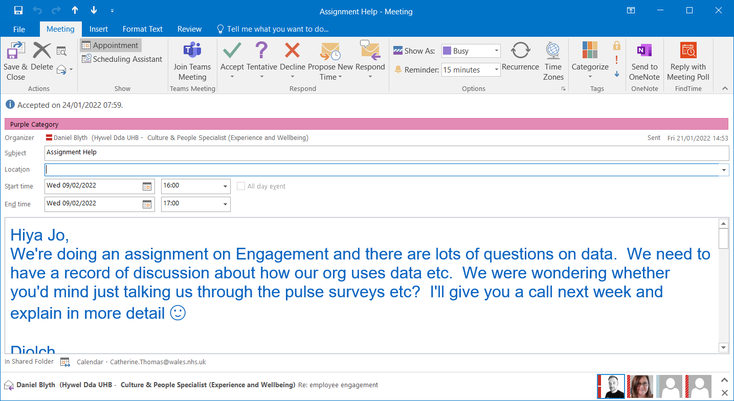
EV1c Email to Workforce Manager about survey questions
From: Sarah Barnes (Hywel Dda UHB - Workforce Manager: Systems and Workforce Intelligence) <Sarah.AM.Barnes@wales.nhs.uk>
Sent: 25 January 2022 08:45
To: Catherine Thomas (Hywel Dda UHB - ESR Administrator/Workforce Information Manager) <Catherine.Thomas@wales.nhs.uk>
Subject: CIPD- Staff Engagement
Please find attached and also below is a better explanation of the caveats around NHS Wales turnover rates we use in benchmarking.
Turnover - Turnover for NHS Wales only includes people who have left NHS Wales. Therefore, staff movement between organisations is excluded. In some case NHS Wales turnover will be lower than all organisations for this reason.
Staff Engagement – Score worked out on the 7 highlighted questions.
I am happy for you to use these questions (particularly the 7 highlighted questions) and think as there have been a lot of surveys recently, and due to work pressures this would be best practice at this moment in time to assist with your employee engagement assignment.
Question | Strongly Agree | Agree | Neither agree nor disagree | Disagree | Strongly disagree
I look forward to going to work | 57 | 111 | 43 | 44 | 11
I am enthusiastic about my job | 83 | 129 | 28 | 21 | 5
I am involved in deciding on the changes that affect my work/team/area/ department | 51 | 88 | 49 | 50 | 28
I am able to make improvements in my area at work | 51 | 100 | 62 | 38 | 15
I am happy to go the extra mile at work when required | 123 | 118 | 18 | 3 | 4
I am proud to tell people I work for Hywel Dda | 90 | 101 | 56 | 10 | 9
I would recommend Hywel Dda as a place to work | 78 | 98 | 64 | 15 | 11
I am able to make a difference to patient's experience | 86 | 129 | 42 | 8 | 1
I feel genuinely listened to | 38 | 102 | 60 | 41 | 25
I feel valued and appreciated at work | 47 | 97 | 60 | 35 | 27
I am safe to be me | 72 | 121 | 51 | 13 | 9
I have the right information and knowledge to do my job effectively | 76 | 157 | 21 | 10 | 2
I have had a PADR in the last 12 months that has supported my development and provided me with clear objectives aligned to team and organisation goals | 75 | 101 | 43 | 28 | 19
Team members trust each other's contribution | 75 | 115 | 47 | 22 | 7
I behave responsibly with regard to environmental issues | 127 | 126 | 11 | 1 | 1
I am able to reflect and offer suggestions | 97 | 124 | 32 | 10 | 3
We are empowered and supported to enact change and continuously learn and improve | 55 | 97 | 76 | 30 | 8
I use the resources available to me in the best possible way | 92 | 144 | 24 | 5 | 1

EV1d Email to Business Intelligence Lead to ask how 2021 Staff Engagement was sent
From: Joanna Thomas (Hywel Dda UHB - Business Intelligence Lead) <Joanna.Thomas4@wales.nhs.uk>
Sent: 27 January 2022 14:51
To: Catherine Thomas (Hywel Dda UHB - ESR Administrator/Workforce Information Manager) <Catherine.Thomas@wales.nhs.uk
Subject: RE: engagement survey
Hi
It was done through Microsoft Forms, it’s simple and does the job. I’m am looking at some software at the moment and can let you know if we decide to go down that route but at the moment Forms does what we need it to do. If you want any help in creating one let me know, I’d be happy to help 😊
Many thanks, Jo
From: Catherine Thomas (Hywel Dda UHB - ESR Administrator/Workforce Information Manager) Catherine.Thomas@wales.nhs.uk
Sent: 27 January 2022 12:46
To: Joanna Thomas (Hywel Dda UHB - Business Intelligence Lead) <Joanna.Thomas4@wales.nhs.uk>
Subject: FW: engagement survey
Hi Jo,
Was the engagement survey (December) done via MS Forms, Survey Monkey or some other program?

EV1e December 2021 Survey and Findings

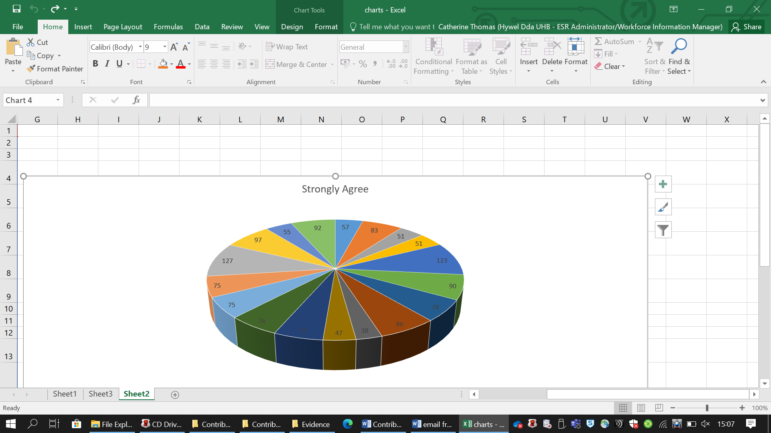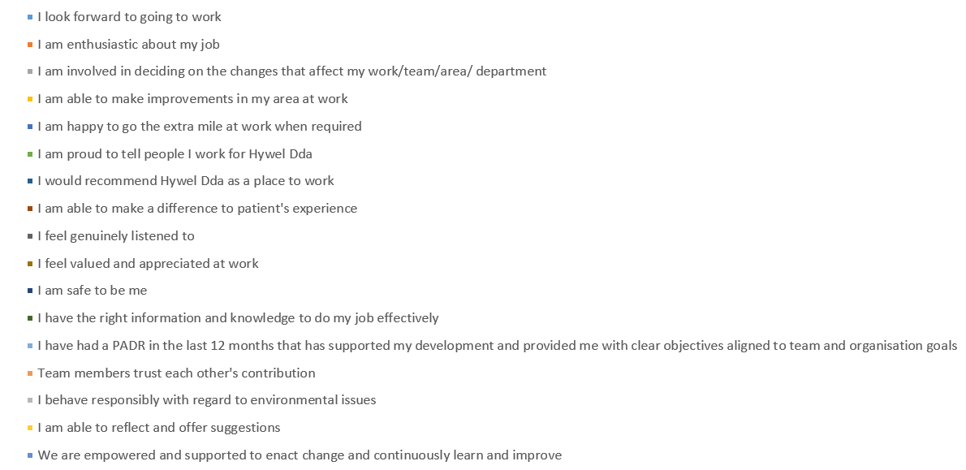
References for Learning Outcome 1
Ashridge Hult Research (2018) Shades of Grey: An exploratory study of engagement in work teams. Hertfordshire. Hult Research Ashridge Executive Education.

CIPD (2021a) Employee engagement and motivation. Available at: https://www.cipd.co.uk/knowledge/fundamentals/relations/engagement/factsheet (Accessed: 31 January 2022)

Gallup (2022a) How to Set Goals at Work That Lead to Higher Performance. Available at: How to Set Goals at Work That Lead to Higher Performance | Gallup (Accessed: 20 January 2022).
Gallup (2022b) Gallup’s Employee Engagement Survey: Ask the Right Questions with the Q12 Survey. Available at: Gallup's Q12 Employee Engagement Survey - Gallup (Accessed: 20 January 2022).

HDUHB Workforce Organisational Development & Education Strategy 2020 – 2030

HBR (2016) The Impact of Employee Engagement on Performance. Available at: The Impact of Employee Engagement on Performance - SPONSOR CONTENT FROM ACHIEVERS (hbr.org) (Accessed: 22 January 2022).

Leadership Review (2022) Why the employee engagement survey is out of date. Available at: https://www.leadershipreview.net/why-the-employee-engagement-survey-is-out-of-date/ (Accessed: 2 February 2022).

Linked in (2018) What Is Employer Branding and How Can It Grow Your Business? Available at: What Is Employer Branding and How It Can Grow Your Business? (linkedin.com) (Accessed: 31 January 2022).

Saunders, M. et al. (2000) Research Methods for Business Students second edn. 2000. England: Pearson Education Limited.

TinyPulse (2020) The Ultimate Guide to Employee Engagement Survey Questions. Available at: https://www.tinypulse.com/blog/sk-employee-engagement-survey-questions (Accessed: 20 January 2022).

  - Analyse the principal ‘drivers’ for employee engagement in the organisation. (333 words) 386

NHS Wales Workforce Key Themes and Trends report (2014) recognised four key driver and these are; Demographic and Social Health & Social Care system design, Quality & productivity, Financial and Economic (Workforce Education Development Services, 2014). Hywel Dda University Health Board (HDUHB) is a National Health Service and part of NHS Wales (Welsh Government) and the same would apply regarding achieving excellence details within ‘The Quality Delivery Plan for the NHS in Wales. With the vision being delivering great quality care and excellent patient experience (NHS Wales, 2012-2016).

Workforce & OD have invested in a new Culture and Workforce Experience department (EV1). Engagement shown below:-

‘Employee Appreciation’ Competition (EV2)
Employee/Team of the Month’ via the collaborative teams channel (EV3)
‘The Hapi’ App is primarily for staff benefits which include eye care, purchase leave, cycle to work and Lease Car Scheme. Along with other benefits including fitness, sports, Health and Beauty, Fashion & Gifts, and Vehicle, Home & Garden (EV4).
During the festive season there were details within the Workforce Collaborate teams from the Consultant Psychologist by (EV5) Oliver Burkeman in that it doesn’t mean by working longer on a particular piece of work that you will make progress on it (Burkeman, 2021).
The Staff Psychological Wellbeing Service has its own intranet page (EV6)
‘Celebrating Success’ intranet page which requests staff to send good news stories via mediaoffice.hyweldda@wales.nhs.uk about achievements, good practice, new initiatives and developments in their area of work (EV7).
Team brief (EV8)
Hywel’s Voice (EV9)
Webinar for hearing loss (EV10)
The Digital Champions Network (EV11)
Well-Being Champions Network, (EV12)
Global Menopause Café, (EV13)
The Induction pack guidance (EV14)
Logo for HDUHB relating to Organisation Values also the nine Personal Values (EV15)
Framework for Values (EV16)
Corporate Health Standard Criteria Pack (EV17)
Mental Health and Wellbeing Globals (EV18)

December 2021 a letter was received from Welsh Government regarding pay and annual leave arrangements for employees covered by the AfC terms and conditions. An additional day’s annual leave will be added to the current contractual entitlements for all staff, will be pro rata and will be recurrent in future years. There is also a scheme whereby staff can sell back a proportion of unused Annual Leave (EV20).

HDUHB staff engagement drivers could be through A4C pay whereby each pay banding has scales and each year there is an increment (EV20a). The HB match the pension payment for each employee in the pension scheme. Membership of the NHS Superannuation Scheme is available to all health service employees (EV20b, EV14). CIPD (2022) state that in the 2019 Reward Management survey, that 60 per cent of employers have a pay structure and are mainly common in large and public sector employers. Another staff benefit is a ‘Purchase Leave’ scheme’, staff can purchase up to 20 days additional leave in the leave year. Deductions from pay are then spread over a fixed period (EV14).

The Organisational Development Dashboard shows engagement this being reverse mentoring, coaching programmes, culture training, performance management training, also exit interviews/questionnaires being sent out (EV21). The Workforce Profile data (EV22) provides a wide variety of dashboards relating to turnover, Headcount of staff groups, and starters and leavers etc. and an example of a driver is that the headcount in December was over the 2,000 mark for Nursing and Midwifery compared to that of Healthcare Scientist which was only a few hundred. Welsh Language skill recording also increased from April 2021 at just over 90 percent to December 2021 over 95 percent.

  - Assess aspects of organisational behaviour which are most likely to hinder employee engagement.(333 words) 463

The Workforce Profile dashboards data evidences aspects of organisational behaviour for drivers and those that hinder employee engagement and it’s not until examining the data it becomes evident of this factor (EV22).

The PADR compliance dashboard for HDUHB to NHS Wales Performance and Target of 85 percent; shows that there is not much difference between HDUHB and NHS Wales but that they are both under target of 85 percent. Also on the Engagement by Staff group the role of Estates, Facilities and Support Services shows 72 percent, Medical and Dental and other clinical services shows 74 percent. With the Nursing and Midwifery showing 70 percent, which was surprisingly low considering it is an NHS environment. Job Evaluation performance for Job Descriptions waiting fell between Jul - Oct, but started to rise again in November. Vacancy creation to conditional offer benchmarking with All Wales NHS shows HDUHB was under 40 days whereby NHS Wales was over 40 days (EV22).

Employee Relations activity showed the Policy Review January 2022 – June 2022 and Extension of sick pay, Term Time Working and Work/Life Balance-Flexible Working Policy shows a status of red – Not started. Employee Relations Activity – Case Load, there were 20 new cases five disciplinary (All Wales and UPSW), Three Grievances, Other types of ESR cases eight, and respect and Resolution four. Ongoing cases (including new) Formal; were 17 Disciplinary (All Wales and UPSW), 0 Grievances, Other types of ER cases five, Respect and Resolution seven totally 29. Ongoing Cases (including new) Informal was a total of eight, closed cases seven, and appeals three. Employment Tribunal cases were two July and October and one in December (EV22).
Transforming Clinical Services can be seen as a barrier following uncertainties which began back in 2016 and continues constantly learning from the pandemic (EV23). Businesses have decreased number of redundancies planned since the height of the pandemic and data from the Insolvency Service stated this was down 86 percent on the same period in 2020 (People Management, 2022).
Previously staff surveys were sent out to staff who had left the HB. These were never a true reflection of the reasons why staff left and the return percentage being low (EV24). The Culture department are now looking at a new process by putting a link on a global ‘are you thinking of leaving the Health Board’? Once opened there is a monkey survey questionnaire (EV25). People Management (2018) state that it is about listening, asking and regularly acting from the bottom up. Also that if engagement measures need to be done carefully as the whole picture may not show when it comes to team engagement. Forty One percent of workers were considering quitting or changing professions this showed via a Microsoft survey of more than 30,000 global workers (Yu Life, 2022).

Evidence for Learning Outcome 2
EV1 Screenshot from OD Directorate paper May 2021 showing Culture and Workforce Experience Structure
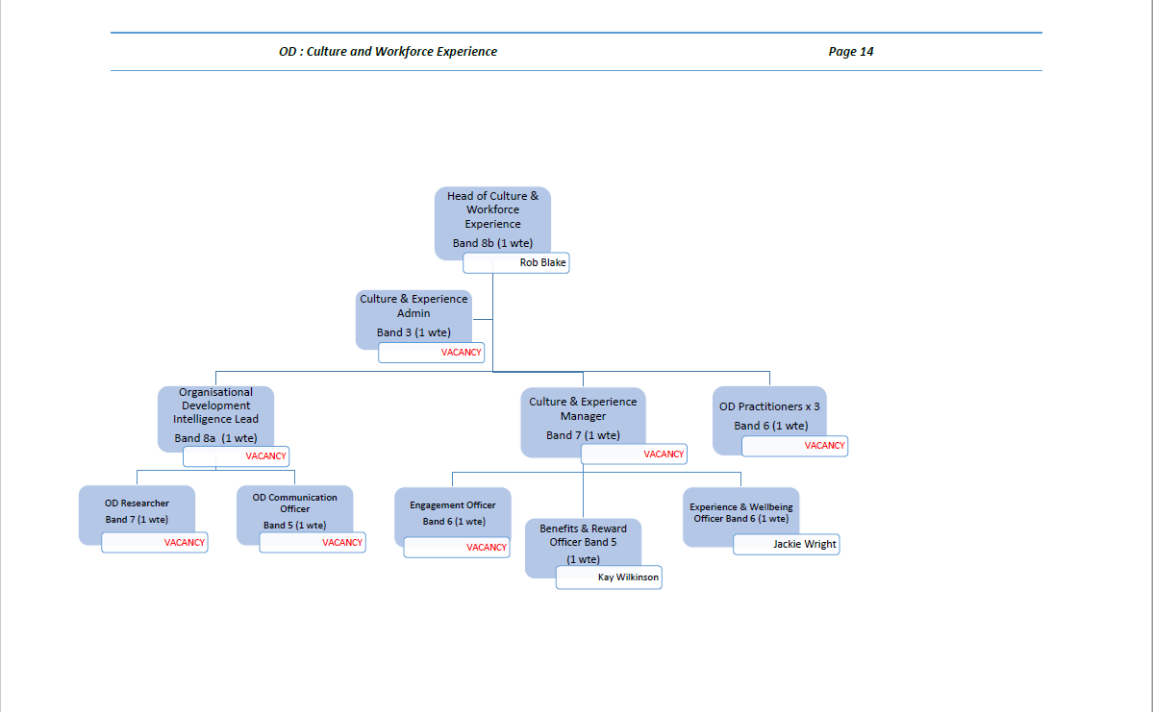

EV2 The department have recently run the ‘Employee Appreciation Competition’ as shown below; which was promoted via the Workforce teams’ channel
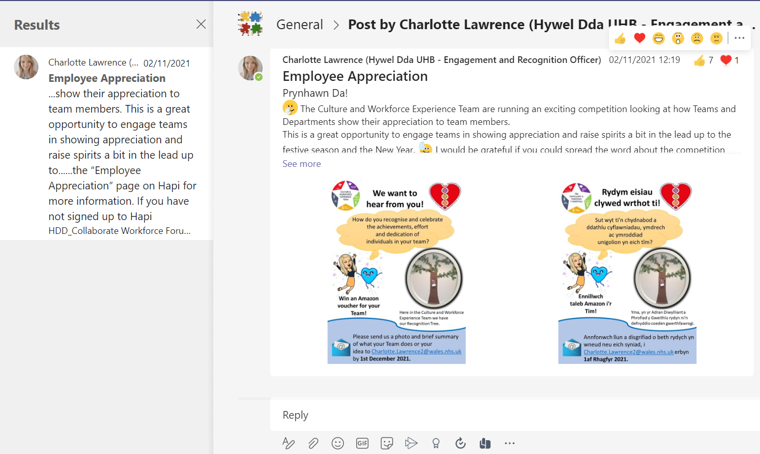
EV3 Employee/Team of the Month
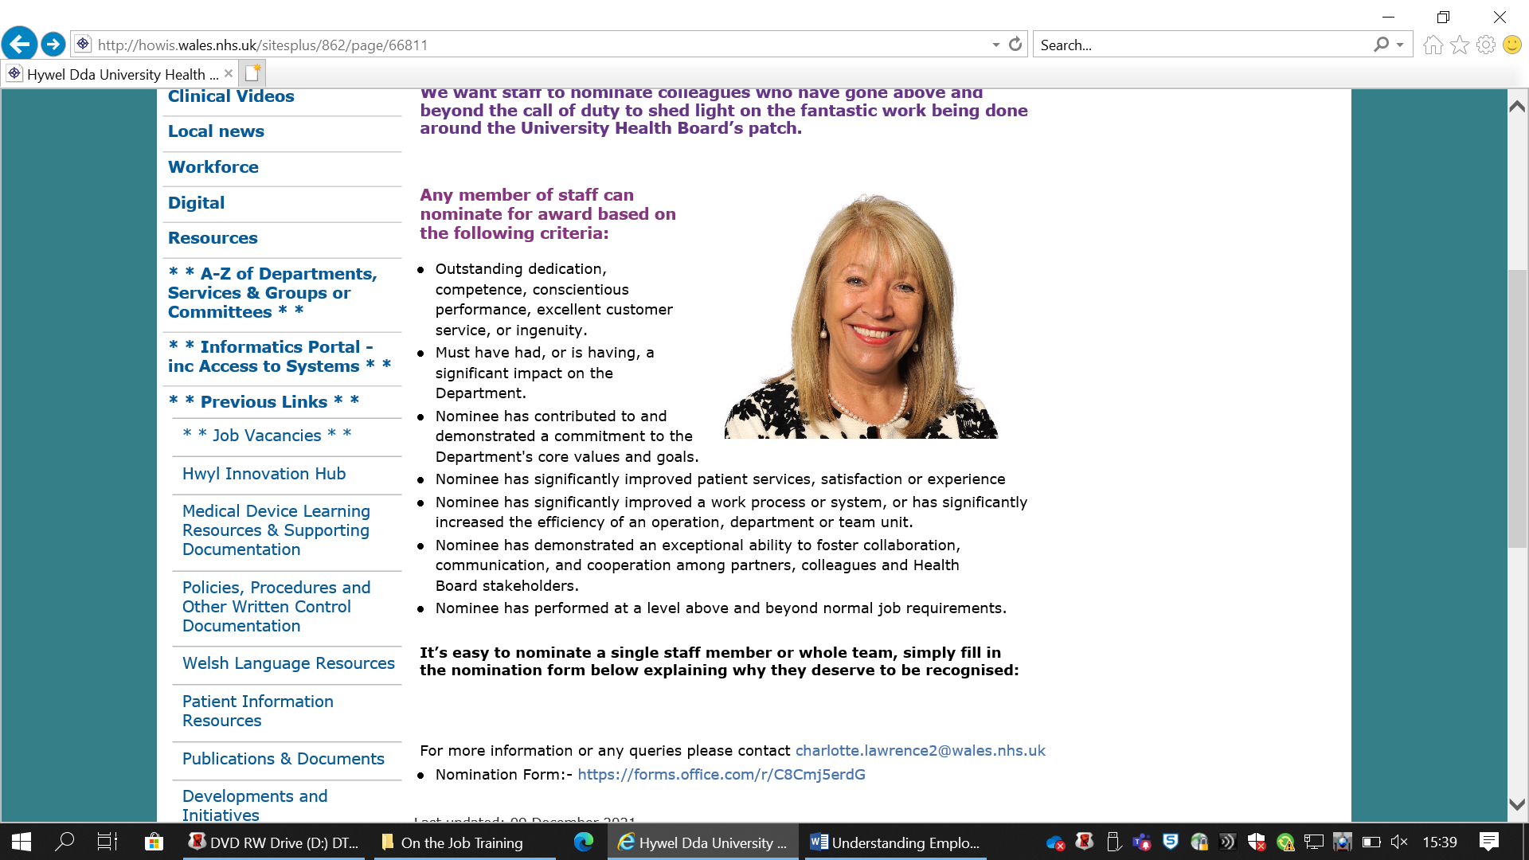
EV4 Hapi’ App for staff benefits
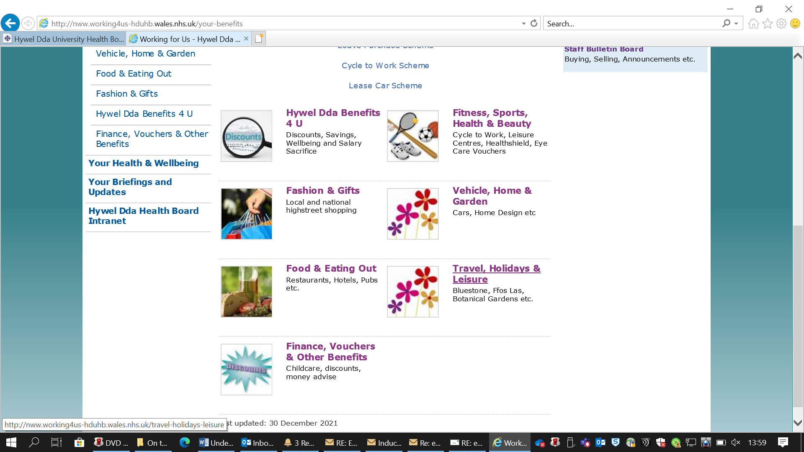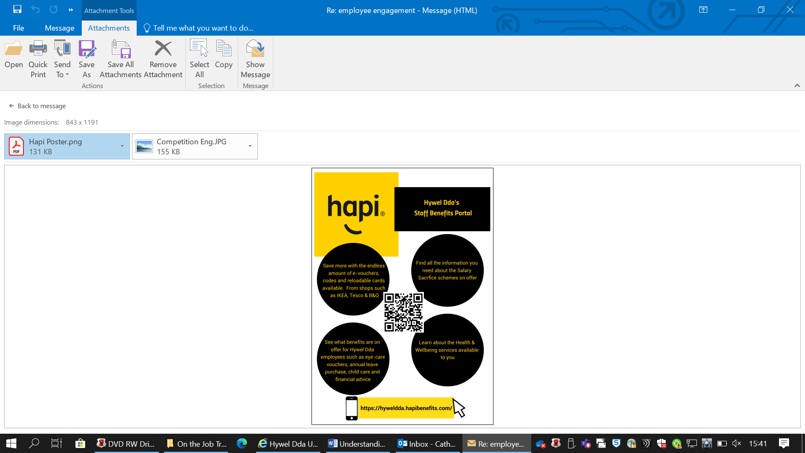

EV5 Details within the Workforce Collaborate teams from the Consultant Psychologist by Oliver Burkeman
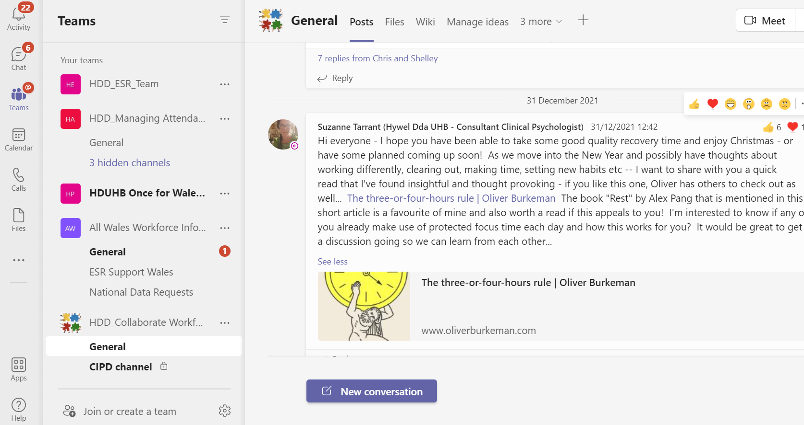
EV6 The Staff Psychological Wellbeing Service has its own intranet page
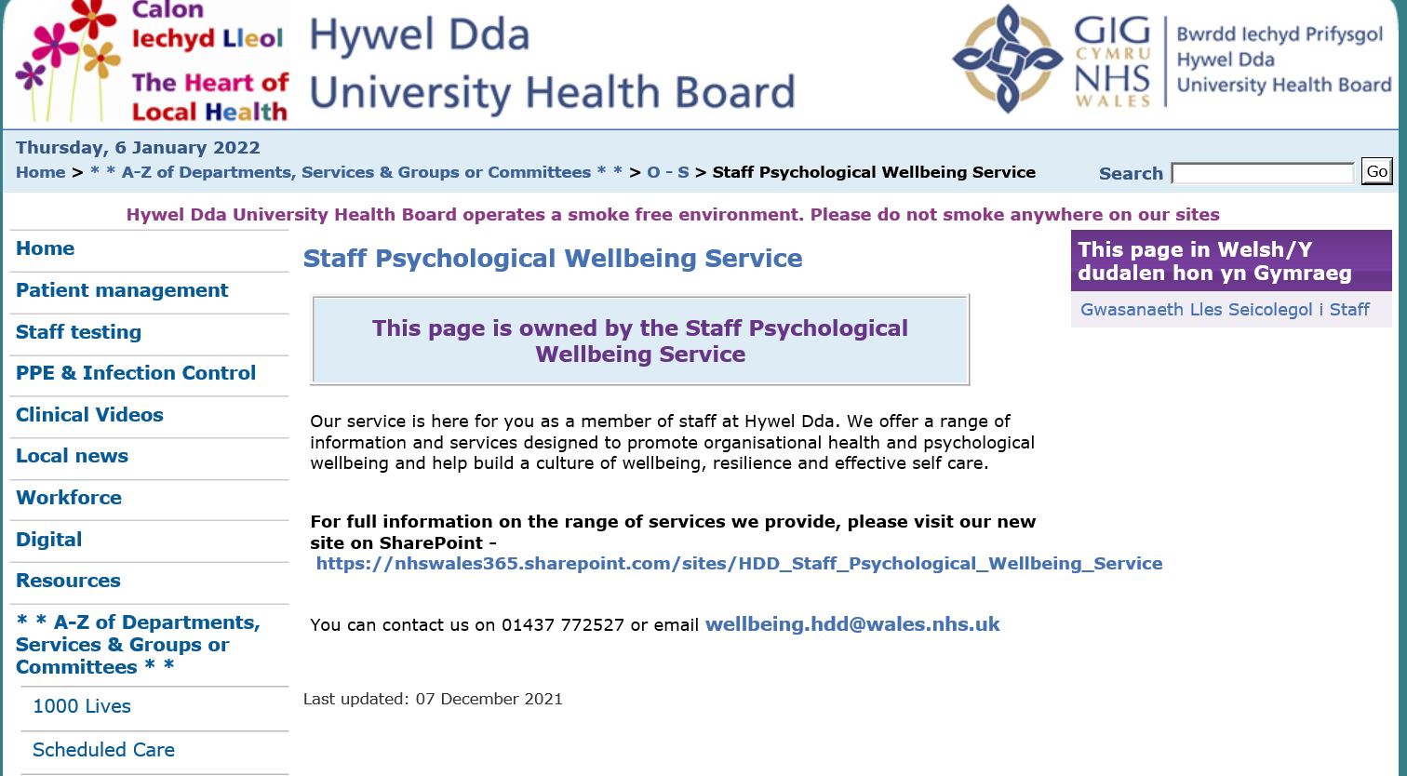

EV7 ‘Celebrating Success’ intranet page EV8 Team Brief
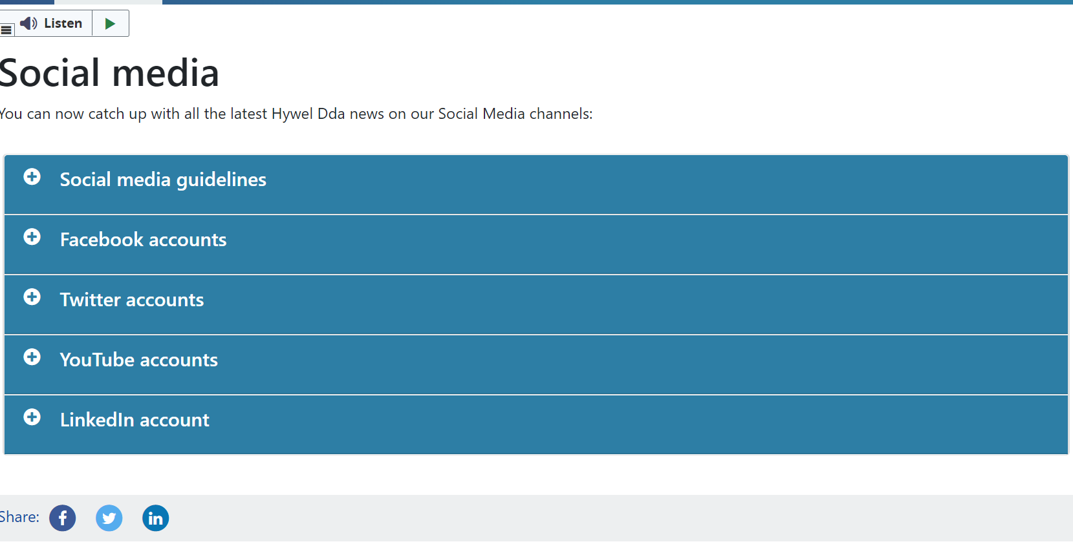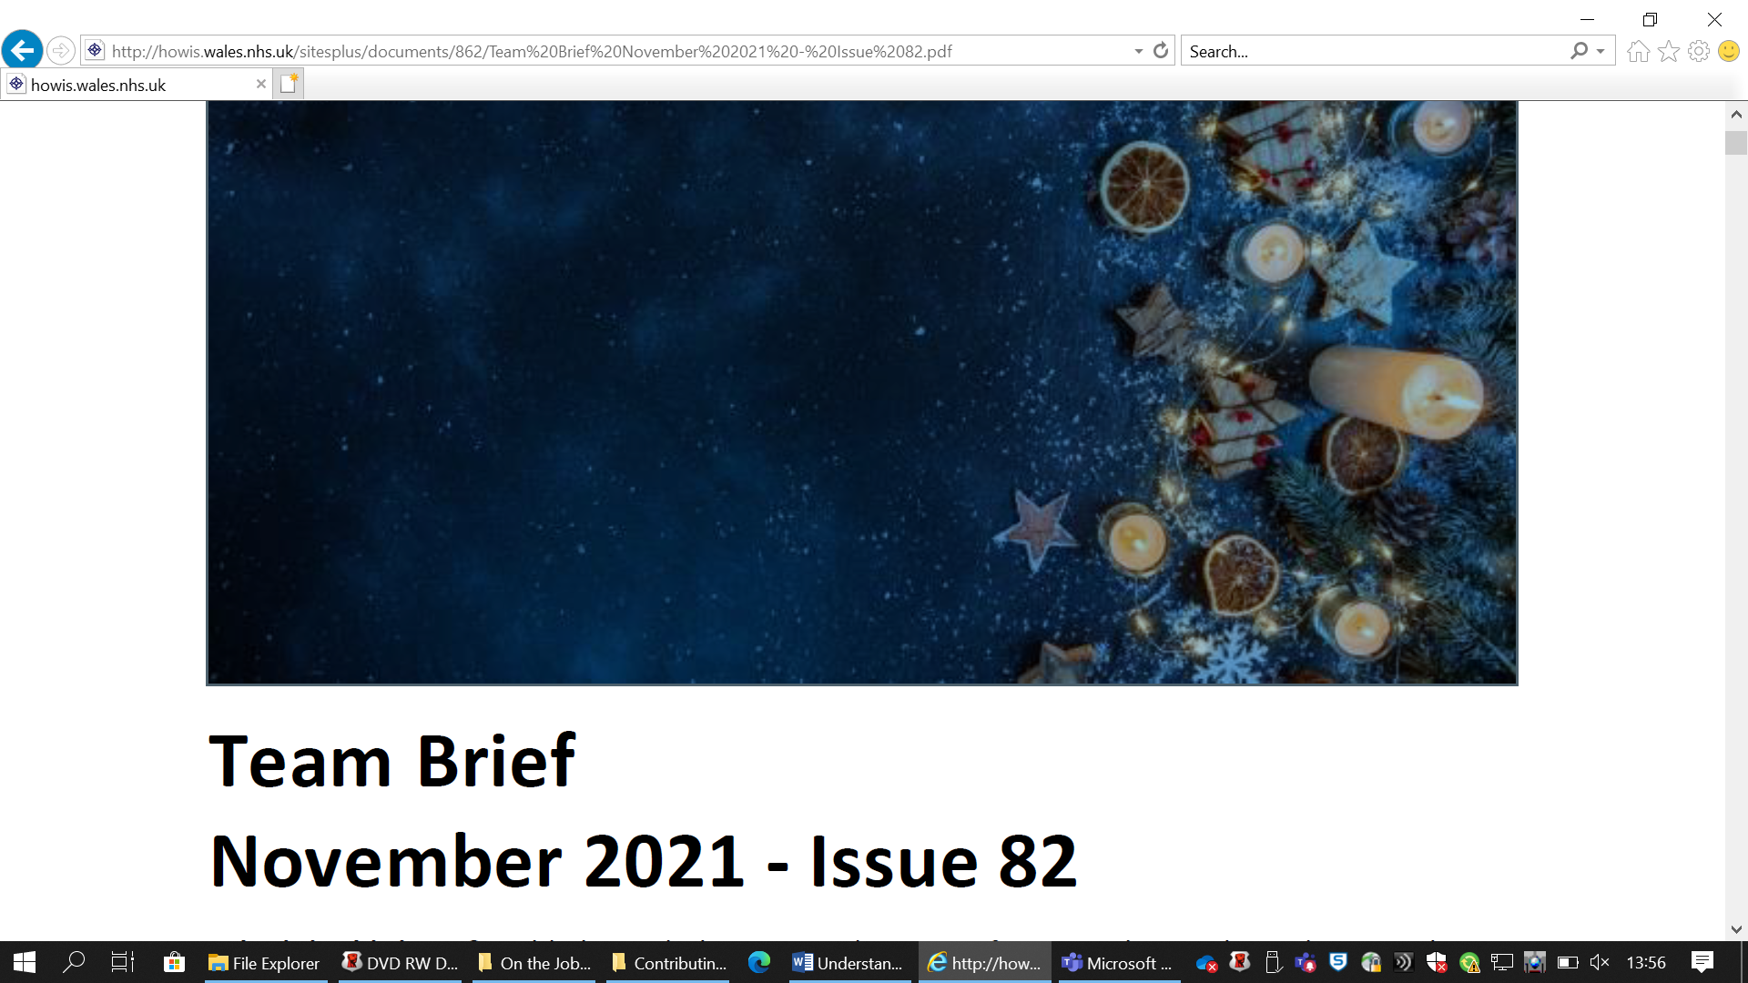
EV9 Hywel’s Voice
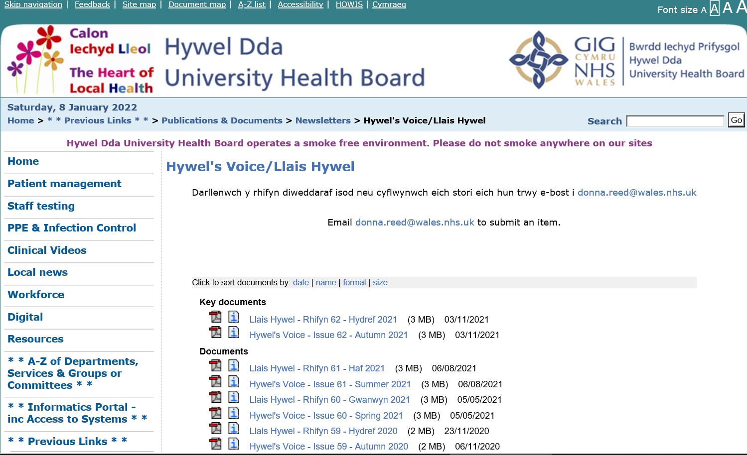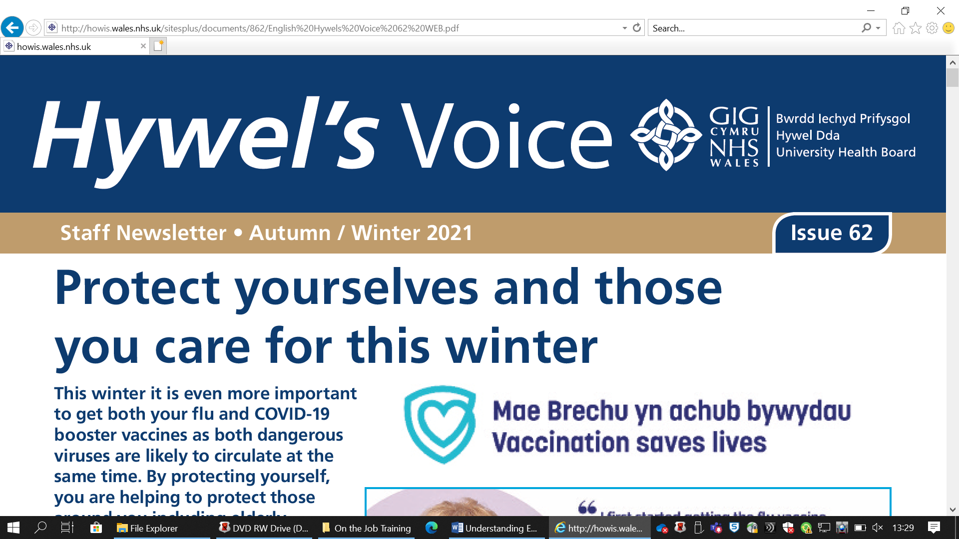

EV10 Culture department promoting a webinar caring for people with hearing loss or carers with hearing loss themselves
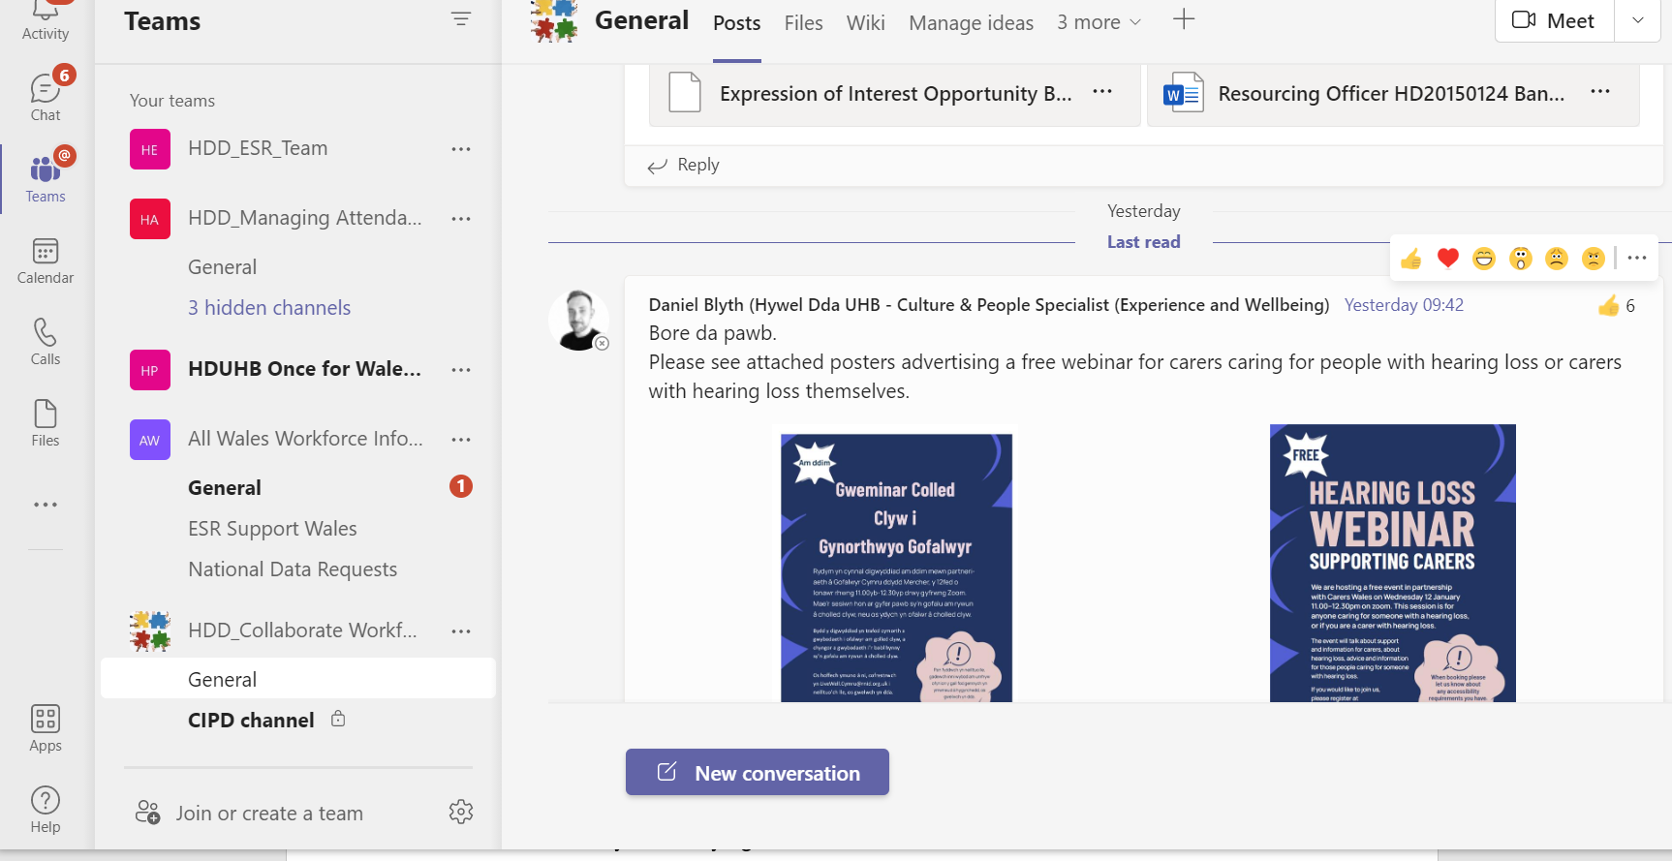
EV11 Digital Champions Network
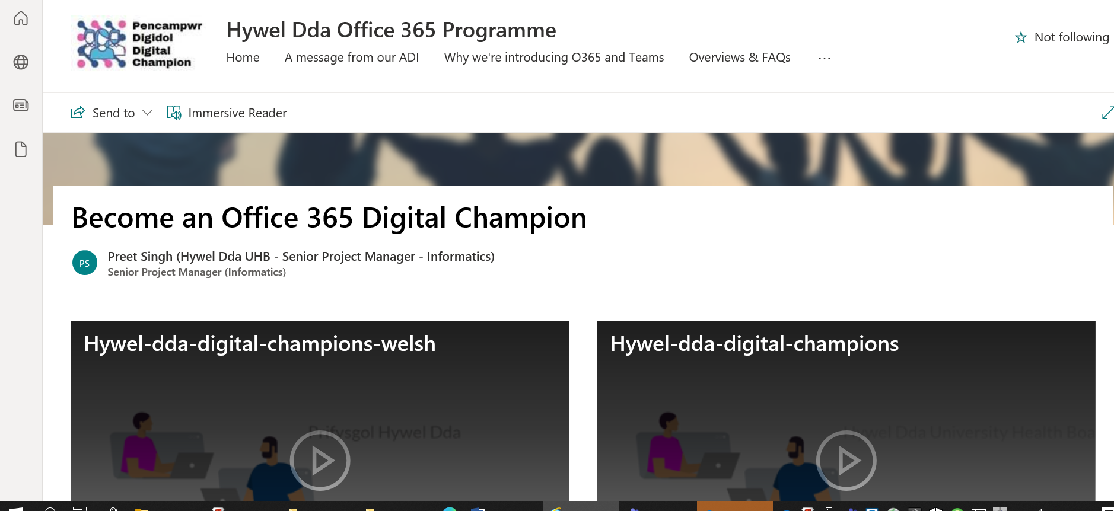
EV12 Well-Being Champions Network
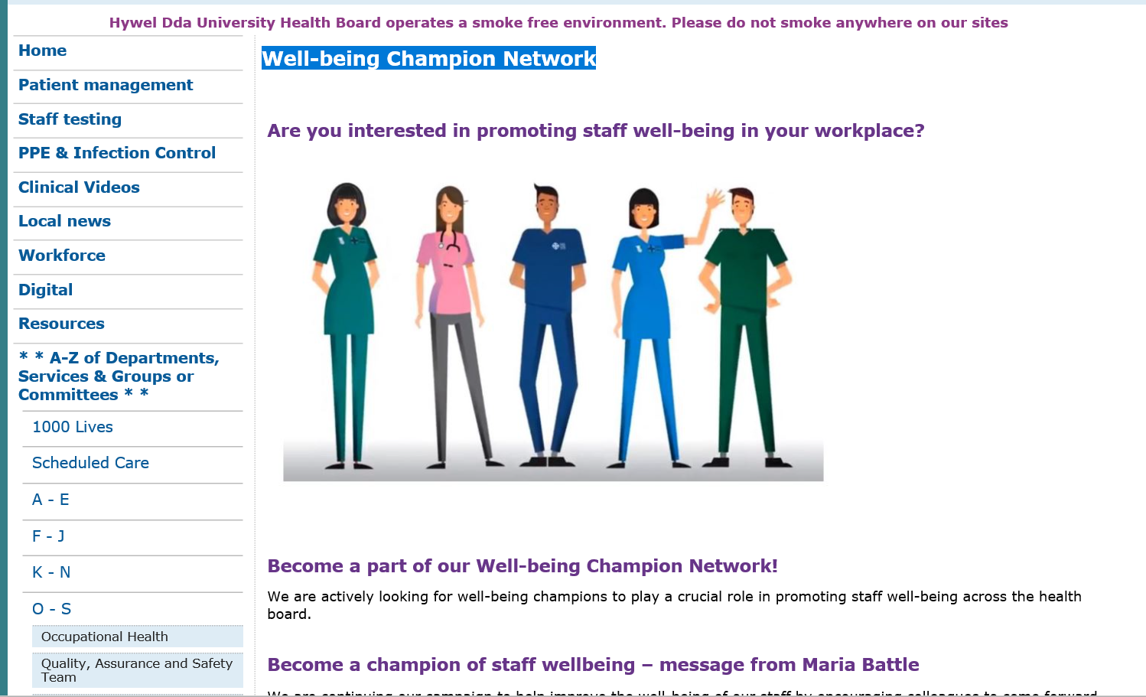
EV13 Global Menopause Café
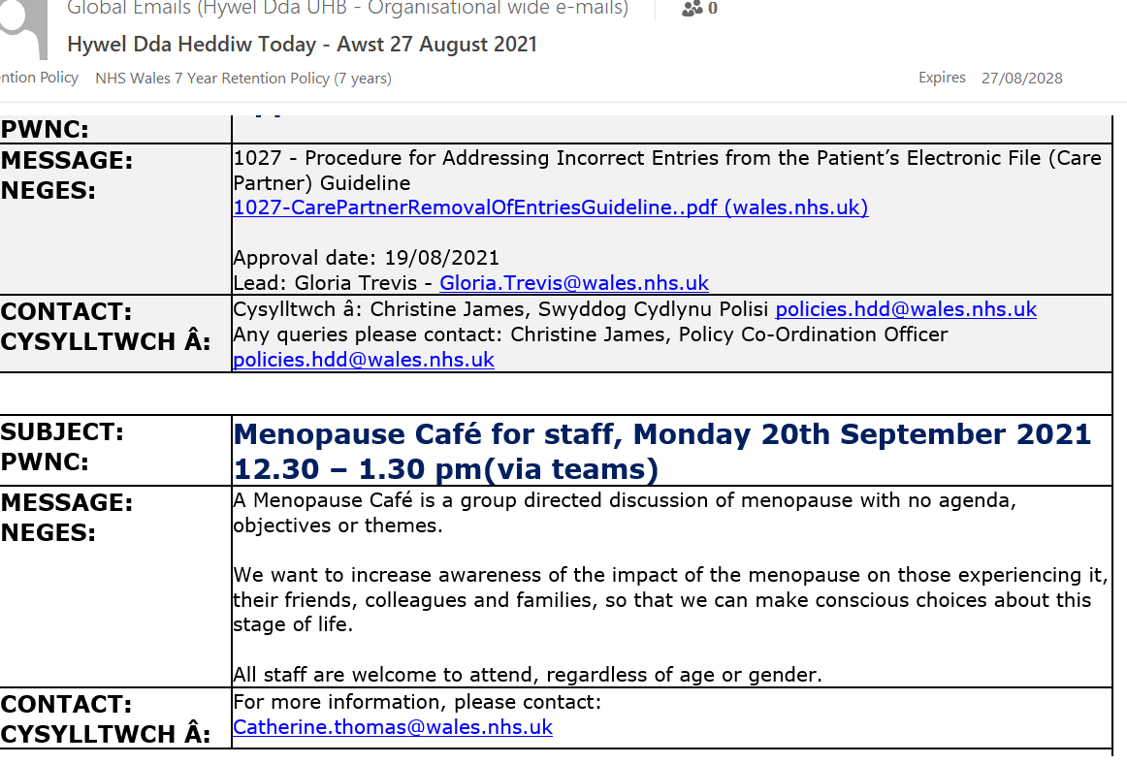

EV14 The Induction pack guidance
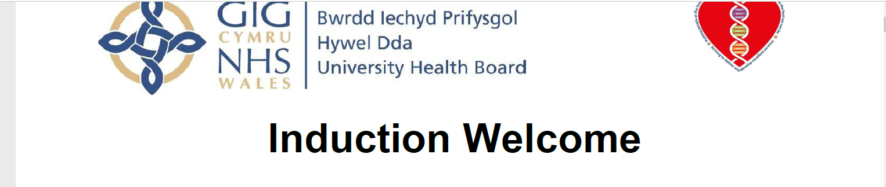
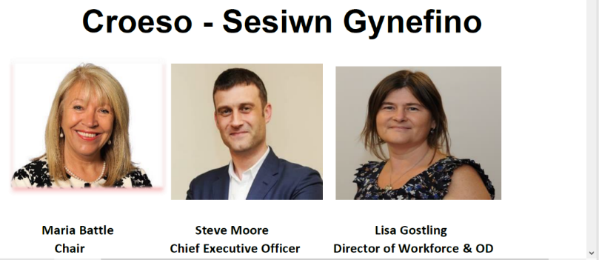

All you need to know from your Induction Pack

Your induction pack is designed as guidance to help you to familiarise yourself with the University Health Board, the services we provide, some key information and support that is available to you as an employee.

Overarching principles The following principles apply throughout the whole of your induction journey: - Clear and accessible information Hywel Dda will ensure that the information we provide at all stages is clear and accessible. Where technical terminology is unavoidable, a clear explanation will be provided.

Staff development All staff will have access to appropriate training and development opportunities, which support them in recognising and addressing the needs of an internationally diverse community.

An inclusive environment Hywel Dda will provide an inclusive environment where your needs are considered and in an integrated and embedded way.

Dear Colleague

I am delighted to welcome you to Hywel Dda University Health Board.
This Induction Handbook is designed to make your first months with us easier by providing you with essential information about the organisation. It contains a great deal of information designed to introduce you to the people, the environment, the systems and procedures.

When you start your new job, you will be asked to attend a Corporate Induction Programme. This programme is designed to complement your Departmental Induction and introduce you on a more global basis to the wider aspects of the Health Board.

The Corporate Induction aims to achieve the following objectives:

• To welcome you to the Health Board and to help you become familiar with new ideals, values and culture.

• To ensure staff have an awareness of Health Board objectives with a clear understanding of the expectations the Health Board has of them and what it will offer in return, in terms and conditions of employment and opportunity.

• To ensure staff understand issues around patients’ rights within legislative frameworks.

• To enable staff to meet the health and safety requirements of their role.

Congratulations on your new appointment. We look forward to welcoming you to #TeamHywelDda.

Steve Moore CHIEF EXECUTIVE
EV15 Below is the logo for HDUHB relating to Organisation Values as stated above and also the nine Personal Values
EV16 Framework for Values
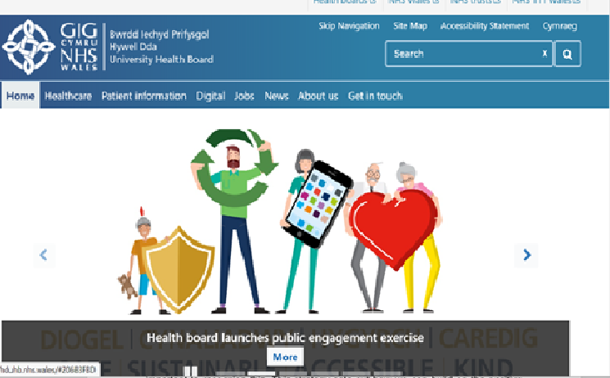

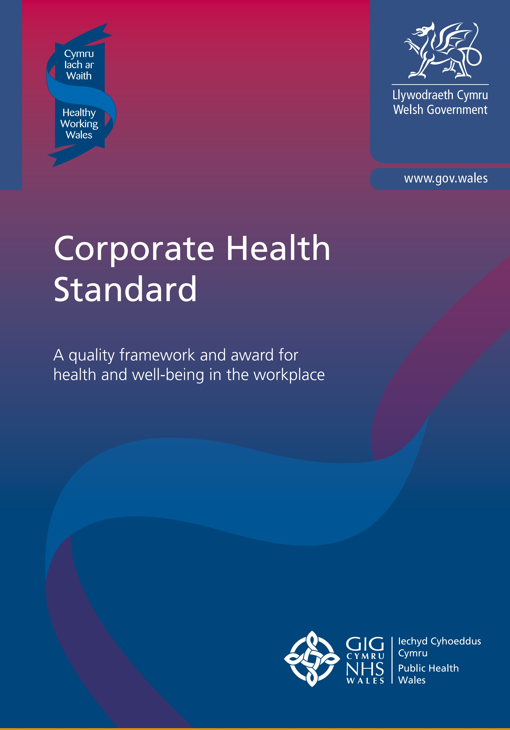
EV17 Corporate Health Standard Criteria Pack below
We found the structure of this accreditation
gave us focus on how to achieve a holistic and
embedded approach to helping our staff make
better life choices.
Ipsen.
The Corporate Health Standard has proved to be a
truly invaluable tool in helping us understand the
multiple determinants of health and, to develop
a comprehensive approach to improving health
and well-being which acknowledges the combined
influence of personal, physical-environmental and
organizational factors.
Heath, Safety and Sustainable Development Manager, Bridgend
College.
The Corporate Health Standard provided an
invaluable framework on which we were able to
build our health and well-being provision at the
University. The assessment process culminated in
a report and an award which provided external
validation of our health and well-being standard
and valuable independent verification of our
health and well-being provision.
Safety and Health Practitioner, Cardiff Metropolitan University.
Being part of the CHS has brought our staff team
together in ways that have had a huge benefit to
our well being and productivity. Instead of only
meeting across desks we now meet to walk, sing,
and learn Tai Chi as regular activities at work as
well as some one-off events such as a cycle ride or
health check. We have enjoyed finding out about
each other in these informal settings and it has
impacted on the culture of the organisation. We
are a more cohesive and healthy team as a result.
Operational Manager, Cardiff YMCA Housing Association.
The Corporate Health Standard Diagram
4
Introduction
5
Organisational Support
7
Senior level commitment
7
Employee engagement
8
Managing for health and safety
9
Health, work and well-being
10
Monitoring, evaluation and review
12
Specific Health Issues
13
Tobacco
13
Mental health and well-being
16
Musculoskeletal disorders
20
Alcohol, drugs and other substance use
23
Food, health and well-being
26

Platinum Standard |  | 34
Introduction 35
Sustainable Development 35
Corporate Social Responsibility 36
Evidencing the Platinum Standard 36
Transport 37
Procurement 37
Facilities management 37
Capital build 38
Employment and skills 38
Community engagement 38





Platinum
Gold
Silver
Bronze
The Corporate Health Standard
SUBJECT:  PWNC: | Covid-19 – Your Mental Health and Well-being
MESSAGE:  NEGES: | The coronavirus outbreak (COVID-19) has affected us all in different ways. One thing that we have seen all over the world is that kindness is prevailing in uncertain times. The added benefit of helping others is that it is good for our own mental health and wellbeing. It can help reduce stress and improve your emotional wellbeing. In short, ‘doing good does you good’.  The Mental Health Foundation have produced some tips to help you bring kindness into your day and help others who may be struggling.  Random Acts of Kindness During Coronavirus Outbreak  There are further resources available to you on the COVID-19 Mental Health & Psychological Wellbeing section on the intranet: http://howis.wales.nhs.uk/sitesplus/862/page/78167
CONTACT:  CYSYLLTWCH Â: | Jackie Wright  Rheolwr Cefnogi Prosiect / OD Project Support Manager  Bwrdd Iechyd Hywel Dda / Hywel Dda Health Board  Canolfan Derwen / Hafan Derwen  Rhif ffon / Tel: 01267 239701 Ext: 4701  Ffacs / Fax: 01267 239860  E-bost / E-mail: jackie.wright@wales.nhs.uk
SUBJECT:  PWNC: | Covid-19 – Your Mental Health and Well-being
MESSAGE:  NEGES: | The coronavirus outbreak (COVID-19) has affected us all in different ways. One thing that we have seen all over the world is that kindness is prevailing in uncertain times. The added benefit of helping others is that it is good for our own mental health and wellbeing. It can help reduce stress and improve your emotional wellbeing. In short, ‘doing good does you good’.  The Mental Health Foundation have produced some tips to help you bring kindness into your day and help others who may be struggling.  Random Acts of Kindness During Coronavirus Outbreak  There are further resources available to you on the COVID-19 Mental Health & Psychological Wellbeing section on the intranet: http://howis.wales.nhs.uk/sitesplus/862/page/78167
CONTACT:  CYSYLLTWCH Â: | Jackie Wright  Rheolwr Cefnogi Prosiect / OD Project Support Manager  Bwrdd Iechyd Hywel Dda / Hywel Dda Health Board  Canolfan Derwen / Hafan Derwen  Rhif ffon / Tel: 01267 239701 Ext: 4701  Ffacs / Fax: 01267 239860  E-bost / E-mail: jackie.wright@wales.nhs.uk
EV18 Mental Health and Wellbeing Globals

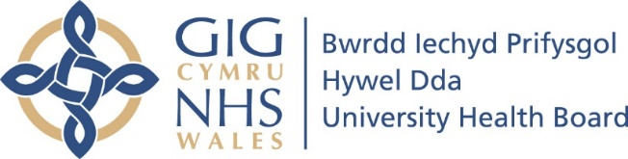
EV19 Workforce, Organisational Development & Education Strategy 2020-2030
Workforce, Organisational Development &
Education Strategy
2020 – 2030

Workforce, Organisational Development & Education

Strategy 2020 - 2030

Contents
- Introduction and Context

- Purpose of the Workforce, OD and Education Strategy

- Changing Our Culture

- The Workforce, OD and Education Strategic Intentions
  - Delivering Collective and Compassionate Leadership
  - Recruiting and Retaining Great People
  - Engaging Our Staff
  - Delivering a Workforce Fit for Our Future
  - Enabling Our People to Release Their Potential
  - Developing High Performing Teams
  - Delivering Innovation, System Learning and Change Agility
  - Delivering workforce efficiency and effectiveness

- Introduction & Context

The Workforce, Organisational Development & Education Strategy will help and support the delivery of the Health Board’s Health & Care Strategy, “A Healthier Mid & West Wales”.
Our staff are our greatest asset. Without them we could not deliver our diverse range of services at local, regional and national levels. Without them, we cannot design and deliver future services which will provide excellence in patient care and meet user, carer and public expectations. We value our current workforce and their recruitment, retention, education and development are key factors to our success. This, coupled with levels of engagement, job satisfaction and motivation in working for the Health Board are crucial. One of the biggest challenges facing us is the uncertainty of what health needs will look like, whilst also dealing with workforce challenges we face today including an ageing workforce, increasing competition for skilled staff and the right of some staff to retire at 55. Within that context, this strategy aims to set out the future vision for the workforce within Hywel Dda University Health Board for a ten year period along with the key themes of work to achieve over the next three years.

Our Directorate Structure needs to be able to ensure that we can deliver the ambition set out in this 10 year strategy

We need to be prepared to reshape ourselves to support the Health Board in addressing its workforce challenges head on. We have many strengths within our team on which we can continue to build and can describe many examples of good practice to truly become a service of excellence and high quality with our users at the heart. We must continue to work as smartly as possible to make the best of our resources.

A revised organisational structure will be implemented during the first year of the Strategy. The revised structure will be the first enabler for the delivery of the Strategy.

Supporting the continuous professional development of our own Workforce & OD team using the CIPD Profession Map, which sets the international benchmark for the people profession, will be a key responsibility of the senior leadership team. Our team need to ensure that they continue to develop their own knowledge, skills and experience aligned to Workforce & OD best practice.

It is a vision where our staff are recruited, developed, supported and valued to deliver excellence in patient care as we progressively move to become an employer of choice. It is a vision where the future workforce has pride in Hywel Dda UHB and all that we do. Whilst this plan sets out our vision and key workforce issues, its successful delivery will primarily rest with the hundreds of line managers and supervisors who lead, manage and support our workforce on a daily basis. We have a lot to celebrate. We have a talented and dedicated workforce; staff who are passionate about what they do and the many thousands of service users/patients they care for. We will strengthen our voice in the context of regional and national work and raise the profile of our excellent work throughout Wales, ultimately helping with recruitment and retention of the workforce.

The context for our work has changed: Brexit, Regional Partnership Boards, the Carter review and the recently consulted ‘A Healthier Wales’. All shape our current thinking.

In particular, the NHS Health & Care Strategy sets out a vision for the future of healthcare in Wales. It was developed to create a collective view of how the health service needs to change over the next ten years if it is to close the widening gaps in the health of the population, quality of care and the funding of services. The future workforce is described as a being a workforce which is flexible and fully equipped with the appropriate skills, knowledge and resources to deliver highly effective evidence based treatments across both community and inpatient services. Collective, collaborative and compassionate leadership are at the heart of what we do and how we will work.

In this future state, the Health Board will take a strategic approach to Talent Management where talent is identified and individuals are developed, engaged and retained within the organisation. All staff show high levels of engagement and are committed to the Health Board and its values and feel a sense of job satisfaction. They are involved in decision making and have the freedom to voice ideas and opportunities to develop their services. Our staff will be empowered to maintain their own wellbeing while continuously improving the way in which care is delivered ensuring best quality outcomes for those using our services.

This plan will focus on building a connected and people focused organisational culture based on shared understanding, strong links to our organisational values of working together to be the best we can be –Striving to deliver and develop excellent services - and putting people at the heart of everything we do. Whilst recognising that hierarchies and systems are important, engaging staff around shared purpose and values will result in increased commitment, morale and a positive attitude to change. There is a wealth of evidence to demonstrate that successful organisations build strong engaged staff and as a result productivity, service user satisfaction rates and employee health and wellbeing are all impacted positively. Much work has already been done and is ongoing to develop the organisation and it is important to recognise this. This strategy sets out how we can build on the positive steps already taken to build a new and different culture, beneficial for staff and service users.

To successfully meet future challenges, our workforce will need to be flexible; they will need to be ready to meet any change which arises from implementing the Health & Care strategy, work across health and social care, with independent or private sector providers, be flexible in the provision of care at differing points of the patient pathway, provide care and treatment for both physical and mental health care, support those with a learning disability to receive care and treatment in mainstream pathways, provide care in different locations and use new technological developments.

The future workforce will provide informal support to help people prevent ill health and manage their own care when appropriate. They will have the skills, values and behaviours required to work with service users, their family and other agencies in the spirit of co-operation. They will need to be adaptable, innovative and able to provide ‘whole person’ care. To do this we need to continue to stretch/push traditional professional roles/boundaries and be courageous in shifting funding from one professional group to another.

Our workforce needs to be ready to respond to further advancements in health and social care science and technology. The future workforce supply will be a challenge and hence the development of new ways of working and innovative roles will be key to a number of our professional groups. We will continue to strengthen our commitment to create local employment opportunities for local people including those who face obstacles in entering or returning to the world of work. We will create innovative pathways to support individuals into professional careers. In the months and years ahead we will need to contend with and plan for:

The development of changing models of care and the impact these will have upon service delivery;
- Transformation both regionally and nationally;
- Increasing mental health prevalence;
- A shift in emphasis towards delivery of care closer to home i.e. in the community;
- A lack of supply and shortages of a number of registered professionals;
- Changes in the way health education is delivered;
- Changes to the way in which services are commissioned;
- The as yet unknown implications of Brexit on the economy and subsequent impact to the NHS;
- Increased financial and efficiency monitoring and optimisation of value and outcomes.

Purpose of the Workforce, OD and Education Strategy

The Strategy’s purpose can be distilled into the following key objectives:-

- To support the delivery of the Health Board’s strategic vision, purpose and objectives and continually improve the services delivered to our service users;
- To create a culture where everyone is united around a shared vision and high levels of staff engagement are the norm;
- Health Board values and behaviours live in everything we do and every change we plan;
- To build capacity for innovation, learning and change;
- To maximise the performance and wellbeing of individuals, teams and the whole organisation, aligning capacity and skills with future models of care;
- To develop the reputation of the Health Board both as a place where service users want to receive healthcare and where people want to come and work, to be an employer of choice;
- The plan applies to all Health Board staff and provides a clear framework of aspirations for the Health Board’s workforce;
- The three year plan developed to deliver this Strategy will be reviewed, refreshed and rolled forward each year as part of the IMTP process.

- Changing our Culture

The Kings Fund emphasises from their research findings that a key foundation for cultural change is having clear vision, values and behaviours. In 2015/16, a large inclusive engagement exercise was undertaken with our staff across the Health Board and our Values Framework was designed. This framework sets out clearly the 3 organisation values which frame the intention and provides the design principles for all that we do:
- Putting people at the heart of everything we do ;
- Working together to be the best we can be;
- Striving to deliver and develop excellent service.
The framework also sets out our core personal values and behaviours which underpin all that we do and the way that we work together and relate to each other.
In November 2018, the Board approved the Health Boards Clinical Services Strategy “A Healthier Mid & West Wales” outlining our vision to achieve population health over the next 20 years;
http://www.wales.nhs.uk/sitesplus/862/page/98252
and so, our vital foundation stones to achieve cultural change are now in place.
However, cultural change ‘doesn’t just happen’. It especially ‘doesn’t just happen’ when the operational pressures and demands on services are so great, when services are fragile, and when workforce challenges are present. Therefore cultural change, particularly in the Health Board at this time will require specific organisation development expertise to support the change programme and a distributed, collective and compassionate leadership body capable of making that change come to life in all of our sites and services.
The challenges faced by all organisations in delivering change can be categorised into two distinct areas (Edgar Schein 1965):
- Continuous adaptation to a rapidly changing external environment;
- Corresponding internal integration that will support the success of the external adaptation.
This ability to cope with the change was named the “adaptive coping cycle” by Schein and helps us to understand the dynamic between organisational strategy and organisational development.
Organisational development (OD) is there to help the organisation to prepare itself internally to deliver the challenging external ambitions. OD practice is there to improve the way that individuals, teams and the organisation as a whole work together. This can sometimes be in a reactive way to help the ‘adaptive coping cycle’ work itself through. However, OD practice is also about a proactive capacity and capability building approach, enabling individuals, teams, organisations and systems to learn and adapt to make changes, innovations and improvements sustainable for the long term.
The ability to practice OD is a way of doing things that must become part of how individuals and teams ‘do things around here’ across the Health Board geographical area with its partners, public and patients. Workforce and OD is everyone’s responsibility if we are to achieve our vision and it is to be sustained. Our leadership body as a collective, has a critical role to ensure that our 3 corporate values and OD design principles inform everything we do to work together for the greater good of the system as a whole to achieve our vision for population health.
Delivering our Health Board cultural change programme over the next 10 years will require focus, concerted effort, resources, reflection on outcomes and practice, and learning on an ongoing basis, from the Board and at all levels of the organisation.

The Workforce, OD and Education Strategy 2020 – 2030

(2) Recruiting and Retaining Great People
(1) Delivering Collective and Compassionate Leadership
(3) Engaging our Staff

Employer of Choice
(8) Efficiency & Productivity
(4) Delivering a Workforce Fit For our Future

(5) Enabling our people to release their potential
(7) Delivering Innovation, System Learning and Change-Agility
(6) Delivering high performing teams

EV2120 Letter from Welsh Government regarding pay and annual leave arrangements for employees covered by the Agenda for Change, Medical and Dental and Executive and Senior Pay terms and conditions

Grŵp Iechyd a Gwasanaethau Cymdeithasol

Health and Social Services Group

Chief Executives – NHS Health Boards/Trusts/Special Health Authorities
Directors, Workforce & Organisational Development – NHS Health Boards/Trusts Directors of Finance – NHS Health Boards/Trusts

Our Ref: Pay Letter AFC, M&D & ESP (W) 01/2021

December 2021

Dear Colleague

Summary
This pay circular informs employers of the pay and annual leave arrangements for employees covered by the Agenda for Change, Medical and Dental and Executive and Senior Pay terms and conditions.
Action

- To pay a one off non-consolidated additional payment of 1% for those on Agenda for Change bands 1-5, and the F1 doctors who fall into this pay bands. This payment would not be pro rata and other criteria is set out in Annex A

- To amend the bottom spine point for those on Agenda for Change (AfC) band 2 and the pay point for band 1 from April 2021 to £18,731 from the 1st April 2021

- An additional day’s annual leave will be added to the current contractual entitlements for all staff. This additional day will be pro rata and will be recurrent in future years.

If staff are unable to take their additional entitlement in the current leave year 2021/22 then it should either be carried forward over and above any organisational limits into the 2022/23 leave year or sold back if preferred by the staff.

- Employers will put a scheme in place for staff to sell back a proportion of unused annual leave which will be in place before the end of the 2021/22 leave year. Details of arrangements are outlined in Annex B.

Enquiries

1. Employers should direct enquiries to: HSSWorkforceOD@gov.wales 2. Copies of this circular can be downloaded from the HOWIS website.
Yours sincerely,



Helen Arthur
Director of Workforce and Corporate Business
Cyfarwyddwr y Gweithlu a Busnes Corfforaethol Annex A
1% Non-consolidated Payment to Agenda for Change Bands 1 to 5 and F1’s

Eligibility criteria

This is a non-consolidated and non-pensionable payment and does not uprate any hourly rates.
- 1% of eligible pay points as at 1st April 2021, i.e Band 3 step £20,330 is £203 or Band 5 step £27,780 is £277
- Payments will be based on an individual’s full time salary as at 1st December 2021 • To be paid to all eligible staff on payroll as at the 1st December 2021
- Payments to also be made to those who moved from Band 5’s and F1’s between the 1st April and 30th November 2021 who are still on payroll as at 1st December 2021.
- To be paid to all substantive staff only, not including bank, locum, ad hoc
- To include those on a Fix Term Contract regardless of length of contract
- Not to pro rata the payment
- New starters after the 1st December will not receive the payment
- Staff on sick, maternity, parental leave included
- Staff on career breaks not to be included
Annex B

Selling back of Annual leave

Employers will put a scheme in place for staff to sell back a proportion of unused annual leave which will be in place before the end of the 2021/22 leave year.
This will include arrangements to sell back all of their unused annual leave which was carried over from 2020/21 leave year.

For the leave year 2021/22, it is recognised that staff need to ensure they rest and recuperate as their wellbeing is paramount. However it is also reconisged that given the ongoing challenges it may not be possible to take the full leave entitlement during 2021/22. Therefore employers shall put in place arrangements for staff to sell back any remaining entitlement above statutory entitlement, so after 20 days. This will be pro rata for those working part time, and this will be inclusive of the additional day’s leave provided in this leave year.

Given the opportunity to sell back annual leave above statutory entitlement annual leave carryover from 2021/22 into 2022/23 will be capped at 5 days, pro rata for part time staff. If the additional annual leave day is carried over this will be in addition to the allowed 5 days.
The payment for annual leave sold back will be at calculated using an individual’s basic pay rate.

EV20a AfC payscales showing increments for each banding from band 1 to band 12
AfC - Non Review Body Pay Grades with effect from |  |  |  | 01/04/2021
Payscale Name
 | Years of Experience |  | < 1 Year | 1+ Years | 1 - 2 Years
 | Grade Step |  | 1 | 2 | 3
CYM(XR01) Review Body Band 1 | Step Point |  | 50 | 60 | 70
CYM(XN01)Non Review Body Band 1 | Salary |  | 18,576 | 18,576 | 18,576
 | Years of Experience |  | < 1 Year | 1 - 2 Years | 2 - 3 Years | 3 - 4 Years | 3 - 4 Years | 4 - 5 Years | 5 - 6 Years | 6+ Years
 | Grade Step |  | 1 | 2 | 3 | 4 | 5 | 6 | 7 | 8
CYM(XR02) Review Body Band 2 | Step Point |  | 50 | 60 | 72 | 80 | 100 | 110 | 130 | 140
CYM(XN02) Non Review Body Band 2 | Salary |  | 18,576 | 18,576 | 19,918 | 19,918 | 19,918 | 19,918 | 19,918 | 19,918
 | Years of Experience |  | < 1 Year | 1 - 2 Years | 2 - 3 Years | 3 - 4 Years | 4 - 5 Years | 5 - 6 Years | 6+ Years
 | Grade Step |  | 1 | 2 | 3 | 4 | 5 | 6 | 7
CYM(XR03) Review Body Band 3 | Step Point |  | 112 | 132 | 142 | 150 | 170 | 180 | 190
CYM(XN03) Non Review Body Band 3 | Salary |  | 20,330 | 20,330 | 21,777 | 21,777 | 21,777 | 21,777 | 21,777
 | Years of Experience |  | < 1 Year | 1 - 2 Years | 2 - 3 Years | 3 - 4 Years | 4 - 5 Years | 5 - 6 Years | 6+ Years
 | Grade Step |  | 1 | 2 | 3 | 4 | 5 | 6 | 7
CYM(XR04) Review Body Band 4 | Step Point |  | 182 | 192 | 200 | 220 | 230 | 240 | 250
CYM(XN04)Non Review Body Band 4 | Salary |  | 22,549 | 22,549 | 22,549 | 24,882 | 24,882 | 24,882 | 24,882
 | Years of Experience |  | < 1 Year | 1 - 2 Years | 2 - 3 Years | 3 - 4 Years | 4 - 5 Years | 5 - 6 Years | 6 - 7 Years | 7+ Years
 | Grade Step |  | 1 | 2 | 3 | 4 | 5 | 6 | 7 | 8
CYM(XR05) Review Body Band 5 | Step Point |  | 242 | 252 | 270 | 280 | 310 | 320 | 340 | 350
CYM(XN05) Non Review Body Band 5 | Salary |  | 25,655 | 25,655 | 27,780 | 27,780 | 31,534 | 31,534 | 31,534 | 31,534
 | Years of Experience |  | < 1 Year | 1 - 2 Years | 2 - 3 Years | 3 - 4 Years | 4 - 5 Years | 5 - 6 Years | 6 - 7 Years | 7 - 8 Years | 8+ Years
 | Grade Step |  | 1 | 2 | 3 | 4 | 5 | 6 | 7 | 8 | 9
CYM(XR06) Review Body Band 6 | Step Point |  | 322 | 342 | 352 | 360 | 380 | 390 | 400 | 410 | 420
CYM(XN06)Non Review Body Band 6 | Salary |  | 32,306 | 32,306 | 34,172 | 34,172 | 34,172 | 39,027 | 39,027 | 39,027 | 39,027
 | Years of Experience |  | < 1 Year | 1 - 2 Years | 2 - 3 Years | 3 - 4 Years | 4 - 5 Years | 5 - 6 Years | 6 - 7 Years | 7 - 8 Years | 8+ Years
 | Grade Step |  | 1 | 2 | 3 | 4 | 5 | 6 | 7 | 8 | 9
CYM(XR07) Review Body Band 7 | Step Point |  | 392 | 402 | 412 | 422 | 430 | 440 | 450 | 460 | 470
CYM(XN07) Non Review Body Band 7 | Salary |  | 40,057 | 40,057 | 42,121 | 42,121 | 42,121 | 45,839 | 45,839 | 45,839 | 45,839
 | Years of Experience |  | < 1 Year | 1 - 2 Years | 2 - 3 Years | 3 - 4 Years | 4 - 5 Years | 5+ Years
 | Grade Step |  | 1 | 2 | 3 | 4 | 5 | 6
CYM(XR08) Review Body Band 8 Range A | Step Point |  | 462 | 472 | 480 | 490 | 500 | 510
CYM(XN08) Non Review Body Band 8 Range A | Salary |  | 47,126 | 47,126 | 47,126 | 47,126 | 47,126 | 53,219
 | Years of Experience |  | < 1 Year | 1 - 2 Years | 2 - 3 Years | 3 - 4 Years | 4 - 5 Years | 5+ Years
 | Grade Step |  | 1 | 2 | 3 | 4 | 5 | 6
CYM(XR09) Review Body Band 8 Range B | Step Point |  | 502 | 512 | 520 | 530 | 540 | 550
CYM(XN09) Non Review Body Band 8 Range B | Salary |  | 54,764 | 54,764 | 54,764 | 54,764 | 54,764 | 63,862
 | Years of Experience |  | < 1 Year | 1 - 2 Years | 2 - 3 Years | 3 - 4 Years | 4 - 5 Years | 5+ Years
 | Grade Step |  | 1 | 2 | 3 | 4 | 5 | 6
CYM(XR10) Review Body Band 8 Range C | Step Point |  | 542 | 552 | 560 | 570 | 580 | 590
CYM(XN10) Non Review Body Band 8 Range C | Salary |  | 65,664 | 65,664 | 65,664 | 65,664 | 65,664 | 75,874
 | Years of Experience |  | < 1 Year | 1 - 2 Years | 2 - 3 Years | 3 - 4 Years | 4 - 5 Years | 5+ Years
 | Grade Step |  | 1 | 2 | 3 | 4 | 5 | 6
CYM(XR11) Review Body Band 8 Range D | Step Point |  | 582 | 592 | 600 | 610 | 620 | 630
CYM(XN11) Non Review Body Band 8 Range D | Salary |  | 78,192 | 78,192 | 78,192 | 78,192 | 78,192 | 90,387
 | Years of Experience |  | < 1 Year | 1 - 2 Years | 2 - 3 Years | 3 - 4 Years | 4 - 5 Years | 5+ Years
 | Grade Step |  | 1 | 2 | 3 | 4 | 5 | 6
CYM(XR12) Review Body Band 9 | Step Point |  | 622 | 632 | 640 | 650 | 660 | 670
CYM(XN12) Non Review Body Band 9 | Salary |  | 93,735 | 93,735 | 93,735 | 93,735 | 93,735 | 108,075
NB: ESR provides two set of grades for each AfC Pay Band due to historical reasons.

EV20b Details of from the Electronic Staff Record which shows pension details
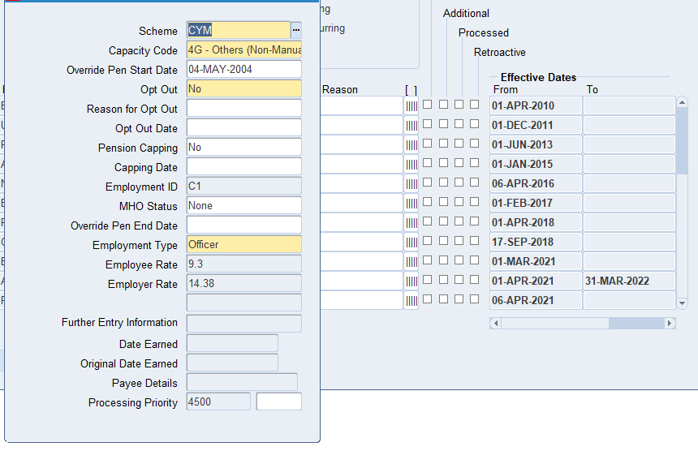

EV21 Organisational Development Dashboard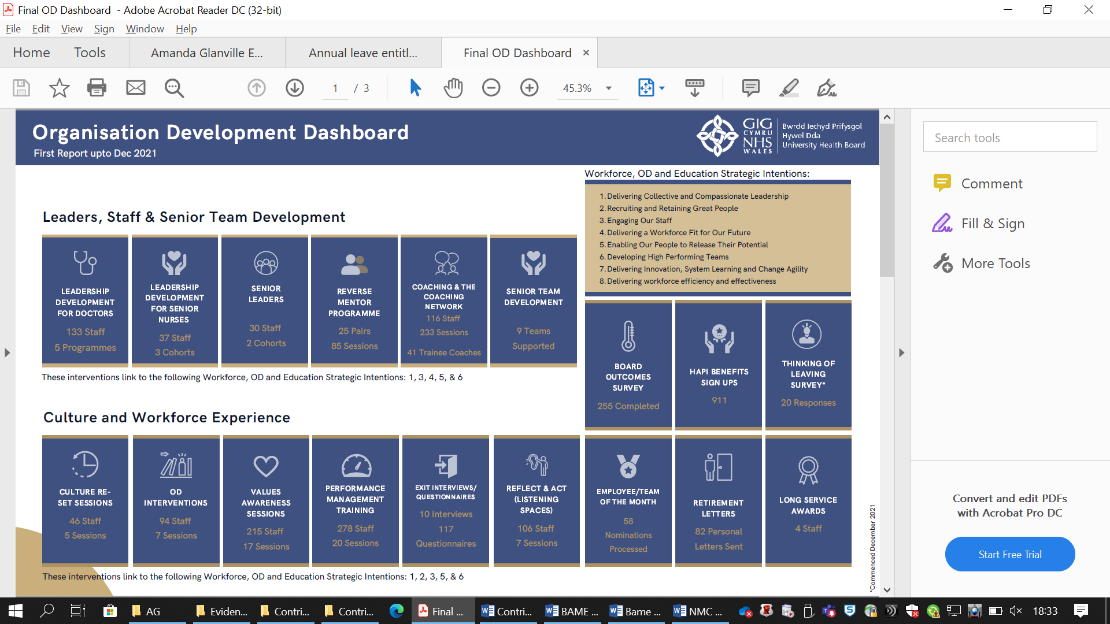 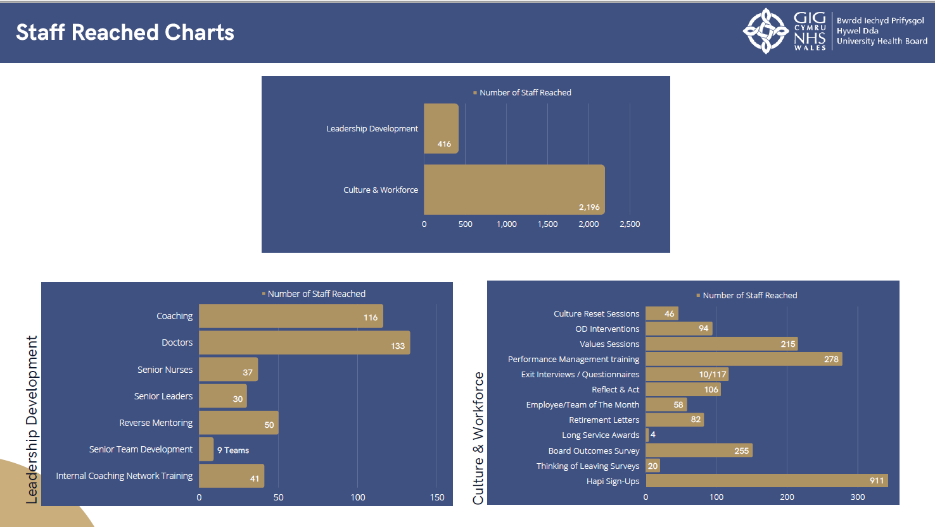
EV22 Workforce Profile
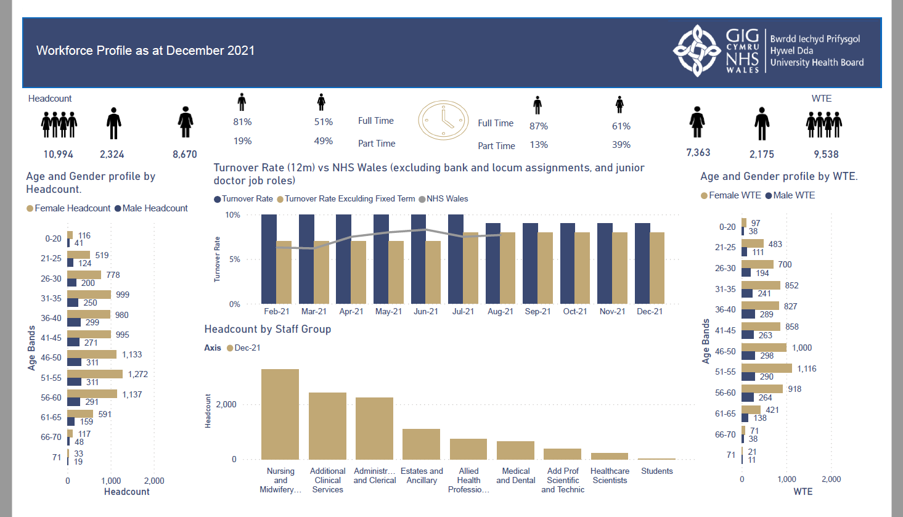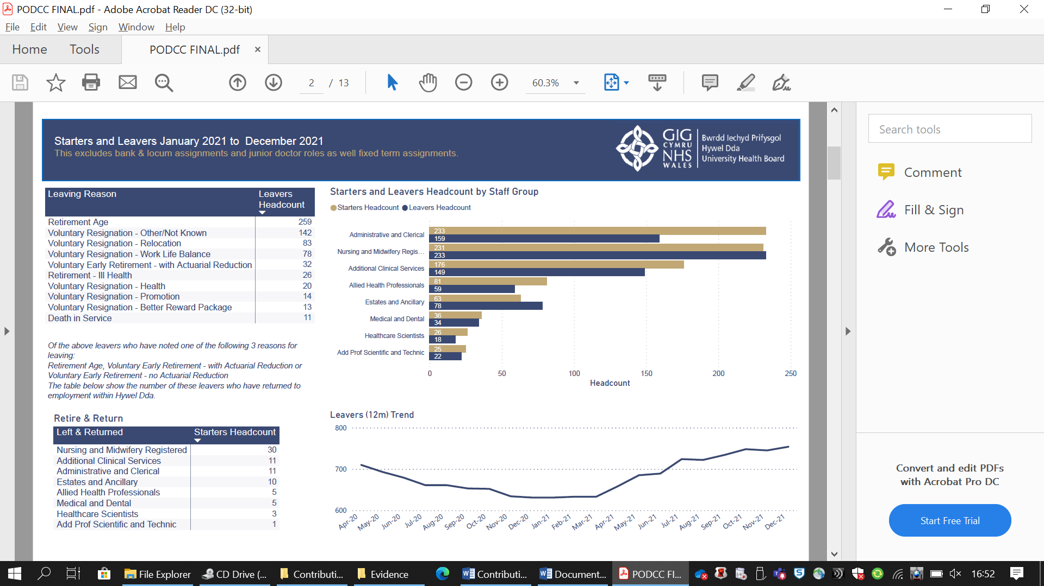

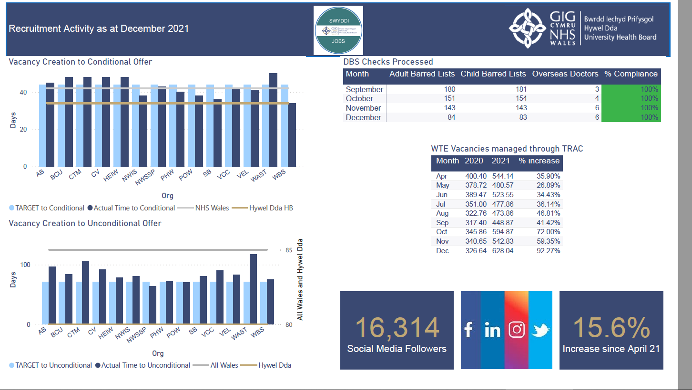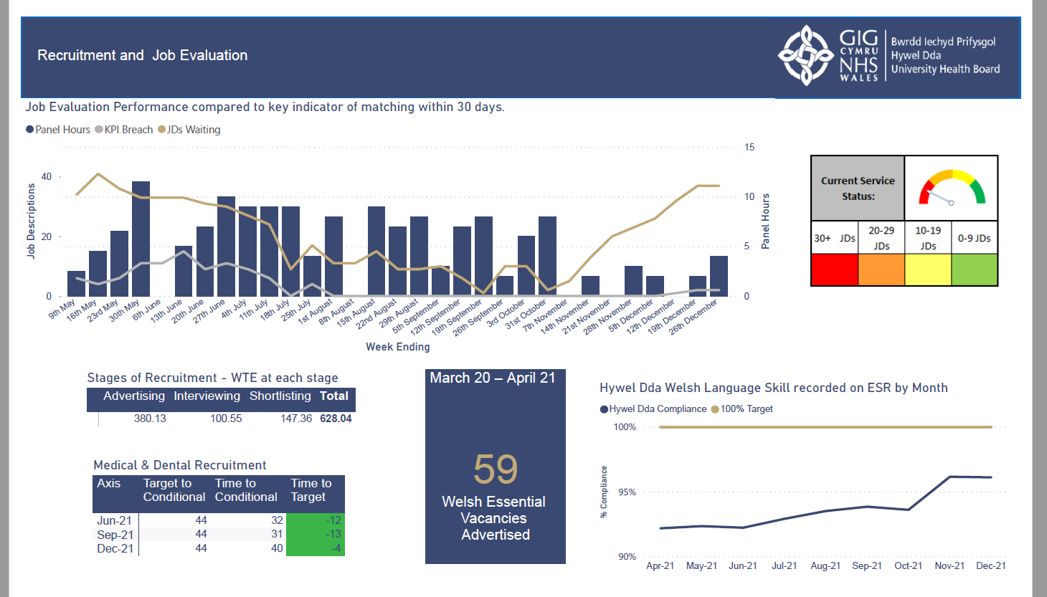
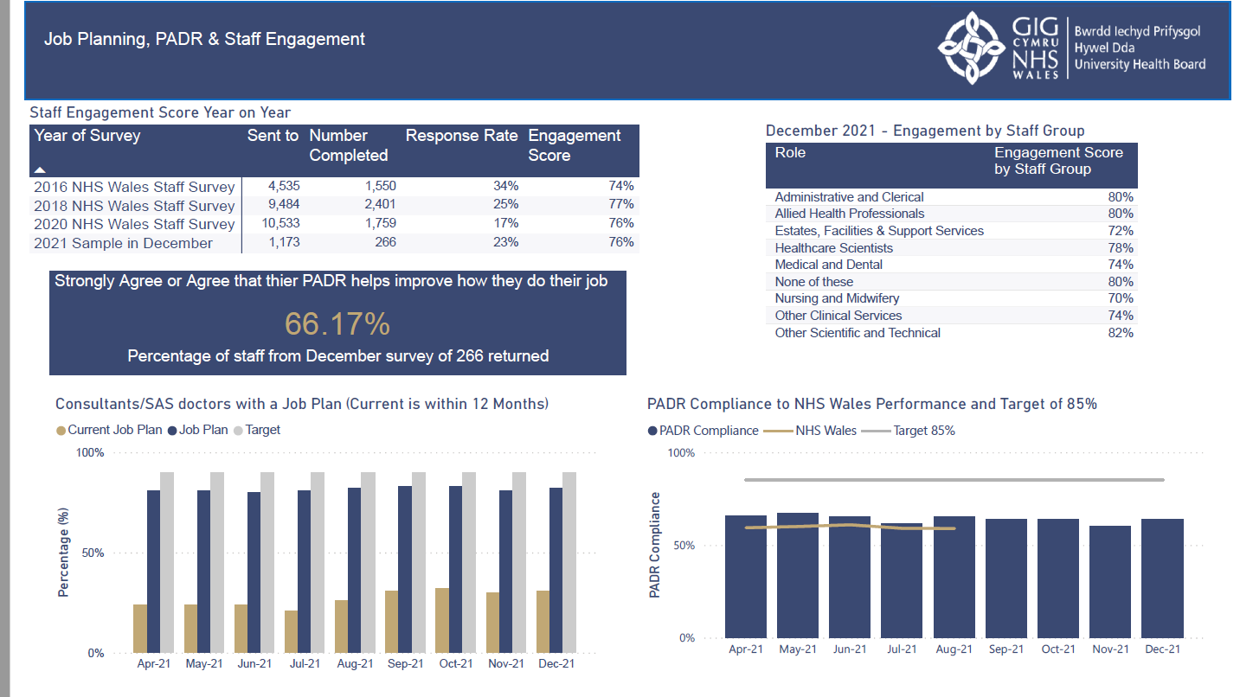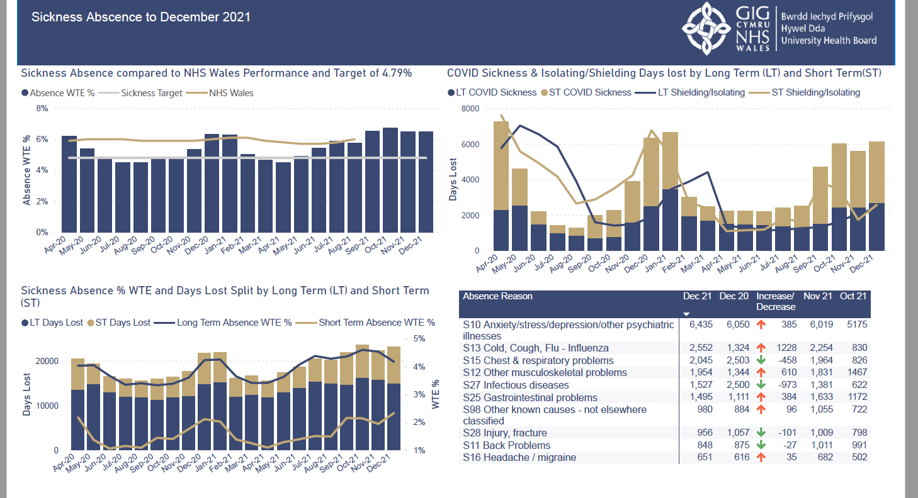

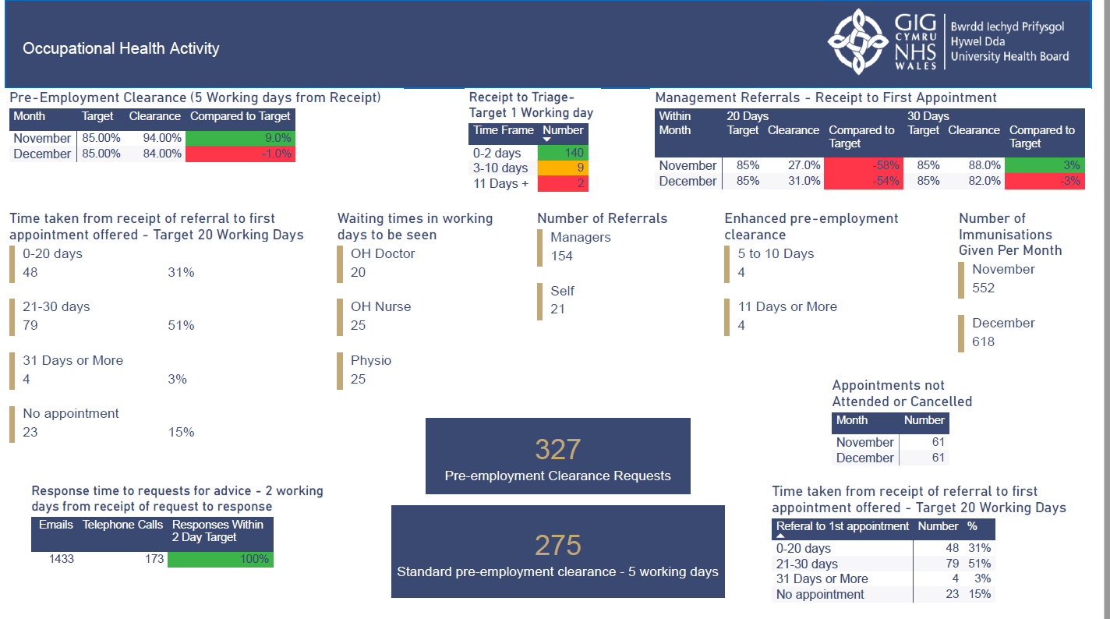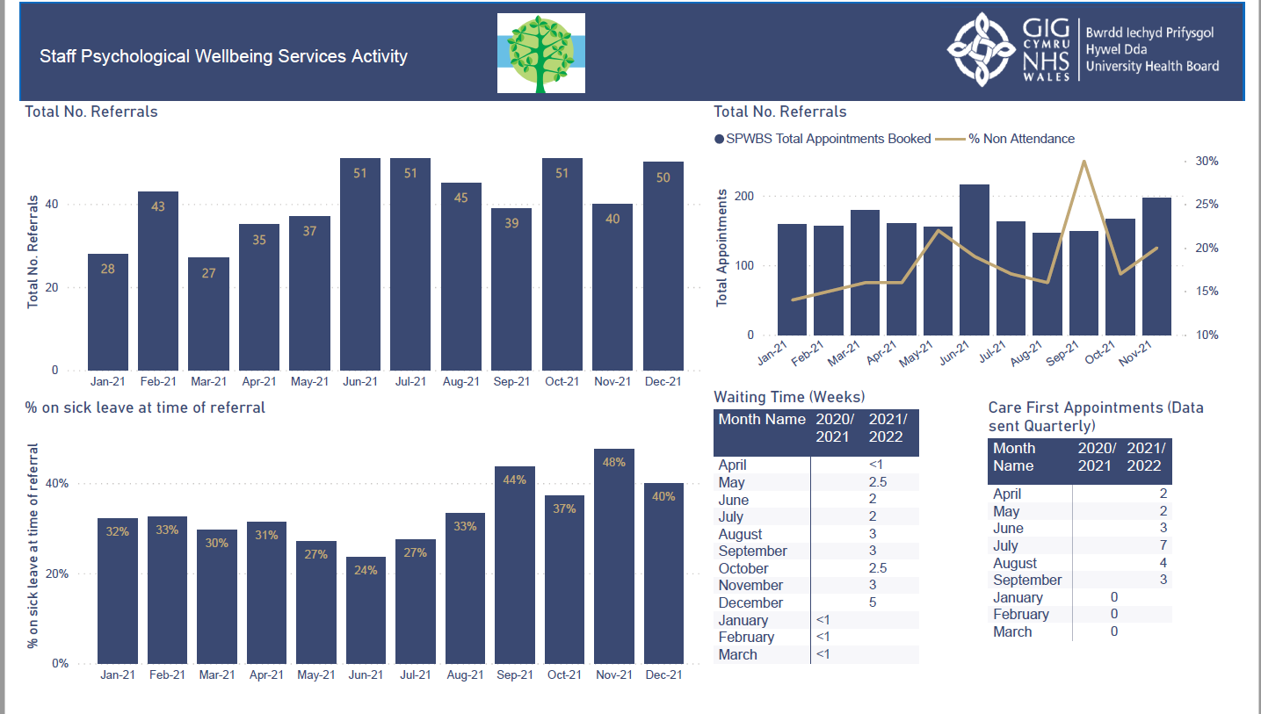

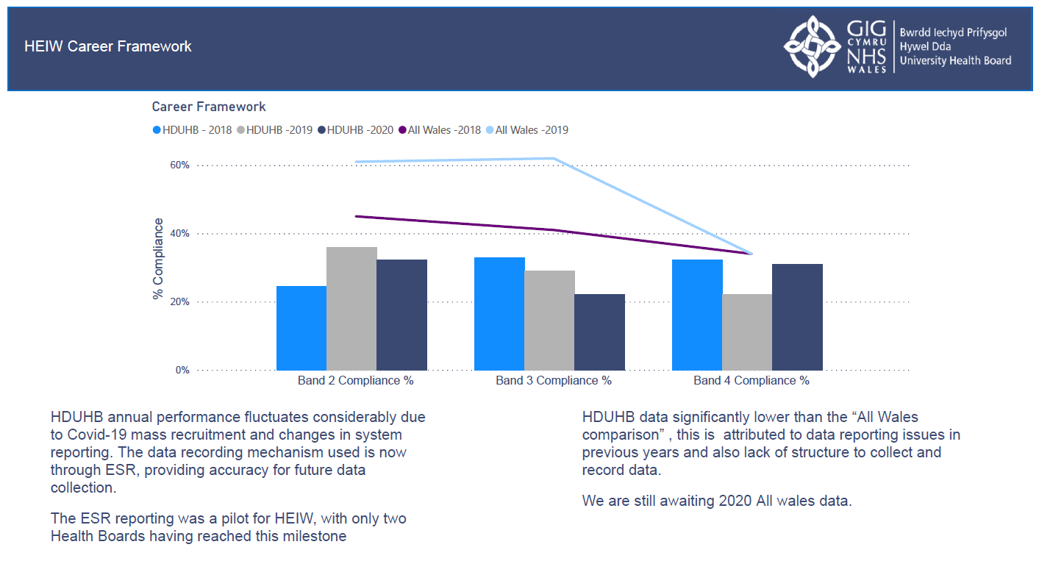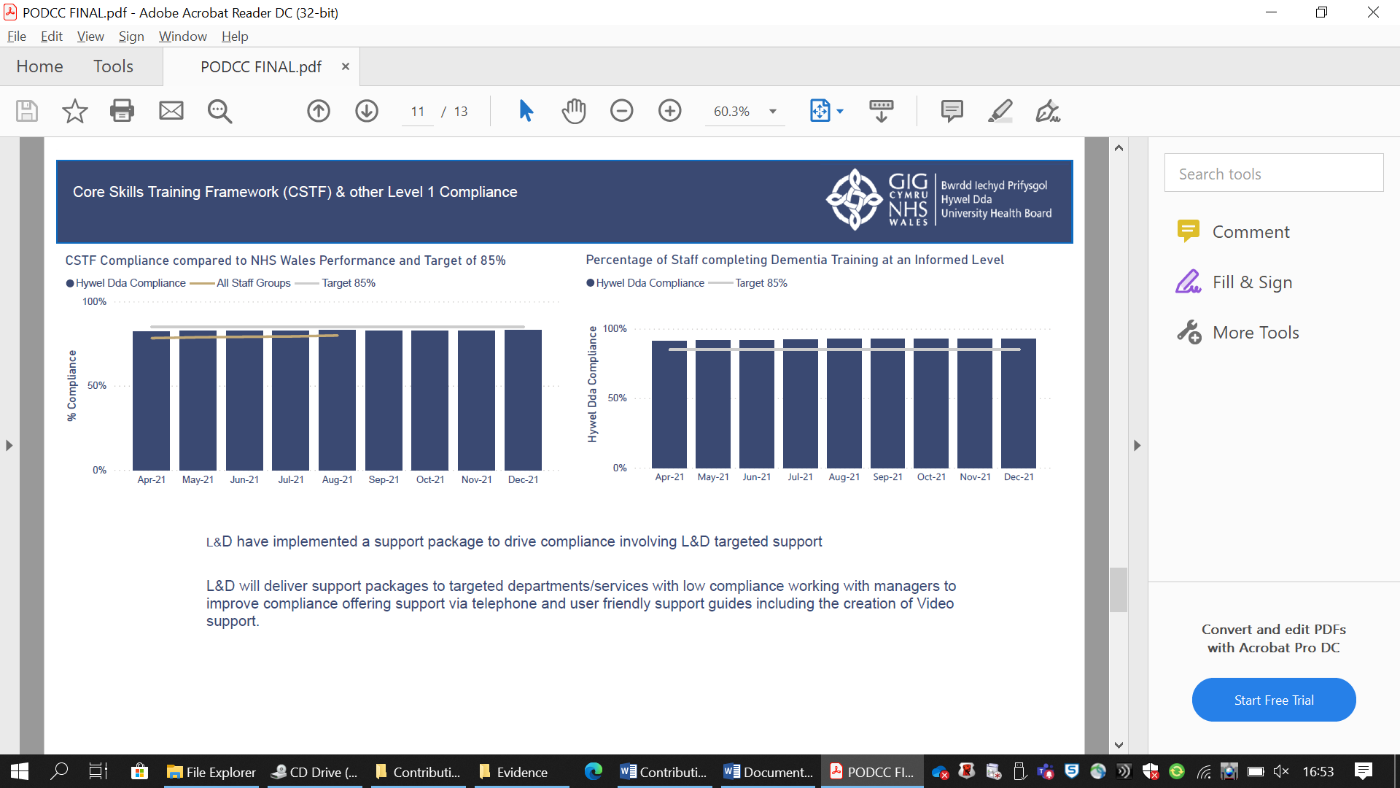

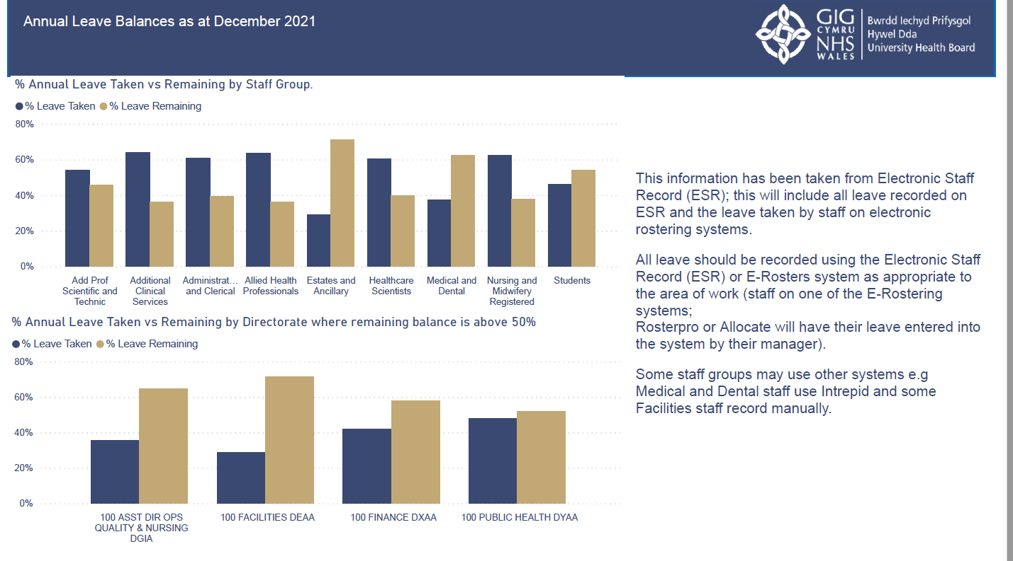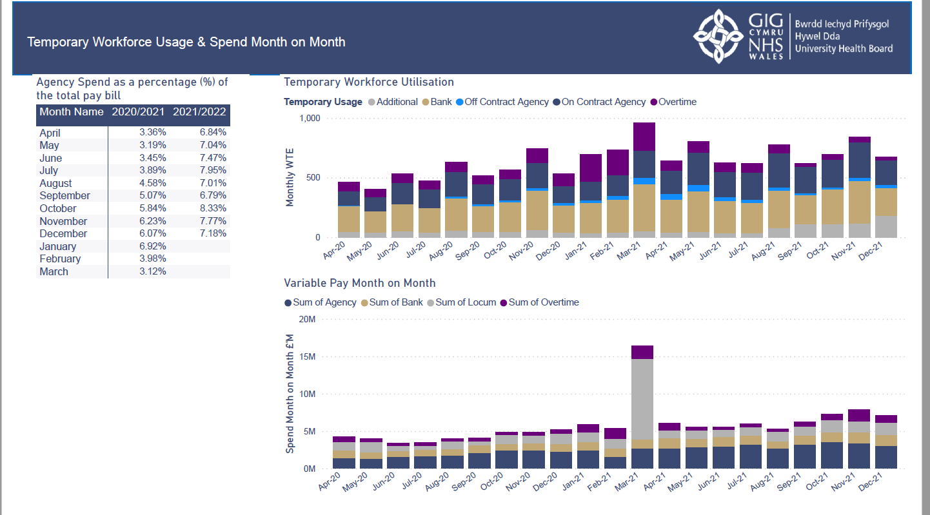

EV23 Transforming Clinical Services
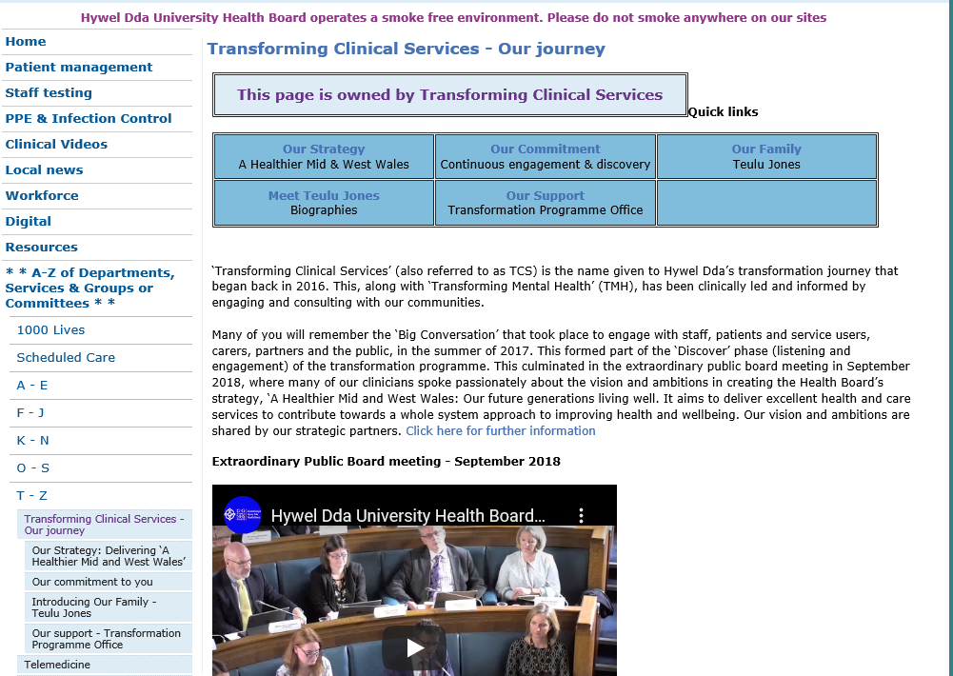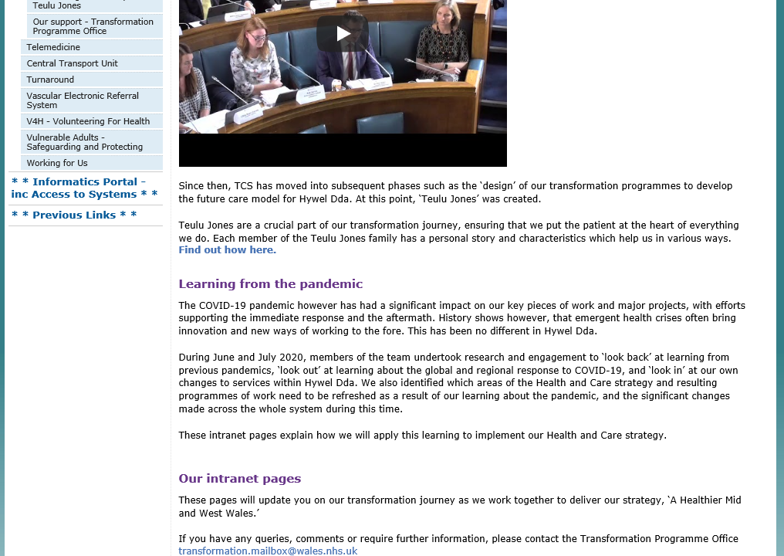

EV24 Old Staff Exit Interview Questionnaire

EV25 Global link for monkey survey to capture staff who are thinking of leaving the Health Board
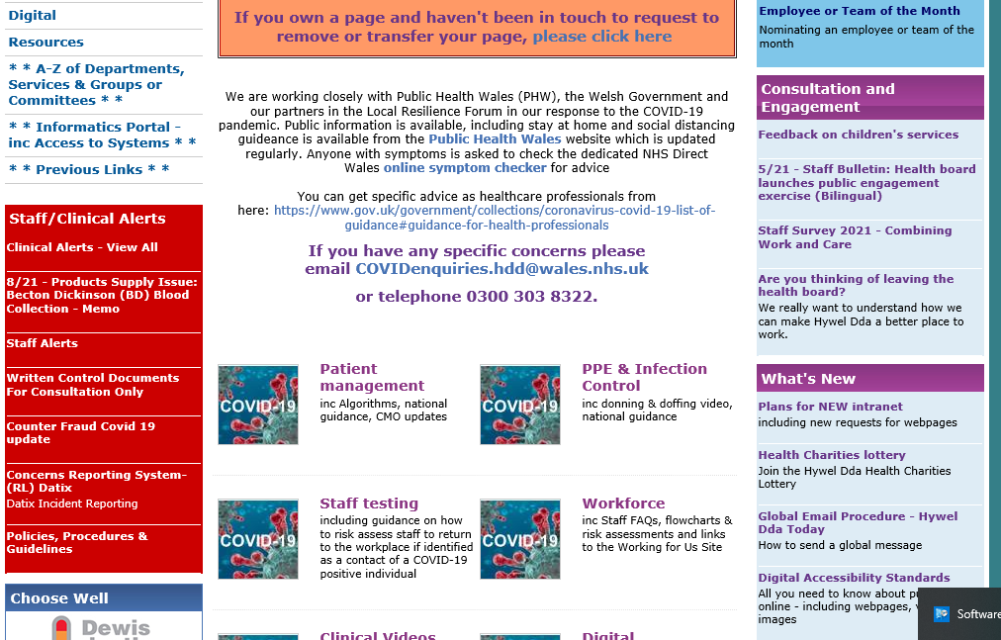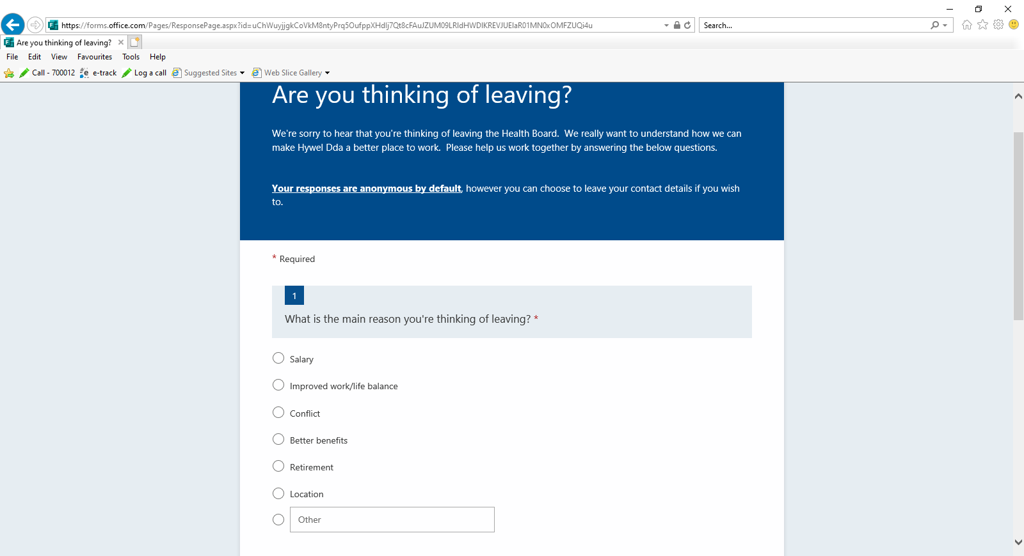
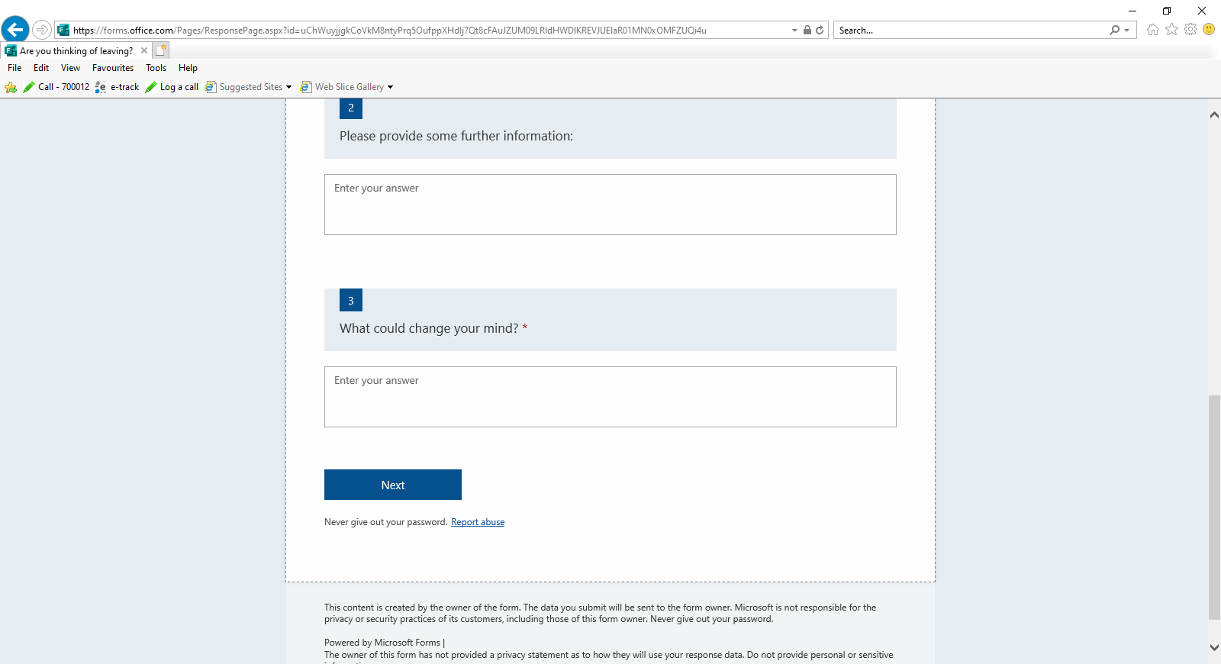
References for Learning Outcome 2

CIPD (2022) Pay structures and pay progression. Available at: https://www.cipd.co.uk/knowledge/fundamentals/people/pay/structures-factsheet#8103 (Accessed: 23 January 2022).

HDUHB Framework for Values. Available at: http://www.wales.nhs.uk/sitesplus/862/page/98252 (Accessed: 23 January 2022).

HDUHB Workforce Organisational Development & Education Strategy 2020 – 2030.

NHS Wales 2012-2016 Achieving Excellence, The quality of Delivery Plan for the NHS in Wales. Available at: http://www.wales.nhs.uk/sitesplus/documents/862/0812-Item14b-AchievingExcellence-TheQualityDeliveryPlanforNHSinWales2012-16.pdf (Accessed: 23 January 2022).

People Management (2018) Do Engagement surveys tell the whole story? Available at: Do engagement surveys tell the whole story? (peoplemanagement.co.uk) (Accessed: 22 January 2022).

People Management (2022) Planned redundancies drop 86 per cent from Covid peak, data shows. Available at:
https://www.peoplemanagement.co.uk/news/articles/planned-redundancies-drop-86-per-cent-from-covid-peak-data-shows. (Accessed: 26 January 2022).

The Times (2020) MVF tops the 100 mid-size Best Companies to Work for 2020 list. Available at: MVF tops the 100 mid-size Best Companies to Work For 2020 list | Best Companies to Work For 2020 | The Sunday Times (thetimes.co.uk) (Accessed: 22 January 2022).

Workforce Education Development Services (2014) NHS Wales Workforce Key themes and trends. Available at: http://www.wales.nhs.uk/sitesplus/documents/866/3.3%20Appendix%20NHS%20Wales%20Workforce%20Key%20Themes%20%202014%20-%2017.pdf (Accessed: 23 January 2022).

Yu Life (2022) The HR leader’s wellbeing guide to attract and retain healthy, happy teams. Available at: Yulife - HR Leader’s Wellbeing Guide.pdf (hubspotusercontent-na1.net) (Accessed: 27 January 2022).

  - Review external studies of employee engagement to identify relevant best practice. (333 words) 338

Recognition of the growth of staff engagement is shown in the HDUHB Workforce Organisational Development & Education Strategy 2020 – 2030. It recognises that staff are the biggest asset and services could not be delivered without them, that workforce is valued with their recruitment, retention, education and development, along with levels of engagement, job satisfaction and motivation in working for the HB are crucial (EV19). When employees feel that are being treated well, they are motivated and commitment this relating to Abraham Maslow's Hierarchy of Needs model (Mind tools, 2021).

Employee engagement is a three dimensional concept being discretionary, and can arise on two different levels; depending on the different drivers of engagement in separate parts of their business Khan (1990 stated within Johns and Ellis, 2016, p.81). According to The Sunday Times (2019) MTV is one of the average size best companies to work for on the 2020 list, the chief executive says that staff engagement being valuable, having a place where staff like going to work, makes the business perform better and more money is made. The whole of the workforce earn a trip to Ibiza when the company hits its targets. Google teach new managers six things Mind-set and Values, Emotional intelligence, Manager Transition, Coaching, Feedback and Decision-making. An article by the New York Times stated that Google conveyed a statistically huge progress in 75 percent of its underachieving managers after applying the program (INC., 2017).

In order to recognise best practice regarding employee engagement there are numerous external studies and these include Gallup’s Q12, David MacLeod’s Engaging for Success and Google’s Googleist Survey. Forbes (2016) states by empowering employees the more they will grow and relates to 10 powerful ways to do this some examples are; set plentiful boundaries, listen, believe in staff, praise effort, ask etc. According to a Gallup survey, (2021) employee engagement shows the participation and enthusiasm of staff in their work and workplace. Organisations with great employee engagement achieve higher productivity, greater customer devotion/engagement, improved safety, lower turnover and top profitability.

  - Identify potential barriers to acceptance of employee engagement strategies and liaise with relevant people regarding how these may be overcome or minimised. (333 words) 394

The HDUHB Workforce Organisational Development & Education Strategy 2020 – 2030 (EV19) enhances ‘Changing our Culture’ which emphasises from a research done by The Kings Fund that a key foundation for culture change is having clear vision, values and behaviour. From this, the ‘Values Framework’ was designed. The document states employee engagement being correlated to individual well-being and to organisational success. The research completed by Michael West and Jeremy Dawson (2012) has shown that staff with higher levels of engagement have lower levels of both absenteeism and presenteeisim. These engaged staff are also less likely to suffer work related stress and rate their own well-being more highly.

Thinking about the well-being I spoke to my manager regarding holding a Menopause Café. I had not seen many details promoting the menopause e.g. globals or café days or information stating that there was a HB menopause policy (EV26). Work on the menopause café continued. There were barriers from managers to myself wanting to know what I had done about setting up the menopause café, worried that advice would be given that shouldn’t be. This was a team’s meeting I had with one of the sisters. I explained it was a case of women turning up and talking about the menopause and that it was not for professional advice. This personally made me feel I did not want to engage further, I felt flat and something I felt passionate about was turned into a professional discussion. The pilot went well via teams (EV27) and staff were asking when would there be another café, they were frustrated that managers didn’t see it as a necessity. Another barrier was that it was to sit in Occupational Health and not in Workforce (EV28).

My manager said she would have put me for an award due to me setting up the menopause café. I advised I did not want an award and I did it because I was passionate about it and did not do it for an award. This made me feel that I wanted to disengaged as I felt it was just to say that Workforce had won an award and wasn’t really about me (EV29). B&Q in 2006 made ‘The Times’ Top 50 places where women want to work and this continues as employ older workers, today over 26% of employees are over 50 (Johns and Ellis, 2016, p.94).

  - Propose strategies to raise levels of employee engagement, based on analysis of the organisation and external reviews of best practice, to key decision-makers. (333 words) 345

As evidenced in the OD Directorate paper May 2021 showing the Culture and Workforce Experience Structure (EV1), this is a new department and staff are involved in culture change. I don’t sit in this department but I am liaising with them on engagement aspects. The Cultures main objectives as a department is to iron out issues with culture etc. and this is evidence in the Ten-year strategy paper (EV19). It relates to staff engagement being where staff can provide feedback and their voices can be heard and focus on staff survey results and engagement indicators for departments to develop and implement actions. The barriers I am finding and will focus on, I know that these along with other barriers are being tackled by the Culture team. I am aware of this as we all sit under the umbrella of Workforce & OD department and when having monthly ‘collaborative’ meetings discussion around this takes place. So any strategies used by me to raise levels of employee engagement I am not sure how much influence I will have.

After my 1-2-1 with my manager I devised an implementation plan and costing details of my time (EV31). The confirmation to and from my manager shows in (EV26). After noting the survey 191 saying that they were ‘proud to work for Hywel dda’ and 176 ‘would recommend the HB as a place to work’ I wondered what other companies had a menopause policy or café. There is the Occupational Health Service, and Psychologist Staff Wellbeing Service and me and my manager discussed these departments being involved (EV28). A survey via a global was sent out by the Nursing directorate which I felt was confusing as there weren’t correspondence previously and I asked about migrating together to stop confusion (EV26).

I raised awareness with the Culture team to put the recent BAME Award announcement on the Electronic Staff Record page (EV30). According to Lawler, 2013 the top way to gage engagement is by a group of survey items which include assesses effort, commitment and satisfaction to the organisation (CIPD, 2014).

Reflection
To look at my reflection I used the Gibbs Reflective Cycle as a framework (Mindtools, 2022). Whilst using the survey that had recently been done, this did not give a true reflection and could be out of date John Bersin (Leadership Review, 2022). However, I have learnt that the new style of survey smiley touch face pads, regular pulse surveys on Smart phones, text messages to a sample of people is a quick and easy response through not much disruption and I would look at this in the future (Disruptive HR Club, 2022).

Evidence for Learning Outcome 3
EV26 Email from managers re setting up café

From: Michelle James (Hywel Dda UHB - Head of Digital Workforce Solutions) <Michelle.James@wales.nhs.uk>
Sent: 25 May 2021 12:03
To: Catherine Thomas (Hywel Dda UHB - ESR Administrator/Workforce Information Manager) <Catherine.Thomas@wales.nhs.uk>
Subject: RE: Menopause Café

Just to say from our 1-2-1 today you mentioned setting up menopause café and I am more than happy to support you. Please feel free to take things further doing what is needed but keeping me in the loop.

Well done for thinking of this engagement.

Watch this space!!

From: Michelle James (Hywel Dda UHB - Head of Digital Workforce Solutions) <Michelle.James@wales.nhs.uk>
Sent: 28 May 2021 11.53
To: Catherine Thomas (Hywel Dda UHB - ESR Administrator/Workforce Information Manager) <Catherine.Thomas@wales.nhs.uk>
Subject: RE: Menopause Café – Implementation Plan

Morning

Please see attached the Implementation plan and costing/time regarding the Menopause Café.

Please let me know if you wish to discuss any of the contents.

From: Michelle James (Hywel Dda UHB - Head of Digital Workforce Solutions) <Michelle.James@wales.nhs.uk>
Sent: 4 June 2021 10.01
To: Catherine Thomas (Hywel Dda UHB - ESR Administrator/Workforce Information Manager) <Catherine.Thomas@wales.nhs.uk>
Subject: RE: Menopause Café

Thanks for sending me the details through it is precise. The costing provides me with the details of the time that you will be either out of the office (if you are able to do menopause cafes in person). Or if not the time spent doing a café via teams. This also provides me with the details of the time taken out of the department and therefore not doing your role as this isn’t part of your current role.

The implementation plan also provides me with a view of what you will be doing and how you will be doing it.

Thanks for this it’s appreciated.

From: Catherine Thomas (Hywel Dda UHB - ESR Administrator/Workforce Information Manager) <Catherine.Thomas@wales.nhs.uk>

Sent: 8 June 2021 11.02
To: Michelle James (Hywel Dda UHB - Head of Digital Workforce Solutions) <Michelle.James@wales.nhs.uk>
Subject: RE: Menopause Café

Great. Should anything change I will let you know.

I’ll keep you posted.

Cath
From: Catherine Thomas (Hywel Dda UHB - ESR Administrator/Workforce Information Manager)
Sent: 10 August 2021 14:05
To: Michelle James (Hywel Dda UHB - Head of Digital Workforce Solutions) <Michelle.James@wales.nhs.uk>
Subject: RE: Hywel Dda Heddiw Today - Awst 9 August 2021
Really good. Few more joined last minute. Very positive.
Many Thanks

From: Michelle James (Hywel Dda UHB - Head of Digital Workforce Solutions) <Michelle.James@wales.nhs.uk>
Sent: 10 August 2021 14:04
To: Catherine Thomas (Hywel Dda UHB - ESR Administrator/Workforce Information Manager) <Catherine.Thomas@wales.nhs.uk>
Subject: RE: Hywel Dda Heddiw Today - Awst 9 August 2021
How did it go?
Regards
Michelle

From: Catherine Thomas (Hywel Dda UHB - ESR Administrator/Workforce Information Manager) <Catherine.Thomas@wales.nhs.uk>
Sent: 10 August 2021 08:54
To: Michelle James (Hywel Dda UHB - Head of Digital Workforce Solutions) <Michelle.James@wales.nhs.uk>
Subject: RE: Hywel Dda Heddiw Today - Awst 9 August 2021
I think loads of staff will engage once information is out there, yes agree there are some that won’t. This café would be huge I think if there were venues and as Gina said it was difficult for herself and the Diane Towell to sustain.
I think the survey is an excellent idea.
Many Thanks

From: Michelle James (Hywel Dda UHB - Head of Digital Workforce Solutions) <Michelle.James@wales.nhs.uk>
Sent: 10 August 2021 08:36
To: Catherine Thomas (Hywel Dda UHB - ESR Administrator/Workforce Information Manager) <Catherine.Thomas@wales.nhs.uk>
Subject: RE: Hywel Dda Heddiw Today - Awst 9 August 2021
Hi Cath,
I think it’s worth a check in with Leony and Denise but I think what you’ve put in place is extremely important, the problem is how do we get the staff most in need to engage with the menopause café as many staff have not been diagnosed or do not realise this could be the issue with the symptoms they’re experiencing and even if they do may not want to discuss so openly.
Good luck for today.

From: Catherine Thomas (Hywel Dda UHB - ESR Administrator/Workforce Information Manager) <Catherine.Thomas@wales.nhs.uk>
Sent: 10 August 2021 08:19
To: Michelle James (Hywel Dda UHB - Head of Digital Workforce Solutions) <Michelle.James@wales.nhs.uk>
Subject: FW: Hywel Dda Heddiw Today - Awst 9 August 2021
Re the menopause survey. I think it can become confusing all people involved in the menopause so after today, I will speak to Leony and cc Denise in to advise how it went and see where they want to go from here.

From: Global Emails (Hywel Dda UHB - Organisational wide e-mails) <Global.Emails@wales.nhs.uk>
Sent: 09 August 2021 17:35
Subject: Hywel Dda Heddiw Today - Awst 9 August 2021
SUBJECT:  PWNC: | Menopause at Work – Questionnaire
MESSAGE:  NEGES: | We are looking to collate responses from HDUHB employees on their Menopause experience and the impact it has had on them in the workplace. We would like to invite all staff who are experiencing symptoms of the Menopause (even if you have not received a clinical diagnosis) to complete the below questionnaire.  The questionnaire will take approximately 5 minutes to complete.  The information you provide is anonymous and participation is voluntary. The responses provided will be analysed and will form part of a report about the impact of menopause symptoms on sickness absence in HDUHB.  If you wish to participate please click the link to be taken to the questionnaire on Microsoft Forms: https://forms.office.com/Pages/ResponsePage.aspx?id=uChWuyjjgkCoVkM8ntyPrqAORx8vOuNNt1QNTVP4b19UMDZNQUkzWUxQVURJRTRJS042T0I1NktQVS4u  Data collection closes on 22nd August 2021.

EV27 Menopause Teams

thanks all, just got the balance app now L... by Rosalind Sandford (Hywel Dda UHB - Rapid Diagnostic Clinic CNS)
Rosalind Sandford (Hywel Dda UHB - Rapid Diagnostic Clinic CNS)20/09/2021 13:41
does podcast by Alison Mann (Hywel Dda UHB - Community Nursery Nurse)
Alison Mann (Hywel Dda UHB - Community Nursery Nurse)20/09/2021 13:42
she also does podcast
Thanks for coordinating the chat - learnt s... by Ceilys Rees (Hywel Dda UHB - Team Secretary)
Ceilys Rees (Hywel Dda UHB - Team Secretary)20/09/2021 13:42
Thanks for coordinating the chat - learnt so much today
podbean by Alison Mann (Hywel Dda UHB - Community Nursery Nurse)
Alison Mann (Hywel Dda UHB - Community Nursery Nurse)20/09/2021 13:42
podbean
- and search for dr louise newson by Alison Mann (Hywel Dda UHB - Community Nursery Nurse)
Alison Mann (Hywel Dda UHB - Community Nursery Nurse)20/09/2021 13:43
and search for dr louise newson
Just ordered her book for the library at HD... by Gaynor Thomas (Hywel Dda UHB - Library & Knowledge Services Manager - Carmarthen)
Gaynor Thomas (Hywel Dda UHB - Library & Knowledge Services Manager - Carmarthen)20/09/2021 13:48
Just ordered her book for the library at HD, thanks for the info And also the new book by Mariella Frostrup on Managing the Menopause.
information was very helpful - will look at... by Helen Davies (Hywel Dda UHB - Towy Ward Medical Sectary)
Helen Davies (Hywel Dda UHB - Towy Ward Medical Sectary)20/09/2021 13:53
information was very helpful - will look at the balance app. Thank you.
- Begin Reference, What do recommend if you c... by Catherine Thomas (Hywel Dda UHB - ESR Administrator/Workforce Information Manager)
Catherine Thomas (Hywel Dda UHB - ESR Administrator/Workforce Information Manager)20/09/2021 14:46
Kim Davies (Hywel Dda UHB - Research Assistant)20/09/2021 13:07
What do recommend if you can't have HRT because the hormones are actually causing you the problems
ladies anyone having same issue as Kim
I've heard from friends that they use magne... by Kirsty Griffiths (Hywel Dda UHB - Mortuary Assistant)
Kirsty Griffiths (Hywel Dda UHB - Mortuary Assistant)20/09/2021 14:47
I've heard from friends that they use magnets that you can buy to help with periods. The merina coil is also supporsed to be helpful if you can use it.
- Begin Reference, due to my age My GP wont e... by Catherine Thomas (Hywel Dda UHB - ESR Administrator/Workforce Information Manager)
Emma Bracher (Hywel Dda UHB - Macmillan Acute Oncology Coordinator)20/09/2021 13:10
due to my age My GP wont entertain Menopause, and wants to prescribe Amitriptyline and gabapentin for fibromyaglia 🙁
my husband had amitriptyline for his shoulder so really strange why they want to prescribe that. sorry to hear your GP isn't engaged with you, maybe see another who may help.
I was unable to join today but even reading... by Annmarie Thomas (Hywel Dda UHB - Assistant Director of Workforce & Organisational Development (Resourcing & Utilisation)
Annmarie Thomas (Hywel Dda UHB - Assistant Director of Workforce & Organisational Development (Resourcing & Utilisation)20/09/2021 14:50
I was unable to join today but even reading the thread has been helpful thanks all
- Begin Reference, I was told three months ag... by Catherine Thomas (Hywel Dda UHB - ESR Administrator/Workforce Information Manager)
Catherine Thomas (Hywel Dda UHB - ESR Administrator/Workforce Information Manager)20/09/2021 14:50
Claire Williams (Hywel Dda UHB - Committee Services Officer)20/09/2021 13:13
I was told three months ago by a GP that I was peri menopausal and prescribed HRT. However, during my 3 month checkup last week with another GP in the Practice, she advised that I was not peri menopausal and told to stop taking the HRT menopausal. I have got the majority of the symptoms.
I had a blood test to see whether I was peri menopausal, maybe something to think about having.
- Begin Reference, Will this thread be open f... by Catherine Thomas (Hywel Dda UHB - ESR Administrator/Workforce Information Manager)
Kirsty Griffiths (Hywel Dda UHB - Mortuary Assistant)20/09/2021 13:35
Will this thread be open for us to be able to chat in the future?
I'm not sure but we can try. Other than that I think I.T. have to setup a group?
- Begin Reference, thanks for arranging Cath... by Catherine Thomas (Hywel Dda UHB - ESR Administrator/Workforce Information Manager)
Carol Ritchie (Hywel Dda UHB - Senior Recruitment Advisor)20/09/2021 13:36
thanks for arranging Cath - I would certainly like to see the Cafe continuing - I have learnt a lot today that I am sure will help me in future
Thanks Carol for the support. Yes it has been a really great experience and I hope it can continue.
- Begin Reference, Thanks for coordinating th... by Catherine Thomas (Hywel Dda UHB - ESR Administrator/Workforce Information Manager)
Ceilys Rees (Hywel Dda UHB - Team Secretary)20/09/2021 13:42
Thanks for coordinating the chat - learnt so much today
Thanks Ceilys that means a lot
- Thanks again everyone for attending today I... by Catherine Thomas (Hywel Dda UHB - ESR Administrator/Workforce Information Manager)
Catherine Thomas (Hywel Dda UHB - ESR Administrator/Workforce Information Manager)20/09/2021 15:02
Thanks again everyone for attending today I just had chance to read through the comments and am overwhelmed by the openness, togetherness, sincerity and understanding that was shown today. Thank you all x
Alison Mann (Hywel Dda UHB - Community Nursery Nurse)20/09/2021 15:11
Menopausesupport.co.uk
Susan Scarr (Hywel Dda UHB - Prescribing Advisor)21/09/2021 13:14
Hi, sorry I missed the cafe session, I was driving. I have a couple of resources I know of that I didn't see in the chat (but may have missed, apologies). Balance app, by Dr Louise Newson who runs "my menopause doctor," it has loads of really easy to read & informative articles and a symptom tracker - also v helpful to take with you to GP. Re appt privately with her clinic, I've been on the waiting list since May and my appointment is video in November. In the meantime I've finally been heard by a GP in my practice (2nd attempt to discuss perimenopause) and have been referred to Dr Munro - NHS - menopause specialist based in Carmarthen, video call in 2 weeks. Here is the clinic link Hywel Dda Sexual and Reproductive Health Services - British Menopause Society (thebms.org.uk) and more details on Dr Munro authors - Faculty of Sexual and Reproductive Healthcare (fsrh.org) Thank you for arranging the cafe Catherine.
Hywel Dda Sexual and Reproductive Health Services - British Menopause Society
thebms.org.uk
Jennifer Evans (Hywel Dda UHB - Undergraduate Officer)21/09/2021 16:41
I wish I could have joined maybe next time.
EV28 Email from Annmarie to stop rolling out
From: Annmarie Thomas (Hywel Dda UHB - Assistant Director of Workforce & Organisational Development (Resourcing & Utilisation) <Annmarie.Thomas@wales.nhs.uk>
Sent: 22 September 2021 08:06
To: Catherine Thomas (Hywel Dda UHB - ESR Administrator/Workforce Information Manager) <Catherine.Thomas@wales.nhs.uk>; Michelle James (Hywel Dda UHB - Head of Digital Workforce Solutions) <Michelle.James@wales.nhs.uk>
Subject: RE: Menopause Cafe
Feedback has been superb Cath I’m sure Leony will want to ensure all your thoughts and ideas are captured in terms of how this could be rolled out HB wide.
Thanks again I will make sure Lisa is updated on how you grasped this idea and pushed the agenda forward.
Regards

From: Catherine Thomas (Hywel Dda UHB - ESR Administrator/Workforce Information Manager) <Catherine.Thomas@wales.nhs.uk>
Sent: 22 September 2021 06:36
To: Annmarie Thomas (Hywel Dda UHB - Assistant Director of Workforce & Organisational Development (Resourcing & Utilisation) <Annmarie.Thomas@wales.nhs.uk>; Michelle James (Hywel Dda UHB - Head of Digital Workforce Solutions) <Michelle.James@wales.nhs.uk>
Subject: RE: Menopause Cafe
Ok thank you
From: Annmarie Thomas (Hywel Dda UHB - Assistant Director of Workforce & Organisational Development (Resourcing & Utilisation) <Annmarie.Thomas@wales.nhs.uk>
Sent: 21 September 2021 15:19
To: Catherine Thomas (Hywel Dda UHB - ESR Administrator/Workforce Information Manager) <Catherine.Thomas@wales.nhs.uk>; Michelle James (Hywel Dda UHB - Head of Digital Workforce Solutions) <Michelle.James@wales.nhs.uk>
Subject: RE: Menopause Cafe
Well done Cath this has been a huge success. In terms of my view as to where it formally sits strategically it would be OH as they lead on employee health promotion. In order to deliver it they may very well call on the time of staff with specialist expertise in the W&C Directorate as lucky for us as an NHS employer we have that readily available when many other employers wouldn’t. I would not have any concerns in you continuing to be involved in shaping what they do now as a strategic approach as I’m sure they will ask you for your views on the evaluation of the pilot but more of a contributor than a leader of the HB health promotion support etc. We can continue to attend sessions as attendees too. I will leave you to discuss the detail with Michelle on her return from leave in case she sees this any differently to me. I would like to applaud you for taking it this far, you should be very very proud of this.
Regards

from: Catherine Thomas (Hywel Dda UHB - ESR Administrator/Workforce Information Manager) <Catherine.Thomas@wales.nhs.uk>
Sent: 21 September 2021 09:28
To: Annmarie Thomas (Hywel Dda UHB - Assistant Director of Workforce & Organisational Development (Resourcing & Utilisation) <Annmarie.Thomas@wales.nhs.uk>; Michelle James (Hywel Dda UHB - Head of Digital Workforce Solutions) <Michelle.James@wales.nhs.uk>
Subject: Menopause Cafe
Just to say it went extremely well yesterday, fab response.
There is certainly a call for it and people are asking whether it is continuing.
As it was a pilot I am not involved from hereon in as I know there are a lot of things going on behind the scenes.
The people below are working towards menopause (not sure what and whether it is more formal)? I also know that Rob Blake mentioned about myself, Leony – Occ Health getting together. There seems to be a lot of people doing things and maybe it should be brought together so it is uniform. Although maybe the café/forum page be under the menopause category along with the others so everyone knows what’s happening, but separate as it isn’t formal if that makes sense.
Sarah Rees – Senior Nurse Manager – Women’s Health, Lisa Humphreys – Interim General Manager, Consultant in Sexual Health, Psychological Sexual Health Team – Lynda Durgan- Psychosexual Therapist, Occupational Health?
For me all I know is women want to talk and share experiences, whether a café or a team’s page something like the collaborative meeting? but they are screaming out for it and want it out there. From a HB perspective I am sure it is high on an agenda as it may help with sickness etc.
I hope you are okay with this email but I think I needed to be the voice from yesterday’s experience. As anything moving forward needs agreeing above me, I’ll wait to hear from yourselves if you need me to be involved that is.
Regards Cath
EV29 Email from Assistant Director of WOD re an award
From: Catherine Thomas (Hywel Dda UHB - ESR Administrator/Workforce Information Manager)
Sent: 11 October 2021 12:56
To: Annmarie Thomas (Hywel Dda UHB - Assistant Director of Workforce & Organisational Development (Resourcing & Utilisation) <Annmarie.Thomas@wales.nhs.uk>
Subject: RE: Menopause Cafe
Aw yes I see thought you were thinking about when it reopened, but I read it again and you were emphasising your comments ☺☺.

From: Annmarie Thomas (Hywel Dda UHB - Assistant Director of Workforce & Organisational Development (Resourcing & Utilisation) <Annmarie.Thomas@wales.nhs.uk>
Sent: 11 October 2021 12:36
To: Catherine Thomas (Hywel Dda UHB - ESR Administrator/Workforce Information Manager) <Catherine.Thomas@wales.nhs.uk>
Subject: RE: Menopause Cafe
Hi Cath,
The awards are to recognise individuals who go above and beyond and this is what you did. I was gutted they are closed as I would have really liked you to have one.
Take care, Annmarie

From: Catherine Thomas (Hywel Dda UHB - ESR Administrator/Workforce Information Manager) <Catherine.Thomas@wales.nhs.uk>
Sent: 11 October 2021 12:21
To: Annmarie Thomas (Hywel Dda UHB - Assistant Director of Workforce & Organisational Development (Resourcing & Utilisation) <Annmarie.Thomas@wales.nhs.uk>
Subject: RE: Menopause Cafe
Thanks very much for the thought and for your kind words. But I really didn’t do anything to warrant being nominated for an award. I wouldn’t want people thinking I did it just for that. Occupational Health, Culture and the Psychological sexual health team I am sure will bring fantastic opportunities in the near future and an award to them would be more justified.
Thanks again for thinking of me.

From: Annmarie Thomas (Hywel Dda UHB - Assistant Director of Workforce & Organisational Development (Resourcing & Utilisation) <Annmarie.Thomas@wales.nhs.uk>
Sent: 11 October 2021 10:46
To: Catherine Thomas (Hywel Dda UHB - ESR Administrator/Workforce Information Manager) <Catherine.Thomas@wales.nhs.uk>
Cc: Lisa Gostling (Hywel Dda UHB - Director of Workforce & OD (Organisational Development) <Lisa.Gostling@wales.nhs.uk>
Subject: Menopause Cafe
Hi Cath,
I have previously thanked you for the initiative you have shown in getting a pilot Menopause café up and running. You shared your thoughts with Michelle having watched the Davina McCall documentary and as a result of this did your own research on how the cafes run and tested a pilot in W&OD. Following this pilot, a global went out inviting wider participants and you did a sterling job in facilitating that café with lots of experiences shared and participants really valuing the opportunity to attend.
In order to recognise the initiative your showed I had intended to nominate you for a Chairman’s Commendation Award. Unfortunately the scheme is currently closed to new nominations until a new award scheme is considered for next year. I was disappointed to see that this was the case so instead I thought I would drop you another line and copy Lisa in so she is sighted on the initiative you showed. Thank you once again, Diolch Annmarie

EV30 Email to Millie in the Culture team re BAME announcement on Electronic Staff Record

From: Catherine Thomas (Hywel Dda UHB - ESR Administrator/Workforce Information Manager) <Catherine.Thomas@wales.nhs.uk>
Sent: 24 January 2022 09:06
To: Millie Thomas (Hywel Dda UHB - Medical Recruitment Officer) <Millie.Thomas@wales.nhs.uk>
Cc: Alex Thomas (Hywel Dda UHB - ESR Support Officer) <Alex.Thomas2@wales.nhs.uk>
Subject: ESR Notifications
My colleague is involved in the BAME network and looking at it I can see that there is nowhere for staff to fill in the BAME Health and Care Awards and I feel in order for staff to be engaged it would be a good idea to put an announcement on the Electronic Staff Record.
Let me know what you think?

Cath
From: Millie Thomas (Hywel Dda UHB - Medical Recruitment Officer) <Millie.Thomas@wales.nhs.uk>
Sent: 24 January 2022 16:33
To: Catherine Thomas (Hywel Dda UHB - ESR Administrator/Workforce Information Manager) <Catherine.Thomas@wales.nhs.uk>
Subject: ESR Notifications

Thanks very much Catherine I think that is an excellent idea and will certainly engage staff as they look at their employee staff record frequently. Please let me know when I can send you the details.

Email from Millie in the Culture team with attachments to be inserted on the employee staff record portal page
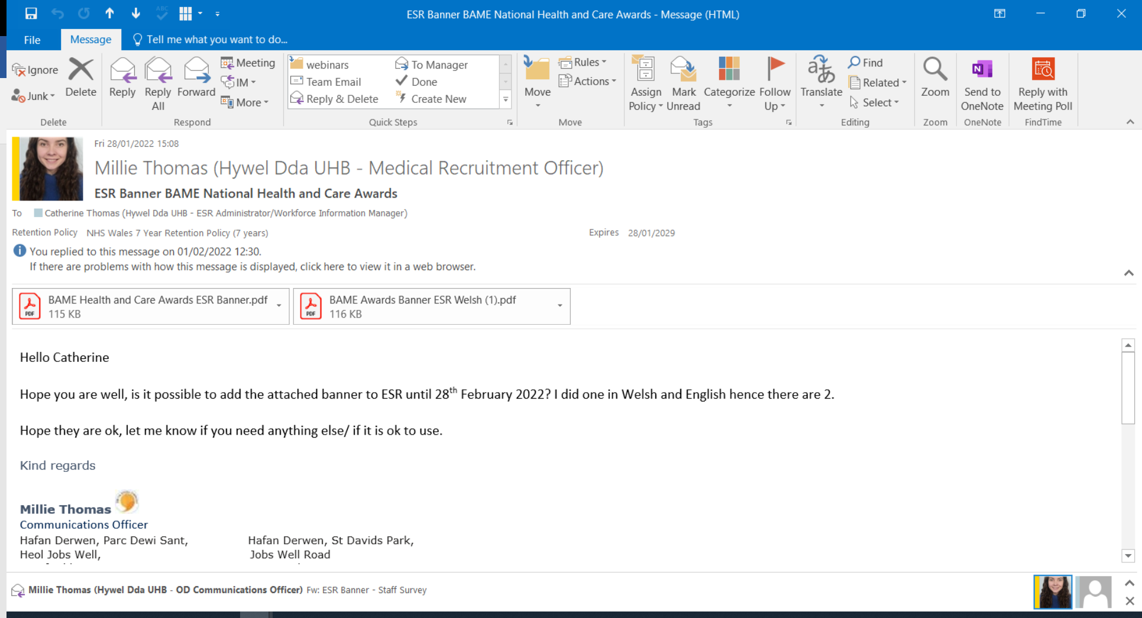
SUBJECT:  PWNC: | National BAME Awards
MESSAGE:  NEGES: | Do you know a healthcare worker you could nominate for the National BAME (Black, Asian, Minority, Ethnic) Health and Care Awards 2022? These awards recognise and celebrate the achievements of BAME staff in healthcare fields and the awards ceremony will be held in London on 19 May 2022. There are award categories for Leadership / Research / Diversity work / Clinical Champions / Digital Champions; as well as categories for Nurse / Midwife / Emergency / Mental Health / Community Nurse of the Year. Nominate via this website by 28 February 2022:-  The National BAME Health and Care Awards | Promoting BAME excellence in healthcare (bamehscawards.org)
CONTACT:  CYSYLLTWCH Â: | Cath Thomas  Administrator  Corporate Nursing  Withybush Hospital  Tel: 01437 834475  Catherine.thomas8@wales.nhs.uk
SUBJECT:  PWNC: | National BAME Awards
MESSAGE:  NEGES: | Do you know a healthcare worker you could nominate for the National BAME (Black, Asian, Minority, Ethnic) Health and Care Awards 2022? These awards recognise and celebrate the achievements of BAME staff in healthcare fields and the awards ceremony will be held in London on 19 May 2022. There are award categories for Leadership / Research / Diversity work / Clinical Champions / Digital Champions; as well as categories for Nurse / Midwife / Emergency / Mental Health / Community Nurse of the Year. Nominate via this website by 28 February 2022:-  The National BAME Health and Care Awards | Promoting BAME excellence in healthcare (bamehscawards.org)
CONTACT:  CYSYLLTWCH Â: | Cath Thomas  Administrator  Corporate Nursing  Withybush Hospital  Tel: 01437 834475  Catherine.thomas8@wales.nhs.uk

EV31 Implementation Plan for Menopause Café and Staff Costing
2021/2022
Task | July | Aug | Sept | Oct | Nov | Dec | Jan | Feb
Project Management Work
Discuss with manager being rolled out & communication
Look on Internet for similar details
Email other Health Boards to see if they have rolled out
Meetings between relevant departments
Question as to whether need Terms of Reference
Tools required to do task
Do necessary background work to enable change
Revisit potential errors preventing roll out
Roll out
Sent Globals with dates and explanation of the menopause café
Examine replies back from Global
Send staff teams meeting Menopause Café date
Speak to I.T. to confirm how many can attend teams
Governance
Continue to monitor through roll out.
Continue to ensure staff wellbeing at all times and point staff into the direct of staff psychological counselling
Costing, Risks etc
The recommendation essentially needs to be implemented over a 12 month period
The cost of 30 hours over a month e.g. 1 day a week would be a band 6, ESR Manager, 20% £8,000
Total Cost £8,000.
Risk - Should this not stay within Workforce or if the person is an extra, it depends on how many staff within Occupational Health or Diversion & Inclusion are involved.

References for Learning Outcome 3
CIPD (2014) The Future of Engagement: Thought Piece Collection. Available at: Title (cipd.co.uk) (Accessed: 3 February 2022).

Disruptive HR Club (2022) 5 Minute Monday: Fresh Approaches to the Engagement Survey. Available at:
5 Minute Monday: Fresh approaches to the engagement survey – Disruptive HR Club (Accessed: 9 February 2022).

Forbes (2016) 10 Powerful Ways to Empower your Employees. Available at: https://www.forbes.com/sites/brucekasanoff/2016/03/24/10-powerful-ways-to-empower-your-employees/ (Accessed: 3 February 2022).

Gallup, (2021) State of the Global Workplace 2021 Report. Washington D.C. Gallup Headquarters.

HDUHB Workforce Organisational Development & Education Strategy 2020 – 2030

INC. (2017) Google Spent Years Studying Effective Bosses. Now They Teach New Managers These 6 Things. Available at: Google Spent Years Studying Effective Bosses. Now They Teach New Managers These 6 Things | Inc.com (Accessed: 22 January 2022).

Leadership Review (2022) Why the employee engagement survey is out of date. Available at: https://www.leadershipreview.net/why-the-employee-engagement-survey-is-out-of-date/ (Accessed: 9 February 2022).

Mindtools (2021) Maslow’s Hierarchy of Needs. Available at: Maslow's Hierarchy of Needs - From MindTools on Management (Accessed: 28 December 2021).

Mindtools (2022) Gibbs’ Reflective Cycle. Available at: https://www.mindtools.com/pages/article/reflective-cycle.htm (Accessed: 9 February 2022).

Taylor, S. and Woodhams, C. (2016) Human Resource Management: People and Organisations. 2nd edn. London: CIPD.

The Sunday Times (2019) The Sunday Times Best Companies to Work For 2020. Available at: https://appointments.thetimes.co.uk/article/best100companies/ (Accessed: 2 February 2022).

