

Title: Technical review of powertrains for 2025
Module: Powertrain and sustainability
M6X01206
Module tutor: Malcolm McDonald
BEng Advanced Engine Design
Compiled by Alex Brannovic-Jones
P142455

Abstract
The Mazda Motor Corporation with have to negotiate a particularly turbulent few years. The 2025 powertrain will undoubtedly be much changed from the current form, a necessity under the changing social and political stresses of the period.
The challenges to the all manufactures over the next seven years will be outlined below, with reference to the Mazda family discussed.
The current vehicle line-up of Hatchbacks, Saloon, Compact SUVs and Convertibles, powered by the highly fuel efficient SKYACTIV-D and SKYACTIC-G powertrains will be changing over the years. The already widely anticipated SKYACTIC-X powertrain, with its Spark Plug Controlled Compression Ignition (SPCCI), will see production lines in 2019, increasing fuel economy by 20-30%. However, looking further ahead, a more diverse powertrain option will be required. The Japan only Mazda 3 Hybrid, based around the Prius powertrain from our Toyota partnership, will be expanded to a globally available rotary engine ranger-extender EV, also by 2019.
By 2020 our line-up of plug-in hybrids based around our existing models will become available, closely followed by our full Electric Vehicle (EV) in 2021, a result of our joint technology development contract with Denso and Toyota, the EV Common Architecture Spirit Company (EVCAS).

Future powertrain options
Several options for powertrains will be laid out below, with current company production aims and relevance to Mazda’s values.

Pure ICE
Mazda has a firm commitment to the Internal Combustion Engine (ICE). With advancements in a number of highly promising ICE technologies, Mazda has made clear that it will pursue the most efficient ICE possible while it is still abides by the "Sustainable Zoom-Zoom 2030" agenda (appendix 5).
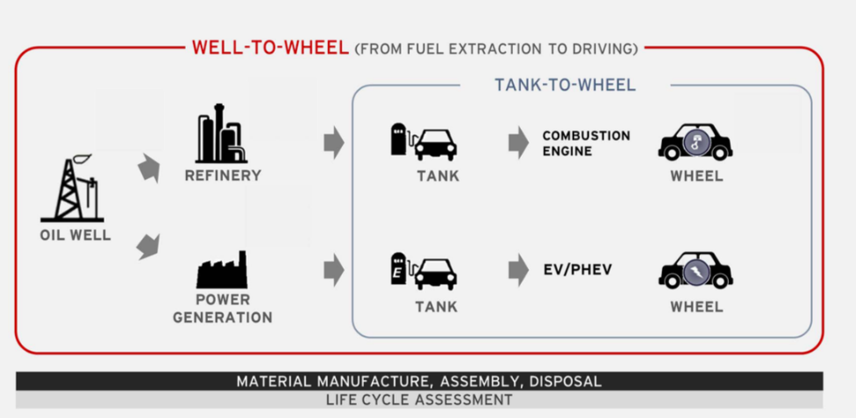
The emissions produced by a vehicle encompasses more than just what comes out of the tail pipe. Mazda has considered this when developing its future production line. The “well-to-wheel” analysis is a system for determining the total CO2 created not just from the car itself, but the production of its needed energy i.e. oil refinement (ICE) or power generation (EV).
Mazda’s patented SPCCI combustion technology, which will debut in the redesigned 2019 Mazda3, will eventually be fitted to all of the brand’s models. By 2020, when the Mazda 3 SPCCI goes on sale globally, it has been claimed 95 per cent of all new vehicles will remain powered by ICEs. The initial two litre SPCCI engine will deliver 30 per cent more torque and 30 per cent lower fuel consumption than the equivalent SKYACTIV-G engine.
Mazda also says it remains committed to diesel power, and plans to reveal a significant upgrade for its SKYACTIV-D engine line-up in 2019.

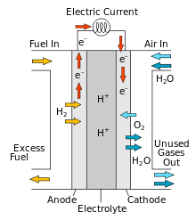
Hydrogen ICE and fuel cell
The current use for hydrogen at Mazda is in a hydrogen rotary engine, which produces no CO2, and through a combined use of lean burn (low RPM) and EGR (high RPM) has reduced NOx emissions. The engine also uses a three-way catalyst used on the standard model.
The engine is a duel fuel system that automatically switches to gasoline fuel when needed, or can be manually switched at a touch of a button.
The hydrogen fuel cell is another method of use in a modern car, which has no tail-pipe emissions due to the generation of electric current from the hydrogen, rather then the burning of it. This is done through the use of an anode, cathode and electrolyte that allow hydrogen ions though, generating a current, thus powering a motor (shown in figure 1, equation 1). Looking at the well-to-wheel analysis, often the hydrogen is derived from reformed natural gas, meaning while the car emissions may be close to zero, the life-cycle still includes some pollutants.
Equation 1$$4H^{+}+O_{2}+{4E}^{-}→2H_{2}O$$
Figure 1 – Hydrogen fuel cell
Mazda’s partnership with Toyota (2015), will undoubtedly aid the development of the use of hydrogen as a possible powertrain option. The long-term agreement saw the exchange of hydrogen fuel systems for the supply of fuel-efficient SkyActiv engines.
However, uptake of hydrogen powered vehicles has been slow, mainly due to poor infrastructure.

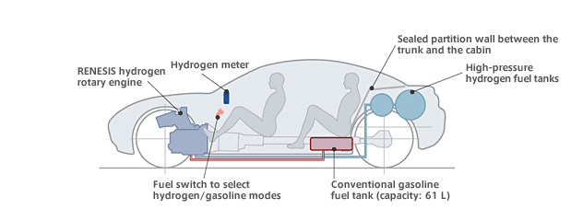
Hybrid Powertrain
Mazda will be investing in hybrid powertrains in a number of forms as it pursues an all-round vehicle line-up. In 2013 our concept Mazda 2 hybrid was tested on the road, featuring a rotary engine range extender. This will be the base for the hybrid powertrain going forward, with a 2019 release for our first electric vehicle. The rotary engine’s compact size and ‘much, much quieter’ (Mitsuo Hitomi) running level lends itself to the near silence of electric cars.
Figure 2 – RENESIS powertrain layout - Note reduced luggage capacity due to hydrogen tanks, a drawback many hydrogen systems.

The duel fuel RENESIS rotary hybrid has the ability to switch from hydrogen to gasoline, with the current Energy Recovery Systems (ERS, detailed below) and the function to recharge the batteries by the rotary engine, means this system is a dynamic tool in Mazda’s arsenal.
Combining Mazda’s SCCI SkyActiv-X ICE with a battery pack will also be a very efficient powertrain system, allowing clean electric city driving, and market leading combustion fuel economy.
The current RENESIS hybrid follows a ‘series’ drivetrain configuration, meaning the driven wheels are powered by an electric motor. This reduces drivetrain weight compared to ‘parallel’ drivetrains. However, a parallel system may be employed for high end or performance models, like the Mazda 6 (SkyActiv-X hybrid)) or an RX-8 (rotary gasoline hybrid).

Full EV
While Mazda is committed to developing its ICE, the growth of EVs is gaining momentum. The EV Common Architecture Spirit Company (EVCAS) is a joint technology contract with Denso and Toyota that will develop solid-state battery-powered models, from small cars to large SUVs and even light trucks. An electrified version of every model by 2030 is on the cards, as laid out by powertrain development, vehicle development and product planning boss Ichiro Hirose.
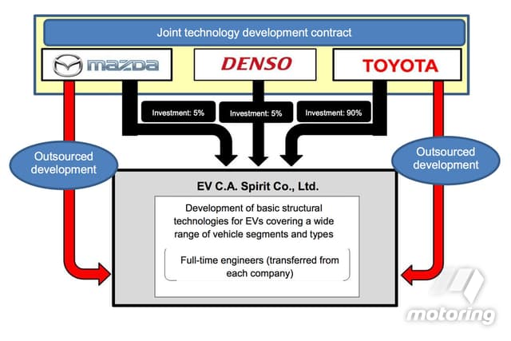
This partnership will aid the three manufactures in keeping up with counterparts BMW, Volkswagen and even Jaguar Land Rover, whom have released, or are planning to release, a number of EVs. While other top tier manufactures are also putting resources into battery technology and developing an ‘electric’ public image, for example Ford Motor Company ‘s GT model being withdrawn from the Endurance Championship, resulting from a probable move to Formula E.
EVs will however depend on a number of criteria being met to remain a possible solution to emission concerns. Advancements in battery technology need to be made to increase energy density. Reducing the well-to-wheel impact, meaning the curbing of fossil fuels in electric generation. And improved infrastructure for EVs, increasing the number of charging output points or making household charger ready.
Figure 3 – EVCAS

Energy Recovery Systems (ERS)
Mazda’s i-ELOOP unit is a regeneration system that recovers kinetic energy as the vehicle decelerates and stores it for later use. Currently it is utilised to power the headlights, climate control, audio system, or any other electrical equipment, reducing the fuel usage. It uses capacitors for fast charge and discharge rates. In future hybrid or EV systems this could be used to power the motor, although a battery system may need to replace the capacitors.
As Mazda chose not to downsize and turbo charge like many manufactures, incorporating an ERS for the turbo would be costly for development, as it would only be compatible with the SkyActiv-D ICE (appendix 2).
While not an ERS, i-Stop stop/start technology improves fuel economy by approximately eight percent (under Japan's JC08 mode test cycle.), with the use on the SkyActiv-D resulting in world's fastest diesel engine restart time of approximately 0.40 seconds.

Global restrictions on emissions
With a number of cities now choosing to restrict access to higher polluting cars, more efficient ICEs, hybrids and EVs will need to be produced.
Mazda’s largest market is the USA, thus its electrification strategy will allow it to continue to sell its vehicles in states like California, where EVs will become the ‘price of admission’ for carmakers.
Under the new WLTP testing systems the drive for reductions in emissions in constant. Therefore, the ‘Sustainable Zoom-Zoom 2030’ plan is a critical part of the Mazda development process.

Conclusion
As can be seen from the above information, the 2025 powertrain option will likely not be a straight forward chose. It will be dependent on manufacturer size, market area of interest, previous development, customer base, social and political pressure and future developments.
For Mazda the path is varied. Commitment to ICE development has produced a powertrain comparable in emissions to a full EV when looking at well-to-wheel figures (based in the USA) (appendix 3). Thus the SPCCI engine will continue to be used in the next seven years and beyond, partially while infrastructure for both EV and hydrogen is expanding.
However, with the growth of renewable power sources across the world, including many emerging markets like China, hybrid and EV emissions for the lifecycle of a vehicle will likely fall. Mazda will need to be ready to fill this gap and stick to its Sustainable Zoom-Zoom 2030 targets. 2025 will likely see small but growing electric sales share in our model line. Our partnerships with Toyota and Denso will be key in maintaining a market share with a steady transfer to hybrid (rotary for historic brand principles and core customer loyalty, SPCCI for high fuel economy), and further down the line full EV (using solid-state batteries from EVCAS).
This shift from ICE to hybrid, with a small share of EV, will be time dependant on a number of aspects. For Mazda, and its large US market (which is still fossil fuel dependant), this will mean a slower transition then the EU based model line.
The social pressure however still seems to be on renewable energy policies, even in the USA where importing solar panels has received a high tax bracket, local, renewable energy sourcing is still gaining momentum. If this local production is coupled with EVs, then the emission reduction can be large, a major selling point for Tesla and SolarCity (EVs and solar roofing)(Appendix 1).
Thus, in addition to reducing emissions under real-world conditions, Mazda believes that the best way to achieve its 2025 powertrain vision is through a multi-solution approach that offers a mix of ICE and EV technologies in view of each region’s energy situation and power sources. ‘A fleet-average “well-to-wheel” CO2 emissions to 50 per cent of 2010 levels, increasing to 90 per cent by 2050’ (Ichiro Hirose)

Appendix

Appendix 1
Exponential Energy | Ramez Naam | SingularityU South Africa – TED talks 2017
Rapid cost reduction in solar panel production, seen to some extent already, will likely drive the renewable electrical generation sector, forcing out fossil fuels. This will make border line ‘greener’ EV a much more viable option when looking at well-to-wheel emissions. Advances in battery technology will reduce charging and usable range issues, although this is not through lithium-ion batteries. Household solar panels charging EVs will be a lifestyle change bought about by a wider public awareness of energy production and usage, a social driven change. This however will not be within the 2025 target.

Appendix 2
Ignoring small-capacity trend vindicated in real-world economy figures, says Mazda
THE head of Mazda’s powertrain development says the company’s decision to not follow the lead of other car-makers in downsizing its turbo-petrol engines when it began working on the SkyActiv engines in 2008 was the right move.
with rival manufacturers recently increasing the size of their engines to achieve better real-world fuel-consumption tests, while Mazda has not needed to with its SkyActiv-G (petrol) and SkyActiv-D (diesel) powertrains.
This includes Volkswagen with the latest Golf’s new European-market 1.5-litre unit, up from the old 1.4.
“Of course I am aware in the market that OEMs (Original Equipment Manufacturers) are tending towards downsizing, and in terms of that they have been looking at three cylinders with (as little as) 1.0-litre engines – that is true,” he told GoAuto through an interpreter at Mazda’s 2017 Global Tech Forum in Frankfurt.
“But if you look at what the trend is now, especially in Europe, because we had NEDC (New European Driving Cycle) before and we’ve changed to WLTC (Worldwide harmonized Light vehicles Test Procedure), manufacturers who were downsizing previously are now upsizing their engines to get better real-world fuel economy.”
Mr Hirose said that as a result, it is not yet necessary for Mazda to develop an engine below the existing 1.3-litre petrol and 1.5-litre diesel units, especially as the new supercharged compression ignition technology (dubbed SkyActiv-X) that can bring upwards of 30 per cent consumption and emissions cuts is adaptable to any size and configuration of SkyActiv-era engine.

Appendix 3
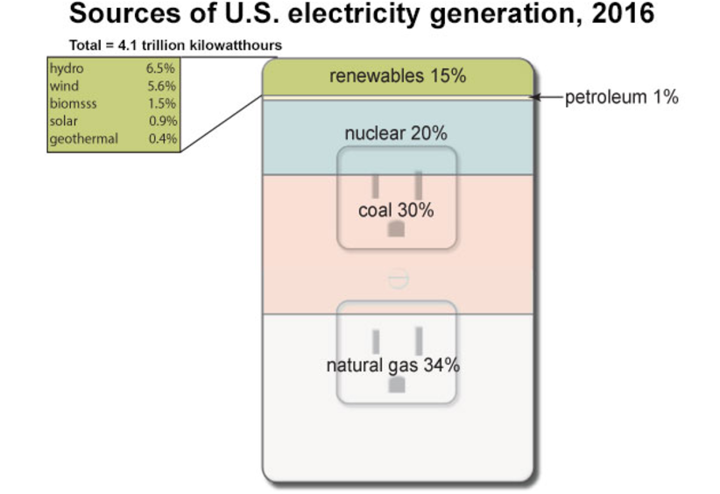

Appendix 4
Mazda Would Like To Remind You All That Electric Cars Are Often Coal-Powered Cars – jalopnik.com
Mazda says it has done such an analysis with one of its current SKYACTIV engines (which has a fuel efficiency of 5.2L/100KM, or about 45 mpg), and compared it to an electric car with an efficiency of 21.2 KWH/100KM.
Mazda says that all its SKYACTIV engine-powered car needs is a 10 percent increase in fuel economy to reach the same overall CO2 output per kilometer as an EV whose battery pack gets its juice from power plants generating electricity via “standard means.”

Appendix 5
'Sustainable Zoom-Zoom 2030', http://www2.mazda.com/en/publicity/release/2017/201708/170808a.html
Mazda's approach
Expand measures for carbon dioxide reduction from a "well-to-wheel" perspective, considering emissions over the vehicle's entire life cycle
Aim to reduce corporate average "well-to-wheel" carbon dioxide emissions to 50 percent of 2010 levels by 2030, and achieve a 90-percent reduction by 2050
Achieve this with a policy prioritizing efficiency improvements and measures for cleaner emissions that apply in the real world
In line with this policy, continue efforts to perfect the internal combustion engine, which will help power the majority of cars worldwide for many years to come and can therefore make the greatest contribution to reducing carbon dioxide emissions, and combine the results with effective electrification technologies
From 2019, start introducing electric vehicles and other electric drive technologies in regions that use a high ratio of clean energy for power generation or restrict certain vehicles to reduce air pollution

Appendix 6
For now, Mazda’s electrification strategy does not include Australia, where the vast majority of electricity continues to be generated by coal-fired power stations and where there are no state or federal Government incentives for EV owners.
Note - E85 is widely used in Australia (as well as the US and Brazil), which can produce less emissions then pure gasoline. Further investigation in wider us of ethanol would have been desirable, but time restraints hindered this.

Appendix 7
2-stroke – not considered due to need for development that Mazda has little current history in, option for other manufactures that have a historical interest (KTM).

Apeendix 8
China requires EV makers to recycle batteries, Feb 2018
The new rules require EV makers to set up recycling channels and service outlets where old batteries can be collected, stored and transferred to specialist recyclers.
End of life battery issues have been discussed, with many government policies (China, EU etc.) now forcing manufactures into providing recycling for old EV cars.
Rise of electric cars poses battery recycling challenge – Financial times, 2017
The batteries used in electric cars are much bigger, last eight to 10 years, and will account for 90 per cent of the lithium-ion battery market by 2025.
Canadian recycling start-up Li-Cycle says to make it profitable you need to recycle all of the battery materials. It claims it can recycle all types of lithium-ion batteries recovering up to 90 per cent of materials including lithium, cobalt, copper, and graphite.

Bibliography/ References
Various lectures by Malcolm McDonald, September 2017, UWTSD.
Mazda Would Like To Remind You All That Electric Cars Are Often Coal-Powered Cars, jalopnik.com, 2017
Mazda outlines EV plans, motoring.com.au, 2017
Mazda.co.uk (2018);
An in-depth look at Mazda’s SKYACTIV-X technology
Model line-up (USA, EU/UK, Japan)
Brake Energy Regeneration System
Idling Stop Technology
WLTP facts.eu, 2018
Series vs Parallel vs Series/Parallel Drivetrains, ucsusa.org, 2018
Mazda to bring back rotary engine as range-extending hybrid, autocar.co.uk, 2018

