personal development portfolio

By Christine Parchment 2026384
Lecturer Farah Islam LCHS4005_BIRM


Contents
1
personal development portfolio
Introduction 3
CV – Christine Parchment 4
Cover Letter 6
Personal Development Plan 8
My SWOT and Personal Development Plan 9
Personal Statement 10
A Reflection on my Presentation 11
REFERENCES 12

Introduction

In my Personal Development Portfolio, I will be evidencing my CV or Resume. An application for a job role and the Cover Letter supporting the role, my personal SWOT Analysis and PDP with information on how they both work, and how I have applied both to my own personal development.
I will also explain the purpose of a SWOT analysis and PDP regarding my personal development, and a Personal Statement for my applied job role which shows how I could be the potential candidate for roles applied for in my health and social care sector.
In the latter part of my Portfolio, I will reflect on the build up to my presentation, the actual presentation itself, and the post presentation feedback information given by my lecturer, and how I felt about the complete process in the form of reflection, using the Gibbs Reflective Cycle.

CV

CV – Christine Parchment
Contact No: 07xxx2 xxx515
Email: mrsparchmentXX@gmail.com

Key Skills
My key skills include Auditing, Documenting, Care Plans, Risk Assessments, Medication Administration, Organising Rotas.

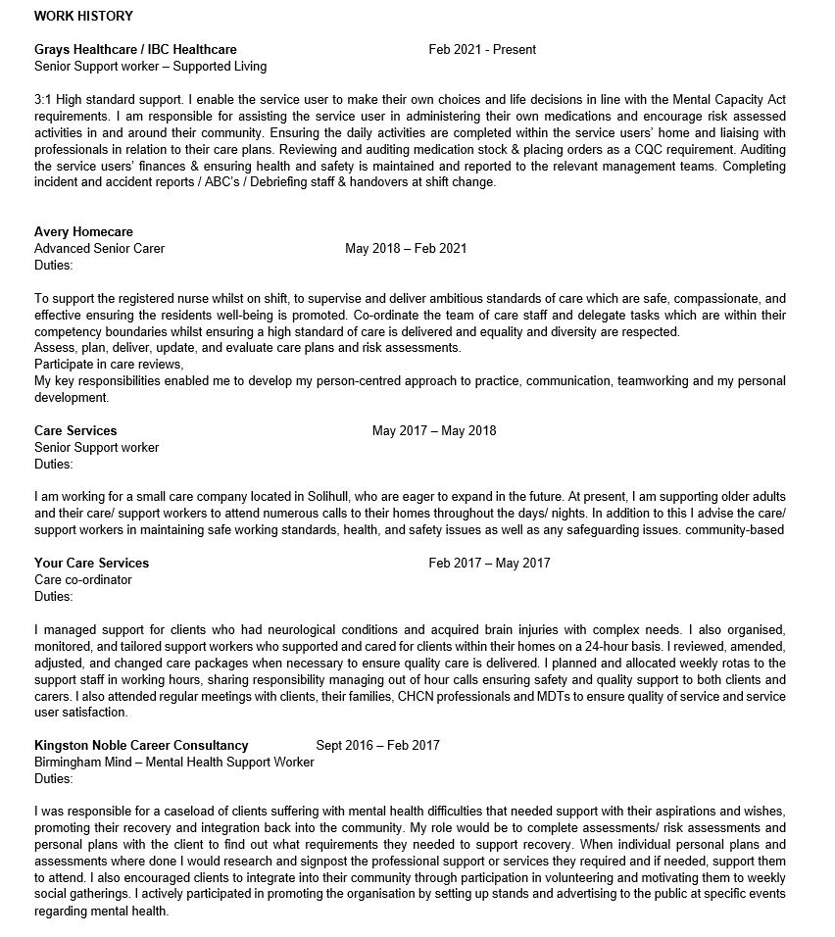
Education & Qualifications
Education: George Salter High School West Bromwich 1979- 1984
University Of Wales Trinity St David May 2021 – Present CERTHE – Health & social care Level 4

Qualifications
YTS Scheme In-house training, industrial wear machinist 1984-1986

Certificates:
Advanced Senior carers course – Accredited by City and Guilds-25/02/2019.
Level 3 NVQ Certificate in Management -Regulated by Ofqual - 02/03/2012.
Level 2 NVQ Health & Social Care – Accredited by City of Guilds/QCA- 13/05/2009.
Food & Hygiene Level 2 Award – Accredited by QCA- 21/05/2007.
Employment Courses:
Emergency First Aid -26/02/2019
Induction Food Safety – Hydration & Nutrition - 27/03/2013
Autism & Asperger’s Syndrome - 18/02/2015
Epilepsy Management - 01/02/2008
Epilepsy Rescue Medication - 01/02/2008
Care & Control of Medicines foundation level - 02/07/2007
Supervision & Appraisals - 09/11/2009
RAMP Risk Assessments - 11/11/2009
Medication Assessments - 12/06/2009
Health & Safety Awareness - 11/01/2007
Nutricia Flocare Infinity Enteral Feeding Pump - 08/08/2017
PEG and Gastronomy Tube Training - 06/09/2018
Administering medication via PEG - 06/09/2018
Competencies in Administration of Medication - 18/08/2018
Moving & Handling - 27/03/2013
Safeguarding - 29/08/2012
Manual Handling - 29/08/2012
Sight Loss Awareness - 26/01/2007
Person-Centred Awareness - 27/11/2009
Autism Awareness - 18/02/2015
DOLS – 25/02/2019
Use of Equipment Inc. Hoists - 29/01/2007
Fire Safety - 23/02/2015
Protection of Vulnerable Adults from Abuse- CIEH accredited training centre 30/07/2009
CIS E- Course - 11/02/2015
BVS Training CPD Accredited study:
Health & Safety - 25/06/2017
Raising Concerns & Whistleblowing - 15/08/2017
Food Hygiene - 18/08/2017
Equality, Diversity & Inclusion -16/08/2017
Effective Communication -13/09/2017

Achievements: Completed a sponsored 5k Run for Cancer Research and Mentoring Staff to achieve their NVQ 2
Interests & Hobbies: I enjoy Cooking, then trying to burn it off by swimming or dancing, I love music, culture, fundraising and socialising.
References
IBC Healthcare, Human Resources Manager humanresources@ibchealt**are.co.uk Tel: 09011106010
Avery Healthcare, Georgiana Nitu, RGN Nitu@yah**o.com Tel: 073776293456

Cover Letter
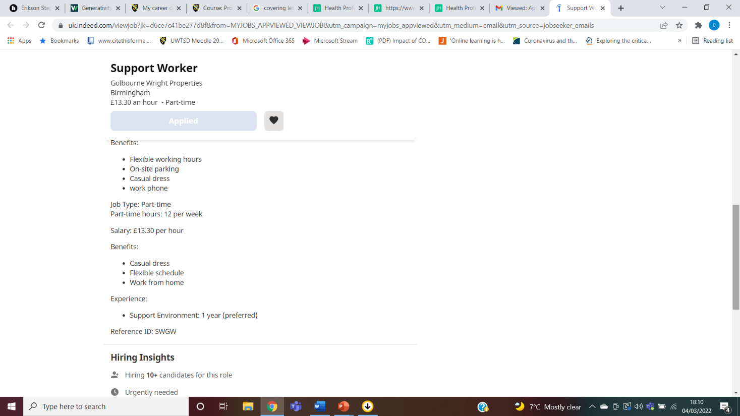

Dear Ms. Zoyah,

Please accept this letter as an expression of my interest in the role of Support Worker at Golbourne Wright Properties.
I am a highly motivated and forward-thinking Support worker with a long history of supporting people in the community throughout my career, with a good track record of consistency and reliability. I believe will prove valuable to your tenants developing their independence in your properties as I have previously supported people with mental health as an Outreach Worker and I am very aware of the issues and concerns of how your company operates to support your tenants. I believe I would be a good fit and the perfect candidate for this role.
Throughout my career, I have perfected my skills in documentation regarding assessments and action plans and like to review and assess individual plans with the view to a positive outcome, with progress towards their target to gain and maintain independence within the community.
I also encouraged clients to integrate into their local community through participation in voluntary and part-time roles to encourage a sense of achievement and self-worth which will elevate their self-esteem during their journey to recovery. In my previous role, I helped organize a weekly self-help group where our clients would meet at the local Fire Station community rooms to chat, share their own issues if they choose to and join in activities, just to show that they were never on their own in their journeys to recovery. With my knowledge in this field and your expertise in housing people with specialist needs, this would give you the opportunity to grow and expand your business.

Please take a moment to look at my CV as I would like the opportunity to speak to you regarding my candidacy.

Thanks for your consideration.

Warm Regards
Christine Parchment
0xxx2 3xx xx5
Mrsparchmenxtxx@gmail.com

Swot Analysis

Strengths  My Verbal communication is good and can adapt to alternative forms of communication.  I can express myself using pen and paper (written documentation).  Years of knowledge and experience gained through the whole spectrum of care and support.  Being able to work alongside health care professionals from many fields used in the healthcare sector. | Weaknesses  Getting my point across in a digital format, using computers/laptops etc.  I find myself struggling to format documentation, or to express myself electronically in an academic aspect.
Opportunities  Finishing my University Course and moving onto bigger and better things (academic progression).  Finding a higher-paid role, due to completing my qualification.  Opening my own business with the experience and knowledge accumulated. | Threats  Being unable to adapt to innovative technology being required by Government Legislation.  Inability to do forward facing roles due to new concerns with another potential Pandemic.  Not being able to do future work, due to rules around registration, (NMC pin).  Potentially, not being able to work, due to physical illness.

Personal Development Plan

My SWOT and Personal Development Plan

I have created my own SWOT analysis and my own Personal Development plan as a future guide of projections, targets, and ambitions I would like to aim for in the future. This shows strengths, aspirations, vulnerabilities and targets with potential dates to aim for and things I need to work on to achieve my own goals and reduce the risk of obstacles slowing me down or obstructing my aims.
,
A SWOT analysis (PMC, 2019) is an acronym for strengths, weaknesses, opportunities, and threats and is used as a tool to assess how an organisation compares to its competition.
A SWOT can be also used for personal development to establish what is important and to prioritise what needs to be done to progress an individual’s career. A SWOT can be flexible, but needs to be updated and reviewed, to remain relevant.

A Personal Development Plan is the process of creating an action plan based on your own aspirations and future ambitions using awareness on self-improvement and goal setting. It is a tool for self-improvement and can be also reviewed upon refection to create a “plan B” or alternative updated versions if a personal or organisational situation changed.
According to (Jackson , 2015) in an academic setting, Skills, attitudes, and behaviours that PDP may promote are being able to,
- Recognise, value and evidence their own learning in academic and non-academic contexts.
- Gather and record information on learning experiences and achievements.
- Evaluate and recognise own strengths and weaknesses and identify ways in which perceived weaknesses might be improved and to make the best use of strengths.
- To learn from things that did not go according to plan.
- To use personal records and evidence of learning to demonstrate to others what they know and can do.

Personal Statement

My name is Christine Parchment, I live in Birmingham where diversity and inclusion are at the heart of the community. I have worked as a health care professional for 27 years and have seen lots of changes to legislation, law, policy, and procedure. These changes have made better outcomes for people being supported in both their physical and mental health wellbeing.

Within my roles, I have supported people of all ages, from young people, adults, to the elderly which includes palliative care. I listened to their needs (if they had capacity). If they did not have the capacity to advocate for themselves, I would consult with their appointed next of kin or their advocate or social worker.
I am a great communicator and a happy conscientious person who likes to think that I could have influence and stay in the memory of the people that I meet in my career. Whether they are a service user or professional who I work in collaboration with.

My greatest aim is to get the person I support integrated back into the community where they can develop as much empowerment and independence as possible to live an inclusive life and feel like they are a member of the community they live in.

I am punctual, well organised, and extremely hard working as I can work alongside management and colleagues to assist with person centred care for everyone.
In my career, I have collaborated with people who have Acquired Brain Injuries, Dementia (Memory Care), Autism ASD, Mental Health, and Complex Needs where service users had primary and secondary disabilities to support.
I have confidence in supporting care managers and nurses with new, current, and ongoing care plans, positive behavioural plans and risk assessments with regular reviews and updates, and assisting in implementing them, with clear instruction and information for the carer or support worker to follow.

I am adept at liaising with family members of the service users with Organisational Involvement, regarding wellbeing and health matters. I have had to work independently at times while sharing information with nurses, GPs and other healthcare professionals and reporting any changes at daily and weekly departmental meeting. My main objective was to promote independence in everyday life activities and to support choice while providing comfort and maintaining wellbeing.
I have received the relevant training to support service users with medication, Insulin pen injections, PEG feeding machinery and Oxygen equipment, as instructed by in-house nurses, community nurses or GPs involved in their care.

I encourage staff to maintain confidentiality and adhere to GDPR guidelines when discussing the client in our care, as all family members and visitors do not necessarily have the right to know all information kept, except for next of kin documented in the care plan. I encourage staff to read, understand and sign company policies and procedure and to take all training offered.
In previous roles, I would ensure staff follow COSHH requirements, reporting issues with utilities, property maintenance, PPE supplies, moving and handling equipment and aids to support persons to safely transfer within guidelines required.
I returned to education to evidence my knowledge with CERTHE level 4 course. I have transferable skills that can be bought to distinct roles within healthcare especially working with young people and mental health, as well as personal experience within my own family.

A Reflection on my Presentation

I was required to do a 5 minute presentation for my lecturer. The aim of this was to demonstrate my understanding of key skills and knowledge needed for working effectively within a health and social care setting.

Out of the key skills list provided I chose to do my PowerPoint presentation on communication.

Initially I thought it may be challenging for me to create a presentation, I felt apprehensive about my IT skills and if I could communicate my knowledge both visually and verbally to a good standard.

I received excellent feedback from my lecturer regarding my presentation and it was clear my work followed the brief. However, a draw back of my presentation was that there was too much information on each slide which looked busy and may not have been easy to read.

I believe I did fairly well overall but think I could have done better or received better feedback

If I had more confidence in my IT skills and overall ability to complete the task.

If I were to do the presentation again, I would make my presentation more visually appealing and stimulating I would add more images to reinforce what I am trying to communicate. I believe people are more likely to enjoy a presentation when they are not required to read reems of dialogue which would better captivate the audience.

REFERENCES

Jackson , norman j (2015) personal development planning? what does it need, Researchgate. Available at: https://www.researchgate.net/profile/Norman-Jackson-2/publication/265158472_Personal_development_planning_what_does_it_mean/links/5674382408ae502c99c78171/Personal-development-planning-what-does-it-mean.pdf (Accessed: March 29, 2023).

SWOT analysis: Factsheets (2021) CIPD. Available at: https://www.cipd.co.uk/knowledge/strategy/organisational-development/swot-analysis-factsheet#8010 (Accessed: March 29, 2023).

