BA (Hons) Leadership and Management Skills for the Workplace

INNOVATION SERVICE PLAN

Adolfo Heras
Student Number 1915415

Module code: BMSW6102_ BIRM
Developing Innovation and Creativity for Business Advantage
Lecture: Dr. Khaza Ahmed

Executive Summary
The marketing plan for such innovation-based service areas tends to highlight the appropriate target customers and the different promotional and marketing activities that would help boost the sales and reputation of such services. Moreover, the current report also tends to highlight the significance of the customer journey in such cases. In this report, the description of the current context of the innovative service idea and the emerging needs of the customers in terms of attending the innovative services have been described. Additionally, the benefits of the target customers and the SWOT analysis of the proposed innovation service have been analysed in detail. Besides, the difference between the value proposition and the innovative services has been evaluated and the actual cost or money that is proposed in e-commerce is employed in this regard and the specific e-commerce platform, 'Shopify' has been selected.

Table of Contents
1. Introduction 4
2. Main body 4
2.1 Innovative service idea 4
Description of the current context 4
Description of the innovative service idea 4
Emerging needs and wants of the customers for attending the innovative services 5
Customer target and benefits of that target 5
SWOT analysis of the proposed innovative service 5
Competitors and the unique value propositions 6
Ways of making differentiation between the innovative service and its value proposition 6
Ways of sustaining innovation business proposition 7
2.2 E-commerce 7
The specialised e-commerce platform, 'Shopify' 7
Description of the content of the website 7
Financing: The amount of money that it would cost and the place from where it may get the required money 8
Required supplies and equipment 8
Staff needed 8
Payment Services 8
2.3 Marketing 9
Promotion 9
Target Customers 9
Description of the customer journey 10
Pre-launch/ Launch promotion 11
2.4 Cash Flow Forecast 12
3. Conclusion 12
Reference list 13

1. Introduction
The purpose of this report is to develop creativity and innovation for showing the advantages of the construction business. The structure of this report contains three major parts including innovative service ideas, e-commerce, and marketing along with the introduction and conclusion of the whole report.

2. Main body

2.1 Innovative service idea

Description of the current context
Innovation creativity may be the ultimate pathway of the business or reaching the new heights of process improvement, product value, internal harmony, and marketing success where the creative process may lead novel ideas and concepts to the entire business. Refinishing the hardwood floors and upgrading the insulation, converting a basement to a living area, and installing the new wooden floors help in developing the renovating closets.

Description of the innovative service idea
The idea relates to the 'innovative service' in which the 'construction of houses' becomes innovative by associating the traditional means of construction that helps in advancing the efficiency and sustainability for improving the construction process of houses. The category of innovation in the construction of houses states the wide concept that invokes the overall improvements in the processes, products, and services by incorporating several new innovative ideas for generating the changes that may be helpful in solving the needs of the construction-based organisation for increasing the desired competitiveness (Pappas et al. 2018). Moreover, the ‘unique selling point’ (USP) in the innovative service idea of construction relates effective marketing to the overall construction business that may be converted into several features of the organisation for containing the key benefits in order to recognise the consumers. The ‘innovation matrix’ itself is a visualisation of the ways for identifying several kidneys of innovation that is dependent upon the necessary goal for a certain perspective where the ways must be analysed in detail for accelerating the innovation and understanding the place where the innovation needs to take place for understanding the ways of managing innovation.
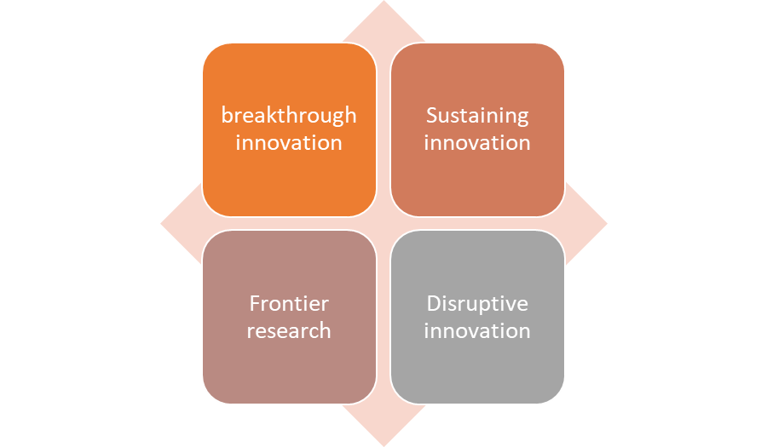
Figure 1: Innovation matrix
(Source: Developed by author)

Emerging needs and wants of the customers for attending the innovative services
The needs and wants of the customers regarding the innovation services of the construction industry are applying the new process, technology, and innovation for making a significant impact on this industry by adding efficiency, and reducing the project duration along with improving the ways of applying technology in buildings and reducing the possibility of making defects. Besides, the implementation of automated mechanics, robotics and other things that are associated with bringing innovativeness in the construction industry should be associated.

Customer target and benefits of that target
The target of the customers is to purchase the land at low prices and establish a popular house and sell it at the time after increasing the prices of this land and house. The benefits of buying land at an affordable price help the customers for addressing no production cost that may not depreciate and multi-utilise the economic zone where the land is in constant demand and it is not also a commodity for showing the availability in the unlimited supply chain (Lee et al. 2018).

SWOT analysis of the proposed innovative service
The proposed innovation service is 'building information modelling.
Strengths  The implementation of building information modelling (BIM) tends to evaluate the advantages and disadvantages as the result of implementing this BIM on the building project | Weaknesses  BIM is the digital process that needs an investment in computer resources that is seen as a long-term investment for the business by expecting the sizable cost savings
Opportunities  Using BIM becomes helpful in increasing visibility, better decision-making, more sustainable options, and the cost-savings in the construction of houses | Threats  BIM spends too much time on creating the overall model information that is not essential at the initiation stage of the project which may negatively impact the schedule and the budget can be shown as the outcome of this
Table 1: SWOT analysis
(Source: Developed by author)

Competitors and the unique value propositions
The competitors are Barratt, Mace, kier and Galliford Try.Besides, the unique value proposition of the construction of houses is to make a promise of the value that can be delivered by the company to the customers and it is also being recognised as an essential part of the business strategy of the contractors for forming the reasoning regarding analysing the ways of making the business 'stand out to the competitors.

Ways of making differentiation between the innovative service and its value proposition
The value proposition on which the customers have focussed and the differentiation is being represented as the competition in the market on which it has thoroughly focussed. Besides, the overall competitive advantage has focussed on the overall internal capabilities of the construction of houses. Likewise, the key difference between the marketing offers and the value proposition is to consider the whole reasons regarding evaluating the reason behind buying the services by customers (Shao et al. 2020). Besides, the entire marketing relating to this construction project should be considered with delivering free and effective services to the customers in terms of exchanging the required values for promoting the delivered services to the customers. The proposition of the value of the 'construction of houses' maintaining such criteria as mentioned above need to carry out the adequate benefits of assimilating the specific set of customers who are ready to acquire the respective service by representing the value chain activities that are also involved in making the 'value chain proposition' effective.

Ways of sustaining innovation business proposition
The construction business proposition can be sustained by building houses across the sectors in terms of reading and developing the new business model of 'innovation management' for making collaboration with other non-profit organisations and the government both for rapidly developing the economy. Besides, improving the overall business ecosystem of the construction becomes beneficial for improving the societal proposition too. The business proposition in construction is sustainable through connecting with the customer needs, making proper sustainability regarding the core principle, developing innovations, and incorporating diverse leadership along with setting a long-term goal and holistic vision for constantly improving the delivered services. The competitive advantage in construction can be maintained by establishing clear performance-based standards starting the incentive scheme and encouraging the customers for developing knowledge (Jalil and Hwang, 2019). Long-term sustainability in construction can be proposed and progressed by taking care of the construction wastes, economising the transportation fleet, and establishing a supply chain and keeping the equipment of construction continuing as per the possible efficiency.

2.2 E-commerce
For developing the website, the following things need to be considered:

The specialised e-commerce platform, 'Shopify'
The specialised e-commerce platforms, for example, Shopify can be helpful and effective in e-commerce by providing advanced functionality with a plunger-style platform that enables the customers for customising the site by installing and downloading it. Alongside this, the features containing increasing sales and social media promotions that may offer overall inventory management are also beneficial for reporting business and accounting of the construction sector. Thus, the improved productivity, increased competitiveness, developed partnerships and relationships as well as the progressed profitability and the developed brand value and recognition by reducing the costs in e-commerce are associated.



Figures 2, 3 and 4: E-commerce
(Source: Developed by prefabricadas FSH.es)

Description of the content of the website
The content marketing of e-commerce enables the brands by covering each step of the journey of the customers which allows the online retailers to establish deep and authentic relationships with the customers. Henceforth, the issues relating to this sector that can be faced by the consumers are the lack of well-defined goals, limitation of the budgets, showing poor communication, making unrealistic expectations, improper time management, inadequate risk management and limited skills among the construction employees (Ullah et al. 2019). The issues described above can be resolved by utilising the technological resources properly, improving communication, setting realistic goals, and offering recognition, and making an investment in training the construction workers for progressing the necessary job experiences.

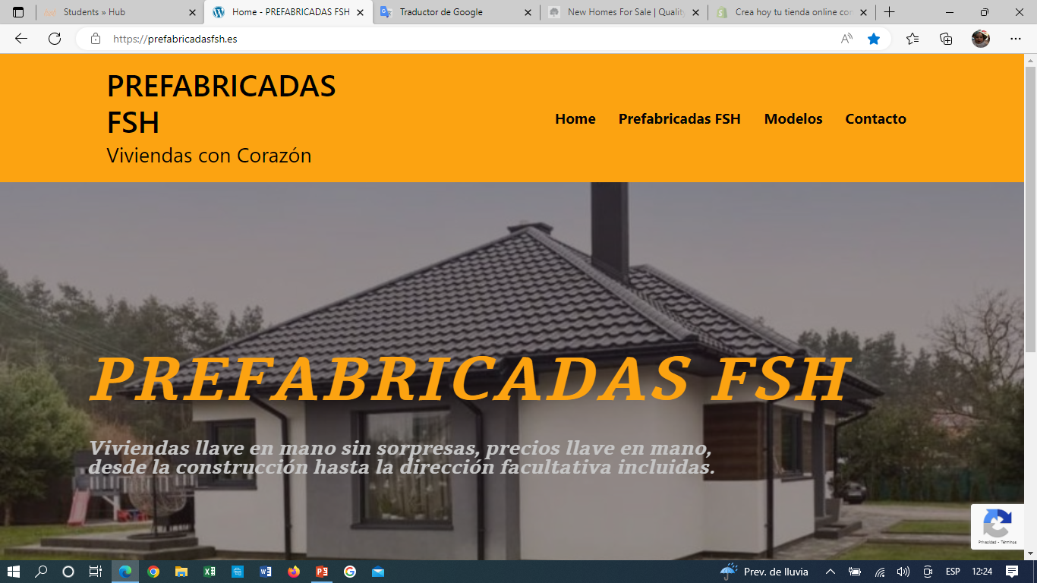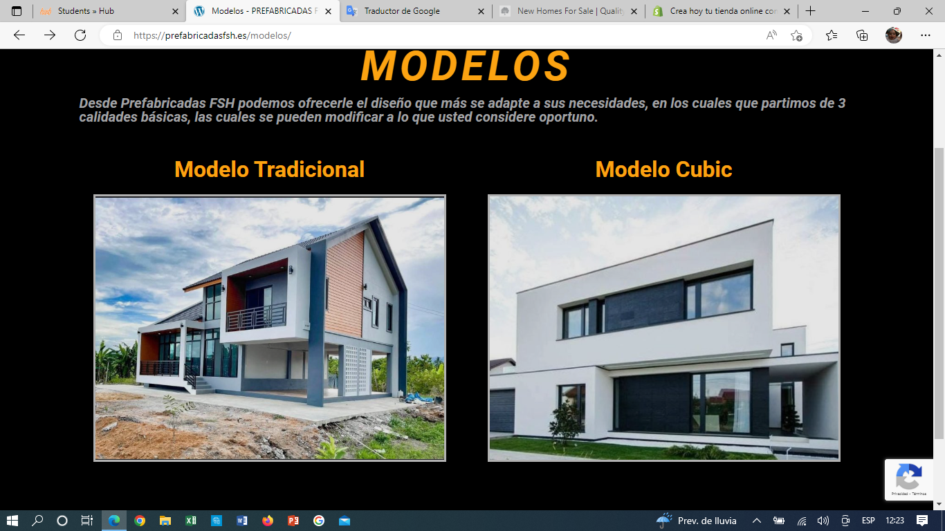
Figures 5 and 6: Website
(Source: Developed by prefabricadas FSH.es)

Financing: The amount of money that it would cost and the place from where it may get the required money
The actual amount of money that it may cost would be £1000 and the demand for e-commerce within the construction industry is higher than that of the cross-industry average where around 84% of the organisations in this same industrial domain may predict the selling amount near about 100% where the service of the construction may be delivered through online in the upcoming future. Thus, the required money can be achieved for e-commerce through affiliate marketing, where the lucrative, as well as the common methods, make an association with a variety of e-commerce websites that tend to be related to direct banner advertising, selling own construction materials and e-commerce-based services related to construction (De Vasconcellos et al. 2019). Along with that, PPC advertising where the construction cum e-commerce organisation may earn a certain amount of money by analysing the entire profitability of those PPC programs that depend on the website traffic, cost-per-click and click-through rate.

Required supplies and equipment
The required supplies for construction-based e-commerce are an enhanced shopping cart, highly customizable themes, email marketing tools, social media integration, a content management system, a flexible return policy and a mobile-friendly website too. Likewise, the required equipment in construction-based e-commerce is the thorough e-commerce platform, website building tool, content filing tools, social media management tools, online asset management tools, tracking and analysing tools, and lastly the email marketing tool.

Staff needed
As per the project plan, the staff will consist of an IT engineer and this team, who will look after the implementation and proper application of the different innovation technologies. Apart from this, the rest of the staff will consist of construction workers and other related personnel who will help in the creation of this service.

Payment Services
As per the project plan, customers are recommended to use either a credit/debit card or an online payment method for purchasing this service. The different recommended online payment methods are Google Pay, Phonepe and Paypal services. This is because most studies have shown that the use of such payment services tends to increase sales, with the added advantage of reduced transaction costs and increased payment security. Moreover, such payment methods tend to increase the availability of the service and boost faster sales and marketing (Park et al. 2019).
However, despite this recommendation, the use of credit or debit card is also accommodated. During a such transaction, the company plans on following all required security measures as per the awareness of Payment Card Industry Data Security Standard (PCI-DSS) compliance rules and regulations. Furthermore, owing to the expensive nature of such services, the company also plans on allowing customers to use other payment methods at their convenience.

2.3 Marketing

Promotion
As per the discussed marketing plan, the selected mode of promotion and marketing will be via the use of social media and other different e-commerce sites. The use of social media sites like Facebook, Instagram, etc has been recommended for conducting different promotional activities because according to different studies these sites tend to provide a cost-effective way of improving Brand Awareness, Brand loyalty, and Search Engine Ranking/Search Engine Optimization (SER/SEO).

Additionally, since such services are not common among the general population, promotions via the use of paid search engines like Google, Yahoo, Bing, Zillow etc are also proposed as this would help increase the visibility and marketing of such prospects. Spontaneous promotions using such services can also help in popularising such ideas, which can indirectly affect the related customer influx, sales and reputation of the service (Ginee, 2021). This will also increase the future scope of such services.

Target Customers
The targeted customers for this type of innovative service are generally upper-middle-class families. This is mostly because of the higher cost price of such services. Moreover, since such services are not popular among the general population, initially the target pool for such services will consist of wealthy people (Lessmann et al. 2021). In the future, it is hoped that such services will be used by the common, general, and middle-class families as well.

Additionally, the targeted customers will also be demographically and geographically segmented based on the different socio-economic parameters of the society. This will be done to determine an appropriate pricing strategy that can help boost the sales and marketing of such products.

Description of the customer journey
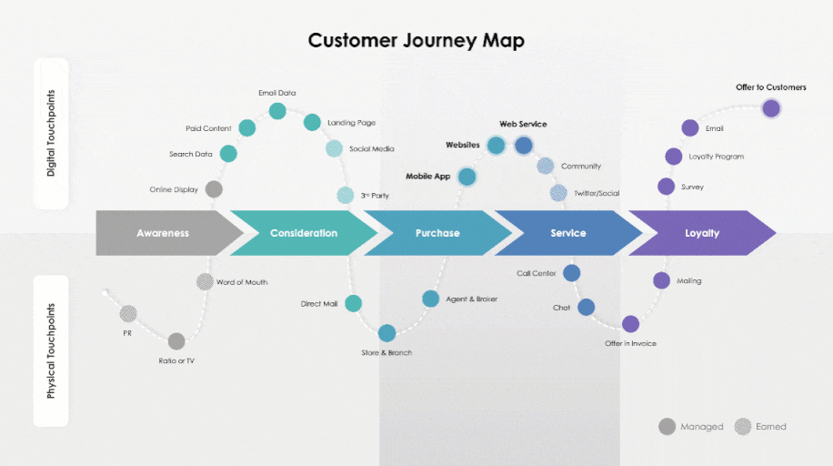
Figure 7: Overview of the recommended “Customer Journey Map”
(Source: Inspired by Rue, 2022)

The innovative nature of such services and the lack of similar products and services in today's market tend to highlight the need for describing the customer's journey in such cases. For this purpose, the company has decided to set up several cross-cultural teams from the service, sales and marketing departments at different levels that will help in the collection of data, which upon analysis will reveal the customer's journey and its impact on the sales and marketing of such companies (Berman, 2020).
Here, in this case, one must mention that as a part of the description of the customer's journey, special emphasis must be laid on the identification of the different factors that have helped these customers find and utilise such services. This is important because according to West et al. (2020), such factors can be used to step up a more geographically customized marketing plan, which will help increase the sales, popularity and reputation of such services.

Additionally, building a customer journey map for such innovation-based service areas also tends to highlight the different benefits of such services. this, according to many sellers helps in generating new buyers who might be interested in such services. Studies have shown that this type of customer influx can be closely related to the popularization of innovation and can be used to innovate the customer experience, on the whole, end-to-end (Rue, 2022).

Pre-launch/ Launch promotion
The recommended promotional activities during the pre-launch and launch of such services, especially for the first time includes the presence and availability of different discounts and other associated benefits. Additionally, as per the given market statistics and the economic conditions of the targeted country, the company has also decided to allow the “Pay Later” option. This has been done to increase the visibility and acceptance of such services among the general population.
Different studies have in this aspect highlighted the fact that such methods can also help in improving the brand image of the company and is more useful in the long run because it helps in the development of the customer-client relationship, which can boost all related parameters.

2.4 Cash Flow Forecast
Table 2: Cash Flow Forecast
(Source: Developed by author)

Conclusion
In conclusion, one can say the use of such innovation-based service areas in the construction sector can help in increasing the overall value of the construction chain. Studies have shown that by promoting innovation-based construction, one can enhance productivity and technology adoption parameters. This by extension in many cases has been proven to improve the urban quality of life. Furthermore, such services help in the positive upgradation of the different variables of the Knowledge Era, which by extension has been proven in many instances to be one of the major causes for growth and development in many companies.

Reference list
Berman, B., 2020. Paths to purchase: the seven steps of customer purchase journey mapping. Rutgers Business Review, 5(1), pp.84-100.https://papers.ssrn.com/sol3/Delivery.cfm/SSRN_ID3660155_code2749276.pdf?abstractid=3660155&mirid=1
De Vasconcellos, S.L., Garrido, I.L. and Parente, R.C., 2019. Organizational creativity is a crucial resource for building international business competence. International Business Review, 28(3), pp.438-449.
Ginee, 2021. 10 Paid Search Engine Marketing Advantages To Help Business. Available at 10 Paid Search Engine Marketing Advantages To Help Business - Ginee [Accessed on 11th October 2022].
Jalil, N.A. and Hwang, H.J., 2019. Technological-centric business intelligence: Critical success factors. International Journal of Innovation, Creativity and Change, 5(2), p.1499.
Lee, M., Yun, J.J., Pyka, A., Won, D., Kodama, F., Schiuma, G., Park, H., Jeon, J., Park, K., Jung, K. and Yan, M.R., 2018. How to respond to the fourth industrial revolution or the second information technology revolution? Dynamic new combinations between technology, market, and society through open innovation. Journal of Open Innovation: Technology, Market, and Complexity, 4(3), p.21.
Lessmann, S., Haupt, J., Coussement, K. and De Bock, K.W., 2021. Targeting customers for profit: An ensemble learning framework to support marketing decision-making. Information Sciences, 557, pp.286-301.https://doi.org/10.1016/j.ins.2019.05.027
Pappas, I.O., Mikalef, P., Giannakos, M.N., Krogstie, J. and Lekakos, G., 2018. Big data and business analytics ecosystems: paving the way towards digital transformation and sustainable societies. Information Systems and e-Business Management, 16(3), pp.479-491.
Park, J., Amendah, E., Lee, Y. and Hyun, H., 2019. M‐payment service: Interplay of perceived risk, benefit, and trust in service adoption. Human Factors and Ergonomics in Manufacturing & Service Industries, 29(1), pp.31-43. https://doi.org/10.1002/hfm.20750
Rue, N., 2022. Innovation Via the Customer Journey. Available at Innovation Via the Customer Journey - InnovationManagement [Accessed on 11th October 2022].
Shao, S., Hu, Z., Cao, J., Yang, L. and Guan, D., 2020. Environmental regulation and enterprise innovation: a review. Business Strategy and the Environment, 29(3), pp.1465-1478.
Ullah, K., Lill, I. and Witt, E., 2019, May. An overview of BIM adoption in the construction industry: Benefits and barriers. In 10th Nordic Conference on Construction Economics and Organization. Emerald Publishing Limited. Pp. 1-12.
West, S., Stoll, O., Østerlund, M., Müller-Csernetzky, P., Keiderling, F. and Kowalkowski, C., 2020. Adjusting customer journey mapping for application in industrial product-service systems. International Journal of Business Environment, 11(3), pp.275-297.Microsoft Word - IJBE110304 WEST_249556_no downsample (researchgate.net)

