2020
Mark Huntly - 1809693
Web Development, UWTSD School of Applied Computing
5/4/2020
Development of Web Application using MVC Pattern
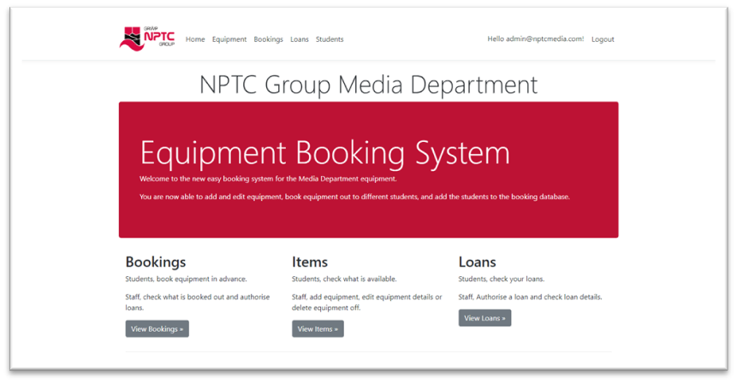
ACCA5012 – Application Development
Table of Contents
1.0 Introduction 1
2.0 Requirements 1
3.0 Design and Implementation 2
4.0 Testing and Evaluation 6
5.0 Conclusion 8

1.0 Introduction
The task presented in this report is the development of a web application to demonstrate understanding of the concepts, principle and technologies used in the Software Development Lifecycle (SDLC) of a web application.
The method chosen is the use of ASP.NET core framework, implementing a Model View Controller (MVC) pattern on Visual Studio, using C#, Html and CSS (in the form of Bootstrap framework). Javascript interactivity was a possibility here also to create further interactivity.

2.0 Requirements
The client brief followed for the application is to provide an online, automated booking system for a college. This system was to digitalise and automate the current paper booking system. The system is implemented to be able to facilitate a digitalised inventory of the equipment for loan to students in the media department.
As a must have, the requirements were to provide:
- A database list of students able to borrow the equipment.
- A database inventory of the equipment for loan, with descriptions and pictures.
- A facility for the students to be able to register bookings for the equipment.
- An authorisation system for administration staff to be able see, change, and authorise bookings and loans.
- An authorisation system for administration to be able to add, remove and change details for equipment and students.
- An authentication system for staff to be able to perform administration functions.
As a wish list, were to provide:
- Interactive search functions for looking up late returns.
- Interactive search functions for looking up student details for specific loans.
- The ability to turn a booking into an authorised loan.
The application had to be simple and easy to navigate and use for the staff and students.

3.0 Design and Implementation

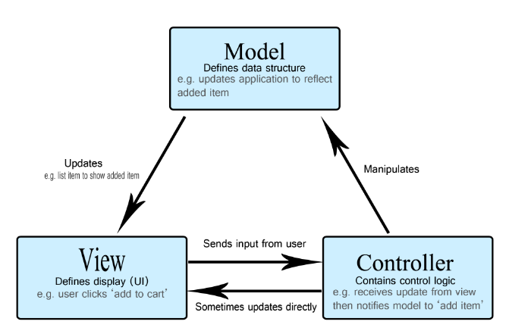
Figure 1 - The MVC Pattern [3]
The application design is following the Model, View, Controller (MVC) pattern, using ASP.Net Core framework to implement it. [1] [2] [3] [4]
This three-layered separation of concerns allows a more modular approach to developing a web application, through classes, enabling a more easily maintained system with the labour divided to separately handle the business logic, the display, and the commands. [3] [4]
The approach taken was the database first approach, as opposed to the code first approach, meaning that the database schema was designed initially to give a structure to how the application would operate and look. The initial stage, once the database and relationships had been designed, was to create the database and tables to enable the structure of the application to be created by Asp.net core.
From here the model classes, control classes, and view files were created to handle the above mentioned three layers, one for each of the functions within the application. In this case that is the bookings, items of equipment, booking of equipment and authorising of the loans. The model and control classes are c# whilst the view files are html with c# injections.
Once the scaffolded items had been created the next step was to manipulate and customise the views to create the navigation bars and home pages.
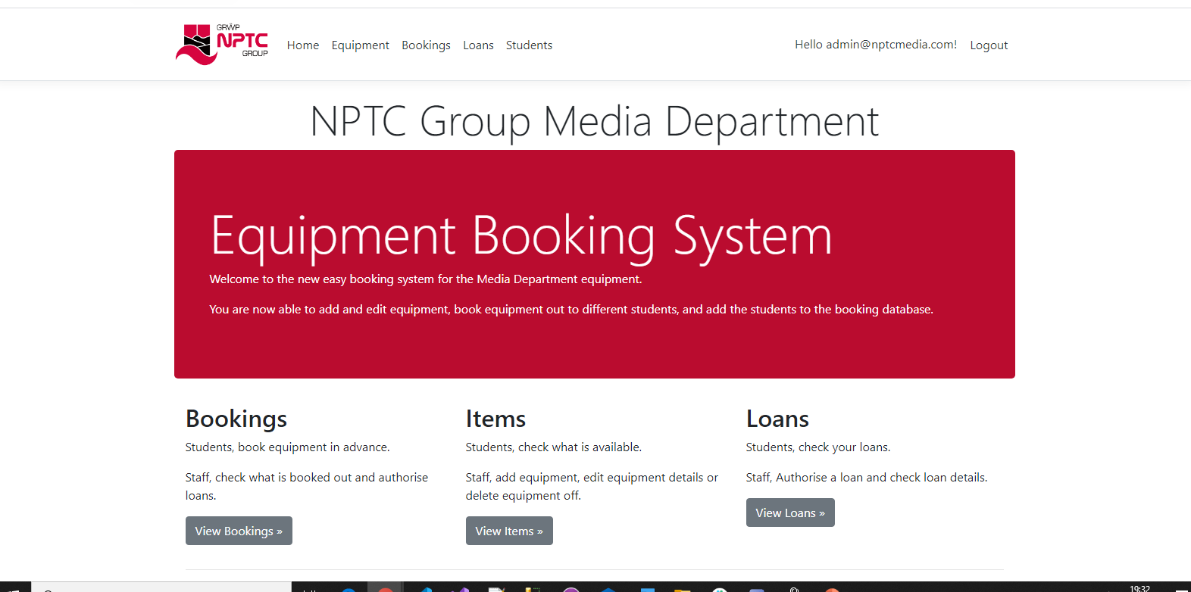
Figure 2- Customised Application Homepage
Each of the following pages connect to the database and create the data structures using the model. The instructions are sent through the controllers and DbContext migration and the model updates the view dependent on what the controller has told it based on user input through the view.
The equipment index page has been designed to give a quick glance of the item description and a picture of the item. It also has the item number so that this can be used in the bookings page.

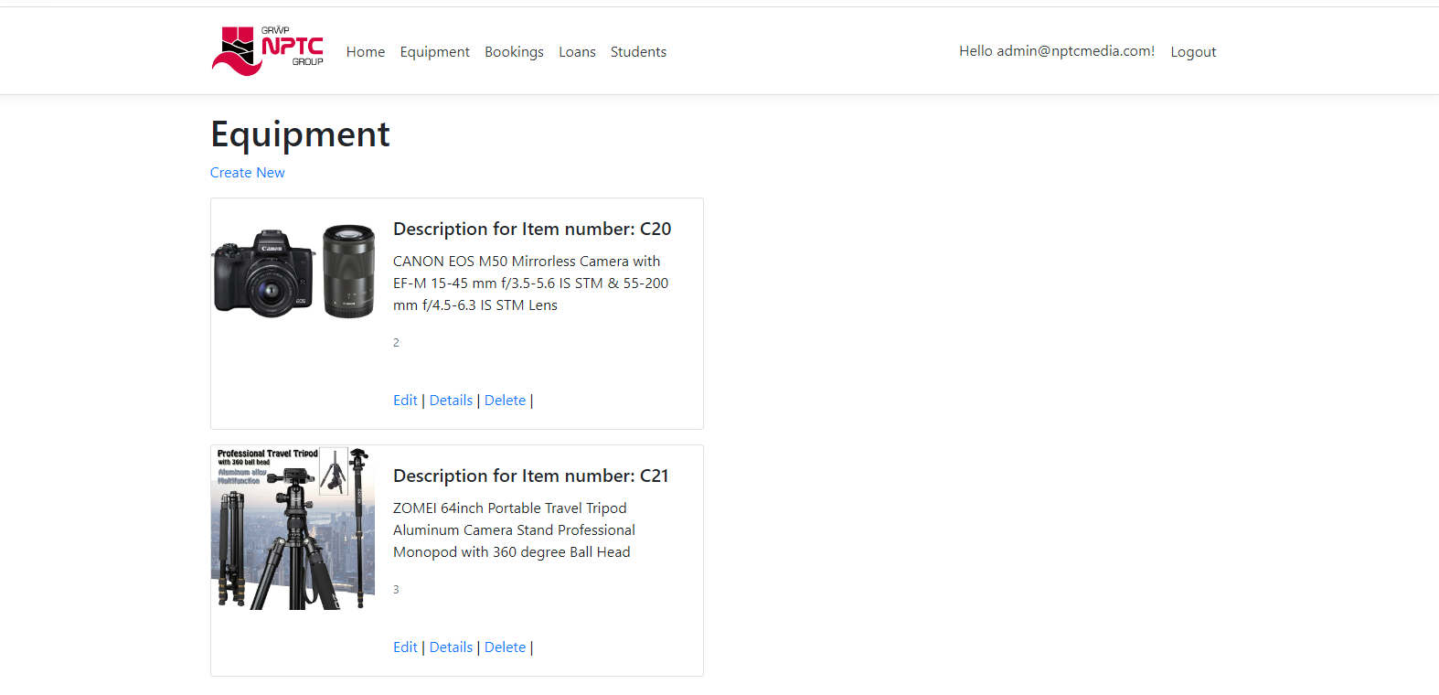
Figure 3 - Equipment index page
The bookings page allows functionality for students to enter a booking and edit it but only staff to be able to delete.
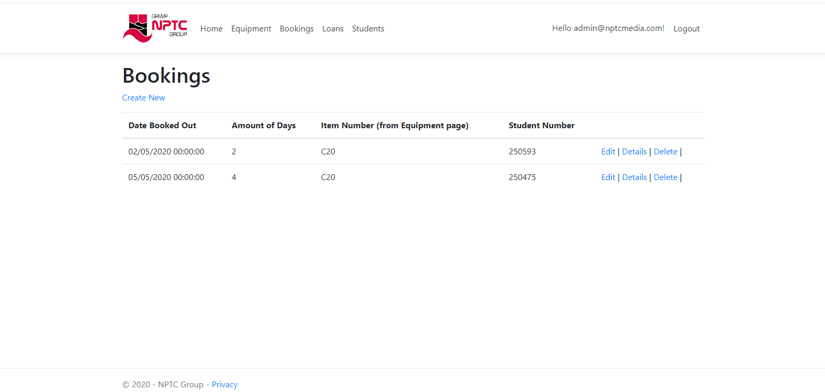
Figure 4 - Bookings index page
Search functionality has been added to the Students index page to be able to search and filter the students from the list by student number, first name or last name. This was done through a method within the controller. The student number is not necessary for the information needed in the student page but is useful as the bookings show the student number. Pagination has also been added to the page to limit the length of the page when more students are added.
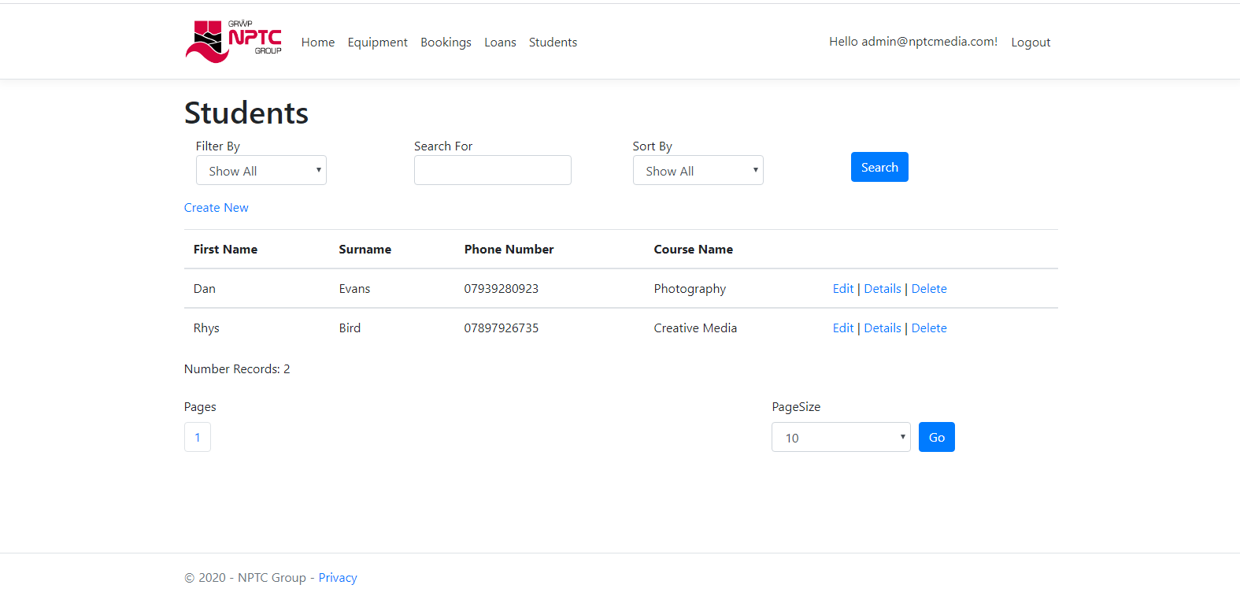
Figure 5 - Students index page
The loans page is ready with staff and admin functionality to perform the CRUD functions as loans need to be authorised by staff.
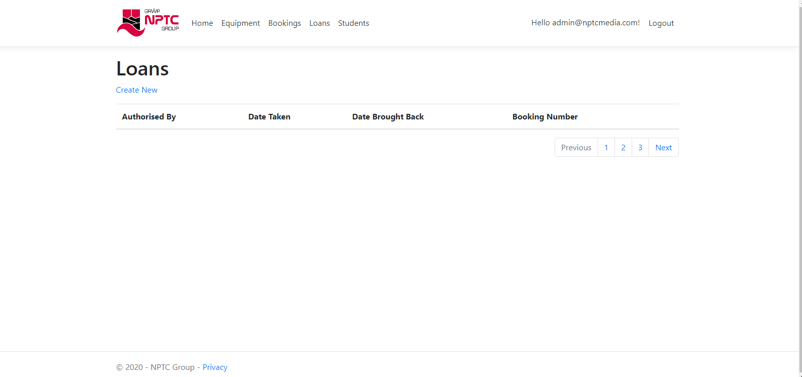
Figure 6 - Loans index page
The equipment create class allows the function to add items and the additional functionality has been added to allow upload of image files to see what the item of equipment look like. The edit has the same method to allow pictures to be uploaded.
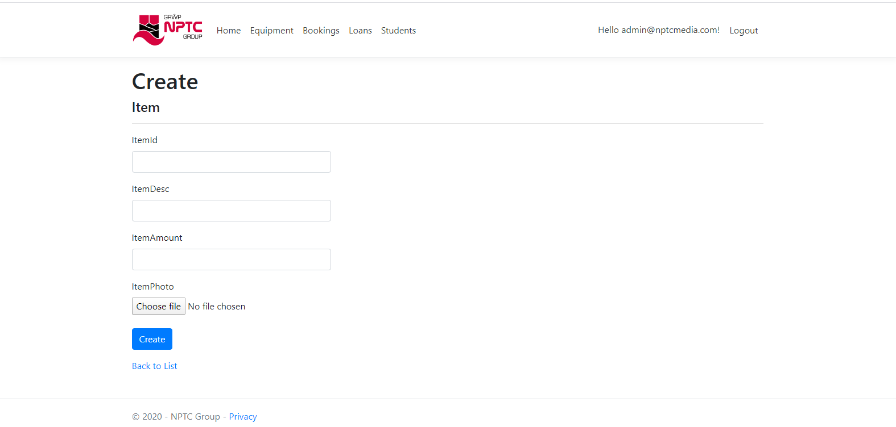
Figure 7- Equipment create page
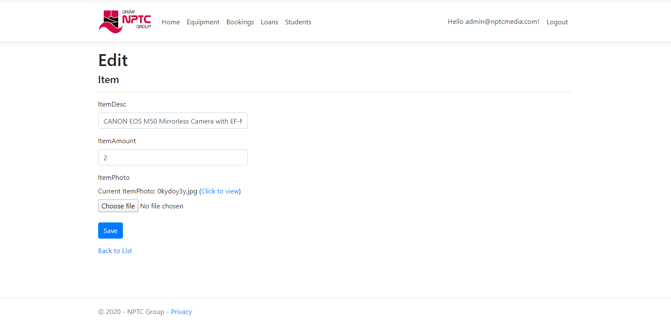
Figure 8- Equipment edit page
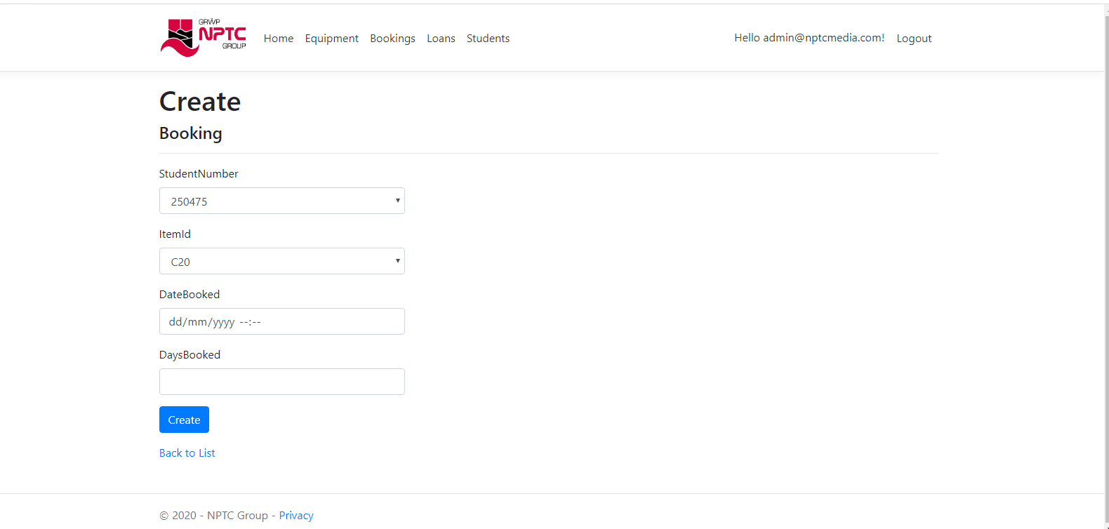
Figure 9- Create bookings page

4.0 Testing and Evaluation
Testing, being part of the software development lifecycle to implement effective software, in this case an effective application. [5] [6] A set of test cases were developed for the functionality implemented within the application and the test results captured. A select few of the tests are shown within the tables below. This allowed the errors to be corrected, so that implementation of a fully functioning application can occur.
Table 1 - Authorisation and authentication test
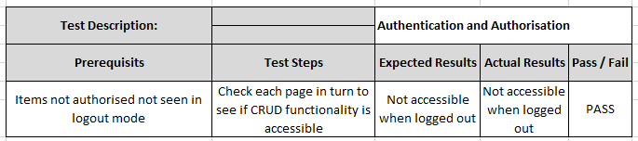
Table 2- Authorisation and authentication test
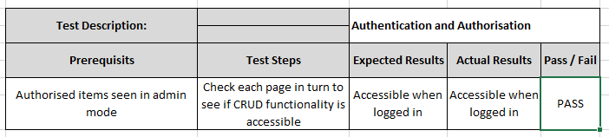
Table 3 - Failed search bar test
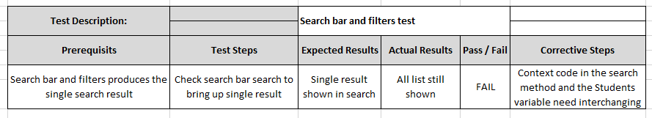
Table 4- Passed search bar test
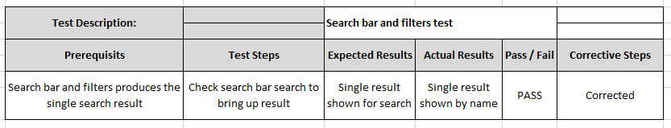
Table 5- Create Image file upload function test
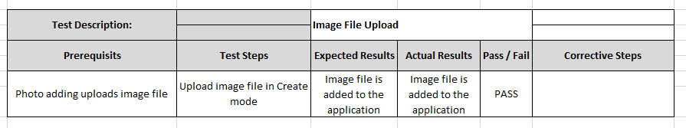
Table 6- Failed Edit image upload test
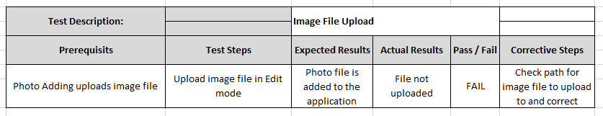
Table 7- Passed Edit image upload test
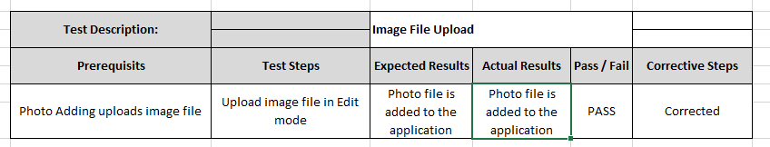

On reflection of the application developed so far, it is a basic functioning web application with the basic CRUD functions and good authentication and authorisation functions. The general data views are the basic views and could be developed further with linked table views to help with functionality in the application. The look of the website is minimalist and functional, and looks pleasing on the eye, with good functionality, as requested for the equipment. Most of the requirements have been met so far, however there are more requirements to complete the application such as linking the bookings table to the items and loans table to allow live interactive functionality. The application isn’t fully complete and doesn’t meet all the requirements as of yet.

5.0 Conclusion
The MVC model is a good model for modular three-tiered approach to development with easily maintained separate operational classes to look after their own concerns within the development and implementation cycle. ASP.NET through Visual Studio was an easy option in as much as the framework creates a lot of the functionality for the developer through an automated system, however, is hard to understand and operate without a full knowledge of Microsoft’s systems. It is felt there could be better ways to implement the MVC model using other frameworks or languages such as Javascript and / or PHP. The application was implemented well with most of the criteria met, and the functionality was good.
Future development of the application will see further search and pagination throughout the application. Moreover, it will have linked functionality to allow easy cross-referencing between views and subsequently tables to improve its functionality and practicality.

References

[1] | “What is ASP.NET?,” Microsoft, [Online]. Available: https://dotnet.microsoft.com/learn/aspnet/what-is-aspnet. [Accessed April 2020].
[2] | “ASP.NET Documentation,” Microsoft, [Online]. Available: https://docs.microsoft.com/en-us/aspnet/core/?view=aspnetcore-3.1. [Accessed April 2020].
[3] | “MVC,” MDN WebDocs, 19th May 2019. [Online]. Available: https://developer.mozilla.org/en-US/docs/Glossary/MVC. [Accessed May 2020].
[4] | D. M. Selfa, M. Carrillo and M. D. R. Boone, “A Database and Web Application Based on MVC Architecture,” in 16th IEEE International Conference on Electronics, Communications and Computers (CONIELECOMP 2006), 2006.
[5] | T. Jindal, “Importance of Testing in SDLC.,” International Journal of Engineering and Applied Computer Science (IJEACS), vol. 01, pp. 54-56, 2017.
[6] | N. Ruparelia, “Software development lifecycle models,” in ACM SIGSOFT Software Engineering Notes, 2010.

marking criteria and Student FEEDBACK

This section details the extent to which the assessment criteria are demonstrated by you, which in turn determines your mark. The marks available for each category of skill are shown. Lecturers will use the space provided to comment on the achievement of the task(s), including those areas in which you have performed well and areas that would benefit from development/improvement.

Common Assessment Criteria Applied (Assignment 2) | Marks available | Marks  awarded
1. Engagement with Literature Skills

2. Knowledge and Understanding Skills

3. Cognitive and Intellectual Skills

Overall, a good set of test cases have been developed highlighting errors and what was done to fix them. Generally, the scope of the test cases needs to be expanded upon. A good evaluation has been provided but generally needs to be expanded upon to provide a more critical evaluation of the application's functionality, highlighting its limitations and practical recommendations for improvements. (Grade mark: 66.67%) | 30 | 20
4. Practical Application Skills

A very good attempt featuring a simple application based on the class tutorial exercise, but there are a few things to note. Overall, a very good and well-thought-out database design, but the integration of these tables in the web application requires improvements to provide a more user-friendly and cohesive application. I think you should also have considered making this an application that requires authenticated access for all pages given the nature of the application. The login partial view could have been added to the home page, and if the current user is not logged in make all the other links invisible. The drop-down lists on the edit and create forms needed to be more user-friendly. Generally, good use of authorisation, but the implementation of authorisation for the Bookings and Loans had some problems. Good attempt at implementing the bookings and loans, but the workings and integration of the bookings and loans process could generally be improved as it was somewhat difficult to understand the difference between the two. (Grade mark: 66.67%) | 60 | 40
5. Transferable Skills for Life and Professional Practice

The report is well written and presented. (Grade mark: 80.00%) | 10 | 8

Assignment Mark (Assessment marks are subject to ratification at the Exam Board. These comments and marks are to give feedback on module work and are for guidance only until they are confirmed. ) | Late Submission Penalties (tick if appropriate) |  | 68%
 | Up to 1 week late (40% Max) |  | 68%
 | Over 1 week late (0%) |  | 68%

