
economics of sustainability bmsp 6007
Tutor: Anthony Burns

The gambling industry – the market failure and solutions implemented. Negative externalities of consumption.

Katarzyna White
1905801

Introduction
Gambling in the UK was legalised on the 1st of September 1960, which was seen as necessary due to outdated and archaic laws on gambling. By legalising gambling, the British government hoped to take gambling off the street, stop criminal activities and allow the government to have greater control over gambling activities (BBC Home, 2022).
Nowadays, the Gambling Commission regulates the UK gambling industry, representing the government's Department of Digital, Culture, Media and Sport (DCMS).
The Gambling Act of 2005 lists various forms of legal gambling in the UK, including arcades, betting, bingo, casino (brick and mortar and online), lotteries and gaming machines (Legislation.gov.uk, 2022).
The gambling industry was also affected by the Covid-19 pandemic forcing all physical establishments to close temporarily, resulting in a loss in revenues. However, there is data available from previous years stating that from April 2019 to March 2020, the UK gambling industry had a total gross gambling yield (GGY) of £14.2bn; the remote (online) gambling was the largest combined sector by GGY and before the pandemic in 2019 number of employees was estimated at 85 thousand (Gambling Commission, 2022).
In relation to the market growth of the gambling industry, the global pandemic has negatively affected the brick-and-mortar premises; however, the online gambling sector boomed due to many consumers choosing online platforms to participate in gambling activities. It is estimated that the online gambling sector will grow at a Compound Annual Growth Rate (CAGR) of 11.49% in the next five years (Mordor Intelligence, 2022). Due to the growing popularity of online gambling, there have been calls to review the gambling regulations to establish if the laws are appropriate to the digital era.

Gambling and its adverse effects
Leisure gambling is seen as entertainment undertaken occasionally and does not become problematic. According to Binde (2011), leisure gambling is motivated by "the dream of hitting the jackpot, social rewards, intellectual challenge, mood change, and the chance of winning viewed as a psychobiological and cultural entity" (Psychology Today, 2022).
On the other hand, a pathological or compulsive gambler is described as "someone who is unable to resist their impulses." Pathological gamblers are usually faced with dire consequences for their actions that have a spill-over effect on to others.
The Public Health England (2021) lists several types of harm caused by gambling: financial, relationship difficulties, mental health, cultural, loss of employment, crime, and homelessness.
Gambling inflicts a financial burden on the individuals, who often pass them on to their relatives, e.g., spouses, parents, children, or family and friends. Studies have shown that pathological gambling causes a loss of trust due to lies and dishonesty between spouses, resulting in the breakdown of the relationship (Corney & Davis, 2010). Moreover, gamblers' spouses reported isolation from family and friends, caused by shame and embarrassment, as well as conflicts in families caused by gamblers' borrowing and stealing of money (Mathews & Volberg, 2013).
Another adverse effect of gambling can be observed in children. Parents who are pathological gamblers are usually not available for their children physically and emotionally. A study suggests that children experience loss, such as loss of stability and reliability, loss of families, loss of trust, and poverty caused by financial and material loss (Darbyshire et al. 2001). Instability in children can have long-term effects that are often carried into adulthood, affecting their development.
Healthcare costs associated with gambling include "suicides, treatment of depression, treatment of alcohol dependence and treatment of illicit drug use" (Public Health England, 2021). A survey conducted by the Gambling with Lives organisation (2018) indicated between 250 and 650 gambling-related suicides every year in the UK. Moreover, there is a clear connection between the gambling problem and depression and impulse control disorders (Beaudoin & Cox, 1999; Black & Moyer, 1998).
Harms of gambling are diverse and negatively affect individuals by compromising their quality of life (Loo et al., 2016). The quality of life can be compromised by losing income, bailouts, unpaid debts and bankruptcies; these are also social costs that affect third parties.
The IPPR report (2016) suggests that gambling costs to the government are estimated between £260 million and £1.16 billion every year. They include health costs, welfare and employment costs, housing costs and incarceration costs (IPPR, 2016).

Negative externalities of consumption caused by pathological gambling

Gambling is classed as a demerit good. Compulsive gambling creates a negative externality of consumption due to addiction to gambling having harmful external effects on third parties.
Negative externalities of consumption refer to external costs created by the consumers while using the product or service where the social costs exceed private costs (AP Microeconomics, 2022). Negative externalities can cause market failure as they negatively affect third parties. In terms of pathological gambling, the direct costs/harms are associated with the individual – the gamblers; however, pathological gambling also causes external costs/harms to the healthcare, the government and the gamblers' inner circle.

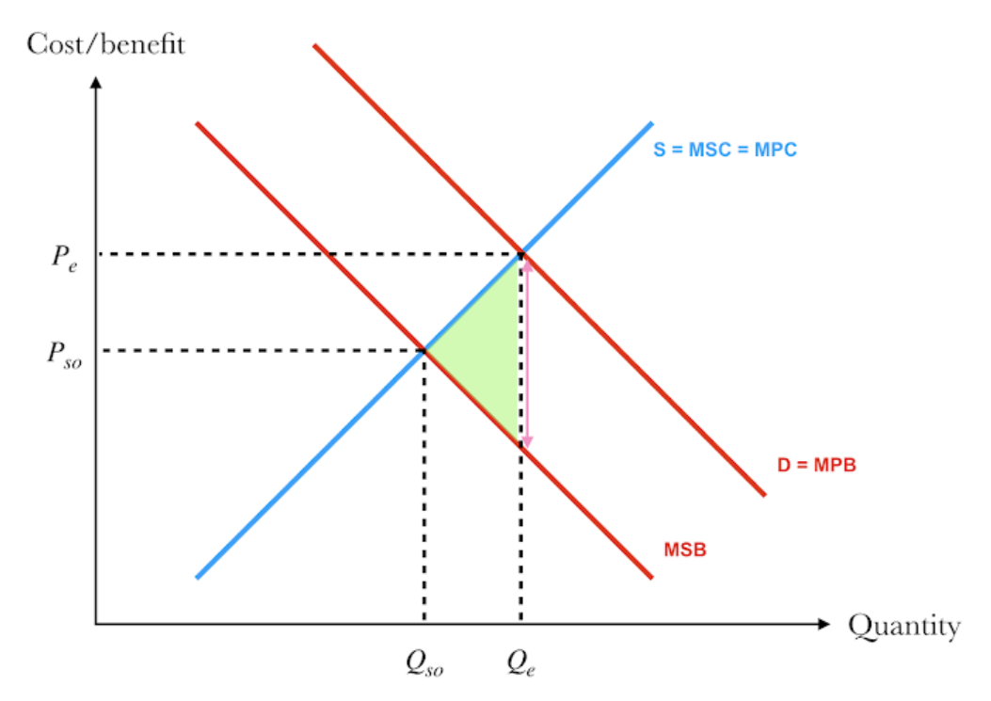

Figure 1. Source:Blitznotes, 2022.

Figure 1 presents the hypothetical negative externality of consumption due to gambling.
In the free market, where consumers are only concerned with the private benefits originating from consuming the product, Qe refers to the quantity of the products, and Pe is the price for which the product is bought and sold. In a situation where consumption of a product reduces the benefits of third parties, the benefits to society are less than the benefits attained by the individual who consumes the product. The marginal social benefits MSB are lower than marginal private benefits MPB. Qe > Qso, therefore, means overconsumption. The allocatively efficient point of consumption is Qso, where a market price is lower, and the quantity bought and sold is lower.
The green triangle presents welfare loss or deadweight loss, which is a total cost to society created by market inefficiency. Moreover, the negative externality of consumption occurs because of MPB > MSB. Additionally, the vertical distance between MPB and MSP marked with the pink arrow shows the negative externality.

Methods to improve market failure
Once the market failure is established, several different solutions can be implemented to fix the failing market.

Solution One – Indirect taxation
The initiatives implemented by the government, such as indirect taxation, can correct market failure. In the UK, gambling is tax-free, legal and fully regulated. Regardless of how much an individual wins, 100% of the win is given to the person, without the need for tax forms. The UK government recognised that the gambling industry is very profitable, as more money is lost by the bettors than won; therefore, the industry operators are required to pay a 15% tax levy. Meaning betting shops, poker rooms, casinos, and other gambling operators must pay tax on their profits. In 2018 the UK government increased taxation from 15% to 21% for remote (online) gaming duty, putting pressure on operators' margins. It was left to the operator to decide how to deal with the increase; they had a choice to accept the decrease in profits or pass the extra tax on to the consumer (HM Treasury, 2019)
In 2020/21 gambling industry contributed £2.8 billion in taxes (Statista, 2021).
Inelastic demand is when demand for goods stays at the same level regardless of the price change, for example, utilities or tobacco. The elastic demand usually refers to luxury items.
In terms of gambling, it can be assumed that for leisure gambling, price changes would affect the demand for goods; however, when it comes to pathological gambling, inelastic demand is more fitting. Pathological gambling is seen as an addiction; just like smoking, therefore, it would be classed as a necessity for some. And because of that reason, indirect taxation might not be the best solution to correct market failure.
Below is the diagram presenting the indirect tax on gambling.

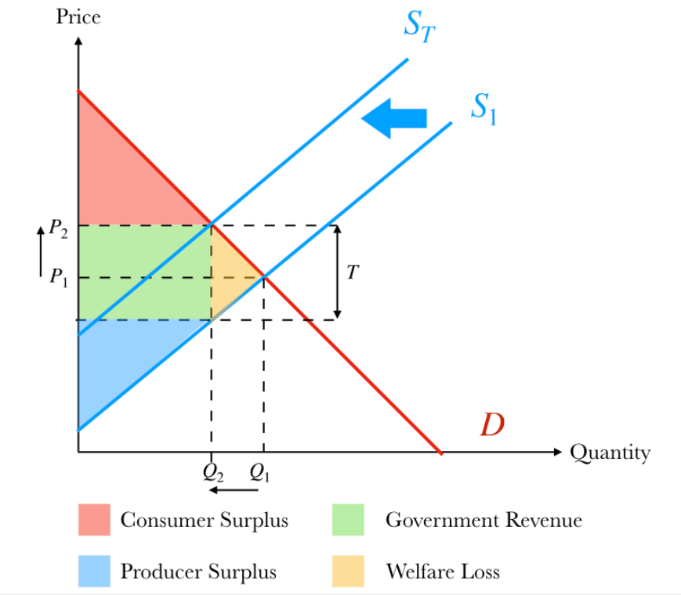

Figure 2 Source: Blitznotes, 2022

Figure 2 shows what happens when the government intervene to reduce negative externalities to correct market failure. The government imposed a tax of 15% on gambling operators. The consumer absorbs the tax through higher prices as gambling can be addictive and, therefore, inelastic. As shown in the diagram above, the supply curve shifts from S to ST after introducing the tax. The quantity Q1 shifts to the right to Q2. The price P1 moves upwards to P2, meaning the price increase. The new market equilibrium is at Q2 and the price P2.

Solution Two – Responsible gambling campaign
Gambling warning labels are used as a tool for responsible gambling. According to a study conducted by Floyd et al. (2006), warning messages were distributed around the gambling venues to educate consumers and reduce the gambling harm. Results showed that consumers were playing more rationally and taking fewer risks. Messages included statements such as "CAUTION: Wining is completely due to chance. No luck is involved. "or "CAUTION: If you bet more to make up for your losses, you are likely to lose even more money".

"When the FUN stops, stop" is a creation used by The Senet Group to support responsible gambling. The partnership between the major gambling operators like William Hill, Paddy Power, Ladbrokes and Coral created The Senet Group to promote more responsible gambling. According to The Senet Group, figures indicated that the campaign positively affected gamblers, with as many as 4 million people agreeing that the slogan helped them be more careful while gambling (The Senet Group, 2019).

Self-exclusion
According to Gambling Commission (2021), self–exclusion is a feature where an individual can ask to be self-excluded; this can be done online or on gambling premises. This facility is beneficial for people who think they might have a problem with gambling and want to stop it. The minimum exclusion time is six months. It is a requirement for all licensed gambling operators to have arrangements to aid everyone who wishes to self-exclude themselves from gambling.

Solution Three – Fixed odd betting terminal limits (FOBT)
On the 17th of May 2018, the UK government announced that the fixed odds betting terminal limits will be reduced from £100 to £2. Their decision was supported by the fact that playing FOBTs is highly addictive, and the intensity of a play can see investments of up to £18000 per hour. The government hopes that limiting the maximum stake to £2 will improve the negative image of the gambling industry but also address the societal issues caused by problem gambling (UK Parliament, 2019; Online Betting, 2022).

Solution Four – Protecting under-18s from gambling-related advertising harm.
Another measure taken by the Committee for Advertising Practice (CAP) to make gambling more responsible and protect the under-18s was to ban gambling ads that use influencers to promote the betting industry. In the article from The Guardian, it was stated that anyone who has a significant following, especially from under -18s, for example, a celebrity, footballer, or TV reality show contestants, is not allowed to be featured in ads promoting gambling. Moreover, the new rules expand to a "ban on showing specific teams' football kit and stadiums in ads, as well as using video game content and gameplay popular with under-18s." (Sweney, 2022).
The CAP reviewed BeGambleAware's report, highlighting that the regulatory changes need to be updated to protect young adults and vulnerable from gambling-related harms in ads. To evidence this point, the Young People and Gambling report 2019 highlighted that 11% of 11-16 years old were targeted with direct gambling marketing. Additionally, 36% of children between ages 11 and 16 admitted spending their own money on gambling activities within the last 12 months. The report has shown a 3% decrease from the previous year (Gambling Commission, 2019). It can be assumed that further bans on advertising mentioned above will offer an even more significant decline in gambling activities amongst under-18s, therefore limiting gambling harms.

In 2018, Gambling Commission announced a three-year National Strategy to reduce gambling harms. The main focus was on preventing harm to consumers and the public, making gambling fair and safe for consumers, and improving how the gambling industry is regulated (Gambling Commission, 2018). The Strategy 2018-2021 document raised concerns regarding increasing the funding necessary to tackle gambling harms. It was stated that the targets set for 2017 had not been met. Moreover, in 2020 an Advisory Board for Safer Gambling issued a paper calling for a statutory levy on all gambling operators, stating that the current voluntary system does not work. The current funding model is a voluntary donation system to a chosen charity called GambleAware. The target for each year is 0.1% of the Gross Gambling Yield. The new levy would provide funding for tackling gambling harms that is adequate and sustainable (Gambling Commission, 2020). The paper also brought up issues regarding the lack of transparency and equity amongst providers.

Due to the Act of Gambling 2005 being relatively new only recently, discussions regarding the failing gambling market started taking place more often in the last two years. It has proven challenging to provide data such as facts and figures representing the market after solutions were implemented. The National Strategy review was due to publish its findings in 2021; however, none were published during the course of writing this paper.

As stated earlier, the gambling industry is very profitable; unfortunately, not all operators behave responsibly and willing to cover the costs created by problem gambling. In order to fix the market failure due to gambling harms inflicted on third parties, it is recommended that gambling operators take full responsibility for the costs imposed on the NHS treatments for gambling addiction. The voluntary donation scheme does not fit its purpose; the set targets are not met; therefore, a more financial burden is placed on the already struggling healthcare system. It is believed that a call for a mandatory levy on all gambling operators should be put in place, making them accountable and liable.
Sticker gambling advertising rules need to be placed on operators, such as removing ads from being broadcast on television and social media. Also, online personalised advertising may seem highly unethical when targeting a specific type of consumer based on their preferences, age or demographic. The personalised ads might target problem gamblers based on their online activities and be very influential for under-18s.
The last recommendation is in regard to online gambling. The choice of games, the £250 maximum stake and no maximum payout amount, provides ample opportunities for consumers but also can be problematic. Therefore, it is also suggested that a maximum stake be limited to a much lower value, similar to FOBTs.
Moreover, it is not recommended to make gambling illegal as this would amplify the already existing issues. The gambling industry would carry on as usual but on illegal bases, with dire consequences for all affected. No one would be held accountable for the gambling harms.

In conclusion, provided evidence established that the UK gambling market is failing. The negative externalities of gambling cause spill-over effects on the third parties. Gambling harms inflict extra costs on healthcare, welfare and employment, housing and incarceration. Moreover, gambling harms are also associated with the breakdown of relationships and the well-being of children.
Although the negative externalities of gambling were relatively easy to evidence, the implemented solutions and market response to those solutions have proven to be challenging to verify. There seems to be an agreement that the gambling industry needs review due to increasing costs, the welfare of consumers, the new digital era and children's protection from gambling harms; however, the government response is slow and inadequate.
There are solutions in place, including the tax on gambling operators that are returned to the HMRC; the responsible gambling campaigns such as "when the fun stops, stop"; the self-exclusion agreements from gambling; the ban on ads that feature celebrities; the fixed odds betting terminal limit and the National Strategy to tackle gambling harms. However, it has to be noted the issues with the gambling industry only recently become spoken about, meaning there is a lot of room for improvement to be made. The government needs to take drastic measures to reduce gambling harms and acknowledge that profiting from someone's loss is not the way to keep the industry thriving.

References:
AP Microeconomics, (2022). Externalities. Available at: https://www.microeconomicsap.com/externalities-ap-microeconomics.html
BBC Home, (2022). On this day 1950-2005. 1 September. Available at: http://news.bbc.co.uk/onthisday/hi/dates/stories/september/1/newsid_2969000/2969846.stm
Beaudoin, C. M., & Cox, B. J. (1999). Characteristics of problem gambling in a Canadian context: A preliminary study using a DSM-IV-based questionnaire. The Canadian Journal of Psychiatry, 44(5), 483-487.
Black, D. W., & Moyer, T. (1998). Clinical features and psychiatric comorbidity of subjects with pathological gambling behavior. Psychiatric Services, 49(11), 1434-1439.
Blitznotes, (2022). Negative externalities of consumption diagram. Available at: https://www.blitznotes.org/ib/economics/market_failure.html
Clark, D. (2021). Statista. Betting and gaming tax receipts in the United Kingdom from 2000/01 to 2020/21(in billion GBP). Available at: https://www.statista.com/statistics/284338/betting-and-gaming-united-kingdom-hmrc-taxreceipts/#:~:text=Betting%20and%20gaming%20tax%20receipts%20in%20the%20UK%202000%2D2021&text=In%202020%2F21%20betting%20and,pounds%20in%20the%20previous%20year.
Corney, R., & Davis, J. (2010). Female frequent internet gamblers: A qualitative study investigating the role of family, social situation and work. Community, Work & Family, 13(3), 291-309.
Darbyshire, P., Oster, C., & Carrig, H. (2001). The experience of pervasive loss: Children and young people living in a family where parental gambling is a problem. Journal of gambling studies, 17(1), 23-45.
Floyd, K., Whelan, J. P., & Meyers, A. W. (2006). Use of warning messages to modify gambling beliefs and behavior in a laboratory investigation. Psychology of Addictive Behaviors, 20(1), 69.
Gambling Commission, (2018). Strategy 2018-2021. Available at: https://assets.ctfassets.net/j16ev64qyf6l/1GBL4oxzfZHLnW6hha6Ixh/f6f50060887d969dfbfa0c4ff6ff3600/Strategy-2018-2021.pdf
Gambling Commission, (2019). 11% of 11 -16 year olds say they have ever received direct marketing from companies about gambling. Available at: https://www.gamblingcommission.gov.uk/news/article/gambling-commission-publishes-the-2019-young-people-and-gambling-report
Gambling Commission, (2020). Advice to the Gambling Commission on a statutory levy. Available at: https://www.gamblingcommission.gov.uk/print/advice-to-the-gambling-commission-on-a-statutory-levy
Gambling Commission, (2021). Self-exclusion. Available at: https://www.gamblingcommission.gov.uk/public-and-players/page/self-exclusion
Gambling Commission, (2022). Industry Statistics - November 2020. Available at: https://www.gamblingcommission.gov.uk/statistics-and research/publication/industry-statistics-november-2020
HM Treasury, (2019). Gambling Duty: Public health effects of gambling duty provisions in Finance Act 2019. Available at: https://assets.publishing.service.gov.uk/government/uploads/system/uploads/attachment_data/file/824535/Final_gambling_duty_PDF.pdf
Legisaltion.gov.uk, (2022). Gambling Act 2005. Available at: https://www.legislation.gov.uk/ukpga/2005/19/contents
Loo, J. M., Shi, Y., & Pu, X. (2016). Gambling, drinking and quality of life: Evidence from Macao and Australia. Journal of Gambling Studies, 32(2), 391-407.
Mathews, M., & Volberg, R. (2013). Impact of problem gambling on financial, emotional and social well-being of Singaporean families. International Gambling Studies, 13(1), 127-140.
Mordor Intelligence, (2022). ONLINE GAMBLING MARKET - GROWTH, TRENDS, COVID-19 IMPACT, AND FORECASTS (2022 - 2027). Available at: https://www.mordorintelligence.com/industry-reports/online-gambling-market#:~:text=Market%20Overview,and%20psychological%20crisis%20during%20lockdowns.
Online Betting.org.uk, (2022). Everything You Need To Know About Fixed Odds Betting Terminals (FOBTs). Available at: https://www.onlinebetting.org.uk/betting-guides/fixed-odds-betting-terminals.html
Psychology Today, (2022). Gambling Disorder (Compulsive Gambling, Pathological Gambling). Available at: https://www.psychologytoday.com/gb/conditions/gambling-disorder-compulsive-gambling-pathological-gambling#:~:text=A%20compulsive%2C%20or%20pathological%2C%20gambler,denial%2C%20of%20having%20a%20problem.
Sweney, M. (2022). The Guardian. UK to ban gambling ads featuring sports and reality TV stars. Available at: https://www.theguardian.com/society/2022/apr/05/uk-to-ban-gambling-ads-featuring-sports-and-reality-tv-stars
The Senet Group, (2019). #BADBETTY CAMPAIGN. Available at: https://web.archive.org/web/20190529192541/http://senetgroup.org.uk/badbetty-campaign/
Thorley, C., Stirling, A. & Huynh, E. (2016). IPPR The Progressive Policy Think Tank. Cards on the table: The cost to government associated with people who are problem gamblers in Britain. Available at: https://www.ippr.org/research/publications/cards-on-the-table
UK Parliament, (2019). House of Commons Library. Fixed odds betting terminals. Available at: https://commonslibrary.parliament.uk/research-briefings/sn06946/#:~:text=What%20are%20fixed%20odds%20betting,the%20simulated%20outcomes%20of%20games

