Figure 1 (Art Pictures, n.d)
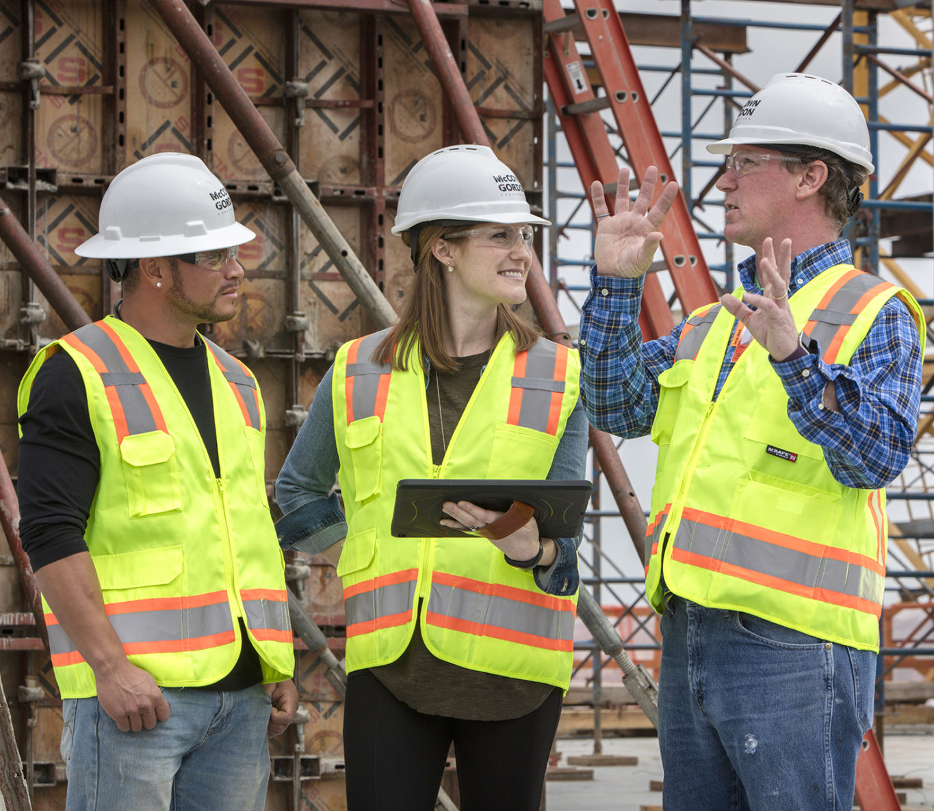
Trainee Health and Safety Officer- A Health and Safety Report for Kings Road, SA1.

Tom Butterworth (2409888) |  | Health, Safety and Welfare

Table of Contents-

1.0- Glossary 2
2.0- Introduction 3
3.0- Building Safety Act 3
4.0- Construction, Design and Management 4
5.0- Relevant Legislation 5
6.0- Conclusion 8
7.0- Appendix 8
8.0- References 10

1.0- Glossary
BSA (2022)- Building Safety Act (2022)
BSR- The Building Safety Regulator
CDM (2015)- Construction, Design and Management (2015)
HSWA (1974)- Health and Safety at Work Act (1974)
LOLER (1998) Lifting Operations and Lifting Equipment Regulations (1998)
NRCP- The National Construction Products Regulator
WAHR (2005)- Working at Height Regulations (2005)

2.0- Introduction-
Health and safety have become among the most important concerns raised in construction over the last few decades, not only for civilians but also for the workers themselves, after many serious disasters have occurred. The first regulation to protect workers' safety and welfare was the Health and Safety at Work Act (HSWA) in 1974 (Owen Construction Consultancy, 2023). Specific to construction, the construction, design, and management (CDM) regulations of 2015 must be followed by all to keep the public safe and construction workers (Owen Construction Consultancy, 2023). These health and safety protocols must be followed, even if they affect a project negatively.

3.0- Building Safety Act

The Building Safety Act (BSA) of 2015 is a law in the UK that aims to improve the design, construction, safety, and management of buildings, especially in the wake of the 2017 Grenfell fire (Pennington Choices, 2025). The act introduces new information for managing fire and building safety risks in higher-risk residential buildings, which must be taller than 18 metres, higher than seven storeys, or contain two or more residential units (Pennington Choices, 2025). These regulations can impact the construction as more extensive health and safety protocols will extend the project's timeline (Tunningley, 2025). With increasing project length, the costs will also begin to increase. This new act aims to put the safety of the occupant as the main priority, ensuring that they feel safe in their housing (Petty, 2024). The creation of the BSA introduced three new bodies that regulate the act: the Building Safety Regulator (BSR) who oversee the performance and safety of all buildings, especially taller ones, The National Construction Products Regulator (NRCP) who are responsible for surveillance and enforcement in construction in the United Kingdom, and the New Homes Ombudsman Scheme is a way for owners of a new-build residential area to let their complaints be heard by developers (Petty, 2024). This ensures that the responsibilities are shared equally, and issues don’t go ignored. The BSA (2022) introduced the ‘golden thread of information’, which means that every stage in construction must be documented and then regularly updated, recording the materials used in construction, the design decisions made by engineers, and modifications, interior or exterior that have been made (PBC Today, 2023). This means that people who are involved in alterations to the structure that weren’t involved in the original construction can have access to all the information they may need. The BSA (2022) also made a change to the materials used in high-risk buildings, demanding higher quality materials, such as cladding, to ensure their fire resistance (PBC Today, 2023). This can affect a project negatively as project costs will increase as higher quality materials cost more.

4.0- Construction, Design and Management
Many relevant pieces of legislation on construction have gained royal assent over the last decade that aim to protect the public as well as workers on and off-site. Construction is one of the most accident-prone industries, with 45 workers suffering life-ending injuries in 2023 (Protecting, 2024). In 1994, the construction, design, and management (CDM, 2015) regulations came into action, which were revised in 2015 (British Assessment Bureau, 2023). The CDM (2015) regulation was introduced to improve health and safety across all projects, regardless of project size, price, and timeline (British Assessment Bureau, 2023). The regulations guide ensures that all workers can identify and eliminate all risks before they appear, being discovered in the design phase of the project (Human Focus, 2022).
The CDM regulations assign different roles to different personnel involved in the project, known as duty holders, with clients, principal designers, and contractors all having differing roles in protecting the health and safety of workers and the public (Make UK, n.d). The client's role in the construction timeline is to begin discussions and ensure that the project is fully resourced, ensuring that health and safety is at the forefront by appointing competent and informed workers (Make UK, n.d). There are two different specifications for a client duty holder- a commercial client who is a business or organisation, and a domestic client who is an individual who has private work done to a residence (Make UK, n.d). The principal designers have their responsibilities, being in control over the pre-construction phase, as Yorkshire Health and Safety (2024) described. The role of the principal designer is to plan and organise the management of the pre-building phase, including preparation to detect and avoid any health and safety concerns (Yorkshire Health and Safety, 2024). The principal contractor also has a critical role during the construction process; having the responsibility of planning and directing the full construction phase of the project, taking into account the health and safety of the public, including people in the vicinity, occupants of the building or prevent unauthorised access, and personnel on-site (Health and Safety Executive, n.da).
The principal contractor and contractors must also communicate with the client and the principal designer to ensure that any risks that are discovered are managed and prevented (Health and Safety Executive, n.da). The designers working on a project also have a duty to follow the CDM (2015) regulations as they are part of the construction process. Project designers must take into consideration any issues regarding health and safety when preparing or modifying designs, eliminating risks before they appear for the principal contractor or the principal designer to discover and remove (Health and Safety Executive, n.db) They must also communicate and provide crucial information to the workers on site to ensure that the project runs without incident (Health and Safety Executive, n.db). Finally, the workers must be fully informed about their responsibilities whilst on-site (Health and Safety Executive, n.db). they must be regularly updated on how to keep themselves, other workers and the public safe.

5.0- Relevant Legislation

One piece of legislation relevant to this construction project is the Working at Height Regulations (WAHR). The main aim of the WAHR is to protect workers on site from injuries from height, most specifically falling. There is no specific height required to meet the WAHR requirements, meaning that any fall that includes a decrease in height is included in this (Health and Safety Executive, n.dc). This could even include injury from falling from the first step in a staircase. This must be reported as a fall from height by law. Workplace injuries must be reported under the Reporting of Injuries, Diseases and Dangerous Occurrences Regulation of 2013 (RIDDOR) (Kelsi, n.d). When working at heights, it is important that the relevant personal protective equipment is worn, such as a harness or fall pads to be in place to cushion any falls.
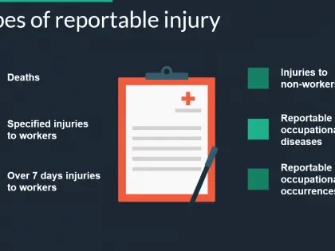
RIDDOR (2013) is a health and safety legislation which applies to all personnel on site, requiring them to record any injuries and incidents that happen at the job site (Guzder, 2019). If you don’t comply to the RIDDOR, it is classified as a crime which can result in fines (Guzder, 2019). When these instances are reported, it allows any risks to be identified to prevent them happening again (Guzder, 2019). Injuries that need to be reported include any that cause an employee to be off site or with their normal responsibilities being affected for seven days, any site deaths or any incidents involving the public being injured due to the sites work (Guzder, 2019). There are a few other instances where reporting is needed, including specific injuries such as burns, fractures and amputations, occupational injuries such as tendonitis, work-related dermatitis or hand-arm vibration syndrome, dangerous occurrences such as a fire and any gas related site instances (Guzder, 2019). These must be related to prevent further instances. One reason that health and safety isn’t always adhered to is inadequate training of personnel. To overcome this barrier to effective health and safety on site is to regularly train staff, giving them regular assignments to help them fully understand how to keep themselves and others safe (Viljoen, 2024). These assessments will also help gauge if the training is working correctly, allowing people in control to adjust accordingly.
Figure 2. (Trainer Bubble, 2015)

Another important piece of legislation for construction is the Lifting Operations and Lifting Equipment Regulations of 1998 (LOLER). The LOLER aims to ensure all lifting equipment is working correctly and is regularly monitored, maintained or replaced (Clarke, 2025). This legislation applies to any company or individual responsible for the use of lifting equipment and operations, with the aim to reduce injuries and dangerous equipment failures (Clarke, 2025). Employers must consider the lifting equipment sustainability, ensuring that is the correct piece of equipment for the project, taking into consideration the total load and its load type and the lifting environment (Clarke, 2025). They must also ensure that the equipment is safely installed, ensuring that the ground is stable, especially for cranes, and that the equipment is correctly set up to ensure that it doesn’t tip over (Clarke, 2025). Prior to use of lifting machinery, it is important to inspect its components (Clarke, 2025). There are mandatory time periods where equipment needs to be monitored, being every six months for machinery that is used to lift workers and every twelve months for all other lifting equipment, such as those lifting building components (Clarke, 2025). It is important to ensure that all lifting equipment is safe for workers to use as health and safety for workers is becoming increasingly important. In this project, it is important to adhere to these regulations as fines and injuries can have major setbacks in terms of time and money. To overcome the barrier of health and safety when using lifting equipment, it is important to invest in new safety equipment, stay informed with changing regulations to avoid penalisation and hire individuals to ensure equipment is safe (Viljoen, 2024).
Another similar regulation protecting workers on site is the Manual Handling regulations of 1992, later amended in 2002. These regulations lay out how to avoid and reduce the risk of injury from carrying equipment on site, laying out maximum weights for workers to carry (Murphy, 2021). There are a few ways that this regulation lays out how to handle heavy objects on site. It lays out how you should plan to carry items, giving you instructions on foot and back positioning, clothing to be worn and how to place down the object (Murphy, 2021). When moving objects on site, it is important to consider the task at hand, the individual tasked with moving the object, the load given to them and the environment surrounding them, also known as TILE (Murphy, 2021). If one of these isn’t right for the job at hand, the task shouldn’t be undertaken as it can be unsafe for the worker and those surrounding. Workers must not lift objects if: They aren’t suited to carrying out the work assigned, they aren’t wearing safe and suitable clothing and footwear, and if they do not have full training or understanding of the task at hand (Murphy, 2021). One way to overcome barriers to health and safety is to ensure that there is a culture of safety across the workers on site (Viljoen, 2024). All workers know what appropriate conduct on site is and how they can reduce injury risk.
6.0 Conclusion
Health and safety concerns are rapidly increasing in the world of construction as it is one of the most injury and death prone fields. Effective health and safety management is crucial for forming a safe and prolific workplace and staying within the law. This report has identified risks for the construction project on hand and how we can comply with them. Many of the issues brought up in the report may delay the project but not complying will delay the project further, extending project time and costs. Ensuring that health and safety is adhered to in construction will help progress the industry forward; increasing the workforce and removing many long-lasting stigmas

7.0 Appendix
Activity to be Assessed |  |  |  |  |  |  |  |  |  |  |  |  |  |  |  |  | Assessment Number
Construction of apartments at SA1. Working at height. |  |  |  |  |  |  |  |  |  |  |  |  |  |  |  |  | 2055
 |  |  |  |  |  |  |  |  |  |  |  |  |  |  |  |  | DKW020616
Persons undertaking or affected by the activity
 |  |  | Employees |  |  | Contractor |  |  |  | Public |  |  |  |  | Pupil |  |  |  |  |  |  | Service User
 |  |  | Other …………………………………………………………………………………………….
Identified Hazards and Associated Risks |  |  |  |  |  |  |  |  |  |  | Likelihood |  |  |  |  |  | Severity |  |  |  |  |  | Risk Level
1 | Fall From Working At Heights |  |  |  |  |  |  |  |  |  | 2 |  |  |  |  |  | 4-5 |  |  |  |  |  | High
2 | Poor weather conditions- Risk of slips |  |  |  |  |  |  |  |  |  | 2 |  |  |  |  |  | 3-4 |  |  |  |  |  | Medium/High
3 | Poor Form When Lifting |  |  |  |  |  |  |  |  |  | 4 |  |  |  |  |  | 2 |  |  |  |  |  | Low
4 | Lack of Knowledge of Safety |  |  |  |  |  |  |  |  |  | 4 |  |  |  |  |  | 4 |  |  |  |  |  | High
5 | Incorrect tool usage |  |  |  |  |  |  |  |  |  | 3 |  |  |  |  |  | 5 |  |  |  |  |  | High
6
Control Measures Required
1 | Ensure you lift objects with the correct technique and only carry heavy objects when necessary.
2 | Only work at heights when necessary, use offsite construction when appropriate.
3 | Ensure that workers are informed about the correct usage of tools
4 | Personal Protective Equipment must be always used on site, regardless of the job
5 | Ensure that machinery is compliant with health and safety protocols and are regularly monitored
6 | Ensure that workers on site are knowledgeable on health and safety protocols.
Reassessment of Activity Hazards |  |  |  |  |  |  |  |  |  |  | Likelihood |  |  |  |  |  | Severity |  |  |  |  |  | Risk Level
1 | Fall From Working at Heights |  |  |  |  |  |  |  |  |  | 3 |  |  |  |  |  | 4 |  |  |  |  |  | Medium/ High
2 | Poor weather conditions- Risk of slips |  |  |  |  |  |  |  |  |  | 2 |  |  |  |  |  | 3 |  |  |  |  |  | Medium
3 | Poor Form When Lifting |  |  |  |  |  |  |  |  |  | 3 |  |  |  |  |  | 2 |  |  |  |  |  | Low
4 | Lack of Knowledge of Safety |  |  |  |  |  |  |  |  |  | 2 |  |  |  |  |  | 4 |  |  |  |  |  | Medium/ High
5 | Incorrect Tool Use |  |  |  |  |  |  |  |  |  | 2 |  |  |  |  |  | 4 |  |  |  |  |  | Medium/High
6
Name: Tomos Butterworth  2409888 |  |  |  |  |  |  | Signed: TB |  |  |  |  |  |  |  |  |  | Date of Completion: 15/05/2025
Reviews |  |  |  | Key
Review Date: |  |  |  | Likelihood |  |  |  | Severity |  |  | Severity of Injury |  | 5 | 5 |  |  |  | 10 |  |  | 15 |  | 20 |  | 25
Reviewed by: |  |  |  | 1very unlikely  2 unlikely  3 likely  4 very likely  5 certainty |  |  |  | 1 nuisance  2 minor  3 medical treatment  4 major  5 fatal |  |  |  |  | 4 | 4 |  |  |  | 8 |  |  | 12 |  | 16 |  | 20
Review Date: |  |  |  |  |  |  |  |  |  |  |  |  | 3 | 3 |  |  |  | 6 |  |  | 9 |  | 12 |  | 15
Reviewed by: |  |  |  |  |  |  |  |  |  |  |  |  | 2 | 2 |  |  |  | 4 |  |  | 6 |  | 8 |  | 10
Review Date: |  |  |  |  |  |  |  |  |  |  |  |  | 1 | 1 |  |  |  | 2 |  |  | 3 |  | 4 |  | 5
Reviewed by: |  |  |  |  |  |  |  |  |  |  |  |  | 0 | 1 |  |  |  | 2 |  |  | 3 |  | 4 |  | 5
Review Date: |  |  |  |  |  |  |  |  |  |  |  |  |  | Likelihood of Injury
Reviewed by: |  |  |  |  |  |  |  |  |  |  |  | Low Risk |  |  |  |  |  |  | Medium Risk |  |  |  |  | High Risk

8.0- References

Art Pictures (n.d) Available at https://artpictures.club/autumn-2023.html (Accessed: 31 March 2025).
British Assessment Bureau (2023) CDM Regulations Made Simple – 11 FAQs Answered. Available at https://www.british-assessment.co.uk/insights/cdm-regulations-made-simple-11-faqs-answered/ (Accessed: 3 April 2025).
Clarke. A (2025) What are the Lifting Operations and Lifting Equipment Regulations 1998? ‘Praxis 42’ Available at: https://praxis42.com/resources/health-and-safety/lifting-operations-and-lifting-equipment-regulations-1998/ (Accessed: 13 May 2025).
Guzder. K (2019) What is RIDDOR & Why is it Important? ‘High Speed Training’. Available at: https://www.highspeedtraining.co.uk/hub/what-is-riddor/ (Accessed: 12 May 2025).
Health and Safety Executive (n.da) Principal contractors: roles and responsibilities. Available at https://www.hse.gov.uk/construction/cdm/2015/principal-contractors.htm (Accessed: 7 April 2025).
Health and Safety Executive (n.db) Summary of duties under Construction (Design and Management) Regulations 2015 (CDM 2015) Available at https://www.hse.gov.uk/construction/cdm/2015/summary.htm (Accessed: 7 April 2025).
Health and Safety Executive, n.dc) General work at height. Available at https://www.hse.gov.uk/work-at-height/faqs.htm (Accessed: 9 May 2025)
Human Focus (2022) What is Construction Design & Management Regulations 2015. Available at https://humanfocus.co.uk/blog/construction-design-and-management-regulations-2015/ (Accessed: 4 April 2025).
Kelsi (n.d) Accident/incident reporting, investigation, RIDDOR and frequently asked questions. Available at: https://www.kelsi.org.uk/__data/assets/pdf_file/0014/23513/Accident-incident-reporting-guidance.pdf (Accessed: 9 May 2025).
Make UK (n.d) CDM 2015 Regulations - Make UK's Ultimate Guide. Available at https://www.makeuk.org/insights/blogs/how-well-do-you-know-cdm-2015 (Accessed: 6 April 2025).
Murphy. N (2021) Manual Handling Regulations, ‘CPD Online College’. Available at: https://cpdonline.co.uk/knowledge-base/health-and-safety/manual-handling-regulations/ (Accessed: 13 May 2025).
Owen Construction Consultancy (2023) A history of safety in the construction industry. Available at https://owenconstructionconsultancy.co.uk/news/history-safety-construction-industry (Accessed: 1 April 2025).
PBC Today (2023) Enforcing the golden thread of information under the Building Safety Act 2022. Available at https://www.pbctoday.co.uk/news/building-control-news/building-safety-act-2022-golden-thread-construction-legislation/128210/ (Accessed: 3 April 2025).
Pennington Choices (2025). The Building Safety Act 2022: Everything you need to know in 5 minutes. Available at https://info.pennington.org.uk/blog/the-building-safety-bill-everything-you-need-to-know-in-5-minutes (Accessed: 31 March 2025).
Petty. L (2024) What is the Building Safety Act (BSA)? ‘High speed training’. Available at https://www.highspeedtraining.co.uk/hub/building-safety-act/ (Accessed: 2 April 2025).
Protecting (2024) Construction Health and Safety Statistics. Available at https://protecting.co.uk/construction-health-and-safety-statistics/ (Accessed: 3 April 2025).
Trainer Bubble (2015) RIDDOR 2013 Regulations – 1 Hour. Available at: https://www.trainerbubble.com/downloads/riddor-2013-regulations-1-hour/ (Accessed: 14 May 2025).
Tunningley. R (2025) Regulator Taking Twice as Long to Approve High Rise Developments in England, ‘Irwin Mitchell’ Available at https://www.irwinmitchell.com/news-and-insights/newsandmedia/2025/April/regulator-taking-twice-as-long-to-approve-high-rise-developments-in-england (Accessed: 1 April 2025).
Viljoen. L (2024) 6 Common Safety Management Challenges and How to Overcome Them, ‘Sheq Management’ Available at: https://www.sheqmanagement.com.au/common-safety-management-challenges/ (Accessed: 14 May 2025).
Yorkshire Health and Safety (2024) Duty Holders under CDM (Part 2): Principal Designer. Available at https://www.yorkshirehealthandsafety.co.uk/post/duty-holders-under-cdm-part-2 (Accessed: 7 April 2025).

