
7/23/2026
University of Wales Trinity Saint David
London campus
E-Portfolio Link: https://2542321.wixsite.com/begumeldek

Module Name: Learning In the Digital Era
Module Code: ACCA 4025

Student Name: Begum Eldek
Student ID: 2542321
Group: 1

Lecturer’s Name: Koushik Modak

LDE Assignment 1
E-Portfolio
Table of Contents
Introduction 2
Main Body 2
Task 1: Essential Academic and Employment Skills for the future career Path 2
Task 1 (a): Report on Essential Academic and Employment Skills 2
Task 1 (b): Evaluation of Task 1 (a) based on Similarity report 4
Task 2a: Mind Map (Collaborative) 5
Task 2b: Poster (Individual) 6
Task 3: Virtual Collaboration and RefWorks 7
Task 3a: Report on Virtual Collaboration 7
Task 3b: Step-by-step process of using RefWorks with visuals 8
Task 4: E-Portfolio Creation and Evaluation 14
Task 4 (a): E-Portfolio Creation 14
Task 4 (b): Illustrative Review of E-Portfolio tool Selection 23
Conclusion 24
References 24
Task 1 References: 24
Task 3 References: 25
Task 4 References: 25

Introduction
Nowadays, computing is becoming more important in many areas. Student need more than technical knowledge to get a good job in the future. They also need academic and employment skill work well and solve problems. In this report. I will discuss some important skills that can help me my study in my future career.

Main Body

Task 1: Essential Academic and Employment Skills for the future career Path

Task 1 (a): Report on Essential Academic and Employment Skills

Computing is an important and growing industry. I have chosen to build my future career in cybersecurity because I enjoy technology and want to help protect computer systems from cyber threats. To become a successful cybersecurity professional, I need to develop both academic and employment skills while I am studying at university.
One important academic skill is problem-solving. In computing, programmers often must find and fix errors in their code. Another important skill is research because technology changes all the time. Learning how to find reliable information helps students keep their knowledge up to date [1], [2]. I also think digital skills are very important because almost every task in computing uses computers, software, and online tools.
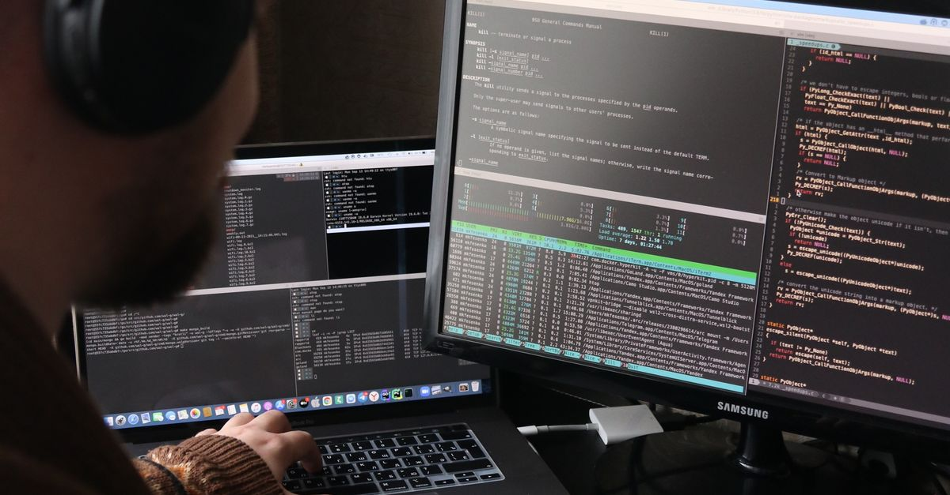Figure 1: Digital skills [3]

Employment skills are also necessary. Communication helps people share ideas with team members and explain technical information to clients. Teamwork is another important skill because many software projects are completed by groups of people instead of one person [4].
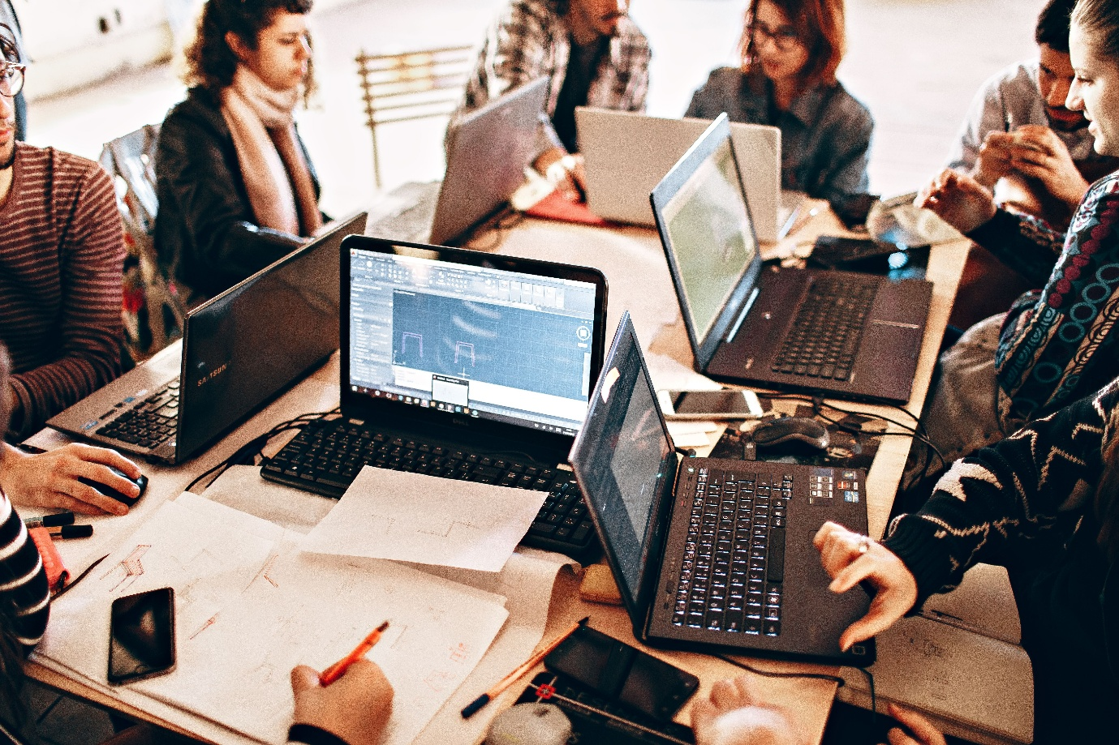
Figure 2: Teamwork [5]
I believe that improving these skills during my studies will help me find a good job after graduation. They will make me more confident. Improve my technical knowledge and help me work better with other people. I can also use AI tools such as ChatGPT to understand difficult topics and practise programming, but I should always use them responsibly and follow my university’s academic rules [6].
In the future, I would like to work as a Cybersecurity Analyst. This career requires strong technical knowledge, problem-solving skills, and continuous learning because cyber threats are always changing. I am motivated to improve my skills so that I can protect computer system and build a successful career in cybersecurity.

Task 1 (b): Evaluation of Task 1 (a) based on Similarity report
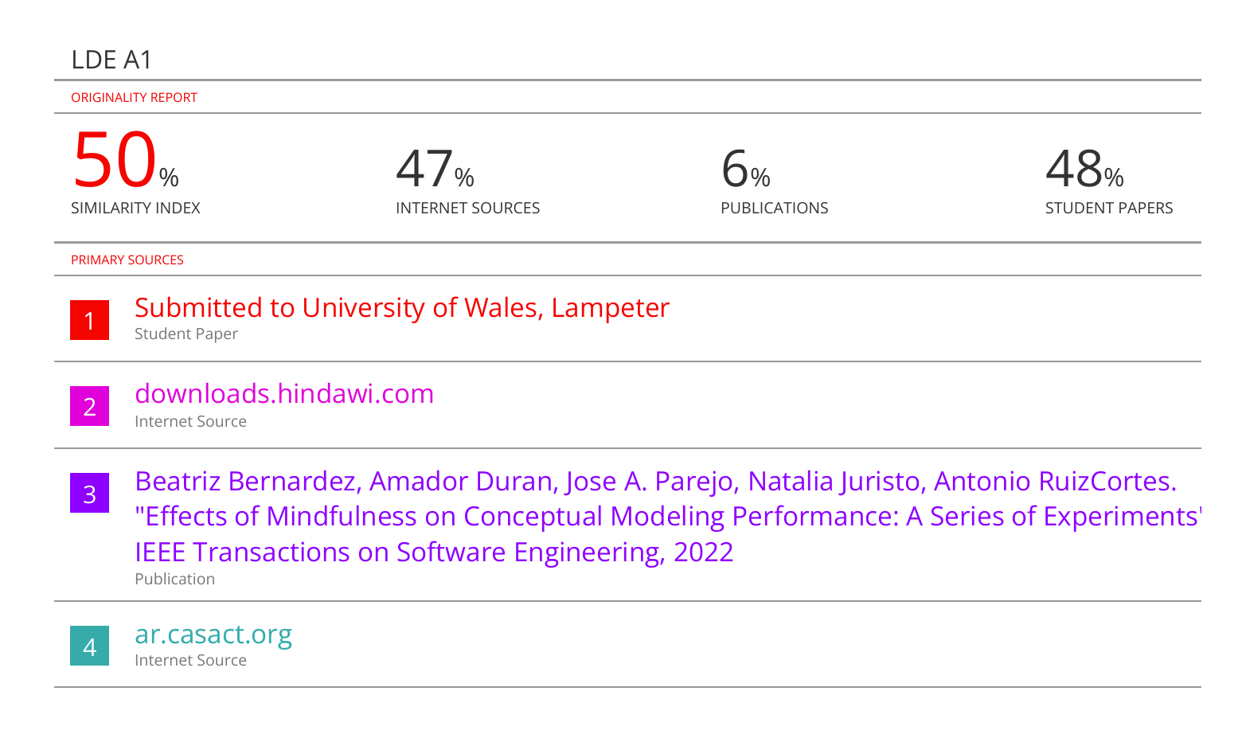
My Turnitin Similarity score is 50%. After applying the exclude quotes and exclude bibliography filters, the similarity score decreases 41%. Most of the remaining similarity comes from the assignment template, section headings, and other standard text provided by the university. I believe the score will be lower after removing the template content and making my writing more original before the final submission.
Based on the Generic Assessment Criteria (GAC), I would award myself 75% because I completed all the required tasks, used IEEE referencing correctly, and organized my work clearly. However, I can still improve my academic writing and provide more detailed discussion in future assignments.

Task 2: Collaborative Mind Map and Individual Poster

Task 2a: Mind Map (Collaborative)
Mind Map link: https://mm.tt/map/4030976520?t=W733O9Thx6
Mind Map Screenshot:
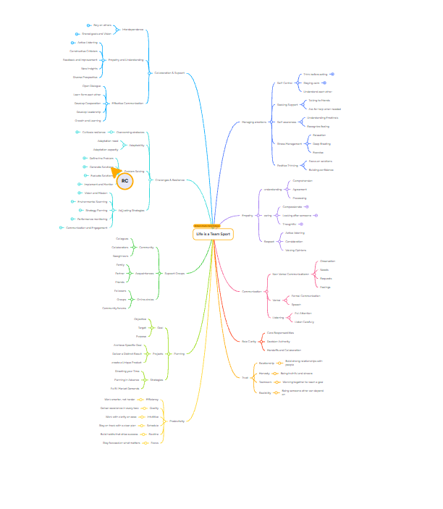

Task 2b: Poster (Individual)

Poster link: https://canva.link/3oczogq6t9hhcty

Poster Image:

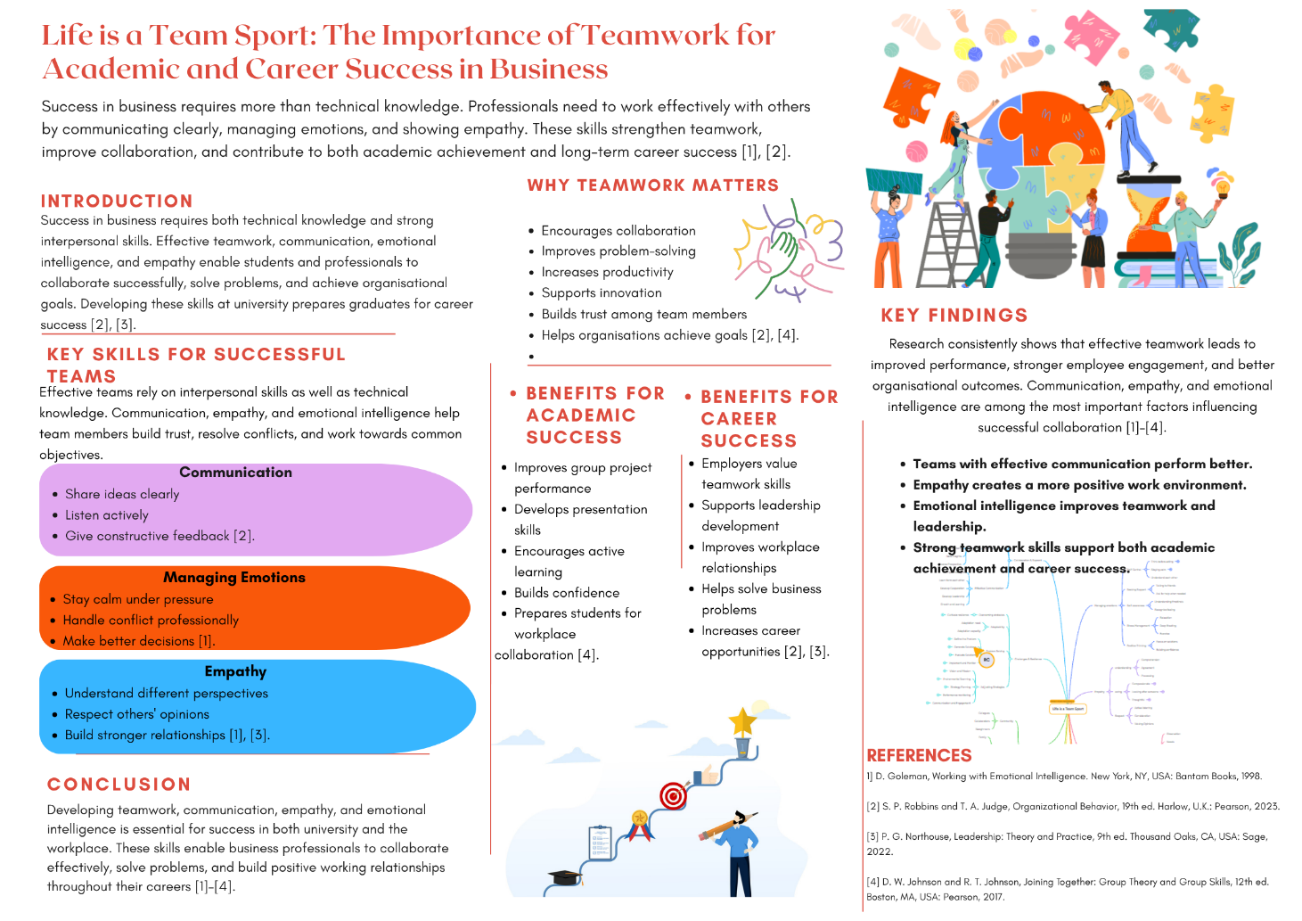

Task 3: Virtual Collaboration and RefWorks

Task 3a: Report on Virtual Collaboration
Unit 3 Topic Summary: Topic 4: Lights, Camera, Action!
Virtual Collaboration is important today. Many companies and universities use online platforms because people do not always work or study in the same place. With virtual collaboration, team members can communicate, share ideas, and finish their work together. To do this successfully, good communication and suitable technology are needed [1].
Many different tools are used for virtual collaboration. Microsoft Teams, Zoom and Google Meet are some common examples. These platforms make online meetings easier and allow people to share their screens or files. Also, shared documents help team members work on the same project at the same time. This makes teamwork faster and more organized[2].
Good communication is one of the most important parts of virtual teamwork. Team members should answer messages on time and explain their ideas clearly. Listening to others is important too. Sometimes, not easy it is to understand another person’s opinion during an online meeting. Because of this, asking questions and giving clear feedback become more important.
There are also some challenges in virtual collaboration. Internet problems can interrupt meetings. Different time zones can make it difficult to find a suitable meeting time. Sometimes, people may misunderstand each other because body language is not always clear through a screen. Small communication problems can become bigger if they are not solved early[3].
To work better as a virtual team, clear goals should be set from the beginning. Every member should know their responsibilities and finish their tasks on time. Regular meetings and updates also help the team stay connected. Important it is to support each other and solve problems together. This creates trust between team members and improves the quality of teamwork.
In conclusion, virtual collaboration is now a normal part of work and education. It has some difficulties, but these can be reduced with good communication and the right digital tools. When everyone works together and shares information effectively, virtual teams can achieve their goals successfully.

Task 3b: Step-by-step process of using RefWorks with visuals
First, I searched for suitable sources related to my topic on Google Scholar. I selected useful references that I wanted to use my assignment.
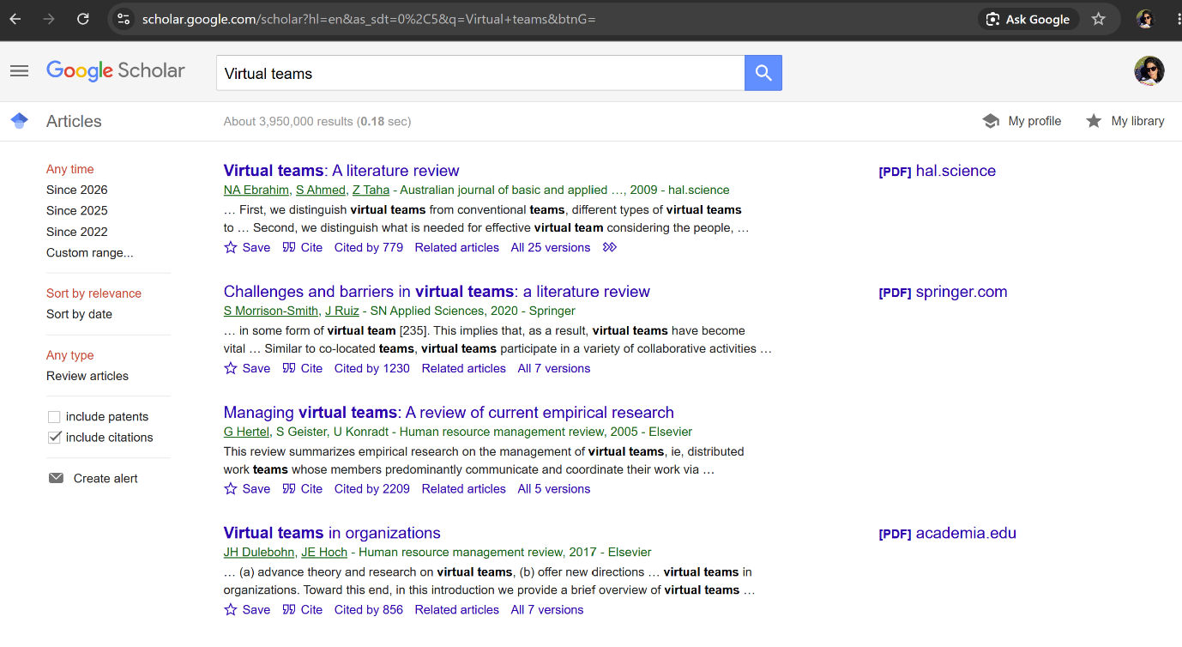Screenshot 1: Searching for sources on Google Scholar

After finding a suitable source, I clicked the “Cite” button on Google Scholar. Then, I selected RefWorks from the available options to export the reference.
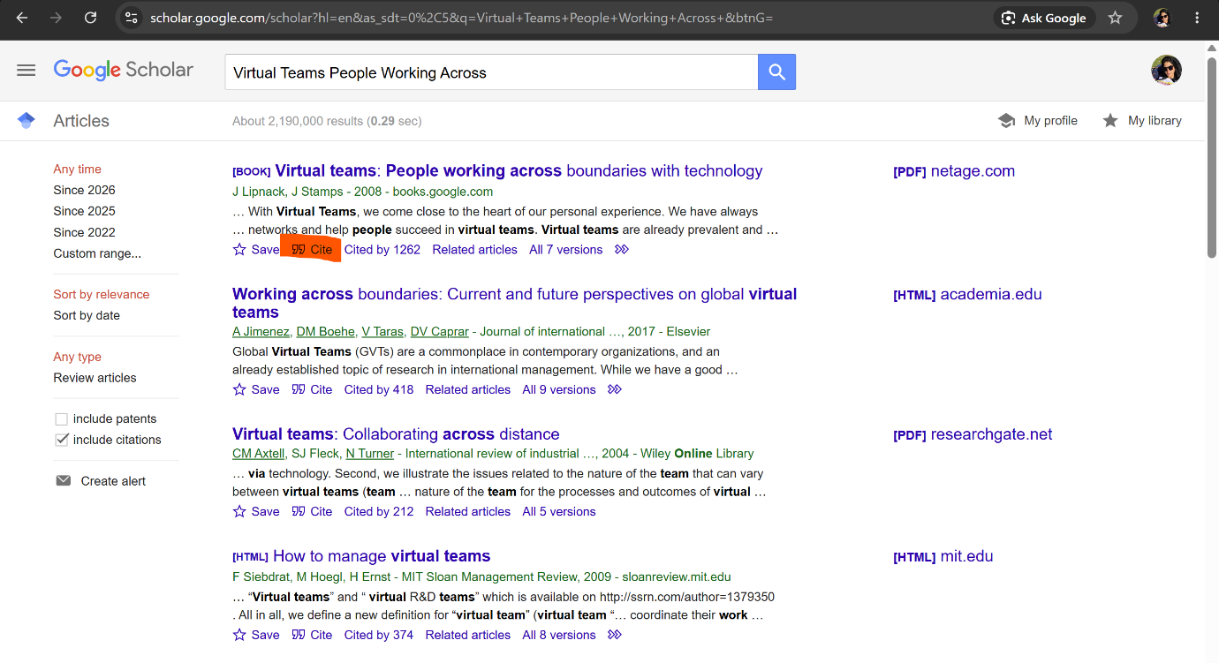
Screenshot 2: Exporting a reference from Google Scholar to RefWorks

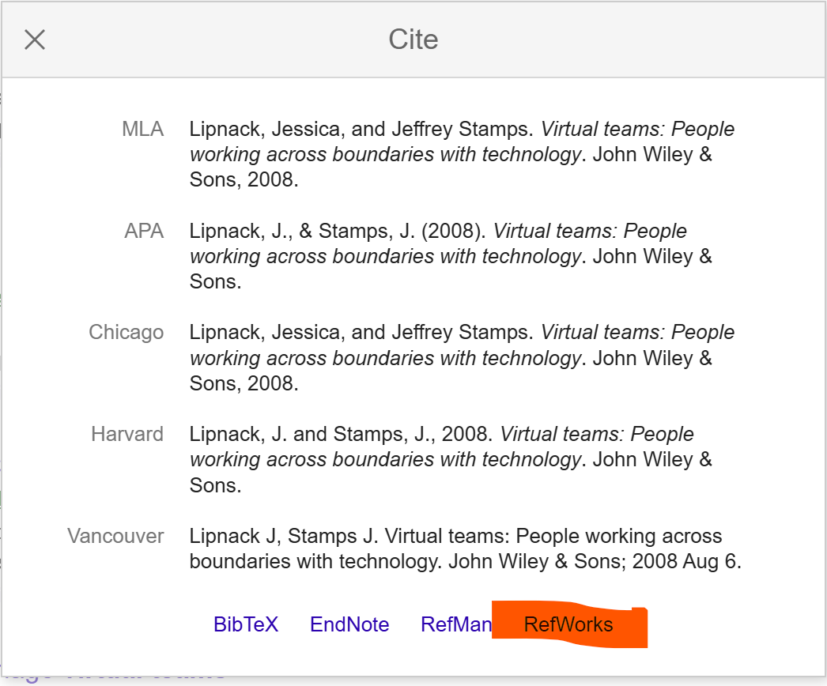
Screenshot 3: Selected RefWorks
This screenshot shows the reference imported into my RefWorks account. The source information was automatically added to my reference library.
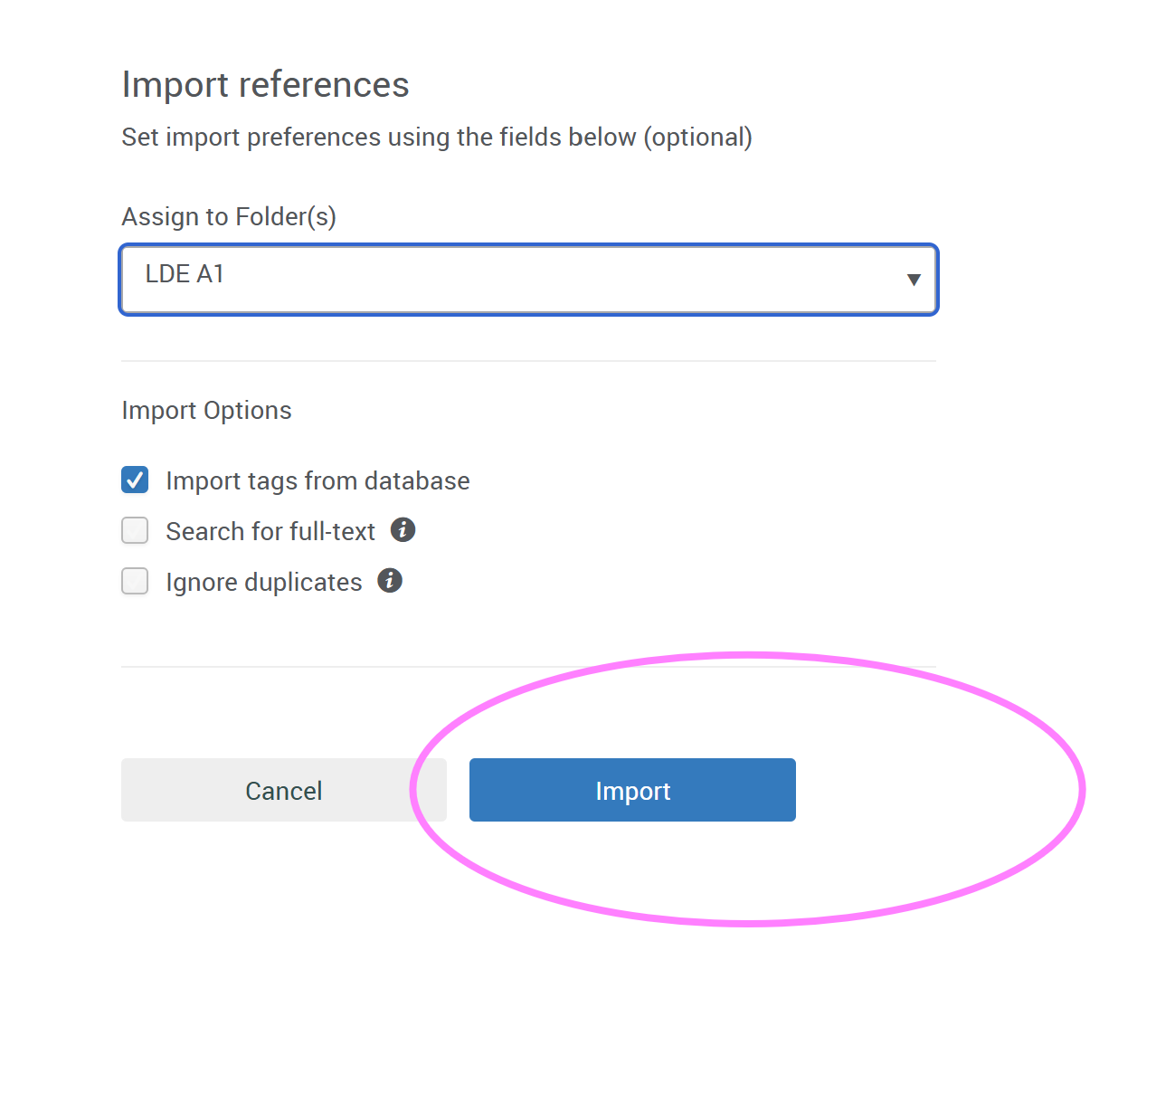Screenshot 4: Importing the reference into RefWorks
I checked the reference details in RefWorks, including the author’s name, title, and publication year. I made sure that the information was correct.
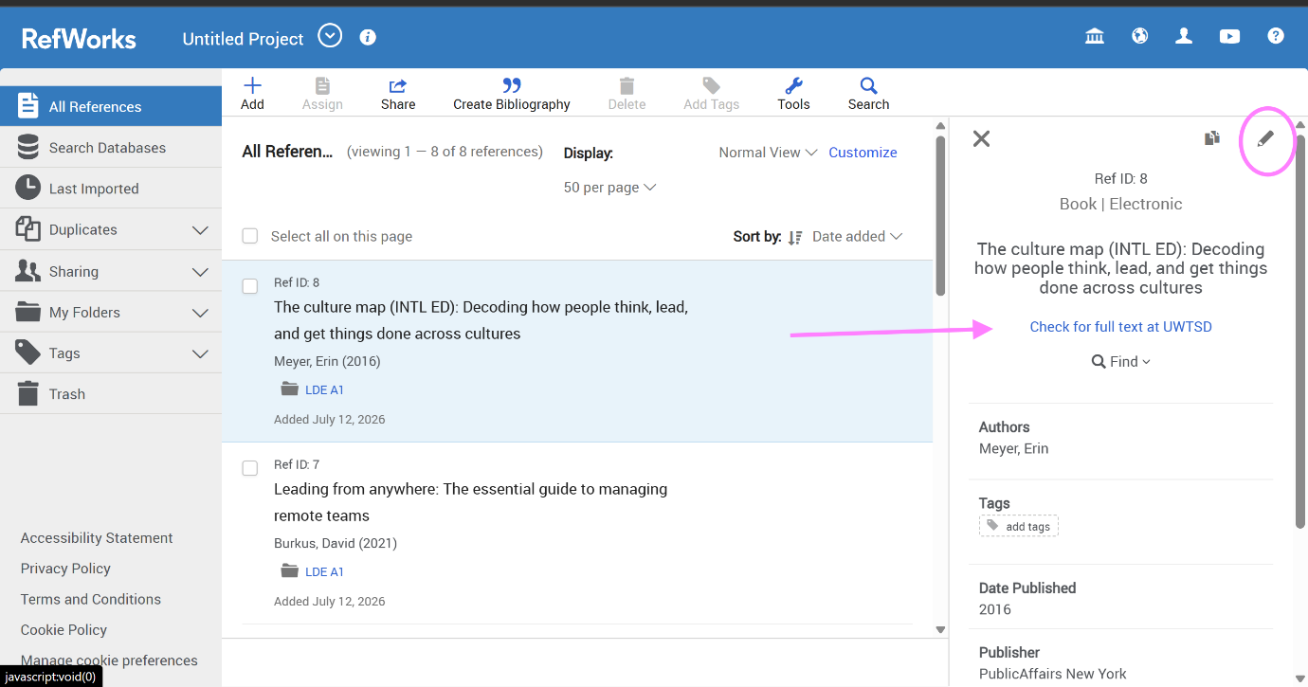
Screenshot 5: Checking and editing references in RefWorks

I opened my assignment document in Microsoft Word and connected it with RefWorks Citation Manager. This allowed me to add citations directly to my document.
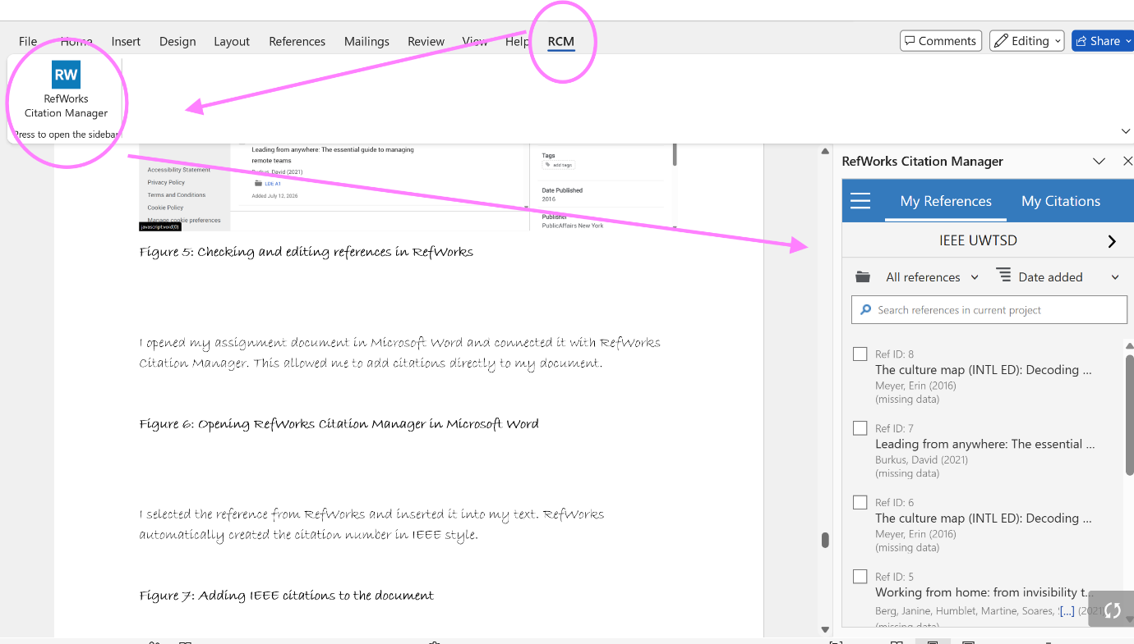
Screenshot 6: Opening RefWorks Citation Manager in Microsoft Word

I selected the reference from RefWorks and inserted it into my text. RefWorks automatically created the citation number in IEEE style.
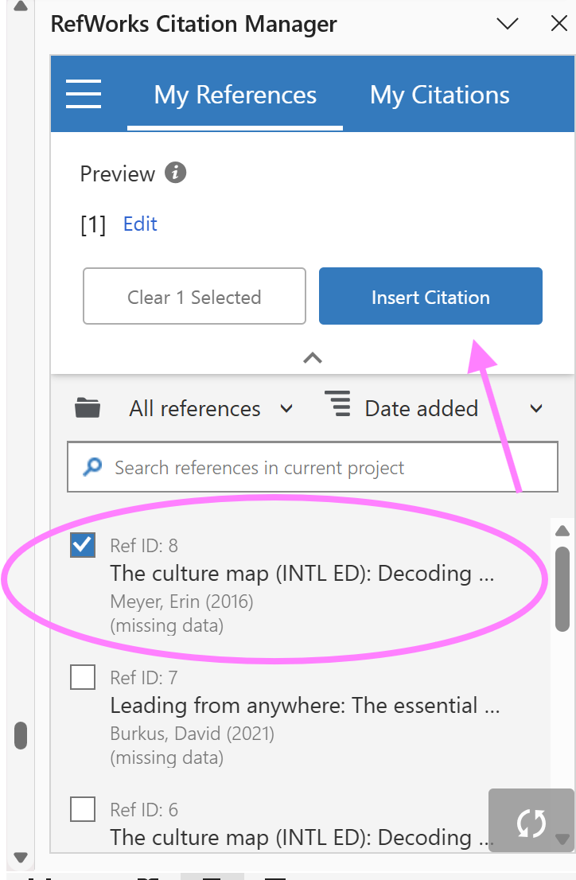
Screenshot 7: Adding IEEE citations to the document

Finally, I used RefWorks to create the reference list. The tool automatically generated the bibliography in IEEE format.
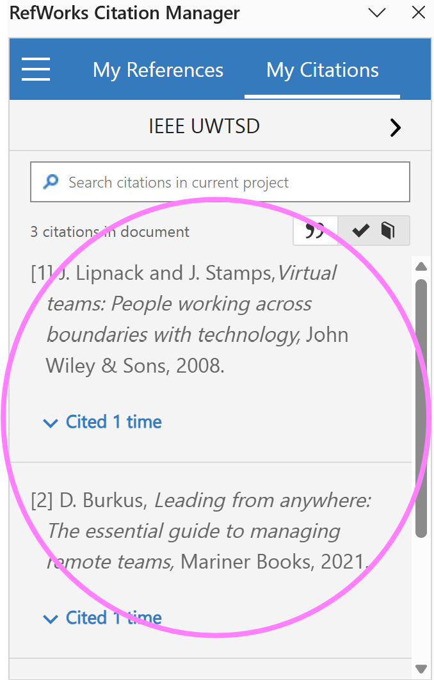
Screenshot 8: Creating the automatic reference list

Task 4: E-Portfolio Creation and Evaluation

Task 4 (a): E-Portfolio Creation
E-portfolio Link: https://2542321.wixsite.com/begumeldek

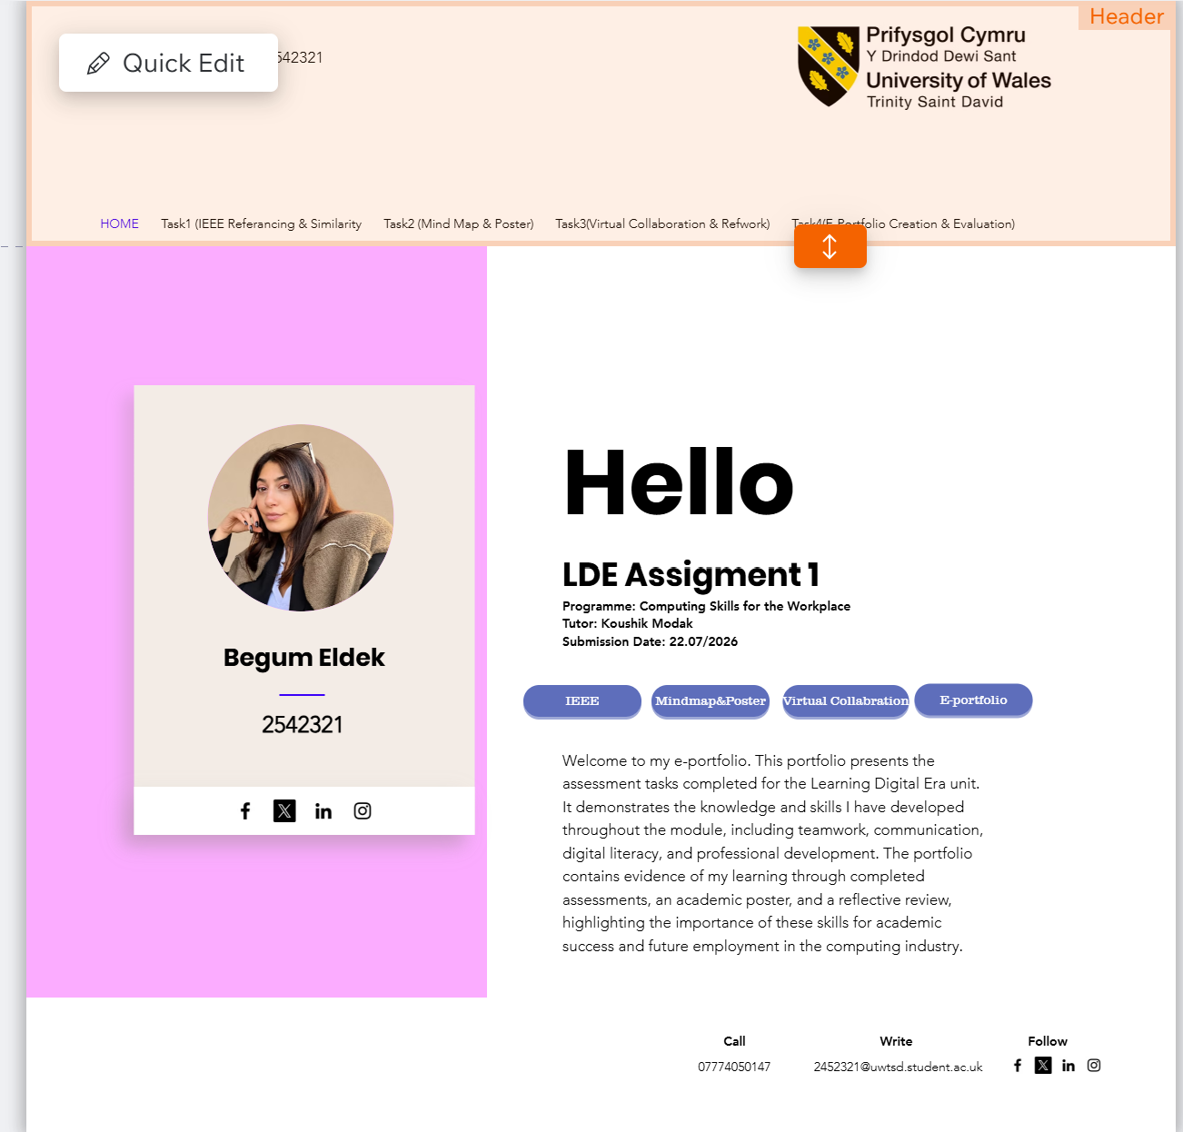
Screenshot 1: E-portfolio Home Page

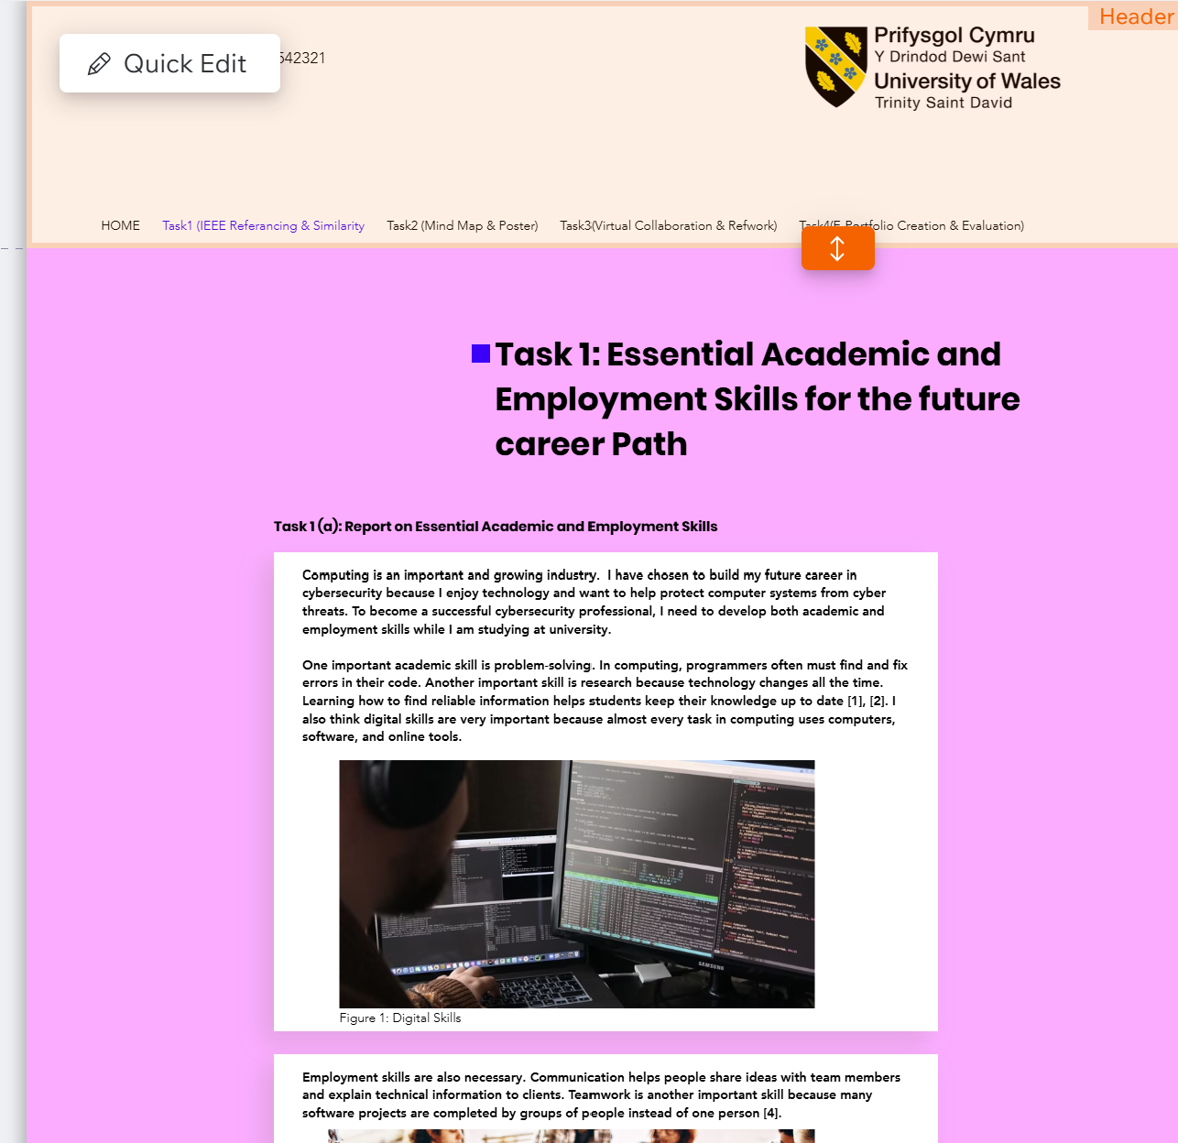
Screenshot 2: E-portfolio Task 1a page
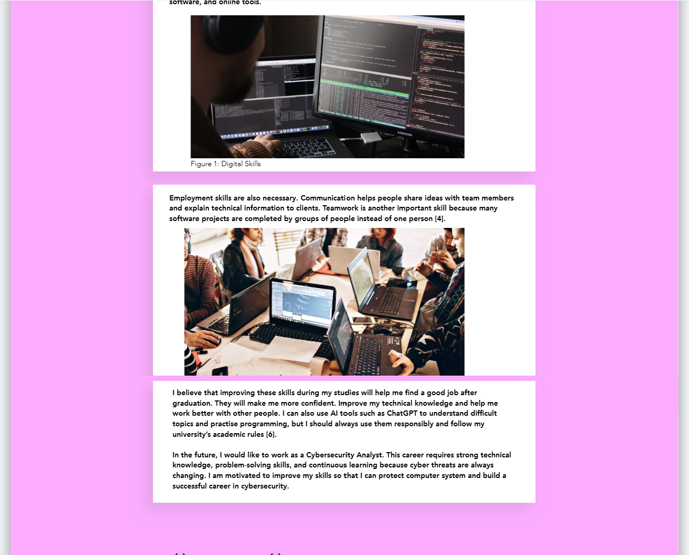Screenshot 3: Task1a -2
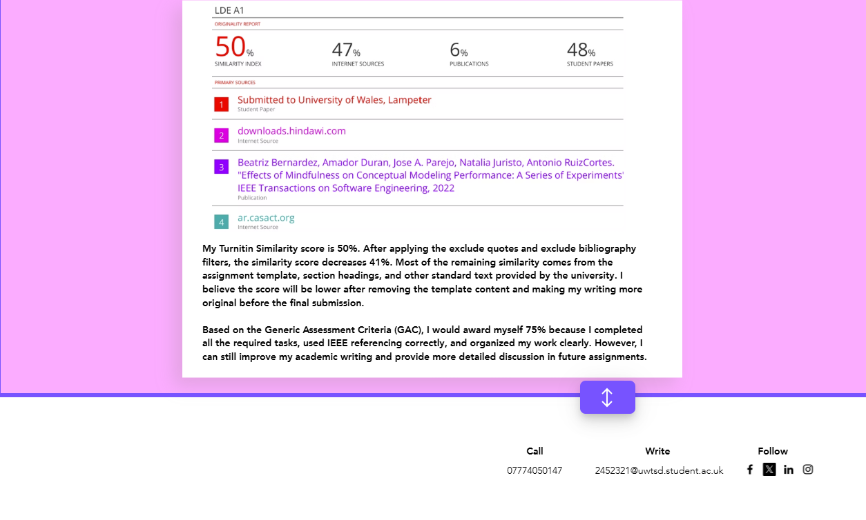Screenshot 4: Task 1b
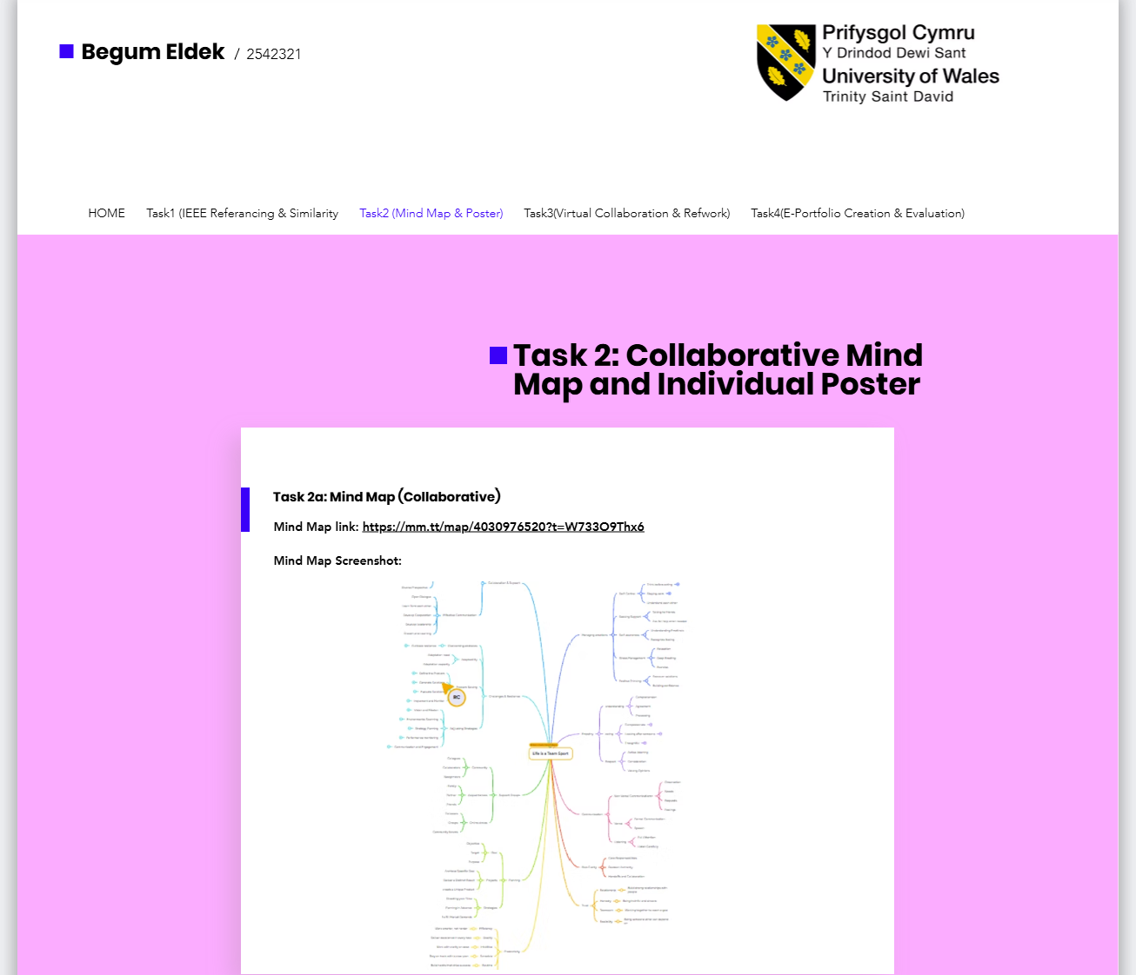Screenshot 5: Task 2a
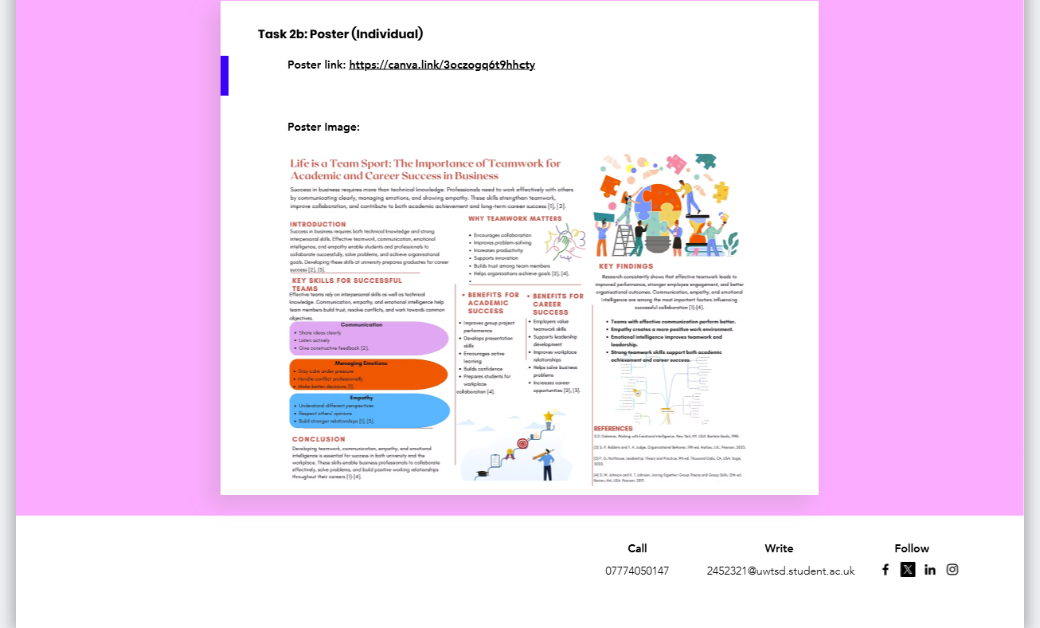Screenshot 6: Task 2b
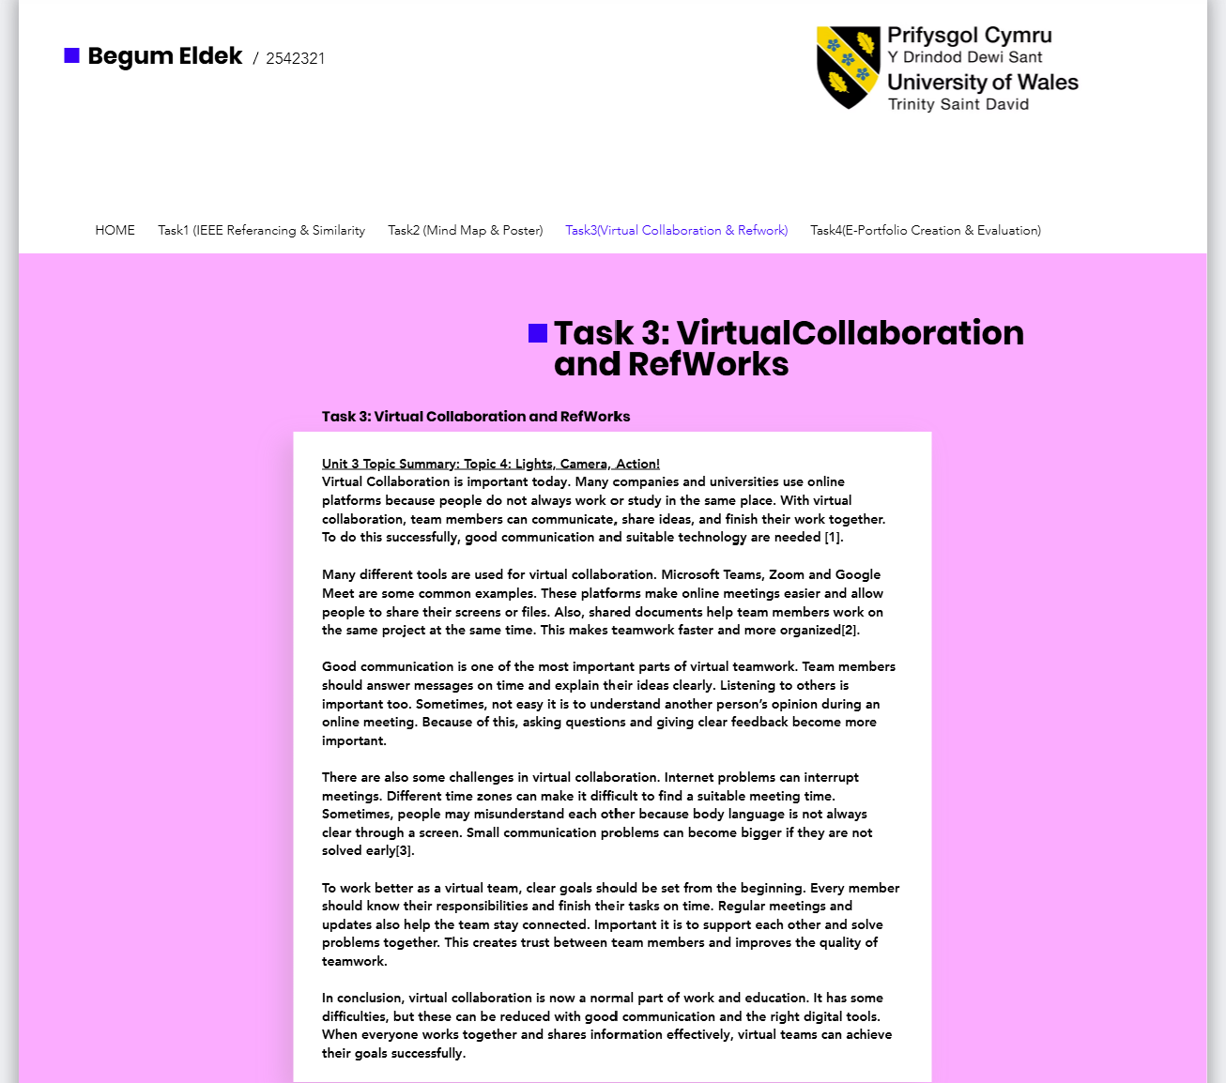
Screenshot 7: Task 3
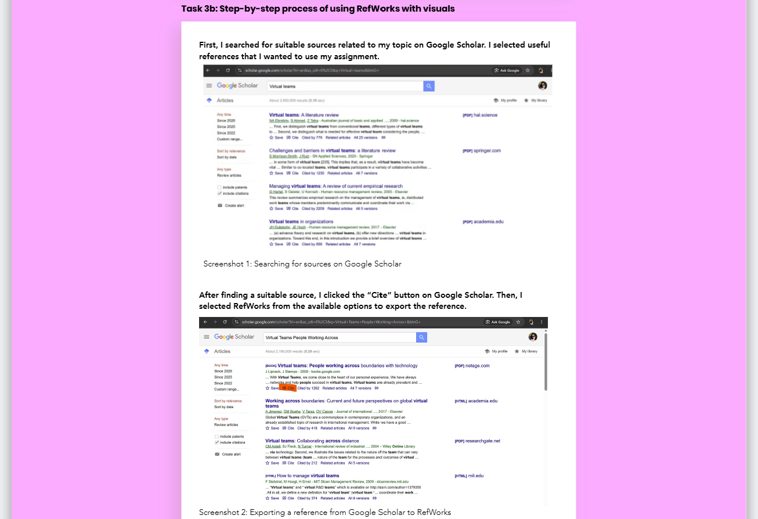Screenshot 8: Task 3b-1

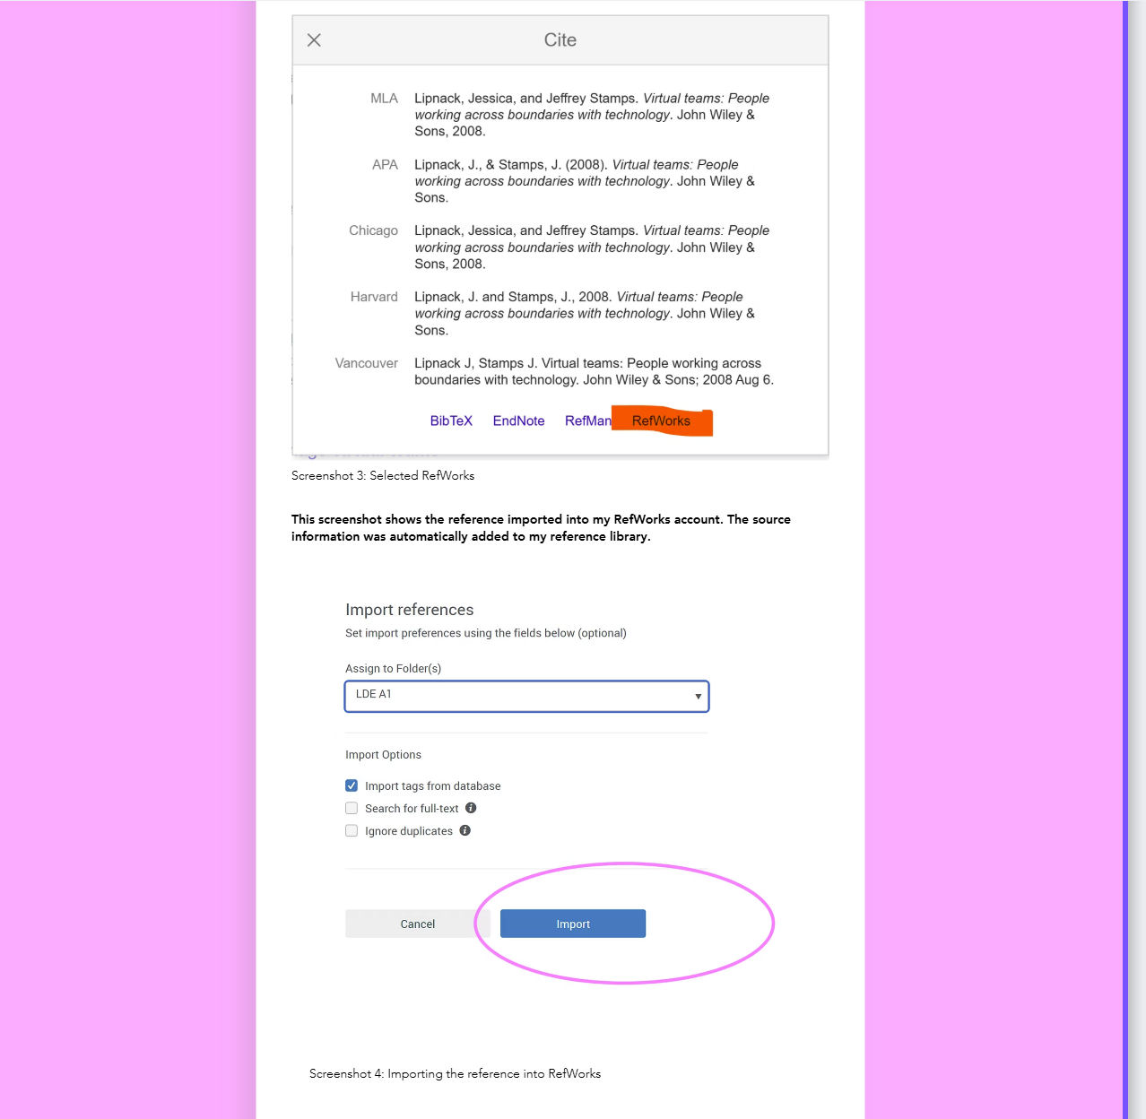
Screenshot 9: Task 3b-2
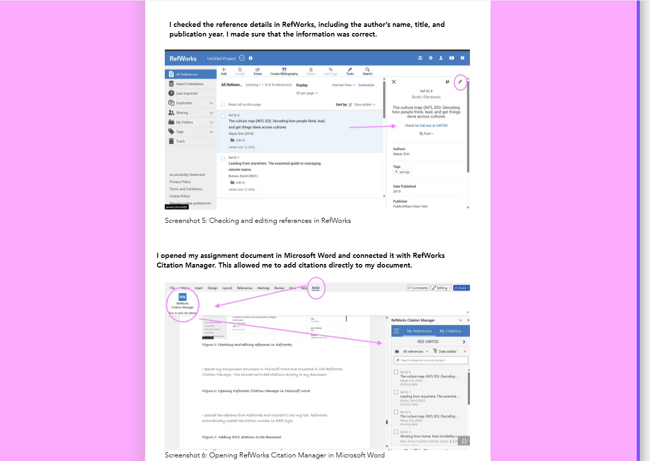
Screenshot 10: Task 3b-3
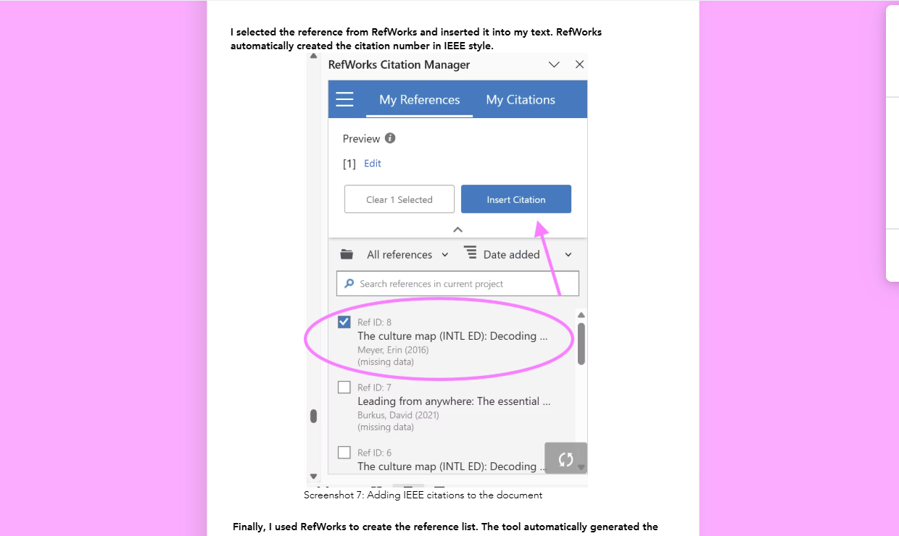
Screenshot 11: Task 3b-4

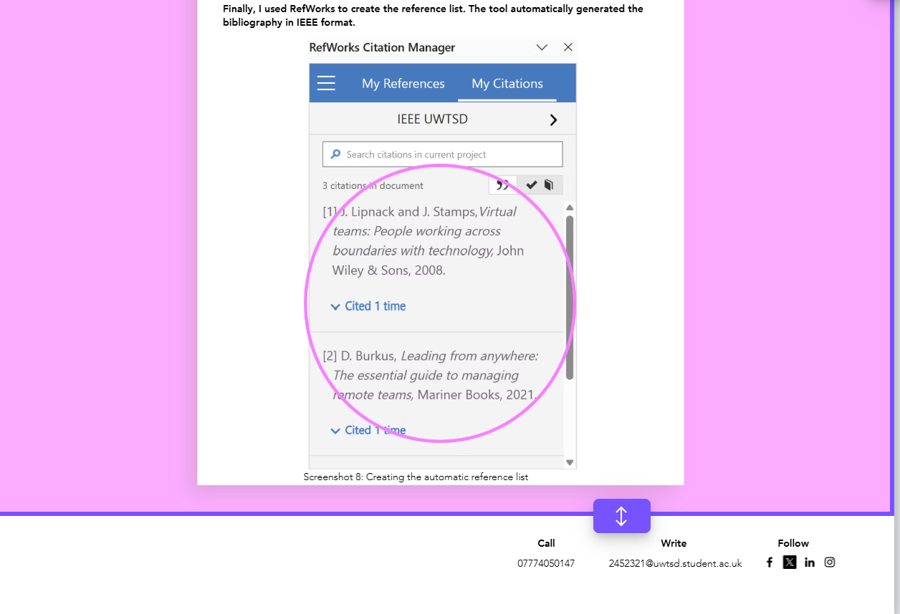
Screenshot 12: Task 3b-4

Task 4 (b): Illustrative Review of E-Portfolio tool Selection
I chose Wix to create my e-portfolio because it was my first time making an online portfolio. I wanted a website builder that was easy to use and did not require coding skills. Wix helped me create a clear and organised website with different pages for each assessment task. It also easy to add text, images, and links. Another advantage is that I can share my portfolio with one online link, so my tutor can access it easily. Overall, I think Wix is a good choice because it is simple, flexible, and helped me present my work in a professional way [1] [2].

Conclusion
In conclusion, developing both academic and employability skills is essential for achieving my career goals in cybersecurity. Skills such as problem-solving, research, communication, teamwork, and digital literacy will not support my success at university but also prepare me to meet the demands of a rapidly changing technology industry. By continuing to improve these skills and using modern tools responsibly, I will be better prepared to become a competent and professional Cybersecurity Analyst.

References

Task 1 References:

[1] | T. DeMarco and T. Lister, Peopleware: Productive Projects and Teams, Boston, MA: Addison-Welsey Proffesional, 2013.
[2] | J. Wing, “Computational Thinking,” Computational of the ACM, vol. 49, no. 3, pp. 33-35, 2006.
[3] | Pexels, “Pexels,” 28 06 2026. [Online]. Available: http:www.pexels.com.
[4] | World Economic Forum, “The Future of Jobs Report 2025,” 2025.
[5] | Pexels, “Pexels,” 2026. [Online].
[6] | OpenAI, “ChatGPT,” 28 June 2026. [Online]. Available: https://chatgpt.com/. [Accessed 28 June 2026].

Task 3 References:

[1] J. Lipnack and J. Stamps,Virtual teams: People working across boundaries with technology, John Wiley & Sons, 2008.
[2] D. Burkus, Leading from anywhere: The essential guide to managing remote teams, Mariner Books, 2021.
[3] E. Meyer, The culture map (INTL ED): Decoding how people think, lead, and get things done across cultures, PublicAffairs New York, 2016.

Task 4 References:

[1] | “https://www.wix.com/.,” 23 july 2026. [Online]. Available: https://www.wix.com/..
[2] | H. L. Barret, “Balancing the Two Faces of ePortfolios,” Educação, Formação & Tecnologias, pp. 6-14, 2010.

