
Skills for the Workplace
Module Assignment Submission
Student Name: | Louise Ricketts
Student Number: | 1910919
Module No: | BMSK4002
Module Title: | Effective Team Working and Communication  Part 1

Statement of Confirmation of Authenticity
By the act of making this submission, the student declares that this is the work of the student named above. The work has not, in whole or in part, been knowingly presented elsewhere for assessment, or where assessment has been built on a previous assessment, this has been identified. Where materials have been used from other sources it has been properly acknowledged. If this statement is untrue, the student acknowledges that an assessment offence has been committed.
Attention is drawn to the plagiarism and unfair practice policies of both the University and of ILM.

Table of Contents
Introduction 3
Analysis 3
Reflection 3
Evaluation 4
Conclusion 5
Bibliography 5
Referencing 6
Appendix A 7
Presentation Agenda 7
Fig.2 7
Presentation slides 8
Appendix B 10
Presentation script 10
Appendix C 13
Presentation handout. 13
Apendix D 15
Feedback sheet. All scores collated onto 1 feedback sheet 15
Appendix E 16
Appendix F 16

Introduction
In these uncertain times, we have had to change and adapt the way we work and study.
We now study online rather than in a classroom. Initially we were supposed to work together in groups on this assignment, but as this is impossible at present, we have all completed a presentation individually.
We will look at how this went and what feedback was given.

Analysis
Throughout the year the group have all been looking forward to doing a presentation, some with anxious feelings and others with positive feelings. As a group we reassured each other we will achieve this assignment by working together, so no need to be anxious.

Unfortunately, we are in an unusual situation where we cannot go to class, meet up to work or socialise.

The decision was made by the University of Wales Trinity St David to change the way we complete this assignment by doing individual Presentations. Some members were nervous, so we all discussed the assignment in our group WhatsApp to help each other get through.

On the day of the presentations, some members stated they were nervous, but once they completed their session, they were relieved it was over, but also relishing the accomplishment they had just achieved. To some this may not be a big deal but to our group is was.

Every member successfully delivered their PowerPoint presentation with confidence, good tone of voice and very few mishaps, considering for some this was the first presentation they have ever been asked to do. It did not help having to perform in front of a laptop or phone, as you couldn’t really clarify body language or eye contact.

Reflection
During my presentation I was very nervous as I have never done anything like this before. I have always considered myself to lack confidence, but I believe I was quite confident relaying my presentation to my audience.

The aim of the presentation was to relay a message across to the audience on Teams versus Groups, how teams are formed and effective team working.
The contents of the presentation were attached to the slides and there is also a contents table. (Appendix A, Fig.1)
The Presentation slides were set out to show each subject on an individual slide, along with a quote from Stephen Covey. (Appendix A, Fig.2 slides 1-16)

I wanted my audience to see that a team and a group look similar, but work in different ways. Just because you see a group of about 10 people working together, does not mean they want the same outcome.

Doing the research and reading the material I found, Belbin team roles and Bruce Tuckman theory, I believe I have strengthened my knowledge and understanding about team formation and effective team working. Even though I work as part of a team and I study in a group, the information I took on board myself has made me look at myself and my work colleagues in a different perspective. I can now acknowledge my weaknesses and work to fill these gaps.

When I started my presentation, nerves got the better of me at first and I was a bit flustered, which caused me to lose track when changing my slides and I missed giving the information off one slide. I realised straight away what I had done, but decided to continue without acknowledging my mistake, so I didn’t lose my pace, therefore continued with my speech. (Appendix B, Fig.3, 3.1, 3.2). This worked well and I completed it without any major mistakes. I acknowledged the mistake to my peers at the end and explained I didn’t correct myself at the time as I felt this would have made me lose track.

I have looked at what I can do to prevent this happening in the future when I complete online presentation’s again, and I have come up with a solution.
As well as having all the information in front of me on the laptop I will also print off a copy of my slides to have at the side of me, this will prompt me to change the slide, and in the event of a glitch, I will have paper copies.

I also produced handouts which showed each slide I was going to present and advised the audience there was room on the side of each slide to write notes if they wish. (Appendix C, Fig.4, 4.1, 4.2)

A feedback/Evaluation form was also provided for my audience to provide feedback.

During our group discussions we all worked together to create a feedback form. This was our way of showing teamwork. Even though we cannot meet up we can still work together.

Evaluation
Once I had delivered my presentation, I asked the audience to complete the feedback forms I had provided. I then collated the information onto one form and attached this in the Appendices. (Appendix D)
I received some good feedback to which I was pleased. My score for first impressions was consistent from all members, confidence was good with 1 person deducting 1 mark, this was put down due to my mishap at the beginning.
General feedback from my peers about my confidence was very encouraging. According to my peers, I came across more confident than I give myself credit for.
Body language and eye contact was consistent as we were all in the same position with this situation. Tone of voice was good, only 1 mark lost.
Overall, I was scored 9/10 which was a pleasing result, for my first attempt.
The downfall for all who participated were the marks given for body language and eye contact. This was due to the fact we were working off laptops and could only see from the shoulders up, also eye contact was deceiving, you are naturally looking at your audience on screen rather than directly into the camera. All participants agreed with the lower scores for these 2 attributes due to the circumstances.

Conclusion
Using Gibbs reflective model (Appendix E) I have reflected on my own experience, and that of my peers.
We have worked extremely well as a group as well as individuals to adapt and deliver some very good work.
It goes to show working as a team is much more effective than working alone. You can achieve satisfaction from helping others achieve their goal as well as satisfaction by accomplishing your own goals with the help from others.
A special mention is also in order to our tutor Bethlyn Lowden, who not only had to adapt to working from home, but also tutoring from home. She went above and beyond to add an extra session each week, utilizing her own time for us to be given extra support.
The group had a discussion on our WhatsApp platform (Appendix F) about the extra mile she had gone for us, and we are all extremely grateful. Thank you Bethlyn.

Bibliography
Baid, H. 2008. Teams V Groups. Available at : https://www.slideshare.net/hitesh447/team-vs-group-presentation Accessed on 30/04/20
Covey, F. (no date) Habit 6: Synergize. Available at: https://www.franklincovey.com/the-7-habits/habit-6.html Accessed on 07/05/20
Covey, S. 2015. The 7 habits of highly effective teens. Available at: https://books.google.co.uk/books?id=GWnrCgAAQBAJ&printsec=frontcover&dq=stephen+covey+quotes+synergy&hl=en&sa=X&ved=0ahUKEwjK77zPoKfpAhXRMMAKHTkQB98Q6AEIOjAC#v=onepage&q&f=false [online] Accessed on 09/05/20
Gibbs reflective model Available at: https://www.bing.com/images/search?view=detailV2&ccid=sy4ehVkl&id=8F88C3172FE0F1C462876C91D0FF87943E7E64F1&thid=OIP.sy4ehVklaSieMO8-ji67XwAAAA&mediaurl=https%3a%2f%2fcpdjuliettewilson.files.wordpress.com%2f2013%2f02%2fgibbs.png&exph=368&expw=370&q=gibbs+reflective+model+1988&simid=608020695684483924&selectedIndex=2&ajaxhist=0 Accessed on 16/05/20
Meyers, S, P. 2013. Team Technology. Available at: https://www.teamtechnology.co.uk/team/dynamics/vs-group-dynamics/ Accessed on 01/05/20
Mind tools. (no date). Forming, Storming, Norming, Performing. Understanding the stages of team formation. Available at: https://www.mindtools.com/pages/article/newLDR_86.htm Accessed on 30/04/20
Romero, L, E. 2015. The ultimate guide to team synergy. Available at: https://www.forbes.com/sites/luisromero/2015/12/01/the-ultimate-guide-to-team-synergy/#489c34352f52Accessed on 07/05/20
Severson, Z. (no date) How to create team synergy and keep it going. https://www.workboard.com/blog/team-synergy.php Accessed on 30/04/20
Smith, Mark, K 2005. Bruce W Tuckman - Forming, Storming, Norming, Performing in groups. Available at: https://infed.org/mobi/bruce-w-tuckman-forming-storming-norming-and-performing-in-groups/ Accessed on 30/04/20
Tuckman, Bruce, W. 1965. Developmental sequence in small groups. Psychological bulletin, Vol 63, No 6, pg, 384 - 389 Available as a PDF file at: https://pdfs.semanticscholar.org/cd78/c763010e6eb856250b939e4eec438e14ef8f.pdfÂ%C2%A0 [online] Accessed on 30/04/20
Wilson, C. 2010. Culture at work. Bruce Tuckman’s Forming, Storming, Norming team development model. Available as a PDF at: http://sst7.org/media/BruceTuckman_Team_Development_Model.pdf Accessed on 09/05/20

Referencing
Baid, H. 2008. Teams V Groups. Available at : https://www.slideshare.net/hitesh447/team-vs-group-presentation Accessed on 30/04/20
Covey, F. (no date) Habit 6: Synergize. Available at: https://www.franklincovey.com/the-7-habits/habit-6.html Accessed on 07/05/20
Gibbs reflective model Available at: https://www.bing.com/images/search?view=detailV2&ccid=sy4ehVkl&id=8F88C3172FE0F1C462876C91D0FF87943E7E64F1&thid=OIP.sy4ehVklaSieMO8-ji67XwAAAA&mediaurl=https%3a%2f%2fcpdjuliettewilson.files.wordpress.com%2f2013%2f02%2fgibbs.png&exph=368&expw=370&q=gibbs+reflective+model+1988&simid=608020695684483924&selectedIndex=2&ajaxhist=0 Accessed on 16/05/20
Meyers, S, P. 2013. Team Technology. Available at: https://www.teamtechnology.co.uk/team/dynamics/vs-group-dynamics/ Accessed on 01/05/20.
Mind tools. (no date). Forming, Storming, Norming, Performing. Understanding the stages of team formation. Available at: https://www.mindtools.com/pages/article/newLDR_86.htm Accessed on 30/04/20
Romero, L, E. 2015. The ultimate guide to team synergy. Available at: https://www.forbes.com/sites/luisromero/2015/12/01/the-ultimate-guide-to-team-synergy/#489c34352f52 Accessed on 07/05/20
Severson, Z. (no date) How to create team synergy and keep it going. https://www.workboard.com/blog/team-synergy.php Accessed on 30/04/20
Smith, Mark, K 2005. Bruce W Tuckman - Forming, Storming, Norming, Performing in groups. Available at: https://infed.org/mobi/bruce-w-tuckman-forming-storming-norming-and-performing-in-groups/ Accessed on 30/04/20
Tuckman, Bruce, W. 1965. Developmental sequence in small groups. Psychological bulletin, Vol 63, No 6, pg, 384 - 389 Available as a PDF file at: https://pdfs.semanticscholar.org/cd78/c763010e6eb856250b939e4eec438e14ef8f.pdfÂ%C2%A0 [online] Accessed on 30/04/20
Wilson, C. 2010. Culture at work. Bruce Tuckman’s Forming, Storming, Norming team development model. Available as a PDF at: http://sst7.org/media/BruceTuckman_Team_Development_Model.pdf Accessed on 09/05/20

Appendix A
Presentation Agenda

Fig.2

Slide | Content
1 | Introduction
2 | Agenda for the day
3 | Team V Groups
4 | Bruce Tuckman Theory
5 | Bruce Tuckman Model
6 | Forming
7 | Storming
8 | Norming
9 | Adjourning
14 | Key to Effective working relationship
15 | The path to synergy
16 | Quote by Stephen Covey
17 | Summary
18 | Bibliography
19 | References

Presentation slides
Fig.2 Slides 1-16
Slide 1 Slide 2
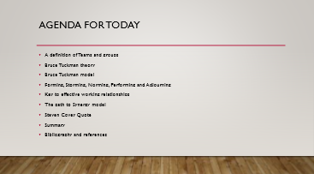
Slide 3 Slide 4
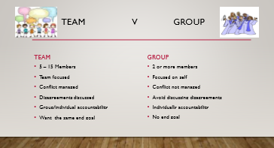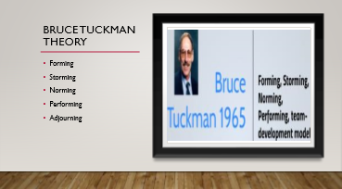
Slide 5 Slide 6
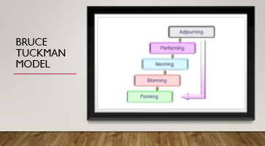
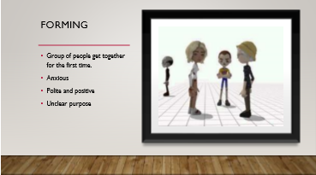
Slide 7 Slide 8
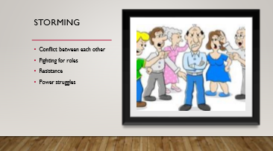
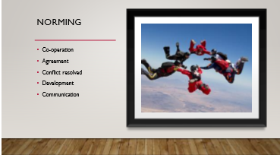

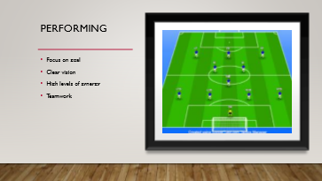
Slide 9 Slide 10
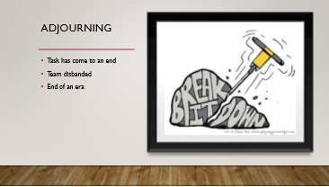
Slide 11 Slide 12 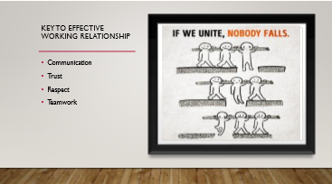
Slide 13 Slide 14 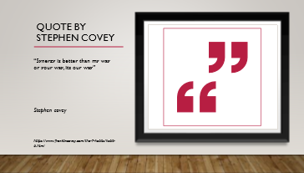 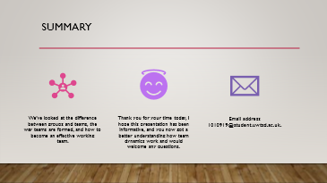
Slide 15 Slide 16 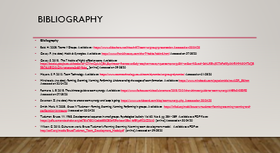 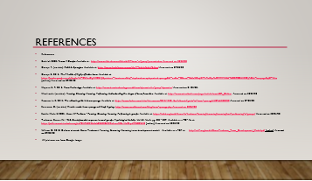

Contents of presentation

Appendix B

Presentation script
Fig. 3

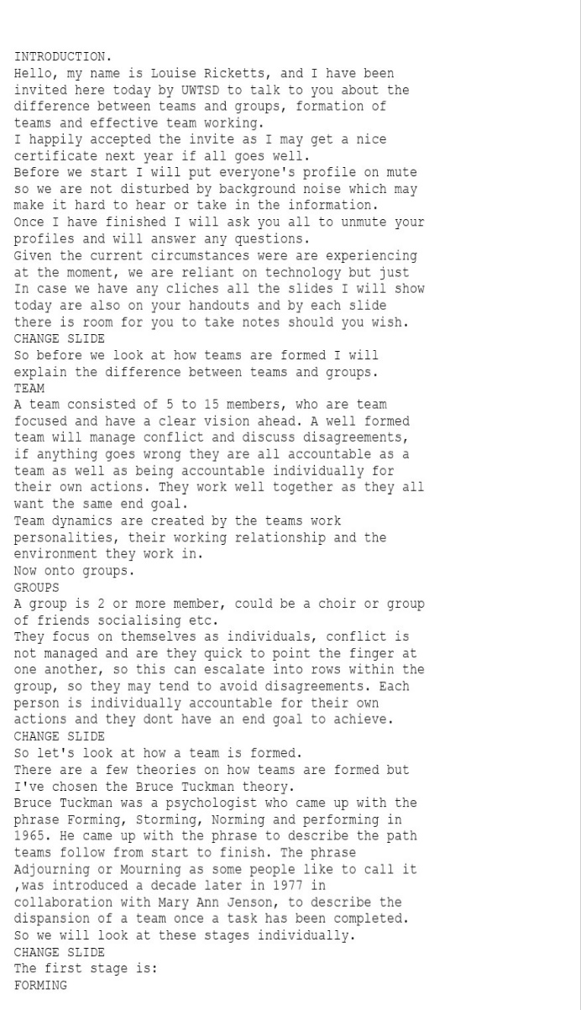
Fig.3.1
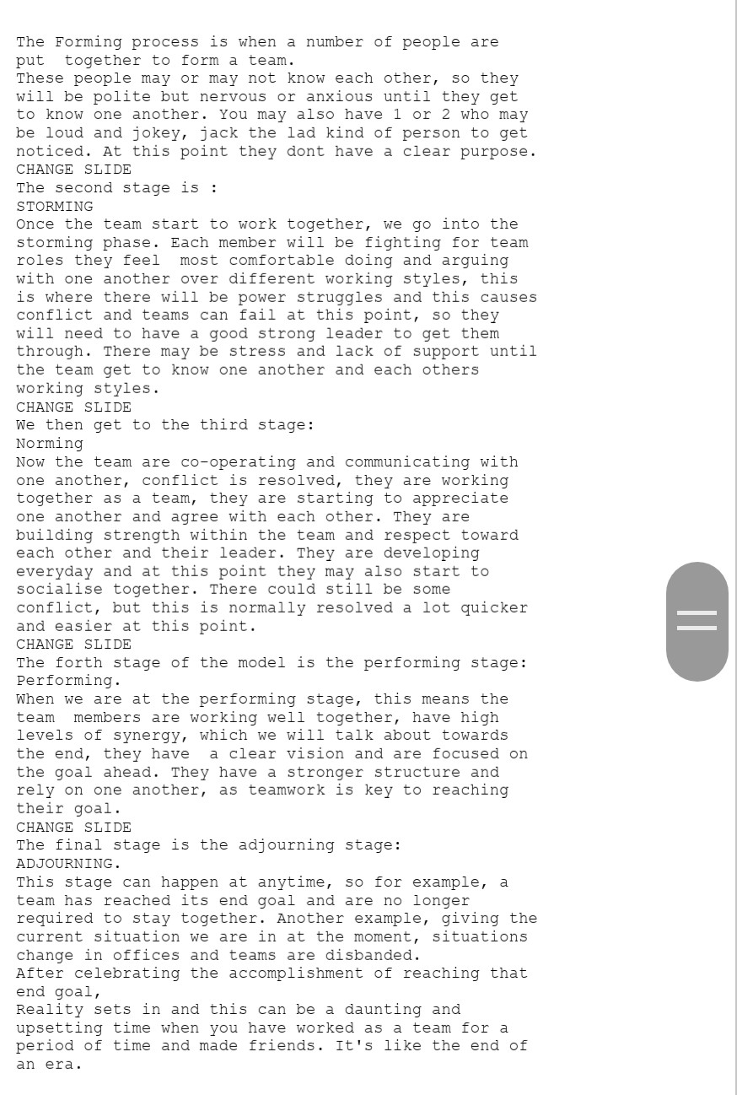
Fig.3.2
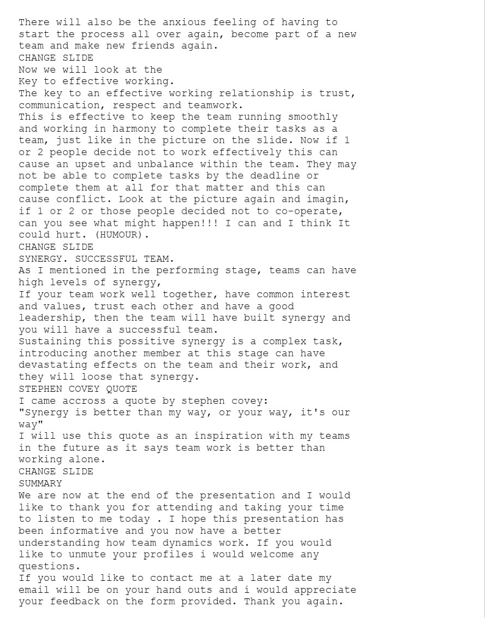

Appendix C

Presentation handout.
Fig. 4
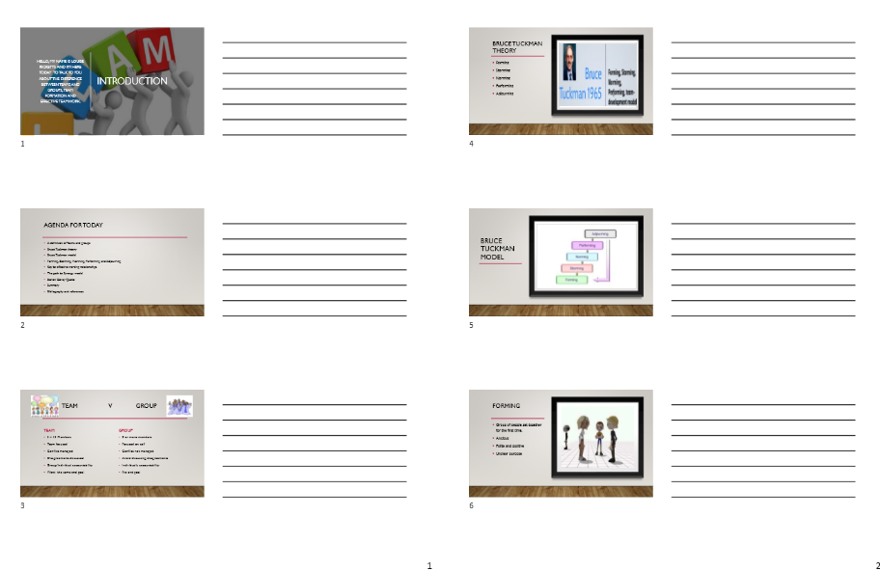

Fig. 4.1
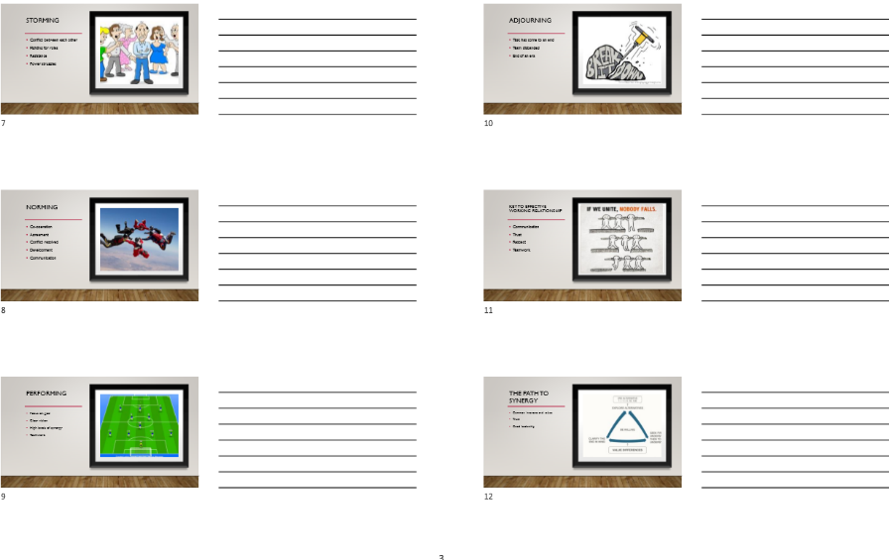
Fig. 4.2
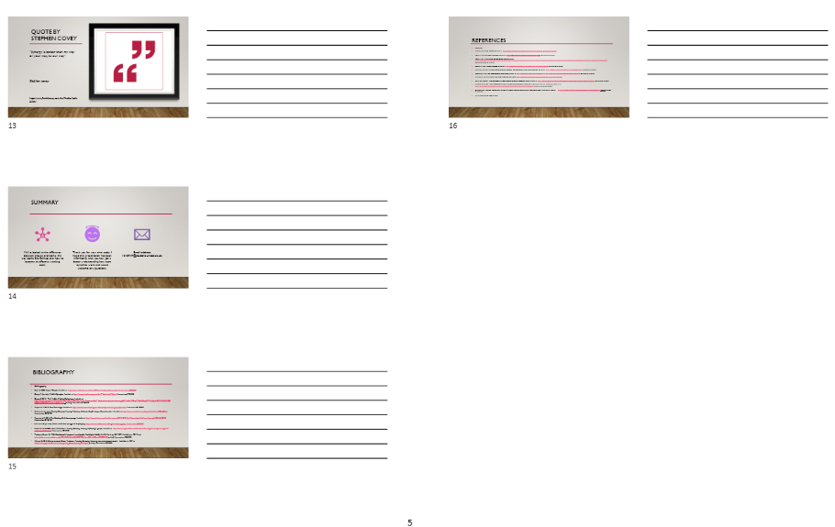

Apendix D

Feedback sheet. All scores collated onto 1 feedback sheet
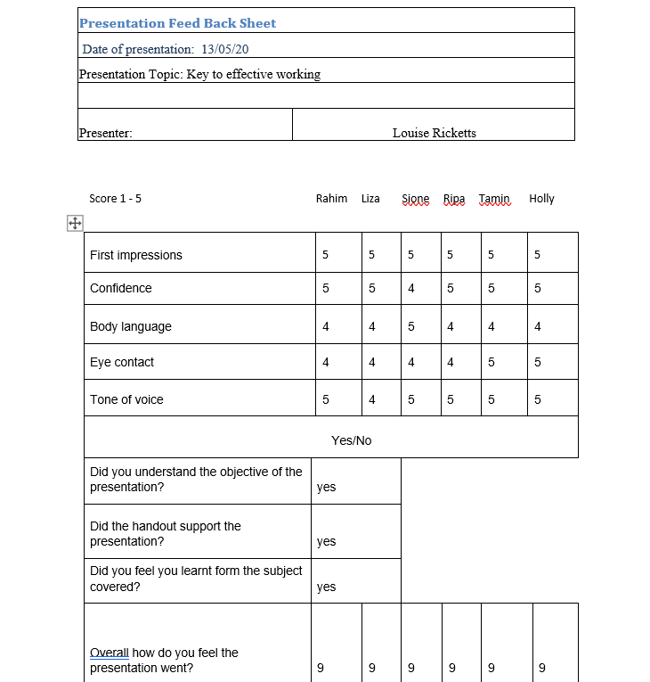

Appendix E
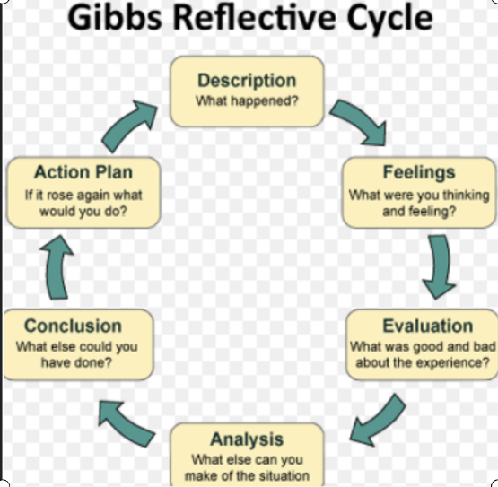

Appendix F


