University of Wales Trinity St David
School of Applied Computing

Worksheet 3: Managing and Maintaining Network Resources Using Network Policy and Security Practices
Network Operating Systems and Services
ACCA5023

Richard Lamnea
1802749
01/04/2021



Managing and Maintaining Network Resources Using Network Policy and Security Practices
Richard Lamnea
School of Applied Computing, University of Wales Trinity St David, Swansea, Wales
1802749@student.uwtsd.ac.uk

ABSTRACT
This report outlines management and maintenance practices of network resources and policies in relation to Microsoft Active Directory Network Service and discusses research about the differences of local and file sharing permissions, group policy management within the network environment and password principles used within a modern network.
TABLE OF CONTENTS
I. IMPLEMENTATION 2
A. Task 1 – Understanding NTFS and Share Permissions. 2
B. Task 2 – Utilising Group Policy Management Console for improved network object management. 7
III. CONCLUSION 23
IV. REFERENCE LIST 23

TABLE OF FIGURES
Figure 1 - User account access control. 2
Figure 2 - Access Control. 3
Figure 3 - Other user access denied. 3
Figure 4 - Creation of a new shared folder. 4
Figure 5 - Permissions configuration. 5
Figure 6 - Completion of shared folder configuration. 6
Figure 7 -Map Network Drive configuration. 7
Figure 8 - Map Network Drive completion. 7
Figure 9 - Group Policy Management Console. 8
Figure 10 - New Organisational Unit. 9
Figure 11 - User added to the Organisational Unit. 9
Figure 12 - Group Policy created for the Organisational Unit. 10
Figure 13 - Access prohibited for control panel access. 10
Figure 14 - Restrictions for control panel 11
Figure 15 - Group Policy Management No Control Panel Access Creation 12
Figure 16 - Group Policy Management Editor 12
Figure 17 - Command prompt restriction 13
Figure 18 - Group Policy Management Object creation. 14
Figure 19 - No Removable Drive enabled within Group Policy Management Policy. 15
Figure 20 - Access denied to removable device. 16
Figure 21 - New organisational unit for computer systems. 17
Figure 22 - New Policy object created. 18
Figure 23 - Prohibit user software installs configuration. 19
Figure 24 - Restricted software installation. 20
Figure 25 - Default password policy. 21
Figure 26 - Password policy configuration. 22
Figure 27 - Password policy enforcement. 23

INTRODUCTION
Students were given 3 tasks to complete. The first task was to demonstrate NTFS permissions within a network environment by implementing local and sharing permissions. The second task was to implement group policy management software within Active Directory.

IMPLEMENTATION
The Implementation of the required tasks are described below:

Task 1 – Understanding NTFS and Share Permissions.
The New Technology File System (NTFS) was developed by Microsoft for the windows operating system and is used for storing and retrieving files located on hard disk drives [1]. This system is used by Active Directory to allow teams within the organization to acquire and utilize files within the network [2]. However, not all files should be able to be accessed by all members of staff as this raise’s security concerns and could also result in Data Protection legislation breaches [3]. Access Control permission management systems should be implemented to prevent possible security incidents. The demonstration of NTFS permissions, file sharing and file accessing within the network environment can be seen below:
- NTFS permissions.
To demonstrate local NTFS permissions within an operating system, a file was created within the C:/ drive. Within the properties of the file, the security permissions were altered to only allow the user who created the file to access, this can be seen in Fig 1. Once this was implemented, the control access of the file was altered to allow this user to have full control which can be seen in Fig 2. To assess if this implementation worked as expected, another used within the network environment attempted to open the file from within the local directory. Access to the file was denied which can be seen in Fig 3.
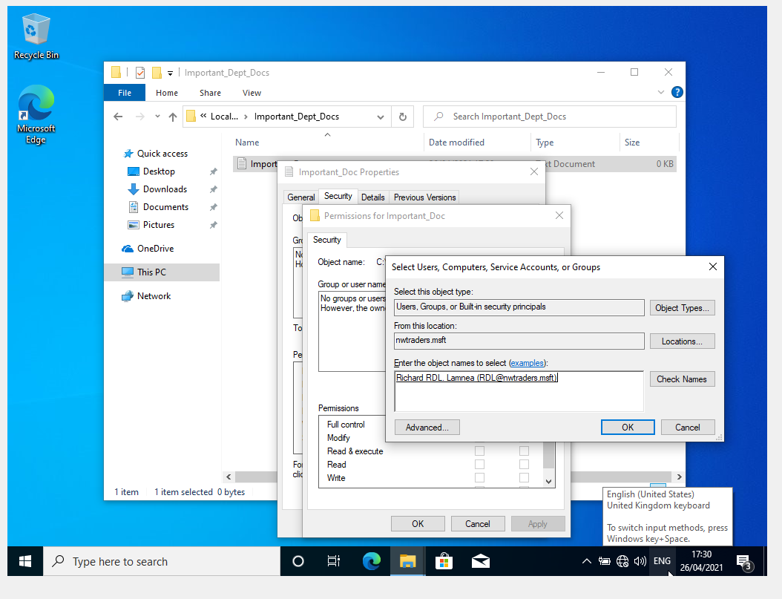
Figure 1 - User account access control.
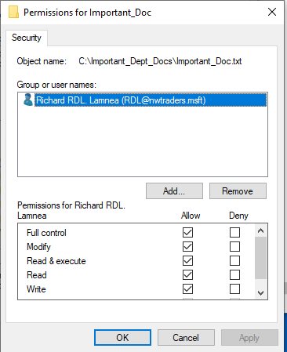
Figure 2 - Access Control.
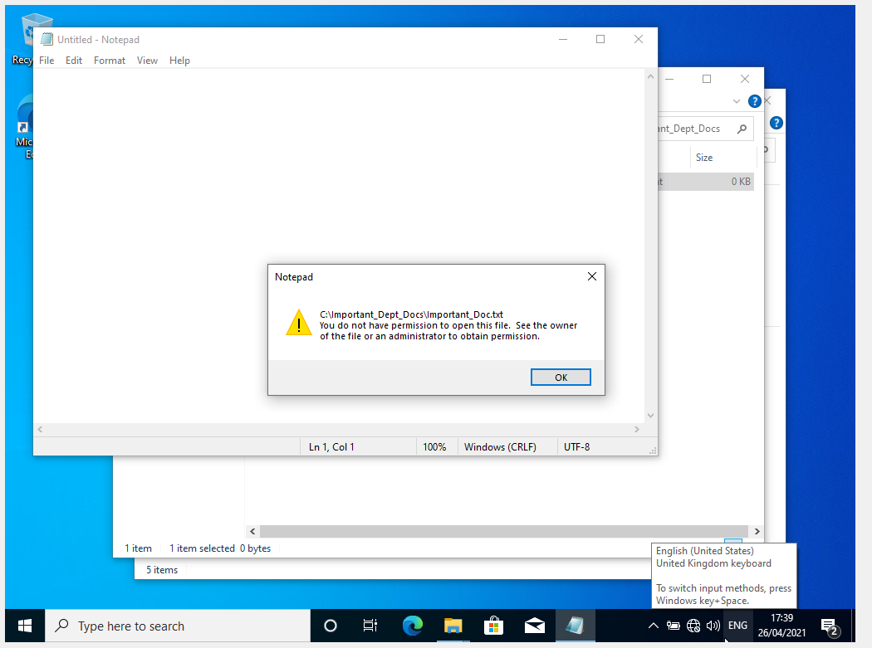
Figure 3 - Other user access denied.
- Share permissions.
Files and folders created within a network are not shared by default, these files and folders must be configured to be specifically shared within the network and or system in which to be discoverable by a PC which exists on the network. Shared network files and folders are co-managed by NTFS permissions via the network controller in which to avoid compromising legislation or theft of data. To demonstrate Active Directory Server Manager was used to enable Storage services, and a shared folder called DeptNetShare was created on the storage server which can be seen in Fig 4 [4]. The remote path is created to allow access to the folder through the network. Once the share folder directory had been configured, the NTFS network permissions were then configured for the folder which can be seen in Fig 5. The completion of the configuration of the shared folder can be seen in Fig 6.
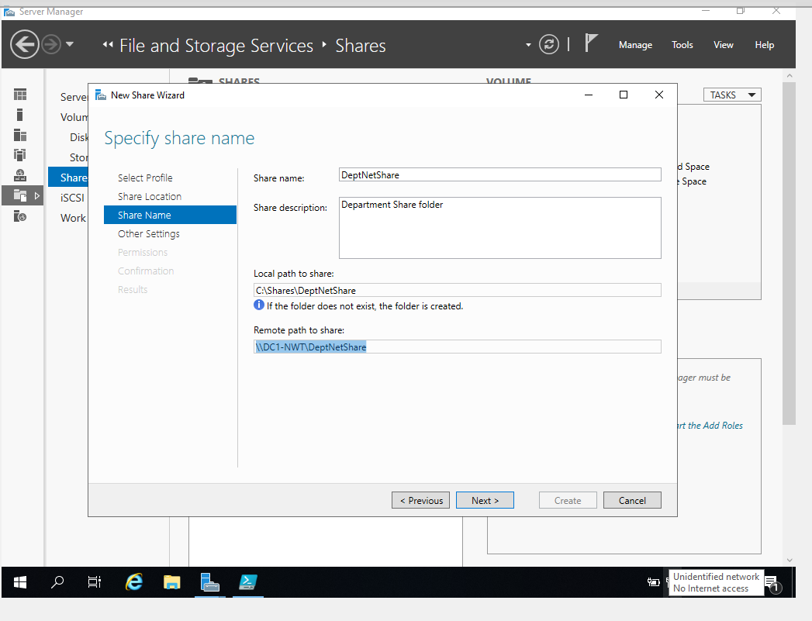
Figure 4 - Creation of a new shared folder.

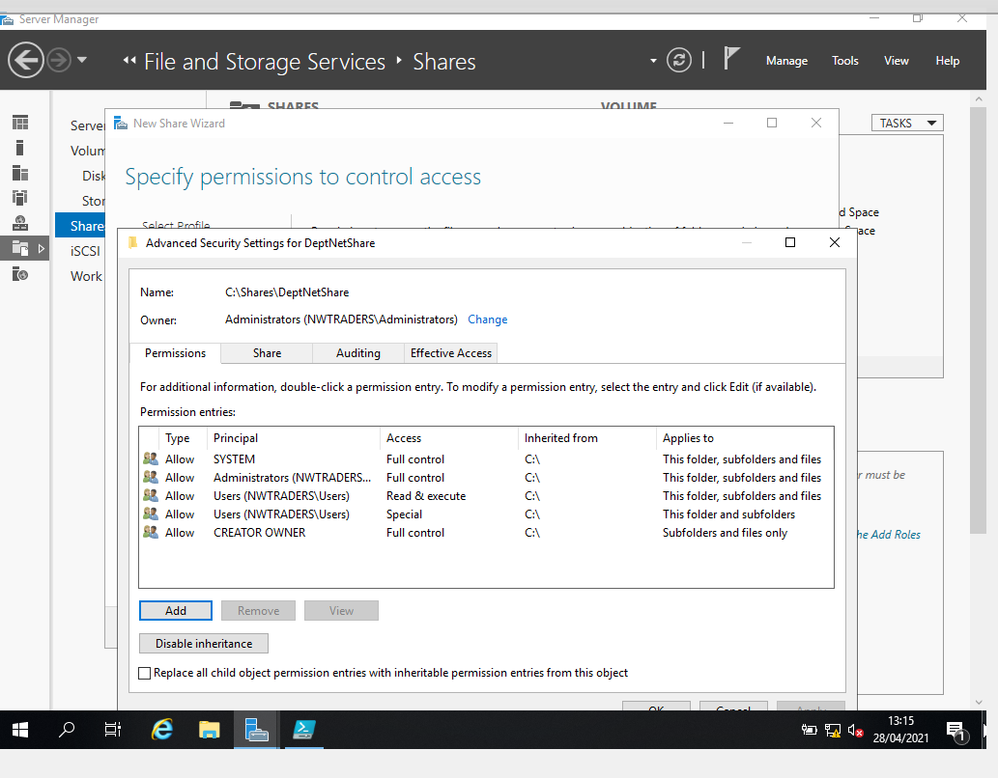
Figure 5 - Permissions configuration.

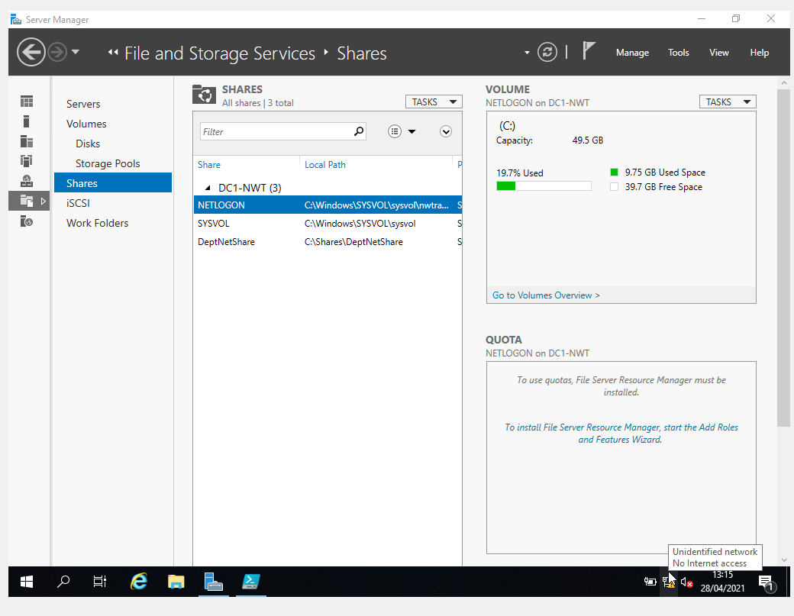
Figure 6 - Completion of shared folder configuration.
- Accessing the file share server.
There are multiple ways to access the shared folder contained within the server however, in this demonstration a Mapped Network Drive will be used to demonstrate remote access to the shared folder [5]. Using a client machine connected to the network a Map Network Drive was created and with the server’s name, and share file location described in the previous section, which can be seen in Fig 7. The completed Map Network Drive can be seen in Fig 8.
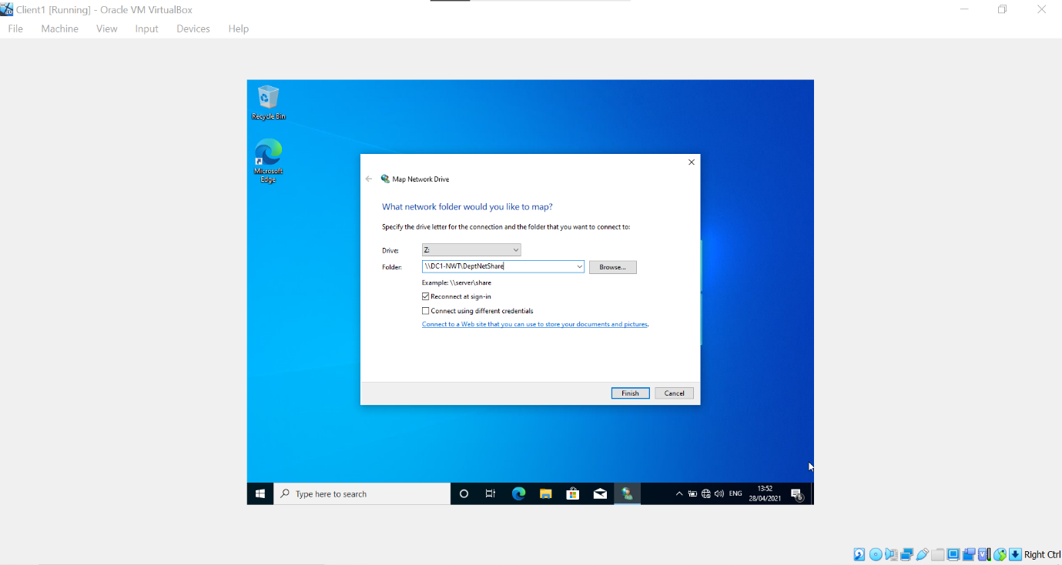
Figure 7 -Map Network Drive configuration.
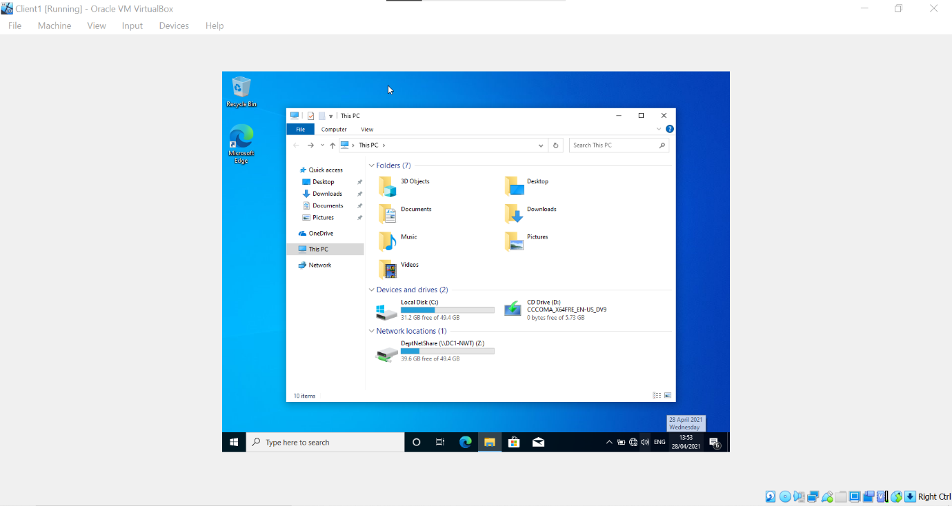
Figure 8 - Map Network Drive completion.

Task 2 – Utilising Group Policy Management Console for improved network object management.
Group Policy Management console provides system administrators with the ability to manage user accounts and computers connected to the domain within Active Directory. The purpose of Group Policy Management is to enable the automation process of system settings to users and machines within the confides of the domain [6] [7]. The group management console which will be used for the demonstration of group policy management within Active Directory can be seen in Fig 9.
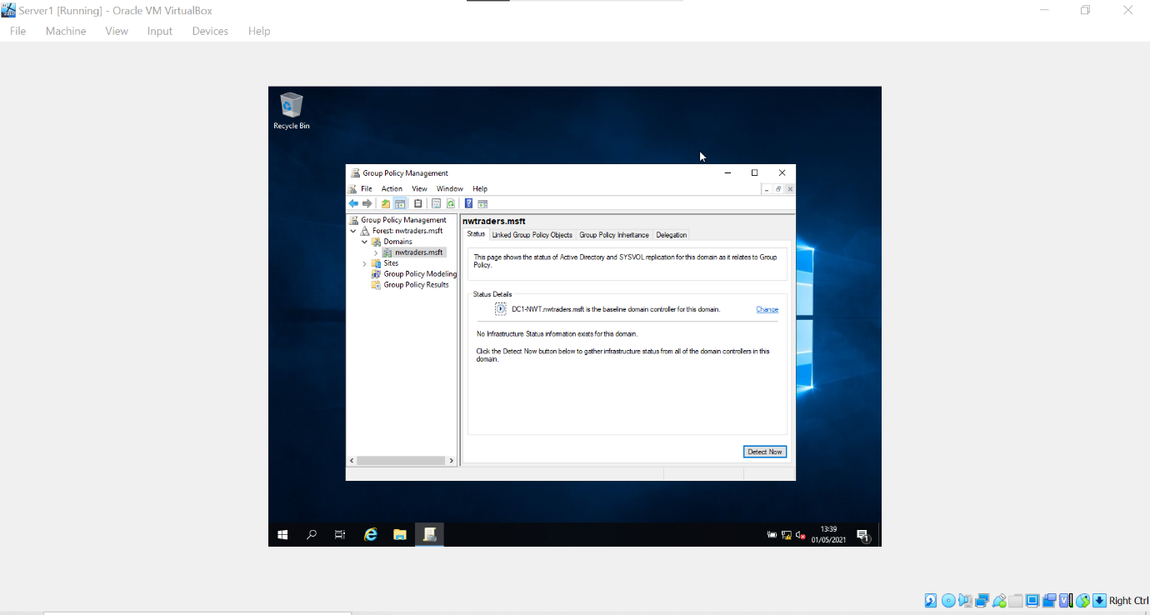
Figure 9 - Group Policy Management Console.
- Group Policy Control Panel Restriction.
To demonstrate group policy management, restriction of the domain user system’s control panel is implemented to reduce the user’s ability to modify administrative settings within the system and ensure consistency over the network and the integrity of managed data. To implement a group policy to all non-administrative user’s an organisational unit was created within the Active Directory User and Computers console which can be seen in Fig 10. Using the Group Policy Management console, a new user was added to the organisational unit which can be seen in Fig 11. A new group policy was created within the organisational unit which can be seen in Fig 12. The group policy was edited using the Group Policy Management Editor and access to the control panel and pc settings were disabled which can be seen in Fig 13. To test the implementation of this group policy the user which was created was logged into through the domain using a client system and access to the control panel was disabled which can be seen in Fig 14.

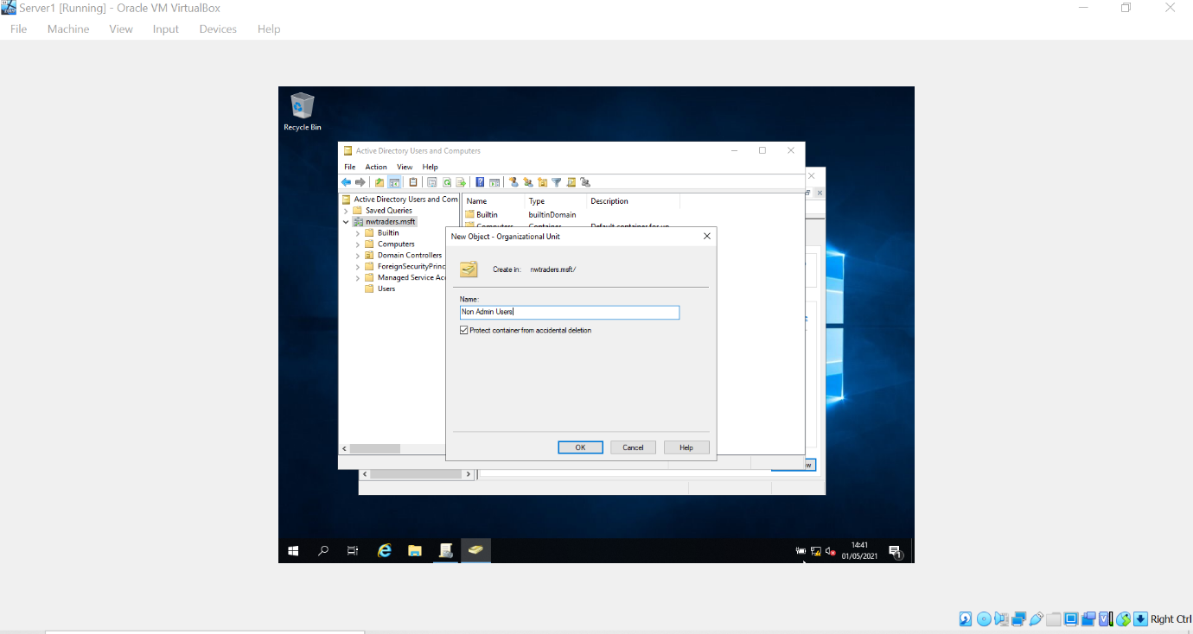
Figure 10 - New Organisational Unit.
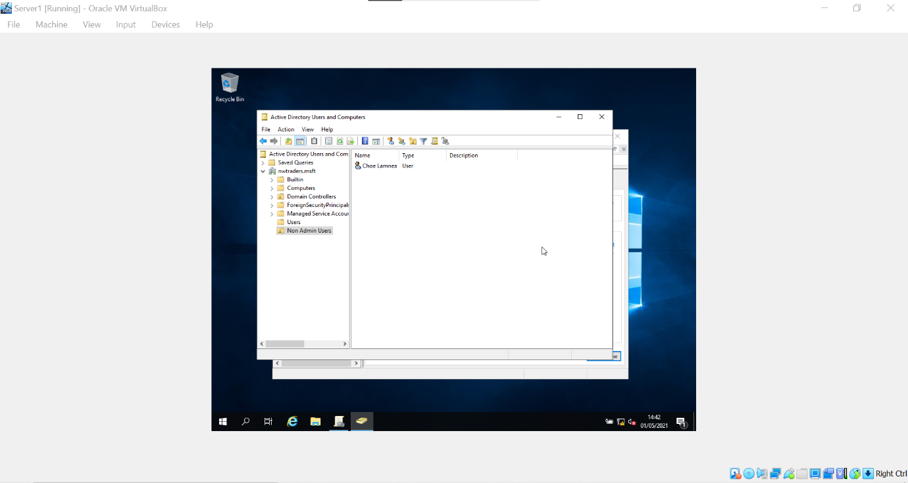
Figure 11 - User added to the Organisational Unit.
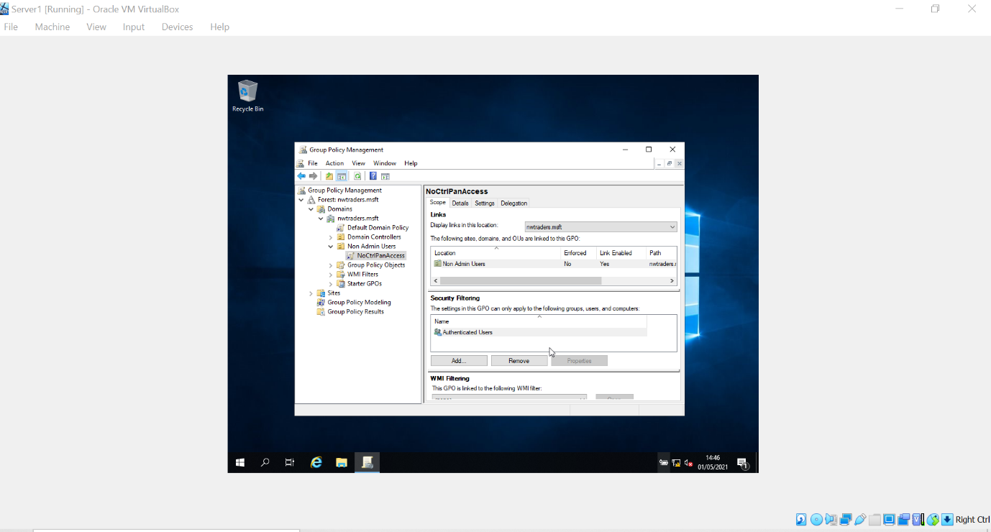
Figure 12 - Group Policy created for the Organisational Unit.
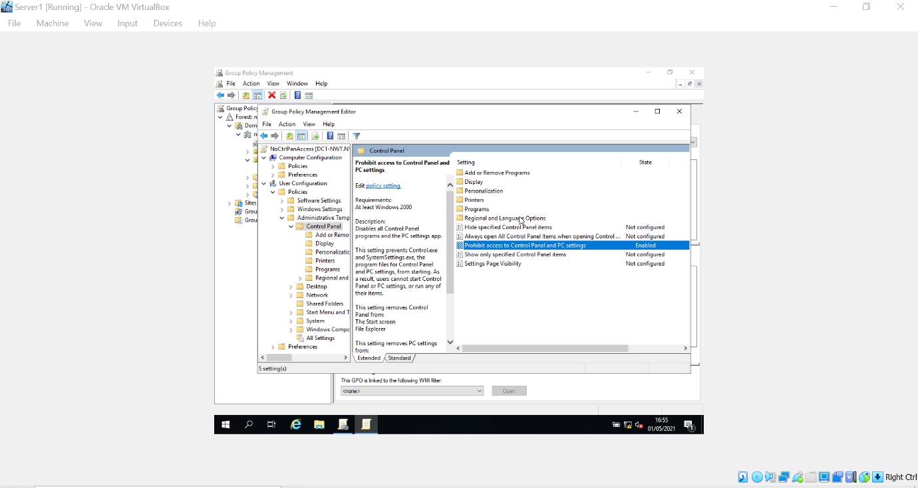
Figure 13 - Access prohibited for control panel access.
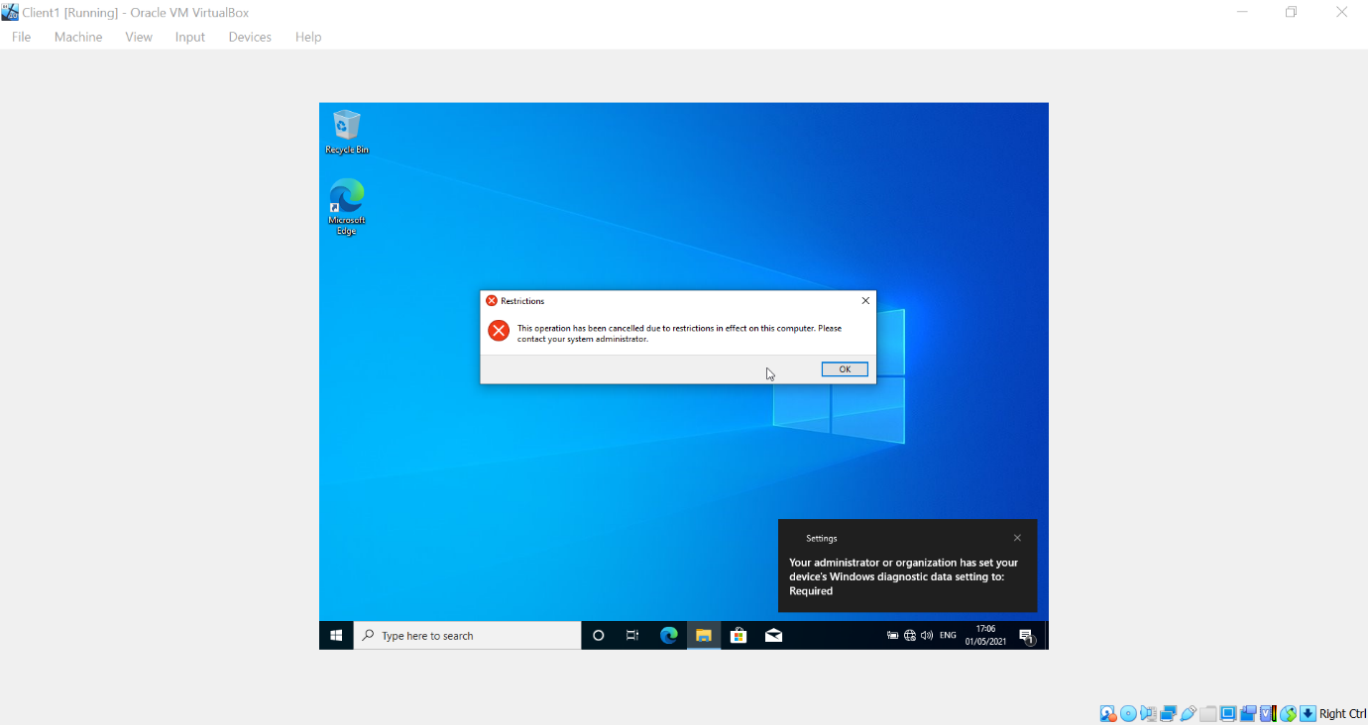
Figure 14 - Restrictions for control panel

- Command Prompt Access Restriction.
The Command Prompt Console enables the user to run commands which can override system settings and can allow users to overcome security policies. The group policy management console permits the domain to restrict users from using the command prompt. To demonstrate this, using the Observational Unit prior, a new Group Policy Object was created which can be seen in Fig 15.
Using the group policy object editor, prevent access to the command prompt predefined policy was enabled to restrict access to the command prompt by users included the Observational Unit which can be seen in Fig 16. When a user included within the OU attempts to open command prompt a messaged displaying that the operation has been cancelled due to the restrictions on the system which can be seen in Fig 17.

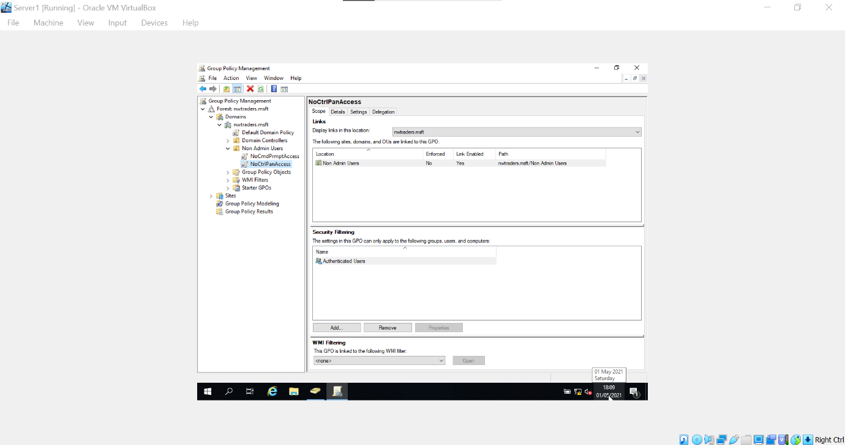
Figure 15 - Group Policy Management No Control Panel Access Creation
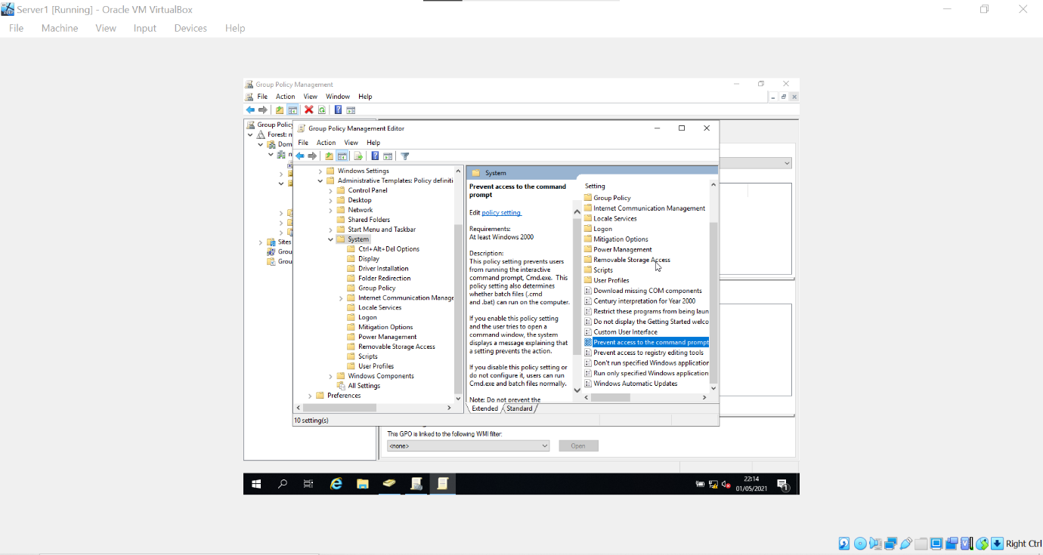
Figure 16 - Group Policy Management Editor
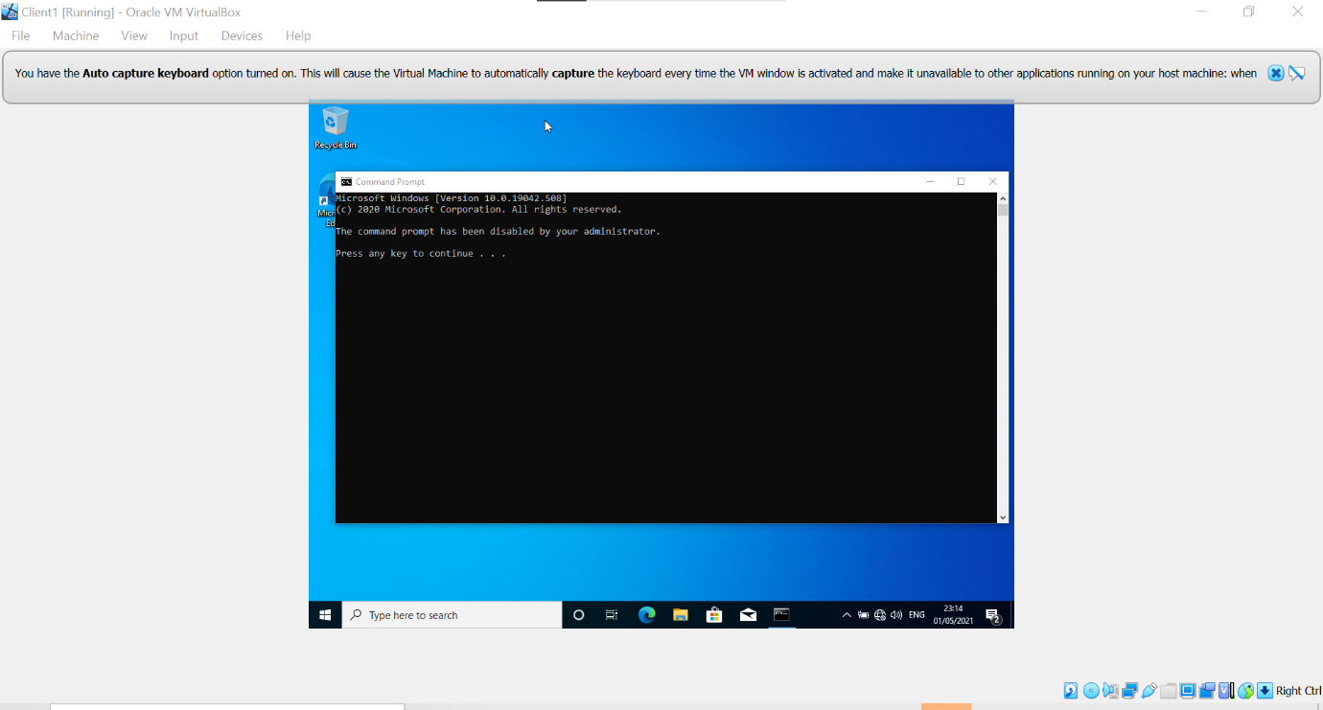
Figure 17 - Command prompt restriction
- Removal Media Drives Access Restriction.
Removable media drives are a common medium for the transport of malware / viruses within a network, and it highly recommended to deny access to these devices [8]. The group policy management console grants the ability to restrict users from using these devices. To demonstrate this a new group policy object was created which was named NoRemDriveAccess which can be seen in Fig 18. Using the group policy object editor, a predefined policy template was enabled to disabled access to the user of removable storage which can be seen in Fig 19. To verify that the policy had been enabled, a removable storage device, a client included within the Group policy object was used to try to access the disc drive, however access was denied which can be seen in Fig 20.

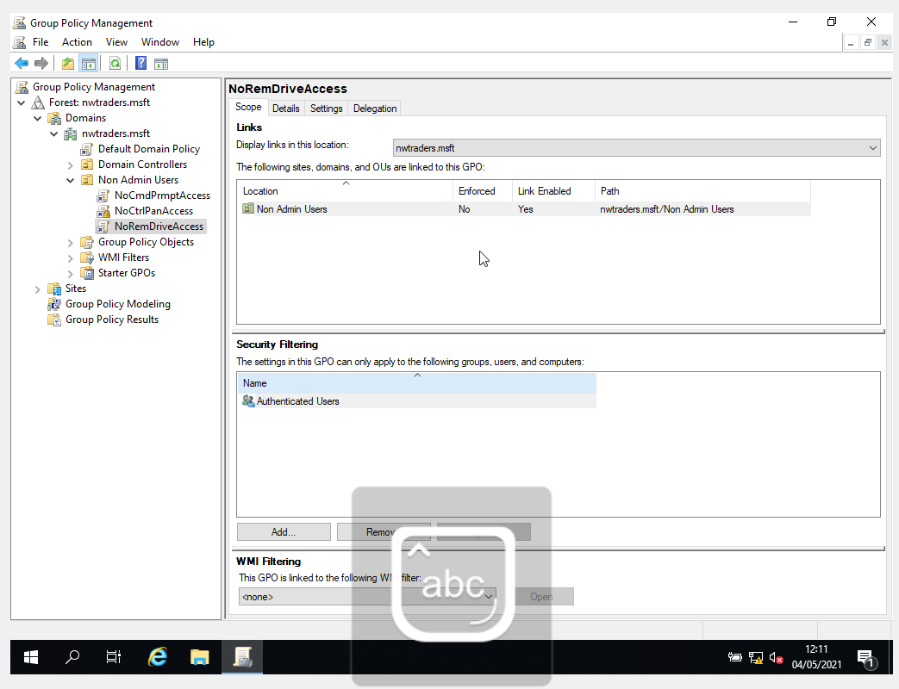
Figure 18 - Group Policy Management Object creation.

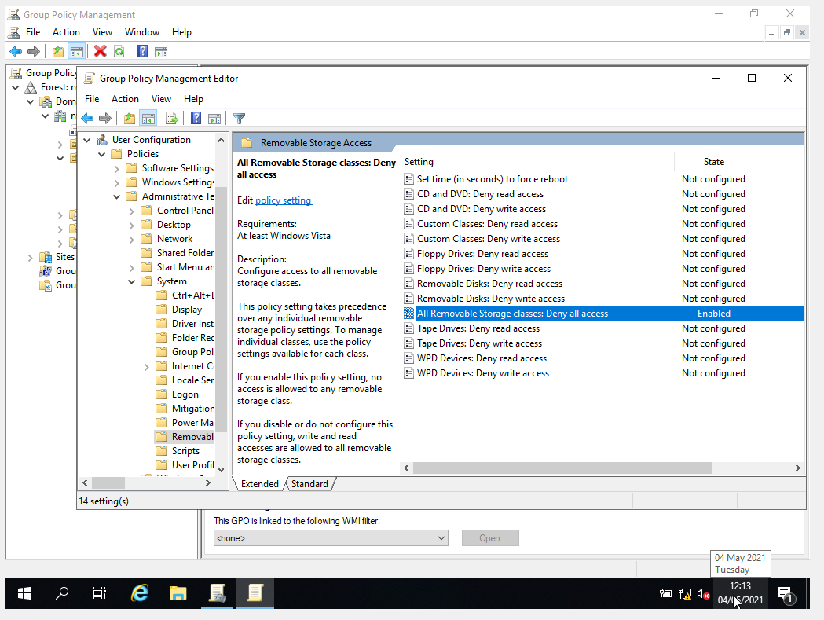
Figure 19 - No Removable Drive enabled within Group Policy Management Policy.
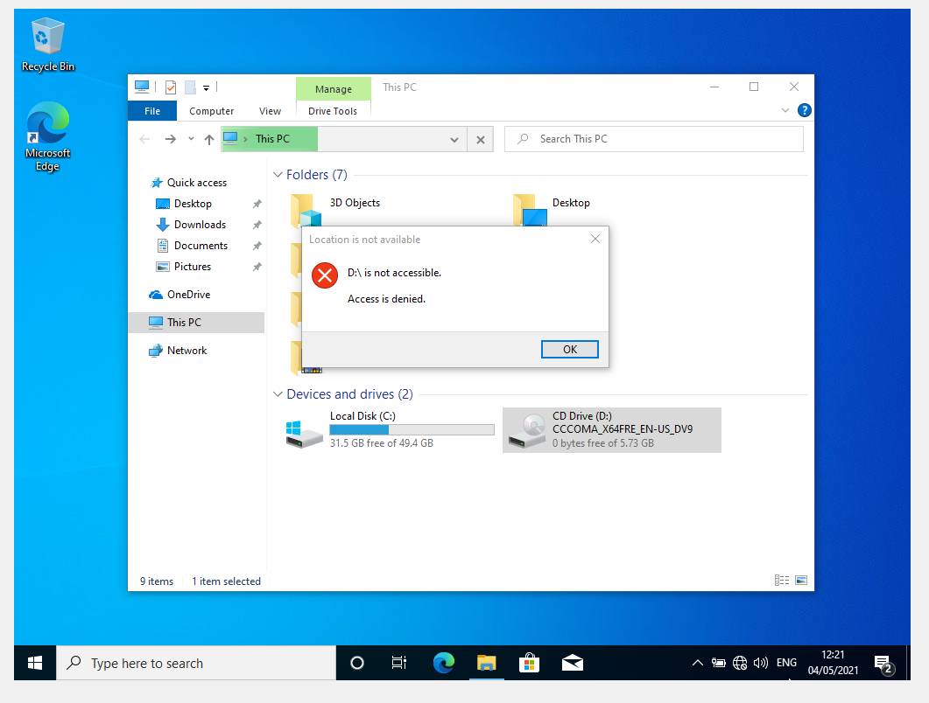
Figure 20 - Access denied to removable device.

- Software Installation Restriction.
Another major threat source with a network environment is unauthorized software installations onto computer systems [9]. Unauthorized software can be a source of vulnerability within the network and is recommended to restrict these installations to only authorised administrators. To demonstrate restriction of software installation a computer policy will be implemented. A new organisational unit was created to include the client computer system which can be seen in Fig 21. When the organisational unit has been created, a new group policy object was created with in the organisational unit was created, named NounauthSoftInstalls which can be seen in Fig 22. Using the group policy editor, a new policy to prohibit user installs was enabled and configured to disable software installations on the computer systems within the organisational unit unless authorised by an administrator which can be seen in Fig 23. To verify that the policy disabled software installations, a user was logged into the computer system within the organisational unit, and an attempt to install software was made. The system requested an administrator to authorize the installation which can be seen in Fig 24.
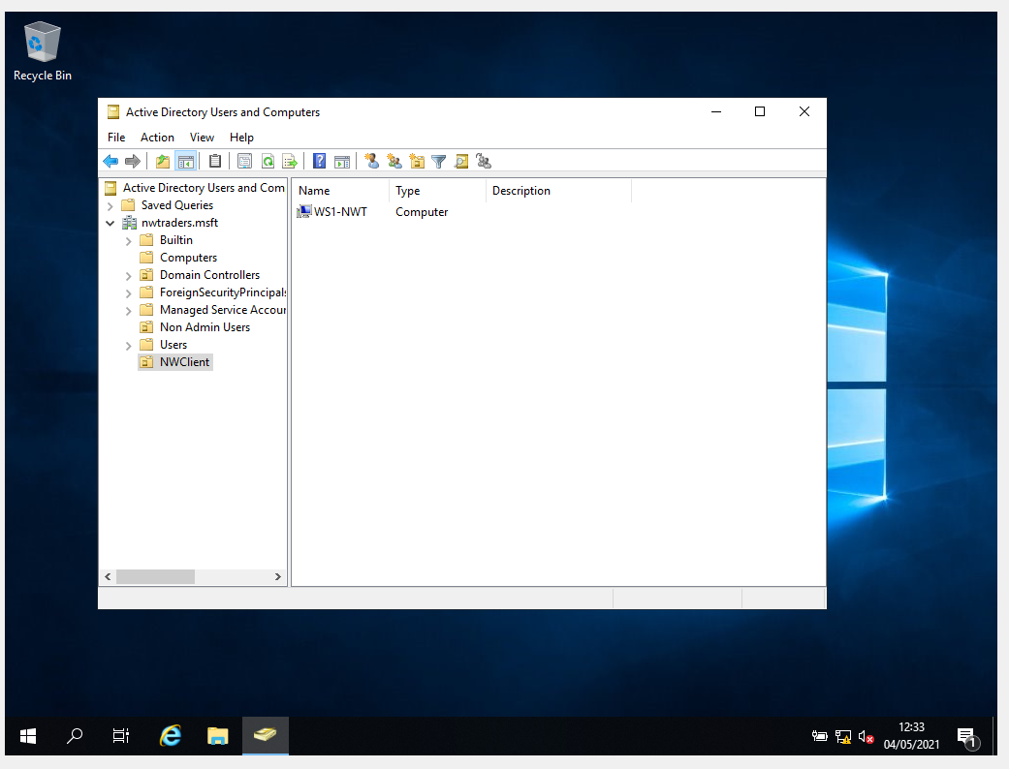
Figure 21 - New organisational unit for computer systems.
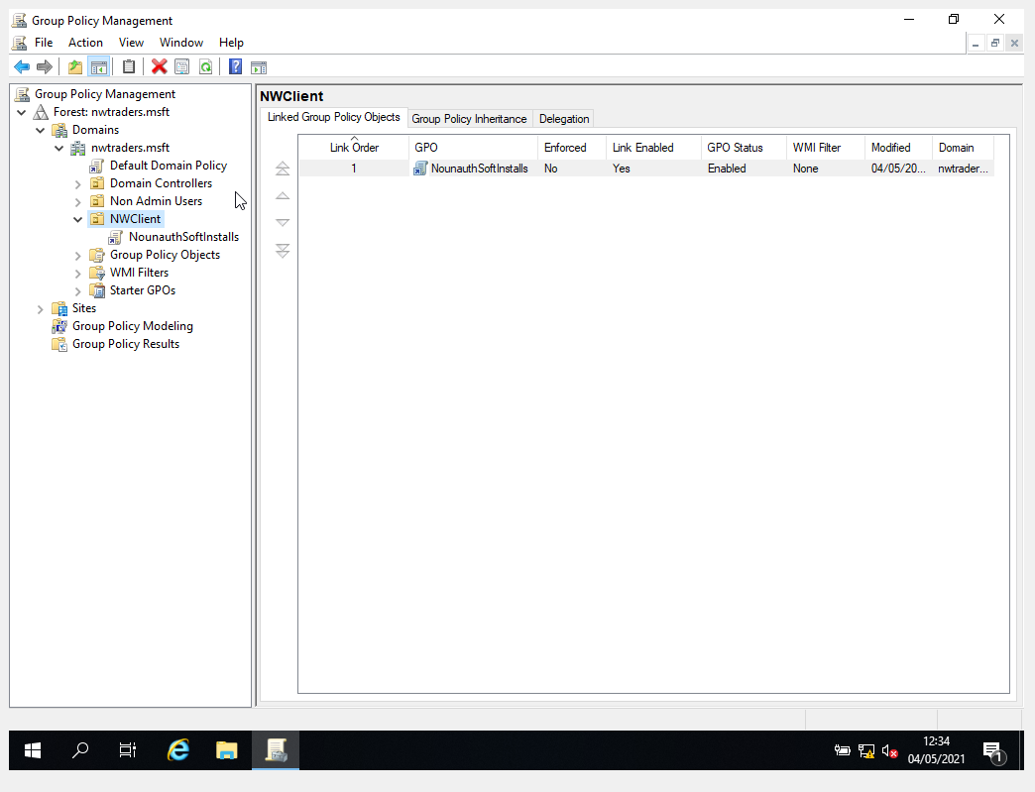
Figure 22 - New Policy object created.
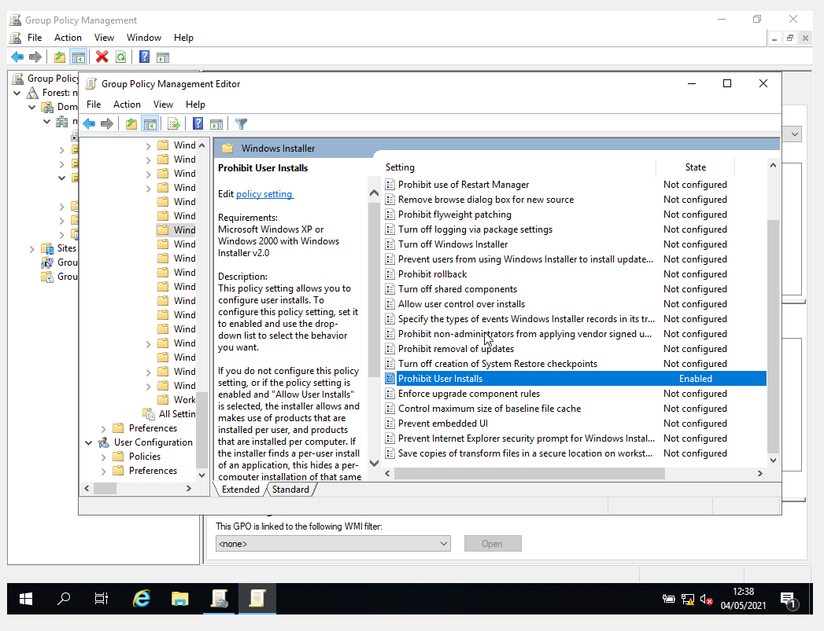
Figure 23 - Prohibit user software installs configuration.
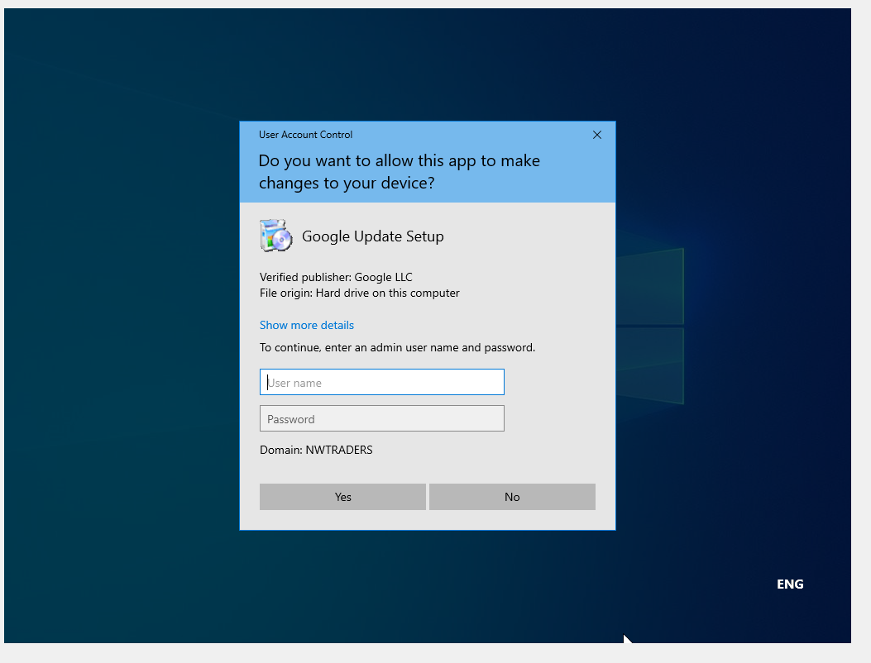
Figure 24 - Restricted software installation.

- Password policy enforcement.
Password security on devices plays a key role in the protection of the network and improves security. The stronger the password, the less likely that the password will be compromised [10]. To demonstrate control over the password policy within the domain the default group policy object was edited to enforce a required strength policy which can be seen in Fig 25. This policy was configured so that a password would require 8 new passwords before a previous password could be used again, the password would only be viable for 31 days before it would need to be changed and would be require a minimum length of 10 characters which can be seen in Fig 26. To verify that that the password policy was enforced within the domain, a new user account was created and a password with 8 characters was submitted. The domain declined the use of this password which can be seen in Fig 27.
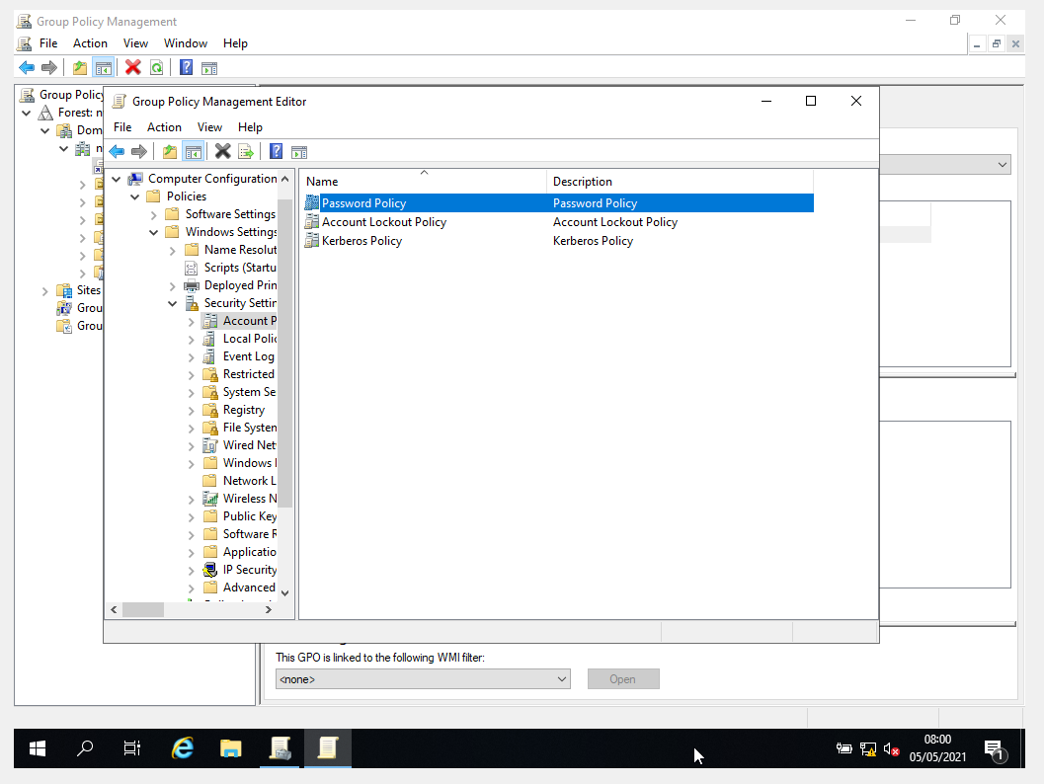
Figure 25 - Default password policy.
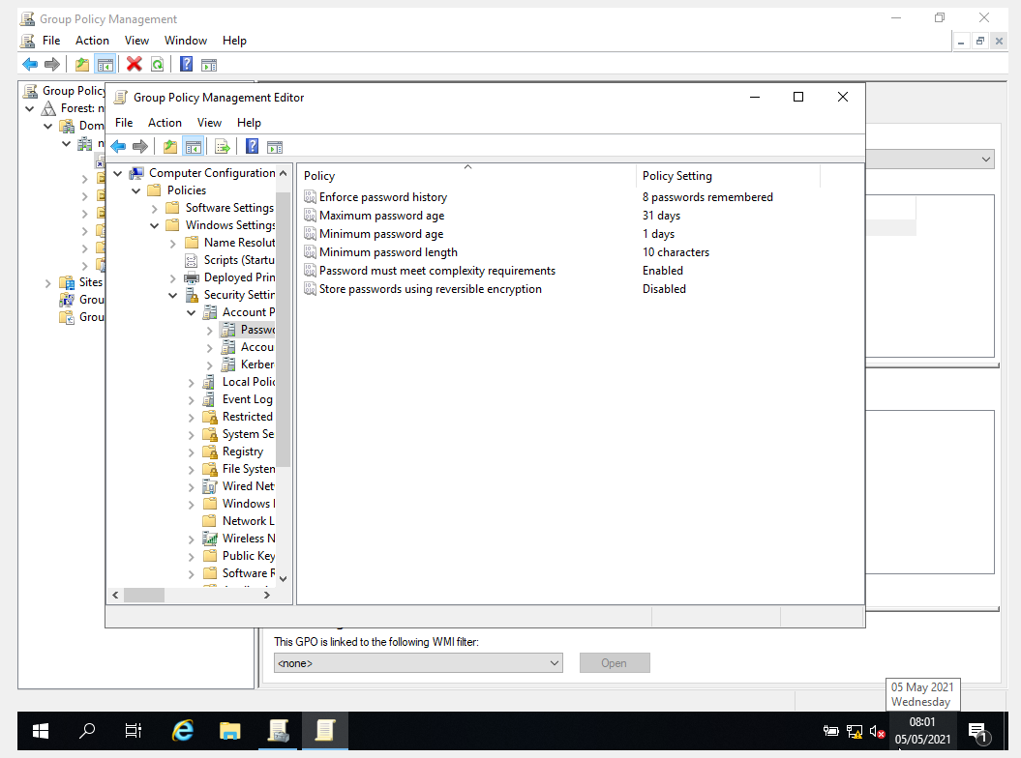
Figure 26 - Password policy configuration.
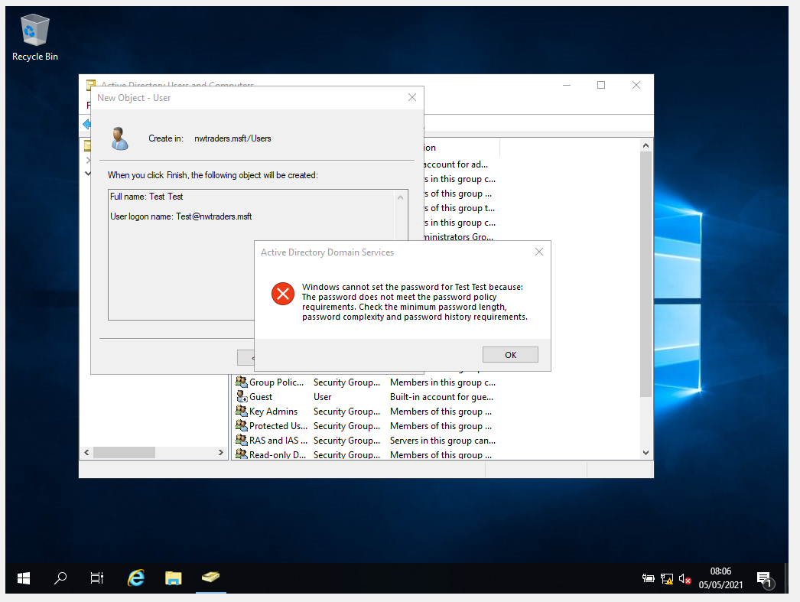
Figure 27 - Password policy enforcement.

CONCLUSION
In conclusion, the use of group policy within Active Directory provides an enormous possibility for the management of users and systems within a network. It is possible to control the security of passwords, restrict software applications, installations, and access to administrative functions within the operating system itself.

REFERENCE LIST
[1] JasonGerend, ‘NTFS overview’. https://docs.microsoft.com/en-us/windows-server/storage/file-server/ntfs-overview (accessed May 05, 2021).
[2] ‘Active Directory File Permissions Management - Manage NTFS and share permissions for folders and files by tightening access controls of users in Active Directory’. https://www.manageengine.com/products/ad-manager/active-directory-file-permissions-management.html (accessed May 05, 2021).
[3] ‘NTFS Permissions Management Best Practices’, Netwrix. https://www.netwrix.com/ntfs_permissions_management.html (accessed May 05, 2021).
[4] iainfoulds, ‘AD DS Simplified Administration’. https://docs.microsoft.com/en-us/windows-server/identity/ad-ds/manage/ad-ds-simplified-administration (accessed May 05, 2021).
[5] ‘Mapping Network Drives’, dummies. https://www.dummies.com/programming/networking/mapping-network-drives/ (accessed May 05, 2021).
[6] ‘Group Policy Management - Guide & Tutorial along with Defintions!’, PC & Network Downloads - PCWDLD.com, Nov. 19, 2020. https://www.pcwdld.com/group-policy-management (accessed May 05, 2021).
[7] ‘Step-by-Step Guide to Managing Multiple Local Group Policy Objects’. https://docs.microsoft.com/en-us/previous-versions/windows/it-pro/windows-vista/cc766291(v=ws.10) (accessed May 05, 2021).
[8] P. Walters, ‘The Risks of Using Portable Devices’, p. 5.
[9] ‘Unauthorized Application - an overview | ScienceDirect Topics’. https://www.sciencedirect.com/topics/computer-science/unauthorized-application (accessed May 05, 2021).
[10] M. Yıldırım and I. Mackie, ‘Encouraging users to improve password security and memorability’, Int. J. Inf. Secur., vol. 18, no. 6, pp. 741–759, Dec. 2019, doi: 10.1007/s10207-019-00429-y.

