Changemakers: Creativity and Value Creation
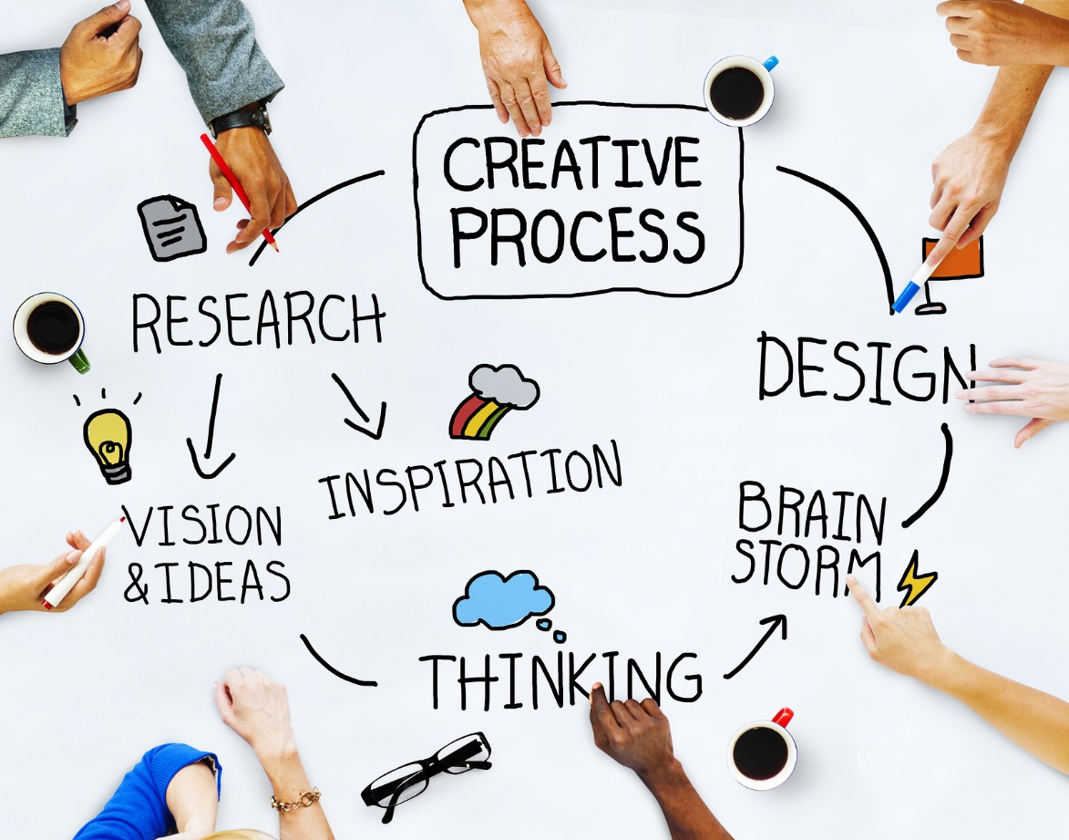

Software Engineering
Changemakers: Creativity and Value Creation

Kayleigh Davies
Student Number: 2316137
Table of Contents
Introduction 3
Task 1: Project Management 3
Part 1: Project Management and Planning 3
Development Method 6
Part 2: Project Design 8
Requirement Specification 8
Flowchart 10
Task 2: Enterprise and Innovation 11
Task 3: Project Reflection 14
Conclusion 15
References 15

Table of Figures
Figure 1. Required Technologies 4
Figure 2. Gantt Chart 5
Figure 3. Project Stages 6
Figure 4. Software Development Life Cycle (SDLC) 7
Figure 5. Illustration of Scrum’s iterative process [14]. 8
Figure 6. Quality Review Flowchart 10
Figure 7. Example SWOT Analysis for AutoDesk 11
Figure 8. Example PEST Analysis for Autodesk (adapted from [19]) 12

Introduction
The purpose of this report is to discuss the development of the project “Automated Drawing Review and Compliance Checker with Model Version Control”. Project management strategies, enterprise and innovation will be considered for the planning and delivery of the project as well as design elements, implementation methods, and evaluation of outcomes to ensure a successful delivery of the project can be achieved.

Task 1: Project Management

Part 1: Project Management and Planning
Project Scope
The purpose of this document is to provide guidance with the organisation, maintenance and troubleshooting elements of the project to sustain quality and control [1]. The scope of works is to develop an automated drawing review and compliance checker with model version control to reduce the workload and strain on engineering resources.
The aim of the scope is to satisfy expectations and the concerns around current working methods, while demonstrating the benefits that these improvements will make [7].
The system will perform checks to identify drawings or models that do not follow the set of standards outlined in the requirement specification. Plus, it will generate reports in formats such as PDFs or Excel to highlight what changes are needed to make our files CAD QA compliant and provide a percentage to show the progress.
Version control components will be developed to track and compare the design revisions of drawing and model files and prompt users to update the dwg and drawing renditions once a new version is available to share with the wider team.
Encouraging regular interaction and communication within the project team is critical for project delivery because it clarifies project requirements and supports team coordination. [7].
The project will not include automation processes to support the creation or editing of models and drawings file or compliance checking for all international standards. However, these are improvements that could be developed at a later stage.

Required Technology and Resources
Outlining clear technical requirements is an essential step for any software development [3]. Having the correct software installed will reduce the risk of delays caused by problems with licences, versions and compatibility. Below are examples of the technologies needed for this project:

Figure 1. Required Technologies
Defining the functions of the software will help developers understand what software and tools can be used for the design stages of the programme [3]. For example, a programming software will be needed to generate the code and scripts for the application, a drafting and modelling software will be used to test the functionality of the application, a database will be needed to store the compliance results and version history of the models, and a spreadsheet can be used to monitor progress [3].

Timeline and Schedule
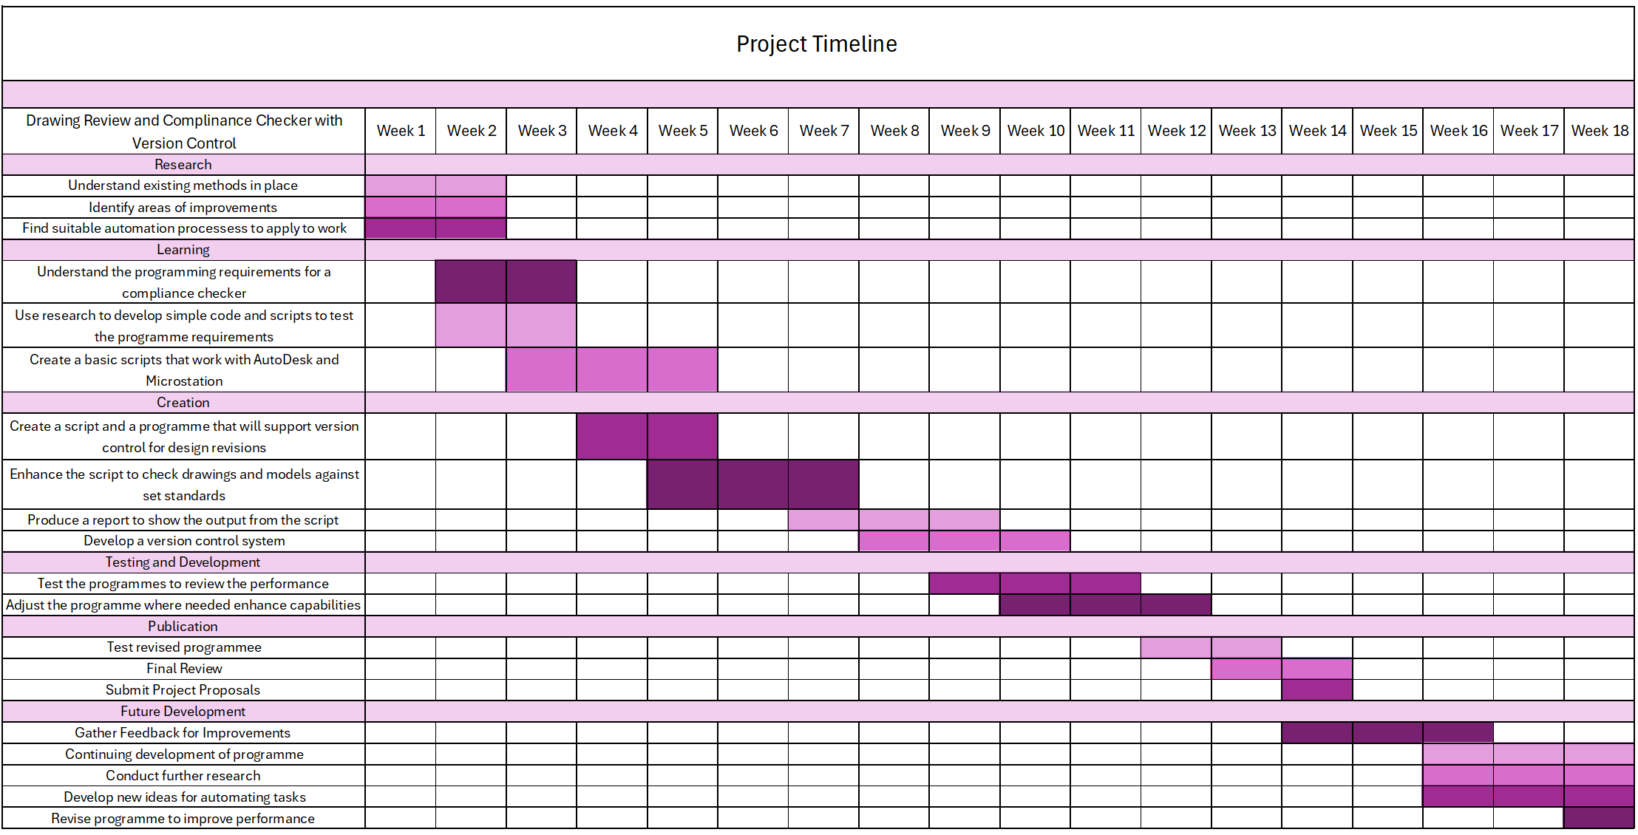
Providing a suitable project timeline will help coordinate the different activities and project expectations outlined in the scope [4]. They can provide a reference point across each project stage, showing the planned sequence of works while also making any conflicts and dependencies clear [4].

Figure 2. Gantt Chart
To demonstrate how much time and resources should be allocated for each task, a Gantt Chart has been developed to ensure the project objectives are met on time and to the required quality and standard. The project duration will run over 14 weeks to allow sufficient time to complete the required tasks for the following projects stages:
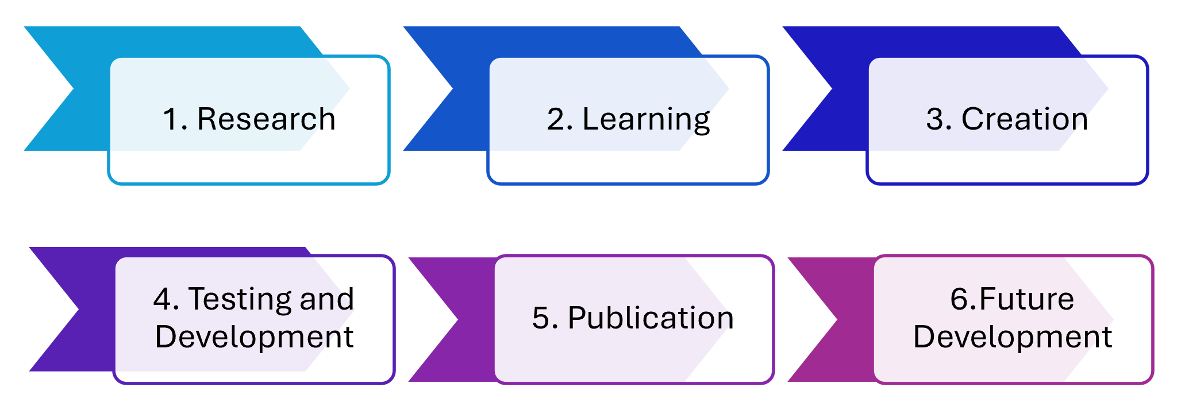
Figure 3. Project Stages

Once the project proposals have been submitted, additional time will be allocated for further development of the programme to enhance performance capabilities. This will be achieved by collecting feedback from colleagues, conducting further research and identifying ideas for other tasks to be automated in the future.
Constraints
During the stages of project management, the Theory or Constraint explains that “every project is limited by at least one constraint that dictates overall performance” [5], highlighting the importance of identifying any project constraints at the earliest stage. Common examples of project constraints include time, budget, skills, knowledge, resources and task dependencies [5].
The main project constraints are the resource and experience available for developing a software program to meet the set requirements. This emphasizes the need to reduce multitasking, allow enough time to stay focused, understand the potential problems that could delay the works and the necessary action needed to realign the project to meet our deliverables [6].

Development Method
A project management methodology will be used to provide guidance on how to plan, execute, monitor, control, and close out each of the project stages [8]. Having a suitable framework in place will provide the required tools and techniques to ensure all aspects are completed effectively and efficiently [8]. Project management methodologies play a crucial role as they encourage standardization, efficiency, clarity, flexibility and continuous development [8].
As this is a software development project, the Agile methodology would be better suited for project planning and delivery as they embrace adaptability to changes which works well with the nature of programming and software development [9]. This framework supports change and recognises the difficulties of having a complete project plan at the beginning of developments due to the volume of iterations required when coding [9].
Agility is based on principles such as “continuous innovation, product adaptation, shortening delivery times, adjustment of people and processes, and reliable results” while aiming to maintain a balance between flexibility and stability to respond to changing requirements [8,9].
The scrum management framework will be used for the Automated Drawing Review and Compliance Checker with Model Version Control project. This is because software development can be a complex process and will usually require room for “multidimensional growth” due to its “adaptive nature” [13].
The framework will provide steps to manage and control the stages of software development [13]. It was designed to increase the speed of development, align individual and organisational requirements to form a culture that focuses on performance and good communication to improve the overall quality of the development [13].

Figure 4. Software Development Life Cycle (SDLC)
The workflow will involve close communication amongst the project team, including the scrum team, scrum master and product owner, to allow for continuous design iterations to be made, while maintaining productivity and steady project progress [13].
The roles and responsibilities of the team are outlined by the scrum master to create an efficient working environment. The product owner will be responsible for defining the requirements of the compliance and version tracker, the development team will divide the requirements into sprint-specific tasks to develop the compliance checks, version control and user interface features [13,14].
A sprint can be described as the time allocated for assigned tasks, which typically lasts 1-4 weeks. The tasks are determined by the sprint backlog which is a record of the requirements for the sprint the team, including the tasks they are currently working on [13,14]. The backlog will contain the full set of project requirements including the CAD QA compliance rules/checks, the list of standards and the version control features.

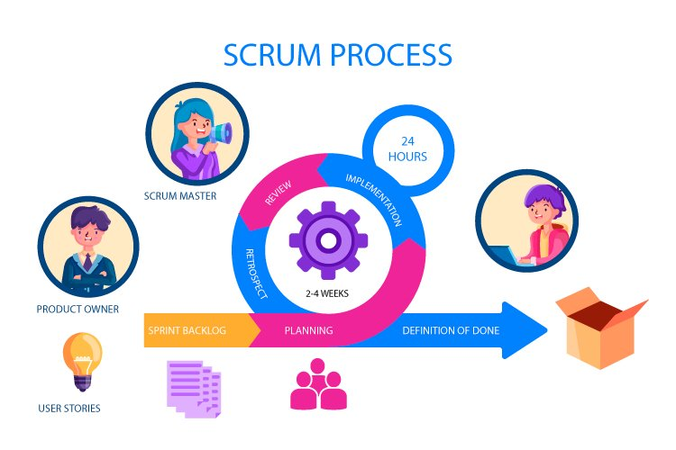
Figure 5. Illustration of Scrum’s iterative process [14].
Arranging time for daily standups allow the team to eliminate any blockers as soon as they are identified, rather than them carrying over into the next sprint improving the overall productivity of the team [14]. The scrum framework encourages constant feedback and frequent reviews, meaning the quality of the work increases in less time [12].
For example, during the sprint reviews, the functions of the compliance checker and version control would be tested, allowing the team to provide ideas for improvements ahead of the next sprint based on what went well and what areas require further development. This allows the team to respond quickly to any requested changes and modify the programme accordingly.

Part 2: Project Design

Requirement Specification
As mentioned throughout the report, the purpose of the programme is to develop a drawing review and compliance checker with model version control with the aim of improving the quality and standards of our work while limiting the amount of manual checks needed.
Functional Requirement
The main functional requirement of the programme is to generate reports in pdf and excel formats to demonstrate a percentage of CAD QA compliance in drawing and model files along with which changes are needed to reach 100% compliance.
The version control aspect of the programme will track and compare previous design revision and prompt users to update the dwg and drawing renditions once a new version has become available.
Non-Functional Requirement
The programme system should be reusable and reliable to ensure that technicians can run several reports throughout the day to monitor the areas of improvements and review the scores once the required changes have been made.
The system will require effective batch processing operations allowing it to respond to several requests at a time as a technician may need to review reports for multiple drawings and models depending on how many are needed for a project deliverable. For example, a report will be needed for 5 drawings, and the 4 models that are referenced into the drawings such as legend, drainage, highways and ordnance survey models.
Interface Requirement
The interface requirements for the programme are to have simple navigation features, making it easy for technicians to interact and engage with, allowing them to have a positive experience.
The programme should consider the visual design and readability of the outputs from the compliance checker to ensure it’s easy to follow and understand what changes are needed to make our model and drawing files CAD QA compliment. Carefully considering the typography and colours will assist with this, avoiding the risks of confusing and overwhelming users [17].
Performance Requirements
The system will need to produce accurate reports of the compliance against standards to show which rules have been met and what changes are needed. It will need to be capable of processing at least 20 files using batch operation without causing any issues with performance. This is because drawings packs can have a range of 5-50 drawings within a set, and multiple reports will need to be generated at a time.
Design Constraints
The design constraints for the project can include, technical limitations, user requirements and resource restrictions [15]. The system must support file formats such as dwg and dgn due to existing workflows and should integrate with existing software and control systems currently in place. It should provide a system that is easy for any user to navigate and have suitable access controls in place so only users with admin permissions can change any compliance rules.

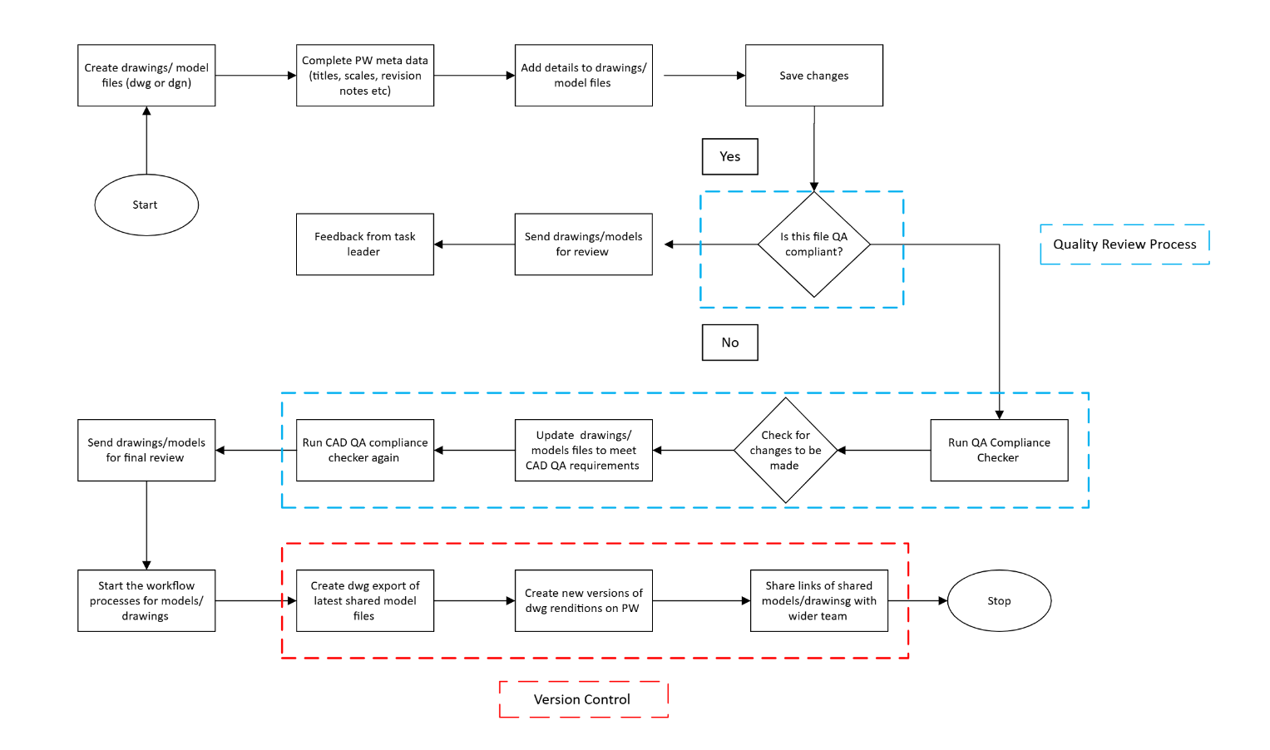
Flowchart

Figure 6. Quality Review Flowchart
Above is a flowchart diagram that demonstrates the process of quality reviews and version control based on the existing working methods in place. This diagram will support the team in developing the new automated system, providing them with each of the steps involved in the process.

Task 2: Enterprise and Innovation
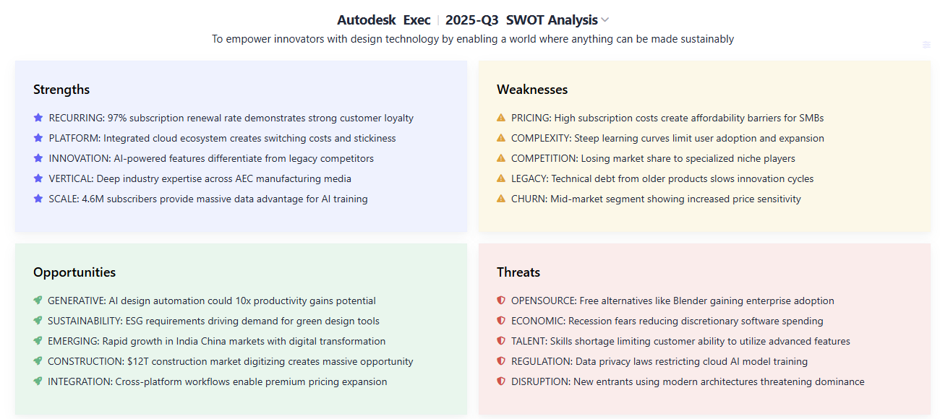
To develop an understanding of the key considerations from a PEST and SWOT analysis for a company such as Autodesk will provide me with examples of the type of considerations that will need to be included for the development of the Automated Drawing Review and Compliance Checker with Model Version Control project. An example SWOT analysis is shown in Figure 7 [20].

Figure 7. Example SWOT Analysis for AutoDesk
After reviewing this SWOT analysis, several points where identified that would also be applicable to our project development. The opportunities of generating automated tools to improve productivity, creating cross platform workflows and considering green design tools are all examples of enhancements that will support the development of new working methods to improve the efficiency of the team and the technology we use [20].
Some of the threats and weaknesses identified are also applicable to our project idea. For example, there can be a steep learning curve if you haven’t used design software and programming tools before, plus there Is a skill shortage in this area which puts us at a disadvantage of utilizing some of these advanced features [20].

When looking at the PEST analysis for Autodesk, there are a range of political, economic, social and technological factors to consider that will also impact our project delivery at times. For example, the new trends in technology to improve user experience, speed and access is something we would need to monitor as these factors will influence the design and development of the automation system.

Figure 8. Example PEST Analysis for Autodesk (adapted from [19])
Another example of the factors to think about are the economic considerations to enhance the skill level and growth of the workforce in the technology sector. This aligns with our project objectives, meaning we would need to monitor what is expected from companies to support the overall performance of the sector.

Project Implementation
To support the implementation of the Automated Drawing Review and Compliance Checker with Model Version Control project within a large organisation, the methods for the development, deployment, maintenance and evolution have been carefully considered to ensure suitable methods are in place.
Development
- To support the development of the project, the scrum framework will be used for the planning and delivery aspects of the project.
- A requirement specification will be created to outline the expectations of the functional, interface, performance and design elements
- The performance and integration of the programme will be tested to ensure there are no problems with the compatibility and function
Deployment
- Arranging training sessions will create a smooth deployment ensuring colleagues have an awareness of the new system
- Providing the correct access controls and permissions to the team based on experience and working requirements
- Create a how to guide to support the team in completing tasks while using the new system
Maintenance
- Providing the team with a clear support system
- Ensuring regular updates are scheduled to review performance and fix any issues
- Monitoring the system performance and gathering feedback from colleagues will provide ideas for further development
Evolution
- Encouraging continuous development amongst the team
- Using new and current technologies to improve working methods
- Launch the system at a bigger scale
- Start enhancing the features of the programme to meet new performance requirements based on feedback

Task 3: Project Reflection
Taking the idea of a drawing review and compliance checker with model version control will provide various development opportunities and contributions to society. Plus, there will be project challenges during which will require effective mitigation measures to assist with a smooth project delivery.
Having the time to reflect on these factors will impact what decisions and problem-solving strategies are implemented during the project as well as what aspects will need to be adjusted based on the findings [24]. Developing new ways of seeing is the most fundamental and neglected form of learning, which emphasizes the importance of developing awareness through reflection [26].
Skill Development Opportunities
Since there are several project stages and tasks involved in satisfying the project requirements, there are multiple opportunities for skill development. The focused skill areas include technical, management and problem solving. These are listed below, along with examples of ways to improve these skills:

Contributions to Society
Improving factors such as compliance and efficiency will contribute to society as it will reduce the stress and workload of the team, improve productivity and boost team morale.
Automating repetitive tasks to minimize input needed from the team will speed up current working methods allowing them to allocate resource elsewhere for other tasks.
Having an automated method available for reviewing our drawing and model files against standards reduces the risk of issuing work that isn’t fully compliant to our required standard.
The version control feature will check that the dwg and drawing renditions are updated once a new shared revision is available, ensuring that the latest design change is shown in our work and are available to share with the wider team.
Project Risks and Mitigation Measures
The main project risks include time constraints and integration problems. To reduce the impact of these challenges, regular testing and communication will occur amongst the project team to quickly identify solutions, avoiding the risk of further delays. Having a clear support network will also help the team in resolving issues with the design or integration of the software.

Conclusion
The Automated Drawing Review and Compliance Checker with Model Version Control project aims to automate the process of reviewing engineering drawings and models to ensure quality and consistency is maintained across the organization. Developing reliable compliance checks and model version control features will improve performance and productivity of the team and encourage them to think of working on other automation projects in the future.
The scrum framework will be used for the delivery of the project to encourage continuous innovation and adaptive planning to allow for an iterative designing process. Following this approach will make the objectives of reducing the volume of manual reviews and improving workflow efficiency achievable. Meeting these project requirements will allow the team to allocate resources elsewhere and use the time more effectively.
These programmes have the potential to include advancements to automate more processes such as drawing and model creation, batch model updates and run compliance checks against various standards. These ideas are something to take forward in the later stages of design and development for the project.

References
[1] Indeed Editorial Team , “How to plan a project in 10 simple steps (with tips),” Indeed Career Guide, 2024. https://uk.indeed.com/career-advice/career-development/how-to-plan-a-project (accessed Aug. 13, 2025).
[2] GeeksforGeeks, “13 Technical Skills You Should Have As A Developer [2025],” GeeksforGeeks, Jun. 25, 2019. https://www.geeksforgeeks.org/blogs/technical-skills-to-have-as-a-developer/ (accessed Aug. 13, 2025).
[3] Indeed Editorial Team , “Technical Requirements (With Definition and List of Examples),” Indeed Career Guide, Jun. 09, 2025. https://www.indeed.com/career-advice/finding-a-job/technical-requirements
[4] E. K. Yakura, “Charting Time: Timelines as Temporal Boundary Objects,” Academy of Management Journal, vol. 45, no. 5, pp. 956–970, Oct. 2002, doi: https://doi.org/10.5465/3069324.
[5] J. H. Blackstone, J. F. Cox, and J. G. Schleier, “A tutorial on project management from a theory of constraints perspective,” International Journal of Production Research, vol. 47, no. 24, pp. 7029–7046, Oct. 2009, doi: https://doi.org/10.1080/00207540802392551.
[6] A. Izmailov, D. Korneva, and A. Kozhemiakin, “Effective Project Management with Theory of Constraints,” Procedia - Social and Behavioral Sciences, vol. 229, pp. 96–103, Aug. 2016, doi: https://doi.org/10.1016/j.sbspro.2016.07.118.
[7] M. K. Fageha and A. A. Aibinu, “Managing Project Scope Definition to Improve Stakeholders’ Participation and Enhance Project Outcome,” Procedia - Social and Behavioral Sciences, vol. 74, pp. 154–164, Mar. 2013, doi: https://doi.org/10.1016/j.sbspro.2013.03.038.
[8] GeeksforGeeks, “Top 10 Project Management Methodologies: An Overview,” GeeksforGeeks, Mar. 27, 2024. https://www.geeksforgeeks.org/business-studies/project-management-methodologies/
[9] M. Špundak, “Mixed Agile/Traditional Project Management Methodology – Reality or Illusion?,” Procedia - Social and Behavioral Sciences, vol. 119, pp. 939–948, Mar. 2014, doi: https://doi.org/10.1016/j.sbspro.2014.03.105.
[10] GeeksforGeeks, “What is Agile Methodology?,” GeeksforGeeks, Dec. 13, 2023. https://www.geeksforgeeks.org/software-testing/what-is-agile-methodology/
[11] GeeksforGeeks, “Agile SDLC (Software Development Life Cycle),” GeeksforGeeks, Oct. 15, 2021. https://www.geeksforgeeks.org/software-engineering/agile-sdlc-software-development-life-cycle/
[12] GeeksforGeeks, “What is Scrum in Software Development?,” GeeksforGeeks, Jun. 07, 2019. https://www.geeksforgeeks.org/software-engineering/scrum-software-development/ (accessed Aug. 14, 2025).
[13] A. Srivastava, S. Bhardwaj, and S. Saraswat, “SCRUM model for agile methodology,” in 2017 International Conference on Computing, Communication and Automation (ICCCA), IEEE, 2017, pp. 8–869. doi: 10.1109/CCAA.2017.8229928.
[14] ProductHQ, “What is Scrum? | Product HQ,” Product HQ, 2021. https://producthq.org/agile/scrum/ (accessed Aug. 14, 2025).
[15] GeeksforGeeks, “Software Requirement Specification (SRS) Format,” GeeksforGeeks, Jun. 18, 2020. https://www.geeksforgeeks.org/software-engineering/software-requirement-specification-srs-format/ (accessed Aug. 14, 2025).
[16] author Institute of Electrical and Electronics Engineers, “Process to enhance the quality of software requirement specification document,” in ICEET : 2018 International Conference on Engineering and Emerging Technologies : 22-23 February 2018, Lahore, Pakistan /, Piscataway, New Jersey : Institute of Electrical and Electronics Engineers, 2018, pp. 431–7. doi: 10.1109/ICEET1.2018.8338619.
[17] N. Hamidli, “Introduction to UI/UX Design: Key Concepts and Principles,” 2023.
[18] L. Colos, “Autodesk: Business Model, SWOT Analysis, and Competitors 2023 - PitchGrade,” pitchgrade.com, Mar. 01, 2024. https://pitchgrade.com/companies/autodesk (accessed Aug. 15, 2025).
[19] E. Pro, “Solved: Autodesk PESTEL / STEP / PEST Analysis & Solution,” embapro.com. https://embapro.com/frontpage/pestelcoanalysis/24565-autodesk (accessed Aug. 17, 2025).
[20] SWOTAnalysis.com, “Autodesk SWOT Analysis & OKR Plan,” SWOT Analysis, Jul. 03, 2025. https://www.swotanalysis.com/autodesk (accessed Aug. 17, 2025).
[21] A. Khan, S. Sepasgozar, T. Liu, and R. Yu, “Integration of BIM and Immersive Technologies for AEC: A Scientometric-SWOT Analysis and Critical Content Review,” Buildings, vol. 11, no. 3, p. 126, Mar. 2021, doi: https://doi.org/10.3390/buildings11030126.
[22] L. Good, “5 Phases of Project Management | Project Phases (PMP),” Project-Management.com, Feb. 28, 2024. https://project-management.com/project-management-phases/ (accessed Aug. 18, 2025).
[23] A. Hartmann, J. Vinke-de Kruijf, and R. van Weesep, “Asking the Right questions: the Role of Reflection for Learning in and between Projects,” International Journal of Project Management, vol. 41, no. 5, p. 102494, Jul. 2023, Accessed: Aug. 15, 2025. [Online]. Available: https://www.sciencedirect.com/science/article/pii/S0263786323000583
[24] Chang, “Reflection in learning.,” Online learning : the official journal of the Online Learning Consortium., vol. 23, no. 1, 2019.
[25] R. J. DeFillippi, “Introduction: Project-based learning, reflective practices and learning,” *Management Learning*, vol. 32, no. 1, pp. 5–10, Mar. 2001, doi: 10.1177/1350507601321001.
[26] P. Walker and N. Finney, “Skill Development and Critical Thinking in Higher Education,” Teaching in Higher Education, vol. 4, no. 4, pp. 531–547, Oct. 1999, doi: https://doi.org/10.1080/1356251990040409.

