Communication:
Models and skills for effective communication

Mohamed Trissia (1921106)

Effective teamworking and communication module

Lecturer name: Mr Shaqib Shamim

Introduction:
Thanks to the means of communication that today the whole planet has become a small village. Everyone may know what is happening in the other side of the world while he is sitting in his house. However, despite the rapid increase of these means of communication and the different reliable ways to transmit the messages, sometimes the communication is ineffective and distorted due to different factors (Sharpe, 1991).
Communication is a two-way directional sequence of transmitting messages where the counterparts are the sender and the receiver. This action takes place through a channel which could be verbal (oral/written) or nonverbal. Guzman 2016 categorized the nonverbal communication in four types:
- Physical: total of the movements of the body like smile, facial expressions.
- Aesthetic: using arts, music, theatre and other creative expressions.
- Signs: sending messages with signs that have special meaning.
- Symbols: mainly using material things such as fancy clothes, expensive jewellery, etc.
Different studies argued about the importance of nonverbal elements for delivering an effective communication. The most used is the Professor Albert Mehrabian’s theory. He suggested that a great amount of human behaviour is emphasized through non-verbal cues and that over 70% of all communication is non-verbal (Buludi, 2008). And when verbal and non-verbal communication conflicts, people usually interpret the true meaning using the non-verbal signals. He illustrated this using the chart in figure 5:

Figure 5: Buludi 2008
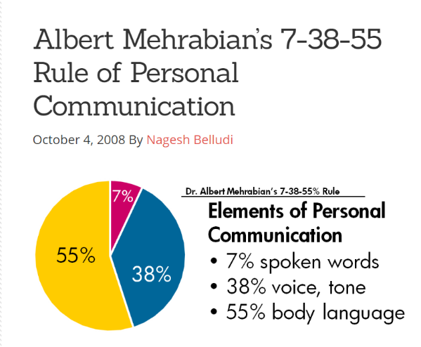
This theory demonstrates that only 7% of the content is verbal, 55% body language and 38% is the use of one’s voice.

After conducting few search, different articles highlighted that communication could be summarized in four levels. For instance (Schmitz, 2012) explained communication forms as follows:
- Interpersonal: is when two persons communicate with each other.
- Intrapersonal: is when we communicate within ourselves.
- Group: is when more than two individuals communicate.
- Mass: is when the communicator is separate from the audience in terms of time and place with help of electronic devices like Microsoft teams, skype.

content:
1. the communication cycle: (figure1)
The communication cycle is essential for the purpose of increasing the effectiveness of communication which could be accomplished only when the message is received and understood in the intended way (Potentialunearthed, 2016). The diagram below explains the way and the main elements involved in exchange of a message:
Figure 1: Potentialunearthed 2016
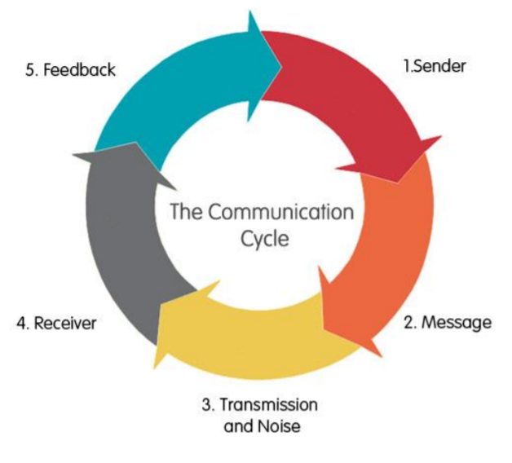
Explanation:
The sender/ the encoder: the person who transmits the message.
The encoding: is how the sender chooses to bring the message appropriate for sending using verbal or non-verbal cues.
The message: the fact that the sender wants to convey.
Decoding: is what the receiver interprets or understands.
The receiver/ the decoder: the person to whom the message was sent.
The feedback is simply the response of the receiver to the sender. This action will make the communicator understands if the message is understood properly. However, it is possible that the recipient can decode the information in a complete different to what the sender is trying to convey because of “noise”, or “barrier”. Comprehensively, four main types of noises affect a good communication (Lunenburg, 2010):
- Cultural noise: it can develop due to differences of languages, values, or attitudes.
- Physical noise: any external distraction like construction, loud music, baby crying.
- Semantic noise: mainly caused by the sender who transmits a grammatical or technical language that the receiver cannot clearly understand (ain’t happy), or sends messages at the wrong time either too early or too late
- Psychological noise: mental barrier such as wondering thoughts, preconceived ideas.
2. models of communication:
2.1 Shannon-weaver model: (figure2)
This mathematical theory was originally created by Claude Shannon and later was developed by Warren Weaver in 1949 (Wikipedia, 2020). It has been considered the most important model as it led to the development of the other models and therefore it is known also as “the mother of all models” (JMC STUDY HUB, 2019).
Figure 2: JMC STUDY HUB 2019
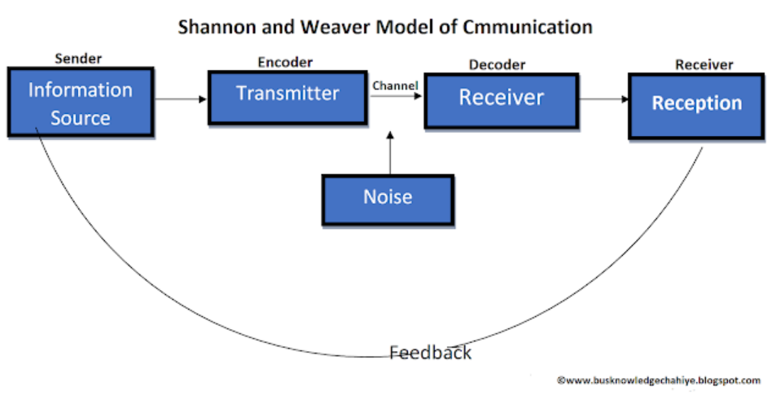

In this model, the information source produces a message which could be spoken or written word. the encoder converts the message to a signal suitable for the channel to be used. The channel is the medium that transmits the signal to the receiver. The receiver reconstructs the message from the signal. And finally, the destination is the person for whom the message is sent to.
Shannon-Weaver model introduced for the first time the concept of noise. it was not taking consideration the feedback as main concept when it was created but later Norbert Weiner developed and changed it from linear to cyclical model (Wikipedia, 2020).
It was criticised for many reasons such as it was created mainly for technical communication like the telephone not for human communication, and that was created for interpersonal communication not for group and mass one (Croft, 2004).

Case study:
As example of the Shannon-Weaver model is Maria and Pedro case:
Maria called her husband Pedro while he was working asking him to bring some chicken in his way back home. He went home without buying anything. Maria asked him where the chicken is, and he replied that he thought she said we meet at the kitchen. As we can see here, there is a lack of communication between Maria and Pedro. Also, it is very clear that some “noise” was obstructing Pedro from understanding Maria’ request. It could be a linguistic noise, meaning that Pedro is not a native English speaker, or may be a physical “noise” by construction site noises, network signal interruption, etc.
2.2 Schramm’s model: (figure3)
This model was proposed by the well-known communication expert “Wilbur Schramm” in 1954. Though, this process has lot of similarity with Shannon-Weaver theory, it is a circular way of communication rather than linear, meaning that it is very essential for the source and the destination to take turns in sending and receiving messages (Wikipedia, 2020). This notion of communication allows both parties to contribute and share equally their feedbacks which act as a confirmation of encoding and decoding the message.
Figure 3: Burgoon J.D 2012
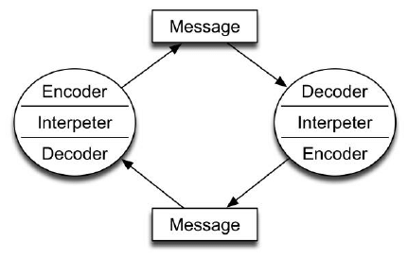
Schramm emphasises that field of experience, cultural backgrounds, and knowledge are very important aspects for an effective communication (Croft, 2004). For instance, it will be very hard of a professor of Maths to transmit a message of Maths principles to a classroom of year one students because they do not share the field of experience that makes the message easy to get.
Although this model is more dynamic and makes an easy approach of communication between the sender and the receiver, it has few drawbacks as well. One disadvantage is that it could be impaired by semantic noise which cause a message to be misinterpreted. As example you can say same things to two people but each one of them understands it differently. Another negative aspect is its simplicity meaning It refers to one-to-one communication rather than multiple participants (Wikipedia, 2020).

2.3 Berlo’s model: (figure4):
Known also as S.M.C.R (source, message, channel, receiver) model, this theory was developed from the Shannon-Weaver model by David Berlo in 1960.
This model focuses on encoding and decoding before the source sends the message and the destination receives it. It also focuses on the purpose and objectives of the communication and uses the verbal and non-verbal cues of the communication (Wikipedia, 2020).
Figure 4: JMC STUDY HUB 2019
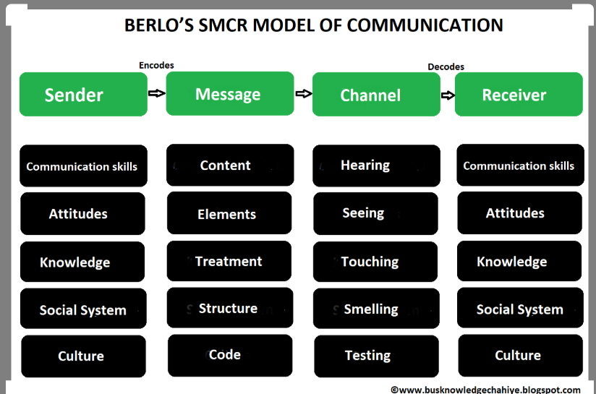
Components of the S.M.C.R:
- S-sender: the person who originates the message. He could transmit the information with the following factors:
- Communication skills: ability to speak, read, write and listen. The sender should know how to speak and pronounce words to have impact on the listeners. Likewise, the receiver should have the same skills to understand the message.
- Attitude: the person’s attitude towards the receiver and the environment changes the meaning and effect the message.
- Knowledge: the clarity of information sent by the sender
- Social system: including values, beliefs, religion, etc.
- Culture: the cultural backgrounds
- M-message: Also called “encoding” is the transformation from thoughts to words. It can be a voice, text, audio, video, or any type of media. It compromises the following:
- The content: all what the message contains.
- Elements: are non-verbal basics such as signs, gestures, body language
- Treatment: is the way in which the message was sent.
- Structure: is the way the massage was organised and arranged.
- Code: the form of the message.
- C-channel: the medium used to transmit the message such as telephone, internet in mass communication and the five senses of human being: Hearing, Seeing, Touching, Smelling, and Tasting in general communication.
- R-receiver: the person who gets the message and responds to the sender.
This model believes that the sender and the receiver must be similar and share the same listening skills and all the factors mentioned above including attitudes, knowledge, social systems, and culture for the communication to be effective.
Like the other models, there are some drawbacks for Berlo’s model too such as it is linear model, no feedback or noise and both sender and receiver must be similar for all factors.
3.Communication skills:
Communication styles differ from person to another. As explained above, during the process of communication, a person can send a message via various channels and methods which are important to make it easy for the receiver to understand the message properly. Therefore, the sender and the receiver must have some communication skills to facilitate the process in effective way.
- Clarity: ability to deliver a clear and concise message rather than too many things.
- Empathy: understanding the feelings, the thoughts, and experiences of others.
- Sincerity: showing sincerity will enhance the interpersonal communication.
- Relaxation: being confident and stress free with deep rhythmic breaths.
- Eye contact: it shows that you are paying attention and that you are actively listening.
- Appearance: the way someone dresses, grooms, and presents himself.
- Posture: can reflect a person’s degree of confidence and how ready to receive another’s views and ideas.
- Listening: Ability to receive and acknowledge the message attentively. It is main key in every effective communication.

Example of a poor communication:
I remember once I was a restaurant supervisor and I there was an employee from the owner’s family. Whenever I approached him to give him some tasks to do, he usually does not pay attention to what I said and ignore my presence with his body language signals. His communication skills created a very bad working environment and I asked the boss to talk to him in order to improve him communication skills by being more active listener and involving better body language and facial expressions on the purpose of having friendly effective productivity at work.

Conclusion:
Effective communication is vital in our modern life. It enables us to work successfully and have good relationships with others whether in a job, a business, or even romantic relationships. Hence, it is crucial to exchange the messages clearly and at an appropriate time considering any distractions and barriers that could prevent those messages to get through. And to remove those barriers, both sender and receiver need to apply proper tools and effective communication skills. For that reason, people should learn how to improve those skills by taking online courses or seeking some professional help.

References:
Buludi, N. (2008). Albert Mehrabian’s 7-38-55 Rule of Personal communication. [online] https://www.rightattitudes.com/2008/10/04/7-38-55-rule-personal-communication/ [Accessed 5th August 2020].
Burgoon, J.D. (2012). Shramm model of communication. [online] https://www.researchgate.net/figure/Schramm-Model-of-Communication_fig1_254051534 [ Accessed 1st August 2020].
Croft, R.S. (2004). Communication Theory. [online] https://cs.eou.edu/rcroft/MM350/CommunicationModels.pdf. [ Accessed 3rd August 2020].
Guzman, A. (2016). Nonverbal communication. [online] https://www.youtube.com/watch?v=SKhsavlvuao. [ Accessed 3rd August 2020].
JMC STUDY HUB. (2019). Berlo’s SMRC model of communication. [online] https://www.pinterest.fr/pin/609885974518647843/?amp_client_id=CLIENT_ID(_)&mweb_unauth_id=&simplified=true [Accessed 5th August 2020].
JMC STUDY HUB. (2019). Shannon and Waver models of communication. [online] https://jmcstudyhub.com/shannon-and-weaver-model-of-communication-mass-communication/ [ Accessed 3rd August 2020].
Lunenburg, F.C. (2010). Communication: The process, Barriers, And Improving Effectiveness. [online] https://www.mcgill.ca/engage/files/engage/communication_lunenburg_2010.pdf. [Accessed 10th August 2020].
Potentialunearthed (2016). Communication Cycle. [online] https://www.potentialunearthed.co.uk/wp-content/uploads/2017/09/Comms-Cycle-Handout.pdf [ Accessed 1st August 2020].
Schmitz, A. (2012). A Primer on Communication Studies (v.1.0). [online] https://2012books.lardbucket.org/books/a-primer-on-communication-studies/index.html. [Accessed 12th August 2020].
Sharpe, D. (1991). Effective Communication. [online] http://www.msucommunitydevelopment.org/effectivecommunication.html. [Accessed 1st August 2020].

Wikipedia (2020). Models of Communication. [online] https://en.wikipedia.org/wiki/Models_of_communication [ Accessed 1st August 2020].

Appendix


