

Postgraduate/Distance Learning
Assignment coversheet & feedback form

THIS SHEET MUST BE THE FIRST PAGE OF THE ASSIGNMENT YOU ARE SUBMITTING (DO NOT SEND AS A SEPARATE FILE)

For completion by the student:
Student Name: Kat Azima

Student University Email: 2219013@student.uwtsd.ac.uk
Module code: HPCA7028  Module title: Sacred Skies | Student ID number:  2219013 |  |  | Educational support needs:  No
Assignment title:

Assignment due date: April 4th
This assignment is for the 1st ☐ 2nd ☐ 3rd ☐ 4th X 5th ☐ 6th ☐ module of the degree
I confirm that this is my original work and that I have adhered to the University policy on plagiarism.
Signed Kat Azima ……………………………………………………………
Email submission:if you are submitting this form via email, please tick this box □
(as a substitute for your signature) to confirm that you agree to the above declaration.
Assignment Mark
1st Marker’s Provisional mark
2nd Marker’s/Moderator’s provisional mark
External Examiner’s mark (if relevant)
Final Mark

NB. All marks are provisional until confirmed by the Final Examination Board.

For completion by Marker 1 :
Comments:

Marker’s signature: |  |  | Date:
For completion by Marker 2/Moderator:

Comments:

Marker’s Signature: |  | Date:
External Examiner’s comments (if relevant)

External Examiner’s Signature: |  | Date:

Kat Azima – HPCA7028– Essay 2
A Critical Examination of the Sky
in Relation to Material Culture
Introduction
The aim of this essay is to critically examine the cultural expression or representation of the sky in relation to material culture. More specifically, this essay will examine the cultural expression of the moon in relation to two different works of art. The primary sources examined are by William Blake, I want! I want!, 1793, Line engraving and etching, 7.1 x 4.8 cm, For the Children: The Gates of Paradise, Library of Congress, Washington, DC. which is an imagining of a lunar ascent. The second piece is by Rodney Winfield, Scientists' and Technicians' Window, 1973, Stained Glass, 5.8m x 4.0m, National Cathedral, Washington, DC which is an artwork that commemorates the Apollo 11 lunar landing. This essay will examine the different ways the images reflect the celestial journey to the moon within their cultural context through the theoretical framework of cultural astronomy, visual culture and materiality. Both works of art will be critically analysed using iconological methodology established by Erwin Panofsky (1892-1968) which investigates the meaning of motifs, symbols and allegories in their cultural context. This essay will conclude with a discussion of the ways in which the cultural expression of the moon is evident in these artworks.
Cultural Astronomy and the Moon
Scholars agree that there is a significant relationship between human societies and the sky/cosmos. As Fabio Silva states ‘the study of the relationship between the sky and human societies has become the purview of Cultural Astronomy.’ As Silva further states, while the terms landscape, taskscape, and seascape have been used in archaeoastronomy the sky has been neglected. Now the term ‘skyscape’ has become more widely used to talk about the use of the sky in culture and how it ‘extends upwards to encompass the heavens and the celestial bodies and how they relate back down to human beliefs and practices, to their notions of time and place, to their structures and material remains.’ The role and importance of skyscapes in social, economic, religious and political spheres of cultures around the world, as Silva contends, can no longer be neglected. Nicholas Campion also highlights the importance of the sky in relation to humanity saying ‘there is no human society that does not somehow, in some way relate its fears, concerns, hopes, and wishes to the sky, and to the organising principle behind it, the cosmos. Darrelyn Gunzburg also imparts that there is both a material and psychological relationship between the sky and human societies saying,
‘We locate ourselves externally and internally, physically and symbolically, by the sky, and humanity uses it to judge its time and set its courses geographically and culturally. By its imagery, transmitted through text, image, oral tradition, physical mapping, and painted description, the sky has reflected our place in the cosmos.’
The moon, which is located within the skyscape, has been a destination in the human imagination for centuries and a site to project our dreams and aspirations as Melanie Vandenbrouck states. The moon is a material entity that exists in deep time similarly, as Gunzburg and Brady describe, in their discussion of mountains. The moon for early modern Englishmen, as David Cressy states, ‘was comfortably familiar yet achingly distant.’ As Cressy further recounts, from ancient times to the age of the telescope, sky-watchers speculated about a face or man on the moon, plurality of worlds and possibility of space travel.
Visual Culture
Many scholars agree that art is delibereately created, with a story that always comes from a point of view. As Campion and Zahrt explain, ‘Art relates to the modern English words aratifice and artificial: a work of art is artificial. It is something deliberately created and, for most of western history, has required a high level of craft. A skill has to be learnt, and if it is implemented well then the viewer, listener, or reader is moved and inspired.’ Alexis L. Boylan states ‘the visual is part of a story that humans weave, but humans are also parts of the narrative created by images. Our wanting gives way to the fact that we are all pulled into the visual, summoned to dance together. As Boylan also states ‘visual culture is never neutral, and is thus never without value. Visual culture is power.’ As Tilly explains ‘representations whether they be in the form of images or words are just that: they are always partial, ambiguous, changing, perspectival, undertaken form a point of view, shaped, and being shaped.’ Describing the world through text, language or images as Tilley says, develops through the ‘subjective and interpretative process of fashioning thick descriptions of the manner in which matter and mind intersect.’ Therefore there is always a point of view and perspective that is taken.
Materiality
In his discussion of materiality, Christopher Tilley states that, ‘people are indeed embedded in a material world, immersed within it, and this sensuous world of material things has effects on the way people think and behave, but not in any simple or deterministic sense.’ As Tilly observes, the discipline of materiality has radically changed from ‘things’ being viewed empirically and decontextualized from their social and historical contexts to a view of ‘things’ and what their properties mean and are experienced in different social and historical contexts. This view is a more holistic approach Tilley says, one that understands the meaningful relationship between
persons and things. Similarly, Amy Whitehead, contends that our humanity means that we interact and relate to material culture whether we like it or not. Materiality she says is ‘not just representational it is sensual, embodied and tangible’. She argues that objects and offerings are subjective, relational participants in ceremony rites and ritual and that the ‘lived reality of religions’ is inescapably entangled with material culture. As Timothy Darvill states ‘cosmologies informed the creation of material culture in the past and thus provide the keys to understanding the past in the present. In his discussion on mountains, Tilley argues that ‘their very materiality both grounds and constrains the way in which people give them human significance and meaning, thorough their relationship to myths, cosmologies, and world views.

Iconographic/iconological analysis
A critical examination of the two pieces of artwork will be carried out using art historian Erwin Panofsky’s three levels of iconographic/iconological analysis. The first level of analysis, referred to as pre-iconographical, will be a basic, factual analysis of forms to describe what can be recognized visually without reference to outside sources. The second level, referred to as iconographical analysis, identifies the image as a known story taking into account the symbolic/allegorical meanings contained in the artwork. The third level analysis, referred to as iconological interpretation, takes the symbolic, intrinsic, cultural values into consideration.
Imagining the Lunar Voyage
‘I want! I want!’ By William Blake
‘I want! I want!’ engraving is part of a book designed and created in 1793 by British Poet and Artist William Blake (1756-1827). The book features 18 small engravings each smaller than a playing card with a size of 7.1 x 4.8cm. Blake created ‘I want! I want!’ in England and was produced as an image for what was originally a children’s book called For Children: The Gates of Paradise. Later in 1818 it was revised for an older audience to For the Sexes: The Gates of Paradise.

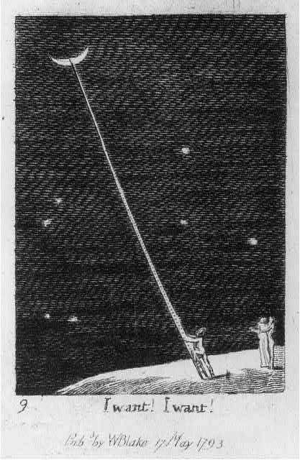
Figure 1: William Blake (1757-1827), I want! I want!, 1793, Line engraving and etching, 7.1 x 4.8 cm,
For the Children: The Gates of Paradise. Image: Library of Congress, Washington, DC.
Pre-iconographical Analysis
Upon a detailed examination of the artwork ‘I want! I want!’ (see figure 1), a crescent moon is set high above the left frame against a black background. The black background takes up almost all of the frame. There are seven white dots scattered around the middle and bottom of the frame. These small dots/spheres are white and sets them apart from the black background. There are three figures standing upright and placed in the bottom corner of the frame standing on top of a surface. This surface is curved and placed in the right corner of the frame. Out of the three figures, two of them stand closely side by side with their bodies facing the back of the other figure. The single figure who is not standing too far from the other two appears to be wearing a clear head cover. The single figure appears to be taking its first step up to climb a very long ladder toward the crescent moon. The ladder width narrows as it gets closer to the crescent moon, giving the appearance of a great distance between the figures and the moon. Below the main frame against a white background is a caption that says ‘I want! I want!’. Below the caption it says ‘Pub by WBlake 17 May 1793’. The plate number is also located on the bottom left side of the image below the main frame.
Iconographical analysis
‘I want! I want!’ was created as part of the story describing the life of man from birth to death. The engraving is a vision of early space travel created almost two centuries before the Apollo 11 moon landing. Each engraving ranges from single words to brief aphorisms. In plate 9, at the height of man’s adult emotions, a small figure reaches for the Moon crying ‘I want! I want!’. There is a child-like perhaps naive desire to want the Moon, something which is so far out of reach for humans. The choice to place a waxing crescent moon, the phase right after a new moon, rather than choosing another phase of the moon phase, suggests this may symbolise growth, hope, and intention. The figure climbing up the ladder to the moon then may have the intention and hope to reach the surface and touch the moon, while the two figures huddled nearby appear to be reaching out to the figure perhaps concerned for its safety. The crescent moon set high above the left frame against a black background takes up almost all of the frame highlighting the vastness and mystery of outer space. There are seven white dots scattered across the black background, suggesting they may be seven stars or planets. There are three figures that appear to be humans standing upright and placed in the bottom corner of the frame standing on top of a curved surface and placed in the right corner of the frame. The surface is ambiguous but may be another moon or planet. Out of the three figures, two of them stand closely side by side with their bodies facing the back of the other figure. The single figure, not standing too far from the couple, appears to be wearing what looks like an astronaut's helmet because it is clear, round and covers the figure's entire head. The single figure appears to be looking up at the moon and taking its first step up to climb a very long ladder toward the crescent moon. The moon is not within easy reach of the figure. The ladder width narrows as it gets closer to the crescent moon, giving the appearance of a great distance and vastness between the figures and the moon. The viewer is left to wonder if the figure will in fact reach the moon.
Iconological interpretation

William Blake was born in central London and was homeschooled as a child. He was known as a working-class London artist in his adulthood, and as Higgs describes, ‘the Bible was the foundation of his work and imagination for the rest of his life.’ In the 18th and 19th century Blake was considered an obscure, mocked failure and did not carry the notoriety he has today according to Higgs. As Higgs further explains, Blake spent long hours working as an engraver both on his own works and commercially. He describes that etching involved scratching intricate patterns of lines, dots, stippling or cross-hatching into a flat sheet of copper, eventually developing an original technique of his own. Blake’s immense posthumous fame and praise as Higgs says is evident by the fact that in 2019, an exhibition of Blake’s collection of over 300 original works at Tate Britain sold close to a quarter of million tickets over its 4.5 month run. Blake and his visions are central to his modern fame and more fundamental to our idea of the man than e​​ven his genius for painting or poetry.’ The 19th-century scholar William Michael Rossetti characterised Blake as a "glorious luminary", and "a man not forestalled by predecessors, nor to be classed with contemporaries, nor to be replaced by known or readily surmisable successors”.
The end of the 18th century was a revolutionary and radical period around the time of the American and French Revolution and was a time when enlightenment values were in ascendance. John Higgs, Blake’s biographer states that Blake was not known for his affiliations with political parties or support for particular candidates but he does deserve a place in the story of the english radical tradition. Higgs goes on to say that Blake ‘produced his art as an individualist antinomian, asking no permission, answering to nobody - a position that we have come to understand better over the past couple of centuries, in Blake’s time, however, these were radical politics indeed.’ Blake was one of the earliest writers and poets of the Romantic period. Andrew Greg describes how Blake ‘believed in spiritual and political freedom and often wrote about these themes in his works. Although some of his poetry was published before the official start to the era, Blake can be seen as one of the founders of this movement.’
Blake’s unique and luminary qualities are visible in this artwork as he envisions humanity's desire to reach the moon before it was ever near to being a technical possibility.
The First Lunar Landing
‘The Space Window‘ by Rodney Winfield
The ‘Science and Technology Stained Glass Window’, more commonly referred to as the ‘Space Window’, (see Figure 2) was designed by American artist Rodney Winfield (1925-2017). The ‘Space Window’ was inspired by scientific achievement of space exploration and the American Apollo 11 mission. The ‘Space Window’ was installed in the Cathedral Church of Saint Peter and Saint Paul in 1971 at the City and Diocese of Washington, more commonly referred to as Washington National Cathedral in Washington, DC, an American cathedral of the Episcopol Church. The gothic style cathedral is the 6th largest cathedral in the world and seats 3,200 people and took almost 100 years to build. As David Hart Nelson notes, the construction of the Cathedral was the realisation of the 1792 plan for a national place of worship and a congressional mandated role to be a National House of Prayer for all people. State funerals of American presidents and other dignitaries have been held here as well as more recently presidential inaugural prayer services.

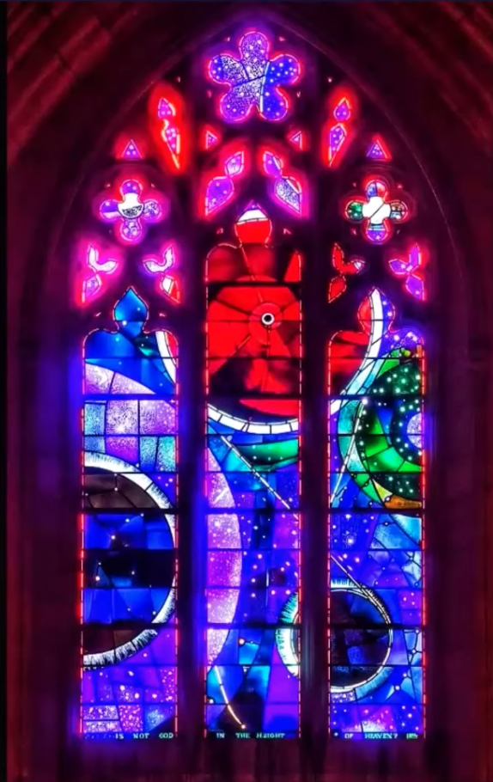
Figure 2: Rodney Winfield, Scientists' and Technicians' Window, 1973,
Stained Glass, 5.8m x 4.0m, National Cathedral, Washington, DC. Image: Cathedral Age Magazine, April 2018
Pre-iconographical Analysis
The ‘Space Window’ is located halfway through the Cathedral's south nave around the mid level of the cathedral. The stained glass window is framed around the pointed arch of limestone which is the primary material the Cathedral was built with and is embedded and runs across three lancets which are vertical panes. Both above and below the ‘Space Window’ toward the top of the building are additional stained glass windows (see figures 3 and 4). The deep hues of blue, purple and navy make up most of the lower part of the background design. Dots of colour are etched off and scattered throughout the design. There are four orbs of different sizes in the scene. In the centre of the image is the largest orb which is red. There is a very small piece of dark material encased in the centre of the red orb. This is the most prominent position of the scene located in the middle top lancet. The first lancet toward the bottom of the frame is another large blue and black orb with a secondary lighter orb around it. Toward the middle top part of the frame on the right lancet is a green and purple orb. From the red orb there is a white line that follows down to another smaller orb below and wraps back up to the red orb. At the very bottom of the frame of the stained glass design is a quote from the Bible, from the Book of Job, 22. 12 which says ‘Is not God in the height of heaven’ (see figure 5). The original design requirements laid out by NASA as well as the cathedral specifications included having at least one human figure, depicting a spaceship with exhaust flares, and for each lancet to be a unique scene related to space exploration. Winfield proposed 11 different designs (see figure 6), but they were all rejected as the criteria changed or evolved.
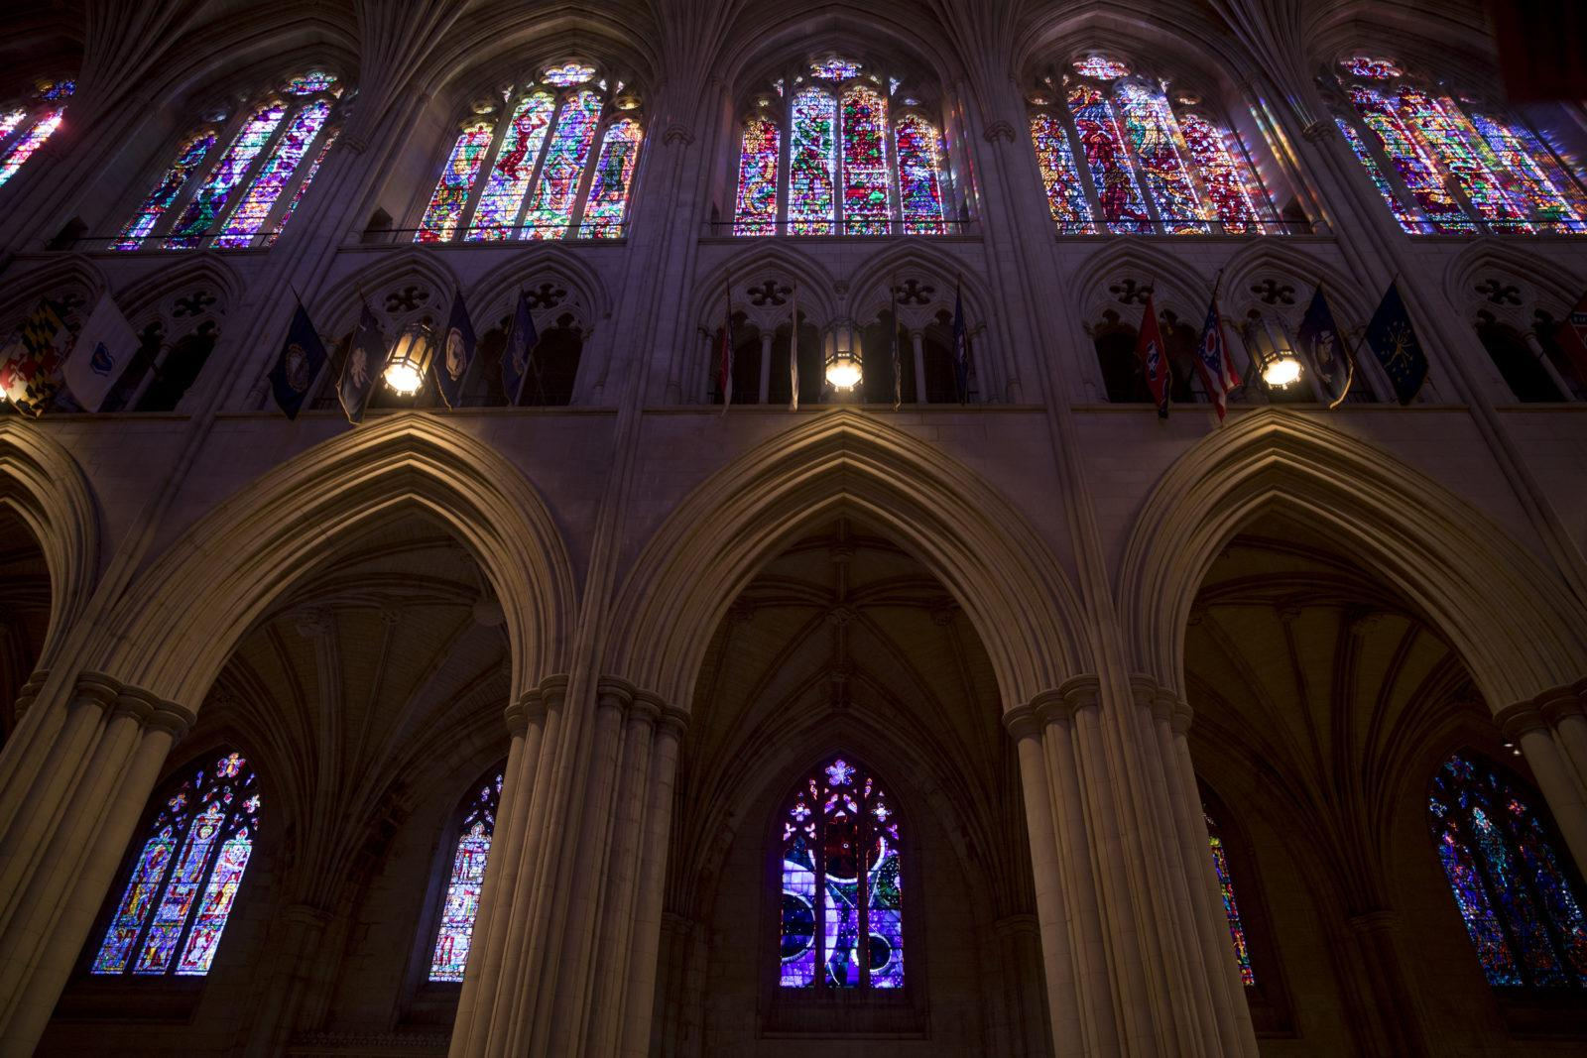
Figure 3: Rodney Winfield, Scientists' and Technicians' Window, 1973,
Stained Glass, 5.8m x 4.0m, National Cathedral, Washington, DC. Image: Tyrone Turner / WAMU, July 2019
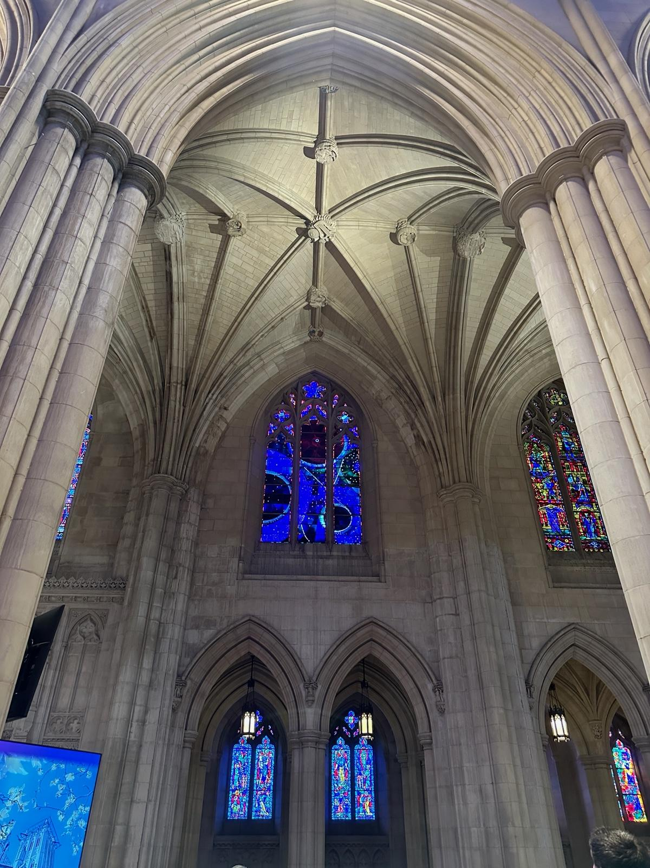
Figure 4: Rodney Winfield, Scientists' and Technicians' Window, 1973,
Stained Glass, 5.8m x 4.0m, National Cathedral, Washington, DC. Image: Kat Azima, July 21, 2024

Iconographical analysis
The pointed arch which is associated with Gothic architecture draws the eye upward to emphasise the soaring height of the Gothic style ceiling. The design itself depicts what appears to be deep space with four large planetary spheres against deep hues of blue, purple and navy that make up most of the lower part of the background. The dots of colour etched off and scattered throughout the design which appear to be stars. In the centre of the image is a large red orb and inserted in the middle is a 2 ¾ inch piece of the 3.6 billion year old lunar rock which was inserted from the Apollo Moon landing. The lunar sample was originally part of a 2-pound sample which Astronauts Neil Armstrong and Buzz Aldrin collected as part of more than 47 pounds of dirt and rock samples from the Sea of Tranquillity, where they landed. From the red orb there is a white line, like a trajectory to a smaller orb which appears to be the moon located below the red sphere on the bottom right corner of the frame. At the very bottom of the frame of the stained glass design is a quote from the Bible, from the Book of Job, 22. 12 which says ‘Is not God in the height of heaven’ (see figure 5) connecting the visual scene directly to the Bible.
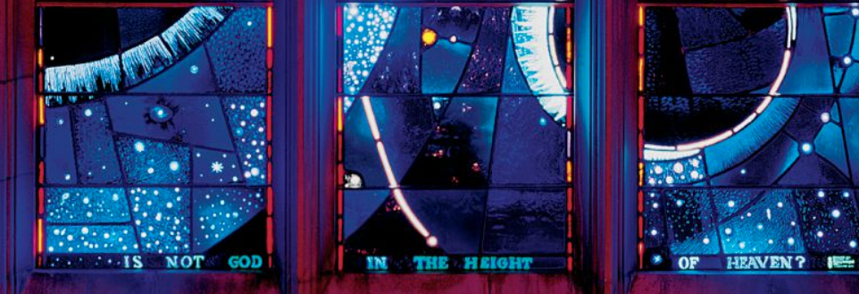
Figure 5. Rodney Winfield, Scientists' and Technicians' Window, 1973, Stained Glass, 5.8m,
National Cathedral, Washington, DC Image: Cathedral Age Magazine, April 2018
Winfield had a long career in liturgical and fine art encompassing various media including stained glass. The ‘Space Window’, considered one of the Cathedral’s most popular windows. As described in the Cathedral’s magazine, as some of the requirements loosened ‘Winfield gradually moved towards an abstract design across all three lancets, suggesting a vast opening into an infinite cosmos, with the trajectory of a spaceship circling one of the immense solar spheres, emphasizing humanity’s smallness in vastness of space. His 12th, and final, proposal was approved. In his notes, Winfield wrote about his creative process ‘My idea is that the artist only holds creation, allows space to flow through him. When the word sings, one has been sung through, that is allowed creation to take its natural form. Ultimately the creative act of prayer - of union and communion.
Iconological interpretation
The space window was commissioned by NASA Administrator Thomas Paine (1921-1992) and Rev. Francis B. Sayer Jr. (1915-2008) the Dean of the Cathedral (1951-1978) to commemorate and honour the scientists and technicians involved in space exploration and the Apollo 11 mission. The intended audience of the ‘Space Window’ is for the visitors of the Cathedral who are local, national as well as international visitors. While the window was completed in 1973, the official dedication of the space window took place at the Cathedral on July 21st, 1974, the 5th anniversary of the lunar landing. Astronauts Buzz Aldrin, Neil Armstrong and Michael Collins were part of the dedication ceremony. Rev. Francis B. Sayer Jr. gave a sermon during the dedication describing that the lunar material brought back by the astronauts was,
‘not just a rock that they returned to earth but in an exciting way the very horizon of
eternity. Good sirs, we do gladly receive at your hand so eloquent a token of God's wondrous making and of man's noble daring to be for us a sign of our striving after his majesty and the sharing of his glory. Now blessed we pray this window, a window of peace and of light, a window of the haunting hues and colors in the depths of outer space, bless this place now set apart to receive a portion of thy creation from the earth's friendly satellite.’
In defining the sacred, Mircea Eliade, suggests a possible definition of the sacred as being the opposite of the profane because it manifests and shows itself as something wholly different from the profane. This act of manifestation is what Eliade calls hierophany. As Eliade states ‘by manifesting the sacred, any object becomes something else, yet it continues to remain itself, for it continues to participate in its surrounding cosmic milieu.’ The lunar rock embedded in the stained glass window then, as Rev. Francis B. Sayer Jr. says in his sermon, becomes a sacred symbol ‘for the very horizon of eternity’ and ‘gods token of wondrous making’ as he says.
The ‘Space Window’ is a representation of the sky from the cultural perspective of white, Christian Americans. As Richard T. Hughes states, it was never the intention of the founders for the United States to explicitly be a Christian nation but rather a secular state.’ Hughes goes on to state that ‘the myth of America as a Christian Nation took on objective truth, especially in the nineteenth century when Protestants succeeded in Christianizing the country through the power of revivalism. From that time through the early twenty-first century, America was a Christian nation of sorts.
As Deborah Cadbury recounts, the race to the moon became a defining struggle for global supremacy between the United States and the Soviet Union where ‘victory in this race meant more than collecting moon rocks and planting flags on barren wasteland.’ In 1967, the United States, the United Kingdom and the Soviet Union (now Russian Federation) signed ‘The Outer Space Treaty’ that declared that the moon belongs to no one and that the moon be used for peaceful purposes only. R.D. Launius, further states regarding the human expedition to the moon, Project Apollo was,
‘a unique confluence of political necessity, personal commitment and activism, scientific and technological ability, economic prosperity, and public mood made possible by the May 25, 1961, announcement by President John F. Kennedy to carry out a lunar landing program before the end of the decade as a means of demonstrating the United States’ technological virtuosity in its desperate rivalry with the Soviet Union in the Cold War.’
The placement of the moon rock onto the stained glass window, which resides inside the National Cathedral in Washington, DC in the United States of America and which was blessed by the Dean of the Cathedral with a quote from the Bible placed right below the frame of the stained glass design all point to the fact that this is not a neutral commemoration to the scientists and technicians involved in successfully placing the first man on the moon but rather an example of the expression of the sky being culturally influenced, that is being very directly part of a distinct religion, nation and culture of its time. The materiality and ritual in commemorating the first human landing on the moon is vital in establishing as well as historicizing the achievements of white, Christian Americans.

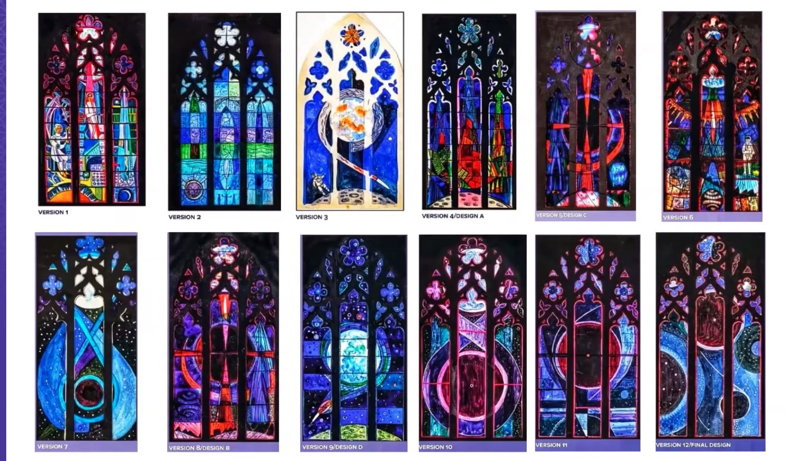
Figure 6. Rodney Winfield, Scientists' and Technicians' Window, 11 Design Versions, 1973, Stained Glass, 5.8m x 4.0, National Cathedral, Washington, DC Image: Washington Cathedral, November 24, 2020

Concluding Thoughts

The aim of this essay was to critically examine the cultural expression or representation of the sky in relation to material culture. This essay specifically examined the western, Christian cultural expression of the moon in relation to two different works of art. The primary sources examined were ‘I want! I want! an 18th century engraving by William Blake which is an imagining of a lunar ascent created in 1793. The second piece was the Scientists' and Technicians' stained glass window more commonly known as the ‘Space Window’ created by American artist Rodney Wiinfield in 1973 which commemorates the scientific achievements of the Apollo 11 lunar landing. Both works of art were critically analysed using Erwin Panofsky iconological methodology to investigate the meaning of motifs, symbols and allegories in their cultural context while also being examined through the theoretical framework of cultural astronomy, visual culture and materiality.
As scholars have widely claimed, the critical examination of these artworks have highlighted how the sky and more specifically the moon in these case studies, have been important to human societies across cultures and time periods. As discussed by Vandeenbrouck, the moon has been a destination in the human imagination for centuries and after the Apollo 11 lunar landing humans were finally able to manifest their desire and imagination to land and touch their feet on the surface of the moon. Both artworks examined in this paper were not created in a vacuum but deliberately designed and created by artists William Blake and Rodeny Winfield respectively. Their artworks are both material entities coming from distinct points of view and from unique historical and cultural contexts. The multiple versions of the ‘Space Window’ stained glass design show distinct differences in their representation of the brief which was given to the artist Rodney Winfield by his patrons. Both case studies show that the cultural expression of the sky in material culture is bound in cultural power, politics and religion. As Tilly says representations, as in the example of the cultural expression of the journey of the moon in material culture, is shaped from a point of view and being shaped in its interpretation. ‘I want! I want’ by William Blake showed the vision and desire to travel to the moon was active in the imagination of an 18th century poet and artist. ‘I want! I want!’ is a cultural expression of the moon that highlights the desires, hopes and ambitions of human society in a period in western European culture that was under immense political and religious changes. The ‘Space Window’ by Rodney Winfied is a more contemporary example that shows human societies' desire to create a sacred material representation of the moon landing to ultimately commemorate not just human achievement but establish America’s technical, scientific and thus national supremacy.
In summary, examining the cultural expression of the sky in material culture helps to highlight as Tilley says how the material world affects how we as humans may think, behave and relate to material culture. In this example, how we may relate to the moon within a western British and American cultural perspective.
Bibliography
Primary Source
William Blake, I want! I want!, 1793, Line engraving and etching, 7.1 x 4.8 cm, For the Children: The Gates of Paradise, Library of Congress, Washington, DC.
Rodney Winfield, Scientists' and Technicians' Window, 1973, Stained Glass, 5.8m, National Cathedral, Washington, DC.
Secondary Source
Boylan, Alexis. L., Visual Culture, (Cambridge, Massachusetts, The MIT Press, 2020)
Buchli, V. (Ed.), The Material Culture Reader (1st ed.). Routledge 2002)
Cadbury, Deborah. Space Race: The Epic Battle between America and the Soviet Union for the Dominion of Space. (New York: Harper Perennial, 2007)
Campion, Nicholas., Astrology and Cosmology in the World’s Religions (New York: New York University Press, 2012)
Campion, Nicholas, and Fabio P. Silva, Skyscapes: The Role and Importance of the Sky in Archaeology (Oxford: Oxbow Books, 2015)
Campion, Nicholas and Jennifer Zahrt, Astrology as Art, Representation and Practice, (Wales, Sophia Center Press, 2018)
Cressy, David. “Early Modern Space Travel and the English Man in the Moon.” The American Historical Review, vol. 111, no. 4, (2006), pp. 961–82.
Darvill, Timothy, ‘Afterword: Dances Beneath a Diamond Sky,’ in Silva, Fabio, and Nicholas Campion, Skyscapes (United States: Oxbow Books, 2015)
D’Alleva, Anne, Methods & Theories of Art History, 2nd ed., (London, Laurence King Publishing, 2012)
Eliade, Mircea, The Sacred and the Profane: The Nature of Religion (New York: Harper & Row, 1961)
Gunzburg, Darrelyn, and Brady,Bernadette, eds., Space, Place and Religious Landscapes : Living Mountains, First edition. (London [England: Bloomsbury Academic, 2020)
Higgs Higgs, William Blake vs. the World, (New York, NY Pegasus Books Ltd., 2022)
Hughes, Richard T., et al. “The Myth of the Christian Nation: The Early National Period.” in Myths America Lives By: White Supremacy and the Stories That Give Us Meaning, University of Illinois Press, 2018)
Lane, Belden C., Landscapes of the Sacred : Geography and Narrative in American Spirituality, Expanded ed. (Baltimore, Md. ; Johns Hopkins University Press, 2002)
Launius, Roger D. Reaching for the Moon: A Short History of the Space Race. (Yale University Press, 2019)
Nelson, David Hart, “Worshipping in the National House of Prayer: Washington National Cathedral,” Anglican and Episcopal History, 79.1 (2010)
Erwin Panofsky, Meaning in the Visual Arts (Chicago: Chicago University Press, 1982)
Tilley, Christopher, ‘Materiality in Materials’, Archaeological Dialogues, 14.1 (2007), 16–20
Vandenbrouck, M., Barford, M., Devoy, L., Dunn, R., The Moon: A Celebration of Our Celestial Neighbour, (Glasgow, HarperCollins Publishing, 2019)
Digital Sources
Andrew Greg, William Blake: the Romantic Visionary. [accessed 28 April, 2024], <https://artuk.org/discover/stories/william-blake-the-romantic-visionary>
Cathedral Age Magazine,Winter 2018, p.21, [accessed 28 April, 2024] <https://mydigimag.rrd.com/publication/?i=476167>
Cathedral Age, Autumn 2019, p.8. [accessed 28 April, 2024], <https://mydigimag.rrd.com/publication/?m=46623&i=638773&p=10&ver=html5>

Gothic Architecture, Cathedral.org, [accessed 28 April, 2024] <https://cathedral.org/discover/art-architecture/gothic-architecture-101/>
Kelly Kizer Whitt, The moon rock in Washington National Cathedral, [accessed 30 April, 2024],
https://earthsky.org/human-world/moon-rock-washington-national-cathedral-stained-glass-window/>
Space Window Dedication 1974, [accessed 17 April, 2024] <https://www.youtube.com/watch?v=y1M2vHhDM-0>
Rodney Winfield, About the Artist, [accessed 28 April, 2024] <https://rodneywinfield.com/About_The_Artist.html>
‘Treaty on Principles Governing the Activities of States in the Exploration and Use of Outer Space, including the Moon and Other Celestial Bodies’, United Nations Office for Outer Space Affairs, [accessed April 17th, 2024] <https://www.unoosa.org/oosa/en/ourwork/spacelaw/treaties/introouterspacetreaty.html>

Washington National Cathedral, Cathedral Docent Spotlight Nov. 24, 2020: Explore Space in Stained Glass, [accessed 28 April, 2024], <https://www.youtube.com/watch?v=9g68t3mlWeU&t=506s>
Weta, All Access National Cathedral, [accessed 4 March, 2024] <https://watch.weta.org/video/weta-all-access-washington-national-cathedral/>

Nicholas Campion, and Fabio P. Silva, Skyscapes: The Role and Importance of the Sky in Archaeology (Oxford: Oxbow Books, 2015), p. 2.
Nicholas Campion, and Fabio P. Silva, Skyscapes, p. 3.
Nicholas Campion, Astrology and Cosmology in the World’s Religions (New York: New York University Press, 2012), p.1.
Nicholas Campion, and Fabio P. Silva, Skyscapes, p. 9.
Andrew Greg, William Blake: the Romantic visionary. [accessed 28 April, 2024], <https://artuk.org/discover/stories/william-blake-the-romantic-visionary
Washington National Cathedral, Cathedral Docent Spotlight Nov. 24, 2020: Explore Space in Stained Glass, [accessed 28 April, 2024], <https://www.youtube.com/watch?v=9g68t3mlWeU&t=506s>
Christopher Tilley, “Materiality in Materials,” Archaeological Dialogues, 14.1 (2007), pp.18-19.
Timothy Darvill, ‘Afterword: Dances Beneath a Diamond Sky,’ in Silva, Fabio, and Nicholas Campion, Skyscapes (United States: Oxbow Books, 2015), p.142.
Darrelyn Gunzburg, and Bernadette Brady, eds., Space, Place and Religious Landscapes : Living Mountains, First edition. (London: England: Bloomsbury Academic, 2020), p.xvii.
Amy Whitehead, ‘The Goddess and the Virgin: Materiality in Western Europe’. The Pomegranate, (Corbett, Or.), 10 (2), (2009), pp.163-4.
John Higgs, William Blake vs. the World, (New York, NY Pegasus Books Ltd., 2022), p.333.
John Higgs, William Blake vs. the World, (New York, NY Pegasus Books Ltd., 2022), p.96.
Darrelyn Gunzburg, and Bernadette Brady, eds., Space, Place and Religious Landscapes, p.xvi.
Darrelyn Gunzburg, and Bernadette Brady, eds., Space, Place and Religious Landscapes, p.xvi.
Alexis. L. Boylan, Visual Culture, (Cambridgee, Massachusetts, The MIT Press, 2020), p. 13 & xxi.
Melanie Vandenbrouk, Megan Barford, Louise Devoy, Richard Dunn, ed., The Moon: A Celebration of Our Celestial Neighbour, (United Kingdom, HarperCollins Publishers, 2019), p.127.
Darrelyn Gunzburg, and Bernadette Brady, eds., Space, Place and Religious Landscapes : Living Mountains, First edition. (London, England: Bloomsbury Academic, 2020) p.1.
David Cressy, “Early Modern Space Travel and the English Man in the Moon.” The American Historical Review, vol. 111, no. 4, (2006), pp. 961–2.
Erwin Panofsky, Meaning in the Visual Arts (Chicago: Chicago University Press, 1982) pp. 40-1.
Nicholas Campion and Jennifer Zahrt, Astrology as Art, Representation and Practice, (Wales, Sophia Center Press, 2018), p. 8.
John Higgs, William Blake vs. the World, (New York, NY Pegasus Books Ltd., 2022) pp.14 & 29.
John Higgs, William Blake vs. the World, (New York, NY Pegasus Books Ltd., 2022), pp.7 & 9.
Weta All Access National Cathedral, [accessed 4 March, 2024] <https://watch.weta.org/video/weta-all-access-washington-national-cathedral/>
David H. Nelson, ‘Worshipping in the National House of Prayer: Washington National Cathedral,’ Anglican and Episcopal History, 79.1 (2010), p.71.
Deborah Cadbury, Space Race: The Epic Battle between America and the Soviet Union for the Dominion of Space. (New York: Harper Perennial, 2007), p. ix.
Launius, R. D. Abandoned in Place: Interpreting the U.S. Material Culture of the Moon Race. The Public Historian, 31(3) (2009), pp. 9–38.
Rodney Winfield, About the Artist, [accessed 28 April, 2024] <https://rodneywinfield.com/About_The_Artist.html>
Cathedral Age Magazine, Autumn 2019, p.8. [accessed 28 April, 2024], <https://mydigimag.rrd.com/publication/?m=46623&i=638773&p=10&ver=html5>
Cathedral Age Magazine,Winter 2018, p.21 [accessed 28 April, 2024] <https://mydigimag.rrd.com/publication/?i=476167>
Gothic Architecture, Cathedral.org, [accessed 28 April, 2024] <https://cathedral.org/discover/art-architecture/gothic-architecture-101/>
Gothic Architecture, Cathedral.org, [accessed 28 April, 2024] <https://cathedral.org/discover/art-architecture/gothic-architecture-101/>
Kelly Kizer Whitt, The moon rock in Washington National Cathedral, [accessed 30 April, 2024], https://earthsky.org/human-world/moon-rock-washington-national-cathedral-stained-glass-window/>
‘Space Window Dedication 1974’, [accessed 17 April, 2024] <https://www.youtube.com/watch?v=y1M2vHhDM-0>
Washington National Cathedral, Cathedral Docent Spotlight Nov. 24, 2020], <https://www.youtube.com/watch?v=9g68t3mlWeU&t=506s>
‘Treaty on Principles Governing the Activities of States in the Exploration and Use of Outer Space, including the Moon and Other Celestial Bodies’, United Nations Office for Outer Space Affairs, [accessed April 17th, 2024] <https://www.unoosa.org/oosa/en/ourwork/spacelaw/treaties/introouterspacetreaty.html>
Hughes, Richard T., et al. “The Myth of the Christian Nation: The Early National Period.” in Myths America Lives By: White Supremacy and the Stories That Give Us Meaning, (University of Illinois Press, 2018), p. 82.
John Higgs, William Blake vs. the World, (New York, NY Pegasus Books Ltd., 2022) p.97.
Mircea Eliade, The Sacred and the Profane: The Nature of Religion (New York: Harper & Row, 1961), pp. 10-11.
Mircea Eliade, The Sacred and the Profane, p. 12.
Darrelyn Gunzburg, and Bernadette Brady, p.xvi.
Cathedral Age Magazine, Autumn 2019, p.8. [accessed 28 April, 2024], <https://mydigimag.rrd.com/publication/?m=46623&i=638773&p=10&ver=html5>

