Appendices
Appendix 1
Observation sheet

Year 6
Date - 02/03/2020
Number of pupils - ___21__
Lesson focus - Drawing a picture from reading a text about Antarctica.
Observer.
Questioning strategy used | Number of particpants - more than half (MTH) / half (H) / less than half (LTH) | Observations
Cosed | H
Think, pair, share | NA | Lots of discussion. Teacher paused discussion - “there’s more than one answer”.  Discussion between learners went off topic after a few minutes.
Lollipop sticks | NA
Open | LTH | Good answers. Range of answers.
Open | LTH | Shouting out / discussion
Open | LTH (1) | Confused learners. Promotion of learner voice. Couldn’t think of question they would like to ask about the topic.
Explained previous question n more depth | H | Answers snowballed.
Closed | H | Shouting out / discussion
Closed | H | Shouting out / discussion. Few hands up.
Closed | H | Shouting out / discussion. Few hands up.
Closed | H | Shouting out / discussion. Few hands up.
Closed | MTH | Shouting out / discussion. Few hands up.
Open | MTH | Lots of discussion
Closed | MTH | Paused task, discussion after starting task.
Closed | MTH | Paused task, discussion after starting task. More discussion from learners and ideas.

Observations / Extra notes
Questions asked around the classroom -
Do you have a favourite subject? If so, do you try to answer more questions or do you react te same?
L1 - Yes. Answer more often for favourite subject
L2 - Same reaction to different subjects.
L3 - Yes. But same reaction to different subjects.
L4 - Yes. But same reaction to different subjects.
L5 - Yes. But same reaction to different subjects.

Do you like answering questions?
L1 - Don’t mind answering questions.
L2 - Yes if I know the answer.
L3 - Yes.
L4 - Don’t mind.
L5 - Sometimes.

How do you prefer to answer questions?
L1 - Don’t like lollipop sticks as it makes me uncomfortable if I don’t know the answer. I like to put my hand p.
L2 - Like hands up and lollipop sticks.
L3 - Likes thinking partners.
L4 - Prefers hands up.
L5 - Prefers hands up. If lollipop sticks are used then think on the spot for answer.

Appendix 2

Do different questioning strategies effect learners progress?
Question | Responses
Please state your gender.

Appendix 2a  How often do you raise your hand to answer questions within these topics? | 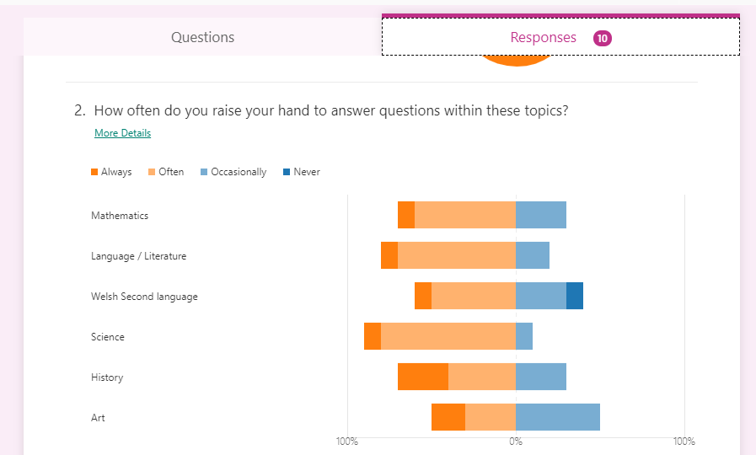
Appendix 2b  How often are you called on to answer questions? | 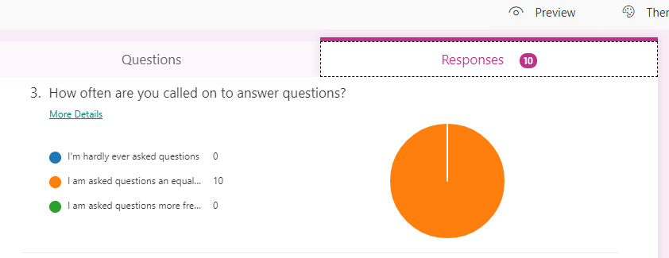
Appendix 2c  Please rate these questioning techniques on how often they are used PER LESSON in the classroom. | 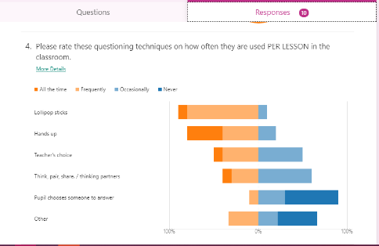
Appendix 2d  When a teacher asks the class a question, which types of discussion do you prefer to use to answer the question. Rank the options in order from most preferred to least preferred. | 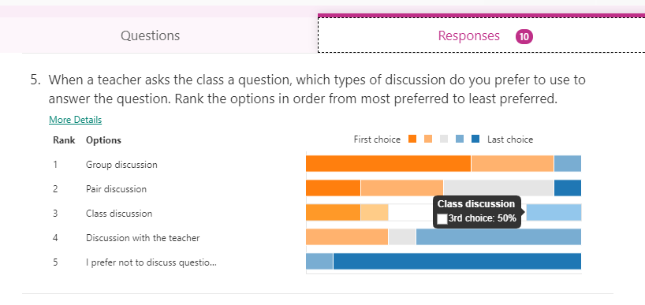
Appendix 2e  Why did this encourage you? What type of question strategies hep you learn better? | 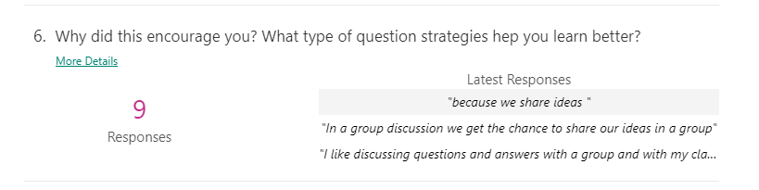
Appendix 2f  When do you feel most confident when answering a question? | 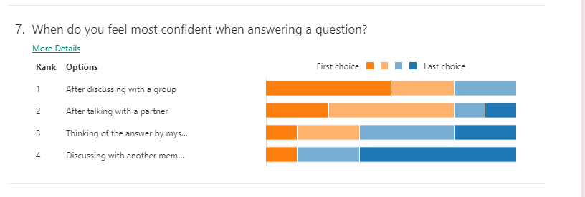
Appendix 2g  Rate each technique as to how well you are engaged in the lesson when these techniques are used. | 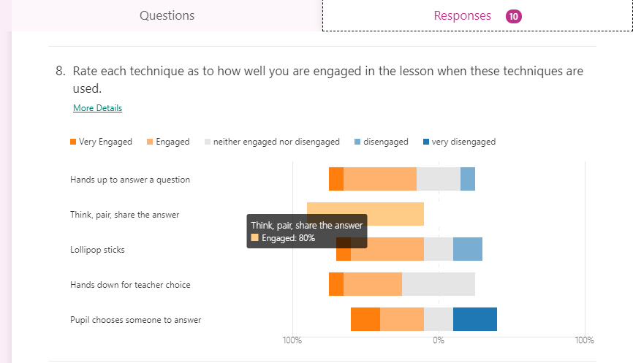

Appendix 3
Interview

Person/s being interviewed - class teacher

Topic - The use of different questioning strategies to engage pupils in the lesson / topic.
The class teacher was interviewed for 10 minutes. The following responses are paraphrased.

Appendix 3a

Do you pre-plan the questions you are going to ask the class?
Particular topics come with particular questions. Depends on different individuals.
Appendix 3b

Do you plan the strategies you use or do you depend on your experience and knowledge?
Experience over time. Depends on class and individuals. Takes time to understand level of class and then adapt techniques and level of questioning as time goes on. To get more discussion out of learners
use open ended questions. Listen to other’s ideas.
Appendix 3c

Does the school provide extra training or workshops on developing the use of questioning in the classroom?
Have had workshops in the past and concentrated on many techniques and strategies.
Appendix 3d

Do you think workshops / extra training on the use of questioning in the classroom is needed?
Does help and it’s important. Good to keep up with new developments.
Appendix 3e

Is there a strategy or technique that you favour for questioning?
No. Depends on situation, individuals and lesson. Lollipop sticks to not pick same people but sometimes don’t use to target certain individuals to check understanding and improve individual’s confidence.
Appendix 3f

Do you encourage class discussion? Why?
Yes. But can go off topic sometimes but also very interesting discussions in result. Inspectors complemented class on how well discussion is used in class and learner’s responses were very good.
Appendix 3g

Do you implement Blank’s level questioning? Do you find it effective?
You have to differentiate questions. Adapt questions to individuals. Can’t treat everyone the same.

Appendix 4
APPLICATION FOR ETHICAL APPROVAL

In order for research to result in benefit and minimise risk of harm, it must be conducted ethically. A researcher may not be covered by the University’s insurance if ethical approval has not been obtained prior to commencement.

The University follows the OECD Frascati manual definition of research activity: “creative work undertaken on a systematic basis in order to increase the stock of knowledge, including knowledge of man, culture and society, and the use of this stock of knowledge to devise new applications”. As such this covers activities undertaken by members of staff, postgraduate research students, and both taught postgraduate and undergraduate students working on dissertations/projects.

The individual undertaking the research activity is known as the “principal researcher”.

Ethical approval is not required for routine audits, performance reviews, quality assurance studies, testing within normal educational requirements, and literary or artistic criticism.

Please read the notes for guidance before completing ALL sections of the form.

This form must be completed and approved prior to undertaking any research activity. Please see Checklist for details of process for different categories of application.

Delete the Guidance Notes at the end of the form BEFORE submitting your application

SECTION A: About You (Principal Researcher)
Full Name: |  | Georgia Evans
Tick all boxes which apply: |  | Member of staff: | ☐ | Honorary research fellow: | ☐
Undergraduate Student | ☒ | Taught Postgraduate Student | ☐ | Postgraduate Research Student | ☐

Faculty/School/Centre: | Initial Teacher Education, Yr Athrofa
Campus: | Carmarthen
E-mail address: | 1802329@student.uwtsd.ac.uk
Contact Telephone Number: | 07946689295
For students:
Student Number: | 1802329@student.uwtsd.ac.uk
Programme of Study: | BA Primary Education with QTS
Director of Studies/Supervisor: | Dr. Sioned V. Hughes

SECTION B: Approval for Research Activity
Has the research activity received approval in principle?  (please check the Guidance Notes as to the appropriate approval process for different levels of research by different categories of individual) |  | YES | ☒ | NO | ☐
 |  |  |  | Date
If Yes, please indicate source of approval (and date where known): Approval in principle must be obtained from the relevant source prior to seeking ethical approval | Research Degrees Committee |  | ☐
 | Faculty Research Committee |  | ☐
 | Other (write in) ECAD5010 Module Lead |  | ☒ | 27.02.20

SECTION C: Internal and External Ethical Guidance Materials
Please list the core ethical guidance documents that have been referred to during the completion of this form (including any discipline-specific codes of research ethics, and also any specific ethical guidance relating to the proposed methodology). Please tick to confirm that your research proposal adheres to these codes and guidelines.
UWTSD Research Ethics & Integrity Code of Practice | ☐
UWTSD Research Data Management Policy | ☐
British Educational Research Association guidelines | ☒
 | ☐

SECTION D: External Collaborative Research Activity
Does the research activity involve collaborators outside of the University? |  | YES | ☐ | NO | ☒
If Yes, please provide the name of the external organisation and name and contact details for the main contact person and confirmation this person has consented to their personal data being shared.as part of this collaboration.
Institution
Contact person name
Contact person e-mail address

Has this individual consented to sharing their details on this form? |  | YES | ☐ | NO |  |  | ☐
Are you in receipt of a KESS scholarship? |  | YES | ☐ | NO |  |  | ☐
Is your research externally funded |  | YES | ☐ | NO |  |  | ☐
Are you specifically employed to undertake this research in either a paid or voluntary capacity? | Voluntary | YES | ☐ | NO |  | ☐
 | Employed | YES | ☐ | NO |  | ☐
Is the research being undertaken within an existing UWTSD Athrofa Professional Learning Partnership (APLP) | If YES then the permission question below does not need to be answered. | YES | ☒ | NO |  |  | ☐
Permission to undertake the research has been provided by the partner organisation | (If YES attach copy)  If NO the application cannot continue | YES | ☐ | NO |  |  | ☐

Where research activity is carried out in collaboration with an external organisation
Does this organisation have its own ethics approval system? | YES | ☐ | NO | ☒
If Yes, please attach a copy of any final approval (or interim approval) from the organisation

SECTION E: Details of Research Activity
Indicative title: | Do different questioning strategies effect learner’s progress?
Proposed start date: | 02.03.20 | Proposed end date: | 01.04.20
Introduction to the Research (maximum 300 words)
Ensure that you write for a Non-Specialist Audience when outlining your response to the three points below:
- Purpose of Research Activity
- Proposed Research Question
- Aims of Research Activity
- Objectives of Research Activity
Demonstrate, briefly, how Existing Research has informed the proposed activity and explain
- What the research activity will add to the body of knowledge
- How it addresses an area of importance.
Purpose of Research Activity

- To explore how questioning is implemented as an AFL strategy
- To trial different research tools in practice
- To develop personal research skills

(this box should expand as you type)
Research Question
Do different questioning strategies effect learner’s progress?

(this box should expand as you type)
Aims of Research Activity
- To explore staff and learners’ perceptions of questioning as an AFL strategy
- To critically evaluate the different research tools
- To further develop personal knowledge and understanding of AfL
- To develop personal skills in research to improve professional practise
- To discuss the outcomes of the research

(this box should expand as you type)
Objectives of Research Activity

- To observe a year 6 class focusing on the use of different questioning strategies used within 1 lesson.
- To interview the class teacher and find out their perceptions of the benefits and implications of questioning as an AFL strategy
- To carry out a questionnaire with the learners in the class to gain qualitative and quantitative data
- To critically reflect on the process of using different research tools to collect data

(this box should expand as you type)
Proposed methods (maximum 600 words)
Provide a brief summary of all the methods that may be used in the research activity, making it clear what specific techniques may be used. If methods other than those listed in this section are deemed appropriate later, additional ethical approval for those methods will be needed.
Observation
I will be observing a year 6 class including the teacher and the teaching assistant. I will not include names but will be focusing on the different types of questioning strategies used and how the learners respond to the strategy. During my observation I will also be interviewing random learners to question them on responses and any other aspects of the activities they may be completing.
I will not be participating in the lesson in order to include as much detail as possible in my research.

Interview
I will be interviewing the class teacher to gain qualitative data on the perceptions of questioning within the class. I will ask a range of questions including open questions and closed questions.

Questionnaire
The questionnaire is aimed at year 6 pupils and asks a range of open, closed and semi- structured questions. There are only 8 questions to answer so qualitative and quantitative data can be managed once collected. I aim to ask the whole year 6 class of 30 to carry out an anonymous questionnaire.
(this box should expand as you type)

Location of research activity
Identify all locations where research activity will take place.
The research activity will take place in a small urban school with approximately 250 pupils.

(this box should expand as you type)
Research activity outside of the UK
If research activity will take place overseas, you are responsible for ensuring that local ethical considerations are complied with and that the relevant permissions are sought. Specify any local guidelines (e.g. from local professional associations/learned societies/universities) that exist and whether these involve any ethical stipulations beyond those usual in the UK (provide details of any licenses or permissions required). Also specify whether there are any specific ethical issues raised by the local context in which the research activity is taking place, for example, particular cultural and/or legal sensitivities or vulnerabilities of participants.
N/A

(this box should expand as you type)
Use of documentation not in the public domain: Are any documents NOT publicly available? | NO | ☒
 | YES | ☐
If Yes, please provide details here of how you will gain access to specific documentation that is not in the public domain and that this is in accordance with prevailing data protection law of the country in question and England and Wales.

(this box should expand as you type)

SECTION F: Scope of Research Activity
Will the research activity include: | YES | NO
Use of a questionnaire or similar research instrument? | ☒ | ☐
Use of interviews? | ☒ | ☐
Use of diaries? | ☐ | ☒
Participant observation with their knowledge? | ☒ | ☐
Participant observation without their knowledge? | ☐ | ☒
Use of video or audio recording? | ☒ | ☐
Access to personal or confidential information without the participants’ specific consent? | ☐ | ☒
Administration of any questions, test stimuli, presentation that may be experienced as physically, mentally or emotionally harmful / offensive? | ☐ | ☒
Performance of any acts which may cause embarrassment or affect self-esteem? | ☐ | ☒
Investigation of participants involved in illegal activities? | ☐ | ☒
Use of procedures that involve deception? | ☐ | ☒
Administration of any substance, agent or placebo? | ☐ | ☒
Working with live vertebrate animals? | ☐ | ☒
Other primary data collection methods, please explain in this box  For example, ‘focus groups’. Please indicate the type of data collection method(s) in this box and tick the accompany box. | ☐ | ☒
Details of any other primary data collection method:  (this box should expand as you type) | ☐ | ☒
If NO to every question, then the research activity is (ethically) low risk and may be exempt from some of the following sections (please refer to Guidance Notes).

If YES to any question, then no research activity should be undertaken until full ethical approval has been obtained.

SECTION G: Intended Participants
Who are the intended participants: | YES | NO
Students or staff at the University? | ☐ | ☒
Adults (over the age of 18 and competent to give consent)? | ☒ | ☐
Vulnerable adults? | ☐ | ☒
Children and Young People under the age of 8? (Consent from Parent, Carer or Guardian will be required) | ☒ | ☐
Prisoners? | ☐ | ☒
Young offenders? | ☐ | ☒
Those who could be considered to have a particularly dependent relationship with the investigator or a gatekeeper? | ☐ | ☒
People engaged in illegal activities? | ☐ | ☒
Others (please identify specifically any group who may be unable to give consent) please indicate here and tick the appropriate box. | ☐ | ☒
Other – please indicate here:  (this box should expand as you type) | ☐ | ☒

Participant numbers and source
. How will you identify participants and how will they be recruited?
How many participants are expected? | I intend on observing 30 learners and 1 teacher. The questionnaire will be completed by all learners that consent to participating. There will be an interview with 1 teacher.  (this box should expand as you type)
Who will the participants be? | 1 class teacher from year 6, 30 pupils from year 6.  (this box should expand as you type)
How will you identify the participants? | I have had previous experience with the participants during PTE2 and so I am able to identify different abilities and personalities during my research. However, I will not mention names within my report of the research conducted to keep my method ethical and confidential.  (this box should expand as you type)

Information for participants: | YES | NO | N/A
Will you describe the main research procedures to participants in advance, so that they are informed about what to expect? | ☒ | ☐ | ☐
Will you tell participants that their participation is voluntary? | ☒ | ☐ | ☐
Will you obtain written consent for participation? | ☐ | ☐ | ☒
Will you explain to participants that refusal to participate in the research will not affect their treatment or education (if relevant)? | ☒ | ☐ | ☐
If the research is observational, will you ask participants for their consent to being observed? | ☒ | ☐ | ☐
Will you tell participants that they may withdraw from the research at any time and for any reason? | ☒ | ☐ | ☐
With questionnaires, will you give participants the option of omitting questions they do not want to answer? | ☒ | ☐ | ☐
Will you tell participants that their data will be treated with full confidentiality and that, if published, it will not be identifiable as theirs? | ☒ | ☐ | ☐
Will you debrief participants at the end of their participation, in a way appropriate to the type of research undertaken? | ☐ | ☐ | ☒
If NO to any of above questions, please give an explanation
(this box should expand as you type)

Information for participants: | YES | NO | N/A
Will participants be paid? | ☐ | ☒ | ☐
Is specialist electrical or other equipment to be used with participants? | ☐ | ☒ | ☐
Are there any financial or other interests to the investigator or University arising from this study? | ☐ | ☒ | ☐
Will the research activity involve deliberately misleading participants in any way, or the partial or full concealment of the specific study aims? | ☐ | ☒ | ☐
If YES to any question, please provide full details
(this box should expand as you type)

SECTION H: Anticipated Risks

Outline any anticipated risks that may adversely affect any of the participants, the researchers and/or the University, and the steps that will be taken to address them.

If you have completed a full risk assessment (for example as required by a laboratory, or external research collaborator) you may append that to this form.
Full risk assessment completed and appended? |  | Yes | ☐
 |  | No | ☒
Risks to participants
For example: emotional distress, financial disclosure, physical harm, transfer of personal data, sensitive organisational information
Risk to Participant:  - Pupils may feel under pressure to give the correct answer to questions asked by the teacher.  - Pupils may not understand the objectives of my research and so this could then put the learner in a vulnerable position.  (this box should expand as you type) | How will you mitigate the Risk to Participant  Pupils will be told that I will be observing the use of questioning within the classroom and that they should not change their normal behaviour or responses. They will also be given an option to not be mentioned within my research if they feel uncomfortable.  I will explain the objectives as simply as possible and ask and highlight the learners right to withdraw from the research at any point.  (this box should expand as you type)
If research activity may include sensitive, embarrassing or upsetting topics (e.g. sexual activity, drug use) or issues likely to disclose information requiring further action (e.g. criminal activity), give details of the procedures to deal with these issues, including any support/advice (e.g. helpline numbers) to be offered to participants. Note that where applicable, consent procedures should make it clear that if something potentially or actually illegal is discovered in the course of a project, it may need to be disclosed to the proper authorities
N/A
(this box should expand as you type)
Risks to investigator
For example: personal safety, physical harm, emotional distress, risk of accusation of harm/impropriety, conflict of interest
Risk to Investigator:  - Complaints from participants or accusations made from improper method of ethical research.  - Conflict of interest may affect the research as learners already have a close relationship with me from placement within the classroom.  (this box should expand as you type) | How will you mitigate the Risk to Investigator:  The majority of the research will be during a normal activity in the classroom. There will be another adult present during the research to ensure the learners safety and and understanding is appropriate.  (this box should expand as you type)
University/institutional risks
For example: adverse publicity, financial loss, data protection
Risk to University:  Not behaving in a way that could impact the relationship between school and university.  (this box should expand as you type) | How will you mitigate the Risk to University:  - I will behave in a professional manner, at all times.  (this box should expand as you type)

Disclosure and Barring Service
If the research activity involves children or vulnerable adults, a Disclosure and Barring Service (DBS) certificate must be obtained before any contact with such participants. | YES | NO | N/A
Does your research require you to hold a current DBS Certificate? | ☒ | ☐ | ☐

SECTION I: Feedback, Consent and Confidentiality
Feedback
What de-briefing and feedback will be provided to participants, how will this be done and when?
N/A

(this box should expand as you type)
Informed consent
Describe the arrangements to inform potential participants, before providing consent, of what is involved in participating. Describe the arrangements for participants to provide full consent before data collection begins. If gaining consent in this way is inappropriate, explain how consent will be obtained and recorded in accordance with prevailing data protection legislation.
I will converse with my class teacher and senior mentor and inform them of the research I will be undertaking, providing reason and rationale behind the research. However, I will verbally ask children identified whether they wish to participate by verbally asking individuals. If they wish to participate then learners show a thumbs up, if they do not wish to participate then they show thumbs down. This will be an individual exercise so that the children are encouraged to respond honestly with their interest and well-being in mind. Children will also be informed they can approach me at any time to ask questions and discuss their contribution to the project.
There is also a letter of consent signed by the school as evidence of consent given.

(this box should expand as you type)
Confidentiality / Anonymity
Set out how anonymity of participants and confidentiality will be ensured in any outputs. If anonymity is not being offered, explain why this is the case.
Questionnaires will not ask for names so that each individual’s response is anonymous. I will not note down any names during my observation to keep data anonymous. My research will not contain the school name, teacher name or any pupil names to keep identity anonymous.

(this box should expand as you type)

SECTION J: Data Protection and Storage
In completing this section refer to the University’s Research Data Management Policy and the extensive resources on the University’s Research Data Management web pages (http://uwtsd.ac.uk/library/research-data-management/).
Does the research activity involve personal data (as defined by the General Data Protection Regulation 2016 “GDPR” and the Data Protection Act 2018 “DPA”)? | YES | NO
“Personal data” means any information relating to an identified or identifiable natural person (‘data subject’). An identifiable natural person is one who can be identified, directly or indirectly, in particular by reference to an identifier such as a name, an identification number, location data, an online identifier or to one or more factors specific to the physical, physiological, genetic, mental, economic, cultural or social identity of that natural person. | ☐ | ☐
If YES, provide a description of the data and explain why this data needs to be collected:
(this box should expand as you type)
Does it involve special category data (as defined by the GDPR)? | YES | NO
“Special category data” means sensitive personal data consisting of information as to the data subjects’ –  (a) racial or ethnic origin,  (b) political opinions,  (c ) religious beliefs or other beliefs of a similar nature,  (d) membership of a trade union (within the meaning of the Trade Union and Labour Relations (Consolidation) Act 1992),  (e) physical or mental health or condition,  (f) sexual life,  (g) genetics,  (h) biometric data (as used for ID purposes), | ☐ | ☐
If YES, provide a description of the special category data and explain why this data needs to be collected:
(this box should expand as you type)
Will the research activity involve storing personal data and/or special category data on one of the following: | YES | NO
Manual files (i.e. in paper form)? | ☐ | ☐
University computers? | ☐ | ☐
Private company computers? | ☐ | ☐
Home or other personal computers? | ☐ | ☐
Laptop computers/ CDs/ Portable disk-drives/ memory sticks? | ☐ | ☐
“Cloud” storage or websites? | ☐ | ☐
Other – specify: | ☐ | ☐
For all stored data, explain the measures in place to ensure the security of the data collected, data confidentiality, including details of password protection, encryption, anonymisation and pseudonymisation:
(this box should expand as you type)
All Data Storage
Will the research activity involve any of the following activities: | YES | NO
Electronic transfer of data in any form? | ☐ | ☐
Sharing of data with others at the University? | ☐ | ☐
Sharing of data with other organisations? | ☐ | ☐
Export of data outside the European Union or importing of data from outside the UK? | ☐ | ☐
Use of personal addresses, postcodes, faxes, emails or telephone numbers? | ☐ | ☐
Publication of data that might allow identification of individuals? | ☐ | ☐
Use of data management system? | ☐ | ☐
Data archiving? | ☐ | ☐
If YES to any question, please provide full details, explaining how this will be conducted in accordance with the GDPR and DPA (and/or any international equivalent):
(this box should expand as you type)
List all who will have access to the data generated by the research activity:
(this box should expand as you type)
List who will have control of, and act as custodian(s) for, data generated by the research activity:
(this box should expand as you type)
Give details of data storage arrangements, including security measures in place to protect the data, where data will be stored, how long for, and in what form. Will data be archived – if so how and if not why not.
(this box should expand as you type)
Please indicate if your data will be stored in the UWTSD Research Data Repository (see https://researchdata.uwtsd.ac.uk/ ). If so please explain. (Most relevant to academic staff)
(this box should expand as you type)
Confirm that you have read the UWTSD guidance on data management (see https://www.uwtsd.ac.uk/library/research-data-management/) | YES | ☐
 | NO | ☐
Confirm that you are aware that you need to keep all data until after your research has completed or the end of your funding | YES | ☐
 | NO | ☐

SECTION K: Declaration
The information which I have provided is correct and complete to the best of my knowledge. I have attempted to identify any risks and issues related to the research activity and acknowledge my obligations and the rights of the participants.

In submitting this application I hereby confirm that I undertake to ensure that the above named research activity will meet the University’s Research Ethics and Integrity Code of Practice
Signature of applicant: | Georgia Evans | Date:  27.02.20

For STUDENT Submissions:
Director of Studies/Supervisor: | Dr. Sioned V. Hughes | Date:
Signature: |  | Date:

For STAFF Submissions:
Head of School/Assistant Dean: |  | Date:
Signature: |  | Date:

Checklist: Please complete the checklist below to ensure that you have completed the form according to the guidelines and attached any required documentation:
☒ | I have read the guidance notes supplied before completing the form.
☒ | I have completed ALL RELEVANT sections of the form in full.
☒ | I confirm that the research activity has received approval in principle
☐ | I have attached a copy of final/interim approval from external organisation (where appropriate)
☐ | I have attached a full risk assessment (and have NOT completed Section H of this form) (where appropriate) ONLY TICK IF YOU HAVE ATTACHED A FULL RISK ASSESSMENT
☒ | I understand that it is my responsibility to ensure that the above named research activity will meet the University’s Research Ethics and Integrity Code of Practice.
☒ | I understand that before commencing data collection all documents aimed at respondents (including information sheets, consent forms, questionnaires, interview schedules etc.) must be confirmed by the DoS/Supervisor, module tutor or Head of School.
☒ | I have deleted the guidance notes before submitting the PG2 for consideration

RESEARCH STUDENTS AND STAFF ONLY
All communications relating to this application during its processing must be in writing and emailed to pgresearch@uwtsd.ac.uk , with the title ‘Ethical Approval’ followed by your name.
You will be informed of the outcome of your claim by email; therefore it is important that you check your University and personal email accounts regularly.

STUDENTS ON UNDERGRADUATE OR TAUGHT MASTERS PROGRAMMES should submit this form (and receive the outcome) via systems explained to you by the supervisor/module leader.

This form is available electronically from the Academic Office web pages: http://www.uwtsd.ac.uk/academic-office/

Application Process

All staff research projects and all research students must submit the Ethical Approval Form to the University Ethics Committee via the Academic Office (pgresearch@uwtsd.ac.uk). Staff research directly in relation to personal study for taught undergraduate or Masters programmes should be submitted via the Faculty procedures explained below.

Taught masters and taught undergraduate research Ethical Approval Forms are considered within Faculties. Faculties will provide details of the specific processes for this. Where the Ethical issues within any single ethical application are of particular concern the Faculty will refer these to the University Ethics Committee. Any student activity that involves the collection of primary data needs to undergo Ethical approval, this includes assignment work as well as dissertations.

