

Name – Jake Howells

Student Number – 2407082

Course – HND Quantity Surveying

Module – Construction Technology 2

Table of Contents
Introduction 3
Environmental impact 4
Building Orientation 4
Building Life Cycle and Material Durability 5
Aesthetic integration with the environment 6
Façade greening and suitable urban drainage systems 7
Green façades 7
Sustainable Urban drainage systems (SUDS) 8
Several SUDS techniques that could be used. 8
Buildability 9
Construction method 9
Site Logistics 9
Wind load calculation example 10
SUDS runoff calculation example 11
Site Drawings 12
Construction Storyboard 12
Conclusion 14
References 15

Introduction
This report evaluates the buildability and sustainability of a proposed multi storey hotel development located in Swansea (South Wales). The purpose of the report is to analyse how environmental considerations, sustainable construction practices and practical construction methods influence the design of the building. Sustainable construction has become increasingly important in the modern construction industry due to the need to reduce the environmental impact, improve energy efficiency and ensure responsible use of the natural resources available.

The proposed hotel development is located in Swansea which is a coastal city that is exposed to strong winds, high amounts of rainfall and changing weather conditions due to its proximity to the Bristol channel. The environmental conditions influence the structural design decisions, material selection and building envelope performance. Buildings located in coastal environments must be designed to withstand wind loads, moisture exposure and potential corrosion over long periods of time.

The structural system that is proposed for the building consists of a steel frame structure that is supported by piled foundations and stabilized using a reinforced concrete core. Steel framing systems are commonly used in commercial building because they provide high structural strength, fast construction speeds and flexibility in internal layouts.

This report examines three key aspects of the design
- The environmental impact of the building orientation and design choices
- Sustainable design strategies including façade greening and sustainable urban drainage systems (SUDS)
- Buildability considerations including construction methods site logistics and construction sequences

Environmental impact

Building Orientation
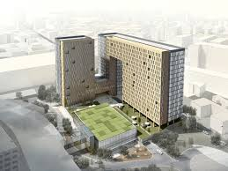
The building orientation plays a very important role in improving the environmental performance of a building, the position of a building relative to the sun and winds influences the natural lighting, ventilation and internal temperature control. Proper building orientation can significantly reduce the energy consumption by improving the daylight access and reducing the need for mechanical heating and cooling systems (Khan et al., 2024).
(thearchspace and ARCHSPACE, 2022)

For the proposed hotel, orientating the building to maximise southern solar exposure would provide the greatest amount of natural daylight throughout the day. South facing windows allow sunlight to penetrate further into the interior spaces reducing the need to rely heavily on artificial lighting in guest rooms and the communal areas such as the reception areas, corridors and restaurants (Thinking Buildings, 2025) (Long, 2024).

However excessive solar gain can lead to overheating during the warmer months, to prevent this shading systems such as overhangs, recessed window frames or external shading devices can be incorporated into the façade design, these systems reduce the direct sunlight while still allowing the natural daylight into the building (Wbdg.org, 2026) (Designingbuildings.co.uk, 2017).

Natural ventilation can also be improved through careful orientation and window placement, by positioning windows on the opposite side of the building, cross ventilation can be achieved allowing the air to flow naturally through the building, this reduces the need for mechanical ventilation systems and improves the indoor air quality (Architecturehelper.com, 2025) (Monash City Council).

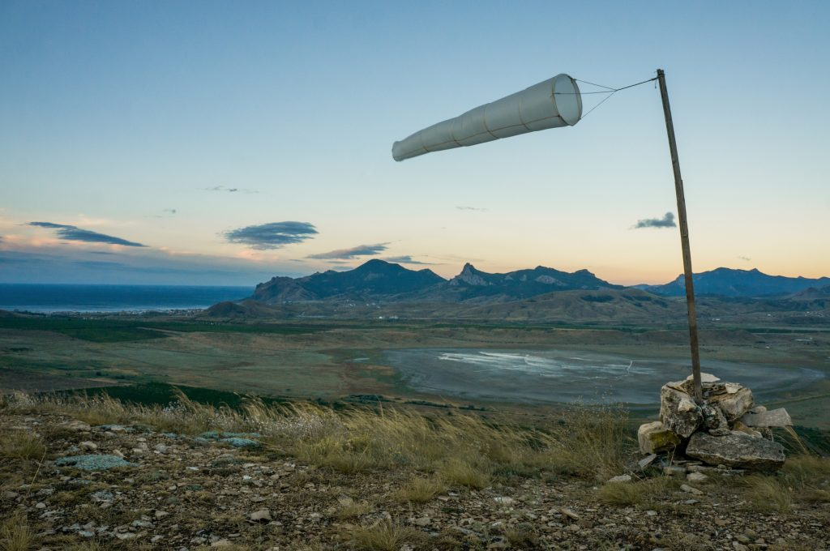
Wind exposure must also be considered due to Swansea’s coastal location the strong coastal winds increase heat loss and place additional loads on the structure of the building. Designing the building with an efficient structural system and durable façade materials helps minimise these environmental impacts (BookMyRoofer.co.uk, 2026) (Colley, 2013).

Overall having an appropriate building orientation improves the energy efficiency, reduces operational energy demand and enhances the comfort of the people in the building.
(Lauralu, 2025)

Building Life Cycle and Material Durability
A buildings environmental impact extends throughout its entire life cycle form the material extraction and construction to operation, maintenance and eventually its demolition. Life cycle assessments is used to evaluate these environmental impacts and identify opportunities to reduce carbon emissions and material waste (Lifecyclelab.org, 2023).
Steel is one of the primary material used in the proposed hotels structural systems, structural stell is widely used because of its high strength to weight ratio and structural efficiency. Steel allows for large spans and flexible floor layouts while using relatively small structural elements (Howells, J. (2026)).
Another important advantage of steel is its recyclability as stell can be recycled repeatedly without losing its structural properties, this reduces the need for raw materials and decreases the overall environmental impact of construction (Howells, J. (2026)).
Durability is also a key consideration in coastal environments such as Swansea, the building envelope must resists the moisture penetration, string winds and corrosion caused by the salt in the air. Rainscreen cladding systems are commonly used in modern buildings because they create a ventilated cavity between the outer cladding and the structural wall. This cavity allows moisture to drain away and prevents the water form entering the building structure (Howells, J. (2026)).
Also having thermally efficient glazing systems can further improve the buildings performance by reducing the heat loss whilst still allowing the natural daylight to enter the building (Howells, J. (2026)).

Overall by selecting materials that are durable and having efficient structural systems the long-term environmental impact of the building can be significantly reduced.
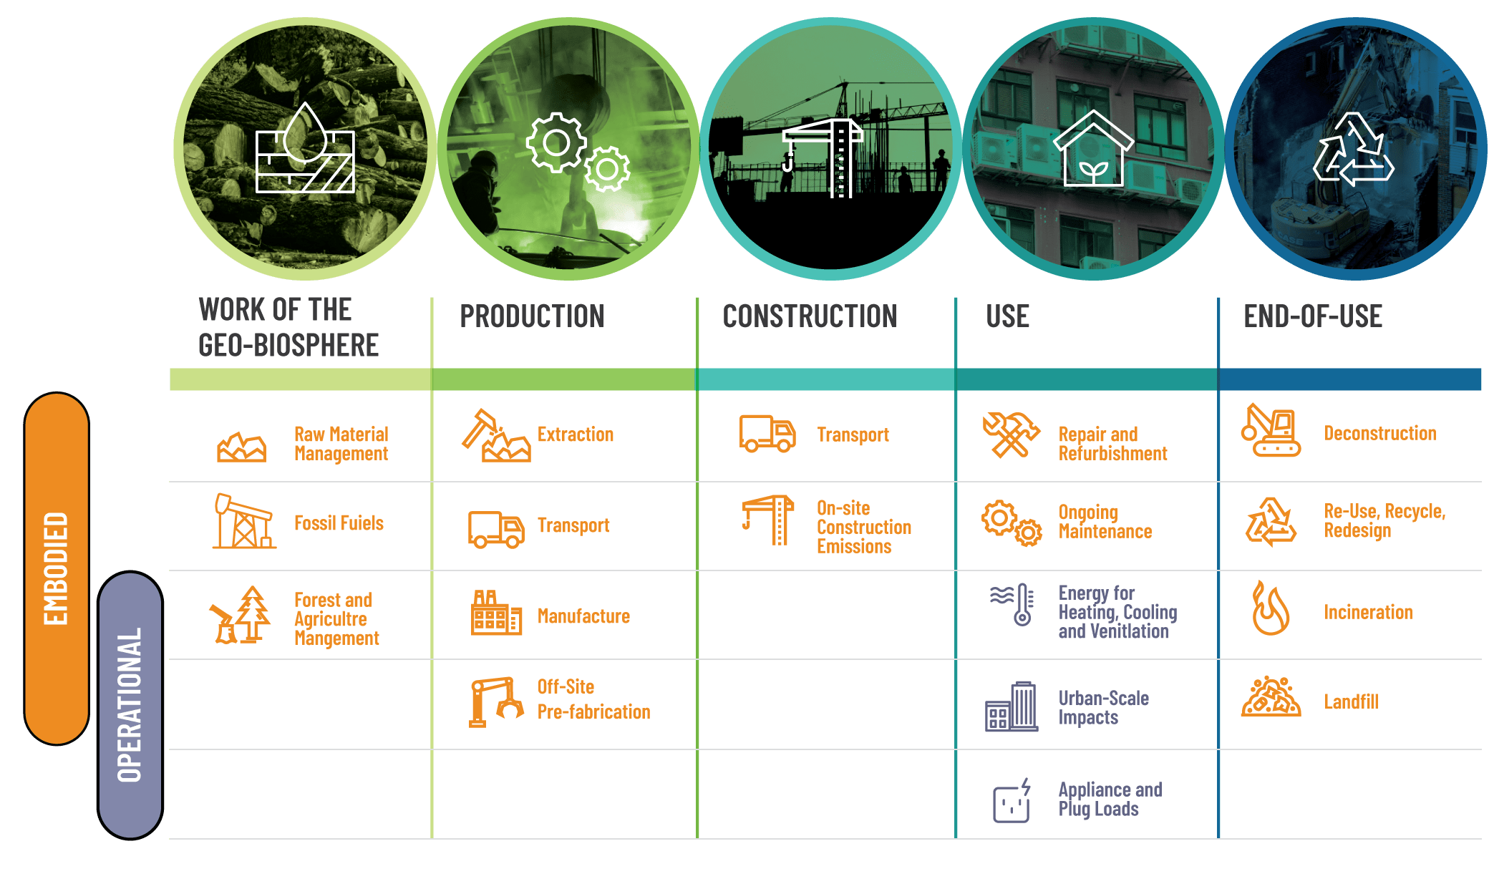

(Globalabc.org, 2020)

Aesthetic integration with the environment
In addition to the environmental performance buildings should also integrate visually with the surrounding urban environment. Having a good architectural designs will positively contribute to the character of the local areas whilst still maintaining functional and environmental performance(Design Commission for Wales, 2025).
The proposed hotel designs incorporates façade materials whilst also maintaining a visually balanced appearance that is suitable for the urban environment of Swansea. The materials such as fibre cement cladding panels or the brick effect façade systems provide durable exterior finishes whilst also complimenting the nearby surrounding buildings (GOV.UK, 2019).
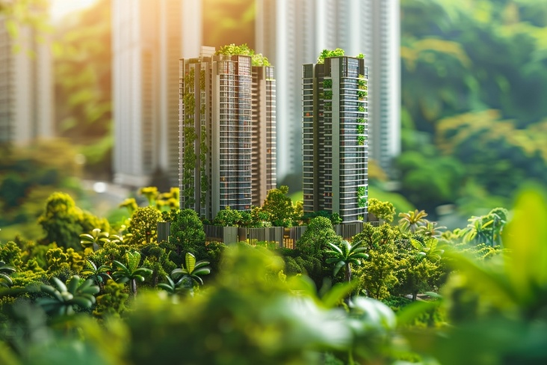
Also having some landscaping and greenery around the building can further enhance the visual appearance of the hotel development whilst still contributing to the environmental sustainability (Leaflike.co.uk, 2024).

(MIPIM World Blog, 2024)

Façade greening and suitable urban drainage systems

Green façades
Green façades involve integrating vegetation onto the external surfaces of buildings using climbing plants or modular planting systems, these systems are increasingly used in sustainable architecture due to environmental and aesthetic benefits (urbangreenbluegrids.com, n.d.).
Vegetation provides additional insulation to the building envelope, helping reduce the heat gain during the summer and heat loss in the winter, this improves the overall building energy efficiency(urbangreenbluegrids.com, n.d.).

Green façades also improve the urban air quality by absorbing pollution and carbon dioxide while releasing oxygen through photosynthesis, In more dense urban environments where natural vegetation in limited, green façades can increase the biodiversity by providing habitats for birds and insects (Rhs.org.uk, 2026).

Another benefit is the reduction of the urban heat island effect, urban areas tend to absorb and retain heat due to large areas of concrete and asphalt surfaces, the vegetation helps reduce this effect by shading surfaces and releasing moisture into the atmosphere(Gherri, 2023) (Yu et al., 2026).

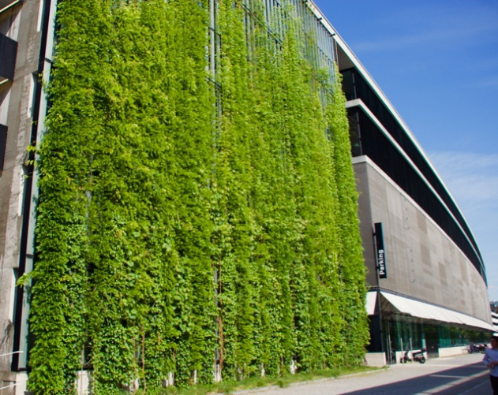
In addition to all of the environmental benefits, green façades enhance the visual appearance of buildings and create a more attractive urban environment, however these systems require appropriate irrigation systems, structural supports and plant selection to ensure the long term performance (Katarzyna Chojnacka et al., 2024) (Manso and Castro-Gomes, 2015).

(Green and living walls – planting the walls of buildings with vegetation, 2016)

Sustainable Urban drainage systems (SUDS)
Urban developments often increase impermeable surfaces such as roofs, roads and pavements, these surfaces prevent rainwater from naturally infiltrating into the ground and can increase the risk of flooding. Sustainable Urban Drainage Systems (SUDS) aim to manage surface water run off in a way that mimics the natural drainage processes(British Geological Survey, 2024) (Local.gov.uk, 2026).

Several SUDS techniques that could be used.
Firstly permeable paving allows for rainwater to pass though the surface and infiltrate into the underlying layers where it can be stored temporarily before gradually draining away (British Geological Survey, 2024).
Swales are shallow vegetated drainage channels that collect and filter surface water while also improving the landscape appearance of the site (Susdrain, 2019).
Underground attenuation tanks can store stormwater during heavy rainfall events and release it slowly into the drainage system (Fixfast.com, 2024).
Green roof systems can also reduce the surface water run off by absorbing the rainfall and improving insulation (client, 2023).
Therefore Implementing SUDS within the development of the hotel helps reduce the risk of flooding while improving the water quality and enhancing the sites environmental performance
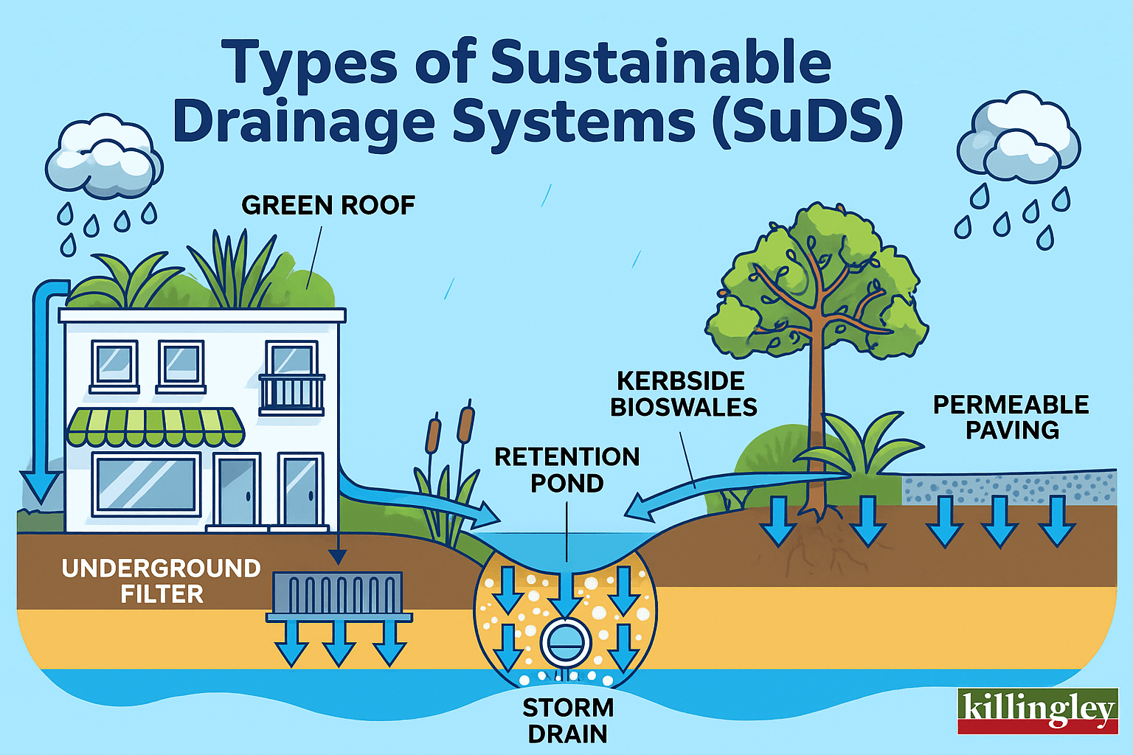

(Killingley Insights, 2025)

Buildability

Construction method
Buildability refers to the ease and efficiency with which a building can be constructed, a well designed building should minimise construction complexity while maintaining structural performance and safety (Procore UK, 2026).

The proposed hotel development uses a steel structural frame combined with a reinforced concrete core, steel frame construction allows for rapid structural assembly because the components are prefabricated off site and delivered ready for installation (Howells, J. (2026)).

Off site fabrication improves the quality control and reduces the construction time because the components are manufactured in controlled factory environments. Modular and prefabricated construction methods can significantly improve the construction efficiency and reduce the duration of the project (Howells, J. (2026)).
Also the reinforced concrete core provides structural stability and contains essential vertical elements such as lifts and staircases (Howells, J. (2026)).

Site Logistics
Construction site logistics are particularly important in urban developments where space may be limited, effective site planning ensures that the materials, equipment and operatives can move safely and efficiently around the construction site (Procore UK, 2025).
Using prefabricated structural elements reduces the amount of on site work required and minimises material storage requirements, the deliveries can be scheduled using a just in time approach, reducing the congestion and improving the site safety (Boury, 2024).
Traffic management plans are also necessary to ensure that there us safe access for construction vehicles and pedestrians (HSE, 2015).

Wind load calculation example
Wind loading is an important structural consideration for buildings located in coastal areas such as Swansea, where the buildings are exposed to higher wind speeds due ti reduced terrain shielding and the proximity to the sea. In the United Kingdom wind loads are calculated using Eurocode 1: Actions on Structures (BS EN 1991-1-4) which provides guidance for determining wind actions on buildings and civil engineering structures (Civilsguide.com, 2021) (Met Office, 2025) (www.engineeringtoolbox.com, n.d.)

The equation for this is:
Where:
- P = wind pressure (N/m²)
- V = wind velocity (m/s)
Assuming a wind speed of 25 m/s:
P=0.613×252
P=0.613×625
P=383N/m2
P=0.613V2
(European Committee for Standardization, 2005) (www.engineeringtoolbox.com, n.d.).

This value represents the approximate wind pressure acting on the building façade, wind pressure is proportional to the square of wind velocity meaning that small increases in wind speed can significantly increase the load acting on a structure (Lisa.blue, 2018).

Steel frame structures are particularly effective for resisting wind loads due to their high strength to weight ratio, ductility and structural stiffness which improves the resistance to lateral forces and reduce the structural defections. These characteristics allow steel frames to perform well in the coastal and high wind environments, where the lateral stability is a key design consideration (Judd, Cluff and Belshe, 2026) (All Answers Ltd, 2025).

SUDS runoff calculation example
A simplified stormwater runoff calculation can be used to estimate the amount of water that must be managed by the drainage system, particularly for small development sites, The rational method is widely used in early drainage design to estimate peak stormwater runoff and size drainage infrastructure such as pipes, culvers and attenuation systems (Drainboss, 2025).
Q = runoff rate (L/s)
C = runoff coefficient
I = rainfall intensity (mm/hr)
A = catchment area (hectares)

Site area = 2380 m² (0.238 hectares) (Please see figures and for site measurements)
Runoff coefficient = 0.9 (This is the typical amount for impermeable surfaces)
Rainfall intensity = 50 mm/hr

Q=C×I×A
Q=0.9×50×0.238
Q= 107.1L/s
(Agriculture Institute, 2025) (Drainboss, 2025).
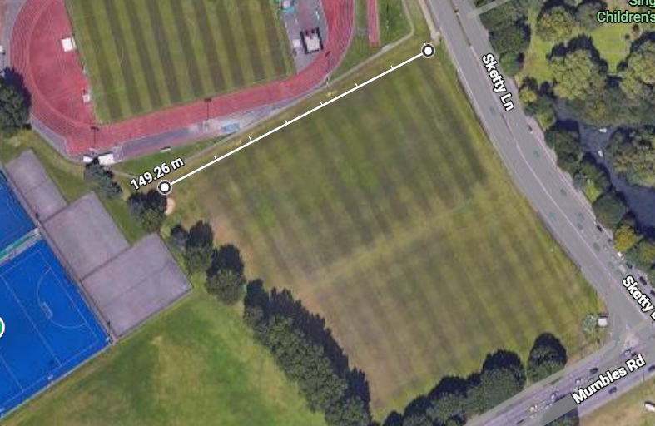
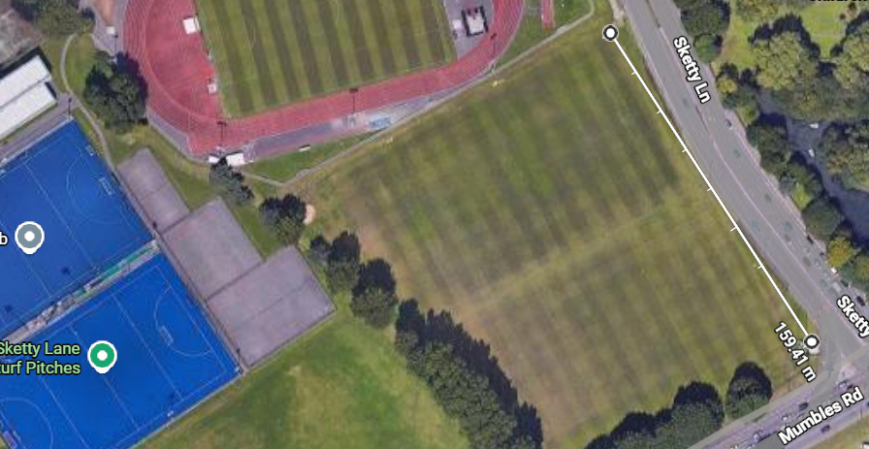
This calculation shows that the site could generate roughly 107.1 litres of runoff per second during heavy rainfall, this means that this runoff must be managed effectively to prevent flooding, erosion and overloading the existing drainage infrastructure
(Google, 2026)
Site Drawings 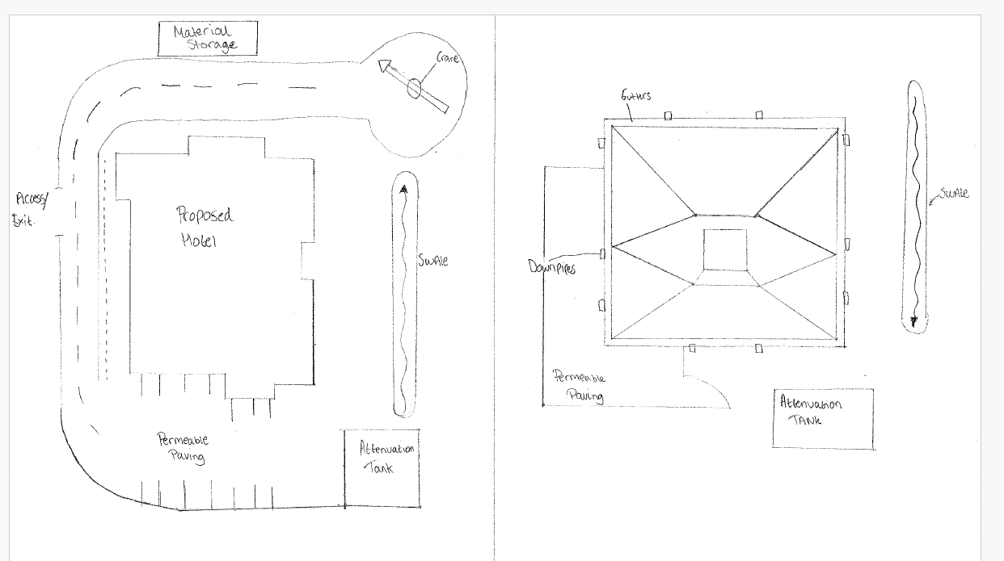
(Howells, J. (2026)).
Here is a drawing of the site plans with the Attenuations tank, Swales, permeable paving, all of which allowing the water to run off.

Construction Storyboard
Stage 1 Site Preparation
The site is cleared of vegetation, debris and any existing structures, Temporary fencing, signage and welfare facilities are installed to ensure safety and site security. Environmental controls such as dust and noise management are also introduced (Mainlinegroundworks.co.uk, 2026).

Stage 2 Groundworks
Excavation is carried out for foundations and services, pile foundations are installed where required to provide structural support, drainage and underground utilities are laid before progressing to the next stage (Designingbuildings.co.uk, 2022) (Contemporary Structures, 2024).

Stage 3 Concrete Core construction
A reinforced concrete core is built to house the lift and staircases, this provides the main structural stability of the building and constructed using efficient methods such as slip form systems (SRC Group, 2024).

Stage 4 steel frame erection
Prefabricated steel columns and beams are assembled on site using cranes, the frame is secured with bolted connections and temporary bracing to ensure stability during construction (Birkbeck - advanced offsite construction, 2025) (SRC Group, 2024).

Stage 5 building envelope
Cladding, glazing, insulation and roofing works are installed to make the structure weatherproof, this stage improves the energy efficiency and allows for the internal works to begin(SRC Group, 2024).

Stage 6 Internal works
Mechanical and electrical systems are installed followed by internal walls, ceilings and floors. Coordination between trades is important to avoid any clashes (SRC Group, 2024).

Stage 7 Finishing works
Final finishes such as painting, flooring and fixtures are completed, external works and landscaping is carried out, followed by inspections and snagging before the project is handed over (SRC Group, 2024).

Conclusion
This report has evaluated the buildability and sustainability of the proposed hotel development in Swansea, Environmental factors such as building orientation, material durability and energy efficiency have been analysed to ensure the building performs effectively within its coastal environment.
The integration of green façades and sustainable urban drainage systems improves the environmental performance by reducing the energy consumption, managing surface water runoff and enhancing biodiversity.
From a construction perspective the use of steel framing, prefabrication and efficient construction sequencing improves buildability while reducing project duration and construction risks.
Overall the proposed design demonstrates how sustainable design principles and practical construction strategies can be successfully integrated to deliver an efficient, durable and environmentally responsible hotel.

References
Agriculture Institute. (2025). Key Characteristics of Rainfall: What You Need to Know - Agriculture Notes by Agriculture.Institute. [online] Available at: https://agriculture.institute/hydrology/key-characteristics-of-rainfall/?utm_source

All Answers Ltd (2025). Lateral Stability of Braced and Unbraced Steel Buildings | UKDiss.com. [online] Ukdiss.com. Available at: https://ukdiss.com/intro/lateral-stability-of-steel-buildings-9979.php?utm_source=

Architecturehelper.com. (2025). Ultimate Guide to Cross Ventilation Design. [online] Available at: https://architecturehelper.com/blog/ultimate-guide-to-cross-ventilation-design/?utm_source=

Birkbeck - advanced offsite construction. (2025). How To Erect a Steel Frame Building | Process | Assemble | Construction. [online] Available at: https://www.birkbeck-structures.com/how-to-erect-a-steel-frame-building/?utm_source=

BookMyRoofer.co.uk (2026). Wind Load Requirements by Region UK: Engineering Standards - BookMyRoofer.co.uk Blog. [online] Bookmyroofer.co.uk. Available at: https://bookmyroofer.co.uk/blog/posts/wind-load-requirements-uk-engineering/?utm_source=

Boury, A. (2024). Benefits of Modular Construction | The Access Group. [online] Theaccessgroup.com. Available at: https://www.theaccessgroup.com/en-gb/construction/resources/benefits-of-modular-construction/.

British Geological Survey. (2024). Sustainable drainage systems - British Geological Survey. [online] Available at: https://www.bgs.ac.uk/geology-projects/suds/?utm_source=
Civilsguide.com. (2021). How To Design For Wind Loads? - Eurocodes 1-1-4 |. [online] Available at: https://civilsguide.com/how-to-design-for-wind-loads-to-eurocode-1-1-4/?utm_source=

client (2023). The Key Role Green Roofs Can Play in Helping to Protect Against Flooding - Wallbarn. [online] Wallbarn. Available at: https://www.wallbarn.com/the-key-role-green-roofs-can-play-in-helping-to-protect-against-flooding/.

Colley, J. (2013). Windy or cold weather: when does heating demand peak? - passivehouseplus.co.uk. [online] Passivehouseplus.co.uk. Available at: https://passivehouseplus.co.uk/magazine/feature/windy-or-cold-weather-when-does-heating-demand-peak

Contemporary Structures (2024). What is Groundworks in Construction? Essential Preparatory Steps. [online] Contemporary Structures. Available at: https://contemporarystructures.co.uk/what-is-groundworks-in-construction/?utm_source=

Design Commission for Wales. (2025). Why design matters | Design Commission for Wales. [online] Available at: https://dcfw.org/about/why-design-matters/

Designingbuildings.co.uk. (2017). Solar shading. [online] Available at: https://www.designingbuildings.co.uk/Solar_shading?utm_source=

Designingbuildings.co.uk. (2022). Groundworks on construction projects. [online] Available at: https://www.designingbuildings.co.uk/wiki/Groundworks_on_construction_projects?utm_source=

Drainboss. (2025). What is a Rational method ? | Drainboss. [online] Available at: https://drainboss.co.uk/glossary/rational-method/?utm_source=

European Committee for Standardization (2005) EN 1991-1-4:2005 Eurocode 1: Actions on Structures – Part 1-4: General Actions – Wind Actions. Available at: https://www.phd.eng.br/wp-content/uploads/2015/12/en.1991.1.4.2005.pdf?utm_source=

Fixfast.com. (2024). What is an underground water attenuation system? [online] Available at: https://www.fixfast.com/skills-hub/what-is-an-underground-water-attenuation-system.

Gherri, B. (2023). The Role of Urban Vegetation in Counteracting Overheating in Different Urban Textures. Land, 12(12), pp.2100–2100. doi: https://doi.org/10.3390/land12122100.

Globalabc.org. (2020). 2.4 Implementing a Whole Life-Cycle Approach to Building Materials. [online] Available at: https://globalabc.org/buildingmaterialsandclimate/chapte-2-life-cycle-thinking/2-4-implementing-a-whole-life-cycle-approach-to-building-materials.html.

Google (2026) [Sketty Ln. Field near Swansea Athletic Track]. Google Maps. Available at: Sketty Ln - Google Maps

Green and living walls – planting the walls of buildings with vegetation (2016). Green and living walls – planting the walls of buildings with vegetation. [online] Livingroofs. Available at: https://livingroofs.org/green-walls/.

GOV.UK (2019). National design guide. [online] GOV.UK. Available at: https://www.gov.uk/government/publications/national-design-guide.

HSE (2015). Construction - Traffic management on construction sites. [online] Hse.gov.uk. Available at: https://www.hse.gov.uk/construction/safetytopics/vehiclestrafficmanagement.htm.

Howells, J. (2026) Construction Technology 2. Unpublished assignment. University of Wales Trinity Saint David.

Judd, J., Cluff, S.P. and Belshe, C. (2026). Inelastic behavior of steel concentrically braced frame buildings under wind loads. Journal of Constructional Steel Research, 236, p.110008. doi: https://doi.org/10.1016/j.jcsr.2025.110008.

Khan, A.M., Tariq, M.A., Alam, Z., Alaloul, W.S. and Waqar, A. (2024). Optimizing energy efficiency through building orientation and building information modelling (BIM) in diverse terrains: A case study in Pakistan. Energy, [online] 311, p.133307. doi: https://doi.org/10.1016/j.energy.2024.133307.

Killingley Insights (2025). What Are Sustainable Drainage Systems (SuDS)? Flood Protection Explained. [online] NT Killingley Ltd. Available at: https://www.killingley.co.uk/hard-landscaping/what-are-sustainable-drainage-systems-suds/.

Katarzyna Chojnacka, Widera, B., Macarulla, M., Anastasios Drougkas, Andreu Balastegui, Van, Cansu Iraz Seyrek Şık, Sadowski, K., Fernandes, J., Gomes, R. and Paulo Ferrão (2024). Green urban transition: interdisciplinary insights on green façades design in hot climates as one of crucial strategies for low-carbon development. Clean Technologies and Environmental Policy. doi: https://doi.org/10.1007/s10098-024-02957-1.

Lauralu. (2025). Why Wind Load Matters for Temporary Structures | Lauralu UK & Ireland. [online] Available at: https://www.lauraluindustry.co.uk/blog/why-wind-load-matters-for-temporary-structures

Leaflike.co.uk. (2024). The Importance of Hotel Plants: Enhancing Guest Experience and Sustainability - Leaflike. [online] Available at: https://www.leaflike.co.uk/the-importance-of-hotel-plants-enhancing-guest-experience-and-sustainability/

Lifecyclelab.org. (2023). Introduction to Life Cycle Assessment of Buildings | Life Cycle Lab. [online] Available at: https://www.lifecyclelab.org/intro-to-lca/?utm_source=

Lisa.blue. (2018). Eurocode Wind actions - EN1991-1-4 General procedure. [online] Available at: https://www.lisa.blue/help/eurocode_wind_actions/en_GB?utm_source=

Local.gov.uk. (2026). Surface water (pluvial) flooding. [online] Available at: https://lb2.local.gov.uk/topics/severe-weather/flooding/flood-and-coastal-erosion-risk-management/surface-water-pluvial?utm_source=

Long, E. (2024). How Building Orientation Impacts Overall Performance and Energy Savings. [online] Building Performance Association. Available at: https://building-performance.org/bpa-journal/how-building-orientation-impacts-overall-performance-and-energy-savings/.

Mainlinegroundworks.co.uk. (2026). Site Preparation guide. [online] Available at: https://mainlinegroundworks.co.uk/site-preparation?utm_source=

Manso, M. and Castro-Gomes, J. (2015). Green wall systems: A review of their characteristics. Renewable and Sustainable Energy Reviews, [online] 41, pp.863–871. doi: https://doi.org/10.1016/j.rser.2014.07.203

Met Office. (2025). UK wind map - Met Office. [online] Available at: https://weather.metoffice.gov.uk/maps-and-charts/wind-map#?model=ukmo-ukv&layer=wind-speed-and-direction&bbox=.

MIPIM World Blog. (2024). Greening the Cityscape: Enhancing Aesthetics and Sustainability - MIPIM World Blog. [online] Available at: https://blog.mipimworld.com/guide-green-real-estate/green-real-estate-enhancing-cityscape-aesthetics-sustainability/.

Monash City Council (n.d.) Natural Ventilation. Available at: https://www.monash.vic.gov.au/files/assets/public/v/1/edms/planning-development/planning/guidelines/casbe-01-2-natural-ventilation.pdf?utm_source=

Procore UK. (2025). Construction Site Logistics: Keeping Projects Moving | Procore UK. [online] Available at: https://www.procore.com/en-gb/library/construction-site-logistics?utm_source=

Procore UK. (2026). Constructability: Reviewing Designs to Mitigate Construction Risks | Procore UK. [online] Available at: https://www.procore.com/en-gb/library/constructability?utm_source=

Rhs.org.uk. (2026). How do we green up cities – and why do we need to? [online] Available at: https://www.rhs.org.uk/science/articles/greening-cities?utm_source=

SRC Group. (2024). New Build Construction Timeline | SRC Group. [online] Available at: https://www.srcgroup.co.uk/new-build-construction-timeline-what-are-the-stages-of-a-new-build/?utm_source=

Susdrain (2019). Swales. [online] Susdrain.org. Available at: https://www.susdrain.org/delivering-suds/using-suds/suds-components/swales-and-conveyance-channels/swales.html.

thearchspace and ARCHSPACE, T. (2022). Importance of Building Orientation In Architecture · the archspace. [online] the archspace. Available at: https://thearchspace.com/importance-of-building-orientation/.

Thinking Buildings. (2025). Why is Choosing the Correct Orientation for your Building so Important? - Thinking Buildings. [online] Available at: https://thinking-buildings.co.uk/news/why-is-choosing-the-correct-orientation-for-your-building-so-important/.

urbangreenbluegrids.com. (n.d.). Green facades | Urban Green-blue Grids. [online] Available at: https://urbangreenbluegrids.com/measures/green-facades/.

Wbdg.org. (2026). Sun Control and Shading Devices | WBDG - Whole Building Design Guide. [online] Available at: https://www.wbdg.org/resources/sun-control-and-shading-devices?utm_source=

www.engineeringtoolbox.com. (n.d.). Wind Velocity and Wind Load. [online] Available at: https://www.engineeringtoolbox.com/wind-load-d_1775.html.

Yu, Z., Shao, M., Yang, W., Zhang, Y., Hu, Y., Ma, W., Zhong, J., Lin, Y., Wang, M., Zhang, H., Chen, J., Wang, C., Rahman, M.A., Weng, Q. and Zhou, W. (2026). Quantifying evapotranspiration and shading cooling of urban vegetation across climates under extreme heat using an integrated SCOPE-SEB model and surface temperature analysis. Remote Sensing of Environment, 338, p.115343. doi: https://doi.org/10.1016/j.rse.2026.115343.

