Everyday Life in Athens and Rome (HPHP4020)
Theatre masks in the Graeco-Roman world

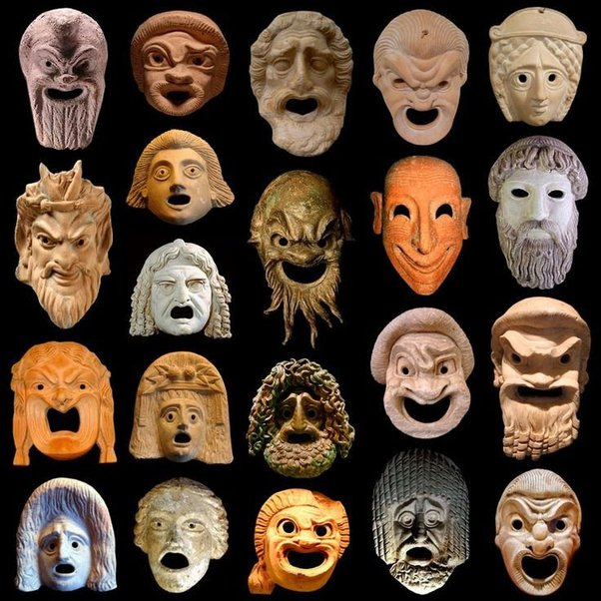

In this workshop we will explore theatre masks and material culture depicting actors in the Graeco-Roman world. In Greek theatre all actors were masked, and these masks were typically large and visually striking, concealing the faces of the actors. Unfortunately, no original masks survive from the ancient world (nor do original costumes). This is unsurprising given the organic materials from which these masks were constructed (stuccoed linen and/or stuck-together pieces of rag). However, we do have depiction which survive in artwork, including terracotta replicas of masks. The latter prove an invaluable source of material for those wishing to explore how actors performed in the Greek theatre. A series of images of ancient terracotta masks and other materials is given below. Have a look at these, and keep the following questions in mind:
- How might these masks be helpful to the performing actors?
- How might they also be a hinderance?
- How easy would it be to recognize stock characters from these masks?

Think about issues such as acoustics, visual effects and how these would be impacted by the surroundings – consider also the circumstances in which the actors would be performing.

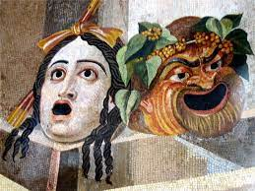
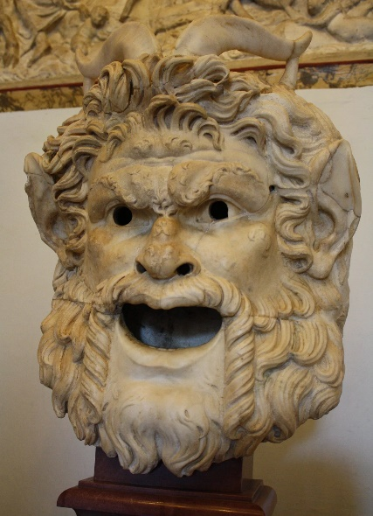
Can you recongise what stock character this type of mask is depicting? What types of performances or roles are they likely to feature in?

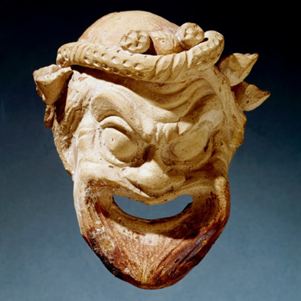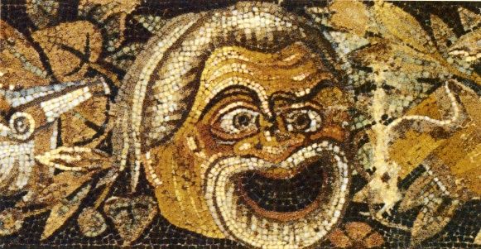
What about this figure – a common character in New Comedy – what role can you guess he played?

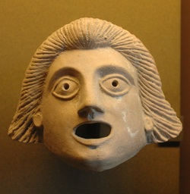
Does this mask seem more attractive than some of the others you have seen so far? What role in the play might this character have?

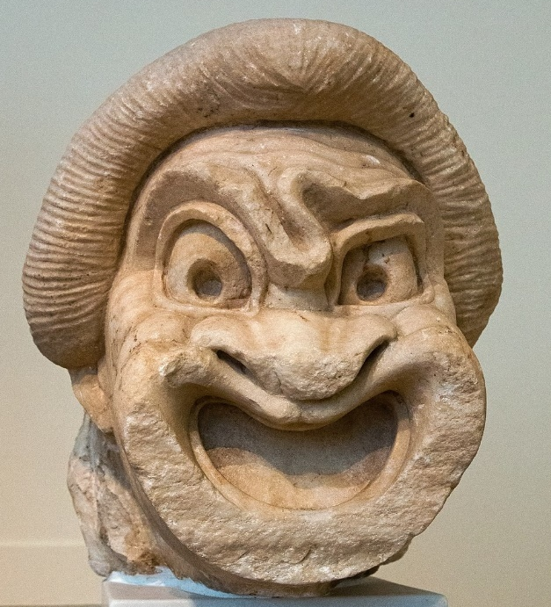
This character would often be linked to the above character, playing an important role in advancing the plot (particularly in New Comedy). Can you guess his role?
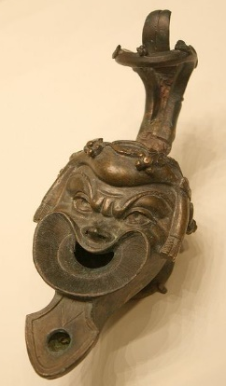 See also this Roman lamp, ca. AD 75-125. The character was popularly depicted in figurines.

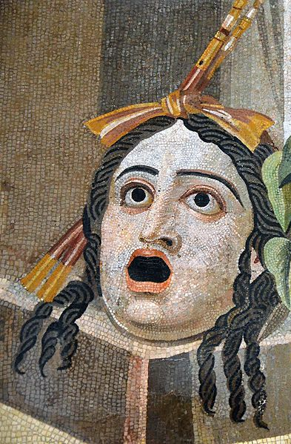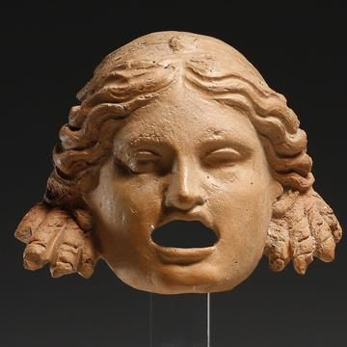

Compare the depiction of this female character, with the two different characters below.


What different roles do you think these females characters played?

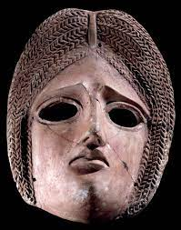
What type of drama (or other performance) do you think this type of mask is likely to feature in?

