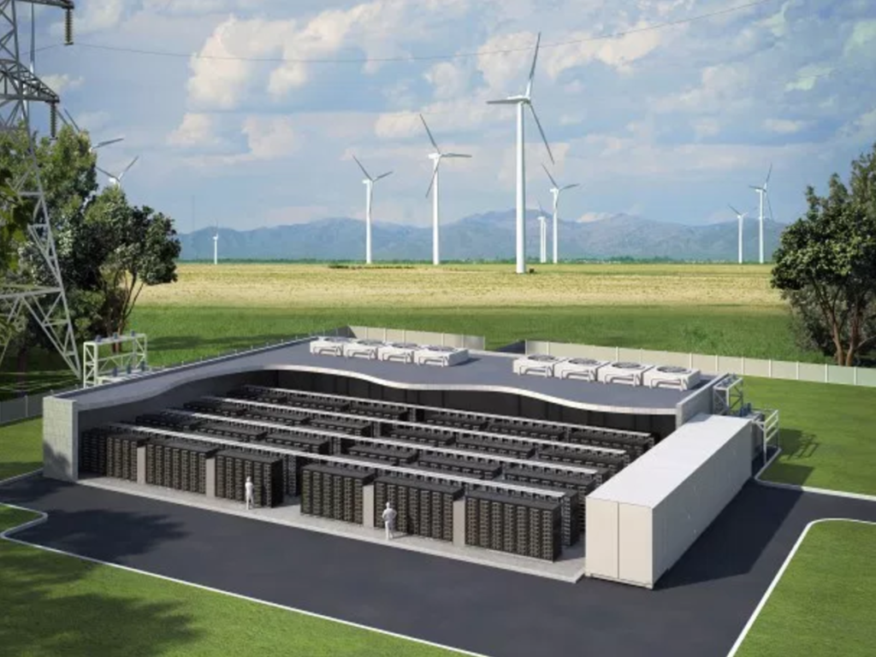
Lithium-Ion Battery Storage.
A Solution to Intermittency of Renewables?
Robert Kendall (P133451)
MSc Environmental Conservation and Management

Table of Contents
1. Introduction 2
2. Battery Storage technology 3
3. Lithium-Ion Battery Storage Technology 6
4. Lithium-Ion Batteries – Applicability and Scale 7
5. Lithium-Ion Batteries – Lifespan 10
6. Lithium-Ion Batteries – Integration 11
7. Lithium-Ion Batteries – Market Readiness 12
Case Study – Tesla mega-battery in Australia 12
8. Conclusion 14
References 15

Abbreviations
CO₂ – Carbon Dioxide
EMS – Energy Management Systems
ESS – Energy Storage Systems
EU – European Union
GHG – Green House Gas
LIB – Lithium-Ion Battery
MW – Mega Watts
Ofgem – Office of Gas and Electricity Markets
PV – Photovoltaic
TMS - Thermal Management System

Front Cover. ESS and windfarm, image taken from (Froese, 2018).

Introduction

Energy is one of the fundamental components towards sustainable development in which modern society depends upon, it promotes economic growth and safeguards the well-being of humans (European Commission, 2018; Price, 2015). However, concerns grow internationally over the environmental effects of using fossil fuels and other non-renewable sources of energy, mainly the Greenhouse Gas (GHG) effect from Carbon Dioxide (CO₂) emissions emitted from the combustion of coal, oil, and natural gas. As a result there has been a shift in recent years towards investing in renewable sources of energy in attempt to decouple carbon emissions from economic growth in order to mitigate against rising global mean temperatures and promote sustainable development. This effort is primarily to try and reduce carbon emissions from peaking beyond 2020 in order to prevent global warming from exceeding a mean global temperatures of 2°C and pushing the earth over universally agreed acceptable limits (Shah et al. 2018; IEA, 2015). It is estimated that the energy related activity accounts for up to 80% of the EU’s total GHG emissions (European Commission, 2010).
These concerns have led to the 2015 United Nations Paris Climate Agreement which is the first global legally binding agreement to reduce GHG emissions. The European Union (EU) officially ratified to the agreement coming into force on 4th November 2016, with an ambitious aim to reduce EU’s GHG by at least 40% before 2030 (European Commission, 2018; Hills & Michalena, 2017). Moreover, under the EU’s Renewable Energy Directive has set a mandatory target of 20% of final energy consumption to be derived from renewable sources by 2020 and recently amended directive 27% by 2030 respectively (European Commission, 2018).
Renewable energy can be produced from a verity of sources such as; wind, solar, geothermal, tidal, hydro and biomass (European Commission, 2018). In recent years the cost of solar photovoltaic (PV) and wind has plummeted, increasing the uptake and lowering the cost even further (Lehtveer et al., 2017; Ofgem, 2017). However, one of the biggest issues related to renewable energy is intermittency and stochastically issues especially in wind and solar technologies (Notton et al., 2018). Simply, it is difficult to predict the short and long term reliability of wind and solar PV technologies as they depend upon fluctuating weather conditions therefore, managing the production/consumption (frequency control) balance with these technologies is challenging for grid operators without the backup of more conventional sources of energy production (non-renewable sources such as natural gas). Therefore, to ensure the stable supply of energy, low cost grid scale energy storage is required if renewable energy is to replace more dependable sources of energy in terms of intermittency and efficiency (Ashour et al., 2018; Notton et al., 2018; Lehtveer et al., 2017; Gersema & Wozabal, 2017; Gitis et al., 2015; Leadbetter & Swan, 2012).

To solve intermittency issues with renewable energy technology, energy storage systems (ESS) are considered fundamental for moving away from more traditional forms of energy production and the uptake of renewable technologies. This is because, the energy produced can be stored when excess is produced and transformed back in times of demand and can also stabilise variability in both supply and demand and help move away from fossil fuel and conventional non-renewable base load power plants (nuclear and coal plants) and dispatchable generators (natural gas) (Olabi, 2017; Gitis et al., 2015; Moseley & Garche, 2015).
The UK Government and Ofgem have released a smart systems flexibility plan in July 2017, in order to upgrade the UK’s energy system and play an important part in the governments Industrial Strategy and Clean Growth Strategy. One of its aims is to amend the Electricity Act 1989 and include a definition of storage, in order to modernise the regulatory framework for ESS to facilitate the growth in renewable technologies (Ofgem, 2017; Sidhu et al., 2018).
There are many types of ESS technologies such as; chemical, electrochemical, mechanical, electrical and thermal (Ould Amrouche et al., 2016).

Battery Storage technology

Batteries have been long regarded as a possible solution towards solving the intermittency issues associated with renewable energy technologies as in theory they can be used to manage sort term fluctuations in demand and generation. However traditionally, the use of large scale batteries have been considered unviable due to them being; too expensive, do not yield enough revenue due to low differences between base and peak load prices, have a short life cycle and come with associated safety concerns (Ashour et al., 2018; Dai et al., 2018; Gitis et al., 2015). However, there are emerging advancements in battery storage technology that can revolutionise the renewable energy industry. The primary reasons for this assertion is due the lowering cost and increased uptake of renewable energy generation due to political action on climate change, very fast response times, low discharge rates, high efficiency and the scalability of modern grid-scale storage technology (Ashour et al., 2018; Dai et al., 2018; Ofgem, 2017; Sidhu et al., 2018; Hesse et al., 2017).
The technical specifications concerning what energy storage technology should be used needs to be assessed on a case to case basis. Before deploying a storage technology , it is imperative that the following factors are properly evaluated; the energy capacity required, the power required, energy to power ratio and the state of charge. These assessments also allow for the economic considerations of the system (Gitis et al., 2015; Posada et al., 2017).
There are many types of electrochemical battery storage technologies; lithium ion (Li–ion) batteries, lead–acid batteries, flow batteries and liquid metal batteries, to name a few (Posada et al., 2017). Each technology has a specific technical characteristics (discharge time, response time, storage duration and number of cycles), that enables them to be better utilised for different ESS applications (frequency control, peak shaving and voltage control) (Sidhu et al., 2018).
Each technology can be broadly grouped into three categories; short, medium and long in relation to its charge/discharge cycle. The main differences between each time category is the power and energy attribute required of the storage (Leadbetter & Swan, 2012). Refer to figure 1 and figure 2.
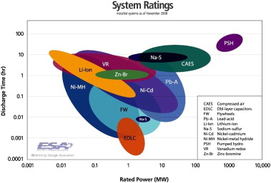
Figure 1. Duration vs. power of energy storage projects (Leadbetter & Swan, 2012).
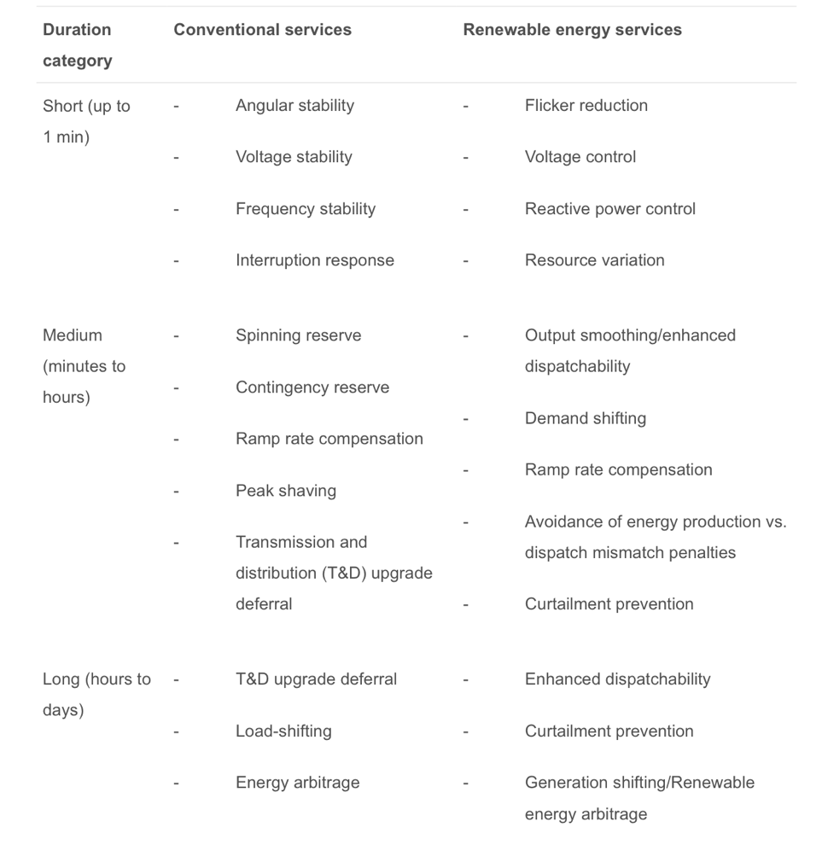
Figure 2. Energy storage duration categories (Leadbetter & Swan, 2012).

The short category lasts up to 1 minute and is mainly related to power quality and specifies the power characteristics. In general, intermittent power generation from renewable sources can cause quality issues and are best remedied by improved power electronics within close proximity to the power generation rather than small or large centralised storage facilities (Zhang et al., 2018; Leadbetter & Swan, 2012).
The medium category can range from minutes to hours to counterbalance the mismatch between generation and demand. If the production of energy decreases from renewables over several minutes there needs to be a sufficient amount of flexible generation to meet demand that is no longer supplied by renewables. Medium energy storage facilities can provide; time shifting, output smoothing/dispatachability and ramp rate compensation (Leadbetter & Swan, 2012).
The long category provides energy wheeling over timescales of hours to days. Furthermore, energy arbitrage and generation shifting (taking energy during high renewable generated output times and supplying the energy at times of high demand/cost) can be done over a few hours to days to meet fluctuation demands of most grids (Leadbetter & Swan, 2012).
This report will analyse lithium-ion batteries (LIB) for energy storage and investigate what step can be implemented to facilitate its implementation.

Lithium-Ion Battery Storage Technology

LIB technology is a relatively new technology that can be traced back as far as the 1960’s in the Bell Labs and was later commercialised by Sony in 1990 (Diouf & Pode, 2015; Leadbetter & Swan, 2012). The main characteristics of LIB are; high energy density, high life cycle, high efficiency and high cost (Leadbetter & Swan, 2012; Diouf & Pode, 2015). However, there are many different varieties of chemistry and designs from a range of suppliers, as a result, innovation and an increase in manufacturing has seen improvements to the cost, energy density and the cycle life in recent years (Froese, 2018).
At present, LIB’s are the most commonly used battery for ESS as they are capable at handling small applications like electric motor vehicles to grid scale applications that require megawatts (MW) of electricity over timescales lasting hours (Froese, 2018). LIB currently account for over 90% of the global newly operational electrochemical storage capacity in comparison to other technologies. Refer to figure 3. Furthermore, electrochemical energy storage with renewable integration saw the largest increase in application between 2016-17 (China Energy Storage Alliance, 2018). Refer to figure 4.
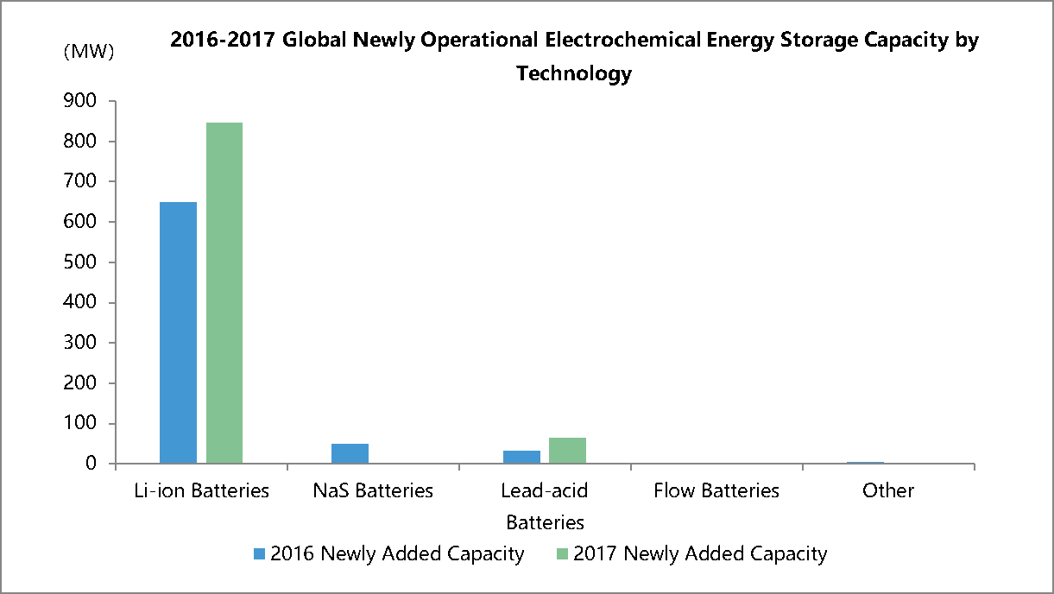
Figure 3. 2016-17 global newly operational electrochemical energy storage capacity by technology (China Energy Storage Alliance, 2018).
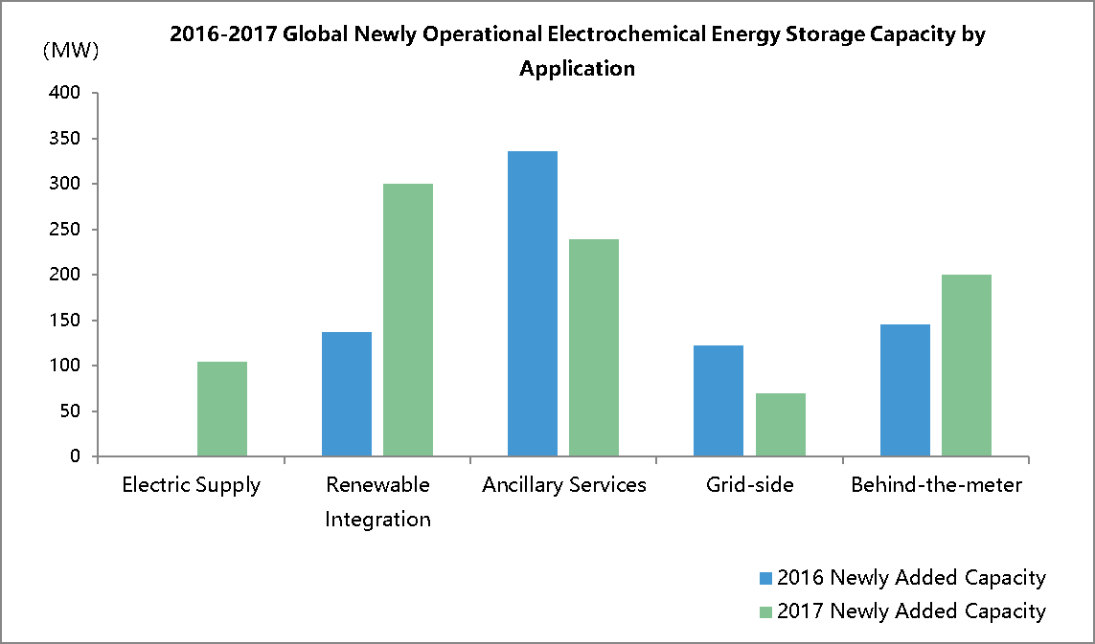
Figure 4. 2016-17 global newly operational electrochemical energy storage capacity by application (China Energy Storage Alliance, 2018).

Lithium-Ion Batteries – Applicability and Scale

There are many ways in which ESS can be implemented and at different scales. ESS can be implemented in behind the meter systems (a battery system that is installed on the customers side of the grid), on micro-grids, island grids and on national grids (usually used with renewables) at different sizes for different functions. Refer to figure 5,6 & 7
Traditionally, battery storage systems are considered better for self-supply systems such as homes with solar PV installations, island power systems and micro-grids, therefore these instances are considered as entry points to the market (Gitis et al., 2015; Taylor, 2018).
Behind the meter systems can help with the intermittency issues related to renewable energy. However, they need to be integrated with smart meters and controls in order to get the best value out of the technology (Bayram & Ustun, 2017).

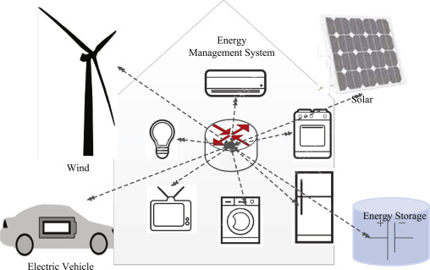
Figure 5. Household behind the meter system (Bayram & Ustun, 2017).

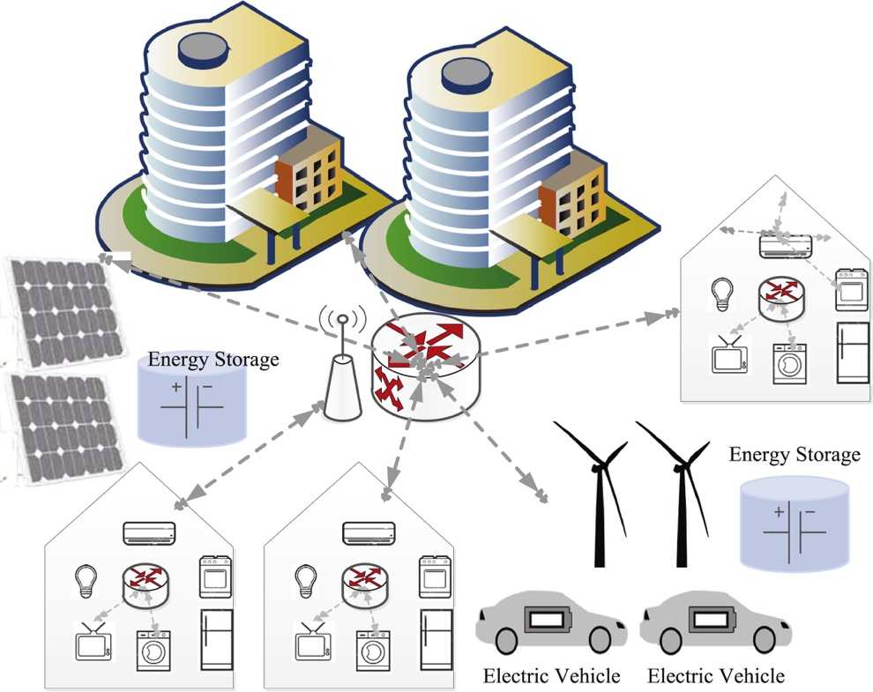
Figure 6. campus behind the meter system (Bayram & Ustun, 2017).

A typical grid LIB storage facility will consist of; the battery Cell (arranged into modules or packs configurations), Thermal Management System (TMS) and Energy Management Systems (EMS) controls. Depending on the application, the power electronics system may need either a singular or multiple DC/AC link and possibly a coupling element transformer for higher grid voltage levels (Hesse et al., 2017). Refer to figure 7.
This configurable aspect of LIB makes them an ideal choice for energy storage systems as they can be specifically designed to store a few Kilowatts for a few minutes of storage or they can be designed to store multi-megawatts for hours of storage that can be used in conjunction with a windfarm or a utility substation (Froese, 2018).
When discussing grid scale storage applications, it’s important to note that its main function isn’t necessarily storage, its flexibility, in order to provide a safe, reliable and efficient grid operation. Furthermore, when discussing flexibility options, it’s important to consider that battery storage technology is in competition with other technologies. Granted, storage technology is the smartest option however, it isn’t necessarily the cheapest option (Sauer, 2015). Moreover, fossil fuel power plants have a high competitive edge over energy storage technologies, mainly because they can provide the same service from a technical and economical point of view especially if those plants are already in place and can be exploited (Gitis et al., 2015). However, due to the environmental concerns related to fossil fuel plants, the demand for renewable and low carbon technologies are likely to grow expediently in the near future and battery storage is one technology that will likely facilitate its growth (Ofgem, 2017; Moseley & Garche, 2015; Sidhu et al., 2018).
LIB for energy storage are currently best utilised for medium time length applications ranging from 30 minutes to 3 hours. LIB’s are also the most cost effective solution for medium length applications however, for long timeframes they may not be the most cost effective solution (Froese, 2018).

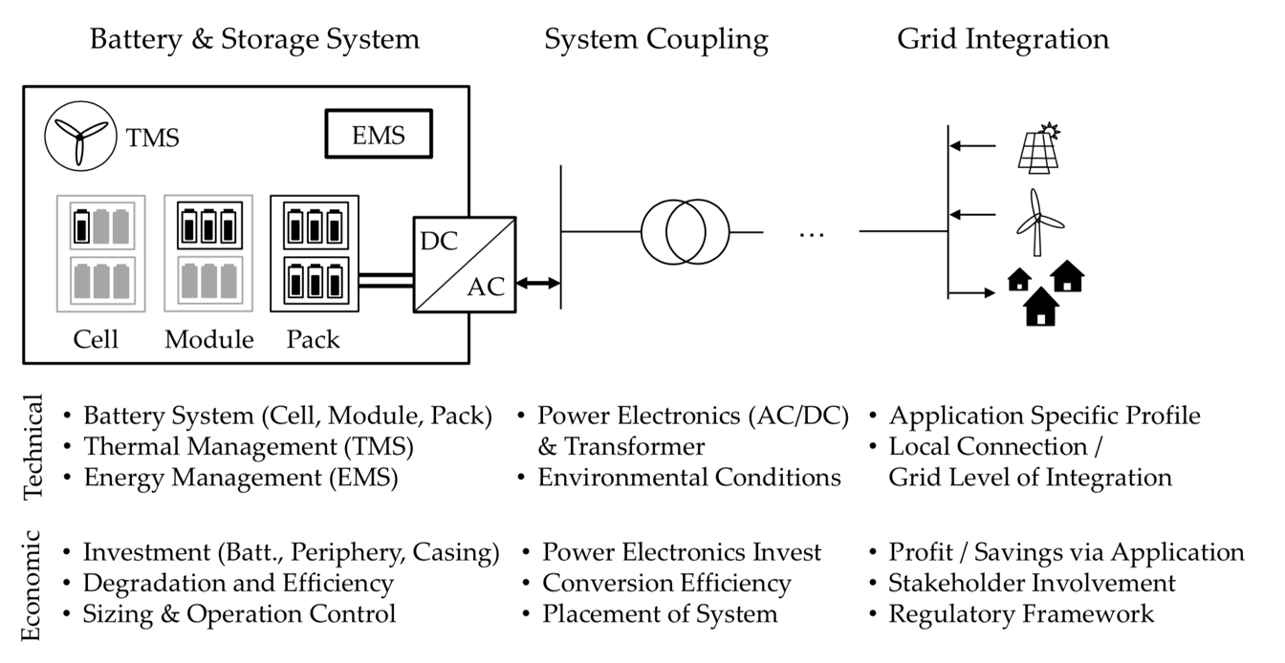
Figure 7. Battery storage system, power system coupling and grid interface components, with its technical and economic considerations (Hesse et al., 2017).

The cost of LIB is still considered too high for mass deployment for ESS. However, the due to the increase in production for the automotive industry, the cost of LIB are expected to drop by as much as $200 per kWh by 2020 (Kubiak et al., 2017; Diouf & Pode, 2015). Moreover, unlike the batteries used for the automotive industry and portable electronics, the batteries for stationary ESS are not restricted by weight or volume. As a result, the focus on the technology can be paid to improving the safety, cycle life and cost rather than the power densities (Kubiak et al., 2017).

Lithium-Ion Batteries – Lifespan

To ensure viability of LIB as an economical stationary ESS for integration with renewables, the lifespan of the battery is considered to be fundamental and requires validation (Kubiak et al., 2017). It is difficult to ascertain the lifespan of LIB storage technology as there are many different types of LIB either in development or currently on the market. (Hesse et al., 2017). However, the general consensus on the lifespan of LIB in ESS ranges from 10-15 years (Kubiak et al., 2017; Sidhu et al., 2018). Refer to figure 8.
One study into the lifespan of LIB ESS lifespan was carried out by Sidhu et al., 2018 as a part of a social cost benefit study of grid scale of ESS. The study evaluated the Smarter Network Storage project, a 6 MW/10 MWh lithium battery deployed at the Leighton Buzzard Primary substation in Bedfordshire, England. The degradation analysis section of this study reported that a degradation rate of 4.6% per 1000 cycles for each cell and pack and when the battery reaches 75% of its nominal energy capacity it has reached its lifespan and needs to be decommissioned or replaced (Sidhu et al., 2018). Refer to figure 8.

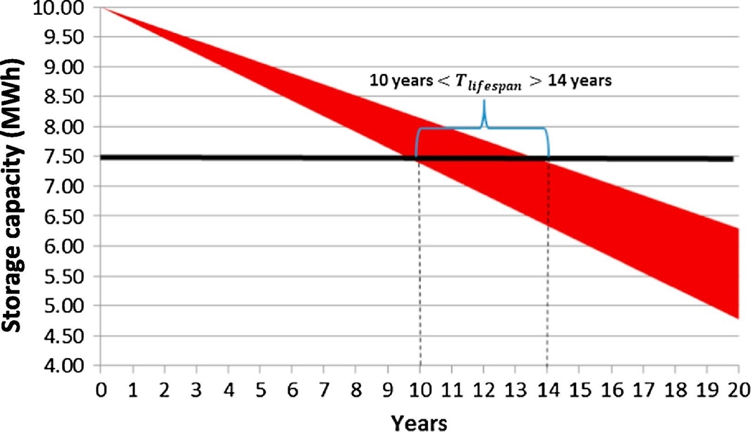
Figure 8. Degradation rate of Samsung SDI lithium-manganese battery cells used for energy storage at Smarter Network Storage project (Sidhu et al., 2018).

Furthermore, LIB have additional benefits over its competitors, they need little maintenance once installed to increase the lifespan, have little to no memory effect and have a longer shelf life (Diouf & Pode, 2015).
Regardless, over time all LIB will degrade therefore, a strategy to replenish, replace and dispose/recycle is fundamental (Froese, 2018). Furthermore, the sustained growth of LIB in the automobile industry could mean that demand could outpace supply for battery grade resources, even lithium itself (Olivetti et al., 2017). Diouf & Pode, 2015 stated that, if 1 billion fossil fuel based automobiles are replaced by electric vehicles and hybrids powered by 15-kWh LIB then around 30% of the global lithium reserve (Diouf & Pode, 2015). Moreover, due to long battery lifespans and multiple end uses, recycling is unlikely to meet short term supply (Olivetti et al., 2017).

Lithium-Ion Batteries – Integration

One major step for Integrating LIB ESS to the current grid is upgrading the old grid infrastructure to a smart grid. By upgrading the grid it will allow for communication between technologies that will allow better understanding of variations between power production and consumption and enables that information to be used in a dynamic way to get the most out of the system. This in turn will facilitate towards the uptake of renewable energy generation and therefore a transition to a low carbon economy (Department of Energy and Climate Change, 2018; Hossain et al., 2016).
BSS and smart grids go hand in hand in the flexibility and stability of renewable energy generation (Sharifzadeh et al., 2017). The UK Government has made a commitment towards upgrading the current infrastructure to accommodate for smarter technology (Ofgem, 2014). Refer to figure 9.
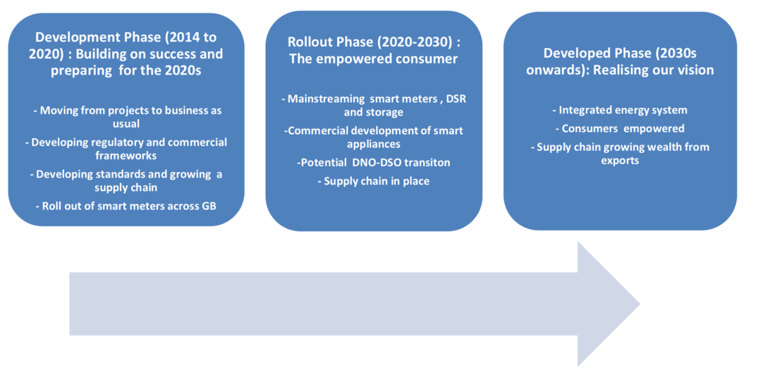
Figure 9. Key stages in the development of a smart grid (Ofgem, 2014)
At present the government roll out of smart meters will facilitate in the uptake of more Behind the meter systems. Around 1 million homes in the UK have solar panels on their roofs can be used with small LIB storage systems such as Moixa and Tesla power wall which in turn can save the consumer money by generating and storing their own energy (Ofgem, 2017; Tesla, 2018). Moreover, if the expected uptake of electric vehicles does happen then it paves the way for “Vehicle-to-Grid” applications. This application enables electric vehicle owners to charge their vehicle during off peak times or through their own means of renewable generation and sold back to the grid in times of peak demand (Diouf & Pode, 2015). At present the UK government has awarded over £30 million towards Vehicle-to-Grid trials in conjunction with Honda, Nissan and Mitsubishi (Pratt, 2018).

Lithium-Ion Batteries – Market Readiness

Low carbon and renewable technologies have seen a rise in recent years, however, the implementation and maturity of the most promising technologies needs to be accelerated in order for them to be ready for market (IEA, 2015). LIB is emerging as the most likely technology to be fully market ready and able to compete economically (China Energy Storage Alliance, 2018). However, the price still needs to decrease for widespread implementation, this will likely happen through the advancement of LIB used in the automotive industry (Diouf & Pode, 2015).

Case Study – Tesla mega-battery in Australia

One case where a large LIB has been utilised with a renewable energy source is the Tesla mega battery project in Jamestown Australia.
In December 2017 Tesla officially activated the world’s largest LIB ESS. The ESS is a 100 megawatt system that can power up to 30,000 homes for an hour but it will mainly be used to stabilise existing energy supplies (BBC, 2018). The battery was deployed in order to solve the power issue in southern Australia where a storm caused major blackout in September 2016 (BBC, 2016).
The system is connected to a wind farm which is operated by a French company called Neoen. Neoen has access to around 30 MW/90 MW in order to trade on the wholesale market and the rest is reserved for the government to stabilise the grid (Lambert, 2018). The system is able to switch from charge to discharge within seconds, this allows Neoen to take advantage of the large swings in energy prices in Australia (during periods of peak demand) (Lambert, 2018).
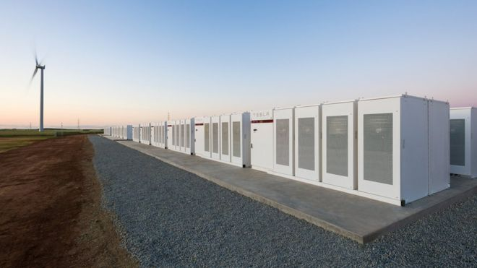
Figure 10. Tesla mega battery Australia (BBC, 2018)

Moreover, Reports suggest that within just a few days the system is highly profitable by generating around $1 million AUD (Lambert, 2018). Refer to figure 11.

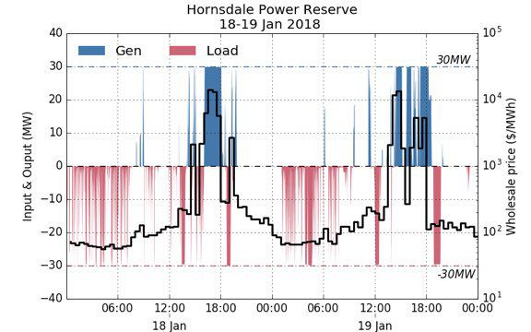
Figure 11. Graph, Hornsdale power reserve input/output wholesale price January 2018 (Lambert, 2018).
Figure 11 shows the ESS enabling Neoen to sell electricity up to $14,000 AUD per MWh and charging at little to no cost. Furthermore, the ESS was also put to use to stabilise the grid when a coal generator failed to stay within frequency (Lambert, 2018). Refer to figure 12.
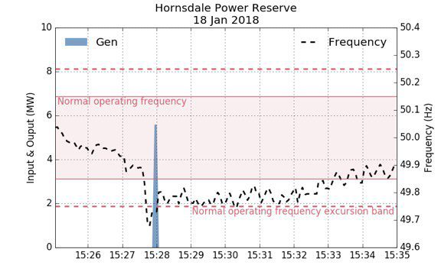
Figure 12. Hornsdale power reserve 2018

This example of LIB ESS demonstrates the market readiness of LIB ESS for wide scale implementation to stabilise the grid with use of renewables. However, it is important to note that this is a new system and some of the issues associated with LIB ESS might not be fully evident yet and more time needs to be given before full conclusions are made.

Conclusion

If we are to ensure that we achieve the targets set by Paris Climate Agreement and the EU’s Renewable Energy Directive, to prevent carbon emissions from peaking beyond 2020 and try to prevent global warming from exceeding a mean global temperatures of 2°C pushing the earth over universally agreed acceptable limits, it is fundamental that there is an uptake of renewables.
One main issue associated with renewable energy generation is intermittency. To solve this issue there has been some recent technological advancements mainly in the form of ESS.
Batteries have been long regarded as a possible solution towards solving the intermittency issues associated with renewable energy technologies as in theory they can be used to manage sort term fluctuations in demand and generation. However traditionally, the use of large scale batteries have been considered unviable due to them being; too expensive, do not yield enough revenue due to low differences between base and peak load prices, have a short life cycle and come with associated safety concerns.
However, there are emerging advancements in battery storage technology that can revolutionise the renewable energy industry. The primary reasons for this assertion is due the lowering cost and increased uptake of renewable energy generation due to political action on climate change, very fast response times, low discharge rates, high efficiency and the scalability of modern grid-scale storage technology.
At present, LIB’s are the most commonly used battery for ESS as they are capable at handling small applications like electric motor vehicles to grid scale applications that require megawatts (MW) of electricity over timescales lasting hours.
When discussing grid scale storage applications, it’s important to note that its main function isn’t necessarily storage, its flexibility, in order to provide a safe, reliable and efficient grid operation. Furthermore, when discussing flexibility options, it’s important to consider that battery storage technology is in competition with other technologies. Granted, storage technology is the smartest option however, it isn’t necessarily the cheapest option
LIB for energy storage are currently best utilised for medium time length applications ranging from 30 minutes to 3 hours. LIB’s are highly configurable and also the most cost effective solution for medium length applications however, for long timeframes they may not be the most cost effective solution.
One major step for Integrating LIB ESS to the current grid is upgrading the old grid infrastructure to a smart grid. By upgrading the grid it will allow for communication between technologies that will allow better understanding of variations between power production and consumption and enables that information to be used in a dynamic way to get the most out of the system.
One case where a large LIB has been utilised with a renewable energy source is the Tesla mega battery project in Jamestown Australia. This example of LIB ESS demonstrates the market readiness of LIB ESS for wide scale implementation to stabilise the grid with use of renewables. However, it is important to note that this is a new system and some of the issues associated with LIB ESS might not be fully evident yet and more time needs to be given before full conclusions are made.
The future of renewables relies on the implementation of ESS as it can solve the intermittency issues associated with renewable energy technologies as they can be used to manage sort term fluctuations in demand and generation improving their efficiency. Moreover, the upgrade of the grid to a smarter grid is also a fundamental component.

References

Ashour R, Kelley D, Salas A, Starace M, Weber N and Weier T (2018) Competing forces in liquid metal electrodes and batteries. Journal of Power Sources. 378, 301-310.
Bayram I and Ustun T (2017) A survey on behind the meter energy management systems in smart grid. Renewable and Sustainable Energy Reviews. 72, 1208-1232.
BBC (2016) The freak storm that took out a state. [Online] Available at: http://www.bbc.co.uk/news/world-australia-37481257 (accessed 25/ 05/ 18).
BBC (2018) Tesla mega-battery in Australia activated. [Online] Available at: http://www.bbc.com/news/world-australia-42190358 (accessed 25/ 05/ 18).
China Energy Storage Alliance (2018) CNESA Storage Market Analysis – 2017 Q4. [Online] Available at: http://en.cnesa.org/featured-stories/2018/3/16/cnesa-storage-market-analysis-2017-q4 (accessed 24/ 05/ 18).
Dai T, Zhao Y, Ning X, Lakshmi Narayan R, Li J and Shan Z (2018) Capacity extended bismuth-antimony cathode for high-performance liquid metal battery. Journal of Power Sources. 381, 38-45.
Department of Energy and Climate Change (2018) 2010 to 2015 government policy: UK energy security. [Online] Available at: https://www.gov.uk/government/publications/2010-to-2015-government-policy-uk-energy-security/2010-to-2015-government-policy-uk-energy-security#appendix-1-future-electricity-networks (accessed 25/ 05/ 18).
Diouf B and Pode R (2015) Potential of lithium-ion batteries in renewable energy. Renewable Energy. 76, 375-380.
European Commission (2010) Energy 2020A strategy for competitive, sustainable and secure energy. Brussles: European Commission Available at: http://eur-lex.europa.eu/legal-content/EN/TXT/?qid=1409650806265&uri=CELEX:52010DC0639 (accessed 21/ 05/ 18).
European Commission (2018). Paris Agreement - Climate Action - European Commission. Available at: https://ec.europa.eu/clima/policies/international/negotiations/paris_en [Accessed: 20 May 2018].
European Commission (2018) Renewable energy - Energy - European Commission. [Online] Available at: https://ec.europa.eu/energy/en/topics/renewable-energy (accessed 21/ 05/ 18).
Froese M (2018) How three battery types work in grid-scale energy storage systems. [Online] Available at: https://www.energystoragenetworks.com/three-battery-types-work-grid-scale-energy-storage-systems/ (accessed 24/ 05/ 18).
Gersema G and Wozabal D (2017) Risk-optimized pooling of intermittent renewable energy sources. Journal of Banking & Finance.
Gitis A, Leuthold M and Sauer D (2015) Applications and Markets for Grid-Connected Storage Systems. In: P. Moseley & J. Garche ed. Electrochemical Energy Storage for Renewable Sources and Grid Balancing. Amsterdam: Elsevier. 33-52.
Hesse H, Schimpe M, Kucevic D and Jossen A (2017) Lithium-Ion Battery Storage for the Grid—A Review of Stationary Battery Storage System Design Tailored for Applications in Modern Power Grids. Energies. 10 (12), 2107.
Hills J and Michalena E (2017) Renewable energy pioneers are threatened by EU policy reform. Renewable Energy. 108, 26-36.
Hossain M, Madlool N, Rahim N, Selvaraj J, Pandey A and Khan A (2016) Role of smart grid in renewable energy: An overview. Renewable and Sustainable Energy Reviews. 60, 1168-1184.
IEA (2015) Energy and Climate Change. Paris: International Energy Agency Available at: https://www.iea.org/publications/freepublications/publication/WEO2015SpecialReportonEnergyandClimateChange.pdf (accessed 20/ 05/ 18).
Kim H, Boysen D, Newhouse J, Spatocco B, Chung B, Burke P, Bradwell D, Jiang K, Tomaszowska A, Wang K, Wei W, Ortiz L, Barriga S, Poizeau S and Sadoway D (2012) Liquid Metal Batteries: Past, Present, and Future. Chemical Reviews. 113 (3), pp 2075–2099. Available at: https://pubs.acs.org/doi/full/10.1021/cr300205k#showReferences (accessed 21/ 05/ 18).
Kubiak P, Cen Z, López C and Belharouak I (2017) Calendar aging of a 250 kW/500 kWh Li-ion battery deployed for the grid storage application. Journal of Power Sources. 372, 16-23.
Lambert F (2018) Tesla’s giant battery in Australia made around $1 million in just a few days. [Online] Available at: https://electrek.co/2018/01/23/tesla-giant-battery-australia-1-million/ (accessed 25/ 05/ 18).
Leadbetter J and Swan L (2012) Selection of battery technology to support grid-integrated renewable electricity. Journal of Power Sources. 216, 376-386.
Lehtveer M, Mattsson N and Hedenus F (2017) Using resource based slicing to capture the intermittency of variable renewables in energy system models. Energy Strategy Reviews. 18, 73-84.
Mourant A (2015) Energy storage research advances. Renewable Energy Focus. 16 (2), 28-29.
Moseley P and Garche J (2015) Electrochemical energy storage for renewable sources and grid balancing. Amsterdam: Elsevier
Notton G, Nivet M, Voyant C, Paoli C, Darras C, Motte F and Fouilloy A (2018) Intermittent and stochastic character of renewable energy sources: Consequences, cost of intermittence and benefit of forecasting. Renewable and Sustainable Energy Reviews. 87, 96-105.
Ofgem (2017) Upgrading Our Energy System. Smart Systems and Flexibility Plan. London: Ofgem
Ofgem (2014) Smart Grid Vision and Routemap. London: Department of Energy and Climate Change
Olabi A (2017) Renewable energy and energy storage systems. Energy. 136, 1-6.
Olivetti E, Ceder G, Gaustad G and Fu X (2017) Lithium-Ion Battery Supply Chain Considerations: Analysis of Potential Bottlenecks in Critical Metals. Joule. 1 (2), 229-243.
Ould Amrouche S, Rekioua D, Rekioua T and Bacha S (2016) Overview of energy storage in renewable energy systems. International Journal of Hydrogen Energy. 41 (45), 20914-20927.
Price A (2015) The Exploitation of Renewable Sources of Energy for Power Generation. In: P. Moseley & J. Garche ed. Electrochemical Energy Storage for Renewable Sources and Grid Balancing. Amsterdam: Elsevier. 3-11.
Rand D and Moseley P (2015) Energy Storage with Lead-Acid Batteries. In: P. Moseley & J. Garche ed. Electrochemical Energy Storage for Renewable Sources and Grid Balancing. Amsterdam: Elsevier. 201-222.
Sauer D (2015) Classification of Storage Systems. In: P. Moseley & J. Garche ed. Electrochemical Energy Storage for Renewable Sources and Grid Balancing. Amsterdam: Elsevier. 13-21.
Shah, I. et al. (2018). How do oil prices, macroeconomic factors and policies affect the market for renewable energy?. Applied Energy 215, pp. 87-97. doi: 10.1016/j.apenergy.2018.01.084.
Sidhu A, Pollitt M and Anaya K (2018) A social cost benefit analysis of grid-scale electrical energy storage projects: A case study. Applied Energy. 212, 881-894.
Sharifzadeh, M., Lubiano-Walochik, H. and Shah, N. (2017). Integrated renewable electricity generation considering uncertainties: The UK roadmap to 50% power generation from wind and solar energies. Renewable and Sustainable Energy Reviews. 72: 385–398.
Taylor H (2018) Should you be tapping into battery storage opportunities behind the meter? - Roadnight Taylor. [Online] Available at: https://roadnighttaylor.co.uk/news/should-you-be-tapping-into-battery-storage-opportunities-behind-the-meter/ (accessed 25/ 05/ 18).
Tesla (2018) Tesla Powerwall. [Online] Available at: https://www.tesla.com/en_GB/powerwall (accessed 25/ 05/ 18).
Zhang G, Li Z, Zhang B and Halangb W (2018) Power electronics converters: Past, present and future. Renewable and Sustainable Energy Reviews. 81 (2), 2028-2044.

