Marketing Plan: The Beach House.
Silvio Lisciandrelli: 2133568.

Module name: Marketing and Promoting Restaurant Facilities (BMGM6002).

Lecturer’s name: Chris Wilkin.

The purpose of this paper is to promote and offer a marketing plan for the Beach House, a Michelin star restaurant in Oxwich; by conducting the marketing related analysis such as 5’C’s, SWOT, PESTLE, SOSTAC, customer segmentation and targeting, competitors’ analysis and collaborators: the marketing plan aims to promote a new advertising strategy, based on a multichannel approach. The restaurant is in fact part of the Seren company, which included diverse hotels and restaurants across UK; so far, the Beach House has an official website, well cured and easy to navigate, and an Instagram account, missing lots of marketing opportunities through different social media platforms, as in multi-channel marketing, multiple distribution channels and promotional strategies are combined into one marketing strategy to attract customers, in addition, using the unique strengths of specific marketing channels, this approach communicates a product or service's value efficiently and effectively. (Marketing Evolution, 2022)

- Multi-channel marketing:

Multi-channel marketing is a strategic approach that utilizes multiple platforms and channels to communicate and engage with customers (Montaguti, Neslin and Valentini, 2016); this strategy is designed to create a seamless customer experience across various touchpoints, including physical stores, websites, social media, email, mobile apps, and more. The primary goal of multi-channel marketing is to reach customers wherever they are and provide a consistent and cohesive brand message (Rangaswamy and Van Bruggen, 2024): the channels used in multi-channel marketing are diverse and encompass both digital and traditional mediums. Digital channels include websites, email, social media platforms like Facebook, Instagram, Twitter, and LinkedIn, search engines such as Google and Bing, online advertising through PPC and display ads, and mobile marketing via SMS and apps, in opposition with traditional channels, on the other hand, cover physical stores, print media such as newspapers and magazines, TV and radio advertising, direct mail, and telemarketing; the integration of these channels is critical, as it ensures a unified customer experience. A significant aspect of multi-channel marketing is the collection and analysis of customer data from various touchpoints as understanding customer preferences and behaviours is vital for effective marketing: this data enables marketers to personalize messages and offers to individual customers, enhancing engagement and conversion rates, moreover, cross-channel analytics play a crucial role in this process since marketers use analytics tools to measure performance across all channels, tracking customer interactions, conversion rates, and return on investment for each channel, finally Insights gained from these analytics help in optimizing strategies and allocating resources more effectively. The benefits of multi-channel marketing are numerous and substantial, one of the most notable advantages is the increased reach it provides; by leveraging multiple channels, businesses can connect with a broader audience, since different customer segments have different channel preferences, and multi-channel marketing ensures that no segment is overlooked. Additionally, this strategy also enhances customer engagement by creating multiple touchpoints for customers to interact with the brand since engaging customers through their
preferred channels make these interactions more meaningful and effective. (Rangaswamy and Van Bruggen, 2024)

Moreover, multi-channel marketing significantly improves the overall customer experience by providing a consistent and seamless experience across channels leads to higher customer satisfaction: customers appreciate a cohesive brand experience, whether they are shopping online, in-store, or through a mobile app, as a consequence this consistency and personalization can lead to higher conversion rates, as customers are more likely to respond positively to relevant offers and communications tailored to their needs. (Linkedin, 2024) Another significant benefit is the wealth of data collected through multi-channel strategies; this data offers invaluable insights into customer behaviours and preferences, which are crucial for refining marketing strategies, understanding customer needs, and predicting future trends. Additionally, consistent, and personalized interactions across multiple channels help build trust and loyalty, in fact, customers who feel valued and understood are more likely to return and make repeat purchases. (Nation, 2024) Multi-channel marketing also provides a competitive advantage because businesses that effectively implement multi-channel marketing can differentiate themselves from their competitors by offering a superior customer experience through integrated channels. This differentiation can be a significant competitive edge in a crowded marketplace, furthermore, relying on multiple channels reduces a business's dependence on a single marketing platform, providing flexibility and resilience; this diversification makes businesses more adaptable to changes in consumer behaviour or disruptions in a specific channel. (Montaguti, Neslin and Valentini, 2016)

Situation analysis:
1.1 Company
In order to achieve a successful outcome, it is important to have strengths that support the process. Among them are a company's unique capabilities, its strong brand reputation, its skilled workforce, its proprietary technologies, or its financial stability; gaining a competitive edge in the market requires organizations to identify their strengths. A weakness is a factor within an organization that detracts from its ability to achieve its goals, as resources may be limited, expertise may be lacking, location could be poor, or products and services might be substandard, in addition, by recognizing weaknesses, organizations are able to identify and address areas where improvement is required, allowing progress to be made. A company can take advantage of external factors to its advantage by exploiting them: there are numerous factors that can impact the market, such as market trends, technological advancements, consumer behavior changes, and regulatory changes, as a consequence the identification of opportunities enables businesses to align their strategies in order to take advantage of favorable conditions and drive growth and innovation. A threat, on the other hand, is an external challenge that could negatively impact the organization; changes in regulations, economic downturns, or disruptive technologies are some of these factors, so organizations can develop plans to
mitigate risks by recognizing threats and developing contingency plans. (Haan, 2023)
By conduction a SWOT analysis of the Beach House, the following have been identified:
- Strengths: the restaurant has the privilege of a Michelin star, offers locally and seasonal products, demonstrating commitment to sustainability and supporting the local community. The service offered can be considered as a strength, considering the preparation that it takes to learn the dishes starting from each ingredient and cooking techniques, in order to enhance guest’s experience. The location should also be considered as a strength, as the restaurant is located in the beautiful environment of Oxwich bay, attracting even more guests during summertime.
- Weaknesses: it can be controversial, but some strengths can also be classified as weakness; the locally sourced and seasonal products can be a challenge to face. The chef must reflect on the right combinations of ingredients and flavours based on seasonality, must deal with local suppliers, and planning each dish ahead. Unfortunately, the restaurant’s promotion is not cohesive trough social media, only using the official website and Instagram. This, especially nowadays, negatively impact your marketing position, as potential guests will struggle more in finding you.
- Opportunities: The current absence from several social media platforms is also an opportunity of growth, not just a weakness. In addition, offering a more personalised service to guests can increase marketing competition and adds more value.
- Threats: competition is surely the most common treat for any business, especially in hospitality. Competition between Michelin star restaurants is tough, as they aim for excellence in both service and quality of food, making it difficult to compete.

- 1.2 Marketing mix 7 p’s: A marketing mix is a tool used to determine what tactics to use to implement a marketing strategy; a traditional 7P marketing strategy consists of products, price, place, promotion, physical evidence, process, people, partners. (Hanlon, 2023)
Products: one of the main core values of the Beach House is offering a unique food experience, based on locally and seasonal sourced products combined with the correct texture and flavours. To do that, the chef must consider the best options available based on the season, as well as constantly search for new combination of sauces, ingredients, flavours, and textures. This process is challenging, as you have to make sure you are always offering something unique and that meets current food trends; in fact, especially when people opt for a Michelin star restaurant, they are expecting to be provided with multiple choices based on different dietary needs or preferences. Michelin star restaurants are well known for high prices and high quality of food and service as well as with a unique food experience; it can be a challenge to meet vegans needs for instance, as their choices are limited. It is also mandatory to pay attention to any specific dietary needs, such as gluten, as at this level you are not permitted to make any mistake. The restaurant has both a six-course vegetarian menu available for guests, as well as 8 courses one; if requested, the chef will make the changes required for a vegan preference. (Beach House, n.d.)
Price: By analysing the current prices for the dining experience offered at the Beach House, findings demonstrate that prices are reasonable in comparison with competitors; Locanda Locatelli offers three different set menus for £125 pp, £130 pp, £155. At the beach House, a three courses menu is offered at £94, six courses at £110, eight courses at £125: both possess one Michelin star. (Beach House, n.d.) (Locanda Locatelli, n.d.)
Place: aiming to a unique dining experience, the Beach House does not offer any ‘’comfortable’’ dining options such as takeaways. If guests want to enjoy the experience of a Michelin star restaurant, they will need to go on site; this can be addressed as a negative aspect, on the other hand, guests are coming from all around Wales, and outside, just to have the opportunity to try the menu. Locanda Locatelli, for example, does not offer any takeaway options, as their mission statement is to provide in-house Italian dining experience, making it clear to guests that the dining experience, the atmosphere, and service are as essential as the quality of food offered. (Beach House, n.d.) (Locanda Locatelli, n.d.)
Promotion: The aspect of promoting the restaurant lacks in cohesiveness; the current adverting and promoting strategy is only based on Instagram as social media. Despite the account is well cured, with eye catching pictures of dishes and location, this lacks in innovation and creativity. In fact, several promotion opportunities are available; as a promotional marketing strategy, email marketing involves sending emails to subscribers about a brand's events, products, or even its values and mission, in addition, using articles, videos, podcasts, and other media, to ommunicate your brand's benefits, as well as exploring new aspects of your brand's mission and values, it can also address the pain points of your target market. (Kindness, 2021)
Physical evidence: the restaurant focuses on offering the best service experience, as such staff member are constantly trained also by the chef with regular meetings to discuss the complexity of each new dish, including the preparation behind it, to make sure staff is provided with the information needed to introduce the dishes to guests. In addition, wine training and testing sessions are available for staff, in order to make sure everyone is provided with the opportunity to learn something outside their field of knowledge, resulting in a very prepared staff. In addition, the location itself is a reason to visit the Beach House, thanks to the beautiful landscapes of sands and shores, that surround the restaurant; it is not surprise that the landscape is addressed as a strength in advertising.
Process: even if opting for locally, healthy, and seasonal products add value and is almost a mandatory condition for a Michelin star restaurant, this can be potentially a hazard; in fact, there are two sides of the coin when it comes to support local suppliers and be sustainable for instance. Unlike the larger market, local farmers are able to grow things that aren't available there, in fact, when a specific specialty crop is coming up, you may be able to ask farmers to grow it for you. If your restaurant offers customers some of these unique, hard-to-find foods, your business will stand out, in addition, there are many benefits to both parties when restaurants and farmers have a good relationship, for instance, if a farmer is having difficulty moving a crop, they may be willing to give you a great deal. Pre-funding a crop allows farmers to invest in land preparation or seeds they might otherwise not have been able to afford. It is simply more enjoyable to eat food that is sourced locally rather than food that is sourced from further away; in local varieties, you will be more likely to choose ingredients with desirable qualities such as tenderness, delicate flavor profiles, and other desirable properties. Customers today care about more than just the product or service they're buying: it is important to them that they feel good about the process involved in producing it, in addition to vegan and vegetarian food, customers are demanding cruelty-free and organic products, as a consequence, customers who care about these aspects of food are more likely to choose your place, resulting into a wide variety of customers can be served by sourcing local food. Your customers will also appreciate that you keep money in the local economy and support small businesses, in addition, restaurants that choose to use sourced locally products are the best places to find food of the highest quality and variety.
Despite all the advantages of sourcing food locally, there are some good reasons why restaurants do not use locally-sourced food or only use it partially. For instance, it will be harder to store food that wasn't bred or treated for long distance travel in your kitchen, in fact, it is recommended that locally sourced ingredients be used within days of purchase to maximize their freshness. There are many restaurants that source local ingredients twice a week and use almost all of them before their next shipment arrives, as a result, there is likely to be food waste and some stress when you only have a couple of days to use ingredients. (Drake, 2022)
People: The staff is provided with regular trainings in order to make sure they are offered the chance to progress and develop professional skills and knowledge, as this is the key to success when aiming to offer excellence. The daily meeting with the chef provides waiters more culinary knowledge, while the wine training tests will help staff in developing wine knowledge, as well as regular meetings with the manager to discuss duties and roles during the service. This could be improved by making links with local universities what promotes gastronomy or hospitality degrees, as this will provide future workforce the more in-depth preparation and industry experience alongside with academic studies.
Partners: The restaurant does not partnership directly with external companies when it comes to marketing promotion, however, the use of TripAdvisor helps in this regard. In fact, this can be considered as a smart way of promoting your restaurants, as future guests can have access to others’ reviews, especially trough referrals.
PESTLE:
A business's strategy and planning must take into account the broader external environment in which it operates, in this regard, PESTLE analysis is a useful tool as its analysis focuses on factors such as politics, economics, social, technological, legal, and the environment. (Indeed, 2023) In fact, this analysis takes in consideration factors related to politics include government policies, political stability, tax regulations, trade restrictions, and tariffs; there is no doubt that political factors can significantly impact the profitability and operations of a business, therefore, supply chains and pricing strategies can be affected by changes in government policy regarding trade tariffs, for example. Factors affecting the economy include inflation rates, interest rates, economic growth, exchange rates, and unemployment rates; the impact of these factors on consumer purchasing power and spending patterns is significant, in order to adjust their strategies according to market conditions, businesses need to understand economic trends. A social factor is defined as a change in demographics, a change in cultural trends, a change in lifestyle, or a growth in the number of people: demand for goods and services is influenced by these factors, so a company's marketing strategies and products can be tailored based on social factors to meet the changing preferences of its target market. Factors associated with technological advancement, research and development activities, automation, and pace of technological change are included in this category: maintaining competitiveness, improving efficiency, and driving innovation require businesses to stay on top of technological trends. Labor laws, consumer protection laws, health and safety regulations, and antitrust laws are among the legal factors affecting business operations, in fact, in order to avoid litigation and reputational damage, it is essential to comply with legal standards. Lastly, there are several environmental factors to consider, such as climate change, regulations regarding the environment, sustainability initiatives, and ecological impacts since regulatory requirements and societal expectations for sustainability require businesses to consider their environmental footprint. (Frue, 2019)
- Political: Swansea, Mumbles and Gower area visitors spent £609m throughout 2023. Swansea Council's STEAM (Scarborough Tourism Economic Activity Monitor) figures indicate that the tourism industry employed 5,470 people in Scarborough last year. In addition, visitors to Swansea Bay can choose from a growing number of indoor and outdoor attractions and events throughout the year. A new visitor center at the Penderyn Distillery, which opened last year, is now boosting visitor numbers in the city, finally, further optimism is expected over the next few years as new projects and business openings are planned. (Swansea Gov.uk, n.d.) This can impact the level of tourism, which can lead to more potential guests.

- Economic: Consumer behavior may change during economic fluctuations, such as recessions or downturns, with individuals cutting back on discretionary expenditures, including dining out. Economic growth, on the other hand, often correlates with increases in leisure spending, including dining out, further, food costs, operating expenses, and ingredients are directly related to restaurant profitability. A restaurant's pricing strategy, menu offerings, and promotional activities are also influenced by economic conditions. As a result of inflation, restaurant goods have become more expensive. As of September 2023, restaurant expenses have risen over 10% due to food and drink inflation; in the past, the cost of goods accounted for a much smaller percentage of revenue than it does today, and as a result restaurants are now spending a larger portion of their revenue on ingredients and supplies as a result of the disruption to COGS. Therefore, restaurants are facing more challenges in maintaining profitability as profit margins shrink. (White, 2023)
- Social/cultural: Consumer preferences, cultural trends, and dining habits are all affected by social factors in the UK restaurant industry; business operations and demand for restaurant services are shaped by these factors, changing consumer dietary preferences impact menu offerings and restaurant concepts, including the choice of healthier foods, plant-based foods, or ethically sourced foods. Consumers are seeking convenient and time-saving dining options, like delivery and takeout, as busy lifestyles and changing work patterns influence dining habits: the dining experience has become increasingly important as a form of entertainment and relaxation for socializing, celebrations, and leisure activities, with restaurants serving as social hubs for socializing, celebrations, and leisure activities. Moreover, consumers seek out healthier, allergen-friendly, and transparently labeled options on restaurant menus due to increasing health consciousness and wellness trends. Over half (49%) of UK consumers avoid buying foods containing added ingredients like trans fats, palm oil, preservatives or E numbers because of their specific health properties. According to consumer surveys, many consumers are adopting a 'flexitarian' diet - in other words, eating mostly plant-based foods and eating meat occasionally. More than 25% of UK citizens said they were still eating meat, dairy, and animal products but cutting back. In addition, 5% are already vegetarians, 3% are pescatarians, and 2% are vegans. Food choices are often influenced by ethical and environmental considerations, with 64% of consumers reporting that they care deeply about animal treatment, and 67% reporting that they avoid plastic-containing food products. A similar proportion of respondents expressed concern about food poverty and inequality (64%) as well as high levels of food waste (65%). (Food Standards Agency, n.d.)

- Technological: Point-of-sale (POS) systems streamline order management, inventory tracking, and sales data analysis, enhancing operational efficiency, furthermore, online reservation systems enable customers to book tables conveniently through websites or mobile apps, optimizing seating capacity and improving the dining experience. Customer relationship management (CRM) software helps restaurants personalize marketing efforts, reward loyal customers, and improve retention through targeted promotions, as well as digital marketing channels and social media platforms play a vital role in promoting restaurants, building brand awareness, and engaging with customers. Finally, advancements in kitchen technology and automation improve operational efficiency and food quality in restaurant kitchens. In addition, the rise of social media platforms as marketing tool has seen significant increase in modern marketing strategies. Developing a brand and engaging customers has been transformed by social media marketing, in fact, if done correctly, it can provide significant benefits, including increased customer engagement, brand awareness, and cost-effective advertising. Marketing through social media offers unparalleled opportunities for communication with consumers, connecting with a global audience, and building loyalty. Customer relationships, revenues, and overall business performance are heavily influenced by social media marketing beyond brand recognition and reach. (Sutarwala, 2023)

- Legal: There are several legal considerations that apply to the UK restaurant industry. Food safety and quality are guaranteed by ensuring compliance with Food Standards Agency regulations: for example, in accordance with the Licensing Act 2003, alcohol service requires a permit. In order to protect employees, employment law requires them to adhere to minimum wage laws, working hours regulations, and health and safety standards. Local health authorities and the Food Hygiene Rating Scheme provide guidance on maintaining high levels of cleanliness and hygiene, in addition, a company's environmental impact must be minimized through waste management, recycling initiatives, and energy efficiency measures. A restaurant's financial viability is significantly impacted by taxes, including income tax, VAT, and business rates. Advertisement transparency, pricing accuracy, and allergen information disclosure are governed by consumer protection laws, in addition, when handling customer data for reservations and marketing, compliance with data protection regulations is essential. Visas and work permits are obtained by non-UK employees in accordance with immigration laws. (Frue, 2019)

- Environmental: Restaurants in the UK are affected by a range of environmental factors that have a significant impact on their operations and sustainability efforts. In fact, there is a critical need for waste management in restaurants since they generate substantial amounts of food waste and packaging waste daily. Minimizing environmental impact requires reducing, reusing, and recycling waste, also, a major consideration is energy consumption, with restaurants often consuming a large amount of electricity for heating, lighting, and cooking. Carbon emissions can be reduced and operating costs can be reduced by implementing energy-efficient practices and technologies, in addition to water usage, restaurants must use water for cleaning, sanitation, and cooking: to reduce the strain on local water resources, it is essential to conserve water using efficient fixtures and practices. The carbon footprint of restaurant operations can also be reduced by sourcing sustainable ingredients and implementing environmentally friendly practices throughout the supply chain. (Bush, 2019)

Based on the above analysis, the main area of weakness for the restaurant is the lack of social media usage; in fact, despite the official website is well cured, easy to navigate, and showcases eye-catching pictures of dishes, it lacks in innovation and is limited to a few social media platforms. In a very digitalised world, missing this opportunity can negatively affect competition; in fact, by considering a well-known competitor, Locanda Locatelli, it is obvious that by comparing the two restaurants social media presence, Locanda Locatelli has a stronger position, offering a more multi-channel approach to guests. The proposed strategy is based on a more unified social media presence and engagement; the strategy is based on improving current social media accounts, after doing research and collect data from competitors. After that, start implementing guests personalised emails; this can be done by taking record of guest’s details and use this opportunity to send them personalised emails for occasions, offers, or newsletter. Additionally, since the restaurant is part of Seren collections, by asking the company to provide additional help with the marketing departments, both the new social media accounts and current can be improved significantly. In fact, apart from showcasing dishes and location, it is also important to consider the current trends in social media marketing; on Instagram for examples, question boxes can be an option to keep guests engaged and active, as well as the live videos, use the correct hashtag, depending on the social media platform. In fact, Twitter and Instagram are specifically designed for photographs, for example, a photo will help promote a new menu item when launching one, while TikTok, Youtube, and Facebook, where the video is quickly gaining popularity, are better places to showcase how it's made. (Bloc for Business, 2022) In addition, influencers should be considered as well as advertising tool; in fact, collaborating with influencers is one of the most profitable and smart strategy, as they will showcase and promote your place via social media, making it accessible and available for a wider target. Monitoring followers on Instagram and Facebook Insights, as well as other metrics to track include likes, shares, mentions, and comments on your posts, the frequency of your posts per week, and the impressions and reach of each post; in addition, implementing a more unified social media marketing strategy can be done By posting two engaging content daily, posting at least 2 IG and FB Stories per day, following at least 50 relevant influencers in the industry and using relevant and trendy hashtags, making it easy to be done in the next 5 months. (Pereira, 2023)

Appendices:
Gannt Chart:
https://uowtsd-my.sharepoint.com/:x:/r/personal/2133468_student_uwtsd_ac_uk/Documents/gannt%20silvio%20marketing.xlsx?d=w228062b25cd048f89d3fc2404bc4d8ce&csf=1&web=1&e=isINm3
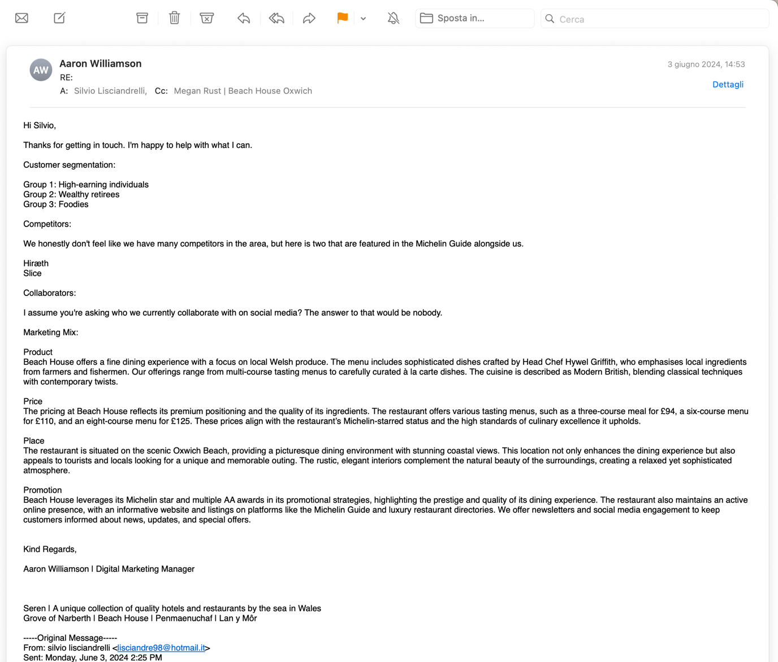

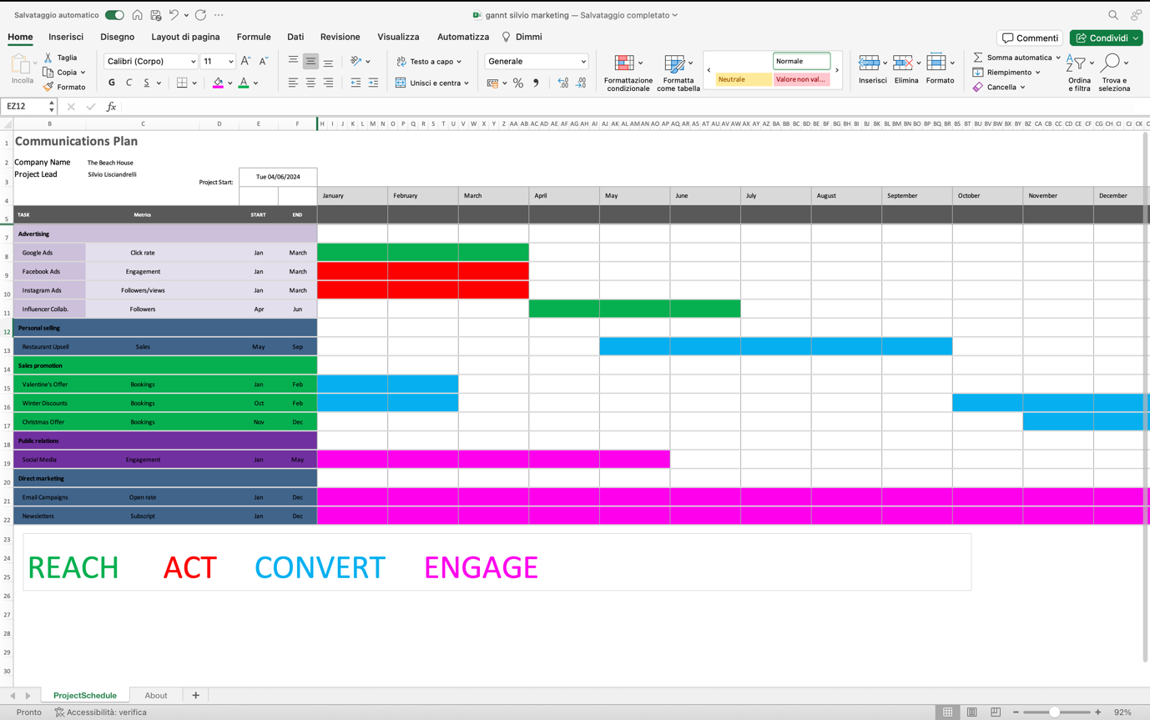

Reference list:

Alae-Carew , C.S., Green, R., Stewart, C., Cook, B., Dangour , A. and Scheelbeek, P. (2022). The Role of plant-based Alternative Foods in Sustainable and Healthy Food systems: Consumption Trends in the UK. [online] Uwtsd.ac.uk. Available at: https://www-sciencedirect-com.ezproxy.uwtsd.ac.uk/science/article/pii/S0048969721061192?via%3Dihub [Accessed 7 Jun. 2024].
Beach House. (n.d.). Our Menus. [online] Available at: https://beachhouseoxwich.co.uk/menus/ [Accessed 5 Jun. 2024].
Blankenship, W. (2023). Multi-Channel Marketing: A Beginner’s Guide (With Examples). [online] www.drip.com. Available at: https://www.drip.com/blog/multi-channel-marketing [Accessed 7 Jun. 2024].
Bloc for Business. (2022). Multichannel Marketing for Restaurants - Fill your Empty Seats. [online] Available at: https://business.getonbloc.com/multichannel-marketing-for-restaurants/ [Accessed 4 Jun. 2024].
Buccheri, R. (2024). Authenticity, healthy, British: hospitality food trends in 2024. [online] The Grocer. Available at: https://www.thegrocer.co.uk/consumer-trends/authenticity-healthy-british-hospitality-food-trends-in-2024/689628.article [Accessed 7 Jun. 2024].
Bush, T. (2019). PESTLE Analysis of the Food Industry. [online] PESTLE Analysis. Available at: https://pestleanalysis.com/pestle-analysis-of-the-food-industry/ [Accessed 26 May 2024].
Christou, L. (2017). Michelin star vegan restaurants, or the lack of them. [online] Verdict. Available at: https://www.verdict.co.uk/michelin-star-vegan-restaurants/ [Accessed 7 Jun. 2024].
Drake, C. (2022). Pros and Cons of Locally Sourced Ingredients. [online] Revel System Blog. Available at: https://blog.revelsystems.com/locally-sourced-ingredients [Accessed 4 Jun. 2024].
Food Standards Agency. (n.d.). Chapter 1: The nation’s plate, our diet and food choices today. [online] Available at: https://www.food.gov.uk/our-work/chapter-1-the-nations-plate-our-diet-and-food-choices-today#:~:text=Changing%20eating%20habits [Accessed 4 Jun. 2024].
Frue, K. (2019a). PESTLE Analysis - Business and SWOT Analysis. [online] PESTLE Analysis. Available at: https://pestleanalysis.com [Accessed 25 May 2024].
Frue, K. (2019b). PESTLE Analysis for Hotel Industry. [online] PESTLE Analysis. Available at: https://pestleanalysis.com/pestle-analysis-for-hotel-industry/ [Accessed 6 Jun. 2024].
Haan, S. (2023). CIPD | SWOT Analysis | Factsheets. [online] CIPD. Available at: https://www.cipd.org/en/knowledge/factsheets/swot-analysis-factsheet/ [Accessed 25 May 2024].
Hanlon, A. (2023). How to Use the 7Ps Marketing Mix? - Smart Insights. [online] Smart Insights. Available at: https://www.smartinsights.com/marketing-planning/marketing-models/how-to-use-the-7ps-marketing-mix/ [Accessed 4 Jun. 2024].
Headlam, R. (2021). Leveraging the power of personalisation in social media advertising – Spindogs. [online] www.spindogs.co.uk. Available at: https://www.spindogs.co.uk/blog/leveraging-the-power-of-personalisation-in-social-media-advertising/ [Accessed 7 Jun. 2024].
HowandWhat.net (2021). PESTEL analysis of the hospitality industry. [online] howandwhat. Available at: https://www.howandwhat.net/pestel-analysis-hospitality-industry/ [Accessed 7 Jun. 2024].
Indeed (2023). What is pestle analysis? Plus its factors and their uses. [online] Indeed Career Guide. Available at: https://uk.indeed.com/career-advice/career-development/pestle-analysis [Accessed 5 Jun. 2024].
Kindness, J. (2021). Social Media Marketing vs. Email Marketing: Comparing the Pros & Cons of Each Channel. [online] AgencyAnalytics. Available at: https://agencyanalytics.com/blog/social-media-vs-email-marketing [Accessed 6 Jun. 2024].
Lindley, S. (2023). How to structure an effective multichannel marketing plan | Smart Insights. [online] Smart Insights. Available at: https://www.smartinsights.com/online-brand-strategy/multichannel-strategies/structure-effective-multichannel-marketing-plan/ [Accessed 24 May 2024].
Linkedin (2024). Multi-Channel Personalization - An Effective Marketing Approach. [online] www.linkedin.com. Available at: https://www.linkedin.com/pulse/multi-channel-personalization-effective-marketing-approach-vspagy-uaalc/ [Accessed 5 Jun. 2024].
Locanda Locatelli (n.d.). Restaurant | Locanda Locatelli. [online] www.locandalocatelli.com. Available at: https://www.locandalocatelli.com/restaurant/#dining-room [Accessed 5 Jun. 2024].
Marketing Evolution (2022). What is Multi-Channel Marketing? | Marketing Evolution. [online] www.marketingevolution.com. Available at: https://www.marketingevolution.com/marketing-essentials/what-is-multi-channel-marketing [Accessed 24 May 2024].
Mehta, J. (2023). The impact of personalized social media marketing on your website traffic and conversions. [online] abmatic.ai. Available at: https://abmatic.ai/blog/impact-of-personalized-social-media-marketing-on-website-traffic-and-conversions?hs_amp=true [Accessed 7 Jun. 2024].
Montaguti, E., Neslin, S.A. and Valentini, S. (2016). Can Marketing Campaigns Induce Multichannel Buying and More Profitable Customers? [online] Uwtsd.ac.uk. Available at: https://web-p-ebscohost-com.ezproxy.uwtsd.ac.uk/ehost/pdfviewer/pdfviewer?vid=0&sid=558d8a27-dafb-40d3-9ad1-be415fc21b65%40redis [Accessed 5 Jun. 2024].
Murray, J. (2017). What is Multichannel Marketing? [online] Emarsys. Available at: https://emarsys.com/learn/blog/what-is-multichannel-marketing/ [Accessed 7 Jun. 2024].
Nation, P. (2024). 39 Multichannel Marketing Statistics To Explore (2024). [online] Persuasion Nation. Available at: https://persuasion-nation.com/multichannel-marketing-statistics/ [Accessed 5 Jun. 2024].
Pereira, J. (2023). How to Set SMART Social Media Goals for Your Business. [online] designstripe Blogs. Available at: https://designstripe.com/blog/smart-social-media-goals [Accessed 4 Jun. 2024].
Rangaswamy, A. and Van Bruggen, G.H. (2024). Redirecting. [online] login.microsoftonline.com. Available at: https://www.proquest.com/scholarly-journals/opportunities-challenges-multichannel-marketing/docview/229641059/se-2?accountid=130472 [Accessed 6 Jun. 2024].
SAS (2019). Multichannel marketing: What it is and why it matters. [online] Sas.com. Available at: https://www.sas.com/en_us/insights/marketing/multichannel-marketing.html [Accessed 25 May 2024].
Smith, A. (2024). Social media personalization: The opportunity and risks to consider. [online] Sprout Social. Available at: https://sproutsocial.com/insights/social-media-personalization/?amp [Accessed 7 Jun. 2024].
Statista (2023). Topic: Restaurants in the UK. [online] Statista. Available at: https://www.statista.com/topics/3131/restaurant-industry-in-the-united-kingdom-uk/#topicOverview [Accessed 7 Jun. 2024].
Sutarwala, U. (2023). Impact of Social Media Marketing on Businesses. [online] www.sprinklr.com. Available at: https://www.sprinklr.com/blog/social-media-business-marketing/#:~:text=Social%20media%20marketing%20provides%20an [Accessed 4 Jun. 2024].
Swansea Gov.uk (n.d.). Over £0.6bn a year - that’s how much tourism is now worth to Swansea. [online] Swansea. Available at: https://www.swansea.gov.uk/Tourism600 [Accessed 4 Jun. 2024].
White, J. (2023). Rising Costs: The Impact of Inflation on Restaurants. [online] Tenzo. Available at: https://www.gotenzo.com/resources/insight/rising-prices-the-impact-of-inflation-on-restaurants/#:~:text=Increasing%20Cost%20of%20Goods%20Sold [Accessed 4 Jun. 2024].
www.locandalocatelli.com. (n.d.). Menu | Locanda Locatelli. [online] Available at: https://www.locandalocatelli.com/menus/#antipasti [Accessed 6 Jun. 2024].

