Worksheet: Creating a Serverless Azure Function using SwDevOps
In this worksheet, you will automate the deployment of an Azure Function using GitHub Actions.
IMPORTANT: Where you see angle brackets < >, this represents a value that you must provide yourself. For example, <YOUR_RESOURCE_GP> requires you to enter an appropriate resource group name of your choice. Unless otherwise stated, these are the names that should be given to a resource or the name of an existing resource that you have already created.
Values not in brackets represent names of resources that you have already created or you should already know, so use the corresponding name for that resource. For example, YOUR_RESOURCE_GP means that you have already created a resource group and you should provide the name of this resource group here.

Only do this once……
If this if the first time you are using Azure, then setup your subscription details as the default so that you do not need to enter them whenever you wish to execute a command.
az account list -o table
az account set --subscription YOUR_SUBSCRIPTION_ID

Once you have set the default subscription, there is no need to repeat this process ever again!!

Resource Group
Before creating any resources, you must create a resource that can contain those resources. For student Azure accounts your location is “uksouth”. Choose an appropriate resource group name.
# create resource group
az group create --name <YOUR_RESOURCE_GP> --location YOUR_LOCATION

You can list resource groups:
# List all the resource groups
az group list -o table
az group list -o table --query "[?location=='ukwest'].name"

Create a Storage Account
The storage account is used to store important app data, sometimes including the application code itself. You should limit access from other apps and users to this storage account.
# Create General Purpose Storage
storageName=<YOUR_FUNC_STORE_NAME>$RANDOM

az storage account create --name $storageName --location YOUR_LOCATION --resource-group YOUR_RESOURCE_GP --sku Standard_LRS --allow-blob-public-access false

Create an Azure Function
The <APP_NAME> is also the default DNS domain for the function app. The command also creates an associated Azure Application Insights instance in the same resource group, with which you can monitor your function app and view logs.
# Create an Azure Function
funcappName=<YOUR_FUNC_NAME>$RANDOM
echo $funcappName
Displays the function name ending with a random number. Let’s say YOUR_FUNC_NAME=”myfirstfuncapp” then the functions name would be myfirstfuncapp13308 assuming the random number was 13308.

az functionapp create --resource-group YOUR_RESOURCE_GP --consumption-plan-location YOUR_LOCATION --runtime dotnet-isolated --functions-version 4 --name $funcappName --storage-account $storageName

# List the functions to get the name of your function including the random number appended to it, you should get something like myfirstfuncapp13308
az functionapp list --resource-group YOUR_RESOURCE_GP --query [].name -o tsv

Clone the Sample Function Code from GitHub

Fork and Clone the Existing GitHub Repository
A UWTSDStudents/LocalFunctionProj repository is required for this exercise.
Login to GitHub and fork your own version of this repository.
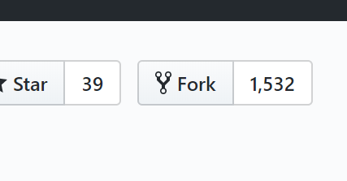
Read the URL of your forked repository so that you can clone it. 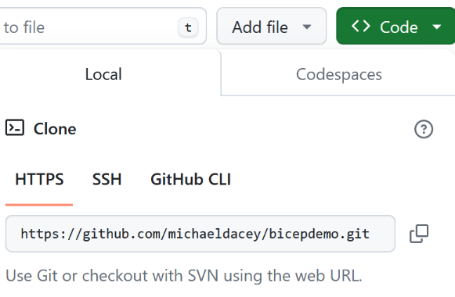
https://github.com/michaeldacey/LocalFunctionProj.git

Clone the code and change the workflow file so that the Workflow deploys to your specific Azure function.
# Clone the sample function app from the GitHub repository
C:> git clone https://github.com/UWTSDStudents/LocalFunctionProj.git
C:> cd LocalFunctionProj

# Edit the function app name in the environment variables of the workflow file
C:> code .github/workflows/workflow.yml

# Push the change to the GitHub repository
C:> git add .github
C:> git commit -m"Change function name"
C:> git push -u origin main

Edit the .github/workflows/workflow.yml file as shown:
name: Deploy DotNet project to Azure Function App
on:
[push]
# CONFIGURATION
# For help, go to https://github.com/Azure/Actions
#
# 1. Set up the following secrets in your repository:
# AZURE_CLIENT_ID
# AZURE_TENANT_ID
# AZURE_SUBSCRIPTION_ID
#
# 2. Change these variables for your configuration:
env:
AZURE_FUNCTIONAPP_NAME: ‘YOUR_FUNC_NAME13308'
AZURE_FUNCTIONAPP_PACKAGE_PATH: ‘.’
DOTNET_VERSION: '8.0.x'
jobs:
build-and-deploy:
…..CONTINUES……

Configure Workflow Identity Federation
We want to authenticate the application (GitHub) to allow it to access the Azure Function we just created, so that it can deploy newly built applications to it automatically. This gives it access, but we will still need to decide what the application will be allowed to do (permissions) with the Azure Function.
# Create the Application object
appId=$(az ad app create --display-name DemoApp --sign-in-audience AzureADMyOrg --query appId -o tsv)

# Create a service principal and assign it to the Application Object.
spId=$(az ad sp create --id $appId --query id --output tsv)

# Configure Workflow Identity Federation to enable the workflow to access
# the Azure Function app
# Create a params.json file to provide the federated credentials
cat <<EOF > params.json
{
"name": "DemoDeployment",
"issuer": "https://token.actions.githubusercontent.com",
"subject": "repo:UWTSDStudents/LocalFunctionProj:ref:refs/heads/main",
"audiences": [
"api://AzureADTokenExchange"
]
}
EOF
az ad app federated-credential create --id $appId --parameters params.json

Set the GitHub Secrets
In GitHub, assign the client Id, subscription Id and tenant Id to the GitHub secrets AZURE_CLIENT_ID, AZURE_SUBSCRIPTION_ID and AZURE_TENANT_ID respectively.
# Get the application (client) ID
echo $appId
# Get the subscription ID
az account list --query "[?isDefault].id | [0]" --output tsv
# Get the tenant ID
az account list --query "[?isDefault].tenantId | [0]" --output tsv

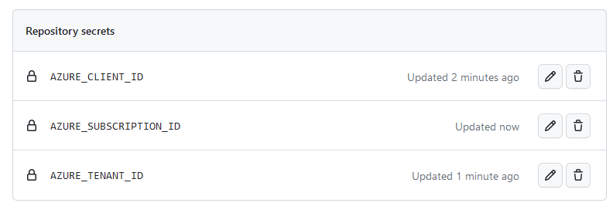

Give GitHub the Permissions
We have to give the service principal the “Website Contributor” role, to grant the permissions required to use the Azure Function we created.
Remember, this service principal is already associated with the Application object. Hence, we are saying that the role grants the Application the authority (certain rights) to perform actions on the Azure Function, where GitHub happens to be the external application in this case.
# Get the id of the Azure Function
funcId=$(az functionapp show --resource-group myfirst-azfunction-rg --name $funcappName --query id -o tsv)

az role assignment create --assignee $spId --role "Website Contributor" --scope $funcId

Browse the Function App
The URL of the function app would have been displayed when you published the function in the step above. However, you can also display it Azure using:
# Display the URL for the function
az functionapp function show --resource-group YOUR_RESOURCE_GP --name YOUR_FUNC_NAME13308 --function-name HttpExample --query "invokeUrlTemplate" --output tsv

The result should look something like this:
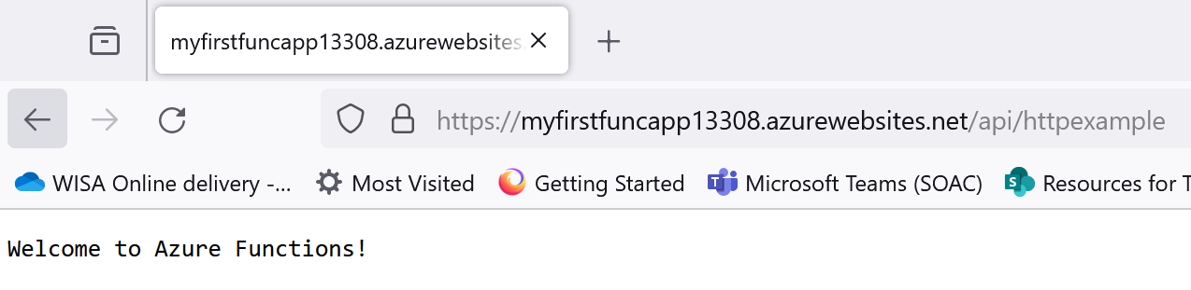

FINISH: Delete Everything
The easy way to stop and delete everything we have created is to just delete the resource group that contains all these resources.
# Clean up
az group delete --name YOUR_RESOURCE_GP --yes

