

BA BUSINESS MANAGEMENT
ENTERPRENEUERSHIP
LCBB5001
Table of contents

1.Introduction 3
2. Business description 3
3. Industry Analysis 4
4. Operational management team 6
5. Marketing plan and strategy 8
6. Financial Plan 11
7. Closing summary 13
8. References 14

1.Introduction
The purpose of the report is to discuss a new business plan in which a brand new product will be introduced. Decription, mission, vission, legal structure, and STP of the compnay will be described. In the next section, industry analysis will be described and operaional management team will be introduced. Marketing plan and strategy along with financial plan will also be presented.

2. Business description
Product Description
Snacky will be an innovative product made from the seeds of ripe jackfruits and will be a fried snack item. The snack will be available in different tastes such as sweet, salty, spicy and in a mixed version. This snack will help people decrease the threat of heart disease, promote weight loss, and prevent constipation. The product's name will be Snacky.
Vision
To provide shape to the future of unusual good snacks for the people of the United Kingdom and also to become the best ever and healthy snack supplier company in the UK and all over the world.
Mission
The mission of this company is to provide healthy and unique kinds of snack items that will not only fulfil the craving for snacks of health-conscious people but also will reduce health risks. To ease the lives and minds of the customers in the UK with safe, delicious, simple, and nutritious snacks.
Logo
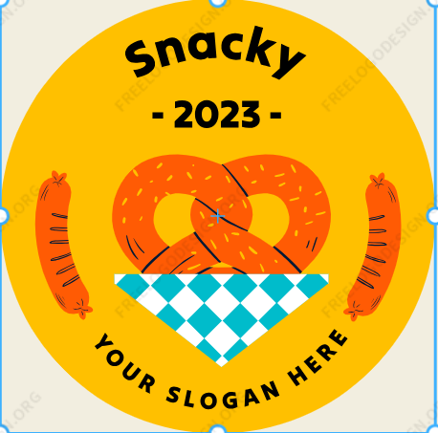
Figure 1: Logo of Snacky
(Source: Self-created)
USP
After the COVID-19 pandemic, people needed to take more care of themselves and they must avoid junk oily snacks that might make them sick. This unique product has its own uniqueness such as it can be fried in the air fryer or can be grilled in the oven. It is full of B-complex vitamins and dietary fibres which will help people to prevent heart disease, and also contains resistant starch, that manages the sugar level of blood (Memon et al. 2019).
Need of the product
After the pandemic people have understood that they need to keep themselves healthy for the future if they want to fight any kind of situation like the Covid-19 pandemic. That is why this kind of product is needed in the snack market of the UK which is healthy and tasty too and can fulfil the craving of snack-loving people.
STP
People of any gender, age and family status are the target customers for these snack products. People doing normal jobs can buy these products. People in London, Birmingham, Wales, Cambridge, and many more areas can have the snacks. People who are conscious of health and also have the desire to eat healthy snacks will be the targeted customers.
The targeted customers of this company are from different age groups and the company will provide high-quality products at reasonable prices to the customer and will generate profits too.
In the beginning, the company will operate under the budget category and will offer extra benefits to the customers at a lower cost than the other competitors.
Legal structure
This company will start its operation as a private limited company because it has limited legal responsibilities which will safeguard the owner and shareholders also. If it starts its operation as a private limited, it will be able to allow any person to introduce other kinds of innovative food ranges under the name of the company.

3. Industry Analysis
VRIO analysis
Resources | Valuable | Rare | Inimitable | Organised
Skilled employees | ✓ | ✓ | ✓ | ✓
Innovation | ✓ | X | X | ✓
Suppliers | ✓ | X | X | ✓
Financial capabilities | ✓ | X | ✓ | ✓
Skilled employees - They are valuable as without skilled employees any business can not operate and these employees are rare also. Skilled employees are inimitable and are organised and serious about taking their organisation to the highest peak in the market. Hiring skilled workers is quite a difficult task for the HR department of a company (Bilan et al. 2020).
Innovation - This is also valuable but not rare as businesses are doing more innovation nowadays. This can be imitated by any other company but can be handled properly.
Suppliers - Suppliers are also valuable but not rare and can be imitated as there are a lot of suppliers in the world. Suppliers can also be organised by building good relationships with them.
Financial capabilities - This is one of the most significant resources as without funding no business can run but it is not rare. Finances can not be intimidated and can be organised if used properly. Financial resources can provide confidence and motivation to develop a company (Kezar and Yang, 2010).
Competitive analysis
 | Snacky | Birds eye | Brown bag crisps
Product | Snacky will provide unique chips and snacks made of jackfruit seeds. | Frozen items such as fish, chicken, seafood, and vegetables (Birds Eye, 2023). | This company provides cris items also (Brown Bag Crisps, 2023).
Price | The price of the products of Snacky will start from 6 British pounds. | The products from Birds Eye mostly start from 8.77 British pounds (Amazon, 2023). | The products of this company mostly start from 9 British pounds (Brown Bag Crisps, 2023).
Social media presence | Snacky also has introduced its own website and already is promoting its products on different social media platforms. | This company has its own website and products are also available on other third party platforms. | This also has its own website and also has a Facebook and Twitter account to promote its products.
Sustainability | The company will also be careful with its packaging and will try to introduce more innovative and healthy snacks. | It sells a huge range of frozen food which means it uses a lot of energy (Birds Eye, 2023). | The company's packaging is unique as it sells its products packed in brown covers (Brown Bag Crisps, 2023).

SWOT analysis
Strengths - The products of this company are totally new products as crisps from jackfruit seeds are not available in any other company in the UK. Moreover, the snacks are vegan and healthy.
Weaknesses - This is a new company and the taste of jackfruit seeds is not known to many people in the UK. The company does not know if the snacks will be welcomed by the UK people or not as it will be a unique kind of taste for them.
Opportunities - The people of the UK have become more health conscious and they do not want to be obese but still demand snack items which will raise the demand for the products of Snacky.
Threats - There are many big companies who also provide healthy stuff such as snacks and all in the UK. So, Snacky will face huge competition in the UK snacks market as it is a newly launched enterprise.

4. Operational management team
Description of operation
The process of making these snacks included some steps such as washing the seeds, cutting them into thin slices drying the slices and putting different types of seasoning on them before packing them. The seeds will be imported from the countries in which jackfruits are available the most. For this crips-making process, the company will need automatic machines to wash the seeds properly cutting machines also to make thin slices and dryer machines to dry them. Different machines will be needed to make different kinds of seasonings and packaging machines will also be needed for packing. Through air or water, the main ingredient will be imported and will be reached to the factory through road vehicles. These snacks will be available in UK supermarkets and also will be available in online shopping platforms.
How to generate revenue
To generate revenue from this business the owner must try to generate new ideas of unique types of products which are still not introduced by any other company. The company needs to sell items at a medium price. The number of consumers needs to be increased and for this, the company needs to promote itself through different ways. The effectiveness, taste, and healthiness of the products need to be increased (Outrise, 2023).
How to prevent loss
From the beginning, the company needs to have a proper plan and arrange its business appropriately. The company needs to make sure that the suppliers are providing top-class materials which are needed for this business. Food safety must be examined before sending the items to the market (Tsvetkov, 2022).
Management team
Position | Qualification | Role | Contribution
Micheal Henry (CEO) | Graduate in Business | CEO who will manage the entire operation of the company Snacky. | In the company Snacky, the CEO will be responsible for the expansion of the organisation, and increasing profitability.
Maisie Roberts (Operation manager) | BBA | She will manage each activity which is connected with everyday retail floor functions. | In this company, an operation manager will control all the activities which are included in the process of making the products.
Oliver Johnson (Marketing Manager) | MBA | He will make marketing campaigns and programs and will provide reports on the metrics of marketing. | In this company, the marketing manager will oversee and plan for different kinds of activities such as advertising, events, email campaigns, and social media.
Arthur Willow (HR manager) | Master's degree in human resources. | The HR manager will be the leader of the daily function and will also provide direction to other staff. | In this company, the HR manager will interview and hire employees and will take care of benefits, pay, and leave for the staff.

5. Marketing plan and strategy
Marketing mix 4Ps
Product - The company will provide healthy and vegan products to the customers. The products are different types of crisps that will be made from the seeds of jackfruits. All the crisps will be fried in the air fryer and can be grilled in the oven too.
Price – market penetration ststargy will be followed by Snacky as the company will gradully increase the price of the products (Konger and Jones, 2023). The prices of all the snack items will be available at medium prices which can be purchased by its targeted customers. The price range can be increased if different kinds of seasoning are added to the crisps.
Promotion – Nowadys, social media is the best promotional way to keep in touch with future customers (Sajid, 2016). The company will promote its products through different types of social media platforms. It will also distribute brochures and provide advertisements on the television, and radio. Through different online applications, it will promote its products.
Place - In London City and also in Wales, Birmingham, and Cambridge, the company will distribute its products through different supermarkets, licences, small convenience stores, etc. The products will also be available through its own online website and other e-commerce platforms.
Perceptual map
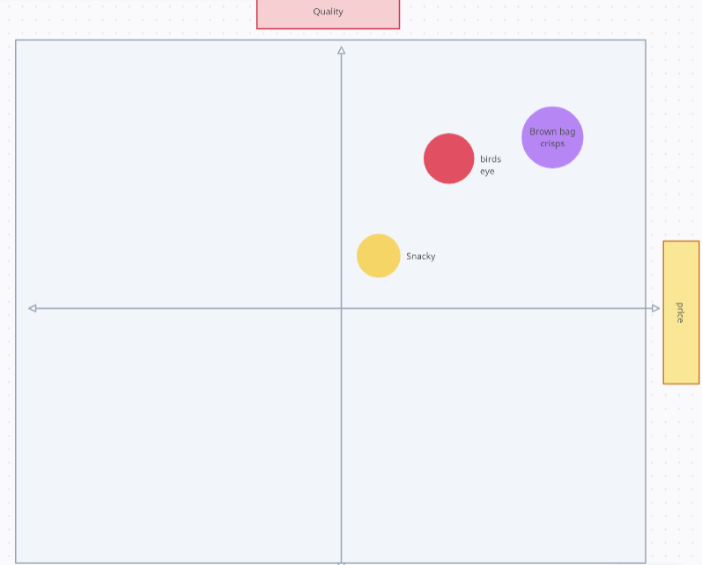
Figure 2: Perceptual map
(Source: Self-created)
Market entry and sales process
The market entry process of this company will be a joint venture. The company will become a partner with the companies to attain the goal of becoming number one in the snack market of the UK. Joint ventures are kinds of arrangements that happen between two companies or more than 2 parties. Joint venture members merge resources to fulfil a common action (Indeed, 2022).
The company will go with a joint venture as though it will be able to enter different markets and product distribution networks. The owner of the company will be able to share costs and risks with the partner. The owner will be able to get new expertise and knowledge and also will be able to get great resources for the company (Nibusinessinfo, 2023).
The process of sales is a set of essential steps that a sales team needs to follow to fulfil a sales cycle. There are seven steps in the process of sales such as prospecting in which Snacky will identify its potential consumers and determine their needs. The 2nd step is preparation in which the company will prepare to get connected with potential consumers. Next, the company will approach its customers with its new products. The use and needs of the products will be presented and the objection that will come in the way of sales will be eliminated. Discounts will be offered and the last step will allow the company to keep in touch with its existing customers (Lucidchart, 2020).

6. Financial Plan
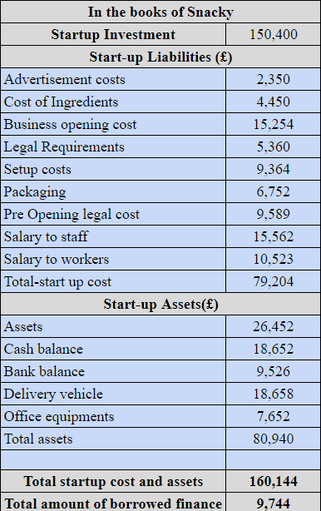
Figure 3: Start-up Cost of Snacky
(Sources: Self-Developed, 2023).
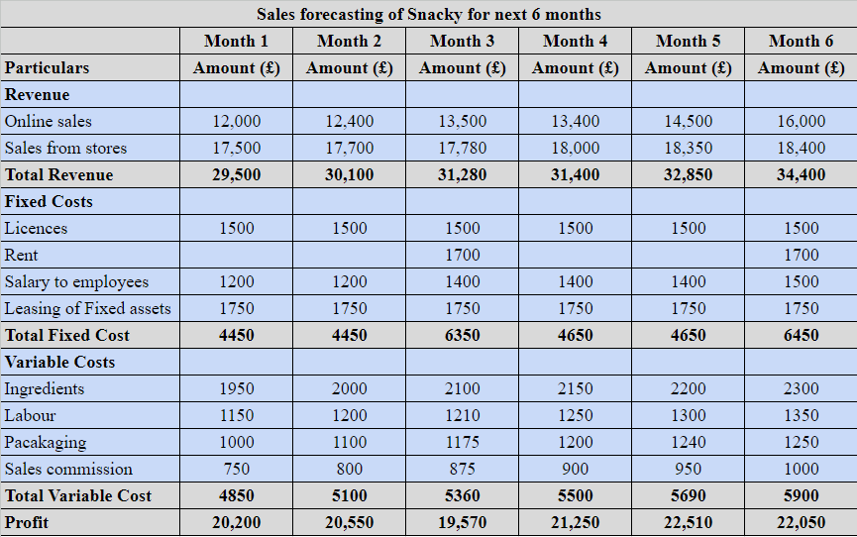
Figure 4: 6-month sales forecast of Snacky
(Sources: Self-Developed, 2023).
Equity finance: Equity finance refers to the money which helps in buying the ownership in the company. This is considered to be the basic equity financing. Snacky Limited are in need of £ 9,744 of which £ 4,000 can be raised by the company through equity finance which is required to sell the ownership of the business worth £ 4,000 (Leonard, 2019).
Debt finance: This type of financing refers to the borrowing of money. In this, the company can avail the loan through a credit union. In this, the risk for the loans is high due to business failure. Through this Snacky Limited can avail of a loan of £ 3,000. This loan requires the business owner's personal backing in some assets that are required to be put on the mortgage as a guarantee (Leonard, 2019).
Bank loan: A Bank loan refers to the amount being taken on credit from a financial institution like a bank. This is the frequently used finance for the start-up business. This type of financing is the easiest and the straightforward way to meet funding needs. So the remaining amount of £ 2,744 can be raised through the bank loan by Snacky Limited (ACCAglobal, 2023).

7. Closing summary
The report concludes with the discussion of a new snack company named Snacky which is going to introduce a range of healthy and vegan snacks which will be beneficial for the health-conscious people of the UK. The mission vision statement and USP of the product are described with the legal structure of the company. In the next section, VRIO analysis, competitive analysis, and SWOT analysis have been done by the researcher. The description of the process of making the products, the ways of generating revenue and preventing loss, and the management team of the company have been briefly described. After all these, the 4Ps of marketing mix, a perceptual map, and the process of market entry and sales have been defined. At last, a financial plan for the company has been introduced and defined briefly.

8. References
ACCAglobal (2023) Bank loans, ACCA. Available at: https://www.accaglobal.com/gb/en/business-finance/types-finance/loans.html (Accessed: 20 November 2023).
Amazon (2023) 1-48 of 89 results for ‘Birds+Eye’ sort by: Featured price: Low to high price: High to low avg. customer review newest arrivals sort by:featured go, Amazon.co.uk : birds+eye. Available at: https://www.amazon.co.uk/birds-eye/s?k=birds%2Beye (Accessed: 20 November 2023).
Bilan, Y., Mishchuk, H., Roshchyk, I. and Joshi, O., (2020). Hiring and retaining skilled employees in SMEs: problems in human resource practices and links with organizational success. Business: Theory and Practice, 21(2), pp.780-791. https://www.ceeol.com/search/article-detail?id=950999
Birds Eye (2023) Welcome to the Birds Eye Homepage, Birds Eye UK. Available at: https://www.birdseye.co.uk/ (Accessed: 20 November 2023).
Brown Bag Crisps (2023) Brown Bag Crisps. Available at: https://www.premiumsnacks.co.uk/brown-bag-crisps-66-c.asp (Accessed: 20 November 2023).
Brown Bag Crisps (2023) Welcome to brown bag crisps, Brown Bag Crisps. Available at: https://brownbagcrisps.co.uk/ (Accessed: 20 November 2023).
Indeed (2022) What is a joint venture? an in-depth guide to how they work. Available at: https://uk.indeed.com/career-advice/career-development/what-is-joint-venture (Accessed: 20 November 2023).
Kezar, A. and Yang, H., (2010). The importance of financial literacy. About Campus, 14(6), pp.15-21. https://journals.sagepub.com/doi/abs/10.1002/abc.20004?journalCode=acaa
Konger and Jones, C. (2023) What are the 4 pricing strategies everyone should know about?: CJ&CO, CJ&COTM. Available at: https://www.cjco.com.au/article/what-are-the-4-pricing-strategies/#google_vignette (Accessed: 20 November 2023).
Leonard, K. (2019) Types of Business Finance, Small Business - Chron.com. Available at: https://smallbusiness.chron.com/types-business-finance-43183.html (Accessed: 20 November 2023).
Lucidchart (2020) 7-step sales process: When to use it and when to break it, Lucidchart. Available at: https://www.lucidchart.com/what-is-the-7-step-sales-process (Accessed: 20 November 2023).
Memon, N. et al. (2019) Jackfruit seed: An accompaniment to functional foods, Brazilian Journal of Food Technology. Available at: https://www.scielo.br/j/bjft/a/5yY7zY6RXVSQQFgnPyKtTqj/#:~:text=The%20seeds%20are%20rich%20in,and%20keeps%20the%20gut%20healthy. (Accessed: 20 November 2023).
Nibusinessinfo (2023) Joint Ventures and business partnerships, Joint venture advantages and disadvantages. Available at: https://www.nibusinessinfo.co.uk/content/joint-venture-advantages-and-disadvantages (Accessed: 20 November 2023).
Outrise (2023) Increase profit: 5 ways to increase profit for your business, Outrise. Available at: https://outrise.co.uk/ways-to-increase-business-profits/ (Accessed: 20 November 2023).
Sajid, S.I., (2016). Social media and its role in marketing.http://41.89.240.73/handle/123456789/810
Tsvetkov, T. (2022) 10 ways to prevent loss in your restaurant - glimpse , Glimpse Corp. Available at: https://www.glimpsecorp.com/efficient-loss-prevention-practices/ (Accessed: 20 November 2023).

