

Baciu Severina 2022009
Global Business Environment
LCBB4005_BIRM
Tutor: Dr. Eric Osei
Individual project report

Table of Contents
Introduction 3
PESTEL 3
P- POLITICAL FACTORS 3
E- Economic factors 4
S-Social factors 5
T-TECHNOLOGICAL FACTOR 6
E-ENVIRONMENTAL FACTORS 6
L- LEGAL ASPECTS OF BUSSINES 8
Conclusion: 9
References 9
Appendixes 12

Introduction
The company selected for this assignment is Wizz Air Holdings Plc. The company has the headquarters in Budapest, Hungary. The CEO is Jozsef Varadi, former CEO of Malev Hungarian Airlines. This business operates as airline services provider. The company is listed on London Stock Exchange and is included in FTSE 250 INDEX. Their Travel & Leisure service has a market of over 20 countries and the business itself is exposed to political, environment, social and other risks. As example, early 2020 COVID-19 shutdowns over all Europe forced their business to reduce staff and referring to Appendix A, lose money “underlying net loss over £400 million” (Air, 2021)
Wizz Air Holdings Plc is a competitive business and the micro- environment factors gives the company an advantage against competitors.
From the assignment requirements, the PESTEL analysis for Wizz Air company has been chosen as the best way to describe and analyse the global business environment.
Other than competitive factors, PESTEL research gives considerable insight regarding the operating problems Wizz Air Holdings Plc will encounter in the current macroeconomic context.

PESTEL
PESTEL is an instrument “for analysing and monitoring macro-environmental elements that can have a significant influence on an organization's success” (Business-to-you, 2016). This tool is very beneficial when launching an innovative firm or move into an external marketplace.
“PESTEL stands for Political, Economic, Social, Technological, Environmental, and Legal aspects influencing Wizz Air Holdings Plc's macroenvironment”. (Fern Fort University, 2019) (Appendix B)

P- POLITICAL FACTORS
These factors represent the governments implication in the economy in general and intervention in some industries in particular. When assessing the potential business in a foreign country, Wizz Air Holdings is analysing potential political risks for the Group. A new market for the travel industry includes a fear of loosing money that is why the key points in assessing risks are:
- The possibility of a military aggression or terrorists attacks – as example, recent war situation in Israel, resulted in cancelation of dozens of flights due concerns from (EASA) the European Union's aviation safety agency “The situation in the region continues to be a major cause of concern for commercial aviation” on Wednesday 12 May, it issued a warning to airline companies. (Alarabyia, 2021)
- Government bureaucracy and involvement in the travel and leisure industry – a recent case in Vienna Airport, Austria, costed Wizz Air company around £3500 for a lawsuit from a family of three because “Wizz Air refused to check them in” (aviation.direct, 2021) all of this because Greek Health Authority allowed minors to be registered on a parent Covid-19 form, but Wizz Air required for all travellers individually, that’s how bureaucracy ruined a holiday in Greece for that family.
- Product labelling and other standards in the Travel and Leisure sector – being an international company the standards must be followed strictly according to respective national Foreign Ministries. Wizz Air’s policy is strictly and according to Wizz air’s webpage “Certain locations may require special paperwork to be completed online or in printable format before to travel - keep an eye out for messages from us and confirm with local authorities if relevant for your trip ahead of time!” (wizz.air, n.d.)
That being unfollowed, the Company may refuse the traveller to check in and miss fly.
Being listed on London Stocks Exchange, Wizz Air Holdings Plc policy is “to comply with current best practise in UK corporate governance to the level appropriate for a company of its size” (annual report, 2021). The Company’s success is directly corelated with political stability across all Europe and South America states.

E- Economic factors
“The aggregate demand and aggregate investment in an economy are determined by macroenvironmental factors such as the inflation rate, savings rate, interest rate, foreign exchange rate, and economic cycle” (Fern Fort University, 2019). Microenvironmental factors such as competition norms have an impact on a company's competitive edge.
Wizz Air Holdings Plc has examined the resulting economic aspects when did PESTEL analysis:
- The country’s economic profile – for Wizz Air company, the growing economy of a country offer huge growth potential for airline company itself rather than mature countries where the airline business is in saturation. For example, the country of Moldova is a rapid Eastern Europe growth country where Wizz Air company has added new airline routes and new direct jobs with Wizz Air. In 2019 they released their plans in a statement “WIZZ's rapidly expanding presence in the country will boost the local economy by generating employment in Moldova's aviation and tourist industries.” (wizzair.com, 2019).
- Inflation, employment, interest rates, and currency exchange rates- for the 2016 financial year Wizz Air expected “The Group's earnings for the year is now expected to grow significantly to between €165 million and €175 million.” (Wizzannual, 2015), (Appendix C). But in fact, they made 193 million (Appendix D) due favourable market conditions of 2016, for example interest rates for 2016 in average were 3.65% which indicates a strong worldwide economy while for 2020 interest rates were 0.1% which indicates an unstainable economy and a loss of £482 million, (Appendix A, E)
- The effectiveness of financial markets - financial consumer choice influences global expansion plans because operating in highly efficient financial markets results in higher liquidity and the ability to enter new markets. The strength and financial system of the nations in which Wizz Air Holdings Plc operates will determine its ability to get money at reasonable rates.
- Economic stability – Analysing early 2020 market collapse (more than 20%) globally due coronavirus pandemic, the economic stability became a key factor for entering a new market. “Wizz Air was flying at 80% of its capacity from the previous year, substantially exceeding the sector. Wizz Air added three more stations to the eleven it had established in the previous two months, allowing the launch of several new routes” (wizzannual, 2020) this statement from 2020 annual report for month of august 2020 allows demonstration of well-handled situation during economic instability with most European countries shut for lockdown.

S-Social factors
Because of the complexity of worldwide company, difficulties with adaptability to diverse markets might arise. Wizz Air must consider not just the many cultural features of the EU's many diverse countries, but also the various religious values on connections to the Middle East, where religious beliefs vary enormously from those of Europe. Changes in the external environment's demographics will likewise have an impact on the particular company. These modifications might take the form of “population increase, migration patterns, and age distribution” (Needham, Dransfield and Unwin, 1996)
“While the numbers reflect a favourable overall picture of each fiscal year, WizzAir's real profitability are heavily reliant on the summer months” (CAPA - Centre for Aviation, 2017). The buying power of money influences consumer spending habits. It is critical to assess customers' preferences and spending patterns by studying and anticipating their purchasing power based on key economic data.

T-TECHNOLOGICAL FACTOR
The fast progress and spread of technology throughout the world have raised the necessity of comprehending technical variables during the strategic decision-making process.
The following technical variables may have an impact on Wizz Air Holdings Plc's business performance:
- Technological advancements and levels of development – “The ambitious development plan of the Hungarian low-cost airline, along with its large amount of cash in reserve, has produced a high degree of trust among investors. The airline is certainly well-positioned to meet the difficulties posed by Covid-19 in 2021.” (www.aerospace-technology.com, 2021). Wizz Air has placed an order with Airbus for “110 new technology A321neo aircraft equipped with sophisticated systems and engines, which will further decrease the company's industry-leading cost base as well as its carbon footprint. Sharklet wingtip devices are standard on all new deliveries”. (www.routesonline.com, 2021)
- Marketing on social media – With the improvement of communication technology and information, the Group proceeded in the process of implementations such as different advertising strategies to develop customer cooperation. In today's corporate world, the use of social media is commonplace. Wizz Air Holdings Plc is maximizing the benefits of social media marketing to improve corporate performance.
- Technology cycle of life - Technological innovations are being developed at a rapid pace, and supply chain partners have gained greater importance. For example, Wizz Air fleet has been operating with “Airbus fleet of a single type from the A320 family, includes A320s and one A321ceo”. (www.routesonline.com, 2021) from 2013 until present and now they are exchanging their old planes for newer, most sophisticated aircrafts.

E-ENVIRONMENTAL FACTORS
Because of rising environment protection related greenhouse gas emissions, ‘environmental risk assessment' has become an essential component of PESTEL analysis. Distinct markets have different environmental norms, rules, and regulations. Wizz Air Holdings Plc international's expansion necessitates careful consideration of these distinctions in order to prevent negative consequences.

Wizz Air Holdings Plc is influenced by environmental variables as next:
- Environmental rules which are in place to protect natural resources-overconsumption of fuels, electricity, water etc. might be disadvantageous for any business as it raises concerns from society and countries also in amount of cash burnt to sustain image of sustainable company. For this society made rules and laws like EMB. The mission of EMB is to “restore, protect, and improve environmental quality in order to promote environmental integrity, economic viability and good public health”. (Emb.gov.ph, 2016)
The EMB mandate is stating 6 important environmental laws:
- Environmental Impact Assessment Law (PD 1586)
- Toxic Substances and Hazardous Waste Management Act (RA6969)
- Clean Air Act Of 1999 (RA 8749)
- Ecological Solid Waste Management Act (RA 9003)
- Clean Water Act (RA 9275)
- Environmental Awareness and Education Act Of 2009 (RA9512)
- Preferences toward environmentally friendly items – Wizz Air is doing its part in what is called sustainable aero-mobility “We will further enhance our operating metrics and decrease our environmental impact with the aid of a variety of fuel-saving measures, including a totally paperless flight deck and our continually updated fleet, in order to make air travel a truly green means of transportation. Our environmental initiatives include a carbon offset programme and a single-use plastic-free cabin.” (wizzair.com, 2021) (Appendix F, Appendix G).
- Carbon Emissions – this is a drastic concern globally as “The G20 countries are responsible for around 80% of global greenhouse gas emissions and 85% of world GDP”. (germanwatch.org, 2018) and Wizz Air Group is well ahead competition in engaging to reduce maximally possible CO2 emissions by their operations “We seek to stay ahead of the industry by operating one of Europe's youngest fleets and emitting the fewest CO2 emissions”. (wizzair.com, 2021) Appendix G.
Wizz Air is to have Europe's lowest Co2 emissions (G/RPK).” We pledge to decreasing CO2 emissions by 25% by 2030 compared to 2019 levels, as well as minimising other GHG emissions. The ambitious strategy is fuelled by our cutting-edge fleet, fuel-saving measures, and the use of sustainable aviation fuel.” (wizzair.com, 2021)
- Weather, climatic conditions, and other environment related variables – the Company’s operations are impacted by these conditions as sometimes flights may be delayed or cancelled and that is impacting in a negative way company’s net profit and sometimes it may result in filled lawsuits which can put the Group in a negative image (Appendix H)

L- LEGAL ASPECTS OF BUSSINES
No company can join a new market without methodically investigating the brand-new customer market's legal environment and regulatory background. To prevent going into significant legal issues, a comprehensive examination of legal factors is necessary. Ignorance in this regard can result in unfavourable outcomes for Wizz Air Holdings Plc., such as a loss of competitive advantage as a result of violation on intellectual property rights and a tarnished organisational image as a result of violations of client protection standards.
Considering legal factors Wizz Air Group is researching next variables:
- Laws governing employee protection, discrimination, and health and safety- that is simple all employers must protect their employees. Wizz Air has a reputation of a good company to work for, but sometimes as an employer they take unreasonable solutions. As a result of the latest lawsuit from Romania resulted in reinstalment back to work, there are four pilots and ten members of the crew cabin. “Wizz Air kicked them out a year ago, blaming the COVID-19 situation as the cause. Following complaints filed by ETF affiliate FPU Romania, the courts have now determined that the airline abused local labour rules and must restore the employees”. (ETF: European Transport Workers’ Federation, 2021)
- Data protection law - Because of customers' privacy and security concerns, data protection has become an essential problem. Wizz Air’s terms and conditions has a legal basis to process any personal data and disclose it to local authorities. “We may use third-party data processors to provide services to us, and courts, government bodies, or other authorities may require us to disclose your data to them. We may also transfer your personal data outside the EU/EEA or, in the case of personal data originating in the UK, outside the UK, using appropriate safeguards”. (wizzair.com, 2021) agreeing with legal terms and condition protects the society and the consumer from fraud or other illegal activities.
- Laws regulating intellectual property - Patents and valuable ideas are meant to be protected by intellectual property laws. Failure to protect intellectual property rights could result in a loss of competitive advantage, putting Wizz Air's market position at risk.

Conclusion:
The Pestel analysis is a useful business tool that provides a comprehensive study of macro-environmental elements that impact the company environment. Starting with political component to legal considerations, all component has a variety of elements that influence the strategic decision-making process of businesses such as Wizz Air Holdings Plc. According to this research the Wizz Air company is placing itself as low-cost, affordable, environmentally friendly, and most important is striving to enter new markets. Before making a move in that new market the experts are examining all the variables described in the report itself and that is how they become a name in the saturated European airline niche.

References
Air, W. (2021). WIZZ AIR AT A GLANCE. [online]. Available at: https://wizzair.com/static/docs/default-source/downloadable-documents/corporate-website-transfer-documents/annual-reports/wizz-air-holdings-plc-annual-report-and-accounts-2020_v3_fd38d396.pdf [Accessed 17 Jun. 2021].
Alarabyia (2021). Wizz Air joins other airlines canceling Tel Aviv flights following rising conflict. [online] Al Arabiya English. Available at: https://english.alarabiya.net/News/middle-east/2021/05/14/Wizz-Air-joins-other-airlines-cancelling-Tel-Aviv-flights-following-rising-conflict [Accessed 18 Jun. 2021].
Business-to-you (2016). PESTEL Analysis (PEST Analysis) EXPLAINED with EXAMPLES | B2U. [online] B2U - Business-to-you.com. Available at: https://www.business-to-you.com/scanning-the-environment-pestel-analysis/ [Accessed 17 Jun. 2021].
CAPA - Centre for Aviation. (2017). Wizz Air SWOT: ultra-low costs drive high growth and margins, in spite of Ryanair competition. [online] Available at: http://centreforaviation.com/analysis/wizz-air-swot-ultra-low-costs-drive-high-growth-and-margins-in-spite-of-ryanair-competition-251605 [Accessed 18 Jun. 2021].
Direct (2021). Home. [online] Aviation.Direct. Available at: https://aviation.direct/en [Accessed 18 Jun. 2021].
Emb.gov.ph. (2016). Citizen’s Charter | Environmental Management Bureau. [online] Available at: https://emb.gov.ph/citizens-charter/ [Accessed 18 Jun. 2021].
ETF: European Transport Workers’ Federation. (2021). Romanian court system forces Wizz Air to give back jobs to fired pilots and cabin crew. [online] Available at: https://www.etf-europe.org/romanian-court-system-forces-wizz-air-to-give-back-jobs-to-fired-pilots-and-cabin-crew/ [Accessed 18 Jun. 2021].
Fern Fort University. (2019). Wizz Air Holdings Plc PESTEL / PEST & Environment Analysis [Strategy]. [online] Available at: http://fernfortuniversity.com/term-papers/pestel/nyse4/6925-wizz-air-holdings-plc.php [Accessed 17 Jun. 2021].
Germanwatch.org. (2018). G20 | Germanwatch e.V. [online] Available at: https://germanwatch.org/en/g20#:~:text=The%20G20%20countries%20are%20responsible%20for%20around%2080%20%25%20of%20global [Accessed 18 Jun. 2021].
Needham, D., Dransfield, R. and Unwin, P. (1996). Advanced business, second edition. London: Heinemann Educational.
Wizz.air (n.d.). WIZZ — Мечтайте. Живите. Воплощайте. [online] wizzair.com. Available at: https://wizzair.com/ru-ru/country-specific-travel-information [Accessed 18 Jun. 2021].
Wizzair.com (2019). WIZZ – Dream more. Live more. Be more. [online] wizzair.com. Available at: https://wizzair.com/en-gb/information-and-services/about-us/news/2019/07/18/wizz-air-expands-its-chisinau-operations [Accessed 18 Jun. 2021].
Wizzair.com. (2020). WIZZ – Dream more. Live more. Be more. [online] Available at: https://wizzair.com/en-gb/legal/privacy-notice/short-privacy-notice-of-wizz-air [Accessed 18 Jun. 2021].
Wizzair.com. (2021a). WIZZ – Dream more. Live more. Be more. [online] Available at: https://wizzair.com/en-gb/information-and-services/about-us/sustainability#emission [Accessed 18 Jun. 2021].
Wizzair.com. (2021b). WIZZ – Dream more. Live more. Be more. [online] Available at: https://wizzair.com/en-gb/information-and-services/flight-status/delay-and-cancellation [Accessed 18 Jun. 2021].
Wizzannual (2015). WIZZ AIR HOLDINGS PLC ANNUAL REPORT AND ACCOUNTS 2015 Wizz Air Holdings Plc Annual report and accounts 2015 2 CONTENTS. [online]. Available at: https://wizzair.com/static/docs/default-source/downloadable-documents/corporate-website-transfer-documents/annual-reports/wizz-air_holdings_plc_annual_report_and_accounts_2015_0178d87d.pdf [Accessed 18 Jun. 2021].
www.aerospace-technology.com. (2021). Wizz Air’s aggressive expansion strategy points to a bright future. [online] Available at: https://www.aerospace-technology.com/comment/wizz-air-expansion-strategy-bright-future/ [Accessed 18 Jun. 2021].
www.routesonline.com. (2021). About | Wizz Air | Routesonline. [online] Available at: https://www.routesonline.com/airlines/4841/wizz-air/about/ [Accessed 18 Jun. 2021].

Appendixes
Appendix A: Wizz Air underlying net losses for 2020
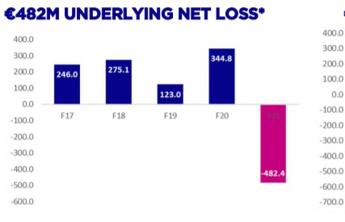
Appendix B: PESTEL Analysis
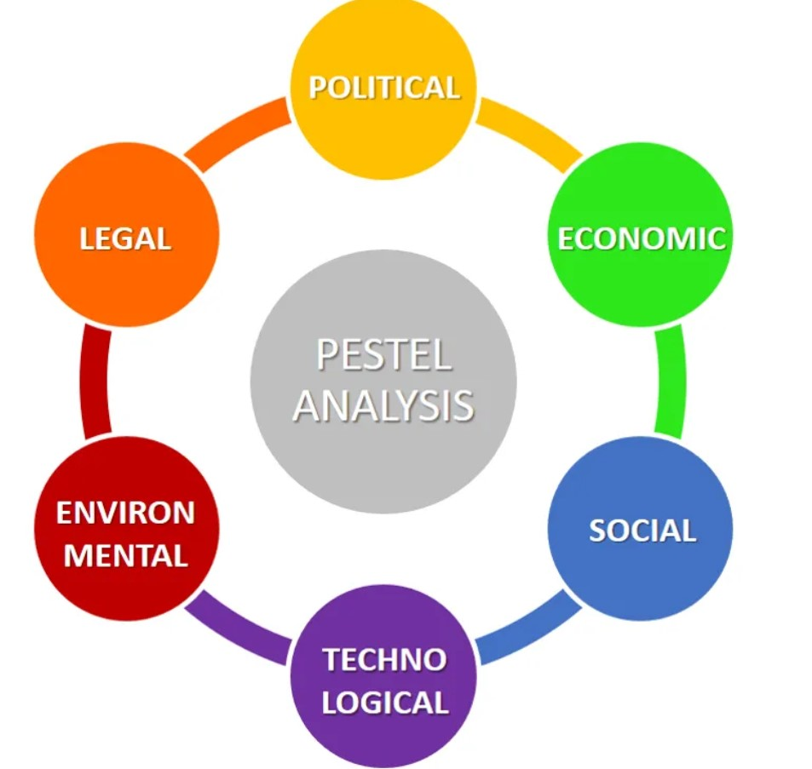

Appendix C: Expected- Economic factors for 2016
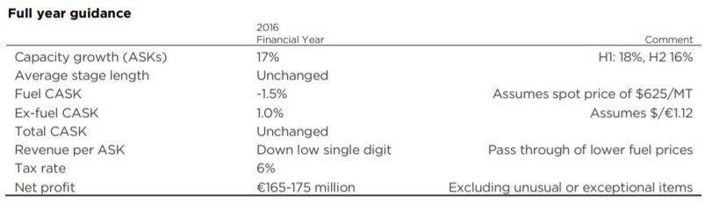
Appendix D: 2016 FULL YEAR RESULTS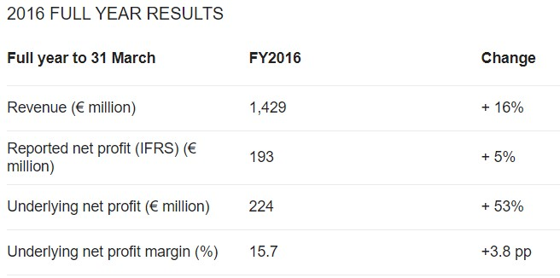
Appendix E: 2020 interest rates comparisons
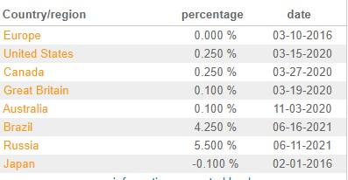
Appendix F: Wizz attitude to customers
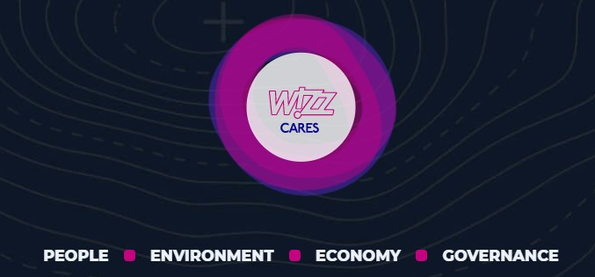

Appendix G: Wizz Air’s carbon emission
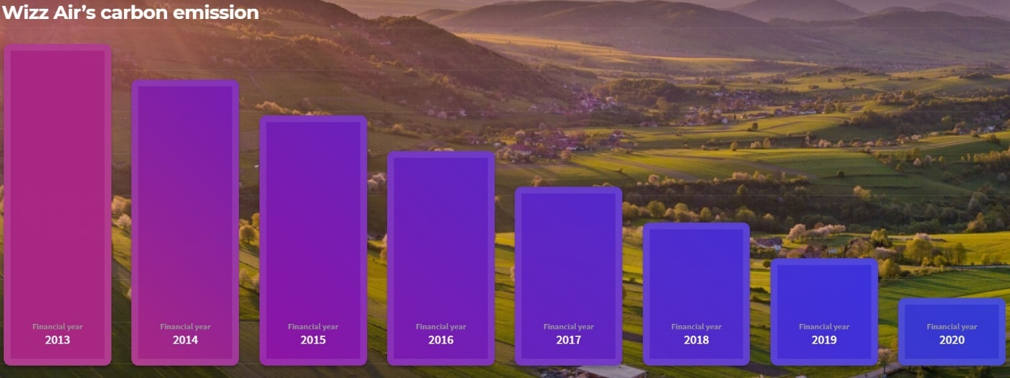
Appendix H: Wizz Air help desk
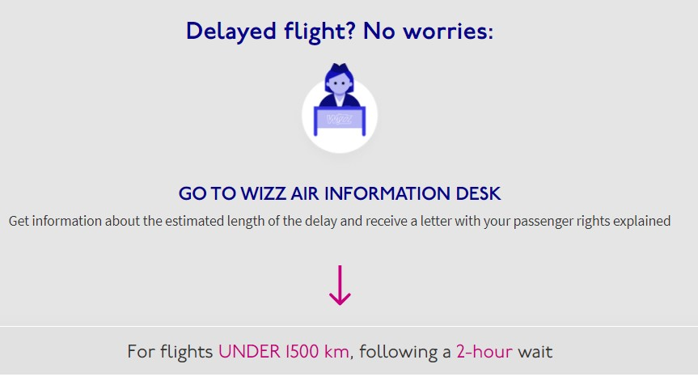
Element /Factors | Examples | Effects on the Industry / Company
Element /Factors | Examples | Positive | Negative
Political | Military attack | Avoid a potential dispute with EASA | Cancelation a lot of flights
Economic | Economic stability | Key factor for entering a new market | Market breakdowns due to coronavirus pandemic
Social & Demographic | Migration patterns | New destinations | It is crucial to know and anticipate clients' purchasing habits to determine their preferences.
Technological | Social media | Boosting business performance | Spending more money for developing and innovation
Ecological/Environmental | Climate pollution | Made a problem like a new business programme. | Many jurisdictions have implemented specific rules to conserve their urban areas by sustainable waste management.
Legal | Data protection law | Save and secure using third-party data processors | Cybernetic attack
Appendix I: Summary of PESTEL Analysis

