Ali Timóteo do Rosário Monteiro 2021167
Module Code: BMSW4005 Lecture Name: Hossein Shokri
University of Wales Trinity Saint David
Professional Career Development
CertHE Skills for the Workplace

Table contents

Introduction 2

Reflection on Role Play 2

Personal Development Plan 3

Smart Objectives 3.1

Swot Analysis 3.2

Gibbs Cycle 3.3

Personal Action Plan 3.4

Recruitment and Selection 5

Conclusion 6

References 7

Appendix 8-11
Introduction

Deciding on a career is not always straightforward and many aspects must be taken into consideration such as the why, how, and what defines an individual and what the individual would like to be in the future. For that, a great deal of reflection and analysis must take place, and sometimes is a process that takes time (Neugebauer & Evans-Brain, 2016). This process is called personal development planning which is used to help individuals develop the skill of reflecting and creating their own personal development plan. Including creativity, curiosity, risk-taking, the learning of new skills, the improvement of weaknesses, critical thinking, reflection and time. Some of the key steps are setting smart objectives, designing a lifeline, SWOT analysis, the use of a reflection cycle, and practice (Cottrell, 2021).
The ultimate goal is employability which is not an issue for a minority that has graduated from elite universities, on the other hand for the majority employability is a challenge. Employability has been defined as a group of attainments such as skills, personal and professional qualities that graduates have that make them more likely to gain employment and be successful benefiting themselves, the employer, their colleagues and communities. Such skills have been identified as self-management, teamwork, business and customer awareness, communication and literacy, good numeracy, problem-solving attitude and basic technology skills (Neugebauer & Evans-Brain, 2016).
The purpose of this report is to describe my journey through my thinking on how I plan to achieve the goals that I have set. Becoming a paramedic is a dream of mine and so I have been studying for a year now so I can achieve that goal. Furthermore, I will explain the strategies and plans that I have set up for the completion of those objectives.

Reflection on your role play

I designed 5 questions for a role-play interview – Appendix 1

Before the role-play: the challenges that I and my partner found were due to us both being full-time workers so the time that I had free sometimes wasn’t great for my partner and the same thing happened to her so the challenge was to find time to sit and discusses our questions.
During the role-play: as I said before we were both professionals and have been interviewed many times for our work and have had to interview numbers of people so, therefore, the interview went very smooth and without any breaks, we both knew our subjects and we answer the question in the best and professional way.
After the role-play: there was a moment of tension even Knowing that we did an amazing job during the role-play, the wait so we could hear the feedback from our assessors it's always nerve-racking because this is the opinion of someone that saw the interaction from the outside and will have a different perspective.

Personal development planning

3.1 Smart objectives
Smart objectives are a smart way of writing objectives this is a golden rule for its achievement giving a clear action plan. This model was created by 1981 George T. Duran and it stands for specific measurable attenable realistic and time-bound. Since then, the smart module has been incorporated and used by organizations in health care but not just. When writing a smart objective, the following must be specific:

- The desired change
- The significance level of change
- How challenging is to get to the change
- The start and end date of when change is achieved
(Ogbeiwi, 2017 )

My primary objective is to become a Paramedic, therefor for that first step I need to fulfill my foundation year at Trinity Saint Davis University once I have completed my diploma, I will be able to apply to the paramedic science course at St. George Hospital University. Once I have been accepted, I will use all the knowledge that I have acquired during my foundation year to years of university. Like any goal, there will be some barriers that I will overcome due to my resilience, determination to achieve my goal and time management. I believe achieving this objective is realistic because I will have the support that is required for me to continue the study full-time. The course in question has a time frame of 3 years so I aim to complete the course in 3 years.
Appendix 2 – PDP

3.2 SWOT analysis
To understand better, the objective itself a SWOT analysis must be done. SWOT stands for Strengths, Weaknesses, Opportunities and Threats focusing on personal or organizational aspects (Cottrell, 2021). SWOT analysis cannot be attributed to a single author however it was developed in the twenty century and is still the most used analysis in organizations management (Vlados & Chatzinikolaou, 2019 ).

The Swot analysis for my goal:
Swot analysis
Objective: Becoming a paramedic
Strengths  My personality:  Interpersonal and communication skills  Empathy  Calm under Pressure  Listening skills | Weaknesses  Time management  Finding difficult working alone
Opportunities  Healthcare industry is always looking for members of staff in any area including privates and national healthcare systems. | Threats  Being accepted by my first university option  Studying and working at the same time can be challenging as there will be less time for everything else.

3.3 Gibbs's reflection cycle on the interview
This model was created by Graham Gibbs in 1988 and is the model used commonly among students which require reflective thinking and writing of their ideas (Sekarwinahyu, et al., 2019 ). His model refers to the processes in the reflection itself and not just the reflection on standard learning and compromises 6 stages (Oviawe, 2020).

Description: The task was to work with a partner and create 5 questions that would have to be related to my future work goal. We were divided into groups of two which were chosen randomly so we wouldn’t know who our partner would be. At first, I wasn’t that comfortable with the situation but then we were explained that that the situation was on purpose to make us feel uncomfortable. My partner wasn’t also comfortable with this situation and the fact that wasn’t easy to meet up in person or online to finalize the questions.

Feelings: Before the interview, I felt comfortable even though we didn’t have enough preparation however as the time approached, I felt little anxiety. My partner was very nervous and she thought she wasn’t able to do it. During the interview I and my partner were completely relaxed as both of us have been in this situation many times before and in the end, we believe that the interview went very smoothly. After we felt relieved and satisfied with the work we have done.

Evaluation: the good point was that we had to research certain questions and we were able to role play and so in the future, we are comfortable with that type of question. On the other hand, we were not ready due to the lack of time for practice and we do not have experience on given feedback to each other. Overall was a good experience.

Analysis: The situation went well because we both had experience and the designed questions created by us were specifically targeting our job selection.

Conclusion: I learned how to answer questions about my future job, what to say and what not to say in future interviews. It could have been a more positive situation for everyone involved if we would have had more time to prepare. Also, I need to improve my knowledge about the position that I applying for.

Action Plan: I would have asked to have more time to prepare. I would develop the skills that I need by practicing.

3.4 Personal Action Plan
On my action plan, I have highlighted some of the skills that I believe need improvement to order to obtain the job I seek such as time-management, writing communicating skills, working alone, and working quickly and carefully.

Recruitment and Selection

Nowadays in England, there is a massive demand for paramedics. A paramedic is the first responder to a medical emergency situation such as cardiopulmonary resuscitation (CPR) and they usually access patients and determine the treatment required. In the UK to be a paramedic practitioner you have to have a paramedic science degree and after that you will do a one-year placement. At this point two options, you can continue in the same Trust where you finalized your placement or you can apply for other Trusts around England. When looking for other opportunities is crucial to know what are the Trusts needs and requirements for recruitment.

Paramedic requirements which are some of my strengths:
- Interpersonal skills
- Teamwork
- Outgoing and caring attitude
- Good skills with people from different social-economic backgrounds

Paramedic requirements which are some of my weaknesses:
- Writing skills
- Time-management
- Working alone
- Working quickly and carefully
(How2become, 2021)

These were added to my PDP in order to improve. See Appendix 4

Role-play
During my studies, we had a role-play task where we had to create five questions related to our future profession. This practice helped me understand what is expected from me once I have finished my degree. With this experience, I learned how to prepare for an interview and what are the key points that I need to focus on the most.

See the designed question on Appendix 1

Conclusion

To conclude in order to understand the employability of my chosen career many steps were taken. First of all, a deep understanding of what my goal is and all the aspects that can influence my achievements was acquired by me through a PDP including the setting of objectives in a smart way with a start and end date and a SWOT analysis which gave me the understanding of my strong and weak skills. Also, the interview role-play did allow me to learn from practice and understand the necessary preparation behind an interview. That will help me not just during my academic path but also during my career to prepare for an interview understanding what the employer is looking for and what other skills are related to higher employability rates.
References

Cottrell, S., 2021. Skills for Success: Personal Development and Employability. 4 ed. London : Red Globe Press .

How2become, 2021. Becomeaparamedic.co.uk. [Online]
Available at: https://www.becomeaparamedic.co.uk/recruitment-process/
[Accessed 29 12 2021].

Neugebauer, J. & Evans-Brain, J., 2016. Employability : Making the Most of Your Career Development. London : SAGE Publications.

Ogbeiwi, O., 2017 . Why written objectives need to be really SMART. British Journal of Healthcare Management, 23(7), pp. 324-336.

Oviawe, J. I., 2020. Application of Graham Gibbs Model of Reflection to Improve Teaching Understanding among Technical Education Students in Ambrose Alli University Ekpoma Edo State. Journal of Education, Linguistics and Literature, 3(2), pp. 8-15.

Sekarwinahyu, M., Rustaman, N. Y., Widodo, A. & Riandi, R., 2019 . (Development of problem-based learning for online tutorial program in plant development using Gibbs’ reflective cycle and e-portfolio to enhance reflective thinking skills. Journal of Physics: Conference Series, Volume 1157, p. 022099.

Vlados, C. & Chatzinikolaou, D., 2019 . Towards a Restructuration of the Conventional SWOT Analysis. SSRN Electronic Journal, 5(2), pp. 76-84.

Appendix 1
Designed Questions:
1. Why do I want to become a paramedic?
2. Why do you want to come to this University?
3. How do you think you would react to an incident as a Paramedic?
4. Give an example where you had to deal with someone in a potential a conflict situation. How did you attempt to control the situation?
5. Why do you think you can successfully pass the course?

Appendix 2
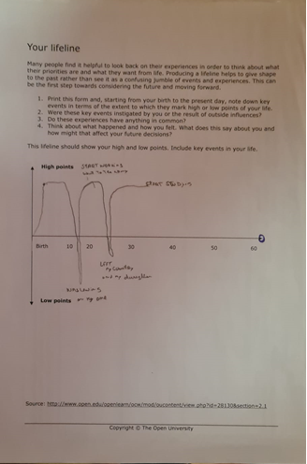
Lifeline

Appendix 3
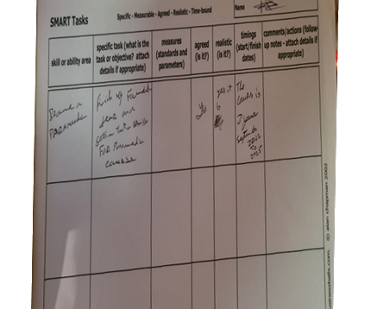
SMART Tabs

Appendix 4
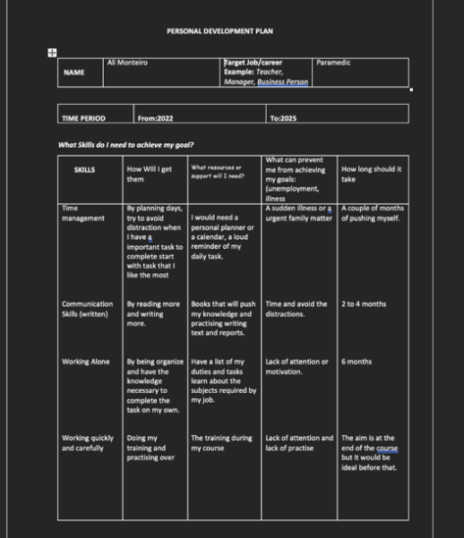
Personal Development Plan

