Managing People
  - Assessment 1

Student: Dimitar Gadov
Student Number: 1913486
Tutor’s Name: Charles Oham
Module: Managing People
Module Number: LCBB5004
2021

Contents
Introduction 3
What is HR 3
The CIPD 3
HR Functions 4
What is HR planning 6
What is Recruitment 6
Analysis 7
Conclusion 8
References: 10

Introduction

What is HR
The HR incorporates all the competence, expertise, perception and feelings of working people plus their inspiration, personality and brain potential. Human resource management represents how they being recruit, organized and progressed in a company. It has a goal to enhance management efficiency together with moral principles. (Armstrong ,2020, pp.34-36) The aims of HR could be defined as: help the firm in accomplishing its goals by applying HR strategies; guarantee that company has top-level talented workforce and auspicious relationship between workers; deliver positive sufficient staff experience and welfare; attain community lawfulness. (pp40, Armstrong ,2020)
The prospective functions of human resource could be described as:
- Administrative vs. Strategic- when the legislative part of the job isn’t done correctly and effectively, the HR managers cannot be able to develop tactical decisions, so the equality between them is compulsory;
- Existing vs. transformed- a HR professional should combine together high-level competence, establishment strategical knowledge and thoughtfulness of workforce’s wellbeing;
- The HR experts become more authoritative, self-confident and distinctive when speaks for future innovations and prosperity of the team members. (Dave Ulrich,1997)
The CIPD (Chartered Institute of Personnel and Development) are professional organization for skilful people at the workplace. They have centres around the world, including United Kingdom, Asia, Middle East with around 160 thousand members. The professional body is reliable partner to authorities and managing directors, and also the exclusive one that could give Chartered status to every HR and L&D expert. The organization believes in man-ability for career development. By CIPD, a corporation is composed of people and profession map stands at that principle. (Gofton,2019) The CIPD profession map helps for making finer decisions, achieve goals with confidence and develop career growth, no matter what is your work position. It involves different levels of knowledge and actions in order to achieve beneficial contribution despite of occupation level and field of action. (CIPD, The Profession Map: standards, 2021)
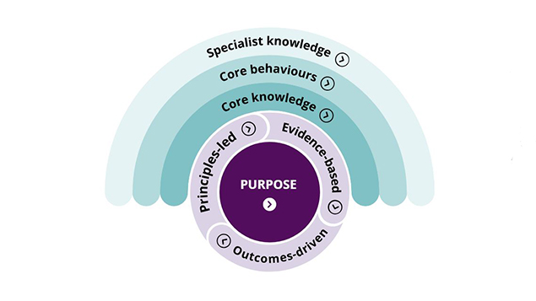
Source: CIPD unveils new HR profession map at annual conference (Faragher J. and Webber A. 2018)

The new scheme brings together the basic principles on ethical, cultural, technical level with core behaviours, basic and specialist knowledge. The core knowledge involve all the basic important information needed to be successful in the profession, despite of a sector, position or speciality. It includes either cultural principles, business and technical practices, innovations and understanding of employment law and policies. The next core behaviour has aim to generate value for workers, companies and whole sectors. Effectiveness of the organizations and profession depends of the staff usefulness, passion of learning and progressing, ability to make accurate decisions and working comprehensively. The specialist knowledge represents how to relate competence in order to make positive influence in profession. It helps to widen opportunities and career development in the chosen sector. It covers spheres as talent management, staff skills and relations, diversity, distribution, workforce analytics and progress. (CIPD, The Profession Map: standards, 2021)

HR Functions
Human resource management is the representation of traditional methodology in a firm to guarantee efficiency of the staff’s expertise, capacity and proficiency to attain organizational objectives. It covers worker’s enrolling, instruction, beneficiation, recognition, appraisal and association in the company. The responsibilities of HR substitute frequently because the community changes too. Nowadays, communal and public-service corporation are experiencing difficulties in economic, societal, legalese and environmental aspect. A tactical HR management recognize these problems and grow successful planning system. (Pynes, 2009)

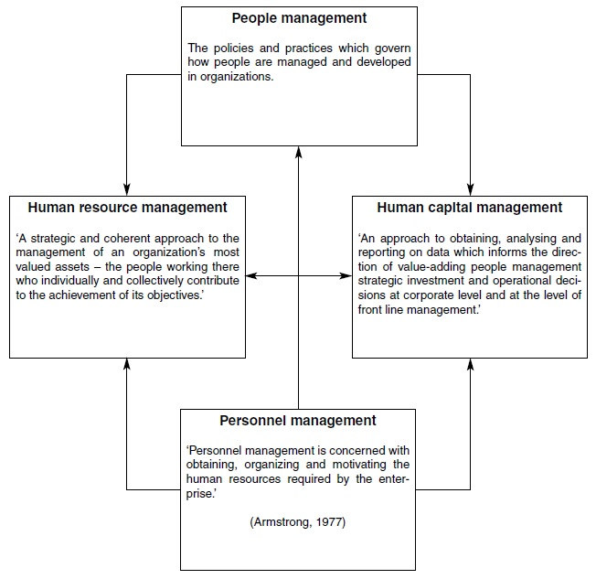
Source: A handbook: Human Resource Management Practice (Armstrong M. 2006, p.2)

By Fomburn, the HRM conception should be controlled compatible with organizational objectives. Further, he described a HR cycle, which has few elements: selection- complement existing hr to positions; appraisal- production management; reward- benefits for short or long-term performance; development- evolving top-level workers. (Armstrong,2006)
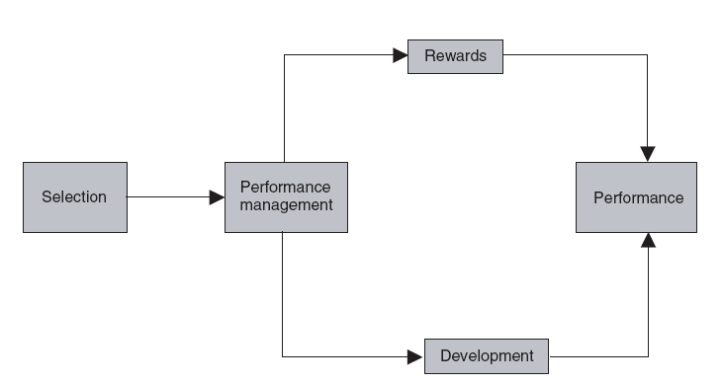
Source: A handbook: Human Resource Management Practice (Armstrong M. 2006, p.6)

HR functions are included in the evolution and application of HR plan of action and guidelines as: HR planning and administration, selection and recruiting, talent and knowledge management, benefit care, staff wellbeing and relations health and safety, diversity and effectiveness of legal necessity. Also it delivers the information and resource which help a company to achieve goals through people. (Armstrong,2006)

What is HR planning
The procedure of HR planning is multiplex and complicated activity. It helps the companies to organize correctly to cover essential needs of the staff. If the organization doesn’t use planning techniques risk to end up without people “with the right skills, in the right places, at the right time”. The aim is to adjust any future gaps in the providing and demanding of workers. For example, the Brexit situation put HR specialists into difficult circumstances of shortages of labour and possible hiring abroad. Main steps of human recourse planning are: prediction of future workers demand, internal and external supply and composing reply to the prognostication. (Taylor, 2019)
By Lawler, it is significantly the HR specialist to be a strategic partner in an organization. In his analysis, firms where HR is a full partner, increased awareness to cluster action as planning, management progressing, institutional framework, career opportunities. Also some of the established methods: hiring, selection, promotion and appraisal, has risen. (Lawler III, 2003)

What is Recruitment
The phrases ‘recruitment’ and ‘selection’ are broadly used together, but while recruitment includes endeavour seeking job requests, selection shows the best appropriate candidates for the particular position among others. The procedure of captivating the applicants continue beyond the application itself. However, nobody wants unsuitable contestant for the chasing position, that’s why recruiting process has to be clear, practical and to minimize inappropriate candidates. When employee market is tight, prompt hire actions are very important, because it is much harder to discover high-skilled and qualitative staff. Nowadays, the recruiting process has change a lot. Increasingly more, social media platforms have been used for targeting certain group of people. Also, still big amount of other traditional and modern ways is used for employing. (Taylor, 2019, pp229,230)

Source: Resourcing and Talent management (Taylor S., 2019, p.230)

Analysis
Hiring is not cheap or easy procedure at all. By CIPD, in 2017 the average cost varies between 2 and 6 thousand pounds, as the largest organizations paid more. That generates questions how it could be modernized and simplified. One option is to be increased the internal and word-of-mouth recruitment. However, this is not reliable itself to find the right candidate in the ocean of applications and employers have to widen their searching methods. (Taylor,2019)
Artificial intelligence, on the other hand, could be very helpful for the employers to screen applications accurately, proceed the interviewing process smoothly and estimate the most skilful job-seekers. For example, the software firm Ideal Corp, uses AI-software to hire, with excellent results: 71% less expenses and triple increasing in the effectiveness of recruiting. The interview is done by robot with beforehand drawn pattern and questions scheme. It could scan mismatching answers and other errors in the candidates’ responses. The software program set 15-minute video interview, where it could detect 20 thousand data spots of facial impressions, voice tone and speech. Biometric identification could be used for tracking where the applicant is correct with documentation or authenticity at the discussion. That help the questioner to boost the productivity without lessen the standard grade of the dialog. (Jia,2018)
Further, the integration of world markets and continual evolution in business operations leading to enhancing the importance of green HR practices also. In order to obtain stable level of eco-friendly utilization, many corporations accept special green HR-policy. That include: reducing waste and recycling; benefit employees when enrolling to green activities; motivate staff and raise awareness for green programmes. The significance of environmental friendly work atmosphere is rising daily, because these practices has positive impact on employees’ performance and position of the company on the world market field. (Kulsum,2019)
The enrolling of well-trained workers become more and more crucial. Some standard practices are not so effective and many companies attract their talented employees via E-recruitment. It is a new approach of using job boards, own website or social platforms for growing work rate and well-being of the staff. Currently, firms are performing interviews via Viber, Skype, Zoom or other similar platforms because of the Covid-19 pandemic and that practice is becoming the new normality. Database shows that large amount of competitors is selecting e-recruitment methods for its simplicity and straightforwardness. Employers prefer it also, because online interviewing notably reduces the operational costs and unnecessarily expenses and boost financial and manpower efficiency of the company. (Malik, 2018) Except that, e-recruitment significantly reduce time. Job-seekers could smoothly entry the online getaways from everywhere, make a profile and always when there is a vacancy, the systems will automatically inform them. For example, platforms like Linkedin or Rozee.pk have online traffic from million users daily and, which makes the hiring process much easier, safe time and financial resources compares of conventional posting of job applications. (Junejo, 2019)
Many companies, including CIPD official website, are offering career opportunities on their web pages. An example is the page for distance job opportunity – Amazon Associates. That is one of the biggest world affiliate scheme for remote work in order to earn money via advertising. Associates are using link-building tools to suggest product on Amazon to their auditory and in result are receiving up to 10 percent commission. (Amazon Associates, 2021)

Conclusion

Globalization, digitalizing and technological evolution is transforming our daily routine continuously. Human resource managers should upgrade their skills and expertise as following modern digital implementations and socio-cultural behavior of the employees. Current HR functions has a goal to create top-level rival advantage as hiring most talented and competence human individuals. Therefore, they have essential role in company’s vision, mission and plan of action. (Sengupta, 2020) Recommendation for bettering the HR professional are not only digitalization, but also improving staff engagement, cooperation between all levels of management and participation in different social activities. When HR practices are well-defined and labours are delighted and high-valued, the organization increase its efficiency, financial productivity, sustainability and overall performance. (Diez,2020,p.146,p.159)

.

References:

Armstrong, M. (2020) Armstrong's handbook of human resource management practice. ISBN: 0-7494-9828-5, 15th E. Publisher: Kogan Page.
Ulrich, D. (1997) ‘Human Resource Management’, Spring 1997 John Wiley & Sons, 36(1), Pp. 175–179.
CIPD (2021) The people profession: Now and the future, Available at : https://peopleprofession.cipd.org/ .
Gofton, M. (2019) Who are the CIPD?- Available at : https://www.emcouncils.gov.uk/write/CIPD-_New_Profession_Map_Workshop.pdf (Accessed: 6th Feb 2019).
CIPD (2021) The Profession Map: standards, Available at: https://peopleprofession.cipd.org/Images/full-standards-june-2021_tcm29-95364.pdf (Accessed: June 2021).
Faragher, J. and Webber, A. (2018) CIPD unveils new HR profession map at annual conference. [Diagram]. Available at: https://www.personneltoday.com/hr/cipd-unveils-new-hr-profession-map-at-annual-conference/ (Accessed 7 Nov 2018).
Pynes, J. (2009) Human Resources Management for Public and Non-profit Organizations. 3rd Ed. John Wiley & Sons Inc.
Armstrong, M. (2006) A handbook: Human Resource Management Practice. 10th Ed. Available at:http://103.5.132.213:8080/jspui/bitstream/123456789/794/1/Handbook%20of%20Human%20Resource.Management.Practice.pdf
Armstrong, M. (2006) A handbook: Human Resource Management Practice. 10th Ed. [Diagram], p.2, Available at: http://103.5.132.213:8080/jspui/bitstream/123456789/794/1/Handbook%20of%20Human%20Resource.Management.Practice.pdf .
Taylor, S. (2019) Resourcing and Talent management. 7th Ed. Kogan Page Limited.
Lawler III, E. and Mohrman, S. (2003) ‘HR as a strategic Partner: What Does It Take to Make it Happen?’, Center for Effective Organizations Marshall School of Business, University of Southern California, CEO PUBLICATION: G 03-2 (430).
Jia, Q. et al (2018) ‘A Conceptual Artificial Intelligence Application Framework in Human Resource Management’, ICEB 2018 Proceedings. 91. Available at: https://aisel.aisnet.org/iceb2018/91 .
Malik, M. and Mujtaba, M. (2018) ‘Impact of E-Recruitment on Effectiveness of HR Department in Private Sector of Pakistan’, International Journal of Human Resource Studies, 8(2). doi:10.5296/ijhrs.v8i2.12869

Junejo, I. et al (2019) ‘Does E-recruitment Matter for Service Sector? An Empirical Study of Hyderabad, Pakistan’, Annals of Contemporary Developments in Management & HR (ACDMHR), 1(3), Pp. 22-32. DOI: 10.33166/ACDMHR.2019.03.003 .
Kulsum Z. (2019) ‘Impact of Green HR Practices on Employees Performance’, International Journal of Research in Engineering, Science and Management, 2(2),URL: www.ijresm.com | ISSN (Online): 2581-5792 .
Amazon Associates (2021) Affiliate program. Available at: https://affiliate-program.amazon.com/ .
Sengupta A., et al (2020) ‘Reinventing HR functions with SMAC technologies- an exploratory study’, Materials Today: Proceedings. https://doi.org/10.1016/j.matpr.2020.10.875 .
Diez, F. and Quan NG,R. (2020) ‘Implementing Lasting Change -HR in the Social Service Sector’, in Lee Kong Chain School of Business (1st Ed.) Human Capital Leadership: Insights. Singapore: Singapore Management University

