
Data Handling & Business Intelligence (LCBB5000) A2
Module Leader: Gasso Wilson Mwaluseke


Student number:2028270
student name: Nevyan Gospodinov

Table of Contents
Introduction 2
Part 1: Data verification and visualisation 2
Overview 2
Data storage methods 3
Analysis 4
Common data mining techniques 5
Classification 6
Clustering 6
Database administration 6
The display and analysis of the collected data 6
Part 2: Ice Cream Consumption Analysis and Evaluation of EXCEL and SPSS 6
Overview 6
Use of EXCEL 8
Analysis using SPSS and Excel 9
Conclusion 9
References 10

Introduction
Business intelligence and data mining are philosophies, methods, and technologies for the study and presentation of data and information that assist companies in making intelligent business decisions (Sjarif et al., 2021). These philosophies, methods, and technologies can be found in the study and presentation of data and information. The process of data management is an important one that enables companies to organise and analyse their data in order to arrive at conclusions that make sense.
The primary focus of the initial stage of our inquiry will be on doing an analysis of the historical patterns of profit and sales. The findings of the research will also be included in the paper, which was written with the assistance of data analytical procedures that pre-processed material pertaining to Superstore data. In order to carry out the study, the spreadsheet tool known as Excel will be utilised on the computer. Excel will be used to perform the analysis of the behaviour of the data when it is presented in a variety of ways. In addition to this, we will investigate the various ways in which data mining can be applied in the real world like in analysing ice cream consumption data. Following the summary of the instrument's benefits and drawbacks that will bring this section to a close, the research instrument in question will have been discussed.

Part 1: Data verification and visualisation

Overview
The assessment of Superstore data in Microsoft Excel and the visual presentation of the findings is a significant component of the process. This portion of the technique is very important. Included are crucially important formulas, tools, and operations. The information received from eating patterns will be investigated and evaluated, and the data on retail nutritional habits will be analysed using a range of methods. The overall objective of this study is to investigate and evaluate the information obtained from eating patterns. The process of data analysis incorporates not only the step of processing the data, but also the steps of preparing and visualising the data. The completion of each of these phases is required in order to ensure that accurate data on the fall in sales and profitability can be collected successfully. On the basis of observations conducted in supermarkets, new procedures are going to be implemented with the purpose of determining whether or not there are differences in the eating habits of men and women.
It has become an extremely significant resource for nearly all businesses as a direct result of the numerous new developments that have taken place in the field of corporate data analysis. The great majority of businesses today are making concerted efforts to improve the capacity of their data storage infrastructure. It would appear that the commercial storage industry is heading in the direction of the application of new analytical methods (Cleff and Springerlink, 2019). This helps contribute to firms' data security, which is a basic objective for many organisations in this day and age due to the prevalence of cybercrime. The most recent advancements in data security demonstrate that the implementation of data security controls is a priority for many different companies. The development of new trends in business intelligence is partially responsible for the advancements that have been made in data storage. It has been shown to be crucial for carrying out data analysis in order to improve the outcomes. [Citation needed] [Citation needed] This ensures that data are safeguarded from cybercrime, which continues to be a significant cause for concern in the modern world.

Data storage methods
As technological advancements grow, more and more options are becoming available to store data in a manner that is not only more secure but also more effective. One of the reasons why many businesses are moving their focus to cloud storage solutions is because these solutions offer a higher level of data protection than traditional data storage tactics. Alterations in the patterns of data storage that have been employed have assisted in the adoption of a cloud-centric data warehouse architecture that optimises data deployment. This adoption has been aided along by these shifts. It is important to implement more complex procedures for data extraction, data ingestion, and data analysis in order to handle the growing number of data storage systems that are suitable for use in data warehousing. The development of data warehouse trends has considerably benefited the expansion of cloud computing and technology, which has resulted in a positive perspective for the future of these disciplines.
"Data preparation" refers to the initial step in the process of transforming raw data into a form that is suitable for analysis. The preliminary processing of the data is an essential step that must be completed before the unstructured data can be converted into a format that is both more useable and more efficient. This transformation requires the data to be in its original form. Raw data should be pre-processed before it is used because unprocessed data may contain errors and inconsistencies that do not fully reflect the changes that have occurred in the organisation. The information that may be gathered from the grocery store often lacks essential qualities, has limited practical use, and possesses a small amount of accumulated information (Sedkaoui, 2018). Data that has not been processed is pointless since it contains a great number of errors and inconsistencies and has not been cleaned up. There are both string and numeric variables inside the data that pertains to a supermarket. Because it is difficult to analyse textual data as well as numerical data, a comprehensive processing method is required in order to uncover patterns in the data. These patterns can then be used to draw conclusions. Every bit of information needs to be transformed into a numeric format before the Excel programme can be used for analysis of the data.

Analysis
The work should be done in Excel, and an explanation of the results should be included - The information was collected from the supermarket.
Excel, a piece of statistical software, is used in the process of data aggregation and analysis. This helps to ensure that the results are accurate. Excel is used to conduct an analysis of data acquired from supermarkets in order to find the elements that contribute to a drop or an increase in consumption. The purpose of this study is to determine the factors that lead to either a decline or a rise in consumption.
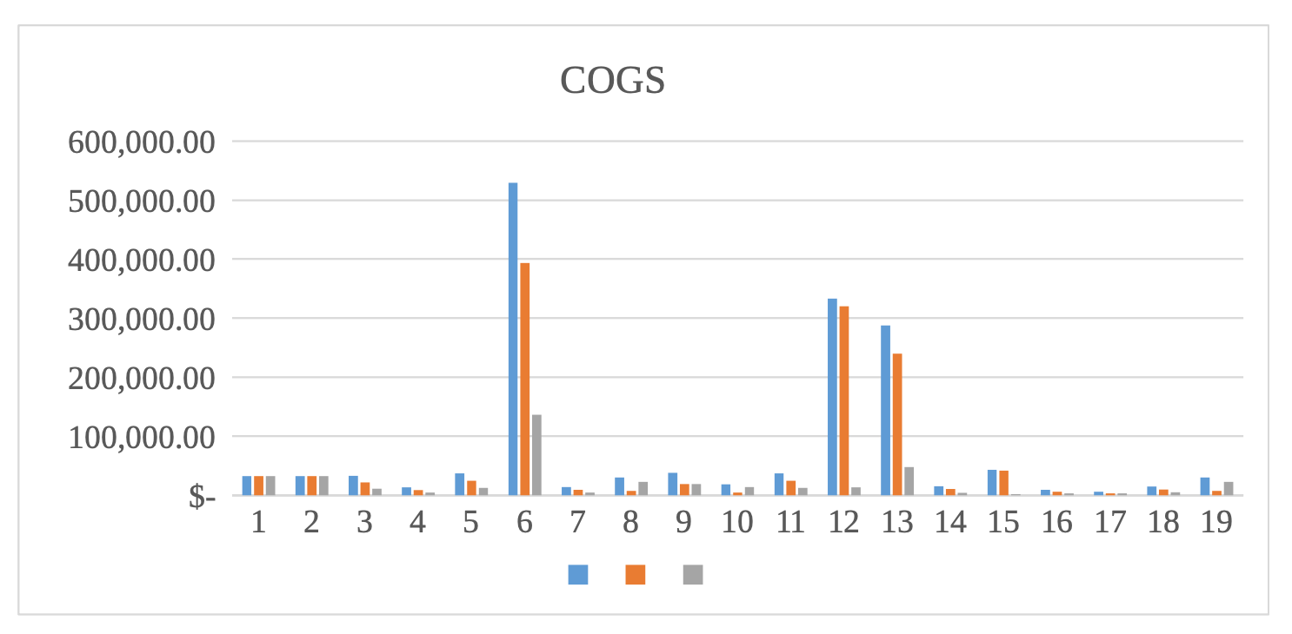
In the graph that is located up above, you will see that the superstore's earnings, product expenses, and sales are all displayed there. It begins in January 2014 and continues until June of that same year. The supermarket has an average daily sales volume of approximately, which is the highest ever reported. The graph depicts a downward trend in revenues for the company, which has been occurring recently. The pattern of the variables and any other shifts that imply changes that are analogous to those that are being observed are what needs to be analysed in order to discover the cause of the decline in sales at supermarkets, which are numerical variables. Other shifts that imply changes that are analogous to those that are being observed are also something that needs to be analysed. The graph analysis reveals a substantial inverse correlation between unit pricing and sales, which explains why the supermarket is seeing a fall in the number of consumers shopping there. This link also explains why there is a significant negative link between unit price and sales.
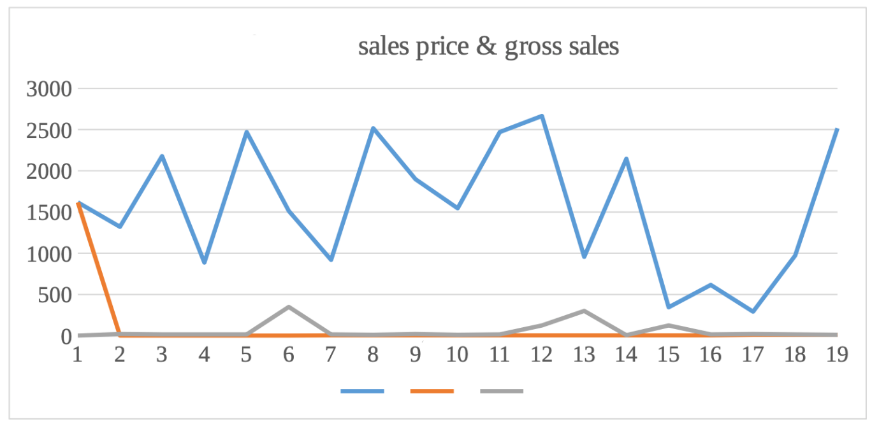
The information presented above illustrates how production, sales, and gross sales have evolved throughout the course of time. The fact that the variables have not changed throughout the course of time is demonstrated by the correlation that exists between the two graphs. According to the information that was acquired from supermarkets that was discussed earlier, Microsoft Excel can be utilised for data analysis, data preparation, and eventually data visualisation. This suggest Excel may be used to analyse the causes and reasons for the store's dropping sales, and it's clear that this is something that has to be done.

Common data mining techniques
These days, companies and organisations have access to an unprecedented amount of data compared to what they had in the past. Large amounts of data provide a number of challenges, the most significant of which is that they do not alter anything because it might be challenging to use unstructured data (Azevedo and Manuel Filipe Santos, 2020).
Because to data mining, businesses now have the ability to recognise patterns within their data and develop hypotheses that are important to the requirements of their organisation. It is essential at the present for both the field of data science and the field of business intelligence (Azevedo and Manuel Filipe Santos, 2020). Data mining refers to the process of evaluating and analysing data using one of a wide variety of approaches that have been created and are now being utilised by a variety of different organisations. Certain operations are necessary for the establishment and ongoing maintenance of an organization's financial data. Certain operations are dependent on these key processes. Trend mining is a technique of data mining in which the primary attention is placed on locating and recognising patterns and trends within the data of an organisation. This method of data mining is known as "trend mining." (Azevedo and Manuel Filipe Santos, 2020). This does so on a consistent basis and looks for data deviations that have occurred at regular times in the past.

Classification
Because of a sophisticated data miming strategy, it is now possible for people to quickly classify individuals according to the features that they share in common with other people (Azevedo, 2021).

Clustering
This one-of-a-kind approach to data mining results in the creation of relatively small data collections that are referred to as "chunks." The outcomes that were intended are acquired after the data were first broken down into into manageable chunks, and then that analysis was performed on those chunks (Azevedo, 2021).

Database administration
One other essential step in the procedures of data mining is the archiving of structured data into a relational database management system. This phase is essential in order to make the data usable for dashboarding, reporting, and basic business intelligence purposes on the fundamental level (Azevedo, 2021). It is now possible to store a substantially bigger quantity of data than was before envisaged because to improvements in technology and the utilisation of cloud data warehouses. This was previously impossible. Because of the improvements that have been made to their data warehouse, the company has been able to speed up the process of implementing business intelligence. This is a direct outcome of the advancements that have been made to their data warehouse.

The display and analysis of the collected data
Data analysis is the second step in the process of processing data, and its goal is to organise and put in order the data that has been received. This step is referred to as the data preparation step. In order to process and visualise the data, respectively, we will make use of the SUM () function that Excel provides (Azevedo, 2021). The primary purpose of the data analysis that was carried out at the superstore was to identify the cause of a decrease in both the number of sales and the amount of profit. The data that is extracted from the PIVOT database will be inserted into graphs and charts in order to illustrate the changes in sales that have occurred over the course of time.

Part 2: Ice Cream Consumption Analysis and Evaluation of EXCEL and SPSS

Overview
The COUNTIF function in Excel can be used to determine the number of persons who like vanilla, chocolate, or strawberry ice cream (Persaud, 2020). The results of this calculation are displayed in the table that follows. A comparison of the amount of persons who select each flavour is one way to accomplish this goal.
The following illustration of these data points using a pie chart is one of several alternative representations:
According to the pie chart and table that can be found above, vanilla was the flavour that was chosen by 47% of the students out of the total of 200 that were surveyed (95 students). 2) In what way are the students segregated into groups that are comprised of males and females?
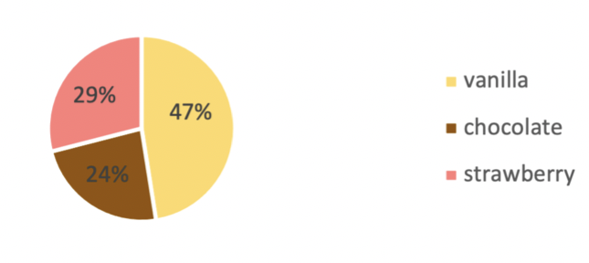
The COUNTIF function in Excel can be used to count either the number of males or the number of women, as is demonstrated in the table that is presented below.
In a bar graph, these data points could be shown in the following manner – The graph and table that can be found up top show that 109 of the students polled are female, while just 91 of the students are male.
What does the mean preference of the participants look like when it comes to chocolate and strawberry flavours, and what does the median choice look like?
We are aware that the material that is presented below is relevant to persons who take pleasure in the combination of strawberry and chocolate flavours and have an interest in gaining additional knowledge regarding this topic.
We will determine the Mean and the Median for these individuals by utilising the features of the spreadsheet programme Excel. After computing the Mean with the AVERAGE function, the next step is to use the MEDIAN function that is located within the same programme to find the Median (Persaud, 2020).
The following are the findings that have arisen as a result of these actions:
 | Frequency | % | Valid % | Cumulative %
M | 91 | 45.5 | 45.5 | 45.5
F | 109 | 54.5 | 54.5 | 100
TOTAL | 200 | 100 | 100
The act of organising a collection in such a way as to group together abstract things that share similar qualities is referred to as clustering. The process of organising data into patterns that are both recognisable and manageable is referred to as clustering. Cluster analysis is another term that can be used interchangeably with clustering. Clustering data using k-means is one of the methods that may be utilised in unsupervised machine learning. It has the ability to identify unlabelled data on the basis of similarities, as stated by (Mat Roni and Djajadikerta, 2021).

Use of EXCEL
Excel is one of the business applications that is used the most frequently for data management (Becker and Gould, 2019). It is one of the programmes included with Microsoft Office that gives users access to tools for data collection, analysis, and collaboration in order to achieve the outcomes they seek. Excel is distinguished from other data management software used in the business world by virtue of a number of unique features that it possesses. Excel's use for data analysis calls for a comprehensive strategy that encompasses all aspects of the process, including collection, entry, and evaluation of the necessary data sets. Spreadsheets in Excel offer a variety of benefits for the process of data research.
The spreadsheet that is used for data analysis may carry any volume of data, regardless of the quantity of information that it includes, thanks to Microsoft Excel's ability to simplify and simplify the process of storing data (Oatley, 2021). Due to the presence of a visible cell within the spreadsheet that stores singularized individual data, data filtering and cleaning may be accomplished with astonishing ease. Excel, in contrast to paper and other data analysis tools, enables the user to locate missing information by simply inputting the correct data names, which then causes the information to become visible.
Finding solutions to calculations with Excel's data analysis capabilities is made easier and takes significantly less time as a direct result of the user-friendliness of the spreadsheet's formula implementations (Oatley, 2021). Excel gives you the option to password-protect the datasheet, which prevents unauthorised individuals from viewing the data. This is helpful for maintaining the confidentiality of your data. Additionally, because of this, it is possible to preserve essential and one-of-a-kind data sets within Excel, thereby preventing unauthorised access to the data. Additionally, Excel possesses a feature that enables the safe storage of data in a single location; in the past, files were manually used for the purpose of data storage and security. Excel possesses this capability. Access to the same files may now be made for quicker and more comfortable by saving them in an Excel file.
A great number of companies in a variety of nations all over the world have made significant investments in business intelligence in order to keep their dominant position in the international market (Bernard et al., 2019). This is being done in the hopes that they will be able to maintain their position for the foreseeable future. The processes of data mining and business intelligence are incredibly significant because they make it possible to transform meaningless data into information that accurately reflects how well organisations are doing in their respective markets. This makes it possible to undertake an in-depth analysis of the data in order to find important trends that may be used as a foundation for attaining strategic goals or altering those goals. This makes it possible to conduct an in-depth analysis of the data in order to identify key trends.

Analysis using SPSS and Excel
Excel's graphing and charting capabilities are limited in comparison to those offered by SPSS. Excel is more difficult to learn and use than SPSS. Because it offers answers that are both dependable and rapid, SPSS makes the process of gathering statistical data much more expedient. There is a possibility that SPSS does not allow more complex methods like programmable coding. Because of its astronomically high price, SPSS is not generally distributed. Training in SPSS is necessary in order to make advantage of the resources that are given. The graphing features in SPSS are more intricate than their counterparts in Microsoft Excel (Bernard et al., 2019).

Conclusion
According to the findings of the report, business intelligence and data mining have a bright future for organisations because of their ability to improve data analysis, which in turn results in the formation of smart decisions. In addition, the essay emphasised the need of using Excel for data analysis because of the program's ability to depict different types of market patterns. Because of this, seeing patterns in one's business and predicting whether those trends would result in profits or losses is a straightforward task.

References
Azevedo, A. (2021). Data Mining and Business Intelligence. Advances in Business Information Systems and Analytics, pp.1–12.
Azevedo, A. and Santos, M. F. (2020). Integration Challenges for Analytics, Business Intelligence, and Data Mining.
Becker, L.T. and Gould, E.M. (2019). Microsoft Power BI: Extending Excel to Manipulate, Analyze, and Visualize Diverse Data. Serials Review, 45(3), pp.184–188.
Bernard, M., Akbar, P., Ansori, A. and Filiestianto, G. (2019). Improve the ability of understanding mathematics and confidence of elementary school students with a contextual approach using VBA learning media for Microsoft Excel. Journal of Physics: Conference Series, 1318, p.012035.
Cleff, T. and Springerlink (2019). Applied Statistics and Multivariate Data Analysis for Business and Economics: A Modern Approach Using SPSS, Stata, and Excel. Cham: Springer International Publishing.
Mat Roni, S. and Djajadikerta, H.G. (2021). Preliminary Data Analysis: An Analysis Before the Analysis. Data Analysis with SPSS for Survey-based Research, pp.15–54.
Oatley, G.C. (2021). Themes in data mining, big data, and crime analytics. WIREs Data Mining and Knowledge Discovery.
Persaud, A. (2020). Key competencies for big data analytics professions: a multimethod study. Information Technology & People.
Sedkaoui, S. (2018). Data analytics and big data. London: Iste Ltd / John Wiley & Sons, Inc.
Sjarif, N.N.A., Azmi, N.F.M., Yuhaniz, S.S. and Wong, D.H.T. (2021). A review of market basket analysis on business intelligence and data mining. International Journal of Business Intelligence and Data Mining, 18(3), p.383.

