Module Title:Digital Skills and Research Methods(BMSW4003_LON)

The Impact of Virtual Learning Environment
Maria Vladulescu 1921608

Lecturer Name:Rula Alousi

Research Methods
TABLE OF CONTENTS
INTRODUCTION 1
MAIN BODY 1
Research-informed Literature 1
Knowledge and Understanding of Subject 2
Analysis 2
Practical Application and Deployment 12
Skills for Professional Practice 13
CONCLUSION 14
REFERENCES 15

INTRODUCTION
Digital skills are considered to be of utmost importance which helps in effectively carrying out the certain set of task with greater degree of accuracy and efficiency. Selection of the research method is of utmost importance because it helps in evaluating what is the right set of research methods which improves the results and outcomes. This study will focus on determining the impact of the Virtual Learning Environment– Moodle on learning experience of the student at the University of Wales Trinity Saint David London Campus.

MAIN BODY

Research-informed Literature
Kerimbayev and et.al., (2020) sought to determine the fact that, virtual learning environment is an approach which has been useful implementing such effective software within the universities. This is one of the key prominent way to teach the students especially during this COVID-19 time. Virtual learning platform is considered to be as one of the key prominent online platform which is significant in allowing the work experience as well as is useful in improving the qualification level. It is prominent in effectively replacing the educational process from face to face classroom interaction to internet. Virtual learning environment in turn is considered to be of crucial importance for the teachers to efficiently plan the lessons, track the performance of the students, managing administrative work level of engagement and activity and also providing additional set of material to the students in turn is considered to be of utmost degree of importance. Sulisworo, Agustin and Sudarmiyati, (2016) sought to examine the fact that, Moodle- a virtual learning platform is prominent in improving the learning results and outcomes among the students. Conditional set of activities can be effectively set up within the Moodle platform which can be relevantly arranges in a proper sequence. These range of activities mainly comprise of assignment, forum, chat, quiz and lesson. Jackson, (2017) argued that, Moodle is considered to be as a significant virtual learning platform which helps in supporting the range of media which helps in presenting and also linking to the learning materials and supporting the learners and also assess the learning process. Moodle is considered to be prominent within the e- learning environment in the universities to collaborate and communicate with the students and teachers. Gogan, Sirbu and Draghici, (2015) sought to examine the fact that, Moodle is considered to be significant in encouraging exploration as well as interaction to improve the learning experience of the students. Moodle is the significant learning platform which has been designed to provide the learners, educators and administrators with the secure, single robust and integrated system in order to create personalized set of learning environment. Moodle is one of the key prominent virtual learning platform because it helps in learning new set of things and has positive set of impact upon the student.

Knowledge and Understanding of Subject

Analysis
Theme 1: How much does this teacher encourage students to using Moodle?
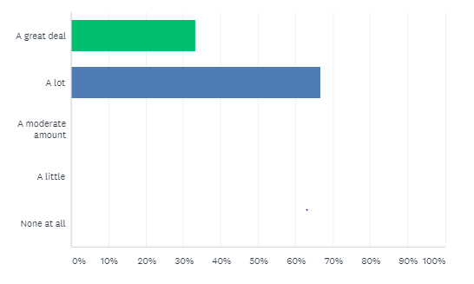
ANSWER CHOICES | RESPONSES
A great deal | 33.33% | 3
A lot | 66.67% | 6
A moderate amount | 0.00% | 0
A little | 0.00% | 0
None at all | 0.00% | 0
Total | 100% | 9

Interpretation: From the above carried out research through the survey monkey from 9 respondents. Out of which, 66.67% interpreted that, a lot of teachers encourage the students within the university to use Moodle. It is prominent in improving the learning results and outcomes among the students.
Theme 2: How many years have you been using Moodle?
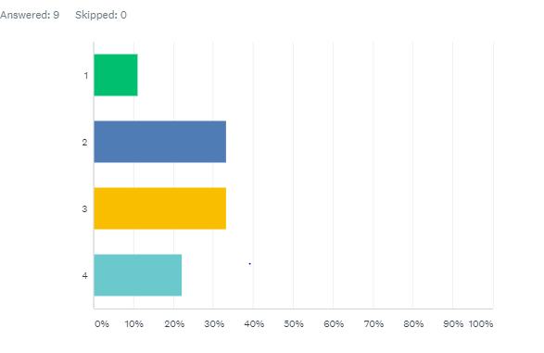
ANSWER CHOICES | RESPONSES
1 | 11.11% | 1
2 | 33.33% | 3
3 | 33.33% | 3
4 | 22.22% | 2
Total | 100% | 9

Interpretation: From the above carried out research through the survey monkey from 9 respondents. Out of which, 66.66% (33.33%+ 33.33%) interpreted that, they have been using Moodle for the period of 2 to 3 years.

Theme 3: How much does this Moodle platform help its students achieve their potential?
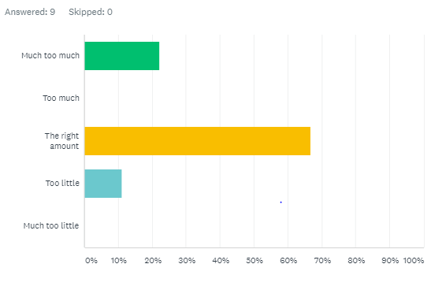
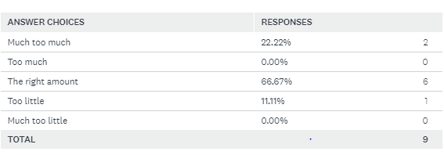
Interpretation: It has been analysed that 66.67% demonstrates that, the Moodle platform is considered to be prominent for the student to attain the right amount of potential. It helps in learning new set of things and has positive set of impact upon the student.

Theme 4: Which of the following Moodle activities do you use most?
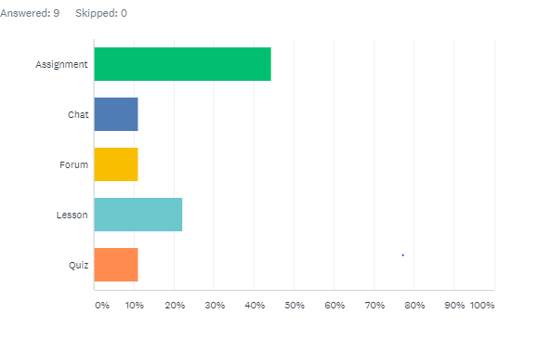
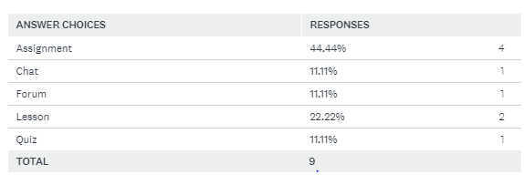
Interpretation: From the above carried out research through the survey monkey from 9 respondents. Out of which, 44.44% interpreted that, Moodle platform is most used for the assignment activities. Remaining 22.22% stated that it has been used for learning lessons.

Theme 5: How often do you logon to Moodle?
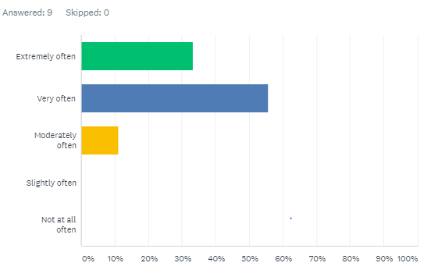
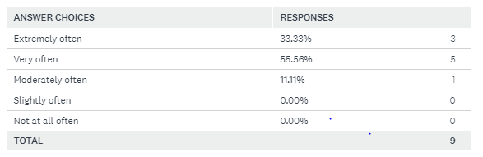
Interpretation: It has been analysed that 55.56% demonstrates that, the students log on to the Moodle very often. This indicates that, it is easy to access and improves the learning process of the student.

Theme 6: Do you find it difficulties to find your way around Moodle?

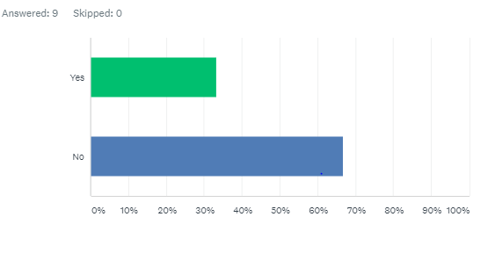
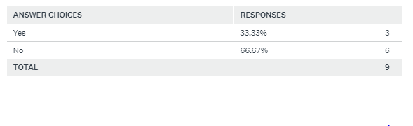
Interpretation: From the above carried out research through the survey monkey from 9 respondents. Out of which, 66.67% interpreted that, most of the students do not find any sort of difficulty while using Moodle. This virtual learning platform is easy to use.
Theme 7: Does Moodle help you learn new things?
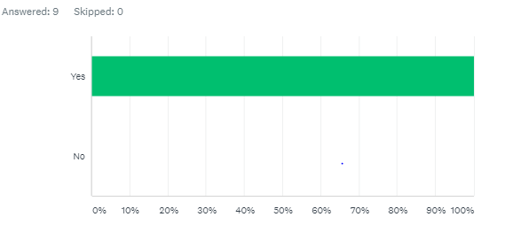
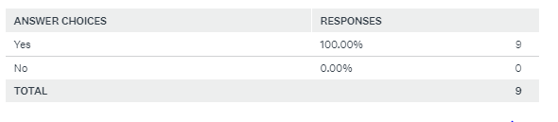
Interpretation: It has been analysed that 100% demonstrates that, Moodle helps the students in effectively learning onto the new things associated with the compliance training, online course development, continued set of education opportunities, online learning, workplace safety training, etc.

Theme 8: Does Moodle help you revise things you learn in lesson?
Interpretation: It has been analysed that 100% demonstrates that, Moodle is a significant way which helps the students effectively revise the things which you tend to learn in lesson. It helps in creating the lesson flow control setting.

Theme 9: The Moodle platform work positively impacts on students?
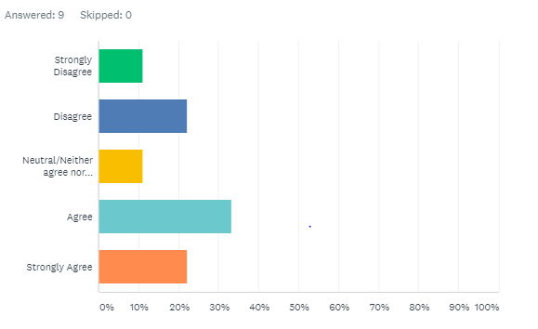
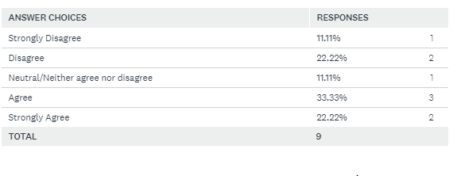
Interpretation: From the above carried out research through the survey monkey from 9 respondents. Out of which, 33.33% interpreted that, Moodle platform tends to have positive set of impact upon the students. It is easy to link up to the learning materials and supporting the learners and also assess the learning process.

Theme 10: How do you find your overall experience With Moodle?
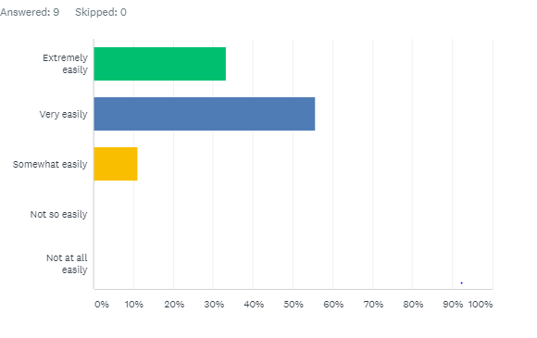
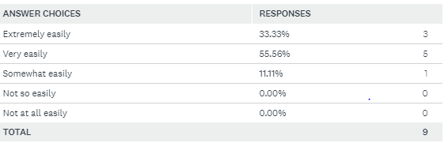
Interpretation: It has been analysed that 55.56% demonstrates that, the overall experience with the Moodle is that it is very easy. It is significant in encouraging exploration as well as interaction to improve the learning experience of the students. It helps in providing students with the integrated system and create personalized set of learning environment.

Practical Application and Deployment
Use of the Virtual Learning Environment– Moodle on learning experience of the student at the University of Wales Trinity Saint David London Campus is considered to be of key significant importance especially in this time of COVID-19 (De Medio and et.al., 2020). It is difficult for face to face interaction with the students and teachers. So, Moodle is effective virtual learning platform as it is useful in improving the learning and impart personalized set of learning to the students with high degree of accuracy and efficiency. This study has used both the primary and secondary set of data collection method to gain wider set of perspective and knowledge regarding impact of the Virtual Learning Environment I.e., Moodle on learning experience of the student at the University. Survey monkey has been used to gather relevant set of data from the respondents and present statistical set of data using table and graphs. The research has been carried out with complete level of anonymity and complete set of confidentiality has been maintained with the great degree of accuracy and efficiency. All the sources which in turn are highly credible has been used in order to ensure data gathered is from the valid and reliable sources and improves the performance. All the sources used are no older than 5 years and also ensures that the research participants must give full set of explanation regarding the specific research topic (Oproiu, 2015). Critical theory has been used within the research with high degree of accuracy because it helps in effectively designing the varied set of research questions and helps in guiding for the appropriate selection of the data. This theory is useful in addressing range of research methodologies which best suits the research. This theory is considered to be as the synthesis of social science and philosophy which has been effectively established to uncover the repressive tendencies as well as the weakness of the modern social structure.

Skills for Professional Practice
Digital skills is considered to be useful because it helps in effectively advancing and also continuously providing the ways to work in a significant manner to complete specific task. It is useful in reaping varied set of benefits and is also useful in collaborating within the workplace in order to improve the business performance and attain greater set of operational efficiency. Digital skills are considered to be of utmost importance which helps in effectively carrying out the certain set of task with greater degree of accuracy and efficiency. Collaborative working skills is another effective attribute within the professional practice. It helps in collaborating with the team, learners and students in an appropriate manner while using virtual learning platform (The Use of Virtual Learning Environment in Education, 2020). Effective communication skills is also crucial within the professional practice. This is mainly because of the effective set of communication skills i.e., both verbal as well as non- verbal skills which helps in improving the performance and leads to better educational experience. Effective presentation skills is also one of the key prominent way to improve the professional practice and attain greater heights. Such attributes and skills helps in improving the professional practice and use the virtual learning experience with high degree of accuracy and key relevance.

CONCLUSION
From the conducted study it has been summarized that, Virtual learning platform is considered to be as one of the key prominent online platform. It is prominent in improving the learning results and outcomes among the students. Moodle helps in supporting the range of media which helps in presenting and also linking to the learning materials and supporting the learners and also assess the learning process. Moodle platform is most used for the assignment activities. Moodle helps the students in effectively learning onto the new things. Digital skills, communication skills, presentation skills, collaborative working skills helps in improving the professional practice

REFERENCES
Books and Journals
De Medio, C and et.al., 2020. MoodleREC: A recommendation system for creating courses using the moodle e-learning platform. Computers in Human Behavior, 104, p.106168.
Gogan, M.L., Sirbu, R. and Draghici, A., 2015. Aspects concerning the use of the Moodle platform–case study. Procedia Technology, 19, pp.1142-1148.
Jackson, E.A., 2017. Impact of MOODLE platform on the pedagogy of students and staff: Cross-curricular comparison. Education and Information Technologies, 22(1), pp.177-193.
Kerimbayev, N and et.al., 2020. Virtual educational environment: interactive communication using LMS Moodle. Education and Information Technologies, 25(3), pp.1965-1982.
Mpungose, C.B., 2020. Is Moodle or WhatsApp the preferred e-learning platform at a South African university? First-year students’ experiences. Education and information technologies, 25(2), pp.927-941.
Oproiu, G.C., 2015. A study about using e-learning platform (Moodle) in university teaching process. Procedia-Social and Behavioral Sciences, 180, pp.426-432.
Sulisworo, D., Agustin, S.P. and Sudarmiyati, E., 2016. Cooperative-blended learning using Moodle as an open source learning platform. International Journal of Technology Enhanced Learning, 8(2), pp.187-198.
Online
The Use of Virtual Learning Environment In Education. 2020. [ONLINE]. Available through< https://scand.com/company/blog/the-use-of-virtual-learning-environment-in-education/#:~:text=Virtual%20learning%20environments%20help%20teachers,for%20those%20who%20need%20that.>

