

Component 1: Online Portfolio of Set Exercises

Programme: BSc Health and Social Care
Module: Changemakers: Creativity and Value Creation
Module Code: BMHP5014
Assignment Title: Component 1: Online Portfolio of Set Exercises
Student Name: _Munaza Sakindar__________________________
Student ID: __2419348_________________________
Lecturer: __Tomy Adattu Chacko_________________________

University of Wales Trinity Saint David
School of Health and Social Care
Academic Year 2025–2026

Main Contents of the Portfolio
Task 1: Concept Map 3
Task 2: Self-Reflection of Group Activity 5
Task 3: Case Study of UK Innovation 6
Task 4: Research Task 7
Task 5: Podcast 8
Task 6: NHS Leadership Framework Analysis 9
Task 7: Self-Reflection Journal Entry 10
References List 11

Task 1: Concept Map
Creativity, value creation, and health and social care improvement are closely connected concepts. Creativity is the way of developing new concepts, methods and solutions to health and social care issues. Creativity enables healthcare professionals to recognize unmet needs, troubleshoot, and devise new approaches to healthcare. Some examples are implementing communication tools, refining care pathways, or creating person-centred care.
Value creation occurs when creative ideas produce meaningful benefits for patients, families, staff, and organisations. In health and social care, value is generated through enhancing patient outcomes, patient satisfaction, dignity and resource effectiveness. Where solutions are creative, if they are helpful to the users of the services and have a positive impact on the delivery of care, they can be valuable.
The continuous improvement of health and social care is about improving quality, safety, efficiency and effectiveness. Improvement is done through the use of good ideas, continually checking the impact, and developing them in light of evidence and feedback. Measurements are necessary to make sure that innovations actually enhance care and are not just change.
These concepts are in a cyclical relationship. Creativity can be a source of innovative solutions that can solve healthcare problems. These ideas become valuable if they enhance experiences and outcomes for those receiving care. The value added at the time helps to improve the service by better practices, improved quality of care and more efficient systems. Evaluation, audits and patient feedback are examples of improvement activities that offer fresh insights to stimulate further creativity. Thus, creativity is the source of value creation, value creation leads to improvements, and improvements call for ongoing innovation.
Figure 1 presents the concept map illustrating the relationship between creativity, value creation, and health and social care improvement

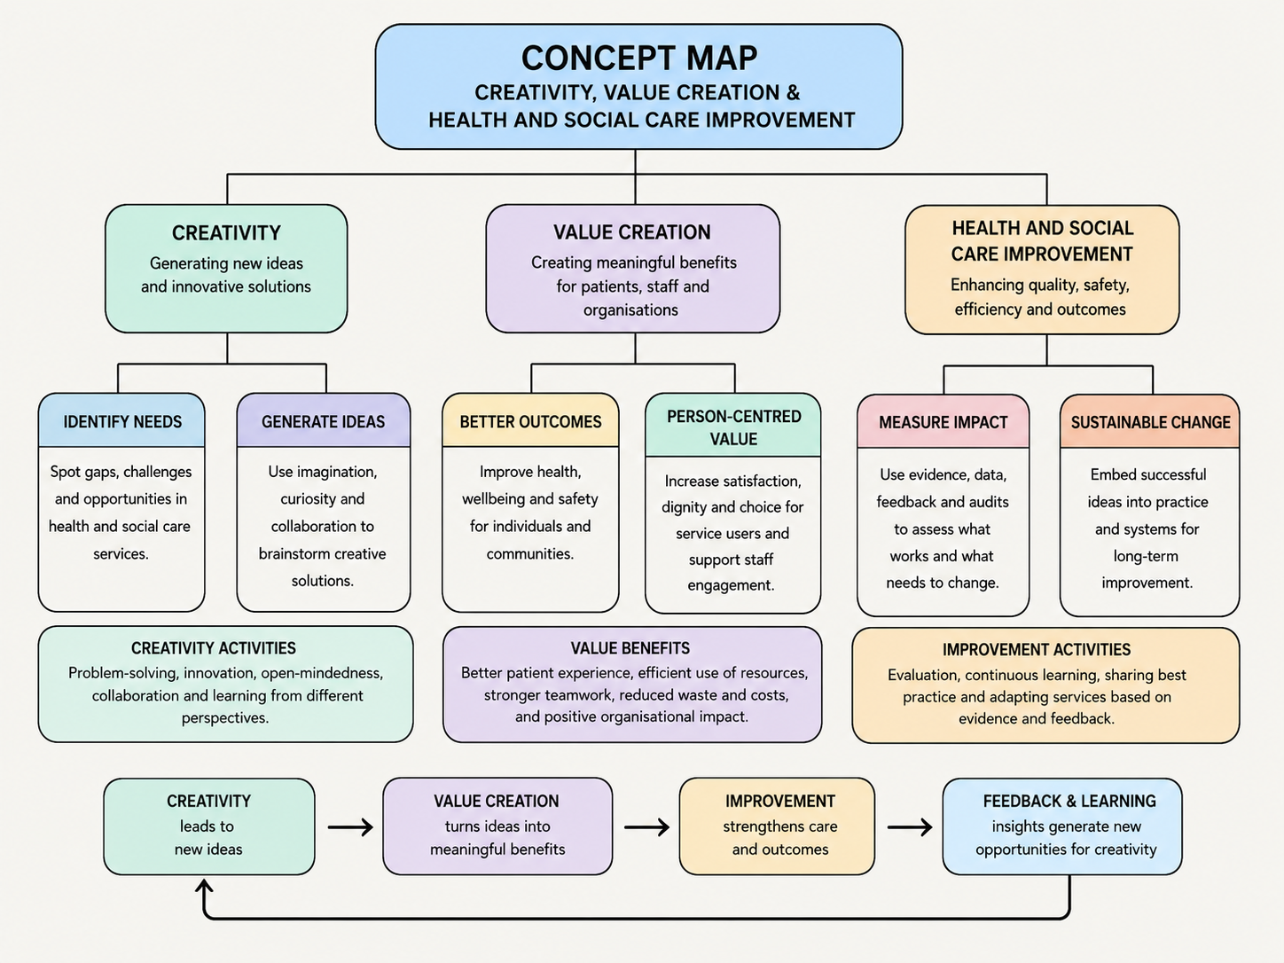
Figure 1: Concept Map (Created by using Visual Paradigm Tool)

Task 2: Self-Reflection of Group Activity
Using Gibbs’ Reflective Cycle (1988), I found the paperclip activity both challenging and useful. During description, I was in a group creating as many ideas as possible for the uses of a paperclip under a time limit. Without thinking twice, I had to be creative and generate as many ideas as possible in this activity. I was able to make quick suggestions and urged others to add to them; this helped to get more responses. When I was in the feelings stage, I was initially unsure as I thought it was quite an easy task, but got more confident when ideas began to pour through. I had come to an understanding that what was being rewarded was creativity, imagination, and openness as opposed to one correct answer (Gibbs, 1988).
I believe it was a successful group in the evaluation phase because everyone was allowed to throw out ideas and no one criticized the ideas, which made the divergent thinking phase easier. The Convergent Thinking was more challenging as we had to evaluate which ideas had been deemed practical, realistic, and feasible. This enabled me to realize that divergent thinking is that of coming up with many different possible solutions while convergent thinking is that of choosing between the options available to assess which solution is best. As stated in the Week 2 lecture, divergent thinking is creative, free flowing, and convergent thinking is logical, systematic and focused on determining the best solution.
During analysis, I identified that creativity and logic go hand-in-hand when problem-solving. The conclusion stage helped me understand that I am more inclined towards divergent thinking and need to develop my confidence in looking at the ideas critically. During the Action Plan phase, I will continue to work on both of these thinking styles in order to be more effective in further group activities and decision-making processes for the future.

Task 3: Case Study of UK Innovation
strong example of innovation in the NHS is the virtual ward / hospital-at-home model, sometimes described as “NHS at Home.” It enables patients, who would otherwise be in hospital, to receive acute care, remote monitoring and treatment at home or their usual place of residence (NHS England, 2022).
The creativity of this project is not just an increase of hospital beds, but the reorganisation of care delivery. The NHS integrated digital monitoring, home-based care and daily clinical review into a single care model instead of the traditional ward-based treatment. It's a creative solution to the pressure experienced on hospital services as it alters where and how care is provided without compromising clinical support for each patient. The model is also flexible, with virtual wards able to be used in the home or in care homes, increasing access for people with a variety of needs (NHS England, 2024).
This innovation added value in a number of ways. Firstly, it enhanced the patient experience, people were not being admitted to hospital unnecessarily, and would have been staying in familiar surroundings. Second, it enabled safer and more timely care as patients on virtual wards have their care assessed daily by a consultant practitioner, enabling practitioners to act swiftly when required. Third, it generated system value by decreasing avoidable hospital admissions, decreasing readmissions and decreasing emergency department presentations. This is important in a busy service, as beds are released for those who need them most for inpatient treatment (NHS England, 2024).
This case highlights from a Week 3 creativity point of view how innovative thinking can be used to solve an actual NHS problem. In the project, technology and service redesign were the key approaches to achieve greater efficiency and person-centred care. It also demonstrates that health care is not the only place where creativity resides in the creation of new devices; it's also about how people, process and technology can be smarter combined. The benefit is both clinical and organizational, greater access, greater patient experience, and greater value to scarce NHS resources.

Task 4: Research Task
Mental health stigma is a current issue in health and social care, as it still serves as a barrier for people in accessing help and support at an early stage. Salaheddin and Mason (2016) identified a lack of self-reliance, stigma, and problems identifying and expressing concerns regarding the need for help, as reasons why young adults in the UK rarely sought support. Their study indicates that it is not just an emotional or social issue but also a practical one as young people may not reach out for services when they are distressed. This could result in symptoms deteriorating before help is offered, putting strain on health and social care services.
This is even more serious, as there is also stigma within healthcare settings themselves, Knaak, Mantler and Szeto (2017) explained. They found that stigma experienced by health personnel and organisational culture can present obstacles to access to and quality of care. This can make service users feel judged and misunderstood or less confident that their mental health needs will be addressed. Thus, stigma is not just a public attitudes issue, but a system issue, as negative expectations about services can discourage people from coming forward and staying in services.
These studies demonstrate that the stigma associated with mental health remains present as individuals may be hesitant to seek support, may not trust or feel confident in seeking support, and may think services will turn them down. Greater emphasis on mental health literacy, early intervention, and non-judgemental support would help to break down these barriers and increase access to mental health care.

Task 5: Podcast
Insert Link Here

Task 6: NHS Leadership Framework Analysis
Key components of the NHS Leadership Framework
The NHS Leadership Framework is not just for those in formal roles of leadership, it's for everyone who works in health and care. It has a consistent leadership development approach across disciplines and it also makes the point that leadership is everyone's business (NHS Leadership Academy, 2012). The framework has seven domains: demonstrating personal qualities, working with others, managing services, improving services, setting direction, creating the vision, and delivering the strategy (NHS Leadership Academy, 2012; NHS Leadership Academy, 2013). These domains collectively illustrate the essence of effective NHS leadership: self-awareness, integrity, teamwork, service management, innovation, evidence-based decision making, vision setting and putting plans into action. The framework is particularly significant as it connects leadership with improvement and not just administration as it empowers staff to play a part in delivering better services at every level (NHS Leadership Academy, 2012; NHS Leadership Academy, 2016).
One component: Improving Services
Improving Services is one important component. This is an area very much related to creativity as it is a commitment to challenging existing practice, trying new things and prioritising patient safety and quality improvement (NHS Leadership Academy, 2013). This component can be used by a leader to establish a culture of trust and safety, so that employees are willing to share their ideas for improvements, such as new ways of reducing waiting times, enhancing communication, or redesigning care pathways. The leader can make creativity a reality by seeking out input from frontline employees and service users. Innovation is also a central theme of the framework and it demonstrates that change must be evidence-based and responsive (NHS Leadership Academy, 2013; NHS Leadership Academy, 2016). Through this, a leader implementing the “Improving services” domain can boost teamwork, staff confidence, and provide safer, more effective and more person-centred care.

Task 7: Self-Reflection Journal Entry
This module has altered my thinking of creativity and value creation in health and social care. Initially I thought that creativity was only about developing new ideas, however now I know that it is about divergent and convergent thinking to develop ideas into practical improvements. Open idea generation and careful evaluation of the ideas is the source of creativity, which I realized in the paperclip activity. I have also discovered that value in health and social care is not just financial, but also about better patient experience, better wellbeing, safer and more efficient service and the use of resources. Through the campaign and design-thinking content I became aware that effective innovation begins with the service-user's needs, and a clear problem and then testing of solutions with planning and feedback. This has shaped my professional practice in that I became more aware of the need for listening, working together and evidence for decisions. I will be more receptive to new ideas in the future, but I will also see if they are feasible, moral, and will have a positive impact on care. In conclusion, I now regard creativity as a professional skill, which has the potential to make health and social work services more responsive, person-centred and resourceful.

References List
Gibbs, G. (1988) Learning by Doing: A Guide to Teaching and Learning Methods. Oxford: Oxford Polytechnic. https://thoughtsmostlyaboutlearning.files.wordpress.com/2015/12/learning-by-doing-graham-gibbs.pdf
Knaak, S., Mantler, E. and Szeto, A.C.H. (2017) ‘Mental illness-related stigma in healthcare: barriers to access and care and evidence-based solutions’, Healthcare Management Forum, 30(2), pp. 111–116. https://doi.org/10.1177/0840470416679413
NHS England (2022) Virtual ward including Hospital at Home. Available at: https://www.england.nhs.uk/wp-content/uploads/2021/12/B1207-i-supporting-guidance-virtual-ward-including-hospital-at-home.pdf (Accessed: 16 June 2026).
NHS England (2024) Virtual wards operational framework. Available at: https://www.england.nhs.uk/virtual-wards/ (Accessed: 16 June 2026).
NHS Leadership Academy (2012) Leadership Framework. Available at: https://www.leadershipacademy.nhs.uk/resources/leadership-framework/ (Accessed: 16 June 2026).
NHS Leadership Academy (2013) Towards a New Model of Leadership for the NHS. Available at: https://www.leadershipacademy.nhs.uk/wp-content/uploads/2013/05/Towards-a-New-Model-of-Leadership-2013.pdf (Accessed: 16 June 2026).
NHS Leadership Academy (2016) Developing People – Improving Care: A National Framework for Action on Improvement and Leadership Development in NHS-funded Services. Available at: https://www.leadershipacademy.nhs.uk/resources/developing-people-improving-care/ (Accessed: 16 June 2026).
Salaheddin, K. and Mason, B. (2016) ‘Identifying barriers to mental health help-seeking among young adults in the UK: a cross-sectional survey’, British Journal of General Practice, 66(651), pp. e686–e692. https://doi.org/10.3399/bjgp16x687313

