
University of Wales
Trinity Saint David

Academic and Employability Skills
Report that Reflects my Development in Academic and Employability Skills
Student Number: 1917693
Student Name: Toni Dimovski
Lecturer Name: Nadeem Mirza

Table of Contents
- Introduction: 1
- Time Management 1
- CV 3
- Critical Thinking 4
- PowerPoint Presentation and Public Speech 5
- Conclusion 5
- Reference 6
- Appendix 7

Introduction:
In my life experience I worked in a position as a manager of 15 years, I always tried to upgrade my skills and adopt new ones. I have very good communication and presentation skills but I am still searching to grow and to learn something new in this area. Attending this course of Certificate of Higher Education in Skills for the Workplace at UWTSD helped me build up my academic development as well as improving my employability skills. In this report I will reflect the 4 topics which I learned throughout Term 1 and Term 2 on the Academic and Employability Skills Moodle.

Time Management
Time management in reality does not really exist. It is not something you can control or manage – time is organized according to what we do and tick away depends of what we think that we can “manage” or not (P.Morgan, 2017 p.49).
During my time in Week 1 Term 1, I had a lecture about time management. The lecturer Walsh explained to us how to organize our time and how to make a to-Do list. She also described the principles where we have to prioritize our time towards the things we have to do and how to reduce our time waste. I couldn’t understand how we can organize our time and we will be sure that is the right choice of order. I always managed to catch up my deadlines of my project. But not always the degree of importance of the things that I had to do was in the right way. I was wondering about this so I asked the lecturer. The lecturer Walsh said that I can use Eisenhower Matrix which helps to priorities the tasks. The lecturer drew a cage which was divided into four different categories. The first two categories that she mentioned are Urgent and Important. I learned that in the Urgent section I have to write the task I have to do as soon as possible. In the Important section I have to write things that don’t have a clear deadline. This means that I could do them later, for example: health, dreams, relationship and others. I can schedule them and decide when I will do them. In the third category I have to write about the Urgent and Not Important such as emails, phone calls and text. In the last category I have to fill in the Not Urgent Not Important which I can always do later. I had an opportunity to do an exercise based on the Eisenhower Matrix in class. I remember what the lecturer exactly said “When you know your priority, you will always have time to do what you think is important and what is important”.
I really liked this topic because it taught me to respect my time. Also my class exercises such as the Eisenhower Matrix helped me investigate my mistake in my time management. This class motivated me search for another method. The result was a very interesting model which is recommended for small projects called Swiss Cheese. This method is based on your knowledge to gather enough information and to do small jobs of the task similar like drilling small holes in the cheese. In my opinion I think that the Eisenhower model is better than Swiss cheese because it’s more organized for me and I can apply it better in my time management
I still have to work on my time management skills. This session was really enjoyable and it inspired me to use my research skills to gather new sources and method.

CV
When you apply for a job you will always need a CV to company your application. The company you apply for, learns information through the CV you apply.
On Week 2 Term 2 I attended the class for CV writing. At the begging of the session I felt really relaxed and honestly quite bored. I knew that on my CV I had to write about my personal details such as age, name and some previous work experience. When the lecturer Mirza started with the class, he said that the aim of this lesson is to make clear what exactly is a CV, why we need a CV, the right context of the CV and what is a Personal Statement. I asked the lecturer why I have to pay so much attention on a CV. The lecturer asked me if when, I am applying for a job am I providing the same CV for the different job applications. I said “of course”. The lecturer Mirza said that if my CV is not suitable for the job, there could be a big possibility that my CV could finish in the trash bin. At this moment I was truly shocked because I have never adapted my CV according to the specific job. This was something completely new for me. I did research and found out that from the other sources that when you are developing your CV you have to make it suitable to the job that is advertised: if it is not your CV it could be ignored (P.Morgan, 2017 p.179). The lecturer Mirza described that the CV is written in a way which presents me to the employer. He pointed out that the most important things that need to be written are the email, name and it has to be written in an appropriate language. He also mentioned that the address and the age are optional. I did not know this. I always thought that I have to write my address and age.
A completely new experience for me was writing my Personal Statement. The lecturer made it clear that the Personal Statement is a brief description of who I am, my strength, my previous work experience and this has to be done with the length of only 2 to 3 lines. . I also learned that I have to provide evidence to support my information.
The CV writing lecture was really useful and I really liked it as it made me aware of the weaknesses on my CV and what I have to improve on. I completely understood this topic because the lesson was supported with presentations and a video “How to write a CV”

Critical Thinking
Critical Thinking is the ability to think about the things in some way to find the best solution. It is also a form of thinking, where it is believed that “critical” is usually taken to mean as a more negative thing than a positive (P. Morgan 2017 p.69). We are using Critical Thinking all the time but we are not aware of it. The first time I met this topic in my Moodle of Academic and Employability Skills in Week 8. I had never heard about this topic before. I knew that there are people who work in marketing and business and they usually use this approach to predict the market but my personal knowledge finishes here.
At the begging of the lesson I thought that it will be boring.The lecturer pointed out that the basic of Critical Thinking is asking questions such as: “Why did this happen?”, “Is it right?”, “Is it true?” and “Was it good or bad?” I still felt quite lost during the task. To make it more clearly the lecturer asked me what I work and in the process of doing my work do I ask this questions. When I started to analyze this question I realised that I am currently using Critical Thinking. The lecturer told me that if I am able to analyze the market this will make me more marketable which I was not aware about it. I asked the lecturer “How can I improve my Critical Thinking?” He said that I can improve Critical Thinking through life, reading and exercises. To make it more clearly the lecturer asked us to do one exercise. I had to join 9 points in 3 by 3 columns with only using 4 lines. After a few minutes I quickly gave up. I tried every single option and there was always a point which was not covered by a line. I felt really uncomfortable in front of all my colleagues. The lecturer asked for the result and only one boy managed to do it. I asked how he did it. He said that it is very easy and that you have to think “out of the box”. This inspired me to research what is the meaning of “out of the box” and how I can imply this in my own thinking.
I admired this lecture even though I was not interested at the begging. This lecture was quite difficult to understand but lecturer helped me understand it way better by providing examples and an exercise.

PowerPoint Presentation and Public Speech
PowerPoint Presentation and the Public Speech is a very sensitive area in which you have to deliver information about a topic which could bring a lot of distress and nerves. For me personally in the area of Public Speech and Presentation always brought enjoyment and made me feel special. I attended a lot of public speeches and gave a lot of presentations. During Week 7 and 9 we discussed about Presentations and Public Speech I was really excited to share my experience with the lecturer and my group as well as learning something new. My strength was always public speech. However there were still a lot of suggestions thrown at me. The lecture Mirza pointed out that the perfect presentation is based on the preparation which I agree with this statement. In addition to this there was a debate in the class about dealing with stress. I shared with them that from my experience you always need to think that you are the same as the audience. I highlighted that at that moment you will start to think that the audience are familiar, you will feel more confident and you will be able to control the pressure. I also suggested to my colleagues that they can prepare themselves by repeating the presentation in front of the mirror. Once you make you goals clear and presentation style, the last part of the presentation is to repeat it (P. Morgan 2017, p.179).
Moving further throughout the class the lecturer said that the construction of the presentation is very important and that the introduction is the main part which you use to grab the public’s attention. The lecturer Mirza pointed out that we need to be very careful with the font and size of the presentation. In my opinion this did not make any sense so I asked the lecturer to elaborate about this advice. He explained that to avoid future uncomfortable situation there could be people in my audience who suffer from colour blindness or difficulty reading different styles. After hearing this I was shocked. I never thought about this category of people and I was never aware that I have to prevent this situation. This explanation helped me understand that when delivering a presentation I have to be very careful.
This model called Mehrabian model is a model which show the importance of body language, speech and tonality. The biggest part of the chart is 55% which is body language, 38% is for voice/tonality and only 7% for words. I really like this model because it matches with my beliefs even though I had never heard about it before.
I completely understand this topic for me it was very easy to understand all the information that was given to me with help of the lecturer and from the exercises we did in class.

Conclusion
These two terms was crucial for my personal and academic development. I had learned many different and useful topics and in this piece of paper I already presented 4 of them which are more relatable to my personality.

Reference

1.Peter Morgan (2017), The Business student guide to study and employability ,SAGE Publication Ltd, London p. 49

2.Peter Morgan (2017), The Business student guide to study and employability ,SAGE Publication Ltd, London p. 69-Critical Thinking

3. Peter Morgan (2017), The Business student guide to study and employability, SAGE Publication Ltd, London, p.339 –CV s and Application form
4. Peter Morgan (2017), The Business student guide to study and employability, SAGE Publication Ltd, London study and employability, SAGE Publication Ltd, London p-179 Presentation Skills
Note from the lecturer J. Walsh
5. Presentation –Week 1b - Organisation Study /Time Management
Available at: Academic and Employability Skills (BMSW_NON) - Moodle
6. Note from the lecturer Mirza and presentation Week 2-CV Writing
7. Available at: Academic and Employability Skill (BMSW 4001_NON)-Moodle
Video: “How to write a CV”
Available at: https://www.youtube.com/watch?v=_fP43gcBywU
Accessed at (20.08.2020);
8. Note from the lecturer and a presentation Week 6 Analytical and Critical Thinking
Available at: Academic and Employability Skill (BMSW 4001_NON)-Moodle;
9. Note from the lecturer and a presentation Week 7&8Presentation and Public Speech
Available at: Academic and Employability Skill (BMSW 4001_NON)-Moodle

Appendix:

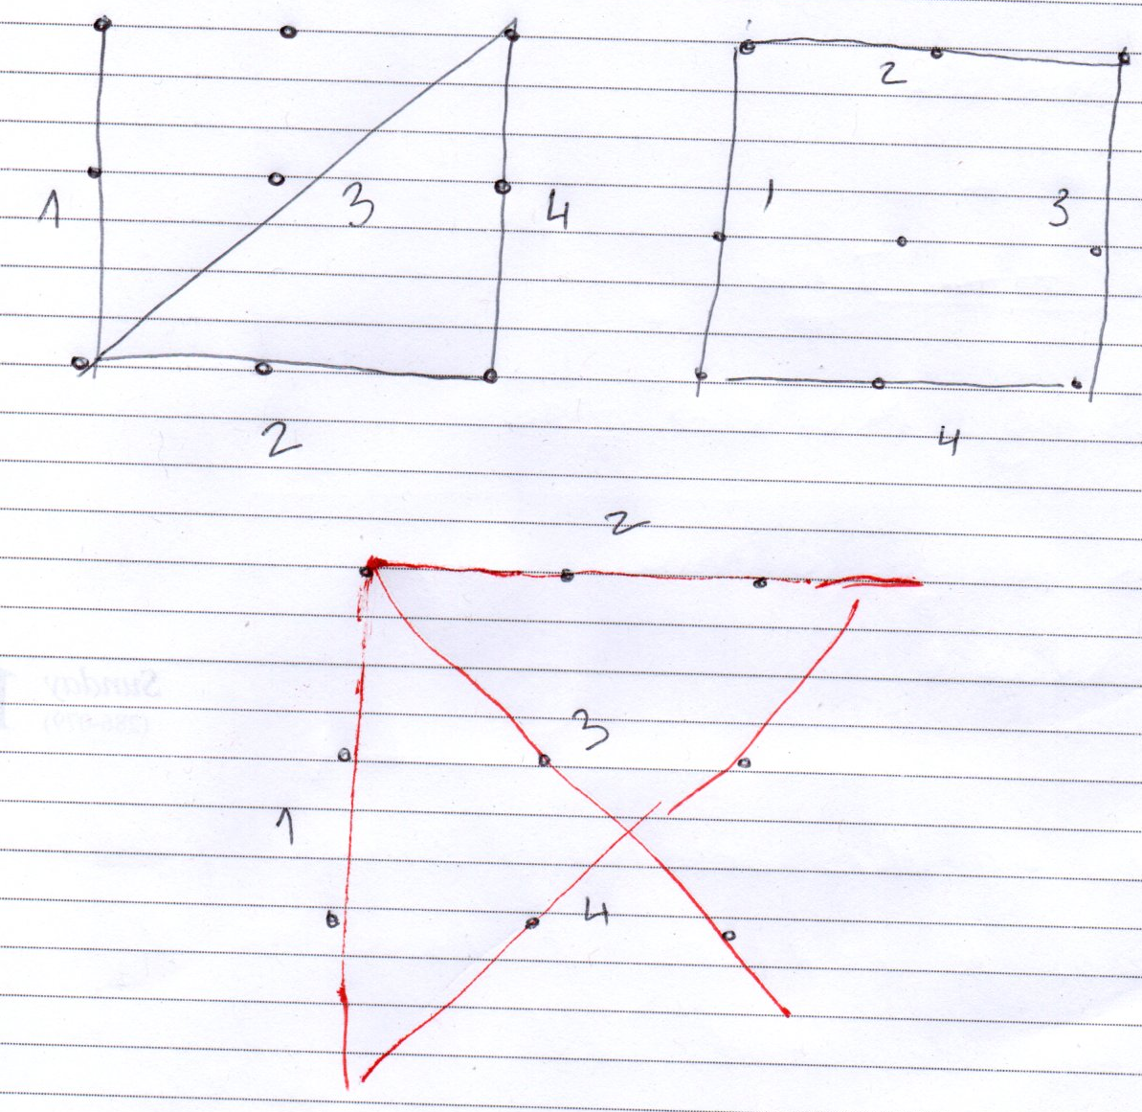
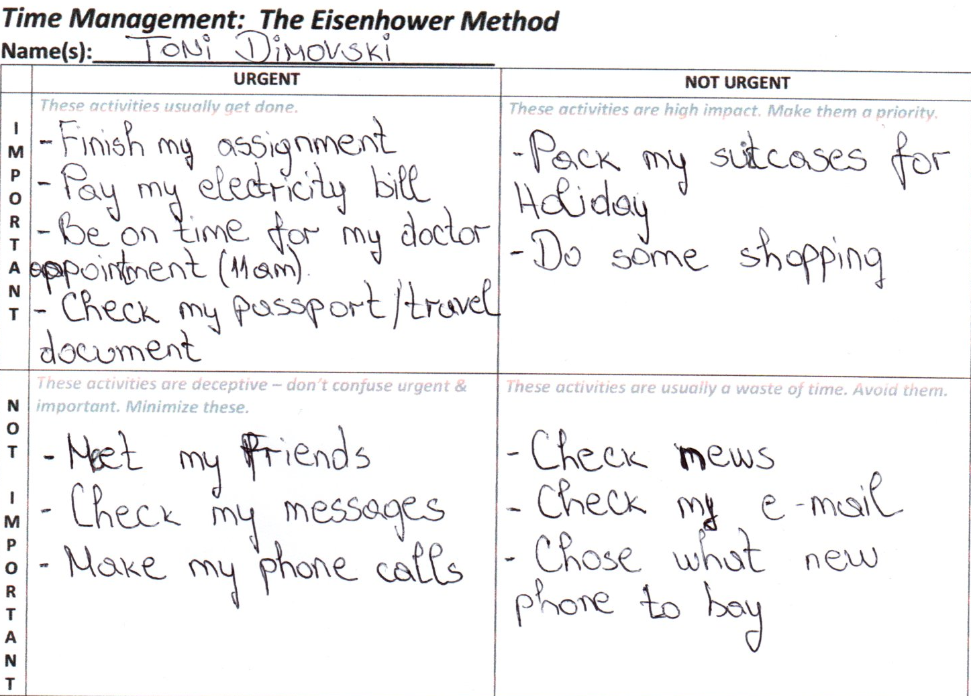

Appendix- PDP
Following Morgan’s (2017) guide on developing the professional development plan, this PDP
is developed.
1. The SWOT analysis helped identify my strengths, weaknesses, opportunities and
threats. This analysis spots things I can exploit, things I have to improve and guides
my plan
2. My career goals are to occupy a senior position within 1 year and then a managerial
position after 3 years.
3. For me to achieve this goal, I have to understand better my work environment and
improve my weaknesses
4. The skills that I would like to work and improve are:
- my time management skills as in my work it is important to deliver the service on
time without delays
- my communication skills for me to communicate well with customers and managers
- my research skills to be able to find solutions for problems I might face
5. for me to accomplish my goals, I have to improve my situation at work by increasing
these skills. For that, I will finish my modules successfully and learn from my
lecturers and classmates. I will also work on my weaknesses and improve my self
expressions and control.
6. Timeline
- in 1 year: improve my communication skills- earn a senior position
- in 2 years: improve my research skills and my work knowledge
- in 3 years: earn an assistant manager position
7. I will be evaluating my plan along for my progress
Appendix- PDP
Following Morgan’s (2017) guide on developing the professional development plan, this PDP
is developed.
1. The SWOT analysis helped identify my strengths, weaknesses, opportunities and
threats. This analysis spots things I can exploit, things I have to improve and guides
my plan
2. My career goals are to occupy a senior position within 1 year and then a managerial
position after 3 years.
3. For me to achieve this goal, I have to understand better my work environment and
improve my weaknesses
4. The skills that I would like to work and improve are:
- my time management skills as in my work it is important to deliver the service on
time without delays
- my communication skills for me to communicate well with customers and managers
- my research skills to be able to find solutions for problems I might face
5. for me to accomplish my goals, I have to improve my situation at work by increasing
these skills. For that, I will finish my modules successfully and learn from my
lecturers and classmates. I will also work on my weaknesses and improve my self
expressions and control.
6. Timeline
- in 1 year: improve my communication skills- earn a senior position
- in 2 years: improve my research skills and my work knowledge
- in 3 years: earn an assistant manager position
7. I will be evaluating my plan along for my progress
Appendix- PDP
Following Morgan’s (2017) guide on developing the professional development plan, this PDP
is developed.
1. The SWOT analysis helped identify my strengths, weaknesses, opportunities and
threats. This analysis spots things I can exploit, things I have to improve and guides
my plan
2. My career goals are to occupy a senior position within 1 year and then a managerial
position after 3 years.
3. For me to achieve this goal, I have to understand better my work environment and
improve my weaknesses
4. The skills that I would like to work and improve are:
- my time management skills as in my work it is important to deliver the service on
time without delays
- my communication skills for me to communicate well with customers and managers
- my research skills to be able to find solutions for problems I might face
5. for me to accomplish my goals, I have to improve my situation at work by increasing
these skills. For that, I will finish my modules successfully and learn from my
lecturers and classmates. I will also work on my weaknesses and improve my self
expressions and control.
6. Timeline
- in 1 year: improve my communication skills- earn a senior position
- in 2 years: improve my research skills and my work knowledge
- in 3 years: earn an assistant manager position
7. I will be evaluating my plan along for my progress
Appendix- PDP
Following Morgan’s (2017) guide on developing the professional development plan, this PDP
is developed.
1. The SWOT analysis helped identify my strengths, weaknesses, opportunities and
threats. This analysis spots things I can exploit, things I have to improve and guides
my plan
2. My career goals are to occupy a senior position within 1 year and then a managerial
position after 3 years.
3. For me to achieve this goal, I have to understand better my work environment and
improve my weaknesses
4. The skills that I would like to work and improve are:
- my time management skills as in my work it is important to deliver the service on
time without delays
- my communication skills for me to communicate well with customers and managers
- my research skills to be able to find solutions for problems I might face
5. for me to accomplish my goals, I have to improve my situation at work by increasing
these skills. For that, I will finish my modules successfully and learn from my
lecturers and classmates. I will also work on my weaknesses and improve my self
expressions and control.
6. Timeline
- in 1 year: improve my communication skills- earn a senior position
- in 2 years: improve my research skills and my work knowledge
- in 3 years: earn an assistant manager position
7. I will be evaluating my plan along for my progress
Appendix- PDP
Following Morgan’s (2017) guide on developing the professional development plan, this PDP
is developed.
1. The SWOT analysis helped identify my strengths, weaknesses, opportunities and
threats. This analysis spots things I can exploit, things I have to improve and guides
my plan
2. My career goals are to occupy a senior position within 1 year and then a managerial
position after 3 years.
3. For me to achieve this goal, I have to understand better my work environment and
improve my weaknesses
4. The skills that I would like to work and improve are:
- my time management skills as in my work it is important to deliver the service on
time without delays
- my communication skills for me to communicate well with customers and managers
- my research skills to be able to find solutions for problems I might face
5. for me to accomplish my goals, I have to improve my situation at work by increasing
these skills. For that, I will finish my modules successfully and learn from my
lecturers and classmates. I will also work on my weaknesses and improve my self
expressions and control.
6. Timeline
- in 1 year: improve my communication skills- earn a senior position
- in 2 years: improve my research skills and my work knowledge
- in 3 years: earn an assistant manager position
7. I will be evaluating my plan along for my progress
Appendix- PDP
Following Morgan’s (2017) guide on developing the professional development plan, this PDP
is developed.
1. The SWOT analysis helped identify my strengths, weaknesses, opportunities and
threats. This analysis spots things I can exploit, things I have to improve and guides
my plan
2. My career goals are to occupy a senior position within 1 year and then a managerial
position after 3 years.
3. For me to achieve this goal, I have to understand better my work environment and
improve my weaknesses
4. The skills that I would like to work and improve are:
- my time management skills as in my work it is important to deliver the service on
time without delays
- my communication skills for me to communicate well with customers and managers
- my research skills to be able to find solutions for problems I might face
5. for me to accomplish my goals, I have to improve my situation at work by increasing
these skills. For that, I will finish my modules successfully and learn from my
lecturers and classmates. I will also work on my weaknesses and improve my self
expressions and control.
6. Timeline
- in 1 year: improve my communication skills- earn a senior position
- in 2 years: improve my research skills and my work knowledge
- in 3 years: earn an assistant manager position
7. I will be evaluating my plan along for my progress
Appendix- PDP
Following Morgan’s (2017) guide on developing the professional development plan, this PDP
is developed.
1. The SWOT analysis helped identify my strengths, weaknesses, opportunities and
threats. This analysis spots things I can exploit, things I have to improve and guides
my plan
2. My career goals are to occupy a senior position within 1 year and then a managerial
position after 3 years.
3. For me to achieve this goal, I have to understand better my work environment and
improve my weaknesses
4. The skills that I would like to work and improve are:
- my time management skills as in my work it is important to deliver the service on
time without delays
- my communication skills for me to communicate well with customers and managers
- my research skills to be able to find solutions for problems I might face
5. for me to accomplish my goals, I have to improve my situation at work by increasing
these skills. For that, I will finish my modules successfully and learn from my
lecturers and classmates. I will also work on my weaknesses and improve my self
expressions and control.
6. Timeline
- in 1 year: improve my communication skills- earn a senior position
- in 2 years: improve my research skills and my work knowledge
- in 3 years: earn an assistant manager position
7. I will be evaluating my plan along for my progress
Appendix- PDP
Following Morgan’s (2017) guide on developing the professional development plan, this PDP
is developed.
1. The SWOT analysis helped identify my strengths, weaknesses, opportunities and
threats. This analysis spots things I can exploit, things I have to improve and guides
my plan
2. My career goals are to occupy a senior position within 1 year and then a managerial
position after 3 years.
3. For me to achieve this goal, I have to understand better my work environment and
improve my weaknesses
4. The skills that I would like to work and improve are:
- my time management skills as in my work it is important to deliver the service on
time without delays
- my communication skills for me to communicate well with customers and managers
- my research skills to be able to find solutions for problems I might face
5. for me to accomplish my goals, I have to improve my situation at work by increasing
these skills. For that, I will finish my modules successfully and learn from my
lecturers and classmates. I will also work on my weaknesses and improve my self
expressions and control.
6. Timeline
- in 1 year: improve my communication skills- earn a senior position
- in 2 years: improve my research skills and my work knowledge
- in 3 years: earn an assistant manager position
7. I will be evaluating my plan along for my progress

PDP
Following Morgan’s (2017) guide on developing the professional development plan, this PDP is developed.
1. The SWOT analysis helped identify my strengths, weaknesses, opportunities and threats. This analysis spots things I can exploit, things I have to improve and guides my plan
2. My career goals are to occupy a senior position within 1 year and then a managerial position after 3 years.
3. For me to achieve this goal, I have to understand better my work environment and improve my weaknesses
4. The skills that I would like to work and improve are:
- my time management skills as in my work it is important to deliver the service on time without delays
- My communication skills for me to communicate well with customers and managers
- My research skills to be able to find solutions for problems I might face
5. For me to accomplish my goals, I have to improve my situation at work by increasing these skills. For that, I will finish my modules successfully and learn from my lecturers and classmates. I will also work on my weaknesses and improve my self-expressions and control.
6. Timeline
- In 1 year: improve my communication skills- earn a senior position
- In 2 years: improve my research skills and my work knowledge
- In 3 years: earn an assistant manager position
7. I will be evaluating my plan along for my progress

