Student name: Ramona Robu Lecturer: Mumtaz Goolam
Student ID number: 1913214

INTRODUCTION TO PHYSIOLOGY
BMHP5003_BIRM

Individual academic poster
THE ENDOCRINE SYSTEM

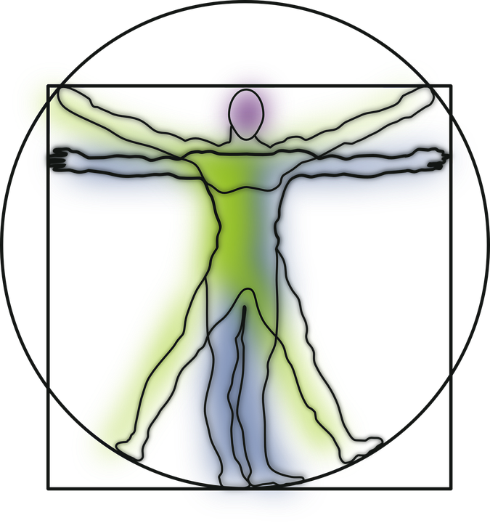

Pituitary Gland is a little gland with the size of a pea but with a big role. It can be found below the hypothalamus gland and together acting as a unit are producing hormones that affect growth and reproduction (Healthdirect, 2021).
Hypothalamus is the gland from the brain that controls the hormone system. Produces multiple hormones that controls the pituitary gland and helps in regulating multiple functions including body temperature, appetite, and sleep patterns (Endocrine System, 2021).
The Endocrine System consists in different organs called glands that are responsible for production and release of different hormones. The main functions of the Endocrine System are growth and function of the reproductive system, development of the brain and nervous system , the metabolism, respiration and blood sugar levels (insulin) (Scanlon and Sanders, 2007).

Thyroid Gland can be found in the front part of our neck and is a butterfly shaped gland. It is verry important for your metabolism, growth, and development of the human body because of the release of thyroid hormones into the bloodstream (Thyroid Function Tests, 2021).

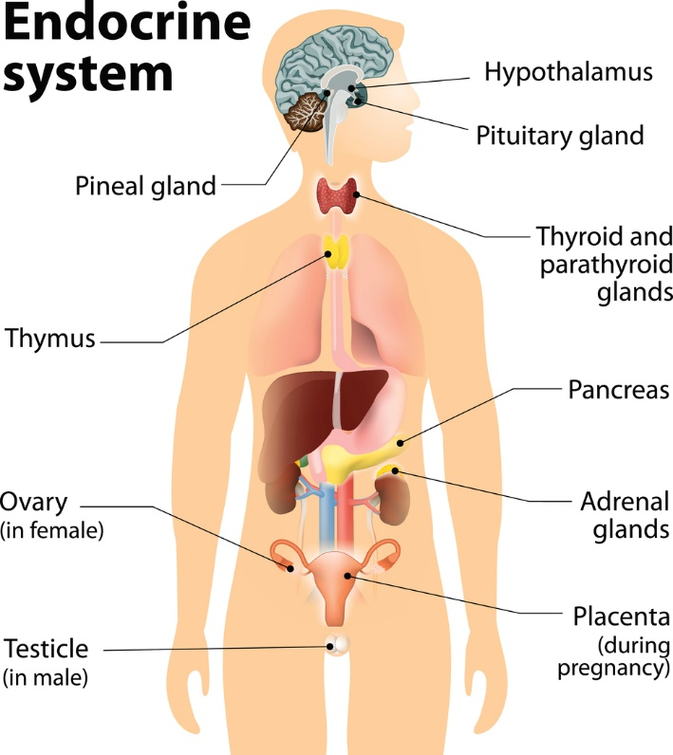
Adrenal (Suprarenal) Glands are located on top of each kidney, are small, triangular -shaped glands. They are important for the produce of hormones to regulate functions as immune system, heart rate, blood pressure, sexual development, and responses to stress.
Pineal Gland is in the middle of your brain, located in the third cerebral hemispheres and is important for our sleep-wake cycles. Produces melatonin and serotonin hormones and plays an important role in the regulation of female hormone levels (Waugh and Grant, 2018).
Parathyroid Gland can be found in front of our neck behind the thyroid gland and there are four parathyroid glands which have the same role. Parathyroid gland role is to maintain control of calcium levels in our bones and blood. The parathyroid problems can be treated only by surgery.
(Mumtaz, 2021)
Thymus Gland located in the upper torso, in the chest between the lungs is active until puberty. Is important for producing a hormone named thymosin that helps to make and develop cell T cells (lymphocytes) (Waugh and Grant, 2018).
Placenta is an organ present only for the length of the pregnancy and produces hormones as human chorionic gonadotropin (hCG), progesterone, leptin, human placental growth hormone (hPGH), relaxin, which are important for a healthy gestational period and successful delivery.
Ovaries are in the pelvic cavity and are producing hormones called oestrogens and progesterone.

Pancreas can be found behind our stomach in our abdomen and is important in controlling the blood sugar levels by producing the hormone insulin. The pancreas consists of 95% of exocrine tissue which regulates the pancreatic secretion and 5% of endocrine cells called islets of Langerhans which are producing the hormones that regulates the blood sugar. The main hormones are insulin which helps to lower the blood sugar, and glucagon with the role of raising the blood sugar.
Testicle (Testes) are lie behind the penis outside of the body in the scrotum, and this because sperm quality and production are optimal at this lower temperature. The testes’ function is to produce hormones called testosterone which is an androgenic hormone and to produce sperm in the seminiferous tubules of the testes.

ThyroidGland/Function/Disorders/Symptoms/Treatment/Recommendations

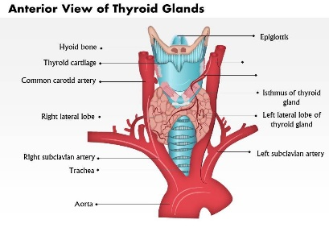

(Slide net,2021)
The thyroid gland plays an important part of the endocrine system and by working together with the nervous and immune system, regulates the body’s metabolism, development of the body and growth. The thyroid gland produces two hormones: thyroxine (T4) and triiodothyronine (T3) that are secreted into the bloodstream to different organs and tissues in the body. The hormones are in charge to tell these organs what to and do how to function. When the thyroid is not producing enough of these hormones T4 and T3, many of the body’s function will not work properly and can get to have different serious health conditions (Pirahanchi, Tariq and Jialal, 2021).

Grave’s disease is an autoimmune condition and occurs when the thyroid gland is attacked mistakenly by the body’s immune system. It can develop at any age but it’s more frequent in women aged 30-50.
Risk factors: stress, smoking, pregnancy
Symptoms: anxiety, fatigue, irritability, hand tremors, excessive sweating, sleeping difficulty, increased/irregular heartbeat, goiter, frequent bowel movements, bulging eyes and vision problems (National Library of Medicine (2017)

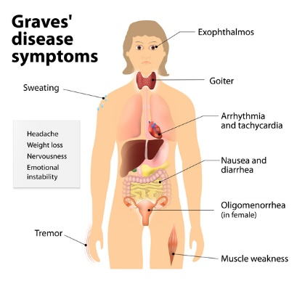
(Healthy diet, 2021)

.

(Conditions, 2021)
Different disorders can appear when the thyroid produces much more hormone than supposed too (hyperthyroidism) or not enough hormone (hypothyroidism). Common disorders are also Hashimoto’s thyroiditis, goiter, thyroid nodules and Grave’s disease.
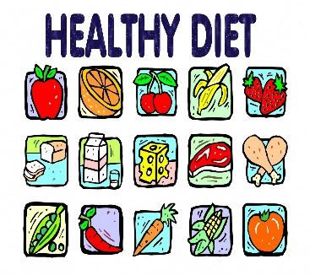
Treatments used for Grave’s disease are:
-radioactive iodine therapy which is the most common
-medication (levothyroxine)
-Thyroid surgery (total thyroidectomy)
Exercise


If noticed the symptoms mentioned above, it is crucial to see your healthcare provider who will guide you for the next steps.
Not stress yourself
Check with your healthcare provider
References:
Cleveland Clinic (2021) Endocrine System: What Is It, Functions & Organs. [online] Available at: <https://my.clevelandclinic.org/health/articles/21201-endocrine-system> [Accessed 14 November 2021].
Graves disease,(2021) MedlinePlus Genetics. [online]. Available at: <https://medlineplus.gov/genetics/condition/graves-disease/> [Accessed 14 November 2021].
Healthdirect. (2021) Pituitary gland. [online] Available at: <https://www.healthdirect.gov.au/pituitary-gland> [Accessed 14 November 2021].
Healthy Diet (2021) [online] Available at: https://www.publicdomainpictures.net/pictures/170000/velka/healthy-diet-educational-poster.jpg {Accessed at 18 November 2021).
Mumtaz, G.(2021) ‘The Endocrine System’ [power point presentation] BMHP5003: Introduction to Physiology, Available at: https://moodle.uwtsd.ac.uk/course/view.php?id=8038 [Accessed: 3 November 2021].
National Library of Medicine (2017) Graves disease [online] Available at :https://ghr.nlm.nih.gov/condition/graves-disease#statistics [ Accessed 18 November 2021].
Nhs.uk. (2021) Overactive thyroid (hyperthyroidism). [online] Available at: <https://www.nhs.uk/conditions/overactive-thyroid-hyperthyroidism/> [Accessed 14 November 2021].
Pirahanchi, Y., Tariq, M. and Jialal, I., (2021). StatPearls : Physiology, Thyroid. Bethesda: U.S. National Library of Medicine.
Scanlon, V. & Sanders. T,(2007) Essentials of Anatomy and Physiology. 5th ed. Philadelphia: F.A. Davis Company, pp.221-247.
Slideteam.net.( 2021). Check out this amazing template to make your presentations look awesome at. [online] Available at: <https://www.slideteam.net/business_powerpoint_diagrams/67817591-style-medical-2-diseases-1-piece-powerpoint-presentation-diagram-infographic-slide.html> [Accessed 14 November 2021].
Thyroid.org. (2021) Thyroid Function Tests. [online] Available at: <https://www.thyroid.org/wp-content/uploads/patients/brochures/FunctionTests_brochure.pdf> [Accessed 14 November 2021].
Waugh, A. & Grant, A.( 2018) Ross and Wilson Anatomy and Physiology in Health and Illness: (10th Edition) London: Churchill Livingstone, pp.136-137.
Waugh, A. & Grant, A.( 2018) Ross and Wilson Anatomy and Physiology in Health and Illness: (10th Edition) London: Churchill Livingstone , pp.224.

